LANDS OF LORE IV
Seeds of the Ancients
Concept review document
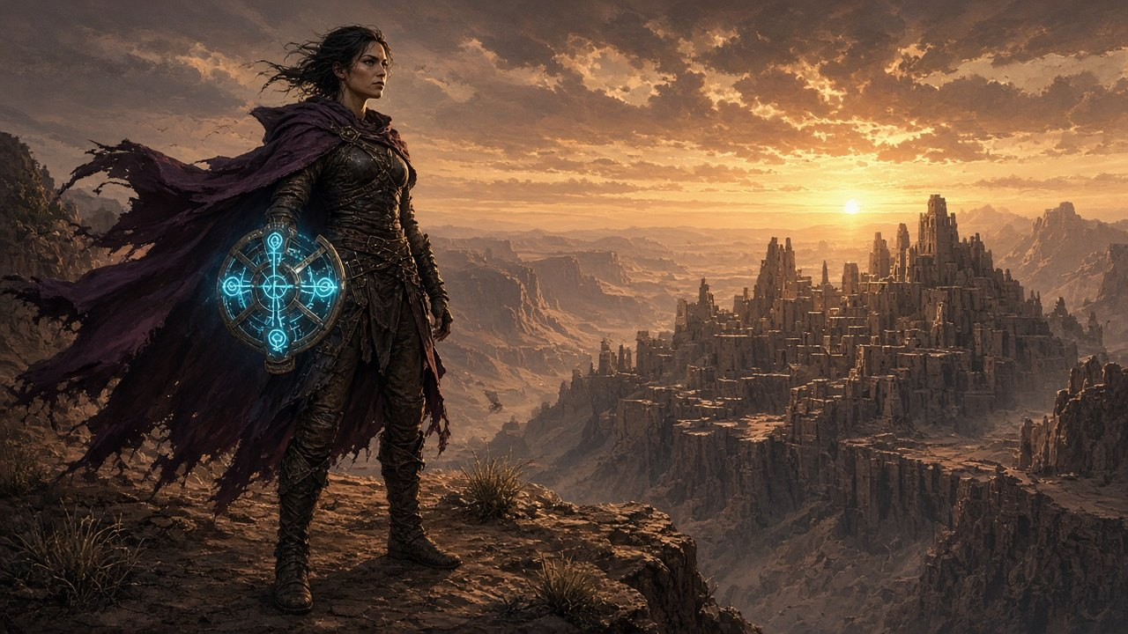
Draft for human review | 2026-09-20 | all decisions recorded and applied
Canon: the GAME4 reference from the master CoT/CoS outline
A new game, not a Classic edition. All pictures are AI look-development stills, not final art.

How to review this document
This is the readable front door to the Lands of Lore IV concept. It gathers the pitch, cast, story, places, quests and endings in one place so a person can read it start to finish and say yes, no or change this. The working files used for building (room layouts, full dialogue sheets, quest scripts) stay separate and are listed at the end. LoL IV is a new game. Classic means Lands of Lore 1 to 3.

What to do
1. Read the pitch, cast and locations. Comment on anything that contradicts the master outline or feels wrong.
2. Check the decision table. It holds your answers and shows which details the AI lane filled in. Comment on any that do not read the way you meant.
3. Ignore the pictures for now. They are placeholders and stay in the document until further notice.

In Google Docs
- Upload the file to Drive and open it with Google Docs. Turn on Suggesting mode for edits.
- Select any text and press Ctrl+Alt+M to leave a comment.
- Open the outline panel on the left to jump between sections.

Labels used
Label | Meaning
Locked | Taken from the GAME4 outline. Safe to build on.
Decided | Your answer, recorded on 2026-09-19 or 2026-09-20. Numbered D1 to D16 in the decision table.
AI call | Filled in by the AI lane because you said “you make them up” or “as you see fit”. Change it if wrong.
Draft | Written by the AI lane and waiting for your approval. Sample dialogue is always draft.

AI calls to check (none block work)
Route order Hut, first stop at Last Haven, cliffs, Haven hub, Canyons, Caverns.
Raven Three random encounters, reveal at the ward court.
Names Oswin Tull, Bran Kettle, Sunna.
Golems Freed by three release words from the mini dungeons.
Messages Four bird messages, the last for Copper.
Places Hut on Royal Road South, three mini dungeons.

Sections that follow: pitch, cast, story structure, locations with a sample scene each, quests, endings, optional places, the decision table, AI calls and what changed, known gaps and where the working files live.

One-page pitch
Genre: First-person action-RPG — explore, puzzle, branch, classic LoL tone (dark fantasy, dry humor, moral ambiguity).
When / where: 10–15 years after LoL3. Southern deserts, Thomgog cliff cities, hidden ancient Draicele.
You play: Elyra — adult daughter of Luther & Dawn. Diluted shapeshift curse + rune magic.
Theme: Legacy vs. Rebirth — what we leave when we die, and whether “seeding” immortality is gift or curse.
Party spine: Elyra + reseeded Baccata + priestess Lira + (Act 2) exile hermit Copper LeGré.
Villain force: Belial-cult remnant led by Melicothor, wielding the corrupted Draracle relic Black Thorn (burns Thomgog souls before they can seed). Elyra first meets him as Raven the Artificer.
Moral gates:
- A — Replant seeds now, or race to Draicele (more deaths).
- B — Respect Draicele wards, or plunder forbidden soul-knowledge.
- Optional Spire — Purify or corrupt the Azure Heart (finale and epilogue modifier).
Endings: Good (Copper Archmage, refuses crown) · Neutral (the player chooses who pays: Baccata's memories or Copper's eternal vigil) · Evil (Elyra Thorn Queen; Copper hunts; Dawn in dark armor).
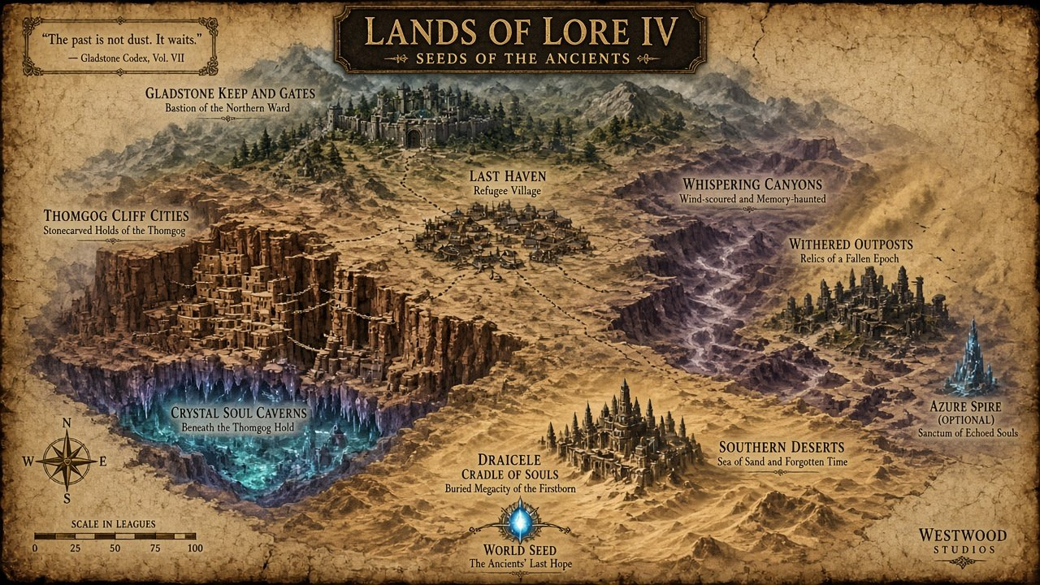
Concept: campaign map — Gladstone north → deserts, Last Haven, Thomgog cliffs, Draicele south.

Cast
Who | Role | Concept art
Elyra | PC — explorer, Rune Wheel, shapeshift
Baccata | Reseeded four-arm mentor — comic + tragic memory | 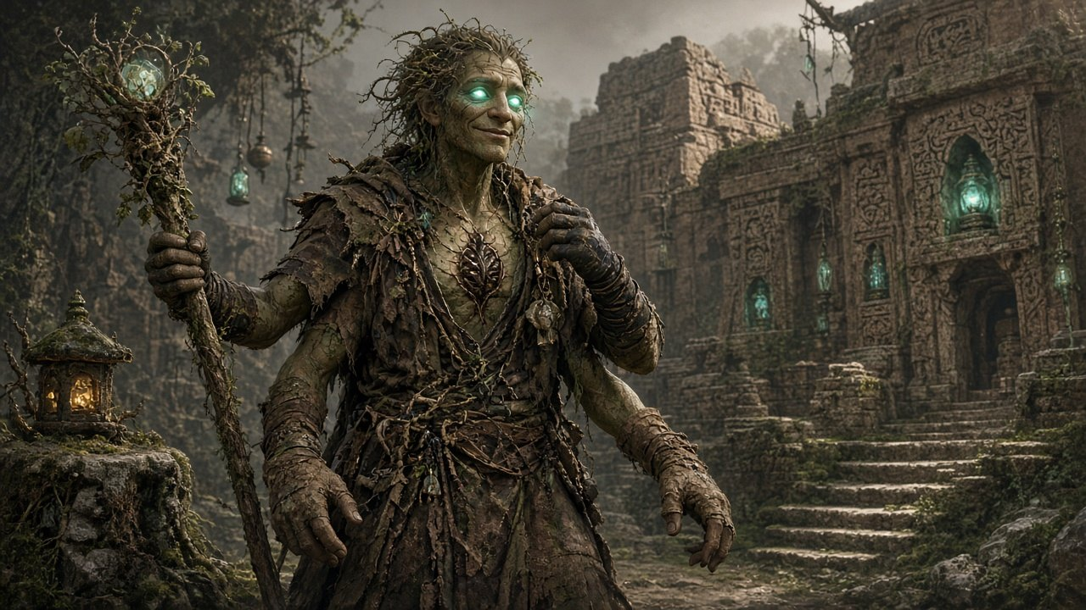
Copper (LoL3) | Youth baseline — mustard tunic, leopard cloak, part-Dracoid | 
Copper (LoL4) | Bearded exile hermit — worn leopard remnant, soul-rune staff | 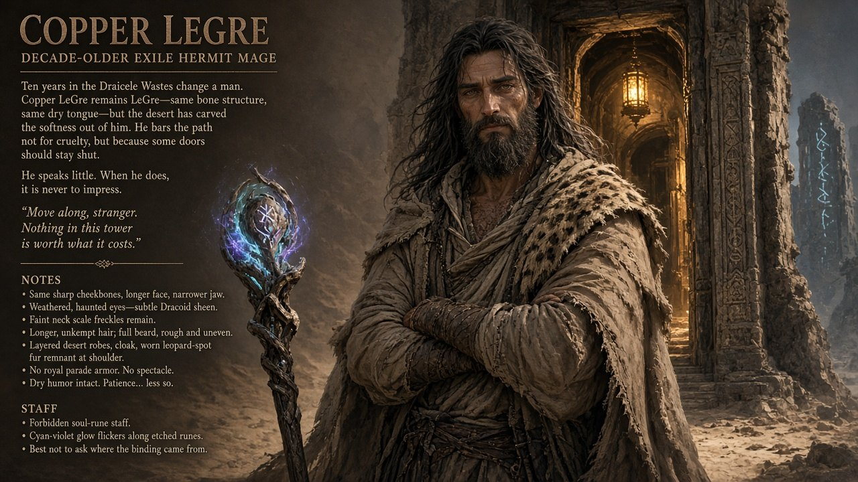
Lira | Thomgog priestess; seed next to plant; friend and ally | Concept image still to do
Luther & Dawn | Cameo mentors (prologue, epilogue, and speaking-stone bird messages) | Cameo only; no image yet

Melicothor, the antagonist
- Background. In his youth a good citizen of Yvel. After Scotia he researched artifacts and found the location of Draicele.
- Manner. Obsessive and cold. Every word is calculated. He is irritated by Elyra's chipper humor.
- Alias. Elyra meets him as Raven the Artificer at random places at the start of Act 2, like Scotia in LoL1. He is unmasked at the ward court beside Choice B.
- Role. He leads the Belial cult remnant and wields the Black Thorn. Belial himself stays dead, and Baccata's memories show Belial as the true evil.
Decided: D1
The antagonist is Melicothor. The Draicele and World Seed scenes are written around him.

Roles and arcs
Character | Role | Arc
Elyra | Player character. Adult daughter of Luther and Dawn. Shapeshifts (Wolfkin, then Drakekin, then the risky Thornbeast) and carries Dawn's six-slot Rune Wheel. | Prove she is more than her parents' shadow. Choose whether power or people define her legacy.
Baccata | Reseeded four-armed Thomgog warrior-mage. Comic and tragic, with fragments of past lives. | Stranger to self. Good ending costs part of his new life-force. Neutral risk is losing every memory.
Lira | Thomgog priestess, friend and ally. No romance. Her own seed is next to be planted. | Her faith in the cycle is tested by the Thorn, so the stakes are personal.
Copper LeGré | Exiled hero of LoL3, hermit mage in Draicele. Hostile at first, then a temporary mentor. | From “leave me dead” to reluctant mentor. On the good path he returns as Archmage and still refuses the crown.
Luther and Dawn | Cameo mentors, mostly voice until the epilogue. Mid-game, a bird from Luther brings a speaking stone with messages. | Let Elyra go. On the evil path Dawn in dark armor faces her daughter.
Melicothor | Male sorcerer of the Belial cult remnant, wielding the corrupted relic Black Thorn. Wants an eternal army of soulless thralls. Meets Elyra as Raven the Artificer. | Cold and calculating, and irritated by Elyra's humor. His plan is the Thorn's answer to Legacy versus Rebirth.
Optional companions | At Last Haven: a Huline scout (routes, canyon stealth) and a human alchemist (seed chemistry, crafting). | Small arcs tied to Last Haven morale. Both get an epilogue shout-out. On the evil path they abandon Elyra.

Continuity rules writers must keep
- Scotia is dead. Luther's curse is diluted in Elyra, not a full return of the Nether Mask.
- Belial stays dead. Only the cult remnant remains.
- Draracle has withdrawn from the mortal plane, so only relics and Draicele's history remain.
- The Chronowalker has no live presence in LoL IV. Echo stones, a hidden painting room and a line from Copper at Draicele are allowed.

Story structure
Gladstone → Luther's hut → Last Haven (first stop) → Thomgog cliffs (Lira joins) → Last Haven (full hub) → Whispering Canyons (required stop) → Crystal Soul Caverns → Draicele → (optional Azure Spire) → World Seed under Draicele. Three optional Ancient mini dungeons sit along the routes.

Acts at a glance
Block | Title | Primary locations | Exit handoff
Prologue | Blood and Seed | Gladstone | South along Royal Road, past Luther's hut, to Last Haven and the cliff cities
Act I | The Withering | Last Haven (first stop) → Cliff cities → Last Haven (hub) → Canyons/Outposts → Crystal Soul Caverns | Tablet → Draicele (Choice A resolved)
Act II | Memories in Stone & The Cradle | Draicele (± Azure Spire) | Descent to World Seed (Choice B + Spire flag set)
Act III | The Eternal Thorn | World Seed chamber | Ending branch → Epilogue
Epilogue | After the Seed | Gladstone and/or Draicele (path-dependent) | Credits / post-credits (evil)

What each act is for
- Prologue, Blood and Seed. Hook the Black Thorn, give Elyra a reason to leave home, attach Baccata and point at Copper without showing him.
- Act I, The Withering. Make the Thomgog cycle felt as culture and crisis, recruit Lira, name the Thorn, reveal Draicele, and force Choice A.
- Act II, Memories in Stone and The Cradle. Thaw Copper, reveal the villain's full plan, force Choice B, and offer the optional Azure Spire.
- Act III, The Eternal Thorn. Resolve the Black Thorn at the Soul Font. The ending branches from everything the player chose.
- Epilogue. Path-dependent slides at Gladstone or Draicele, with a post-credits sting on the evil path.

Locations
Eight places in story order. Each has a picture, who is there, the plot points and one sample scene from the draft dialogue.

1. Gladstone Gates — Prologue
Act: Prologue · Feel: Cool green Scotia, duty, parental legend shadow
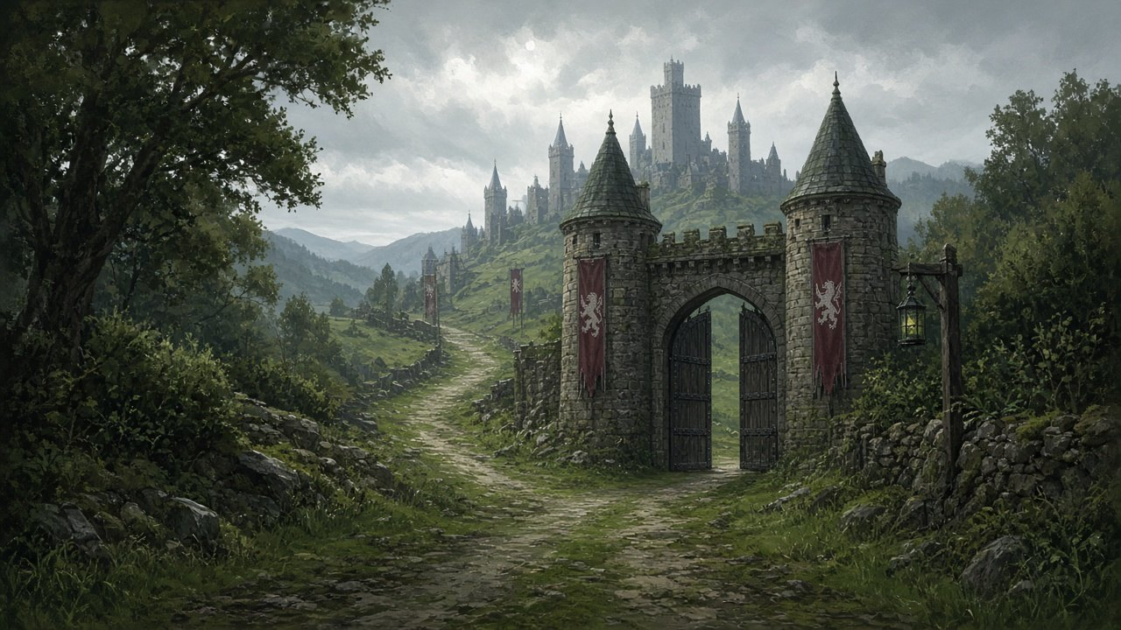
What it is: Kingdom on-ramp. Not a full city crawl — gates, plaza, keep as backdrop.
Who’s here: Elyra, Luther & Dawn (cameo), collapsing Baccata, guards/healers.
Plot points
1. Rumors: southern seeds “won’t take”; caravans missing.
2. Reseeded Baccata collapses at the gates muttering black thorn / cycle bleeding.
3. Parents brief Elyra; name Copper LeGré (left a letter and vanished rather than take the throne).
4. Elyra accepts — duty and independence from legendary parents.
5. Depart south with Baccata, past Luther's hut.
Key line energy: Baccata — “These stones feel familiar…”
Sample scene: Baccata collapse first-pass draft, not approved
Crowd: "Make way—!"
(Four-armed figure hits the stones. Seed-crystal dust on his sternum.)
Baccata: (half-conscious) "…cycle's bleeding… black thorn… burning them before they… seed…"
Elyra: "Stay with me. You're in Gladstone."
Baccata: "Gladstone… stones… I know these stones… why do I know these stones?"

2. Last Haven — Act 1 hub
Act: Act 1 · Feel: Scrap-built hope; LoL2 war hangover; mixed Huline / human (~150)
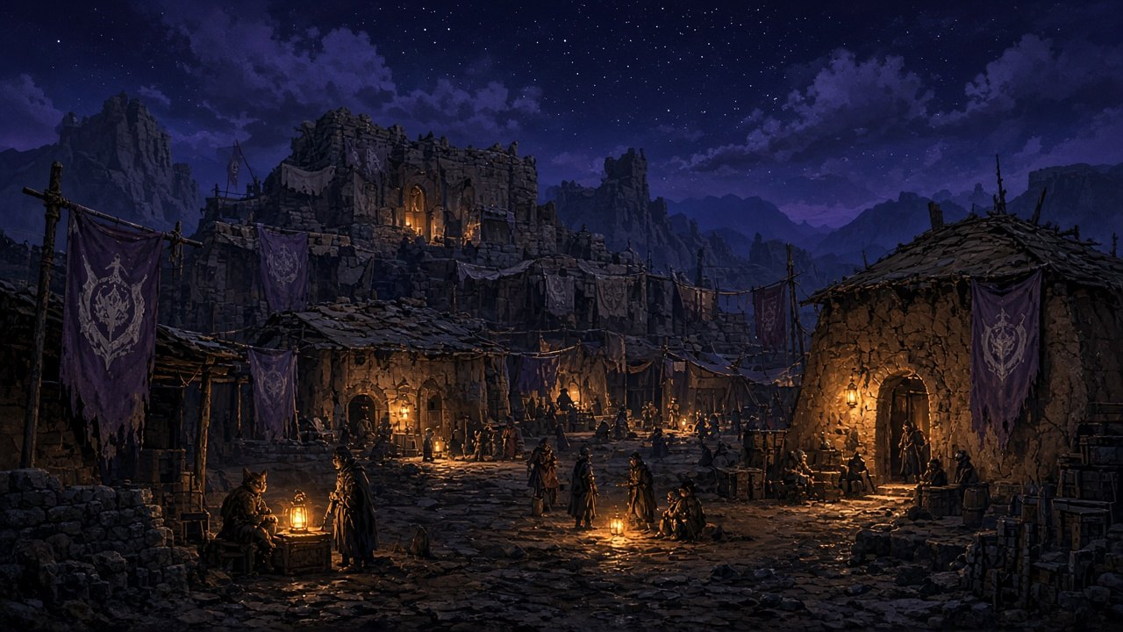
What it is: First desert hub after Gladstone. Trade, craft, morale meter, companion hooks.
Who’s here: Party, Huline elder, refugees, optional scout & alchemist. Named residents: Marshal Oswin Tull (leader), Bran Kettle (shopkeeper), Sunna (Huline mother).
Plot points
1. Grateful, exhausted welcome; hub unlocks.
2. Morale rises or falls with how you help — trade/craft vs local Thorn corruption.
3. Side: replant corrupted seed rows (preview of Choice A).
4. Belial-era hauntings on faded battle banners (history, not Belial revival).
5. Baccata’s first strong memory return — recognizes a Huline elder from a past life.
6. Paths open: cliffs southwest, canyons southeast.
7. If too many seeds are lost, Tull, Kettle and Sunna die and their places stand empty.
Sample scene: Elder memory surge first-pass draft, not approved
Elder_Mira: "A four-armed shadow in my doorway. Either the cycle is kind, or it's mocking me."
Baccata: "Mira—? I do not know that name. My mouth does. Traitorous mouth."
Elder_Mira: "You wore different eyes last time. Same stubborn shoulders. You pulled my sister out of a Belial trench and then forgot to write."
Baccata: "I apologize for every life where I was late with letters."
Elder_Mira: "Don't apologize. Finish something. The Thorn doesn't care about reunions."
Elyra: "He'll finish it. We're not here for nostalgia tourism."
Baccata: "Correct. Nostalgia is just grief with better lighting."

3. Thomgog Cliff Cities — Act 1 culture core
Act: Act 1 · Feel: Ochre mud-brick vertical city; rope bridges; soul-lanterns; four-arm life
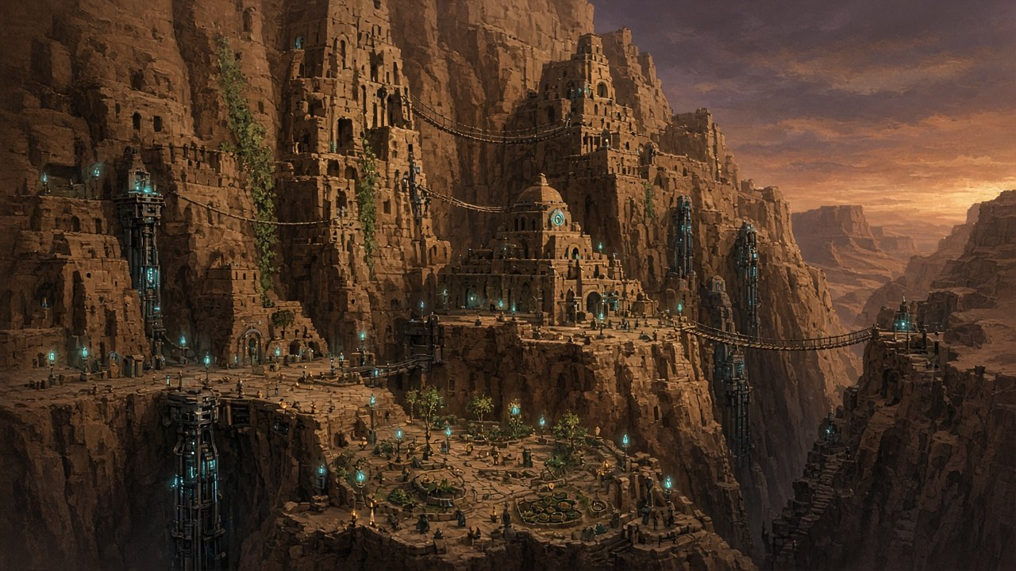
What it is: Living Thomgog civilization — reincarnation as practice, not a lore dump.
Who’s here: Elyra, Baccata, Lira (joins), elders, Burdenforged & Machinelings.
Plot points
1. Arrival: Baccata’s body knows the bridges before his mind does.
2. Meet Lira — her own seed is next to plant; crisis becomes personal.
3. Elders argue: plant what remains vs hunt the thief.
4. Black Thorn / Belial-cult remnant named as external malice burning souls before seeding.
5. Party locks: Elyra + Baccata + Lira.
6. Elevator path down toward Crystal Soul Caverns.
Sample scene: Arrival — Baccata body-memory first-pass draft, not approved
(Ochre cliffs rise in stacked mud-brick tiers. Rope spans tick in the wind. Burdenforged grind somewhere above.)
Baccata (hands already finding the rock before he looks): “Left hand here. Right span three breaths later. The fourth—” (stops, blinks) “—I do not remember learning that.”
Elyra: “Your body got here first. Mind’s still unpacking.”
Baccata: “These bridges remember me louder than I remember them. That is either homecoming or a trap with good masonry.”
Elyra (dry): “Cheerful. Try the market before you invent a third option.”

4. Whispering Canyons / Withered Outposts — Act 1 horror
Act: Act 1 · Feel: Purple-grey sandstorms; scarce light; ghost echoes
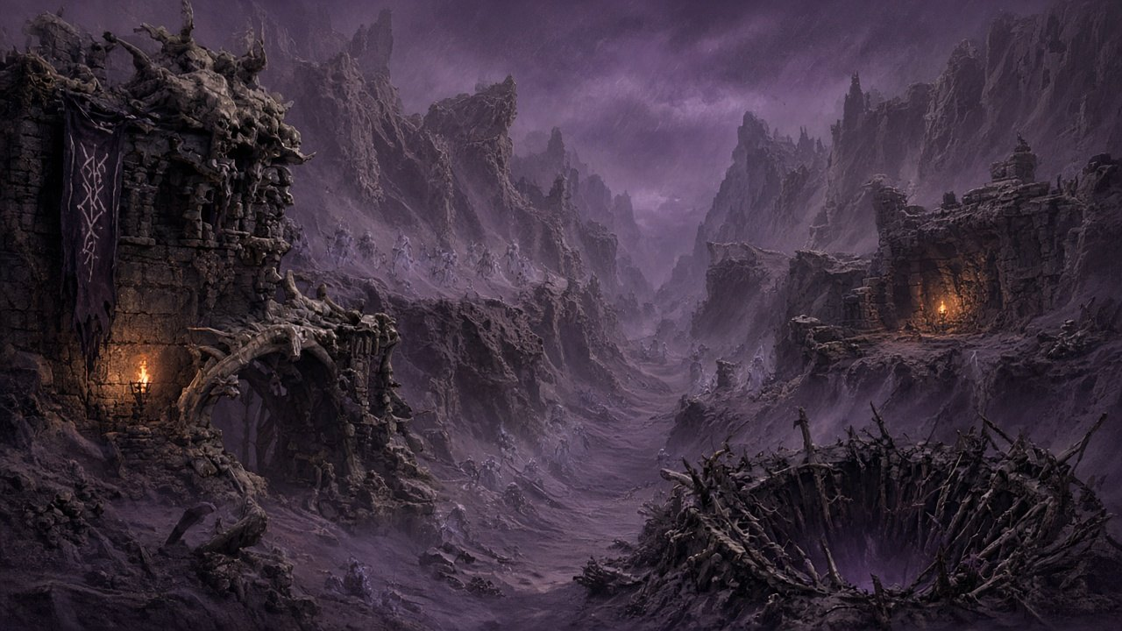
What it is: Horror traverse between hubs — stealth, light management, echo events. A required stop.
Who’s here: Party; failed-seed ghosts; cult experiment residue (no required face).
Plot points
1. Echo events briefly replay LoL2 battles in first person.
2. Ghosts revealed as failed Thomgog seeds — early Thorn experiments that never reincarnated.
3. Resting them (mini-game) advances the main quest.
4. Establishes the Thorn as desecration of the cycle, not mere theft.
5. Lira under stress: if the cycle can be burned, what are we?
Baccata: fear he is only a “successful” seed.
Sample scene: Rest niche — failed seed first-pass draft, not approved
Ghost_Seed: "…furrow… warm… I was supposed to wake as someone kind…"
Lira: "Early Thorn work. A soul burned mid-dream. She isn't a monster. She's a sentence without an ending."
Elyra (rest): "Then we end it gently. Rest."
Ghost_Seed (rest): "…oh. Cool soil. Thank—" (fades)
Baccata (rest): "That could have been me with worse timing."
Elyra (hurry): "We can't stop for every echo. The Font won't wait."
Lira (hurry): "Then walk faster than your guilt. It has longer legs than you think."

5. Crystal Soul Caverns — Act 1 → 2 gate
Act: Act 1 late · Feel: Living cyan crystal; soul-essence rivers; wonder + unease
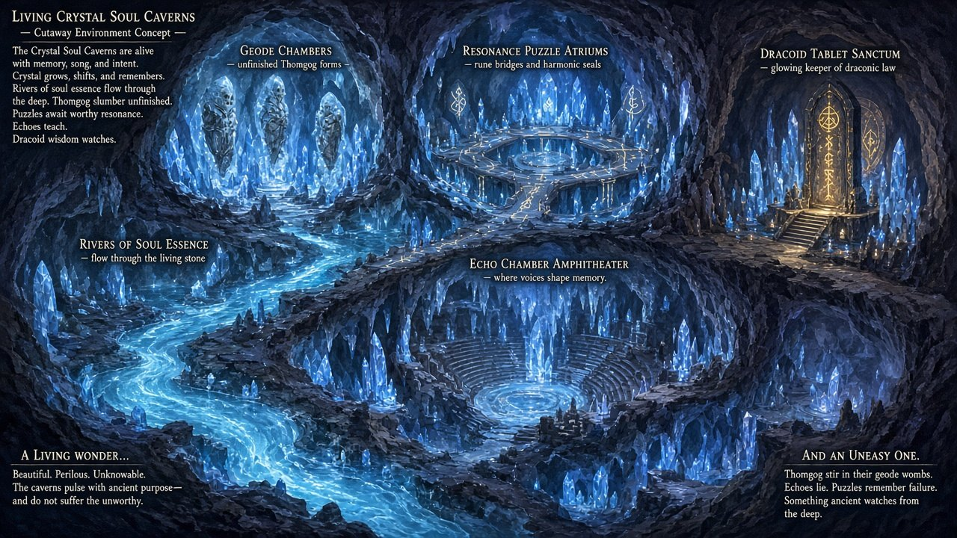
What it is: Under the largest cliff city — puzzles, geodes of unfinished Thomgog forms, the tablet to Draicele.
Who’s here: Party; memory echoes; tablet (not a living guide NPC).
Plot points
1. Resonance puzzles (rune combos → bridges / allies).
2. Echo Chamber — unfiltered Baccata past-life memories (LoL1 + LoL2 callbacks).
3. Geode mercy — free or end incomplete forms (moral lean).
4. Dracoid tablet names Draicele, Cradle of Souls, origin of the Thomgog cycle.
5. Moral Choice A: replant seeds now, or race to Draicele (more deaths meanwhile).
6. Optional hook: ritual tunnel toward Azure Spire (not required for main plot).
Sample scene: Choice A at desert exit first-pass draft, not approved
Lira: "We can turn back to the rows and plant what life remains — or race the bearing to Draicele while more seeds blacken behind us."
Baccata: "I have lost wars by hurrying and funerals by waiting. Pick the sin you can carry."
Elyra (replant): "We plant first. Draicele won't forgive us for arriving pure and leaving graves."
Lira (replant): "Then we move like gardeners with swords. Thank you."
Elyra (race): "We race. If the Font dies, every furrow is theatre."
Lira (race): "Then I will hate you a little and follow you anyway. Do not waste that."

6. Draicele — Cradle of Souls (Act 2)
Act: Act 2 · Feel: Sand-buried vertical megacity; floating rune platforms; exile loneliness + awe
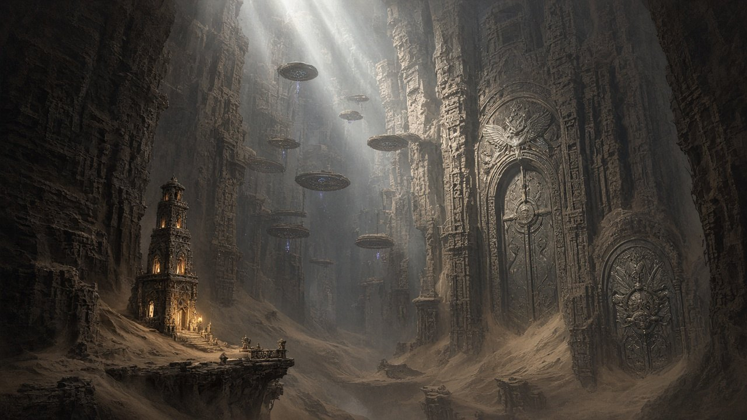
What it is: Ancient Soul-Era city — Draracle’s old seat. Soul-vaults open to Thomgog or hybrid Dracoid blood. Copper’s tower becomes a player hub.
Who’s here: Full party; Copper LeGré; Raven the Artificer; vault guardians; cult as needed.
Plot points
1. Arrival through dunes into living forges and vault rings.
2. At the start of Act 2, Raven the Artificer meets Elyra at random places, unscripted, the way Scotia appeared in LoL1. Courteous, precise, useful.
3. Copper at the hermit tower — hostile opener (GAME4 lock):
“Go tell Luther and Dawn I’m dead. I like it that way.”
4. Sincerity thaw → temporary mentor (no crown talk, no Gladstone sermons).
5. Vault access makes Copper’s part-Dracoid heritage load-bearing.
6. Sacred sites → Baccata memory surges: his own death in LoL2, and Belial as the true evil.
7. Villain plan clear: hijack the cycle → eternal soulless thrall army.
8. Moral Choice B: plunder forbidden soul-knowledge or respect the wards. Right after, Raven is unmasked as Melicothor.
9. Chronowalker traces: echo stones, and a hidden room with a painting of her young and at about forty, facing each other. No live presence. Copper wonders aloud who she is.
10. Path opens down to the World Seed (Act 3).
Sample scene: Copper hostile first contact (GAME4 line) first-pass draft, not approved
(Hermit tower: craft bench, stacked reagents, desert dust on everything except the wards. A bearded man in worn exile cloth — no court shine, no parade kit — looks up like the door insulted him.)
Copper: “Go tell Luther and Dawn I’m dead. I like it that way.”
Elyra: “I’m not their courier with a prettier seal. I’m Elyra. The southern seeds are burning before they wake. Baccata crawled to Gladstone naming a Black Thorn.”
Copper: “And Gladstone’s answer was to send me a heirloom problem with company. Charming.”
Lira: “Priestess of the cliff cities. My seed is next. If you hide while the cycle is nailed shut, your ‘death’ is just a hobby.”
Copper (bitter) : “I refused a throne so I wouldn’t hollow out. Don’t recruit me with sermons about duty. I’ve heard better lies in quieter rooms.”
Baccata: “I am not worshiping you. I am… continued. Like you. Badly. With more arms.”
Copper: “…Four arms and a death wish for poetry. Get out of my tower before I decide hospitality is a curse.”
Decided: D10 and D1
Chronowalker traces, no live presence. Melicothor walks here as Raven the Artificer.

7. Azure Spire — Optional Act 2 super-area
Act: Act 2 optional · Feel: Cold geometric blue; time puzzles; precise vs Draicele’s organic soul-work
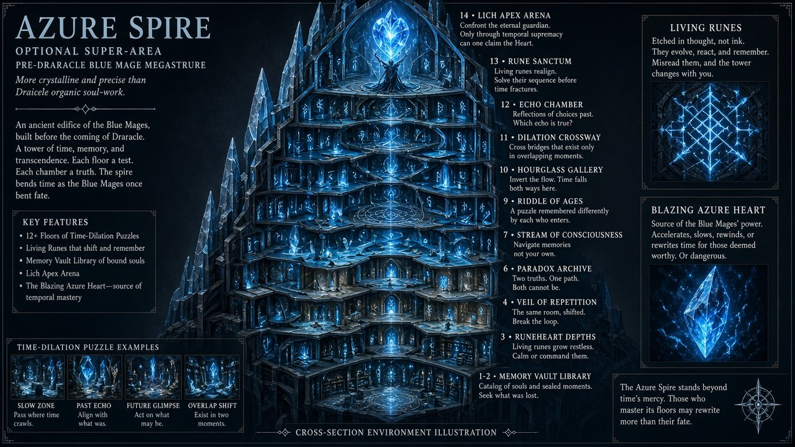
What it is: Pre-Draracle Blue Mage megastructure (12+ floors). Entry via cavern ritual tunnel.
Who’s here: Party ± Copper; last Blue Mage (lich).
Plot points
1. Entry needs four-arm ritual (Baccata + Elyra Drakekin + soul-forged key).
2. Living runes teach advanced spells; Memory Vault holds Copper’s exile journal.
3. Lich thesis: Thomgog cycle as abomination (foil to Lira).
4. Purify Spire → spirit allies in the finale · or corrupt Azure Heart → cursed power (evil lean).
5. Secret exit fast-travels back toward Draicele.
6. Locked stone-golem guardians from the Golden Age wait here and help at the ending.
7. Spire outcome shapes the finale and epilogue — not required for the main spine.
Sample scene: Heart choice first-pass draft, not approved
Elyra (purify): "We purify it. Allies over mutations."
Blue_Lich (purify): "Then die interesting." (spirits loosen — not kind, but free)
Copper (purify): "Rare. Someone picks the boring courage. I can live with boring."
Elyra (corrupt): "We take the Heart's bite. If the Thorn writes in power, so do I."
Blue_Lich (corrupt): "Good. Symptoms recognizing symptoms."
Copper (corrupt): "Don't ask me to clap. You've volunteered to be a cautionary tale with better teeth."
Decided: D5
Stays optional. Freed stone-golem guardians help at the ending.

8. World Seed Chamber — Act 3 climax
Act: Act 3 · Feel: Dying cyan Soul Font vs bruised-purple Thorn tree; boss-arena scale
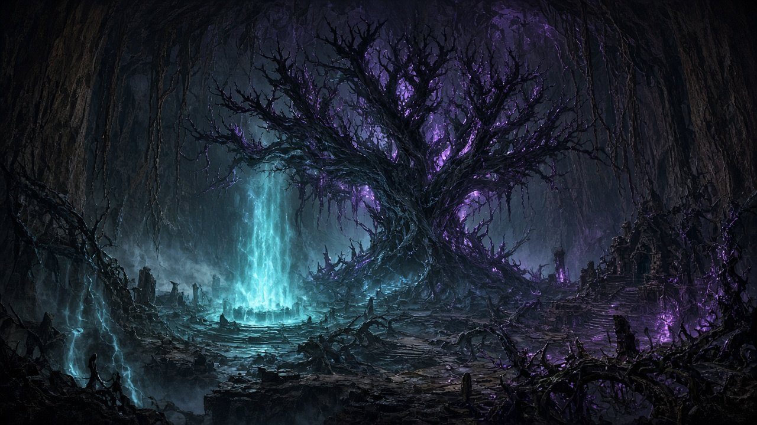
What it is: Beneath Draicele — the Soul Font grove, source of Ascendant reincarnation, twisted into a black-thorn tree.
Who’s here: Full relevant party; Melicothor with the Thorn power; ending-specific cameos.
Plot points
1. Descent; first sight of the corrupted Font.
2. Confrontation with Melicothor: thrall-army “mercy/order” thesis vs Legacy vs Rebirth. Freed golems, if any, arrive to help.
3. Good: Copper stabilizes; Baccata sacrifices life-force; Thorn purged; Copper returns as Archmage (still refuses crown); Luther & Dawn welcome him.
4. Neutral: Cycle saved, but Baccata blanked or Copper stays eternal guardian. The player chooses which.
5. Evil: Elyra seizes power → Thorn Queen; her companions abandon her; in a post-credits sting Copper hunts and Dawn arrives by portal in dark armor.
6. Prior seed-loss and Choices A/B gate which endings stay reachable; the Spire adds allies and dresses the epilogue.
Sample scene: Confrontation first-pass draft, not approved
Melicothor: "Grief is a design flaw. We remove it. Bodies keep their habits; souls stop arguing. An army that never mornings."
Lira: "You call emptiness mercy because you fear funerals."
Copper: "I know that sales pitch. I almost bought a version with a nicer title."
Elyra: "We're here to cut the Thorn out — not negotiate a lease."

Optional places

Luther's hut — Royal Road South
Feel: Crooked, lived-in, green
What it is: A hut where Luther has residence, a day's walk south of Gladstone. Magic plants grow food in the garden. Luther is never there in person. The bird that carries the speaking stone roosts here.
Who’s here: Elyra, Baccata; Luther and Dawn by voice.
Plot points
1. Rest, food and healing plants, storage.
2. The first bird message. Luther and Dawn both speak.
3. Luther's notes show he suspected the trouble before Baccata fell at the gates.
Sample scene: First message (MSG_01) first-pass draft, not approved
(A bird with a copper-ringed leg lands on the perch and drops a smooth grey speaking stone on the hearth. It glows.)
Luther (stone): "Elyra. If you're hearing this, you found the hut. Good. Eat something green."
Dawn (stone): "He has been pacing since dawn and I have been letting him. We are proud of you. We are also nosy. Tell us if the road is kind."
Luther (stone): "It won't be kind. Tell us anyway."
Elyra: "The road's fine, Dad."
Dawn (stone): "She said 'fine.' Luther, write it down. She is lying with style."
(If the hut was skipped, the same scene plays at the Last Haven stockade gate.)

Ancient mini dungeons — three, optional
Feel: Small, old, quiet. Each is four rooms.
What it is: Ruins from the time of the Ancients, one for each people of the Golden Age. Each holds lore, one artifact and one piece of the words that free the Spire's golems.
Sites
1. The Sundered Observatory (Human), off Royal Road South.
2. The Burrow of Songs (Huline), off the Wither Track.
3. The Sun-Scale Vault (Dracoid), off the Bearing Path, behind a hybrid-blood lock.
Sample scene: The Sundered Observatory (Human) first-pass draft, not approved
Tablet: "We built this to watch the sky. Then the Draracle taught us to watch what falls upward: souls."
Elyra: "Falls upward. That's a very tidy way to describe grief."
(In the vault, on the clue stone, in Human script:) Tablet: "For the servants: say Leash."
(Artifact: the Surveyor's Compass, which points at hidden doors. Placeholder effect.)

Quests
The main quest spine is required. Side quests are the major ones each hub should ship with, not a full fetch-quest catalog.

Main quest spine
ID | Name | Act | Start | End / unlocks
MQ-00 | Blood and Seed | Prologue | Gladstone gates | Depart south with Baccata
MQ-01 | Cliffs of the Living | Act I | Arrive cliff cities | Lira joins; Thorn named
MQ-02 | The Withering Road | Act I | Cliff cities | Reach Last Haven
MQ-03 | Ashes of Last Haven | Act I | Last Haven | Morale live; canyon routes open
MQ-04 | Voices in the Sand | Act I | Enter Canyons/Outposts | Failed seeds rested / pushed through
MQ-05 | Crystal Below | Act I | Enter Crystal Soul Caverns | Tablet found; Choice A
MQ-06 | Choice: Plant or Pursue | Act I gate | Caverns / cliff overlook | Choice A locked; Draicele path opens
MQ-07 | Cradle of Souls | Act II | Enter Draicele | Find Copper
MQ-08 | The Hermit Who Would Stay Dead | Act II | Copper first contact | Copper joins as mentor
MQ-09 | Memories in Stone | Act II | Sacred sites | Villain plan fully known
MQ-10 | Choice: Ward or Plunder | Act II gate | Major vault | Choice B locked
MQ-11 | The Twisted Font | Act III | Descend to World Seed | Climax resolution
MQ-12 | After the Seed | Epilogue | Path-dependent | Credits

Optional main branch
ID | Name | Act | Notes
MQ-S1 | Azure Spire | Act II | Optional super-area; purify vs. corrupt; epilogue variable

Side quests per place
Gladstone 2 | Luther's hut 1 | Thomgog cliffs 3 | Last Haven 6 | Canyons and Outposts 3 | Crystal Soul Caverns 4 | Draicele 6 | Mini dungeons 3 | Azure Spire 4 | Total 32
Each side quest has a name, type, summary and reward in _story/05_QUEST_LIST.md.

Endings and moral gates
Three primary endings, chosen by the player's moral leaning across two required gates and one optional one.
Gate | Where it lands | Good lean | Evil lean
A | After Crystal tablet / seed plaza | Replant now | Race to Draicele
B | Draicele ward court | Respect wards | Plunder soul-lore
Spire | Optional | Purify | Corrupt Heart
Climax | World Seed | Purge / stabilize | Seize Thorn

The three endings
Ending | How you reach it | What happens
Good: Cycle Restored | Respect the wards (Gate B), seed loss not catastrophic, Copper with the party and respecting you. | Copper stabilizes the World Seed, Baccata spends part of his new life-force, the Black Thorn is purged. Copper returns as Royal Archmage and still refuses the crown. Luther and Dawn welcome him “like the son they never had.”
Neutral: Cycle Saved, Cost Paid | Mixed choices, for example race and respect, or respect with moderate seed loss. | The cycle is saved at a cost, and the game asks the player who should bear it. Either Baccata loses all his memories, or Copper stays as Draicele's eternal guardian. One, not both. Gladstone gets a thin peace.
Evil: Thorn Queen | Plunder forbidden knowledge (Gate B) and/or seize Thorn power at the climax. | Elyra claims the corrupted power and becomes the Thorn Queen. Her companions abandon her and call her a new Belial. In a post-credits sting Copper hunts her, and Dawn, in dark armor, arrives through a portal from Gladstone and appears in front of Elyra.

What steers the ending
- Gate A, plant or pursue. Replanting saves seeds and raises Lira's trust. Racing to Draicele is faster but costs Thomgog lives.
- Gate B, ward or plunder. Respecting the wards is the good lean and raises Copper's respect. Plundering unlocks cursed power and the evil lean.
- Azure Spire, optional. Purify gives spirit allies in the finale. Corrupt gives a cursed shapeshift upgrade. The Spire's locked stone-golem guardians also help at the ending (D5). Skipping is a valid completion.
- Seed loss. Too many lost seeds permanently kills a shopkeeper, the leader and one Huline mother (D4). It also blocks some warm epilogue slides and makes Neutral more likely than Good.
- Companions. The Huline scout and the alchemist get an epilogue shout-out. On the evil path they abandon Elyra (D11).
- Last Haven morale. Colors the epilogue only.

Branch shape
Prologue > Act I > Gate A (replant | race)
> Act II > Gate B (respect | plunder)
> [optional Spire: none | purify | corrupt]
> Act III > Good | Neutral (player picks who pays) | Evil
> Epilogue (tinted by Spire)

Out of scope for this game
- The twelve CoS meta-endings.
- An on-screen Chronowalker reveal.
- Elyra revealed as the CoS connecting hero.
- Belial resurrected.
- Copper accepting the crown, which contradicts GAME4.
Decided: what shapes the endings
D3 Neutral: the player chooses who bears the cost.
D4 A shopkeeper, the leader and one Huline mother can die.
D9 Dawn arrives by portal in dark armor on the evil path.
D11 The scout and alchemist abandon an evil Elyra.

Decision table
All sixteen items are answered. The Decision column is your answer, tidied for reading, plus the details the AI lane filled in. Comment on any row that is wrong.

Blocking questions
ID | Question | Decision | Status
D1 | Named antagonist. Who is the main enemy? | Melicothor. Male. In his youth a good citizen of Yvel. After Scotia he researched artifacts and found where Draicele lies. Obsessive and cold, every word calculated, irritated by Elyra's chipper humor. He meets Elyra as Raven the Artificer at random places at the start of Act 2, like Scotia in LoL1. | Decided. Reveal timing is an AI call
D2 | Baccata flashbacks. Which LoL1 and LoL2 moments must the Echo Chamber and sacred sites replay? | LoL1: saving Dawn, and seeing Elyra as her daughter. LoL2: his death, and Belial as the true evil. These are Baccata's memories. | Decided
D3 | Neutral ending priority. When both costs qualify, who pays? | Neither by default. The game asks the player who should bear the cost. | Decided
D4 | Permanent-death NPCs. Which named NPCs die when too many seeds are lost? | A shopkeeper, the leader, and one of the Huline mothers. All at Last Haven: Marshal Oswin Tull, Bran Kettle and Sunna. | Decided. Names are AI calls
D5 | Azure Spire scope. Is the Spire required? | Optional. Its locked guardians, stone golems from the Golden Age, are gatekeepers on the last floor, bound to the lich. They are ancient Draicele servants. Clues show how to free them, and freed golems appear at the ending and help. | Decided. Clue details are AI calls

New content
ID | Question | Decision | Status
D15 | Luther's hut. Is there a place for Luther in the world? | A hut where Luther has residence, with magic plants that grow food and so forth. On Royal Road South, a day from Gladstone. Zero combat. Luther is heard, never seen. | Decided. Placement is an AI call
D16 | Mini dungeons. Are there small optional dungeons? | Mini dungeons from the time of the Ancients, Dracoid, Huline and Human, with lore and artifacts. Three sites of four rooms each, each with one artifact and one clue to freeing the golems. | Decided. Sites are AI calls

Grey-area questions
ID | Question | Decision | Status
D6 | Luther and Dawn mid-game. Letters and voice only, or a scene? | A bird from Luther carries a speaking stone. Luther and Dawn both speak on it, with messages that lift Elyra's spirits and general doting. Four messages, the last one for Copper. | Decided. Count is an AI call
D7 | Romance scope. Lira only, or more? Any effect on endings? | No romance options. | Decided
D8 | Copper's crown refusal. How widely known is it in the Gladstone prologue? | He left a letter. It says he must research souls and make peace with his own, and that he cannot become king because he is broken. | Decided
D9 | Dawn's dark armor. Cold open in Act III, or earlier foreshadowing? | Cold open. Dawn arrives through a portal from Gladstone and appears in front of Elyra while Copper is hunting her. It is the post-credits sting. | Decided
D10 | Chronowalker traces. One Echo Stone clue, or strict zero? | She is most present around Draicele: echo stones, and a hidden room with a Draicele painting of her young (from CoT) facing her older self at about forty. No live presence. Copper wonders aloud who she is, because of the echo stones. | Decided
D11 | Companion climax lines. Do the scout and alchemist get Act III callouts? | Both get a shout-out in the epilogue. If Elyra turns evil they abandon her and call her a new Belial. | Decided

Series questions
ID | Question | Decision | Status
D12 | CoS genealogy wording. How is the link back to Thomgog soul work phrased? | Souls echo through true time. Draicele is itself an experiment about souls, as seen in games 4 and 6 through the mirror world and the completed soul cycle. | Decided
D13 | Remake vs Baccata's death. What if a remake changes how Baccata dies? | Baccata's death in LoL2 stays canon, because D2 relies on it. Reseeding stays the LoL4 hook. If a remake changes how he dies, he must still end up dead and open to reseeding. | AI call. Change it if wrong
D14 | GAME3 rework vs Copper's voice. What if the GAME3 soul rework changes Copper? | Three fixed points hold: the hostile GAME4 opener, his farewell letter, and a decade of soul research to mend his own damaged soul. A rework may change details around them but not these. | AI call. Change it if wrong

AI calls to check and what changed

AI calls to check
You said “you make them up” or “as you see fit” for these. None block work. Change any that are wrong.
- Route order. The master outline lists the cliffs before Last Haven, but the map forces a pass through Haven. Order of play: the hut, a short stop at Haven, the cliffs where Lira joins, Haven as a full hub, the Canyons (required), the Caverns, Draicele.
- Raven. Three encounters at random spots from a pool of five, then a fixed reveal at the ward court right after Choice B.
- Names. Marshal Oswin Tull, Bran Kettle and Sunna. All three live at Last Haven.
- Golems. Freed by three release words found in the three mini dungeons: Leash, Fall, and Servants, stand. Freed golems join the spirit allies. Not freed, they fight at the Spire.
- Messages, hut and dungeons. Four bird messages, the last for Copper. The hut on Royal Road South. Three sites: the Sundered Observatory, the Burrow of Songs, the Sun-Scale Vault.
- Lost paragraph. Your earlier paragraph about the golems was lost in drafting. If you find it, it replaces the golem details.

What pass 2 changed
Decision | Where it was applied
D1 | Plot, locations and cast, roster, Draicele layout and dialogue (Raven and the reveal), World Seed dialogue, quest The Artificer.
D3 | Endings file, a new choice scene in the World Seed dialogue, systems checklist.
D4 | Last Haven layout notes and dialogue, with four new scenes, and the endings soft-lock table.
D5 | New golem gate in the Spire layout, Spire and World Seed dialogue, quest Free the Gatekeepers, endings.
D6 | Side quest rewritten as Words on the Wing, with four bird scenes.
D7 and D8 | Roster, plot and art notes have no romance. Gladstone dialogue and roster carry Copper's letter.
D9 and D11 | Endings, act structure and World Seed dialogue: Dawn's arrival, the companions leaving, the epilogue shout-outs.
D2 and D10 | Echo Chamber and Draicele dialogue, plus echo stones and a hidden gallery in the Draicele layout.
D15 and D16 | A new layout file and a new dialogue file, four new quests, the world routes notes and the systems checklist.
Wording | The word Classic no longer describes LoL IV. It is kept only where it means LoL1 to 3.

Known gaps and caveats
- Art stays as placeholder until further notice. The AI images are inconsistent between pictures, and they cannot serve as game maps. Local and world maps will be drawn from the layout data, not generated. There is no image yet for Lira, Luther, Dawn or Melicothor.
- The world map has stray branding. The still shows a “Westwood Studios” logo and an invented codex quote. Regenerate it before this leaves the team.
- Dialogue is first-pass. The sample scenes illustrate tone and structure, not approved lines. Nothing is voice-over ready.
- This document is a summary. Room layouts, full dialogue sheets and quest scripts exist as separate files and are not reproduced here.
- Systems are only a checklist. There is no combat tuning, rune combo table or shapeshift design yet.
- Build-layer gaps found in review. Five route nodes on the critical path (cliff path, wither track, seed road, ritual tunnel, spire exit) have no layout entry, and eight layout nodes are never referenced by the path, dialogue or quests.
- The old HTML overview is out of date. This Word file replaces it.

Where the working files live
All under /home/bob/lol4_concept/. The master CoT/CoS outline lives outside it and is read-only.
Folder | Holds
_story/ | Plot start to end, locations and cast, character roster, act structure, quest list, endings, open questions.
_world/ | World map, local maps, travel routes, location dossiers, level flow, map image prompts and samples.
_art/ | Art direction, character concepts, Copper LeGré appearance lock, cast sheets, mood board, image prompts and samples.
_layout/ | Room and node graphs for the eight places, plus the critical path from prologue to epilogue.
_dialogue/ | First-pass dialogue sheets for the eight places, bound to layout node IDs.
_quests/ | Quest schema, main quest spine and side quest hubs.
_systems/ | Systems implementation checklist.
_inbox/ | Source outlines copied from the master plan, used as reference only.

