Tutorial – MySQL and Workbench

Inhalt

Installation 1

Home screen 2

Create connection 2

Create Database 3

Create table 4

Insert, change, delete data 5

Create and call functions and stored procedures 6

Functions 6

Stored Procedures 7

Users and roles 8

ER-Diagramm 10

Exercise 14

# Installation

You can download MySQL Server and Workbench from official MySQL homepage and install it. A oracle wab account is not necessary.

For Windows: [dev.mysql.com/downloads/windows/installer/5.6.html](https://dev.mysql.com/downloads/windows/installer/5.6.html) it includes both of them.  
For Mac: <https://dev.mysql.com/downloads/mysql/> and <https://dev.mysql.com/downloads/workbench/>   
For Linux: "apt-get install mysql-server" and "apt-get install mysql-workbench"

# Home screen

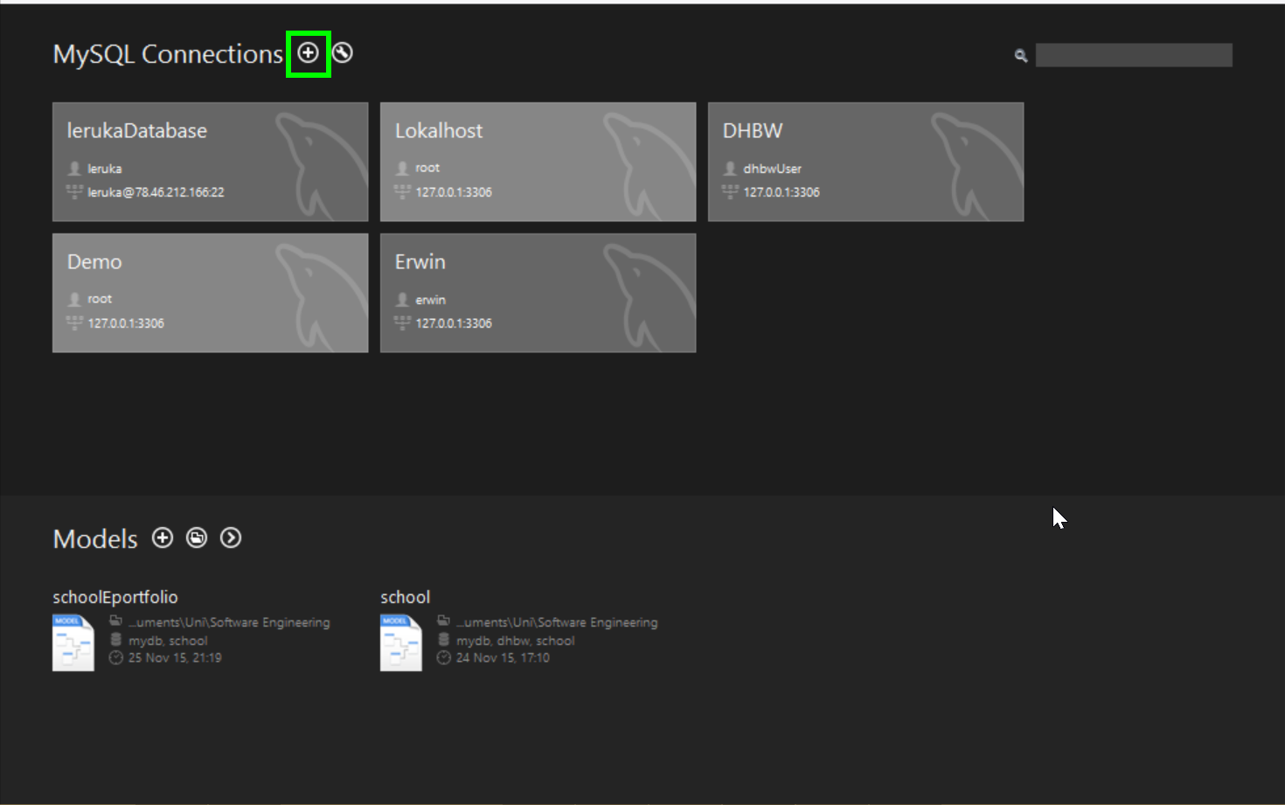

Here you are on the home screen. You can see your connections and ER-Models.

To create a new connection click the plus beside MySQL Connections. To enter into a connection click on the connection.

# Create connection

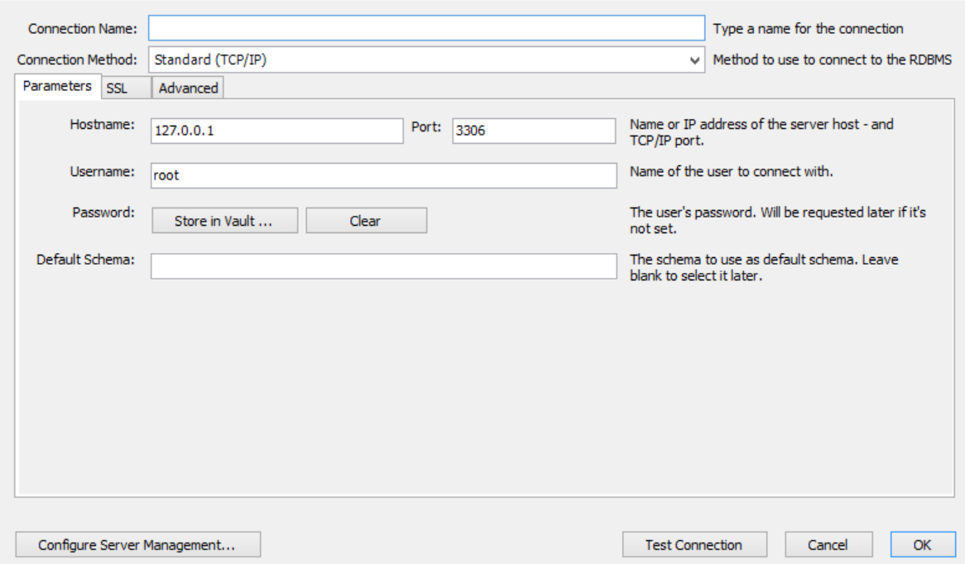

Fill in a connection name which will be displayed on your home screen.

Choose your connection method:

* TCP/IP
* TCP/IP over SSH
* Socket/pipe (only possible if you are on the same computer as your server)

For TCP/IP (over SSH) you have to fill in the IP or Hostname of the computer where your MySQL Server is hosted and the port (default 3306).

Choose a user which have access to the MySQL server and if you want you can store your password in vault.

I recommend to test the connection with the „Test Connection“ button.

If you didn’t store the password in vault a dialog appears which asks for your password.

If all works fine you click „ok“ and the connection will be shown in your home screen. Otherwise there will be an error message and you have to check your data.

# Create Database

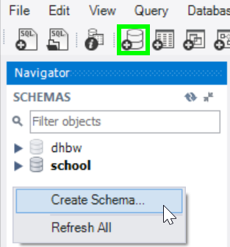

Right click in „SCHEMAS“ or click the button „create new schema“ in the task bar.

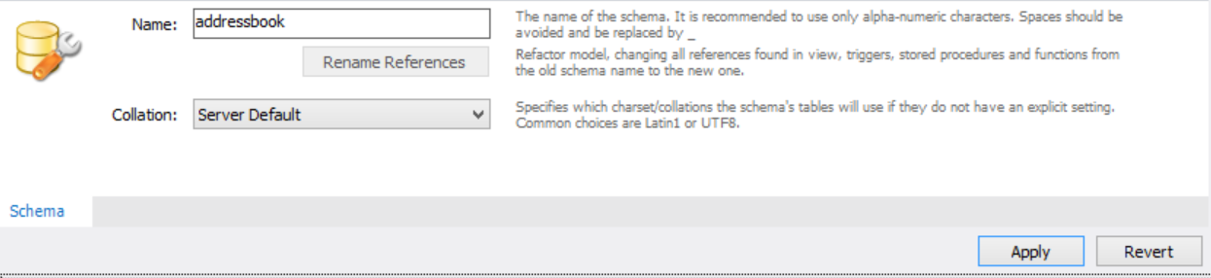

Fill in a name and press „apply“. A dialog shows you the used SQL statement, press apply and the database will be created.

# Create table

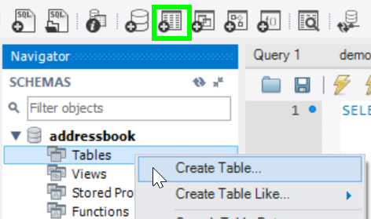

Right click in „Tables “ in your selected database or click the button „create new table“ in the task bar.

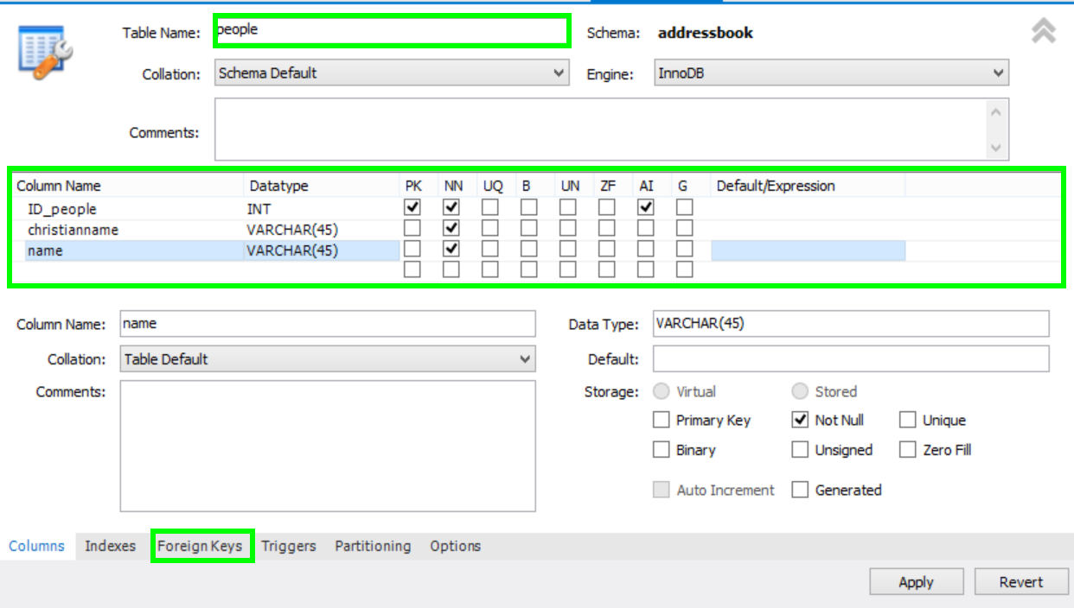

Fill in a table name and add columns with theire datatype. For each column you can choose a datatype like integer, varchar or datetime, and you can select that it is a „Primary Key“ (PK), Not NULL (NN), „Unique“ (UN) and so on.

Additionally it is possible to show the relation between table by generating a foreign key. On the bottom you can see the menu itmen „Foreign Key“.

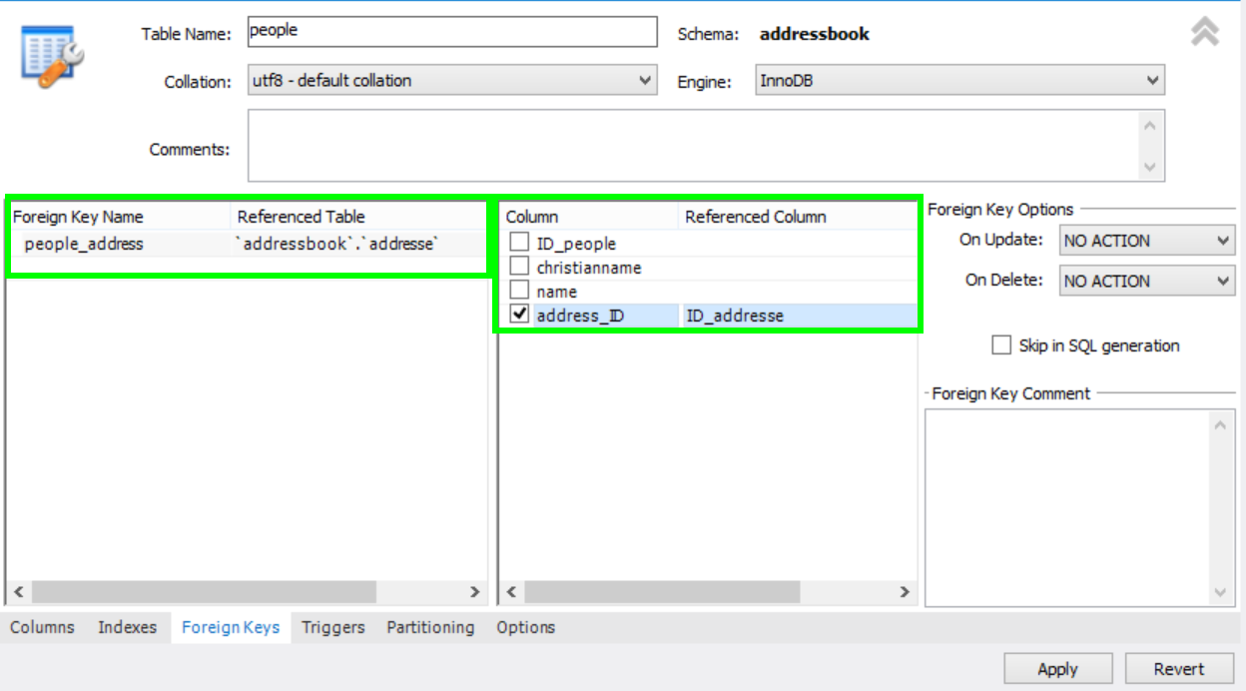

Choose a name for your foreign key and choose the referenced table. At the right side the columns of your table will appear and you can choose the column which reference to a column oft he referenced table. If datatypes oft he both columns doesn’t match an error message appears.

After you filled in all your required columns of your table you press „Apply“ and the table will be created.

If you want to change a column or have to add a new column you can right click on your table and choose „Alter table“ and the window like above appears.

# Insert, change, delete data

Select your table and execute the Select-Statement. Workbench will return a „Result Grid“ as you see below.

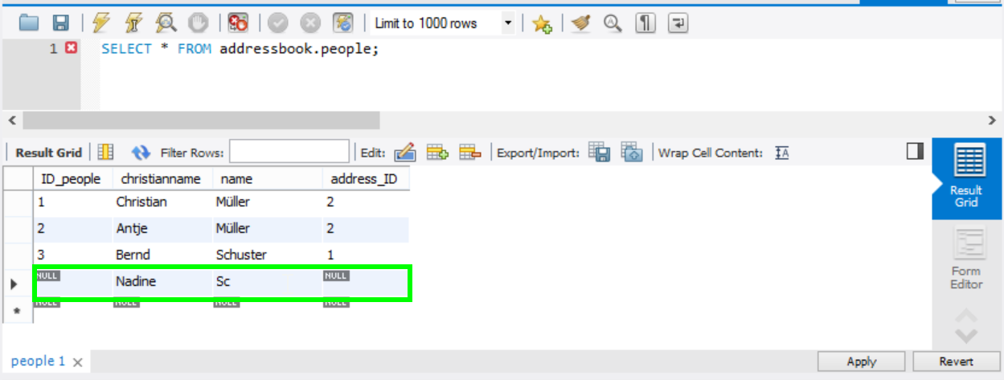

In the result grid you can see your table and you can easily write data into the fields or change it. To delete a row right click on it and choose „delte row“.

If you have finished inserting, changing and deleting data you have to „Apply“ and all chances will be done by the showed SQL-Statements.

# Create and call functions and stored procedures

## Functions

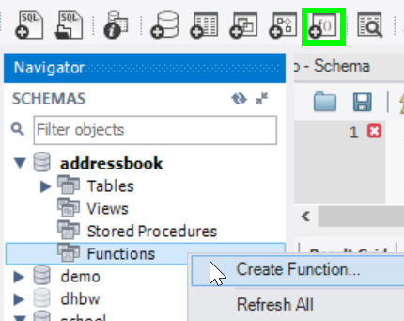

Right click on „Functions“ in your selected database or click the button „create new function“ in the task bar.

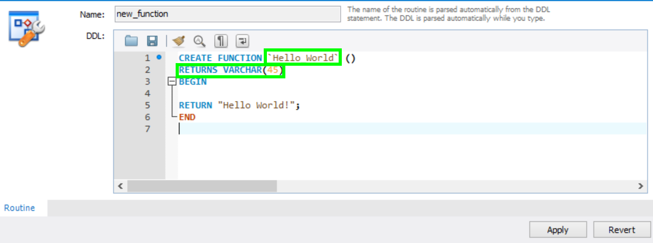

You have to name your function after the CREATE FUNCTION statement and you have to declare the datatype of your returned value. Between BEGIN and END you can define your function and at the end you have to return a value.

NOTE: function can only return one value but they can be used in SQL statements directly

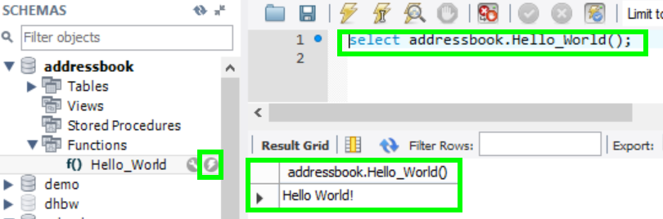

To call your function press the flash beside your function which only executes a SELECT-statement. The returned value you will see in the result grid.

## Stored Procedures

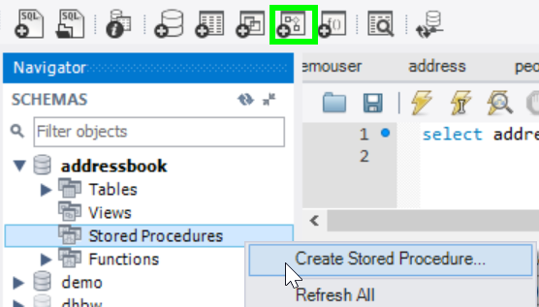

Right click on „Stored Procedures“ in your selected database or click the button „create new stored procedure“ in the task bar.

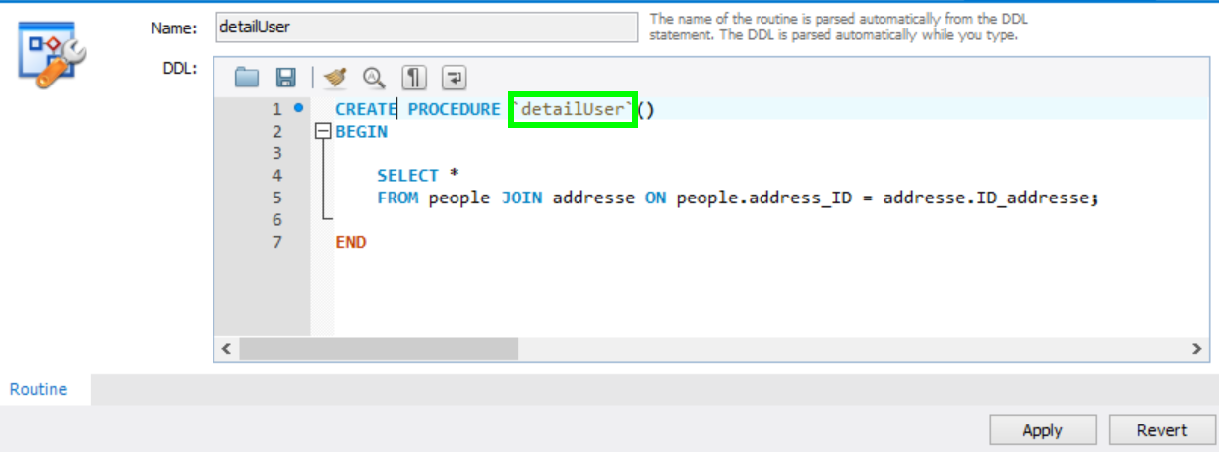

Like functions you have to name your stored procedure but you don’t have to declare the datatype of a returned values because the stored procedure don’t return directly a value.

NOTE: Procedures cannot be used in a SQL-statement but they can have multiple returned values if you use the OUT keyword.

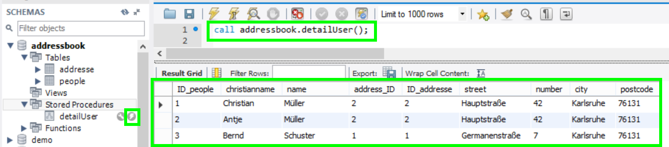

Like functions you can execute the stored procedures by clicking on the flash beside the stored procedure. But at the opposite to functions you have to use a CALL-statement. The returned values will be shown in the result grid.

# Users and roles

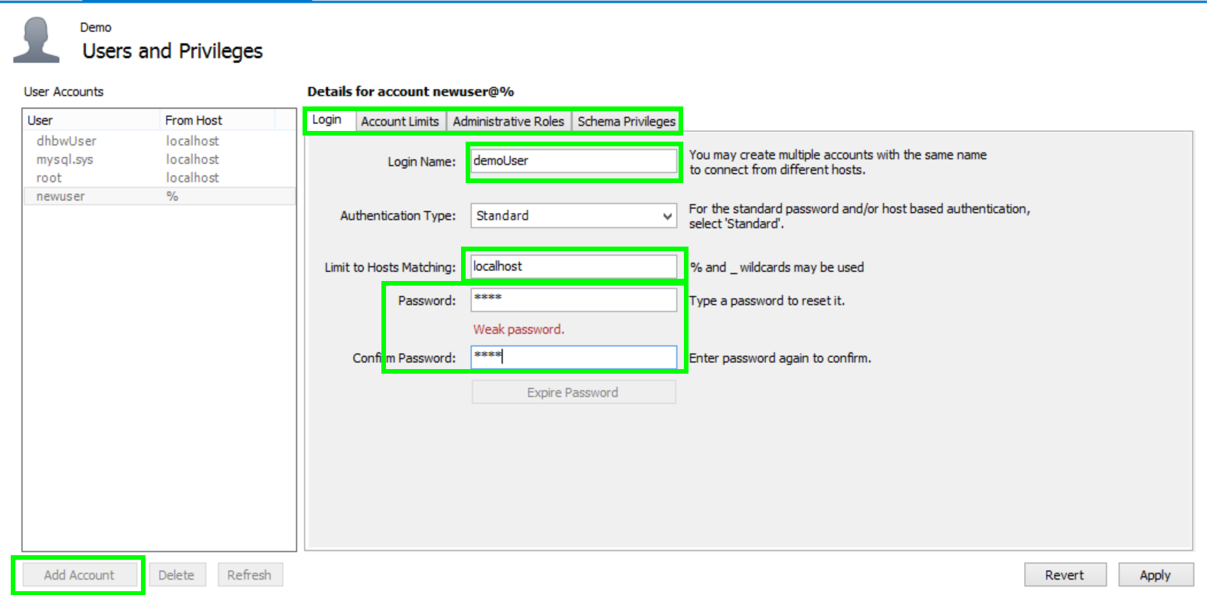

When you click on „users and privileges“ then you will see all users listed and you can see the different details and rights of this users.

To add a new user click „Add Acount“ at the left side on the bottom. Now you can choose a login name and a password fort he user and to which server he has access.

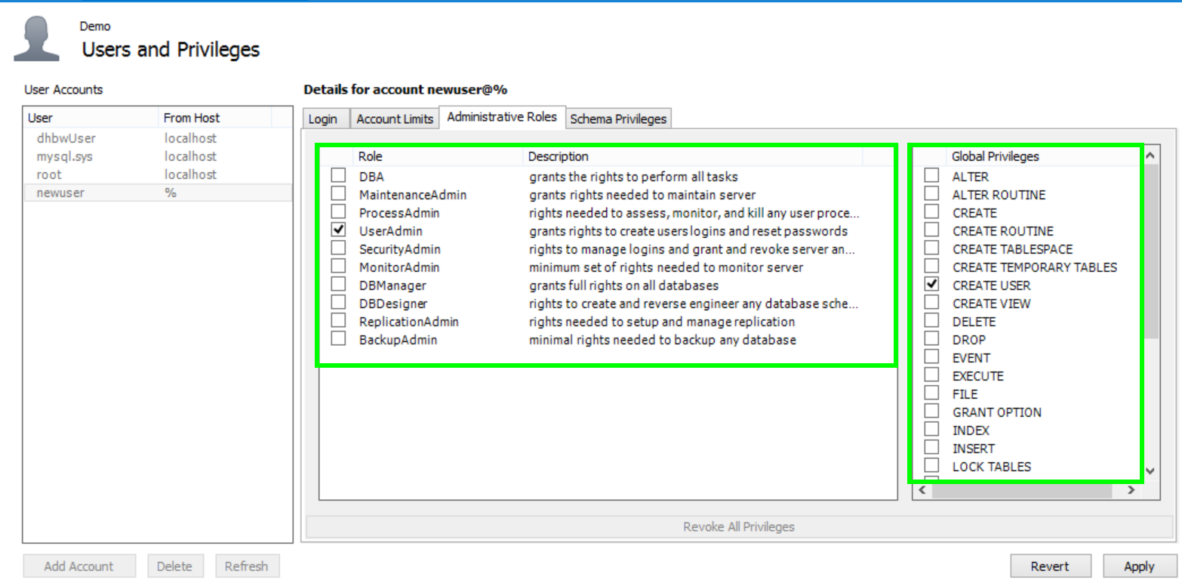

In the menu item „Administrative Roles“ you can choose between different roles. If you click on a role at the right side you will see the global privileges of this role, so as „UserAdmin“ you have the global privilege to create users and relod.

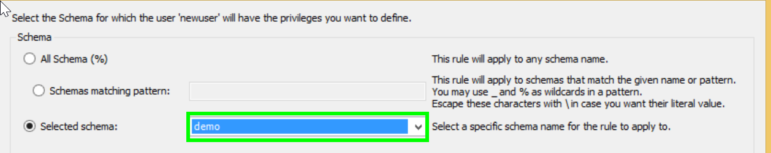

In the menu item „Schema Privileges“ you can add a new entry. So you have to choose a schema.

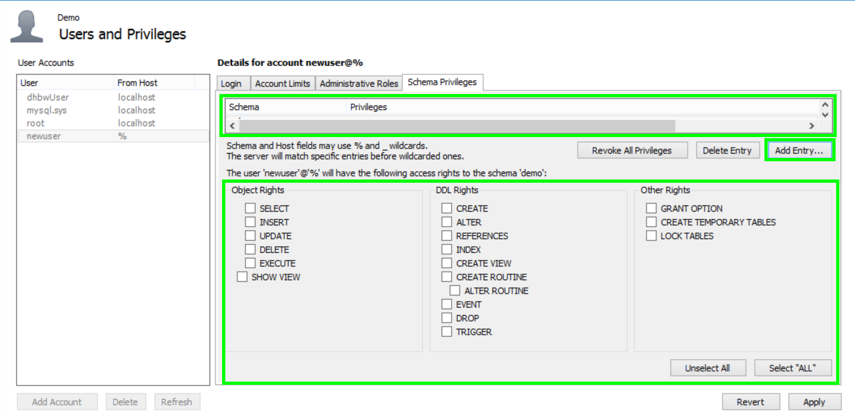

After choosing a schema it will be displayed in the list on the top. When you click on a entry then you will see on the bottom which rigths the user have on this schema and you can select or unselect them.

# ER-Diagramm

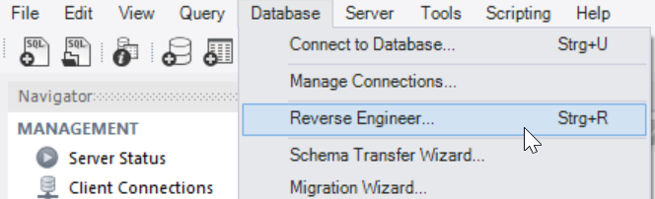

Choose „Reverse Engineer“ from the menu item „Database“.

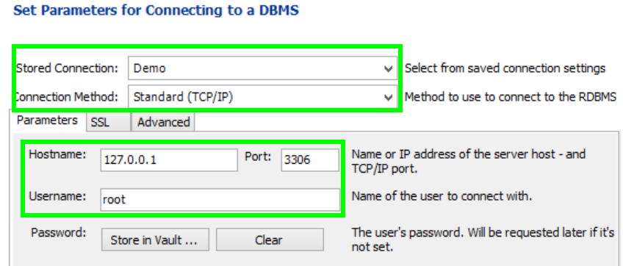

Choose an existing connection and the connection method. Like in create connection you have to fill in the IP and Port where your server is hosted and a user which have access tot he server.

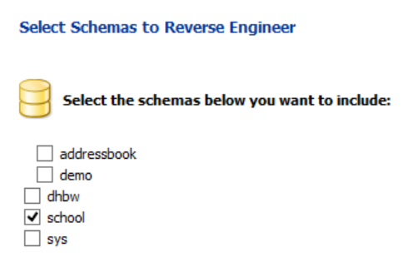 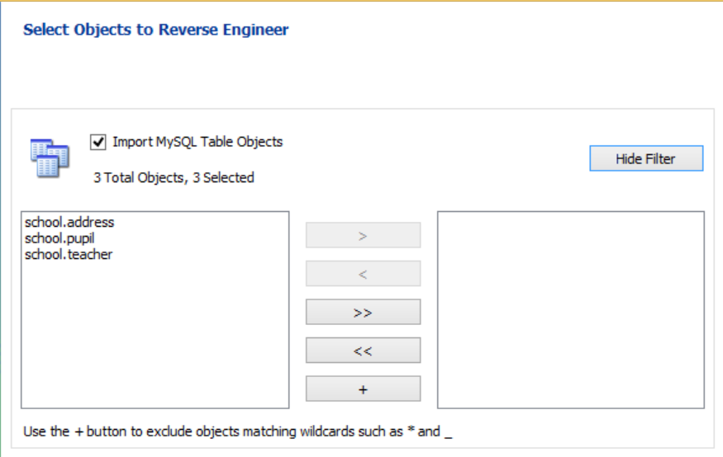

Choose the schema and the tables you want to draw.

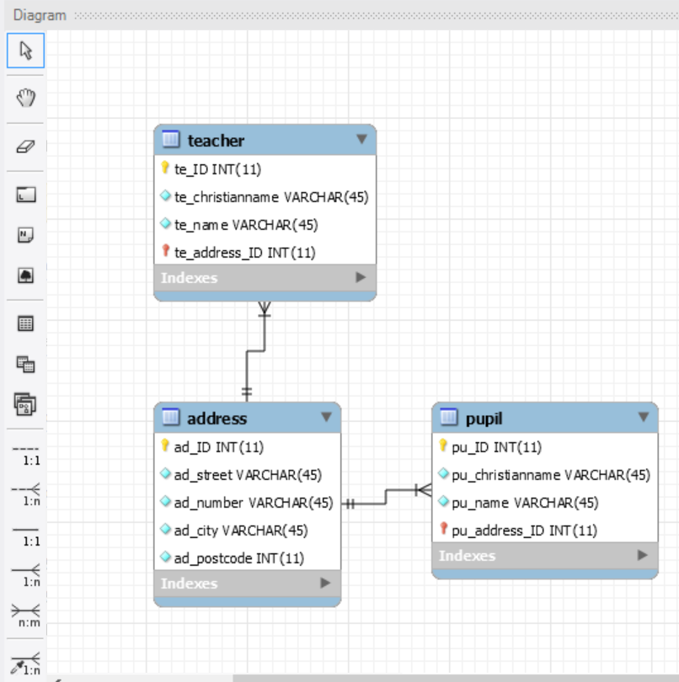

You will see a ER-Diagramm like this. At the left side you can choose the options like drwaing a new 1:1 relation. If you mouse over the relation you will see the two coloumns which have a relation.

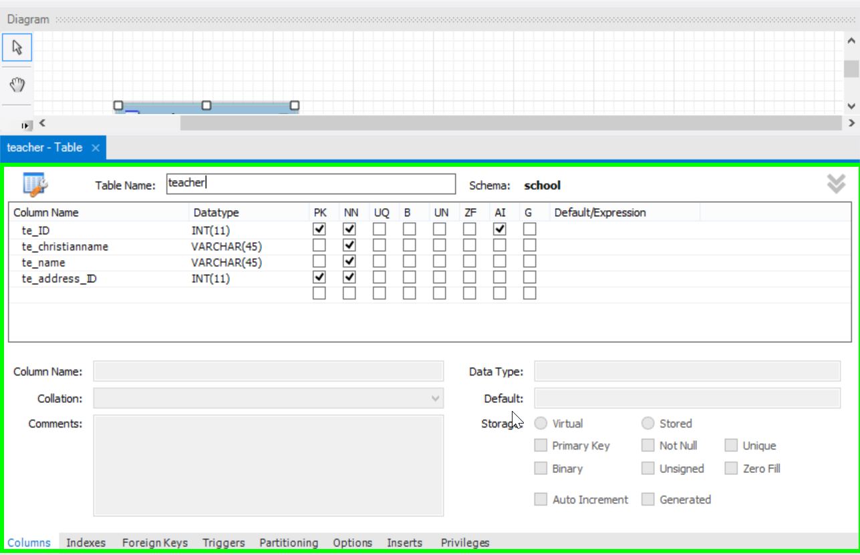

Double click on a table and you will see a window to see details of the table and you can change things.

You can add new tables and relations and after this you can synchronize it to your database. But first you have to save your ER-Diagramm.

Press again on the menu item „Database“ and then „Forward Engineer“. Like „Reverse Engineer“ you have to choose your connection.

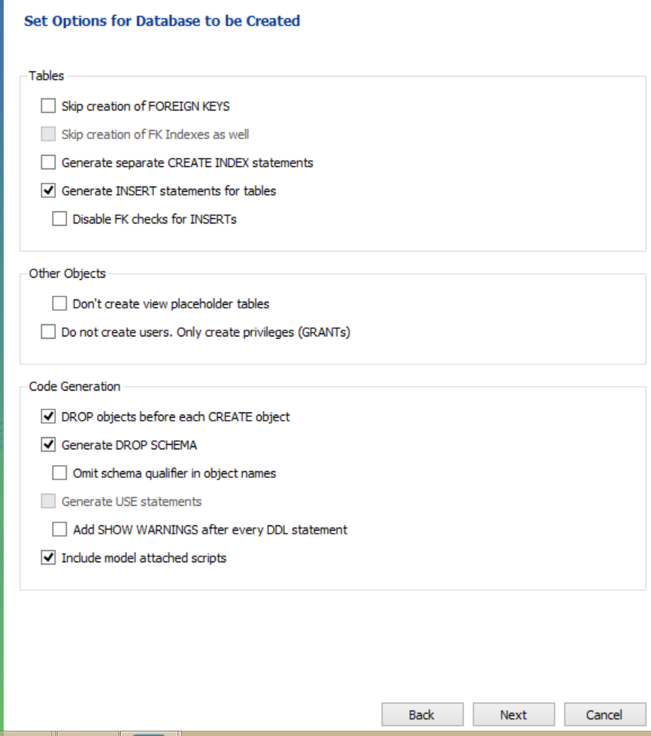 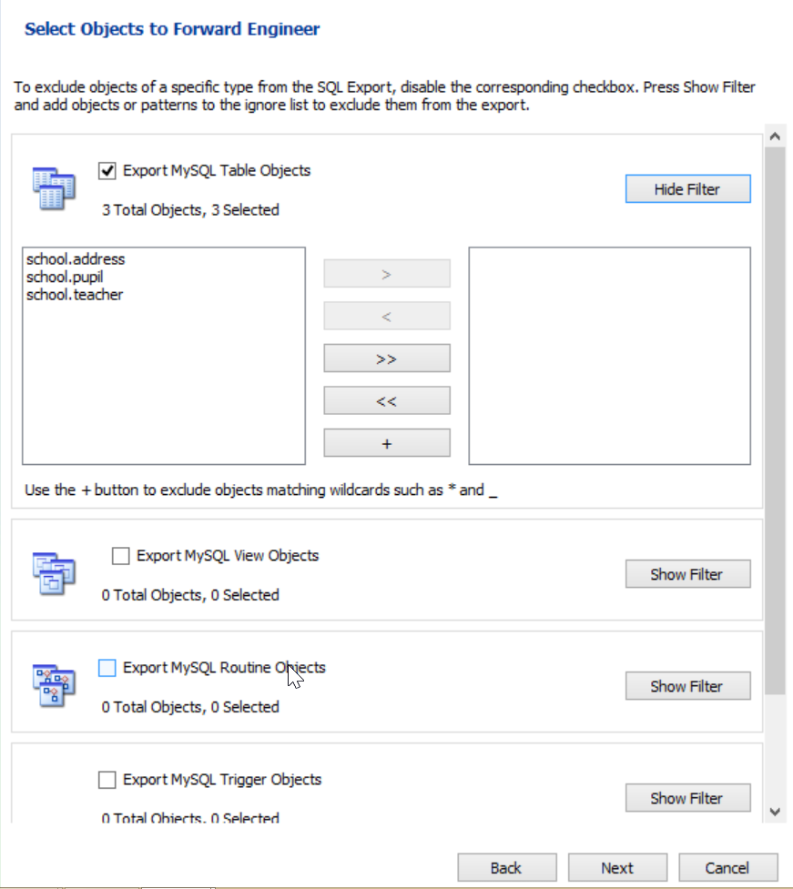

After this you have several options to select, what you want to add and you can choose the tables.

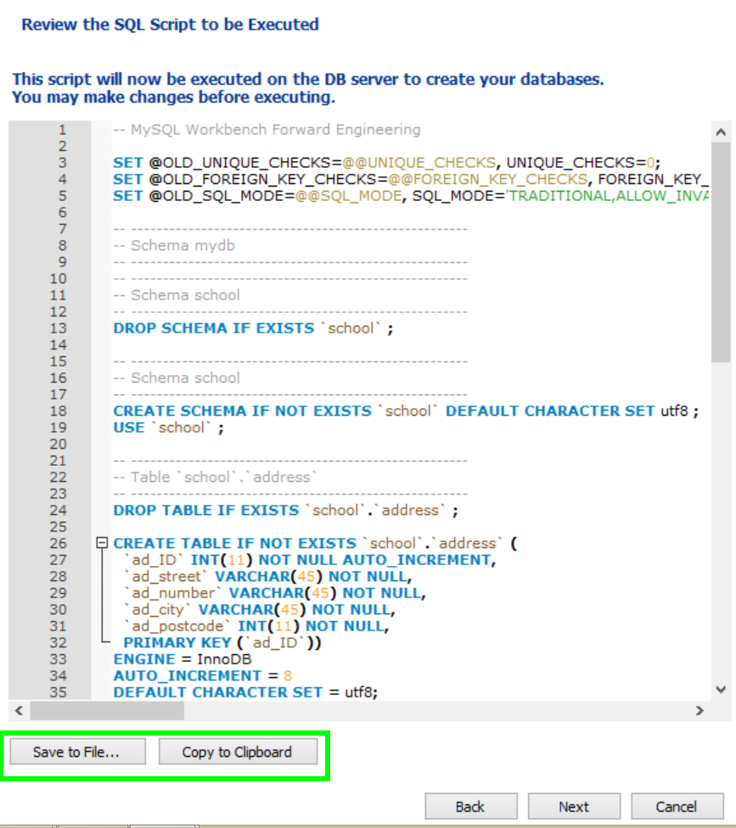

A SQL script will be generated which you can save to file or copy to clipboard, too.

Press next and the skript will be executed and after this you will see the changed things in your databse.

# Exercise



Click the plus beside MySQL Connections at the top.

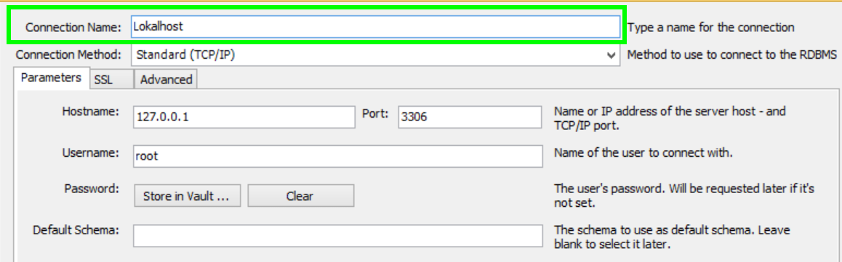

Type in as connection name „Lokalhost“, choose connection method Standart (TCP/IP). Type in the IP 127.0.0.1 (lokalhost) and the port 3306 and as user use root.

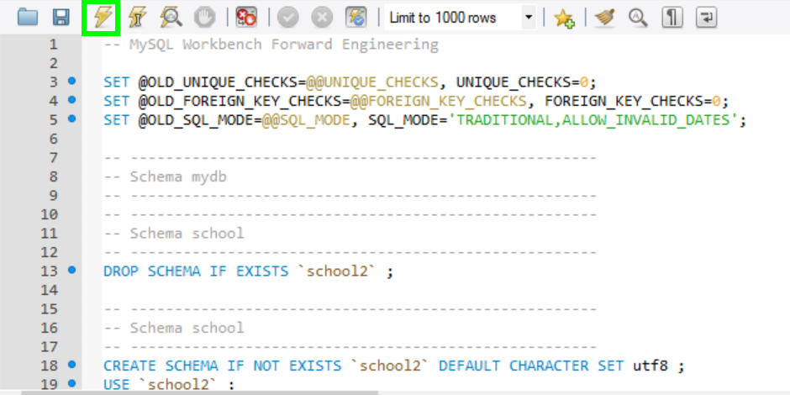

Download the school.sql file from <https://github.com/KFrank12/MySQL> , open it and execute the skript.

Click on „Users and Privileges“ on the left side.

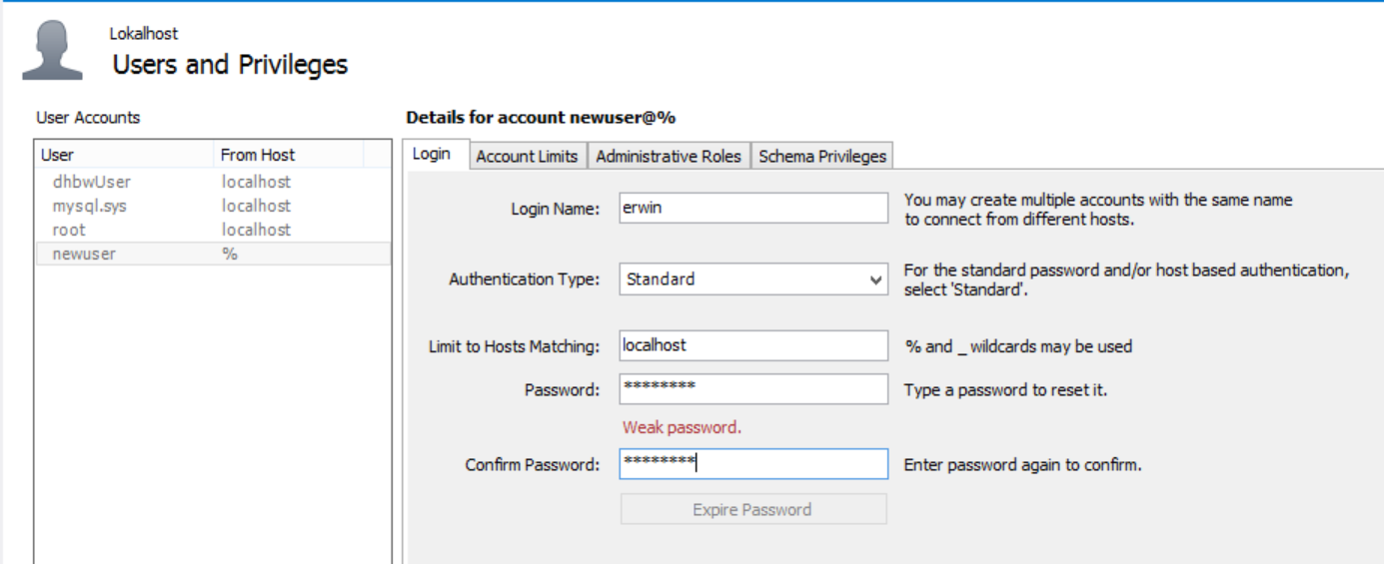

Fill in „erwin“ as login name, localhost as limits to hosts matching an das password use „erwin123“ for example.

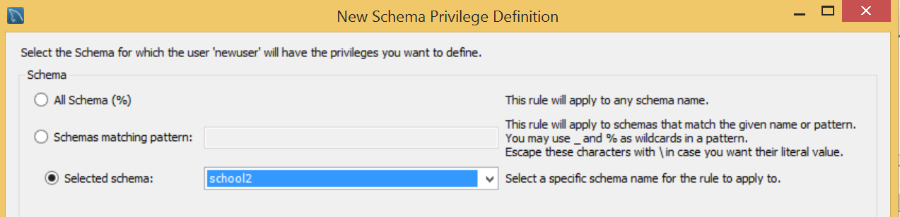

Select menu item „Schema Privileges“ and add an entry for „school“.

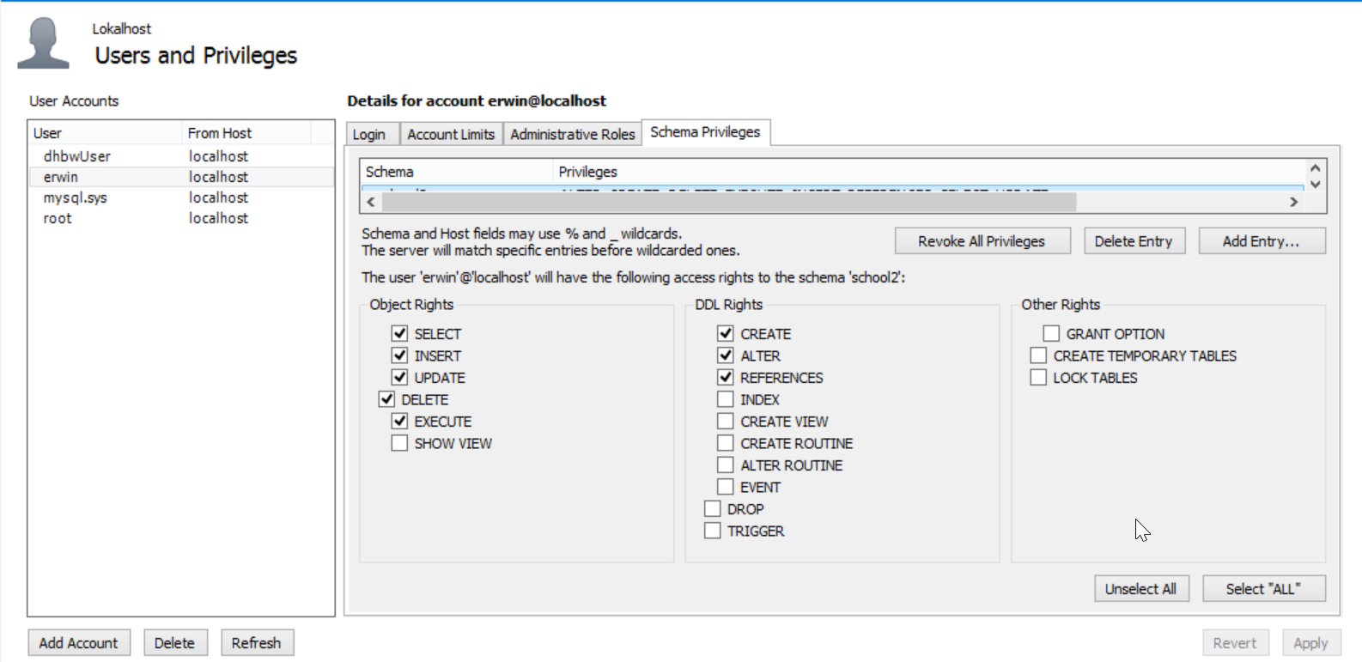

Select the following rigths: select, insert, update, delete, create, alter and references and press „Apply“.

Now whe have created our user „erwin“ and we can go back to the home sreen. Here we create again a connection but this time with the user erwin.

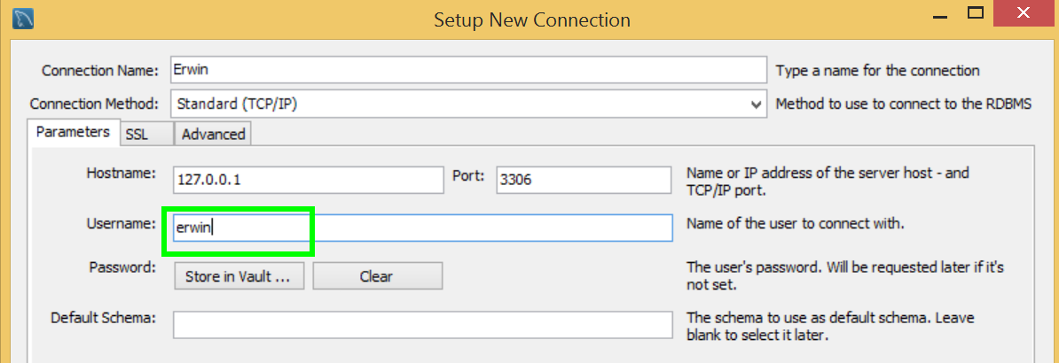

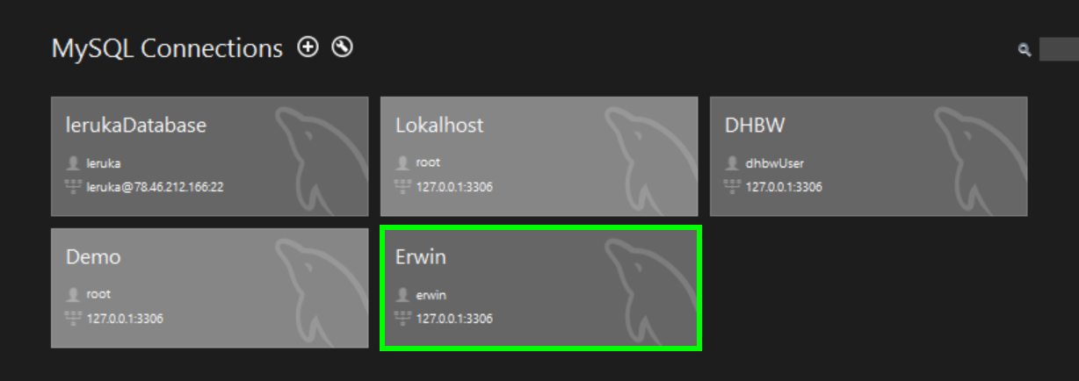

Click on the connection „Erwin“ and type in the password „erwin123“.

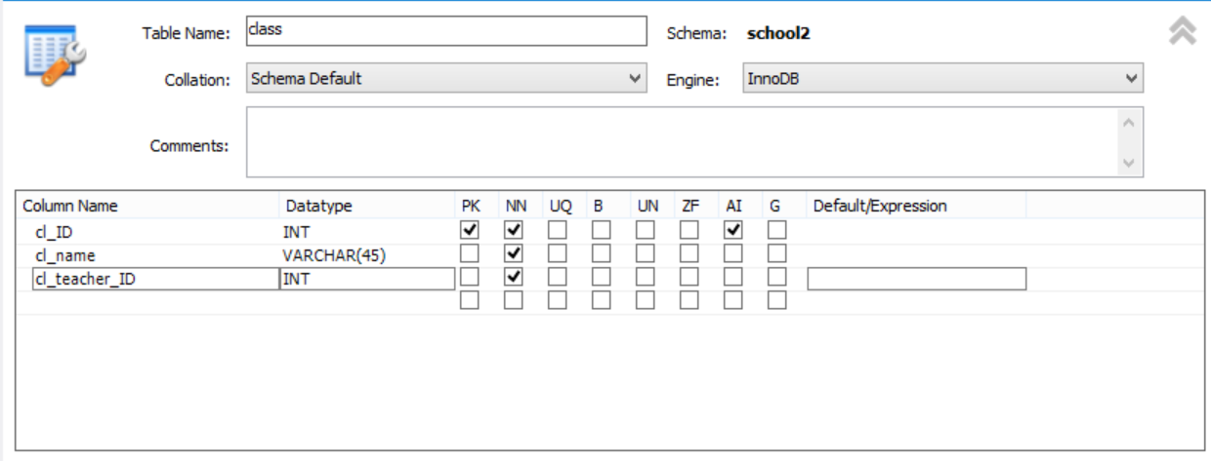

Create a table class with the following columns „cl_ID“ to identify the rows, „cl_name“ as classname and „cl_teacher_ID“ to relates to the table teacher. So you have to add a foreign key for „cl_teacher_ID“.

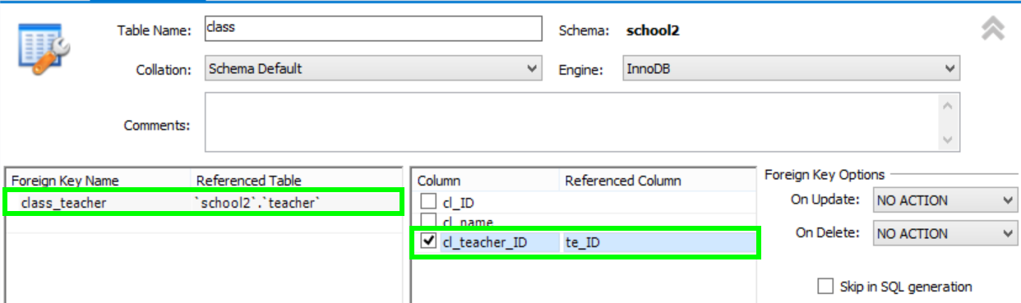

Type in as foerign key name „class_teacher“ and choose as referenced table the table „teacher“. At the right side choose the column „cl_teacher_ID“ an das referenced coulumn „te_ID“.

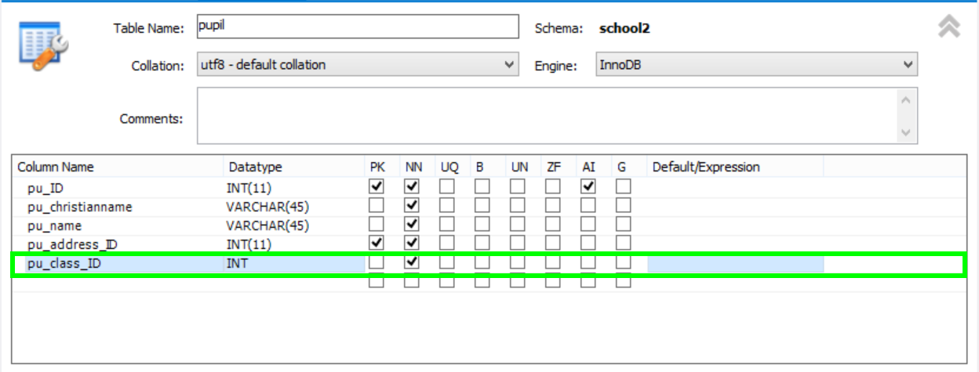

To add the relation between the tables „class“ and „pupil“ you have alter the table „pupil“ and add the column „pu_class_ID“.

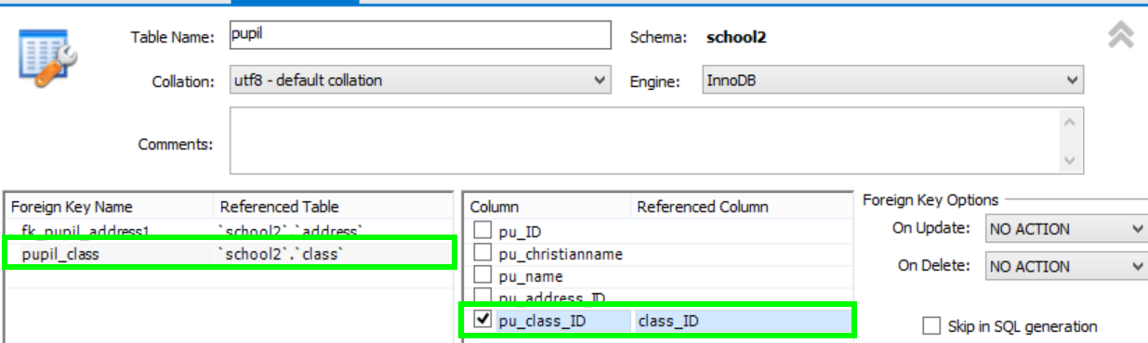

After adding the culoumn „pu_class_ID“ you have to add a foreign key like above to have a relation between „pupil“ and „class“ over the class_ID.