­

2024

EXCELLENT COACHING-WEB











Table OF Content

Page Name

* 1. *Project Team---------------------------------------------------------- 3*
  2. *Abstract---------------------------------------------------------------- 4*
  3. *Acknowledgement-------------------------------------------------- 5*
  4. *Background----------------------------------------------------------- 6*
  5. *Introduction----------------------------------------------------------- 7*
  6. *Scope Of Project------------------------------------------------------ 8*
  7. *Problem Statement-------------------------------------------------- 9*
  8. *Proposed Solution--------------------------------------------------- 10*
  9. *Design Specification ----------------------------------------------- 11*
  10. *Functional – Non Functional Requirement-------------------- 12*
  11. *Home Page----------------------------------------------------------- 13*
  12. *About Page----------------------------------------------------------- 14*
  13. *Course Page---------------------------------------------------------- 16*
  14. *Diploma Page------------------------------------------------------- 17*
  15. *Short Course Page-------------------------------------------------- 18*
  16. *Contact Page-------------------------------------------------------- 19*
  17. *Header & Footer Page-------------------------------------------- 20*
  18. *Task Allocation----------------------------------------------------- 21*
  19. *Hardware & Software Requirement-------------------------- 22*
  20. *Conclusion---------------------------------------------------------- 23*



PROJECT TEAM

|  |  |  |
| --- | --- | --- |
| **S.NO** | **NAME** | **STUDENT ID** |
| 1 | KIRAN GULL | 1529285 |
| 2 | UZMA GHAFOOR | 1389230 |
| 3 | SADIA MAJEED | 1537722 |
| 4 | UMAIMA AZMAT | 1529007 |



ABSTRACT

The project "Excellent Coaching" is a comprehensive web platform designed to revolutionize the landscape of online education. Aimed at enhancing learning experiences across diverse subjects and grade levels, this innovative platform integrates cutting-edge technology with pedagogical expertise to deliver high-quality educational content.

"Excellent Coaching" offers a user-friendly interface that caters to the needs of students, parents, and educators alike. Key features include interactive video lessons, personalized learning paths, and real-time progress tracking. Through these features, learners can engage deeply with their studies while receiving targeted support to maximize their academic potential.

Moreover, the platform fosters a collaborative learning environment through forums, virtual classrooms, and peer-to-peer interaction, promoting knowledge sharing and community engagement. It prioritizes accessibility by ensuring compatibility across devices and offering offline access options, thereby accommodating diverse learning preferences and geographical locations.

With a commitment to excellence, "Excellent Coaching" not only supports academic growth but also empowers users with the skills and knowledge necessary for success in today's competitive world. By harnessing the power of technology and educational expertise, this project seeks to redefine online education, making learning more engaging, effective, and accessible for all.

ACKNOWLEDGEMENT

We begin by expressing our gratitude to Almighty ALLAH, the Most Beneficent and Merciful, who has endowed us with the faculties of thought and emotion, essential for fostering creativity and bringing ideas to fruition. Through His grace and mercy, we were granted the strength and ability to successfully complete this Project.

First and foremost, our heartfelt appreciation goes to our mentor, SIR ABDUR REHMAN, whose unwavering support and invaluable guidance were instrumental in guiding us through this project within the allotted time frame. We also extend our thanks to the other mentors at APTECH LEARNING who provided us with crucial insights and direction throughout the project's development.

The realization of [Plant Palace] owes its existence to the collaborative efforts, dedication, and support of numerous individuals and resources. Each contribution played a vital role in bringing this endeavor to life.

Lastly, but significantly, we extend our sincere gratitude to the users and visitors of the website. Your interest, feedback, and engagement have been indispensable in shaping the "EDUCATION-WEB" project. Your interactions motivate us to continually enhance and expand its offerings, ensuring its continued relevance and value.

In conclusion, we acknowledge with humility and appreciation the role of divine providence, mentors, collaborators, and users in the success of this project.



BACKGROUND

"Excellent Coaching" is a pioneering online educational platform dedicated to enriching the learning experiences of students globally. Founded on the principle’s of accessibility, quality, and innovation, it aims to bridge educational gaps and empower learners to achieve their academic goals effectively.

The inception of "Excellent Coaching" stemmed from the collective expertise of seasoned educators and technology specialists who recognized the need for a comprehensive digital learning environment. This platform offers a diverse array of educational resources, personalized tutoring services, and skill development programs to cater to the individualized needs of students across various disciplines and levels.

Driven by a passion for excellence, "Excellent Coaching" combines advanced learning technologies with expertly curated content to deliver engaging and impactful educational experiences. Students benefit from interactive lessons, real-time feedback, and adaptive learning pathways designed to optimize their academic performance and foster holistic growth.

With a user-centric approach, "Excellent Coaching" prioritizes user experience, ensuring intuitive navigation, robust support systems, and seamless integration of learning tools.

INTRODUCTION

The "Excellent Coaching" is pivotal in shaping an exceptional educational journey for its users. As the primary interface of this web platform, it provides a gateway for students to explore a rich catalog of courses, interact with instructors, and manage their academic progress with ease. Designed with a focus on user experience, the frontend emphasizes intuitive navigation and accessibility, ensuring seamless interaction across various devices and screen sizes.

Through its thoughtfully crafted design, "Excellent Coaching" aims to foster a supportive learning environment where users can effortlessly access educational resources, engage in discussions, and track their learning milestones. The frontend prioritizes simplicity and functionality, allowing users to focus on their educational goals without distractions. By adhering to these principles, "Excellent Coaching" endeavors to empower both students and educators to make the most of their educational journey, providing them with the tools and resources necessary for success in their academic pursuits.

SCOPE OF PROJECT

The "Excellent Coaching" education web project aims to establish a dynamic online platform dedicated to enhancing learning experiences for students across diverse academic disciplines. This initiative focuses on creating a user-centric environment that facilitates interactive and personalized educational journeys.

1. Objectives:
   * Content Development: Curate comprehensive study materials, including notes, videos, and quizzes, tailored to various educational levels and subjects.
   * Interactive Learning: Implement tools for virtual classrooms, live sessions, and real-time collaboration between students and educators.
   * User Engagement: Foster a supportive community through discussion forums, mentorship programs, and peer-to-peer learning opportunities.
   * Accessibility and Usability: Ensure the platform is accessible across devices and user-friendly with intuitive navigation and responsive design.
2. Features:
   * Tailored subject-specific resources and practice exercises.
   * Interactive virtual classrooms featuring live tutoring options.
   * Robust progress tracking and performance analytics tools.
   * Engaging community forums and mentorship programs.
   * Seamless mobile-responsive interface for enhanced accessibility.

Conclusion:

The "Excellent Coaching" web project endeavors to revolutionize online education by providing a comprehensive and interactive learning ecosystem that empowers students to achieve academic excellence.

PROBLEM STATEMENT 

Excellent Coaching is into business for more than a decade. They have been

Advertising about their coaching classes through newspapers, pamphlets, television.

Now with changing times, they have decided to go online as most of the students

Today are frequent users of Internet. They have planned for a website with complete details about the Coaching classes.



PROPOSED SOLUTION

The front-end design of "Excellent Coaching" emphasizes user-friendly interfaces with responsive layouts and intuitive navigation for seamless access on all devices. It integrates interactive tools like virtual classrooms and progress tracking to enhance engagement. Personalized user profiles and curated content ensure tailored learning experiences, while community features such as forums and mentorship programs promote collaboration and support. This approach aims to create a dynamic and inclusive educational platform that maximizes user satisfaction, facilitates effective learning interactions, and empowers students to excel academically in an adaptable online environment.

DESIGN SPECIFICATION

OUR WEBSITE CONTAIN THESE DESIGN SPECIFICATION

* Modern and intuitive user interface design.
* Cohesive color scheme and typography aligned with educational themes.
* Responsive layouts for optimal viewing on all devices.
* Seamless integration of interactive components like virtual classrooms and progress trackers.
* Clear navigation paths and consistent design patterns.
* Adherence to accessibility standards for compatibility with assistive technologies.
* Aim to create a visually appealing, user-friendly, and operative educational experience.



FUNCTIONAL REQUIREMENTS

1. Course Management:

Enable easy searching courses, and downloadable detailed descriptions and instructor profiles.

1. Interactive Learning Tools:

Support multimedia content such as videos, simulations, and quizzes. Facilitate communication through forums.

1. Responsive Design:

Ensure the platform is accessible and user-friendly across different devices and browsers, prioritizing intuitive navigation and readability.

NON-FUNCTIONAL REQUIREMENTS

1. User Interface Design:

Ensure an aesthetically pleasing and consistent interface that enhances user experience and engagement.

1. Reliability:

Maintain high uptime and availability to ensure users can access the platform whenever needed.

1. Compatibility:

Ensure compatibility across various devices and browsers to cater to diverse user preferences and technological environments.

HOME PAGE SCREEN

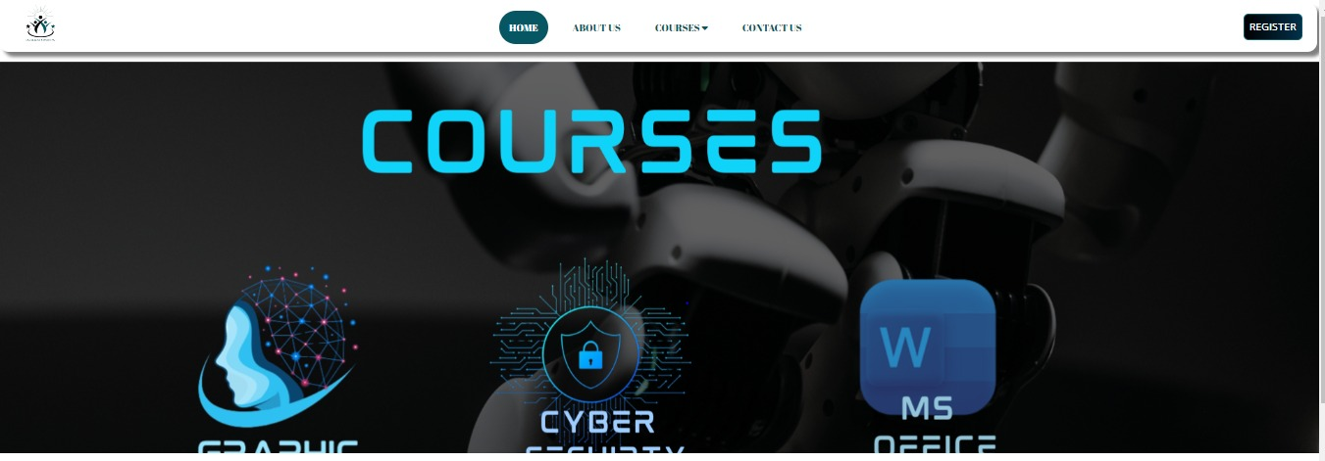

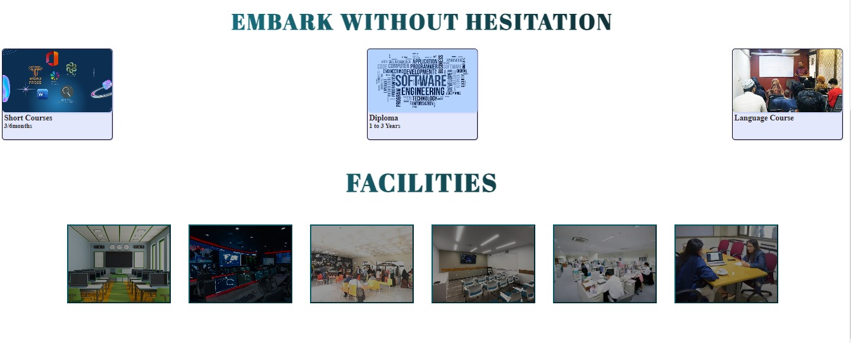

* Included Navbar.
* Sliders four banners.
* About courses.
* About faculty.

ABOUT US PAGE SCREEN

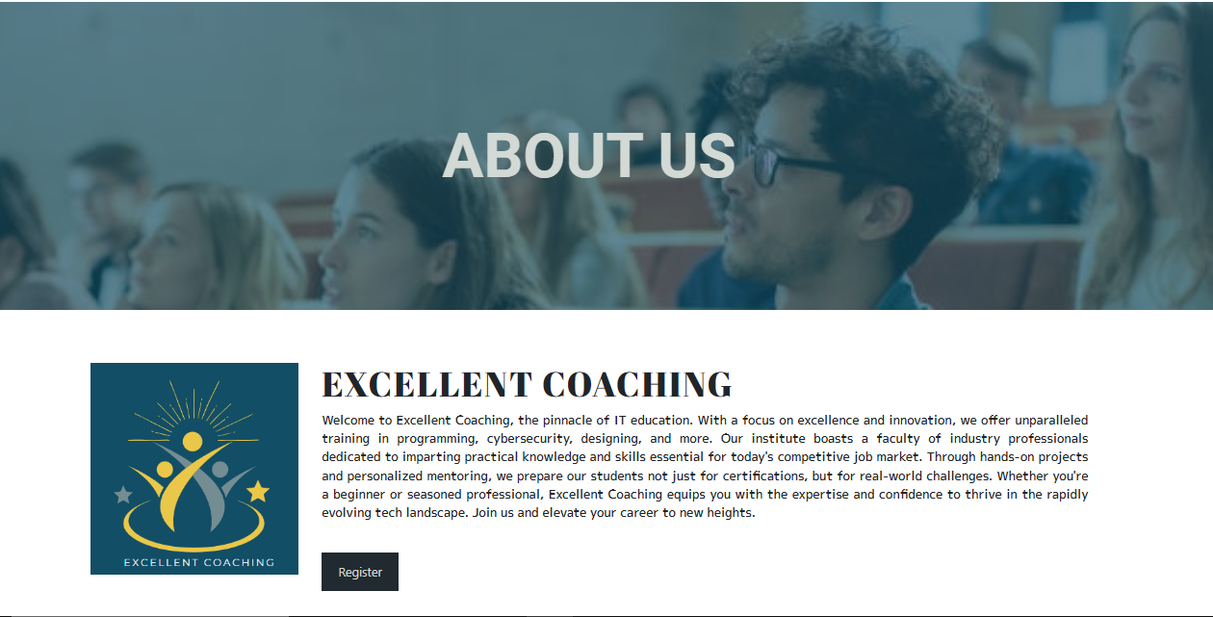

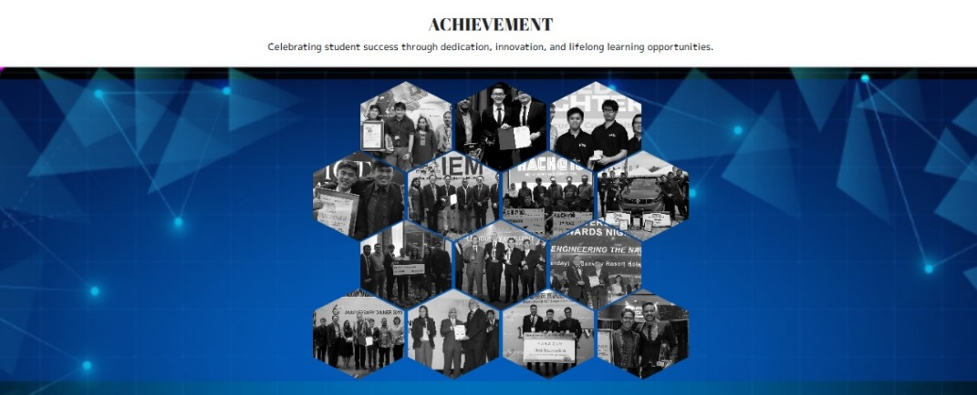





ABOUT US PAGE SCREEN 

* Banner
* Information about Coaching
* About Achievements
* About faculty
* About Team
* Student Reviews
* Animations and hover effects.

COURSES PAGE SCREEN



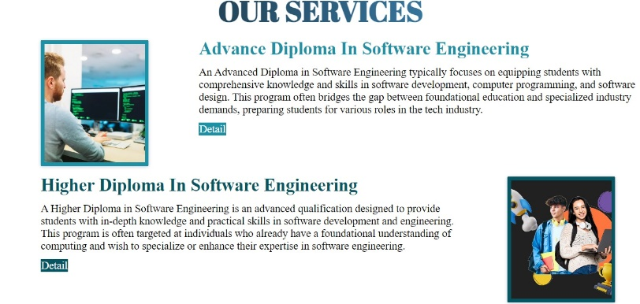



• Detail of diploma

• Detail of short courses

• Detail of language course

DIPLOMA PAGE SCREEN 

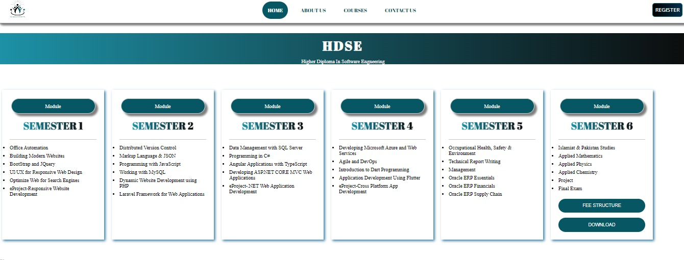

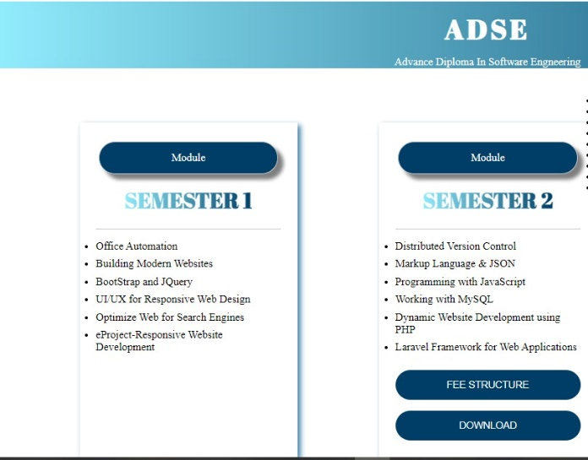

About ADSE Page:

• Information

• Download

• Fee Structure

About HDSE Page:

• Information

• Download

• Fee Structure

SHORT COURSE PAGE SCREEN 

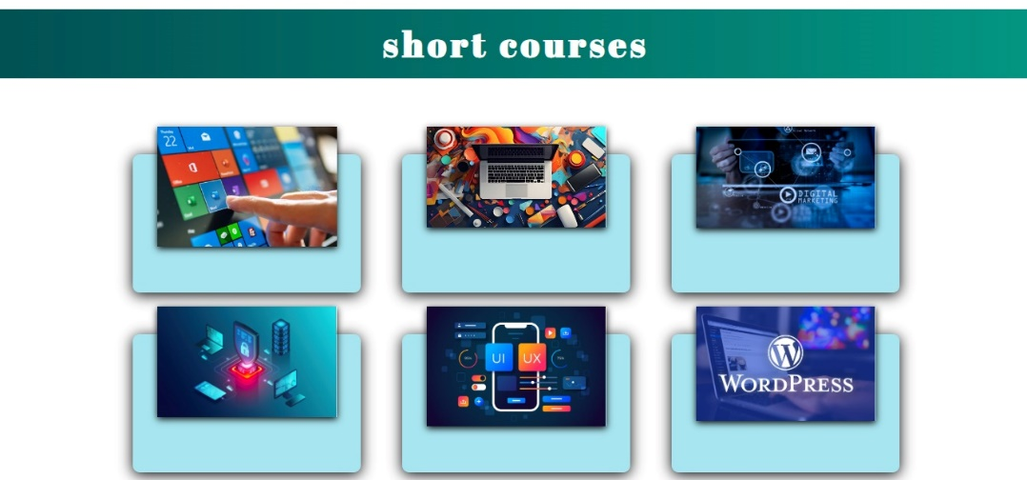

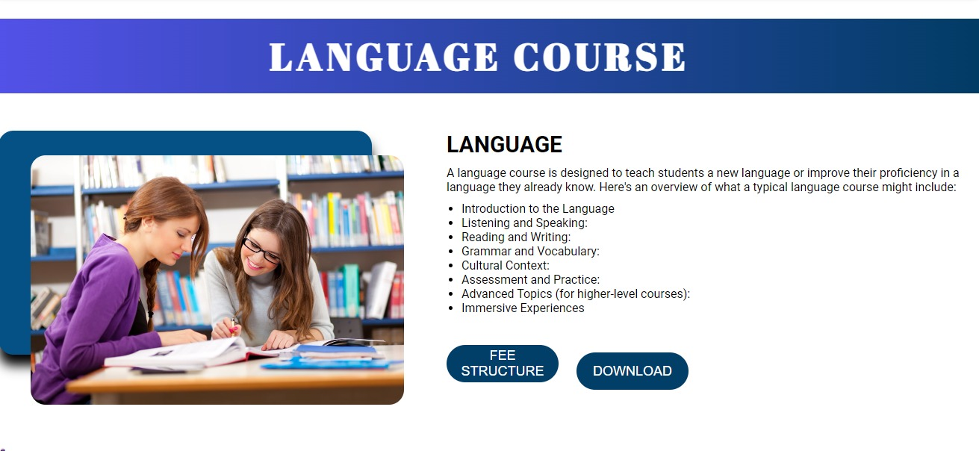

About Language Page:

• Information

• Download

• Fee Structure

About Short Courses Page:

• Information

• Download

• Fee Structure

CONTACT PAGE SCREEN

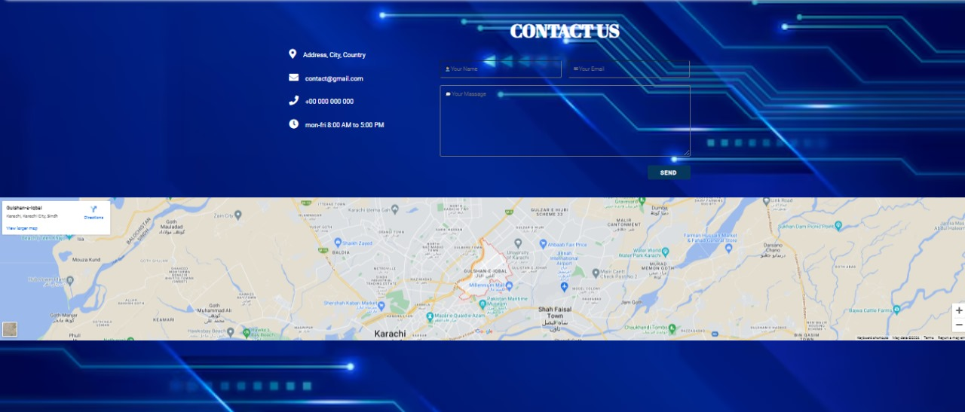

• User can submit their contact us.

• Client-side Validation implemented.

• Included map.

• Record input field.

HEADER-FOOTER PAGE SCREEN 





NAV_BAR:

* Logo
* List
* Button

FOOTER:

* Animated Icon
* Navigated Link

TASK ALLOCATION

ACTIVITY & PLAN

PREPARED BY:

|  |  |  |  |  |  |  |
| --- | --- | --- | --- | --- | --- | --- |
| **Project Ref No:** | | **Title** | DATE OF PRAPERATION | **OF ACTIVITY PLAN** | | |
| S.NO | TASK | Education-web | ACTUAL  START DATE | Approx. End Date | TEAM MEMBERS NAMES | STATUS |
| 1 | Project plan | 24june | 24june | KIRAN, UZMA , SADIA , UMAIMA | OK |
| 2 | Home page,  & 6 pages more | 25june | 20july | UZMA GHAFOOR | OK |
| 3 | About us, | 25june | 20july | KIRAN GULL | OK |
| 4 | Contact page | 25june | 20july | UMAIMA | OK |
| 5 | Registration page | 25june | 20july | SADIA MAJEED | OK |
| 6 | Header & Footer | 25june | 20july | UZMA , KIRAN | OK |
| 7 | Downloadable word files | 15july | 20july | KIRAN,UMAIMA | OK |
| 8 | documentation | 10july | 20july | KIRAN GULL | OK |



Hardware/ Software Requirements

1. Hardware

* A minimum computer system that will help you access all the tools in the courses is a Pentium 166 or better
* 64 Megabytes of RAM or better

1. Software [Either or Combination as per Course]

• Notepad/HTML editor/Coffee Cup

• Angular / Angular JS / React / Bootstrap

• Dreamweaver / FIGMA

• MS IE / Chrome / Firefox / Netscape /MS Edge



CONCLUSION

* The "Excellent Coaching" education web represents a transformative approach to online learning, designed to cater to the diverse needs of modern students seeking academic excellence. By integrating cutting-edge technology with educational expertise, our platform provides a dynamic and interactive environment where learning becomes engaging and effective.
* Our commitment to personalized learning starts with curated subject-specific resources, including comprehensive study materials and practice exercises. These resources are complemented by innovative tools such as virtual classrooms and live tutoring options, which foster real-time interaction and deeper understanding.
* Moreover, our emphasis on community engagement sets us apart. Through forums, mentorship programs, and collaborative learning opportunities, students can connect with peers and educators, creating a supportive ecosystem that enhances learning outcomes.
* In conclusion, "Excellent Coaching" is more than just an educational platform; it is a catalyst for academic achievement and personal growth. By empowering students with knowledge, skills, and a supportive community, we aim to inspire a lifelong love for learning and prepare students for success in a rapidly evolving world.



