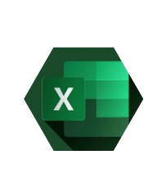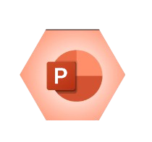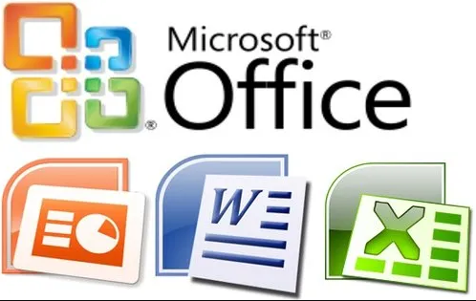

* MICROSOFT WORD

THIS COURSE CONTAINS

* MICROSOFT EXCEL
* MICROSOFT POWER POINT
* MICROSOFT ACCESS
* MICROSOFT OUTLOOK

8000/-

COURSE FEE



**MICROSOFT OFFICE**

Boost Your Productivity

3

MONTHS

**Course Duration**