SAP BOM CREATION - COPY

Finding the Material group

  - Use T code – MM03 (View Material) 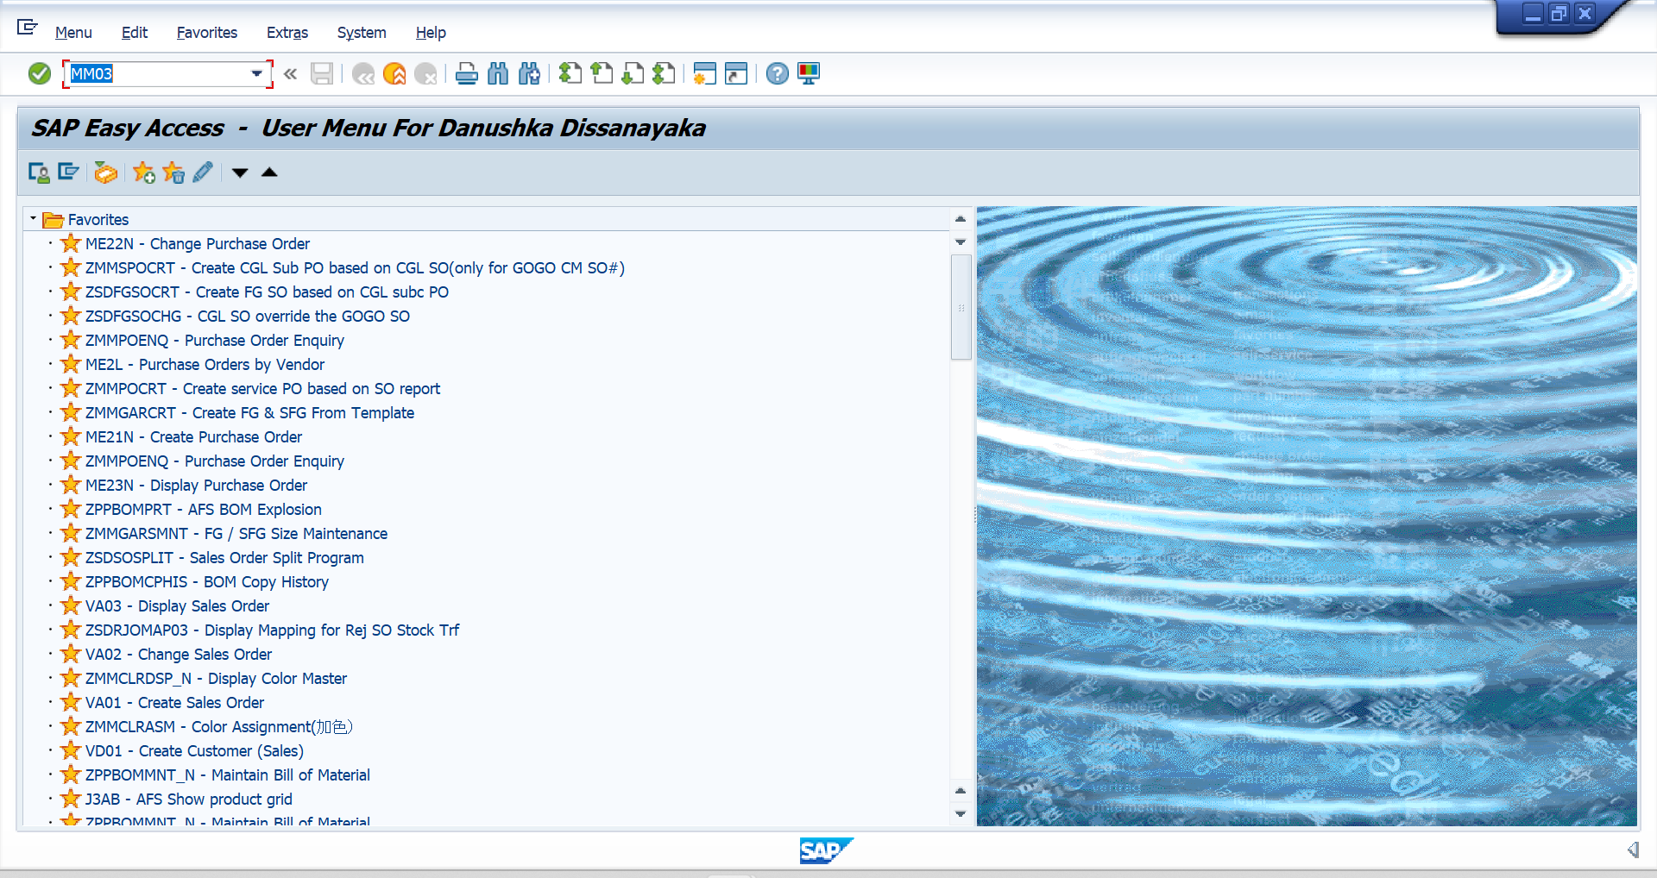

  - Add Previous Season Material (Source Material) in Material box & click ENTER. 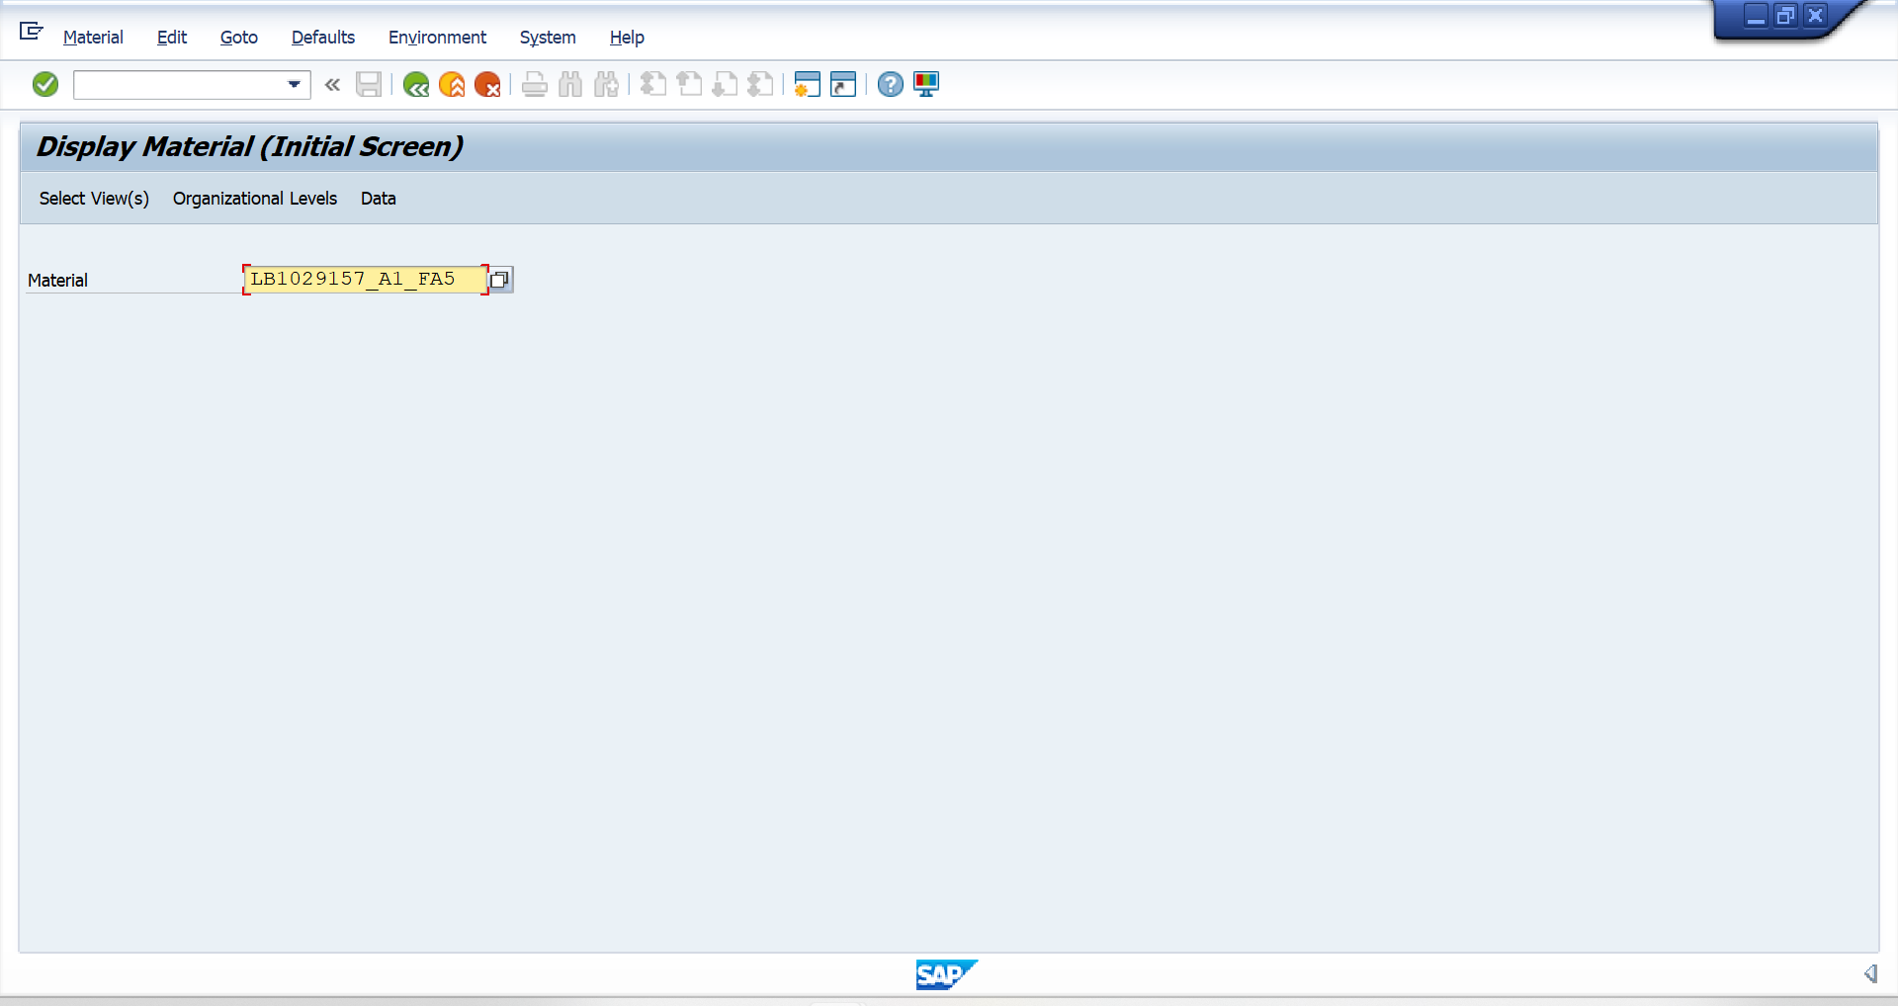

  - Select *Basic Data 1* & click the tick or click ENTER. 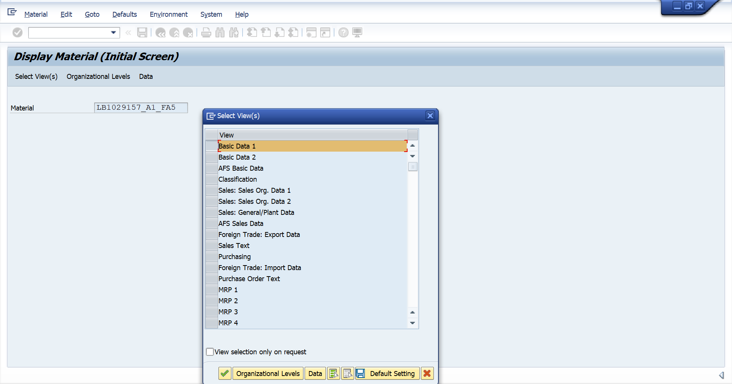

  - In the full view the Material group (garment type) can be identified in 4 digits. 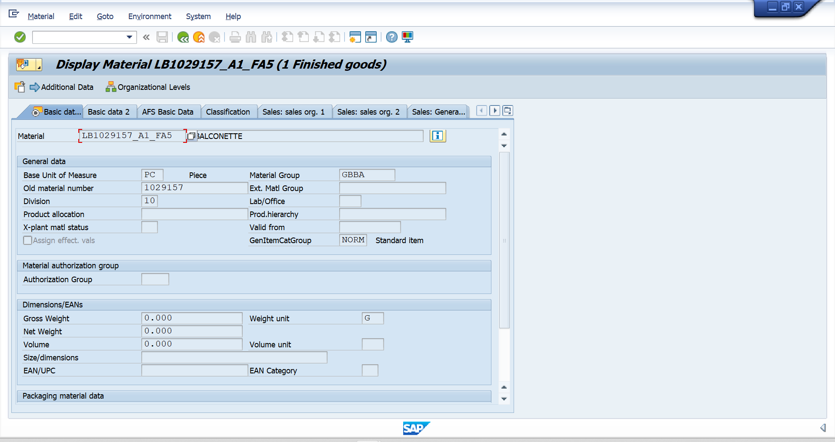

*The Material Group given in the attachment sholud match with the Material Group of Previous Season Material (Source Material)*

BOM CREATION – CARRY OVER STYLE

  - Use T code – ZMMGARCRT (Create FG & SFG from Template) 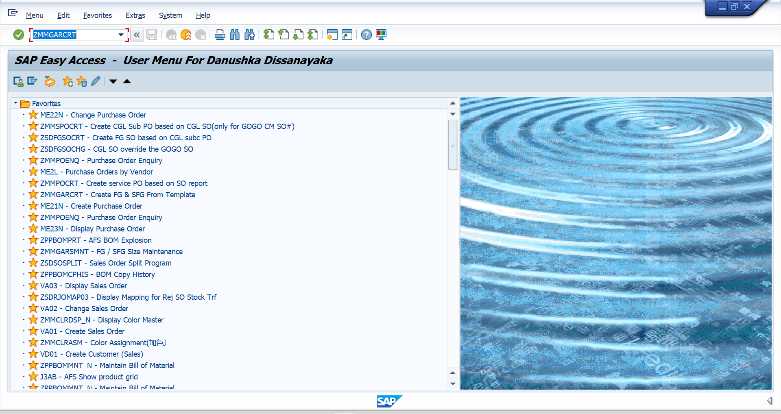
  - Material type should be selected as “Finished Goods – FERT”
  - Add the correct material group (Ex: GBBA, GBPL, GBDE, etc.)
  - Add the new material code with the new season. (Ex: LB1029157_B1_HL5)
  - Need to make sure to add the BOM version for each material code and maintain the same sequence.
Ex: starting from “A0” and continue as “A1”, “A2”, etc. as per the each request shared within the season.

Old Material Code | New Material Code
LB1029157_A1_FA5 | LB1029157_B1_HL5

  - Add the old material code for the copy from existing material (Ex: LB1029157_B1_HL5) and “Execute” 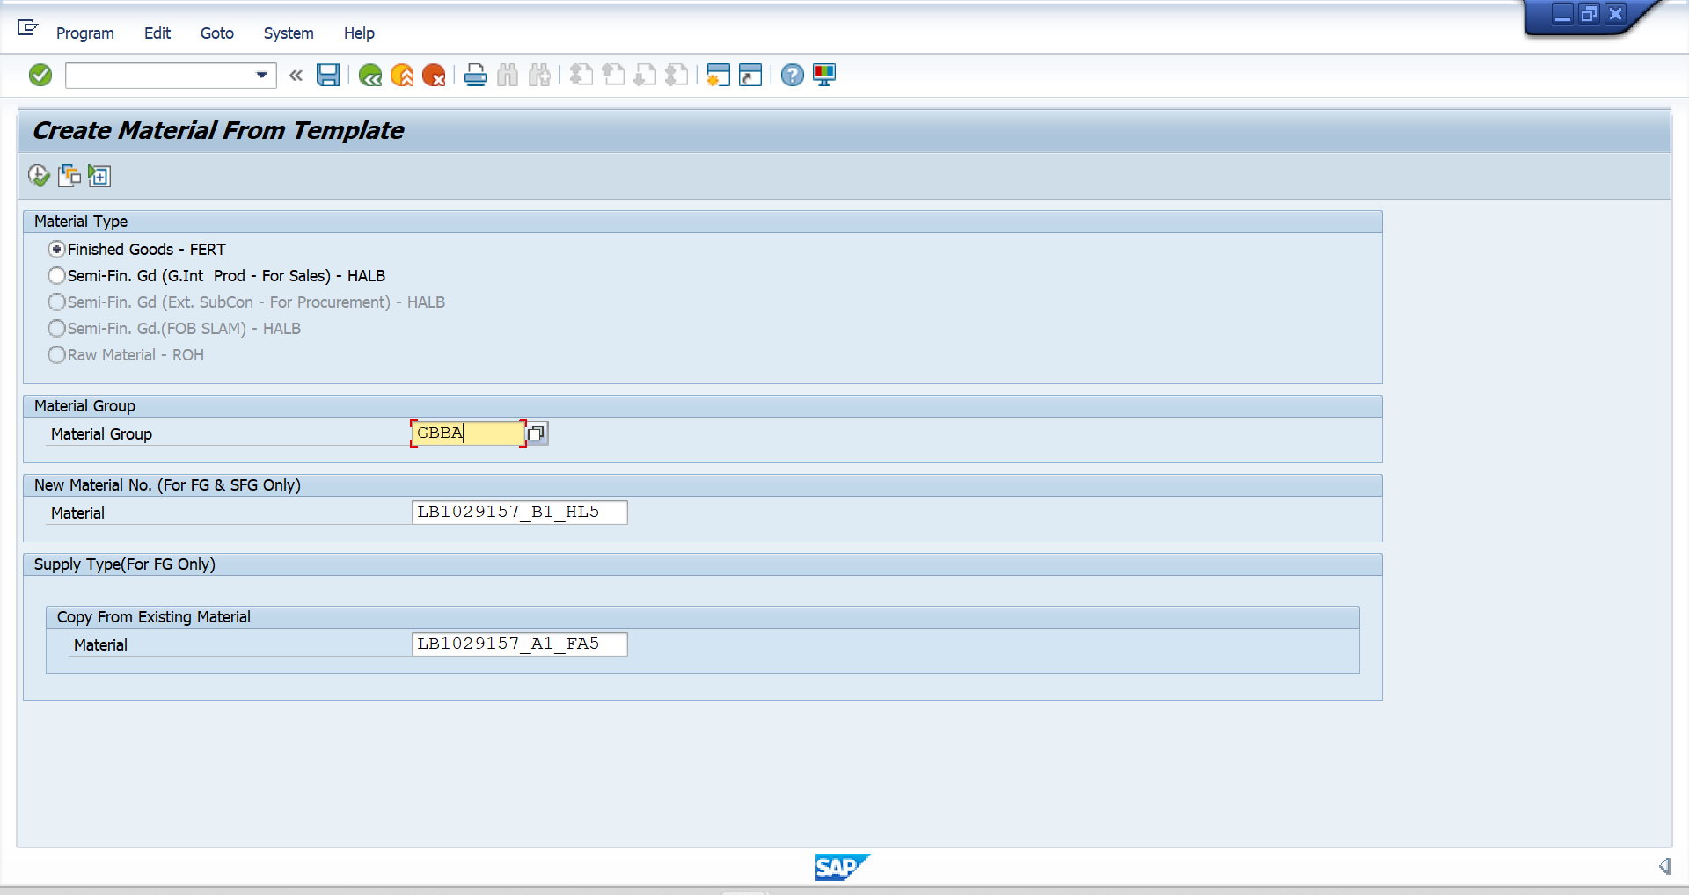

  - Add the current Season code
  - Check and Save 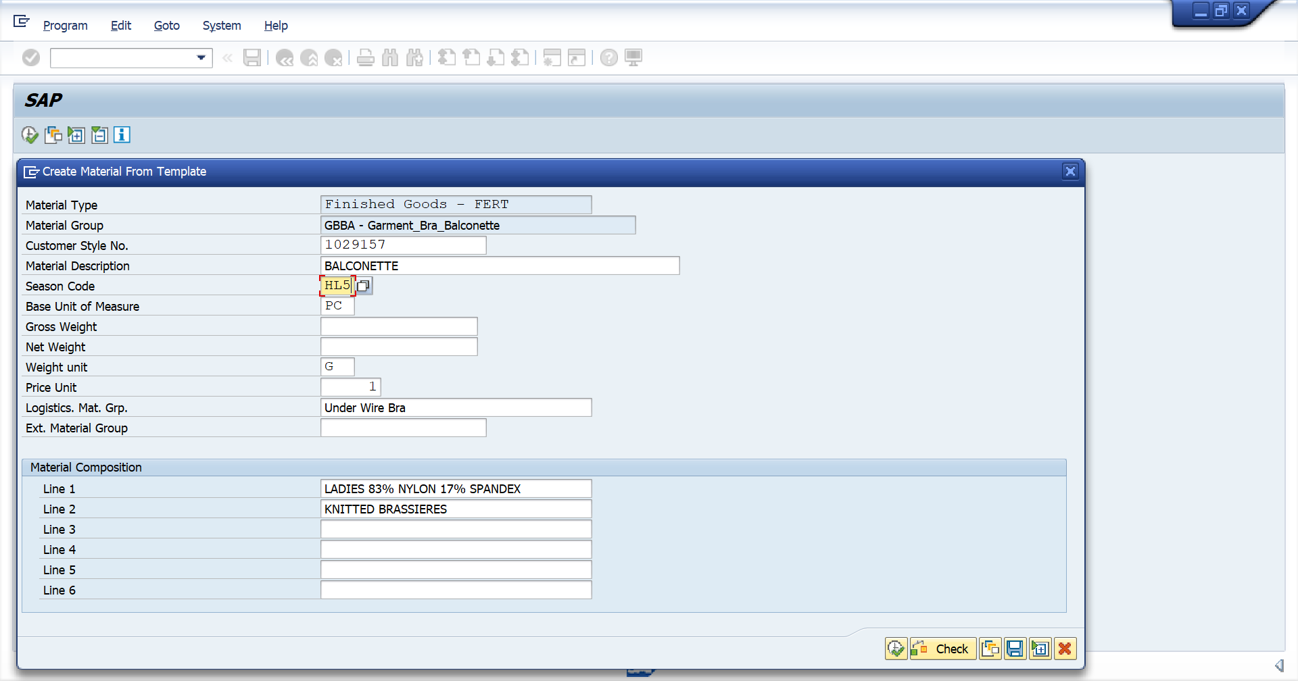

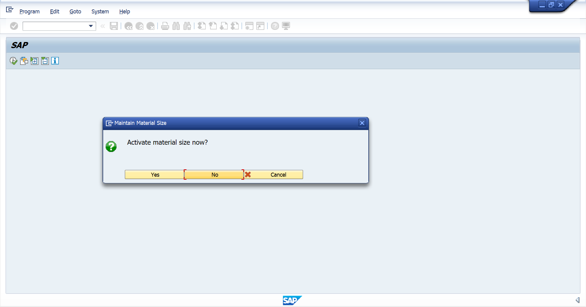
Activating the Size & color

  - Click “Yes”
  - Add the color codes
All base Z colors (Ex: ZCLF, ZCLL, ZWSF, etc.) from previous material code are automatically copying in this initial BOM creation stage. If the fashion colors (Ex: B017, C948, C950, etc.) given to add into new BOM, click multiple selection and add all the fashion colors
*All base Z colors of the previous material code should be copied into new material code*
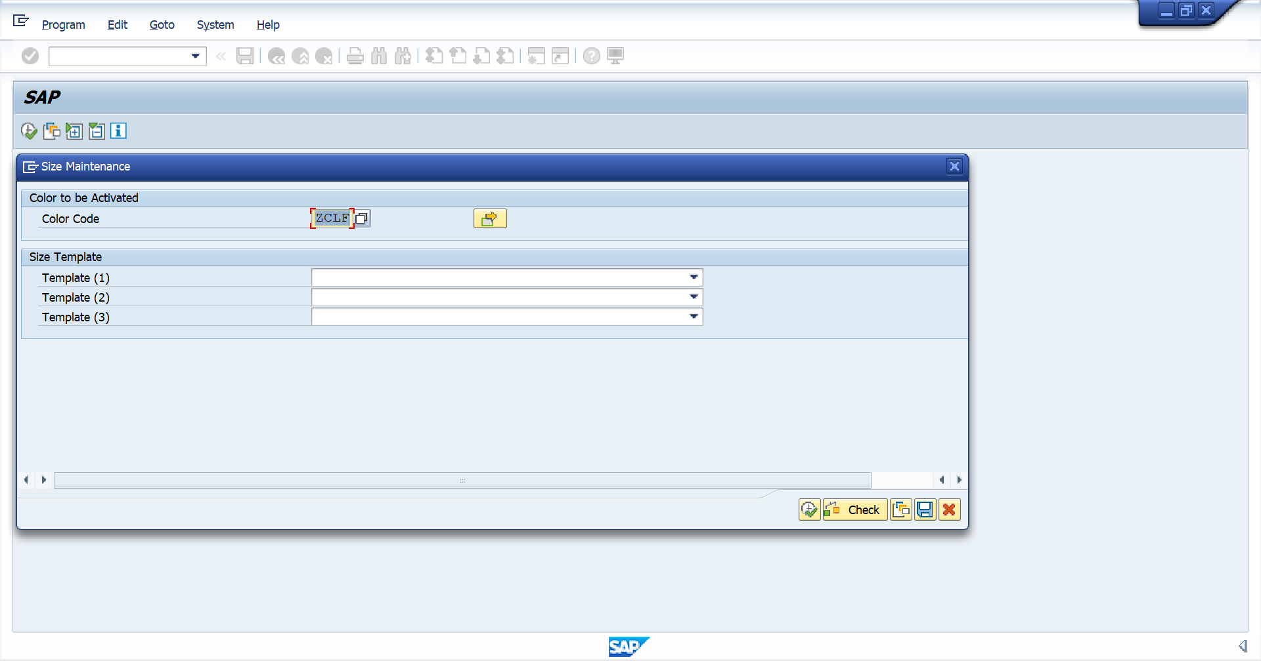
Multiple Selection

  - Check & save 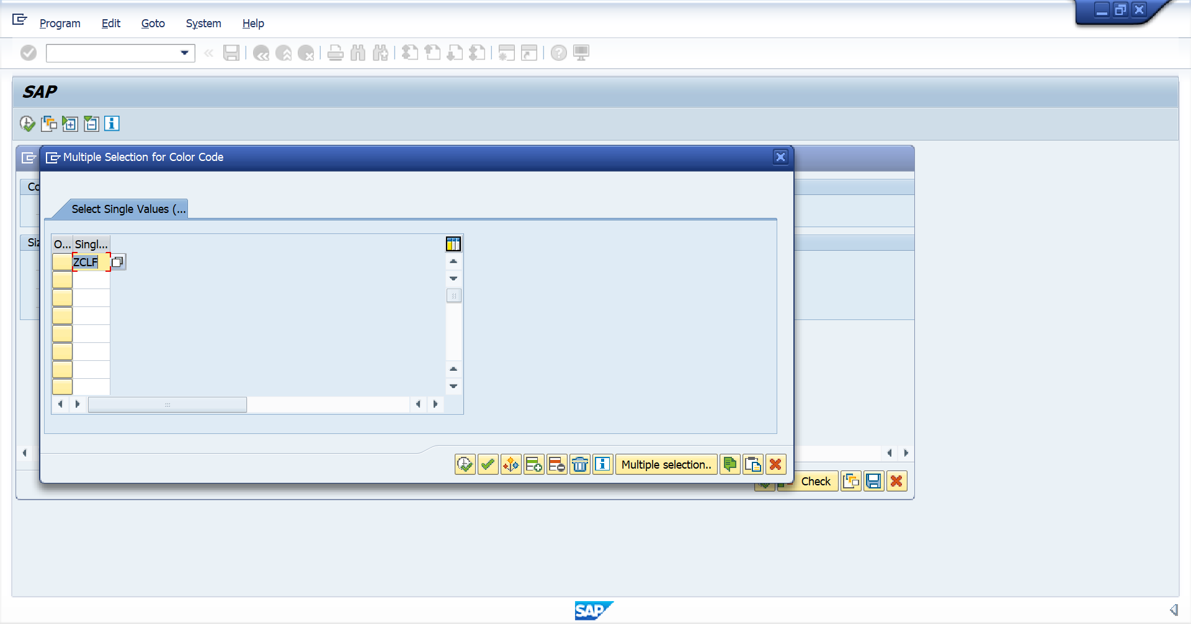
If given fashion colors, add here

  - Add the sizes

  - Tick Activate for the required sizes
  - If a size is not required in the current season, then need to maintain the order as Zero units (bulk stage) since a size cannot be removed once activated. 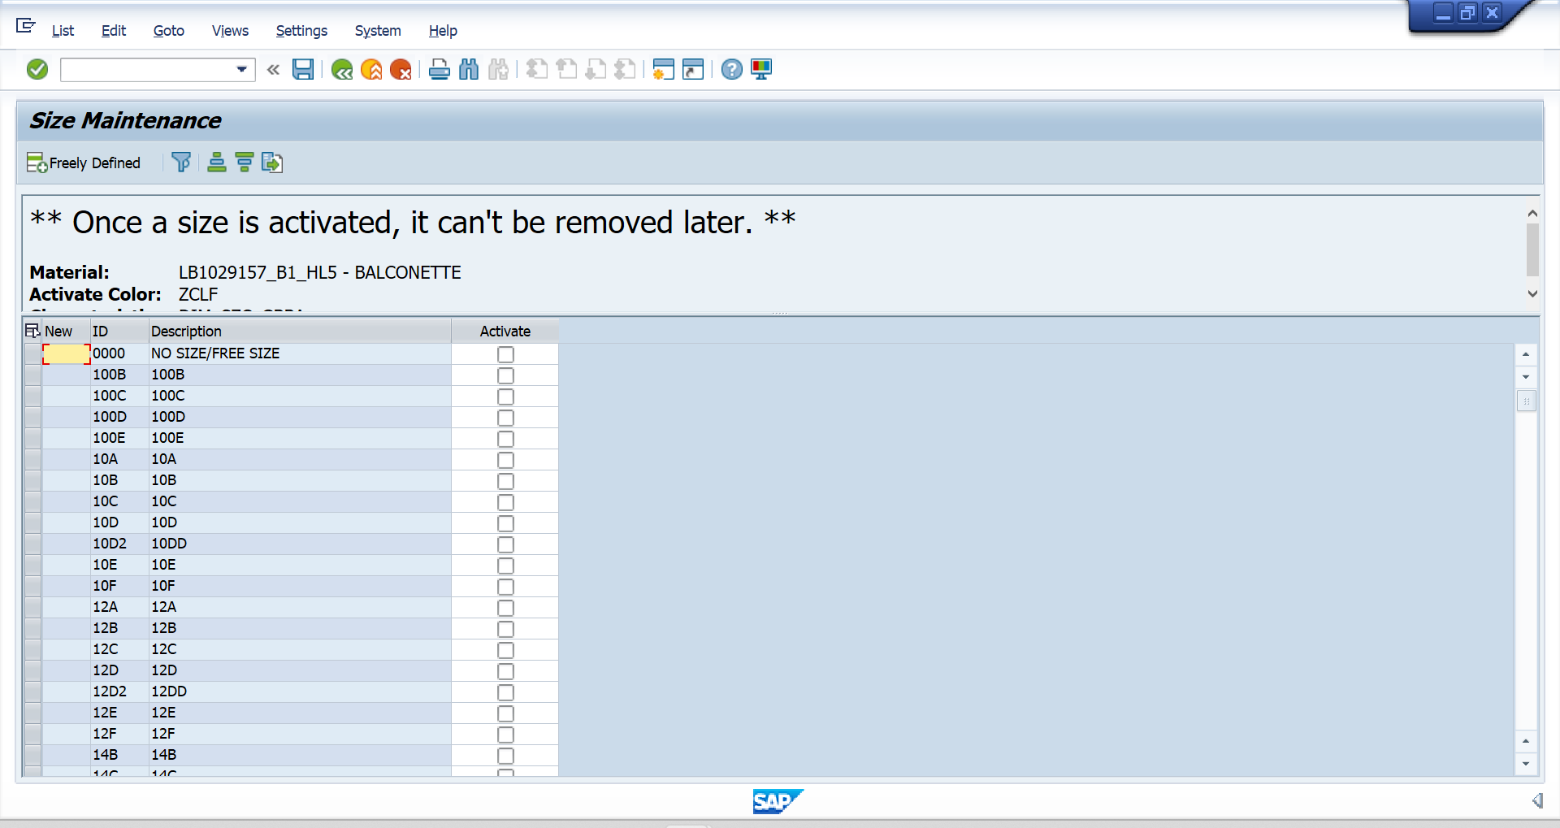

  - If a new size needs to add into the BOM, select the required size in this stage. (Newly added sizes should be clearly highlighted in the attachment)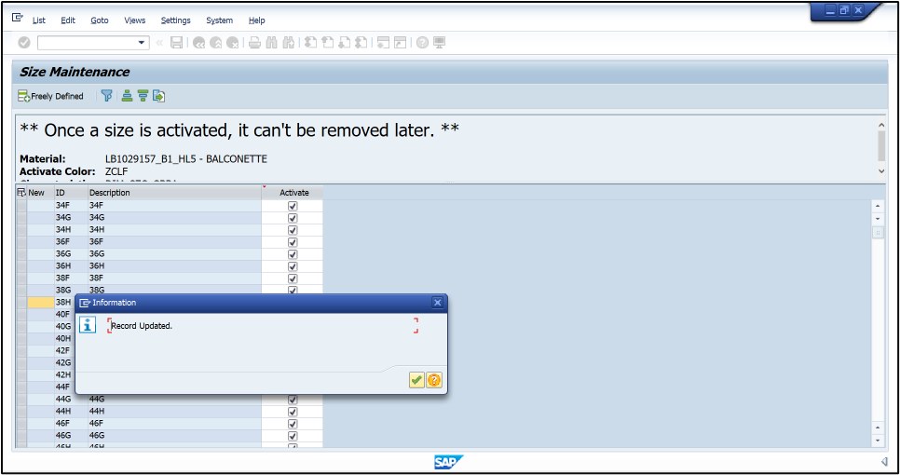

  - Save

Creating SAP BOM
  - Use T code – ZPPBOMMNT_N (Maintain Bill of material) 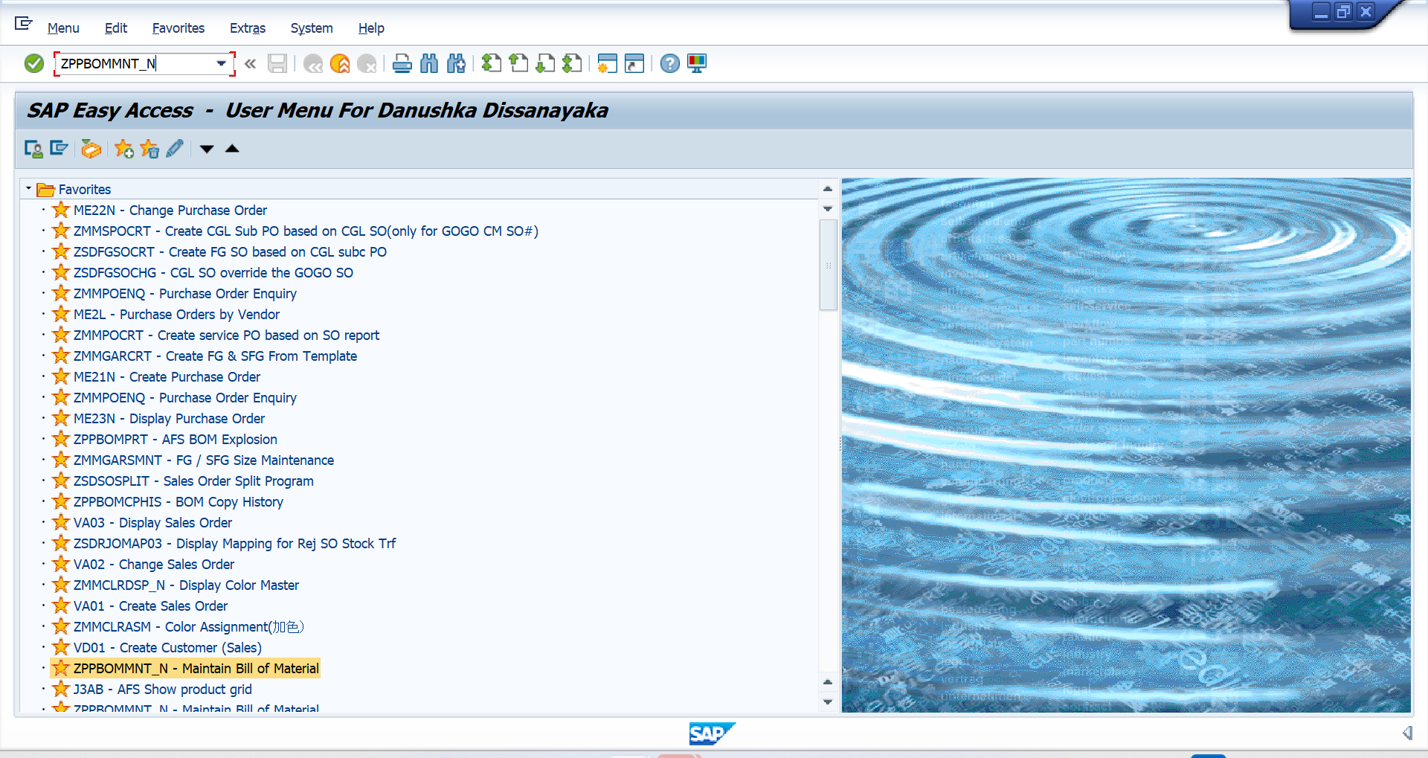
  - Add the material code of the current season
  - Add the plant code and the BOM usage (Plant Code – 1001, BOM usage – 1)
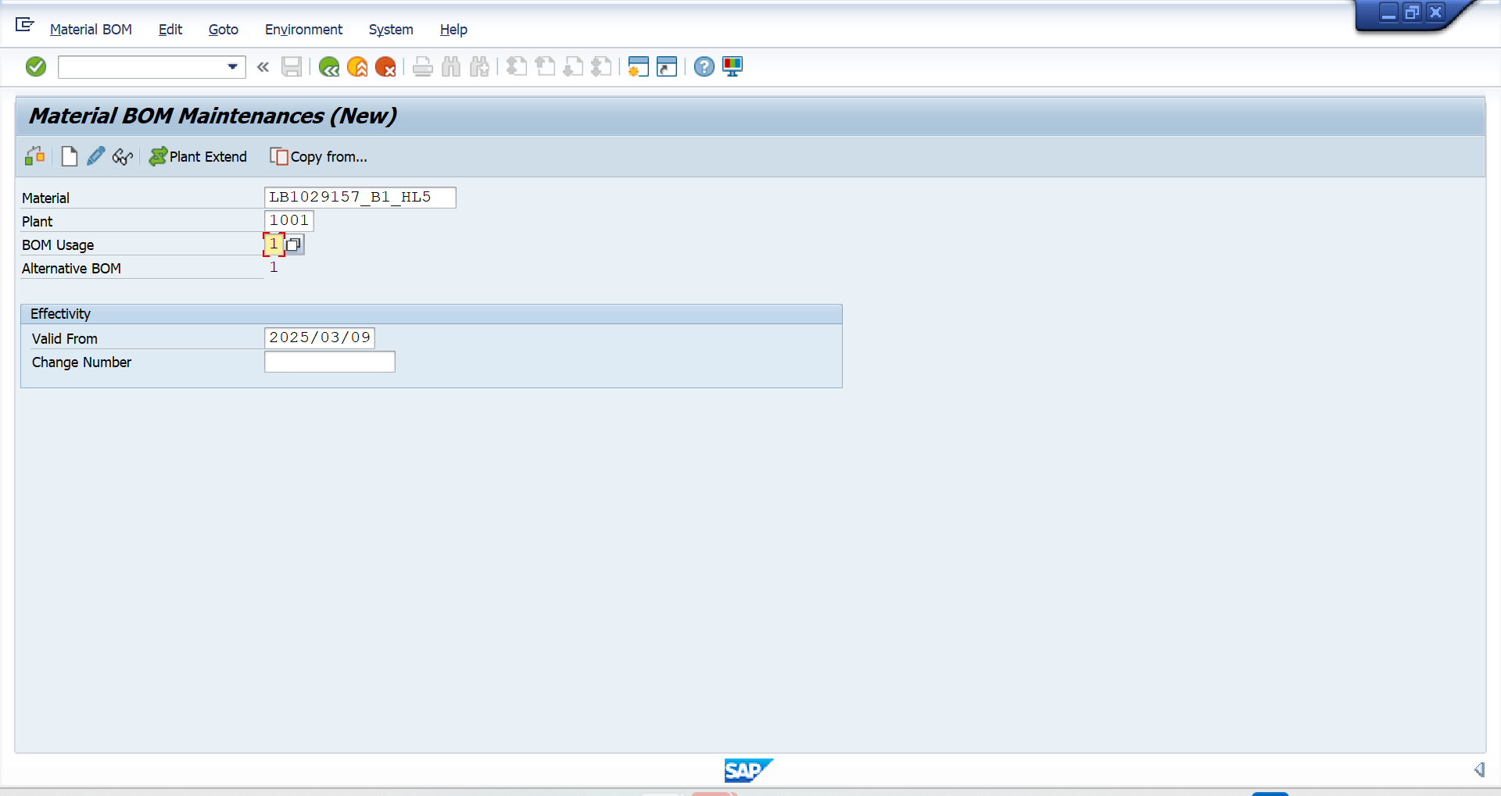
  - Press copy from

  - Add the old season material as source material
  - Select all color
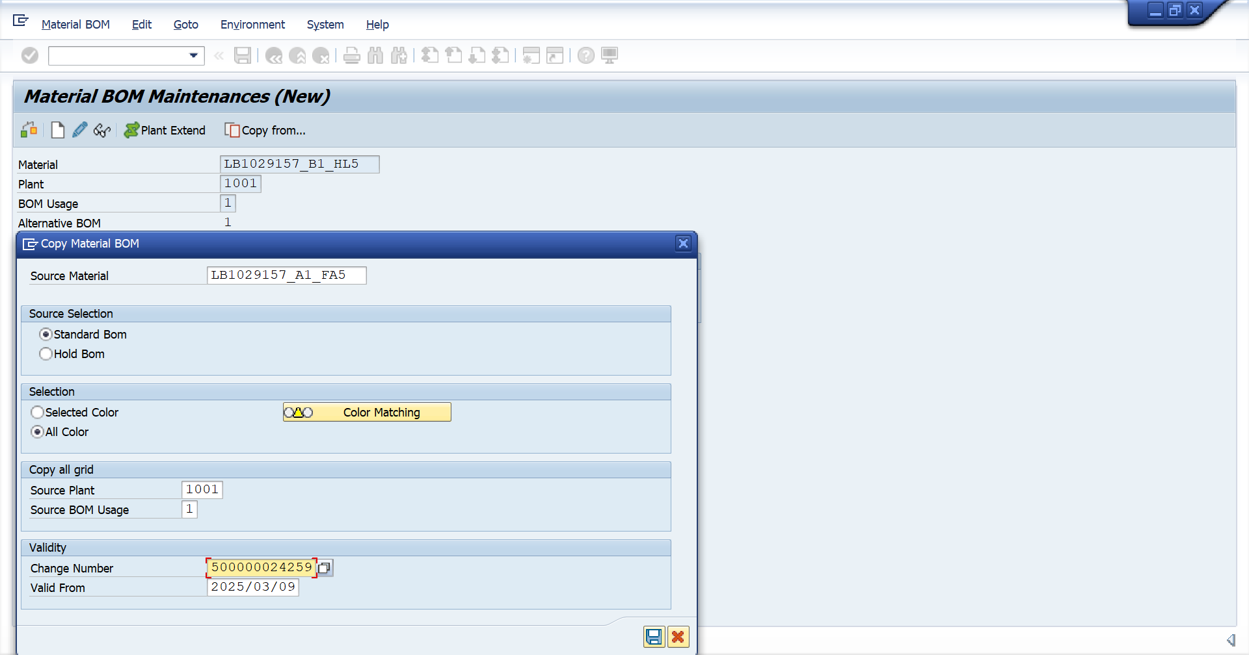
  - Add change number (ECN number) if needed
  - Save
  - Press create BOM and check the created BOM 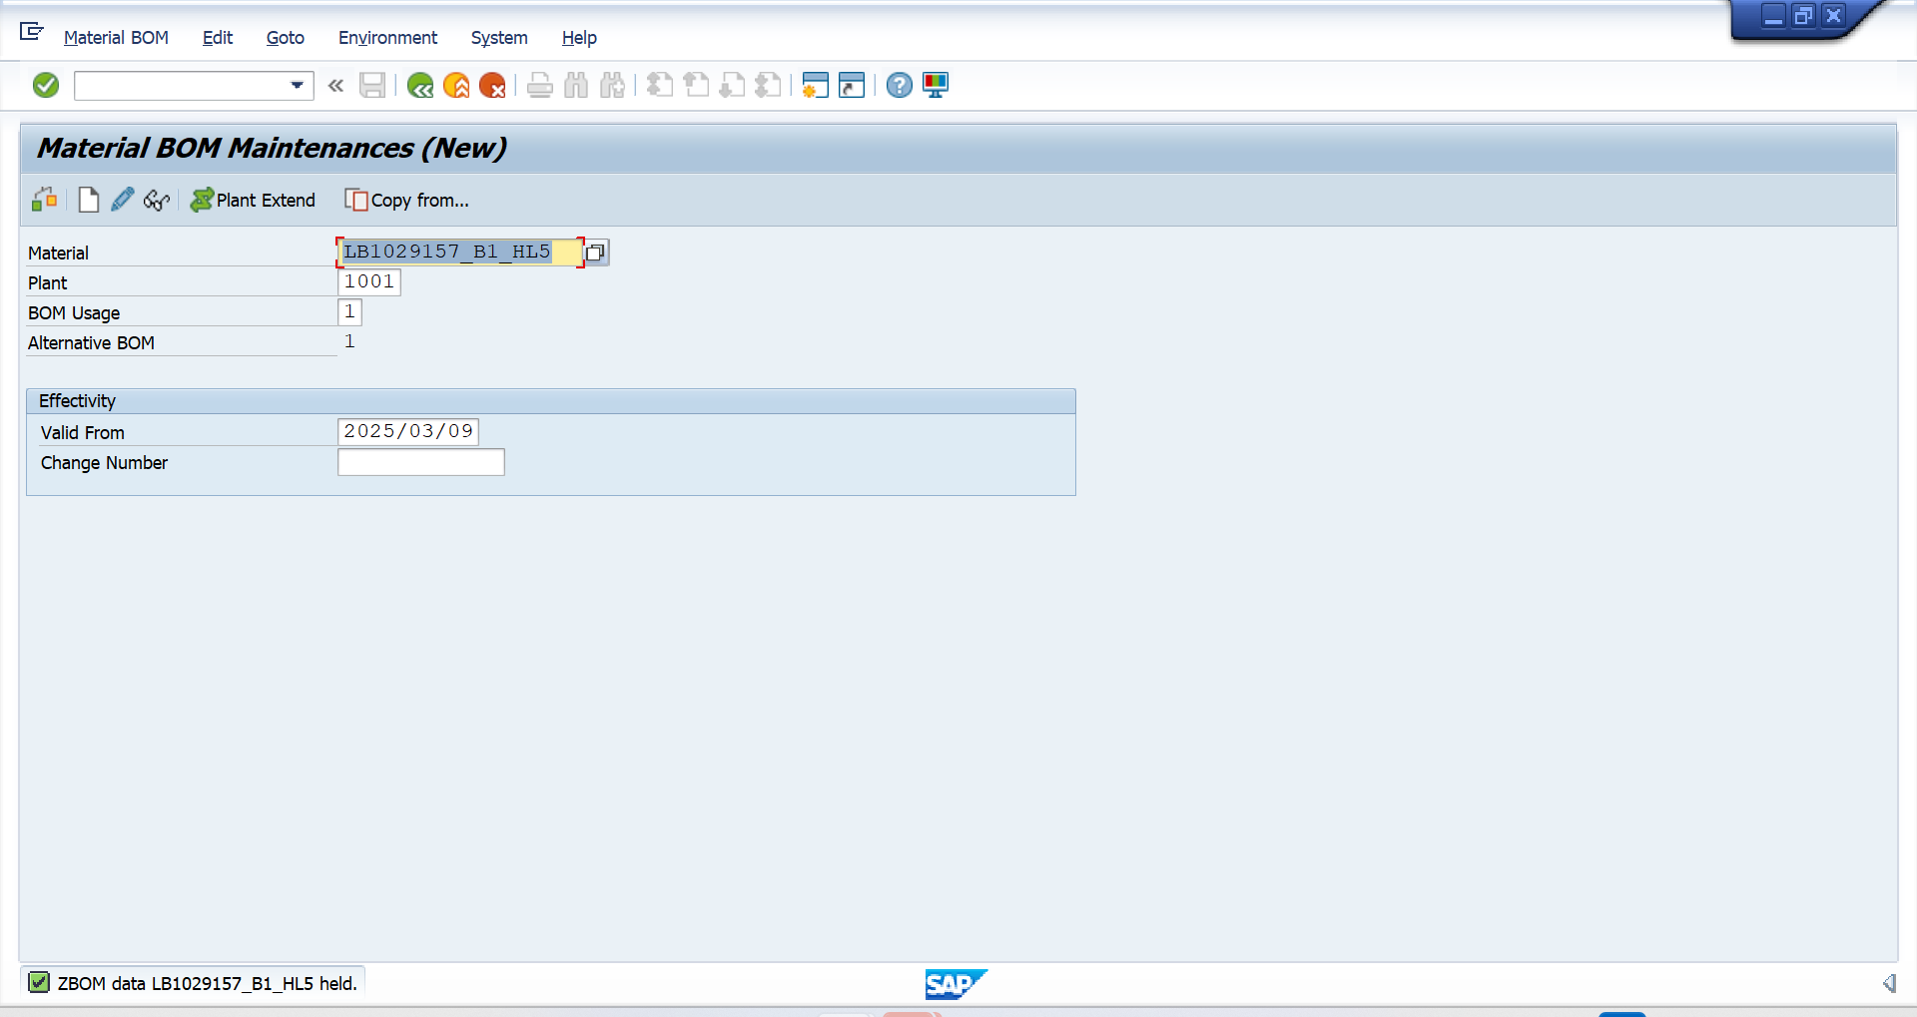

View the previous season BOM to copy the OBD (Operation Break Down)
  - Go to the previous BOM from Display material BOM T code ZPPBOMMNT_N
  - Copy the OBD using CTR + C 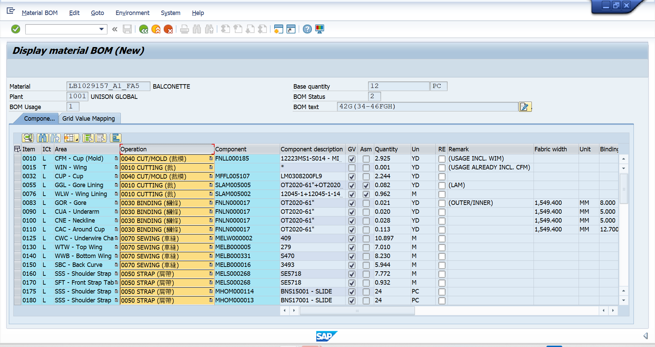

  - Paste the Operation Break Down in the New BOM using CTR + V 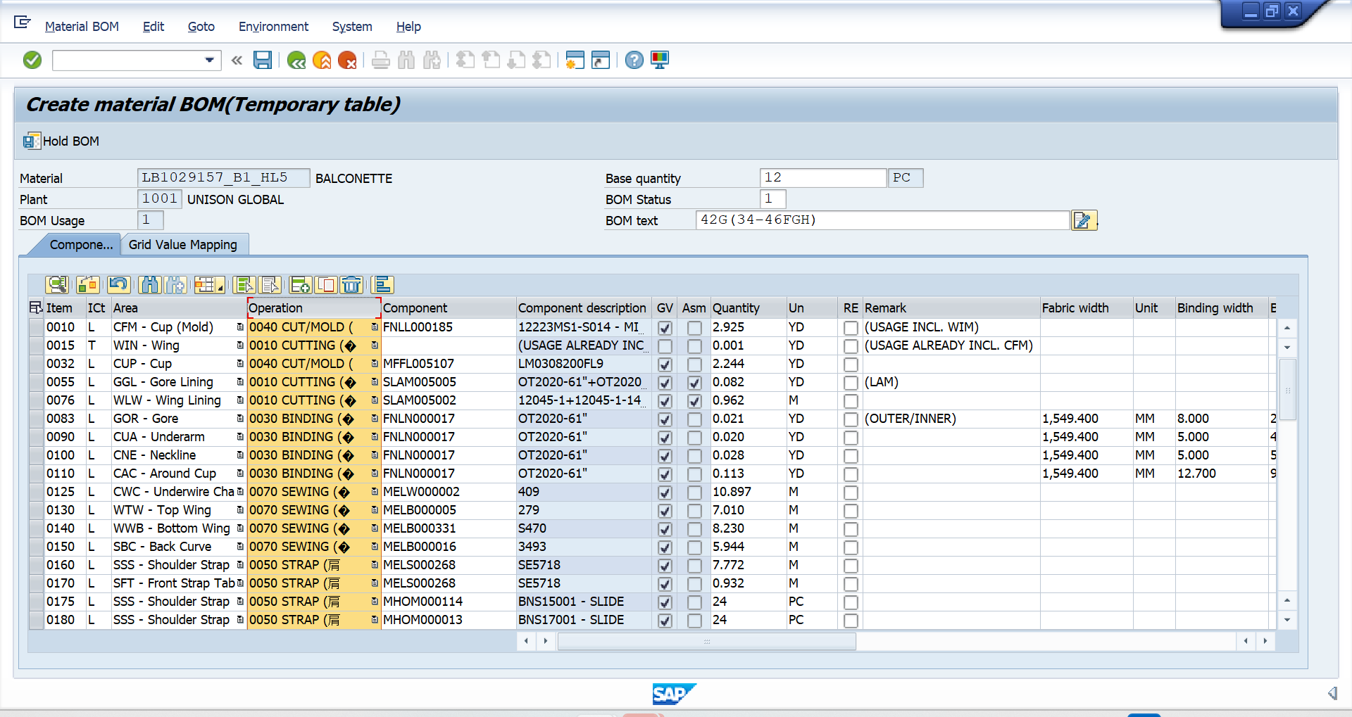

  - Go to color mapping and remove color mapping of fashion colors

  - Save

Validation (BOM Comparison)
  - Use T code – ZPPBOMCMP (BOM Comparison Report)
  - Add the material in BOM1 – carryover style source material code, color – base color, plant - 1001, BOM usage - 1
  - Add the material in BOM2– carryover style new material code, color – base Z color, plant - 1001, BOM usage - 1 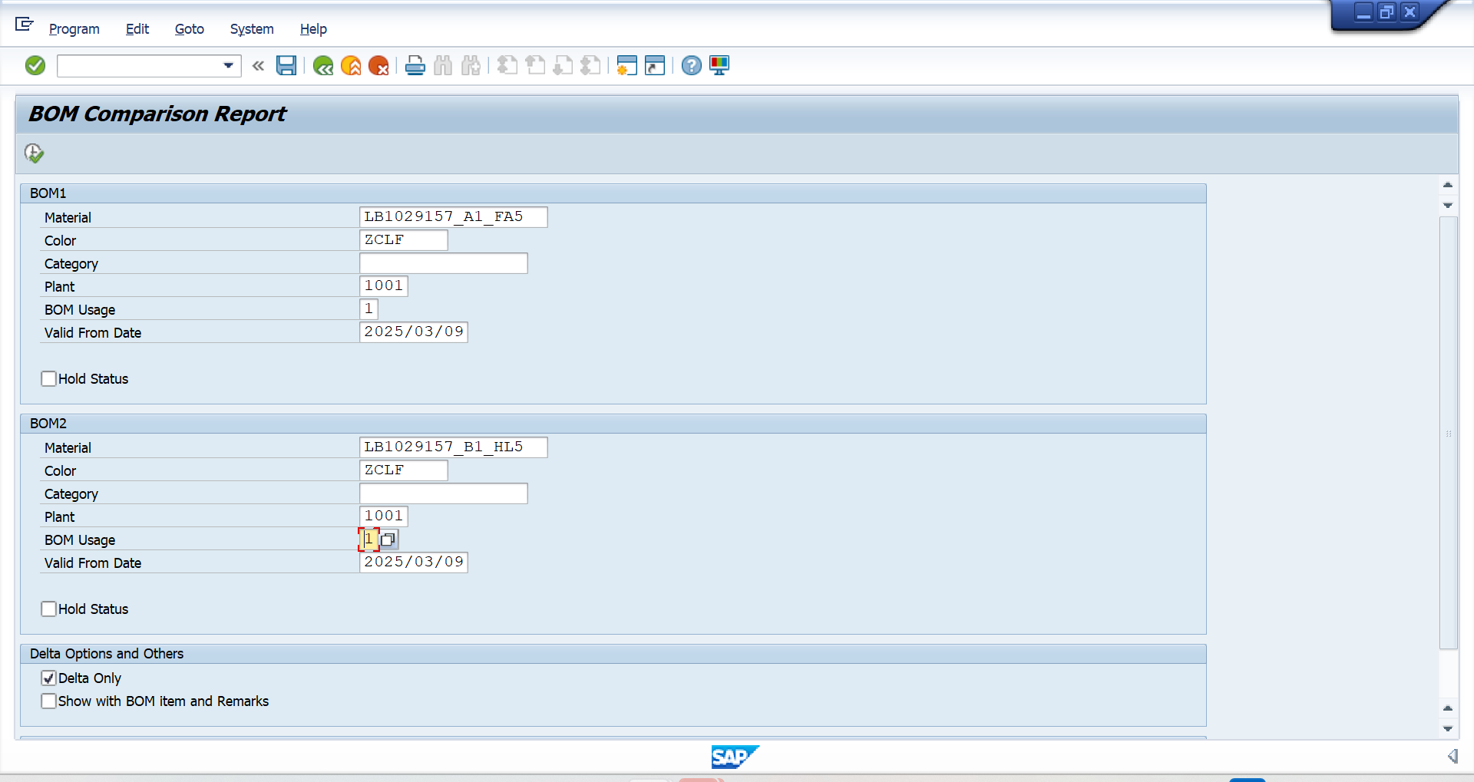

If the BOM comparison report is with no deviations, it indicates “No Differences Found” as below. 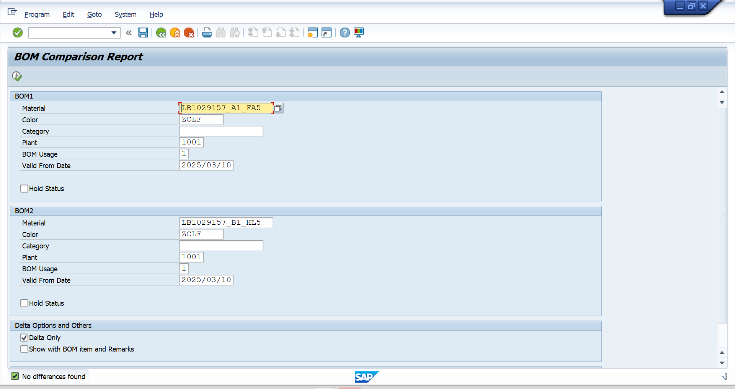
*Please note that, BOM comparison should be done all the base Z colors separately*
If the BOM comparison report is with deviations, the report indicates the differences as below. 