BOM YY UPDATE – SAP

Introduction:
Updating BOM YY in the SAP system is essential for generating accurate RM (Raw Material) requirements for all measurable and countable trims. This allows the correct RM requirements to be shared with the supply chain team, enabling them to connect and manage the procurement process effectively.
Application/System
- SAP system
- COE Job Tracker
- SAP validator web application
- MS Excel
- Email

Process Mapping
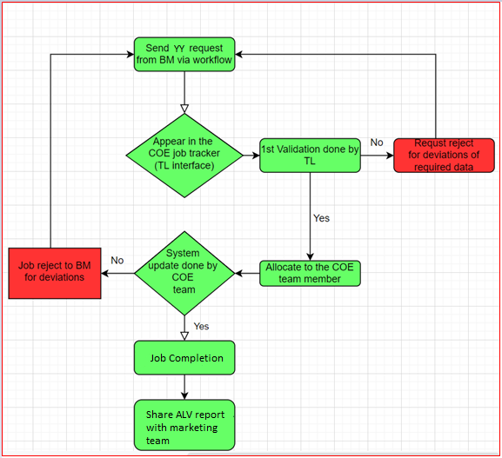

Check the received BOM and do the pre excel working:
- Ensure sizes are in 30D3 format instead of 30DDD. There should be no line breaks between two sizes in a single-line garment size entry.
- Verify that YY is listed under Ordering Consumption > Gross Consumption Column. If YY appears in any other column, remove the “Gross Consumption” label from the unwanted columns.
- Review the Description column to ensure the word “Fabric” is not included in any description line.

  - Invalid: 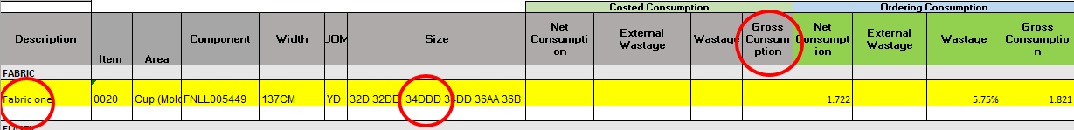
  - Valid:
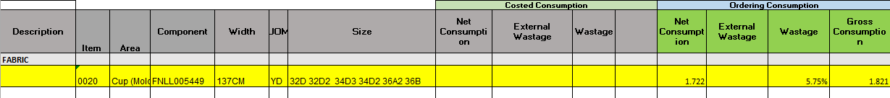

- Separate Excel files need to be created for each given colorway
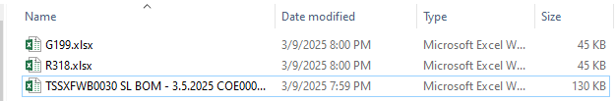
- Access the SAP BOM using ZPPBOMMNT_N and put the BOM on hold.

Need to log in to the SAP system.

Initial Screen
Logging to the SAP system
Navigation >> Enter “Username” and “Password” >> Press Enter
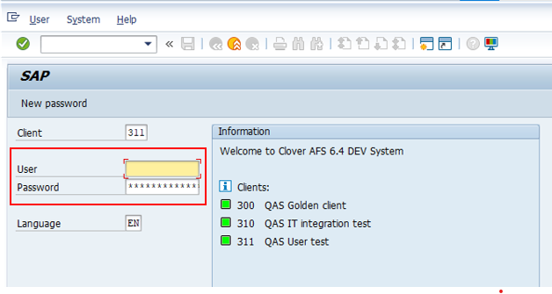

Use T code - ZPPBOMMNT_N
Navigation >> ZPPBOMMNT_N >> Enter >> Please refer below screenshot
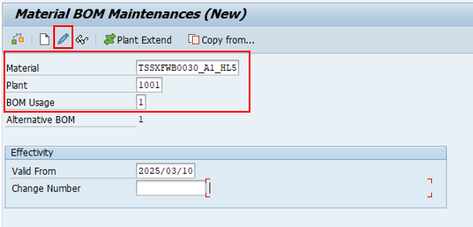
- Enter below mentioned details and click change BOM

- Navigate to the 3rd level of the SAP BOM.

Navigation >> Components >> Grid Value Mapping >> Color Mapping.
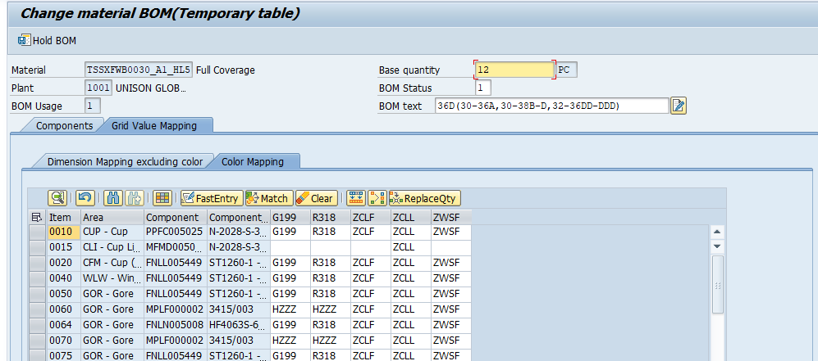

- Click on 'Color Mapping' to navigate inside any line, as shown below.

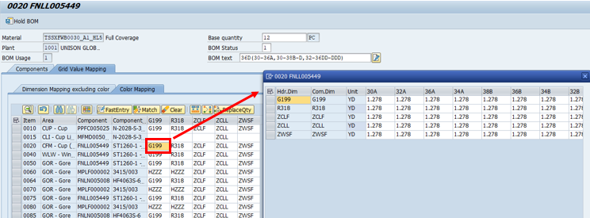

- Download the system-generated spreadsheet in .xlsx format.
Navigation >> Double click color mapping of any RM >> Right click >> Spreadsheet >> Ok >> Save >> Save as in .xlsx format
- Navigate to https://sfx.inqube.com/inventory/Report/yy_update and upload the files.
Need to log in to the SAP validator web application
Log in to the SAP validator web application system with user credentials
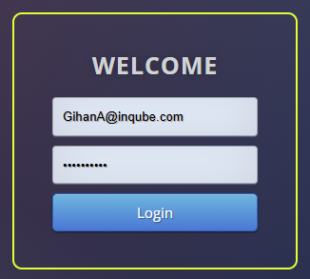

Go to the YY update chart generation interface
Navigation >> COE >> YY Update
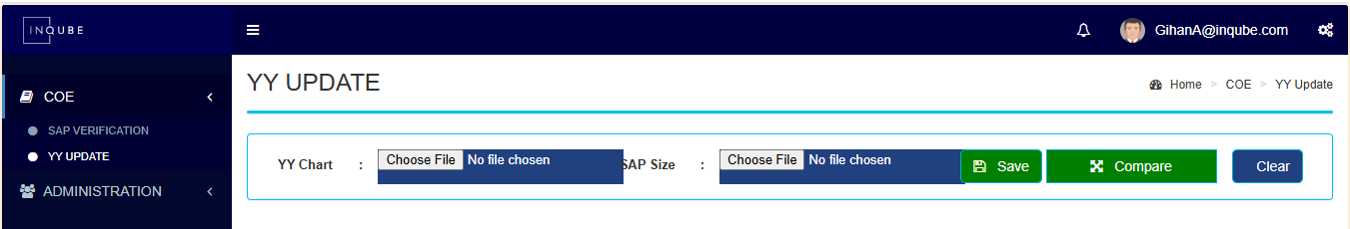
- Upload each colorway Excel file to 'Y Chart' one by one, clicking the 'Save' button after each upload.
  - Upload one colorway chart
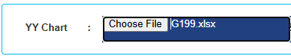
  - Click Save
  - If any error shown like below
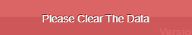
  - Click clear 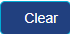
  - And again click save
  - Repeat the working until upload the all colorways.

- Once all colorway sheets are uploaded, upload the previously downloaded SAP Excel file into 'SAP Size'.
  - Upload the system generated SAP spread sheet into SAP Size
  - Click Save


Finally, download the generated YY_Details chart.
  - Click compare

Update the YYs:
- Filter the line items based on the yellow-highlighted rows in the shared BOM Excel. Retrieve the line item numbers from the shared BOM Excel and use them to filter the corresponding line items in the generated YY chart.
BOM
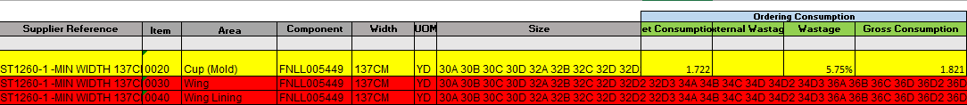
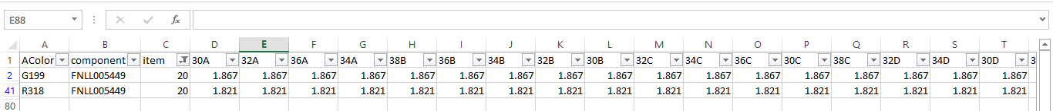
Generated YY chart

    - Update the YYs line by line accordingly.

- Update the YYs line by line accordingly into the SAP system BOM.

  - Copy the full line like below in YY Details chart and paste it as it is into the SAP BOM line.

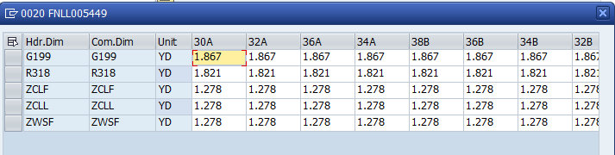

  - Click ok

- YY Removal – Update YY values to zero.
  - Identify the lines highlighted in red in the excel BOM.

  - Remove the color mapping in SAP BOM for these lines accordingly.
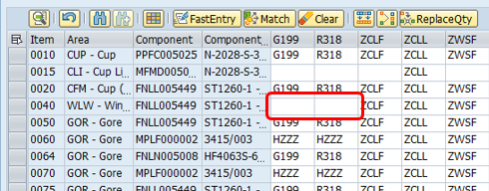

- Update Binding YY – Modify the binding YY at the first level.
  - Check the right corner of the shared excel BOM. Marketing team will share the binding consumption details as mentioned in below.
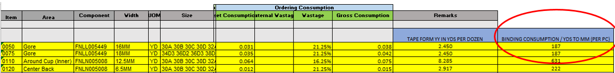

  - Have to update those given binding consumption into SAP. Need to go the first level of the SAP BOM and update binding consumption values.
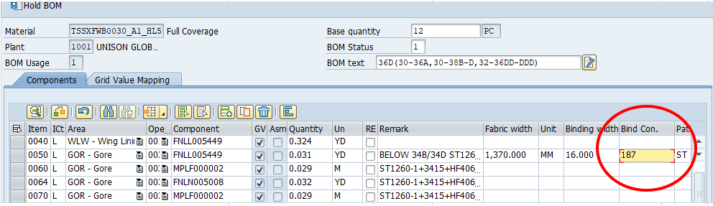

- After updating all line items click save
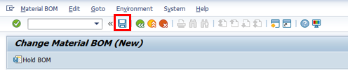

Do the YY Validation:
- Download SAP excel for all colorways using ZPPBOMEXP T-code.
  - Access the t code
  - Enter the Material, deselect the 'Ignore Semi-Finished Goods' option, and click the 'Color' button
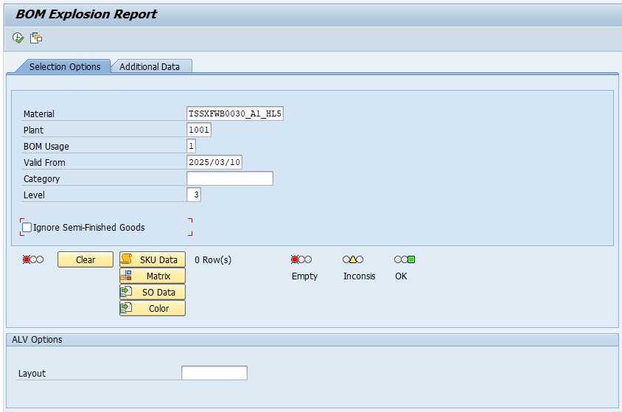

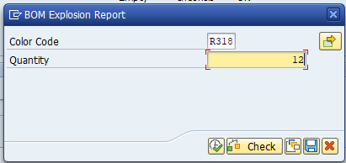
  - Enter the SAP color code and set the quantity to 12. Click 'Check,' then click 'Execute

  - Click 'Execute' and download the SAP spreadsheet in .xlsx format.
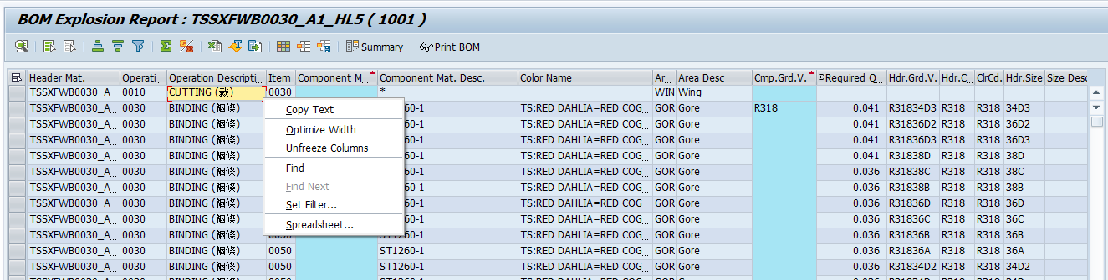

  - Validate YY one by one color using BOM validation as below
Navigation >> COE >> SAP Verification >> BOM validation
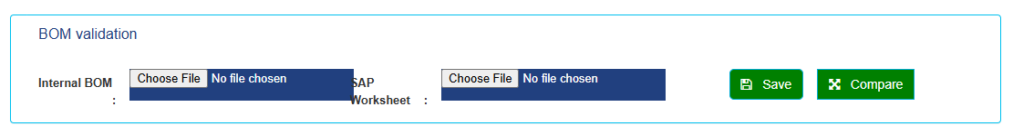
  - Can validate one colorway at one time. Upload files as mentioned in below and click save and click compare to generate validation chart.
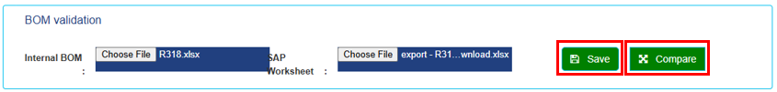

Share ALV report with marketing team:
Have to download system print for updated all colorways at one go.
Navigation >> ZPPBOMALV >> Enter >> Please refer below screenshot
  - Enter material (FG code)
  - Enter plant
  - Enter BOM usage
  - Enter one SAP color (Can use to add multiple colors.
  - Deselect the 'Ignore Semi-Finished Goods' option
  - Click execute.

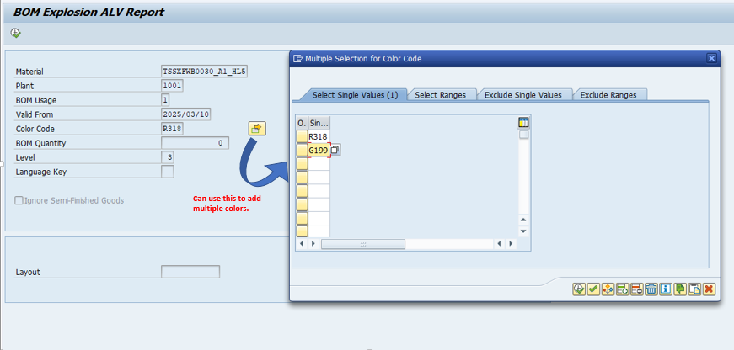

  - Download the ALV report and save it as mentioned format.
    - <FG code> <SAP color names>

  - Complete the Job in COE job tracker.
  - Share the ALV report with marketing team

