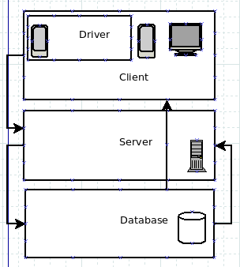

KGBTaxi: Design document
Polimi, Software Engineering 2, 2015-2016

Contents

KGBTaxi: Design document
Contents
Glossary
INTRODUCTION
ARCHITECTURE DESCRIPTION
The subsystems
PERSISTENT DATA MANAGEMENT
Conceptual Design
Logical Design
Observer pattern
A client-side model
A server-side model
Use case

Glossary
- Client - a client in an client-server architecture
- Customer - a client with access to customer account
- Driver - a client with access to driver account
- Server - our server-side application
- Database - our server-side database

INTRODUCTION

ARCHITECTURE DESCRIPTION
We are building our application with Java and Maria DB.
The website, the application and the server-side are all going to be written in Java, while the database would be managed by Maria DB SQL. This architecture enables advanced serialization and compatibility among all the subsystems.
Client (both driver and customer)

The subsystems
Our application is utilizing Observer and Node patterns, and in our case the subsystems is split equally from the root node.

The subsystems include:
- Root node
- Account manager
- Location system
- Payment system
- Feedback system
- Order system

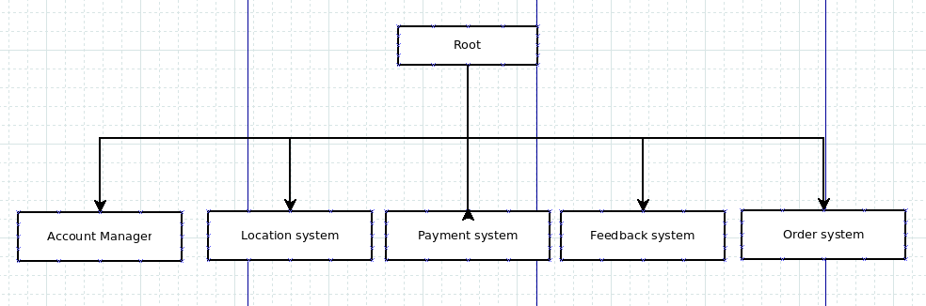

PERSISTENT DATA MANAGEMENT
In our project we store data in a relational database. In the next section we will describe design of our database in terms of Entity-Relationship Diagram.

Conceptual Design
Conceptual design allows to start thinking about the data we want to store and about the relations between them.
In our system we have two types of users: “Driver” and “Client”. Both of them can access the database via server.

Logical Design
The aim of this phase is to develop a relational schema of the database starting from the conceptual design.

Observer pattern

The observer pattern is a software design pattern in which an object, called the subject, maintains a list of its dependents, called observers, and notifies them automatically of any state changes, usually by calling one of their methods. It is mainly used to implement distributed event handling systems. The Observer pattern is also a key part in the familiar model–view–controller (MVC) architectural pattern.^{[1]} The observer pattern is implemented in numerous programming libraries and systems, including almost all GUItoolkits.

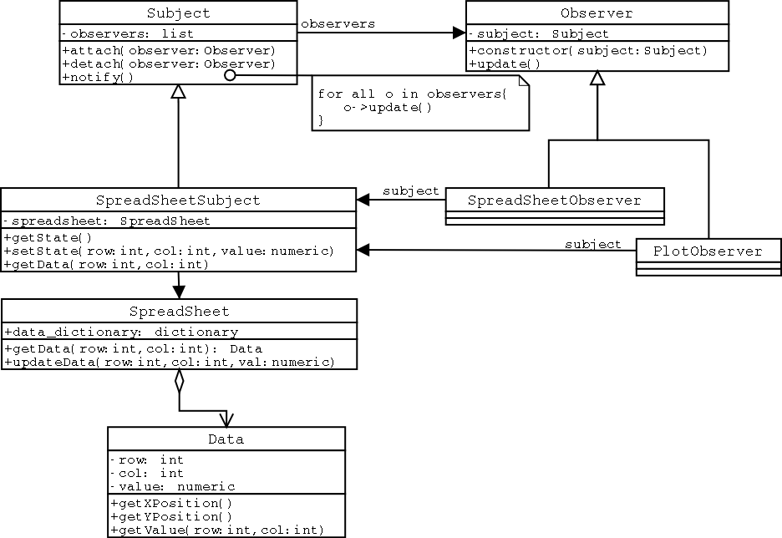

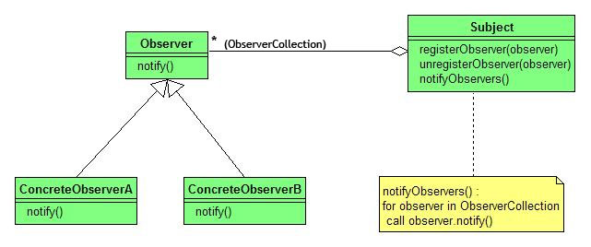

A client-side model

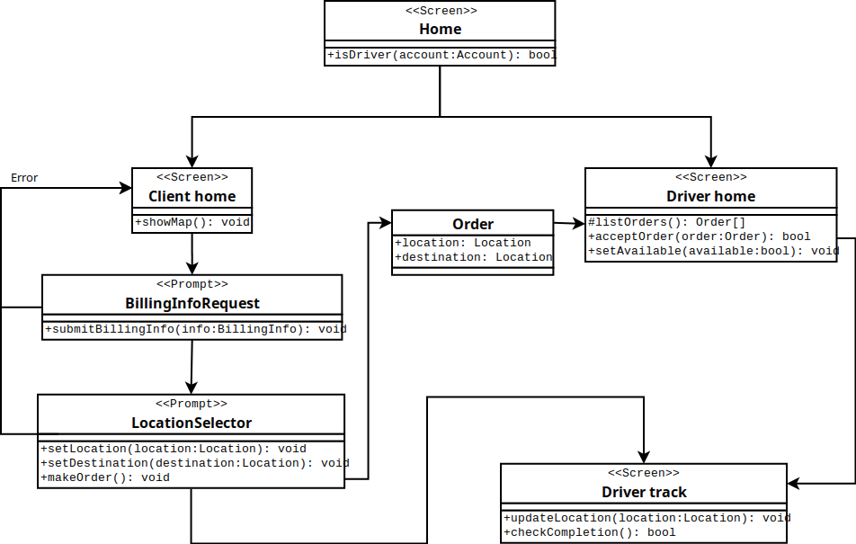

This diagram shows data managing in the program, various interfaces and gives a fair understanding of how program will work in general.
All starts from the “Home” screen, here user can select his profile (Driver or Client), then program separates into two separate modules, which can communicate with server or receive data from database itself.

A server-side model

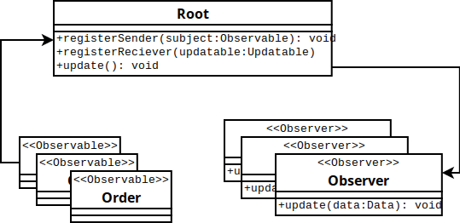

The main objective of the server is to manage data transmission between users and database. Also it process registration of Drivers and Clients.

Such method of storing and processing events also ensures the fair schedule of events.
The downside is the speed, but execution time is not a strict restraint in our case.
This is where Java works the best - we can utilize interfaces to implement <<Observable>> and <<Observer>>.

Use case

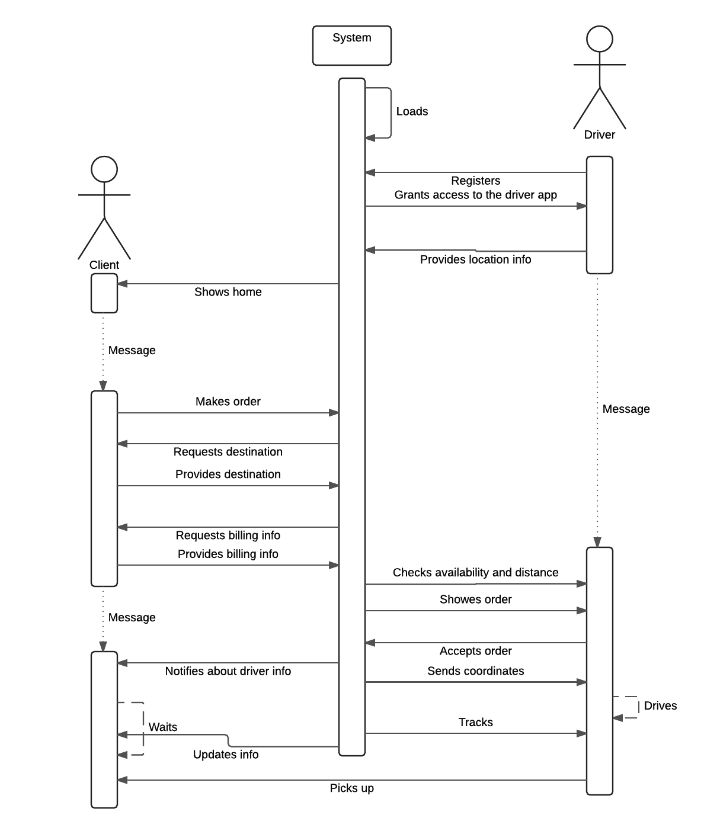
This diagram gives final picture of all data transferring processes in program. Complete image of project gives opportunity for programmers to make release in a short period of time.

