RASD-Taxi “KGB Taxi Service”
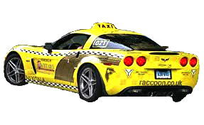
Introduction
1.1 Description of the problem
1.2 Goals
1.3 Domain Properties
1.4 Glossary
1.5 Assumptions
1.6 Proposed system
1.7 Identifying Stakeholders
1.8 Other considerations
2 Actors Identifying
The client
The driver
The watchdog
The third party
3. Functional Requirements
X. Visual interface prototyping

Introduction
For our project we are going to stick to the “Abstract factory” design pattern. This would allow to create agents and maintain their independence inside the system.

1.1 Description of the problem

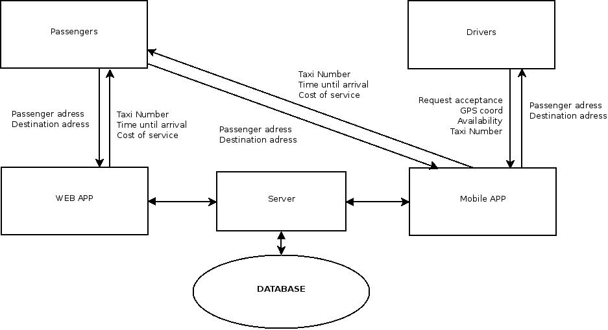

1.2 Goals
Goals of the first usable release:
- Customers can access the database either via web or mobile app;
- Drivers interact with database only via application;
- For each customer a fair schedule and current state of system load is provided;
- The interaction between driver and customer is absent;
- Automatic fetching and updating of GPS coordinates;
- Payment should be accepted via credit card, paypal or even bitcoin.

1.3 Domain Properties
- When user asks for taxi he must enter a desired destination;
- Every driver in selected radius would receive a notification about new client, but only one driver would be able to accept the order;
- The order can not be cancelled once driver accepted it;
- The radius should increase if there are no drivers in the given radius, and the client should receive a notification about possible delay with additional confirmation;
- Price of the ride should be estimated using traffic load provider;
- Price should have fixed minimal margin for each retrieval and final price depends of conditions of order;
- System should track drivers to ensure they are not choosing wrong or malicious paths to exploit distance in order to gain more profit;
- The service should include extra attendances for extra payment.

1.4 Glossary

Price - nominal amount of money for assumed standard unit of a ride
Tariff - summary standard unit of multiplex of price and class of a car
Cost - total sum of multiplex of price and tariff
Itinerary - path, which customized by the driver
The driver - person, who drives taxi-cars, worker of the service, which provide clients with request of their delivering to the point of destination
The client - person, which is passenger, who sends requests for ordering taxi
The watchdog - automate system which control order requirements and execution
The third party - constantly changing database which influence to prices of orders
Additionals - different things which could be executed
Feedback - opinions, comments, marks and complaints about application’s functioning

1.5 Assumptions
There are few points that are not very clear in the specification document, so we will have to assume something.
We assume that:
There is a well-defined range of itineraries, conditions of trips and depending prices that the taxi service can offer. Prices depends on length of path, class of a car, weather conditions because they influence to level of danger on roads and additional options. Clients define all details by themselves, but some factors can be defined only by default settings and settings, provided by the third party, so the client can’t use taxi without paying, but client can customize necessary details.
For detecting clients and stay connected we assume that users input their cell-phone numbers. Drivers can connect to clients through phone-numbers and the system can identify users.

1.6 Proposed system
We propose the system, consisting of a database, server, an Android™ application and a web interface. Web and Android™ application should provide identical services to the client, while drivers can only interact with Android™ application, since it is required to track them and can be customized and embedded into drivers cars. After the ride clients are welcomed to leave from 0 to 5 stars and comment on the ride, though it is not enforced.

1.7 Identifying Stakeholders
Our “financial” stakeholder is the owner of this transport company who gave us task to create this project to automate the system, to reduce amount of workers, to avoid frequent mistakes as result of human factor. Our boss needs are to have, within the end of the semester, a product that at least works and we think the main thing that interests the boss is to show that we have understood the development process in all its parts and that we can carry out a project from the beginning to the end passing from all its development phases.
So we want to show that we can identify requirements and specifications, design our web and mobile applications, implement it and then test it, providing all the documents that developers use in developing real software.
It still remains that we have to focus on some functionalities that the boss gave us to have applications that works.
We think that our typical client will be an occasional one, because our platform is intended to work this way. Once a user finds help it is very probable that he will not use the platform until he needs help another time (and this doesn’t happen every day).

1.8 Other considerations
We view our system as a “KISS”-type of system. Both mobile and web apps should work immediately, and be accessible and fast. So, our main goals to provide such an experience for our users are:
- We should not force or even prompt our users to register in the service - once a new device is connected we should associate it with a new or previously recognised user, so the customer would be able to order a taxi immediately after starting the app.
- The interface should be minimalistic and with as less buttons as possible.

2. Actors Identifying
There are 4 actors in our system, with each of them holding a unique role:

The client
is the person who wants to order a taxi. We always assume that whoever has opened a website or the mobile application is the client. The client is always prompted to make an order.

The driver
is the person who registered as a driver in our system. Upon doing so his number is elevated from client, and necessary data, like legal name or car model and number are assigned. Driver receives orders, and constantly reports his location.

The watchdog
is not a person, but an intelligent algorithm which keeps track of all the drivers and clients, spreads orders, and estimates order costs.

The third party
is the collection of third-party services, providing the watchdog with such information as traffic load, weather conditions, etc.

3. Requirements
Assuming that the domain properties, written in paragraph 1.3, holds, from the goals, written in paragraph 1.2, we can derive our requirements. We write below, for each goal, what we can derive:
1. Inserting of a person to the system:
- The system has to provide a signup functionality by cell-phone number;
- The system create new row in database with cell-phone number of a person and his orders.
2. Ordering a ride:
- The system accept inserting required data about departure and destination points and tariff;
- The system will search for drivers by GPS-navigators within default minimal radius;
- In case of lack of free drivers the system will increase the radius step by step until the driver would not be found;
- The system will notify the client about accepting order.
3. Executing an order:
- The driver takes the client and drive him;
- The system watches executing order.
4. Executing payment for an order:
- The client make payment by card or by special application;
- The driver accepts order by his application;
- The database of the system confirms execution of transaction.

3.1 Functional Requirements
Now that we have defined the main feature of RASD-Taxi, we can find some
functional requirement concerning each defined actor:

The client can:
- make an order
- reject the order
- choose conditions of the trip from offered and fix-priced list
- send feedback

The driver can:
- accept the order in case of accessibility of the client
- execute the order, transferring the client, following the order
- establish the price after arrival to the point of destination, following the conditions of the order and financial policy

The watchdog can:
- watch the executions of orders and acceptance the rules of clients
- solve the problems in case of misunderstanding, criminal, etc
- keep count of busy and free drivers
- keep count of bank account of the system
- estimate financial policy of campaign

The third-party:
- providing the system with environmental conditions
- notifying the watchdog about current changes

3.2 Non-functional Requirements
3.2.1 User Interface
The interface of our application is thought to be used via web and mobile applications.

We want to provide three sketches of the pages we consider the most important.

The first is the HOME page, where the user can see the information about our service and immediately click the button to make an order

The second is the ORDER page, where the client can watch the details of his order and reject the order in case of dissatisfactory

The third is the PATH page, where the driver can construct the itinerary to the client and to the point of destination and watch the details of order

As we seem ORDER and PATH pages are entangled between themselves

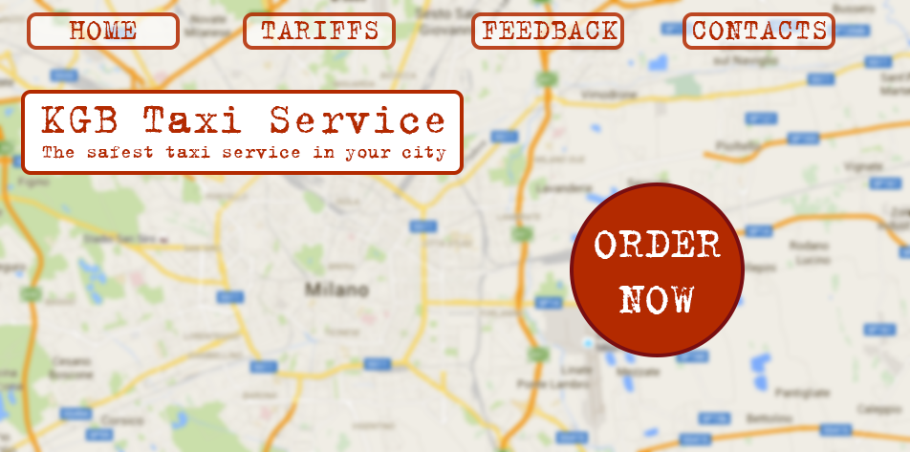
Pic.1 HOME page
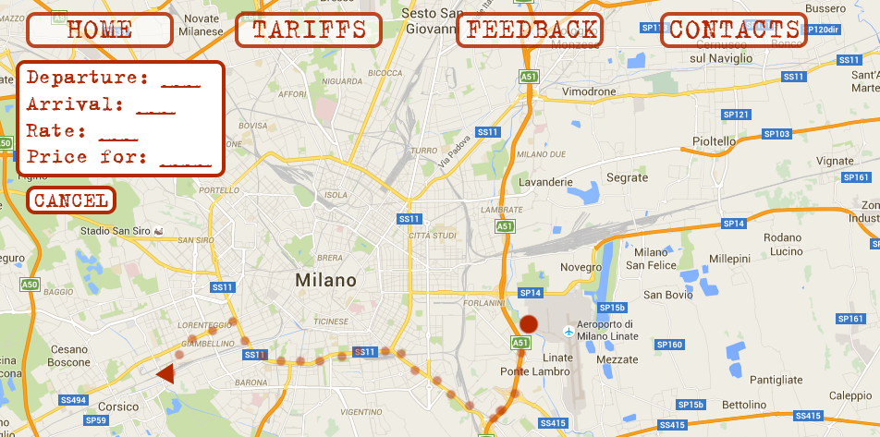
Pic.2 ORDER page

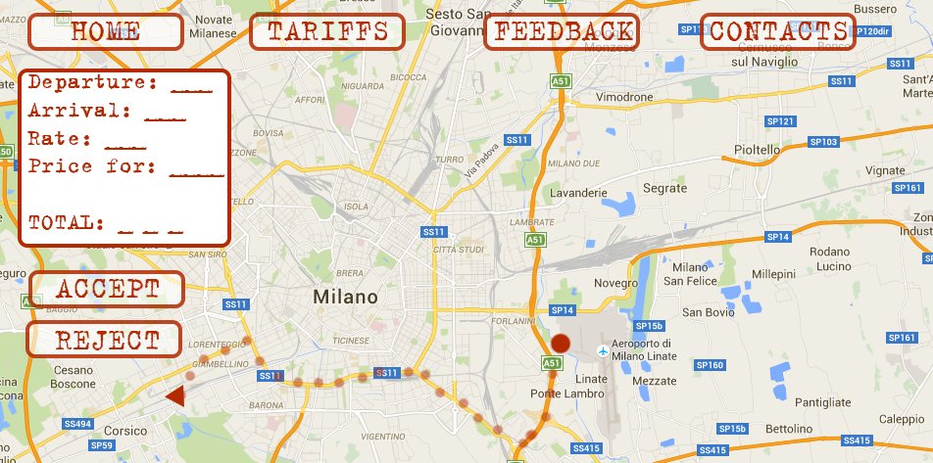
Pic.3 PATH page

3.2.2. Documentation
We will release the following documents in order to organize our work in each
phase of the development process and keep in touch with the stakeholders.
• RASD, Requirement Analysis and Specification Document, which defines
our goals and assumptions and contains an overall description of the
system (using scenarios and use-cases) and the models describing
requirements and specifications.
• DD, Design Document, which contains a functional description of the
system using models such as UML diagrams.
• Installation manual, which explains how to deploy the web and mobile application.
• User manual for clients, which explains how to use the main functionalities of
applications.
• User manual for drivers, which explains how to use the main functionalities of
mobile application for drivers
• Testing report, which contains the results of the testing activity performed
on a system developed by another group.
• Project reporting, which is the result of some analysis done on the project
activity.

4. Specification
We have written down some specifications for KGB Taxi Service that will state clearer how we can reach the goals listed above:

5. Scenarios Identifying
Here are some possible scenarios of KGB Taxi working process
- Lucia decides to make a ride from San Cristoforo to Linate Airport. She looks for the cheapest way to get to Linate because usually rides to airports are rather expensive. She googles for services and among voices finds our web application. Lucia thinks that service enough user-friendly, suitable because of differentiate financial policy and card-payment (no more worries about changes). She clicks for ordering taxi, chooses the type of tariff and may be extra additionals, gets the information about departure time and conditionals which can influence on final cost, and waits for the driver.
- The service gets requirement. Third party sends the circumstances, determining the price (in our case roads are perfectly clear of traffic jams, so price depends only on the distance between departure and destination points). The system executes algorithm of searching the closest for departure point driver and sends him the offer with the details of the order. Concurrently, watchdog carries out his duties, enter corrections if it necessary and keep watching right execution of the order.
- The driver gets offer, accepts it or not, according to his abilities, plans the itinerary and goes to the client, takes him and carries the order. At the destination point the driver takes the payment by card using mobile application to confirm the cost.
- The client makes the payment and finishes the order. According to his wishes client send positive response to application

6. UML Class diagram

6.1 Use Case Diagram
We can derive some use cases from the scenarios identified in the previous paragraph:
- Require for a ride
- Inserting the client into database
- Searching suitable driver
- Establishment connect between client and driver
- Establishment optimal itinerary and cost of ride
- Transferring money from client account to system account
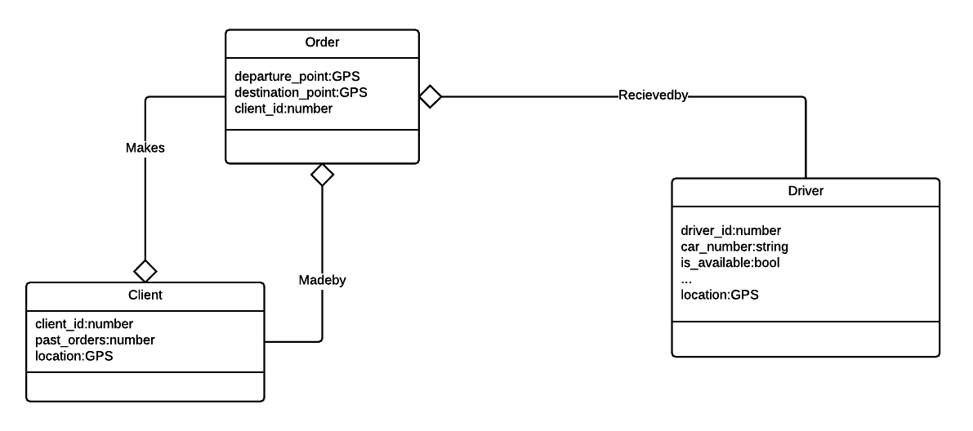

Ordering taxi
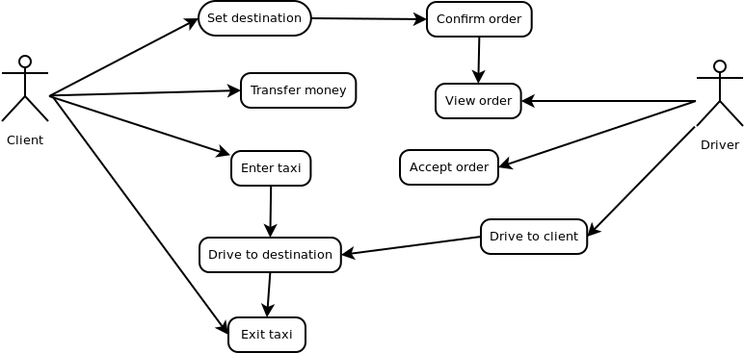
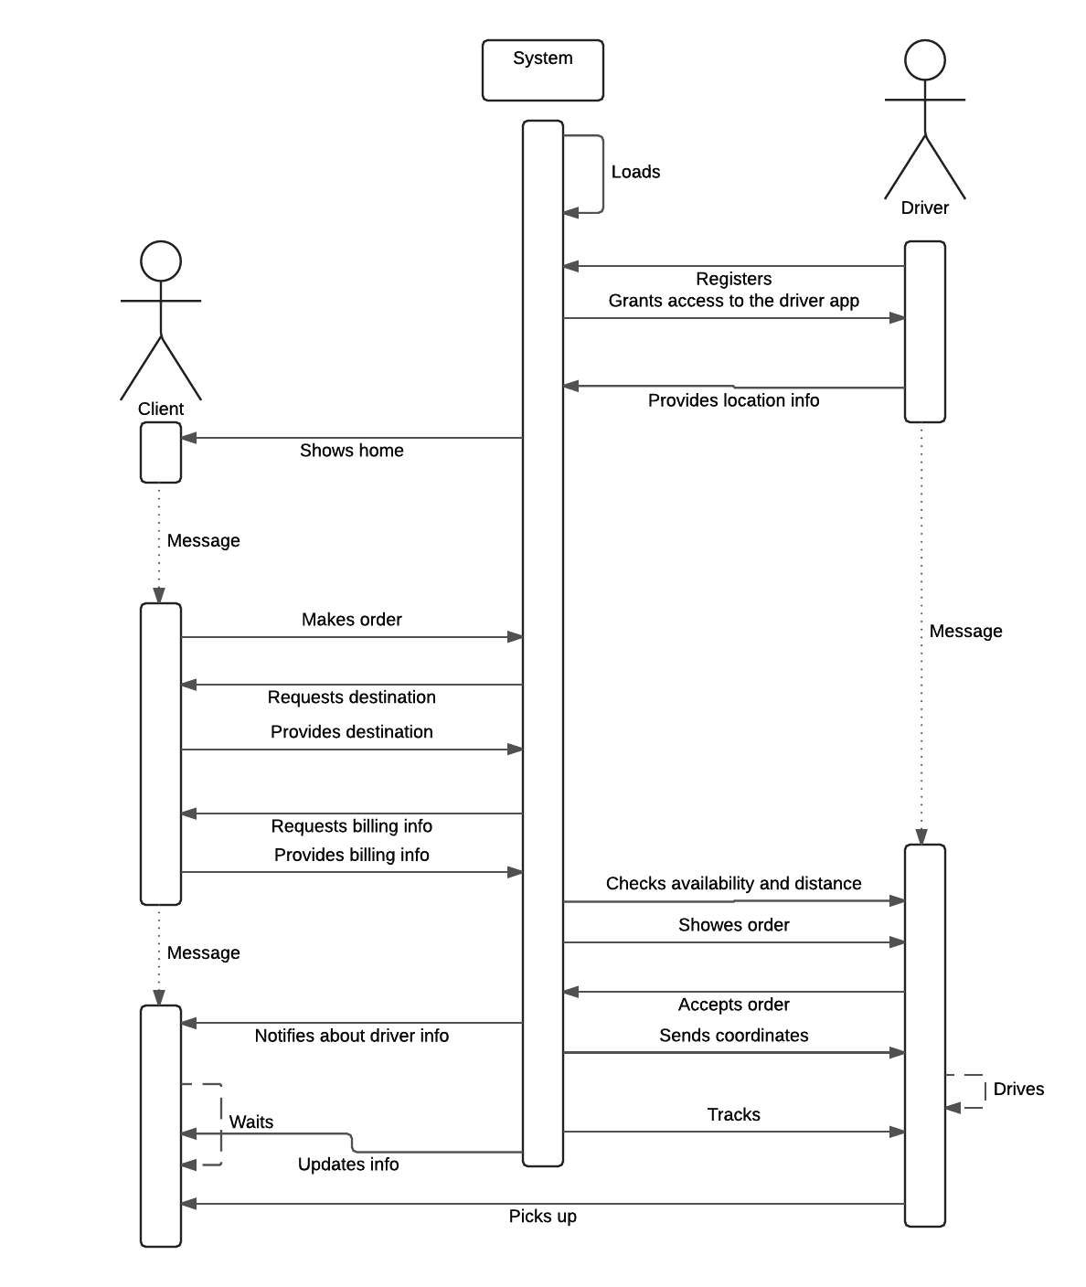

X. Visual interface prototyping
