Task 13: Dockerfile and Docker Compose Stack
Streetlight Fault Reporter
Repository | https://github.com/KGD2417/DevOpsProject
Project | Streetlight Fault Reporter
Task / status | TS-13 — Implemented in source; containers not started for these reports
Branch / baseline | main / 8b80b70
Visibility | Public

1. Deliverables
Deliverable | Repository evidence
Dockerfile | src/main/docker/Dockerfile
docker-compose.yml | docker-compose.yml
docker-compose.test.yml | docker-compose.test.yml
default.conf | nginx/default.conf
deployment-guide.md | docs/deployment-guide.md
Verification note | Acceptance is reported as source review, not a fresh test result.

2. Task Scope and Source Evidence
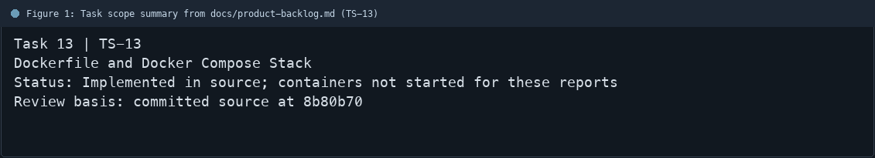
Figure 1: Task scope summary from docs/product-backlog.md (TS-13)

3. Repository Structure
Path | Task relevance
src/main/docker/Dockerfile | Implementation or documentation evidence for this task
docker-compose.yml | Implementation or documentation evidence for this task
docker-compose.test.yml | Implementation or documentation evidence for this task
nginx/default.conf | Implementation or documentation evidence for this task
docs/deployment-guide.md | Implementation or documentation evidence for this task
Review note | Dockerfile uses Maven/Temurin 21 for build and Temurin JRE for runtime.
Review note | The final image runs with appuser.
Review note | Compose files define app and MySQL services; the main stack also uses Nginx.
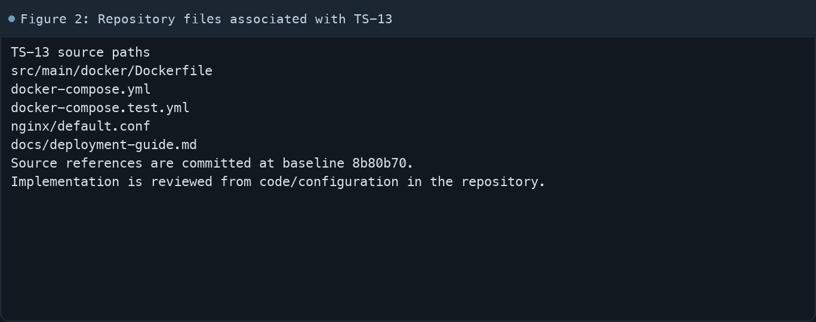
Figure 2: Repository files associated with TS-13

4. Implementation Review
Work area | Finding
Model/configuration | Dockerfile uses Maven/Temurin 21 for build and Temurin JRE for runtime.
Application behavior | The final image runs with appuser.
Persistence/integration | Compose files define app and MySQL services; the main stack also uses Nginx.
Security/validation | Actuator health endpoint is used by container checks.
Evidence review | No containers were started during creation of these documentation files.
Review scope | No fresh tests were run for this report.
Evidence and status
- Committed source baseline: 8b80b70.
- Paths above identify the reviewed implementation and configuration.
- Status distinguishes source presence from a fresh run.
- No tests or deployment commands were rerun for this document.
- Next: Run docker compose up --build -d and verify service health and port mappings.

5. Acceptance Checkpoints
# | Review result | Acceptance checkpoint
1 | Source present | Multi-stage Dockerfile builds the application
2 | Not rerun | Runtime image uses a non-root user
3 | Source present | Compose includes app, MySQL, and Nginx
4 | Source present | Health checks are configured
5 | Source present | Test Compose stack is isolated from development
6 | Not rerun | Fresh container health checks
7 | Not rerun | Fresh targeted verification result is recorded
Review basis: committed source at 8b80b70, backlog TS-1–TS-15, and existing project documentation. No tests were rerun for this report.
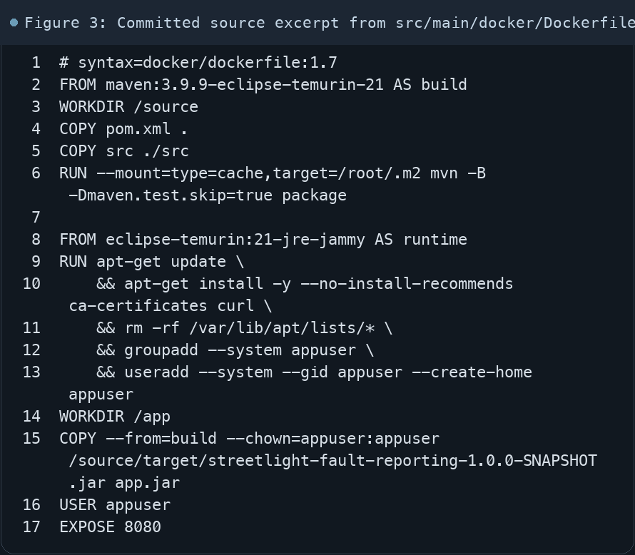
Figure 3: Committed source excerpt from src/main/docker/Dockerfile
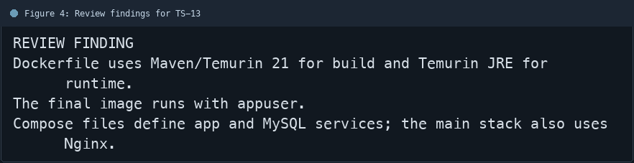
Figure 4: Review findings for TS-13
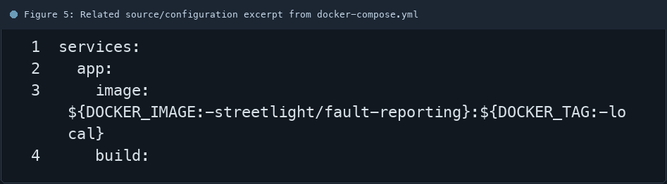
Figure 5: Related source/configuration excerpt from docker-compose.yml
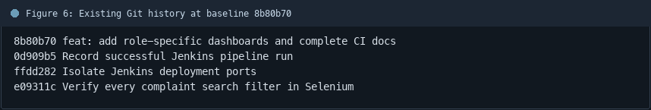
Figure 6: Existing Git history at baseline 8b80b70

6. Follow-up Items
# | Open item | Action | State
1 | Runtime proof | Start Compose stack | Pending
2 | Service readiness | Check health endpoint | Pending
3 | Stack cleanup | Stop stack safely | Pending
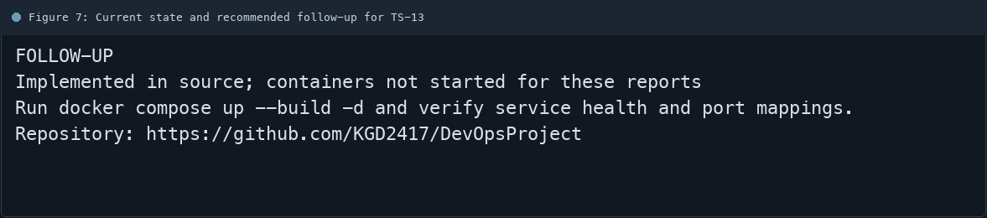
Figure 7: Current state and recommended follow-up for TS-13

