Task 8: Web Controllers, Role Dashboards, and Complaint Views
Streetlight Fault Reporter
Repository | https://github.com/KGD2417/DevOpsProject
Project | Streetlight Fault Reporter
Task / status | TS-8 — Implemented in source; UI journeys not rerun for these reports
Branch / baseline | main / 8b80b70
Visibility | Public

1. Deliverables
Deliverable | Repository evidence
ComplaintController.java | src/main/java/com/streetlight/controller/ComplaintController.java
DashboardController.java | src/main/java/com/streetlight/controller/DashboardController.java
dashboard.html | src/main/resources/templates/citizen/dashboard.html
dashboard.html | src/main/resources/templates/technician/dashboard.html
dashboard.html | src/main/resources/templates/admin/dashboard.html
detail.html | src/main/resources/templates/complaints/detail.html

2. Task Scope and Source Evidence
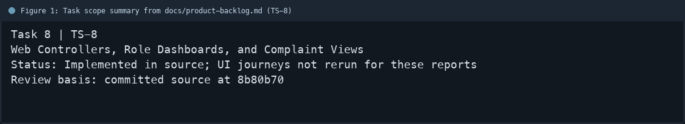
Figure 1: Task scope summary from docs/product-backlog.md (TS-8)

3. Repository Structure
Path | Task relevance
src/main/java/com/streetlight/controller/ComplaintController.java | Implementation or documentation evidence for this task
src/main/java/com/streetlight/controller/DashboardController.java | Implementation or documentation evidence for this task
src/main/resources/templates/citizen/dashboard.html | Implementation or documentation evidence for this task
src/main/resources/templates/technician/dashboard.html | Implementation or documentation evidence for this task
src/main/resources/templates/admin/dashboard.html | Implementation or documentation evidence for this task
src/main/resources/templates/complaints/detail.html | Implementation or documentation evidence for this task
Review note | DashboardController selects citizen, technician, or admin dashboard content.
Review note | ComplaintController supports list, detail, creation, assignment, status update, and reopen acti
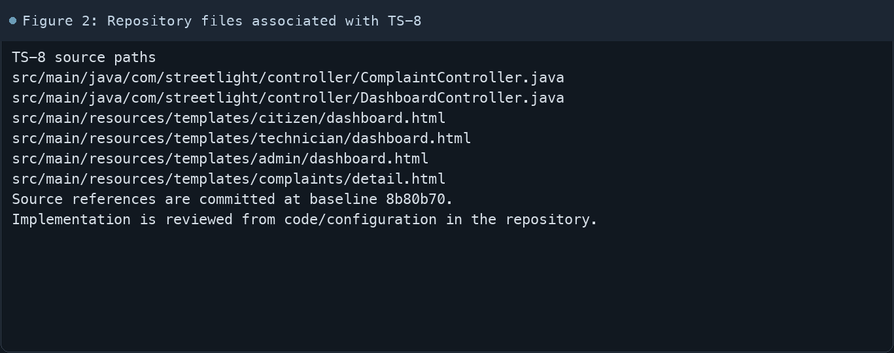
Figure 2: Repository files associated with TS-8

4. Implementation Review
Work area | Finding
Model/configuration | DashboardController selects citizen, technician, or admin dashboard content.
Application behavior | ComplaintController supports list, detail, creation, assignment, status update, and reopen actions.
Persistence/integration | Thymeleaf templates are separated by role and feature.
Security/validation | Complaint detail includes reported information and status history.
Evidence review | Server-side authorization remains the security boundary.
Review scope | No fresh tests were run for this report.
Evidence and status
- Committed source baseline: 8b80b70.
- Paths above identify the reviewed implementation and configuration.
- Status distinguishes source presence from a fresh run.
- No tests or deployment commands were rerun for this document.
- Next: Start the app and manually walk all three dashboard-to-complaint flows.

5. Acceptance Checkpoints
# | Review result | Acceptance checkpoint
1 | Source present | Dashboard routes select a role-specific view
2 | Source present | Citizen can submit and view own complaints
3 | Source present | Technician view shows assigned work
4 | Source present | Admin view exposes complaint management
5 | Source present | Complaint details display status and history
6 | Not rerun | Fresh UI review
7 | Not rerun | Fresh targeted verification result is recorded
Review basis: committed source at 8b80b70, backlog TS-1–TS-15, and existing project documentation. No tests were rerun for this report.
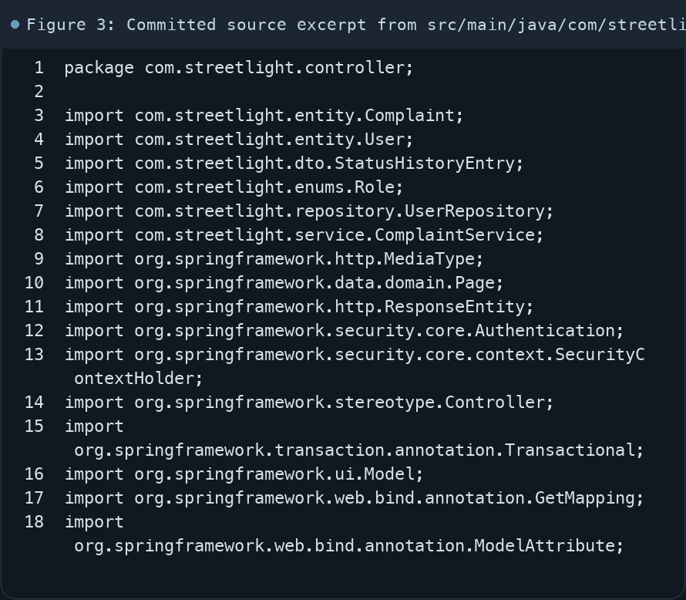
Figure 3: Committed source excerpt from src/main/java/com/streetlight/controller/ComplaintController.java
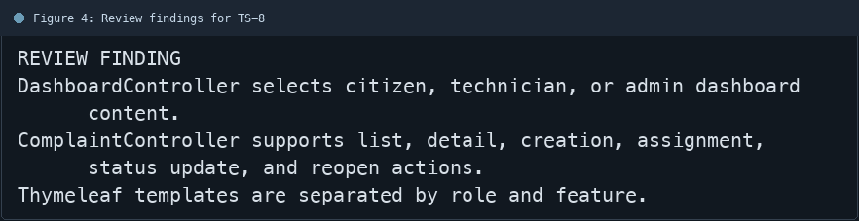
Figure 4: Review findings for TS-8
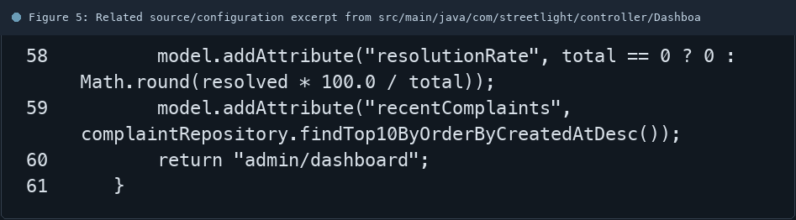
Figure 5: Related source/configuration excerpt from src/main/java/com/streetlight/controller/DashboardController.java
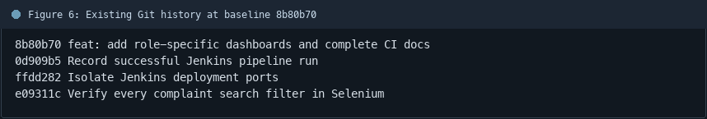
Figure 6: Existing Git history at baseline 8b80b70

6. Follow-up Items
# | Open item | Action | State
1 | Fresh automated check | Run targeted check | Pending
2 | CI evidence | Attach current report | Pending
3 | Task-specific review | Complete follow-up | Pending
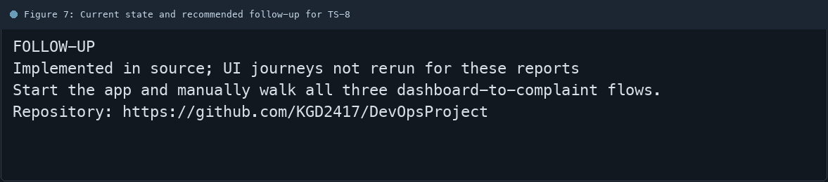
Figure 7: Current state and recommended follow-up for TS-8

