Task 9: Role-Based Actions in Thymeleaf Templates
Streetlight Fault Reporter
Repository | https://github.com/KGD2417/DevOpsProject
Project | Streetlight Fault Reporter
Task / status | TS-9 — Implemented in source; template authorization not rerun for these reports
Branch / baseline | main / 8b80b70
Visibility | Public

1. Deliverables
Deliverable | Repository evidence
base.html | src/main/resources/templates/base.html
detail.html | src/main/resources/templates/complaints/detail.html
list.html | src/main/resources/templates/complaints/list.html
dashboard.html | src/main/resources/templates/admin/dashboard.html
Scope note | Implementation evidence is listed in the next section.
Verification note | Acceptance is reported as source review, not a fresh test result.

2. Task Scope and Source Evidence
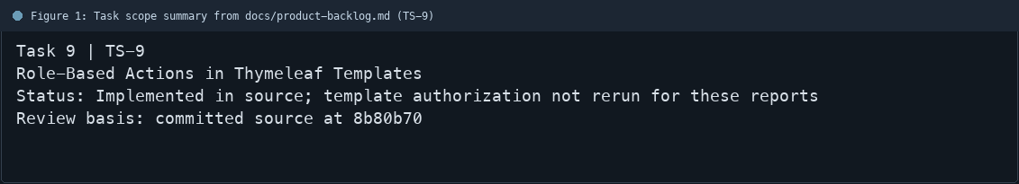
Figure 1: Task scope summary from docs/product-backlog.md (TS-9)

3. Repository Structure
Path | Task relevance
src/main/resources/templates/base.html | Implementation or documentation evidence for this task
src/main/resources/templates/complaints/detail.html | Implementation or documentation evidence for this task
src/main/resources/templates/complaints/list.html | Implementation or documentation evidence for this task
src/main/resources/templates/admin/dashboard.html | Implementation or documentation evidence for this task
Review note | The shared layout includes authenticated-user navigation.
Review note | Complaint views conditionally render staff actions based on the current role.
Review note | The admin dashboard contains management-oriented summary and controls.
Review note | Template visibility improves the UI but is not treated as an authorization control.
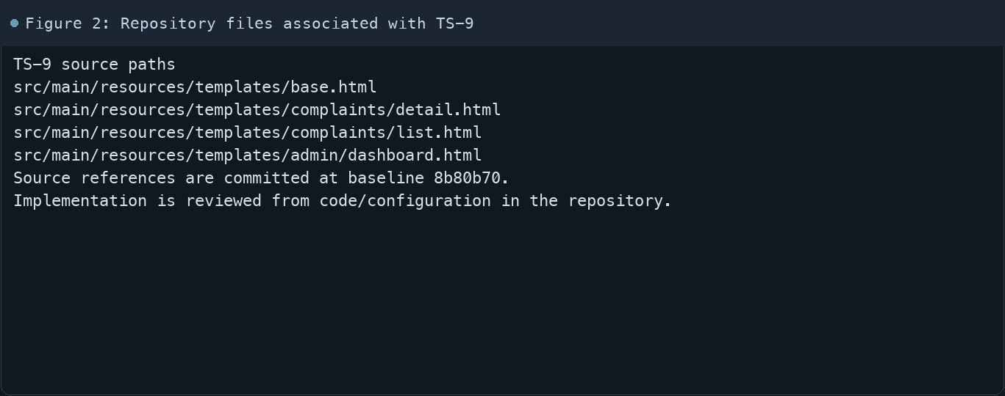
Figure 2: Repository files associated with TS-9

4. Implementation Review
Work area | Finding
Model/configuration | The shared layout includes authenticated-user navigation.
Application behavior | Complaint views conditionally render staff actions based on the current role.
Persistence/integration | The admin dashboard contains management-oriented summary and controls.
Security/validation | Template visibility improves the UI but is not treated as an authorization control.
Evidence review | SecurityConfiguration and controller checks protect the underlying requests.
Review scope | No fresh tests were run for this report.
Evidence and status
- Committed source baseline: 8b80b70.
- Paths above identify the reviewed implementation and configuration.
- Status distinguishes source presence from a fresh run.
- No tests or deployment commands were rerun for this document.
- Next: Compare rendered citizen, technician, and admin views after a fresh login for each role.

5. Acceptance Checkpoints
# | Review result | Acceptance checkpoint
1 | Source present | Role-specific navigation is present
2 | Source present | Admin-only assignment action is conditional
3 | Source present | Technician status action is conditional
4 | Source present | Citizen cannot see staff workflow controls
5 | Source present | Server-side endpoint authorization remains active
6 | Not rerun | Fresh role-view review
7 | Not rerun | Fresh targeted verification result is recorded
Review basis: committed source at 8b80b70, backlog TS-1–TS-15, and existing project documentation. No tests were rerun for this report.
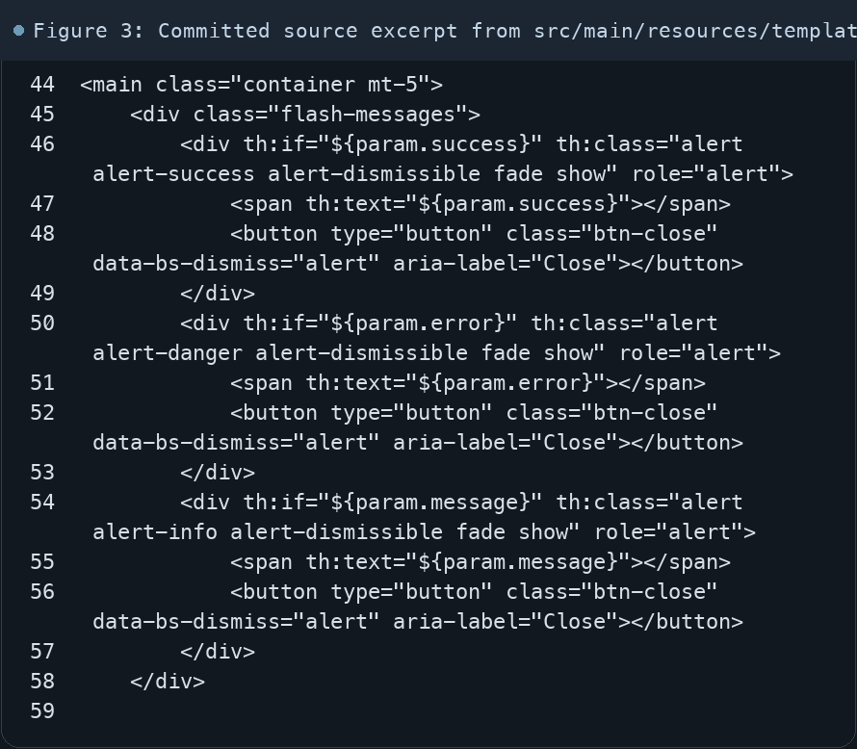
Figure 3: Committed source excerpt from src/main/resources/templates/base.html
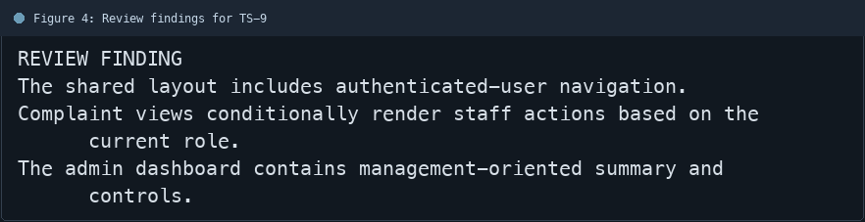
Figure 4: Review findings for TS-9
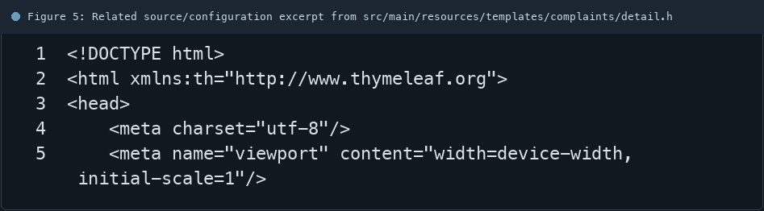
Figure 5: Related source/configuration excerpt from src/main/resources/templates/complaints/detail.html
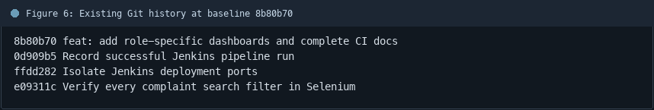
Figure 6: Existing Git history at baseline 8b80b70

6. Follow-up Items
# | Open item | Action | State
1 | Fresh automated check | Run targeted check | Pending
2 | CI evidence | Attach current report | Pending
3 | Task-specific review | Complete follow-up | Pending
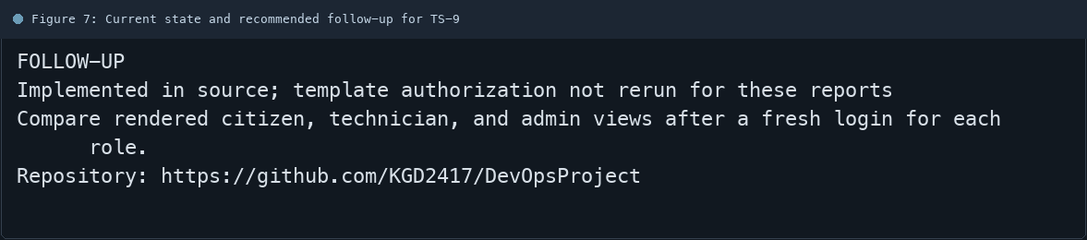
Figure 7: Current state and recommended follow-up for TS-9

