Task 5: Complaint Status History Audit Trail
Streetlight Fault Reporter
Repository | https://github.com/KGD2417/DevOpsProject
Project | Streetlight Fault Reporter
Task / status | TS-5 — Implemented in source; audit journey not rerun for these reports
Branch / baseline | main / 8b80b70
Visibility | Public

1. Deliverables
Deliverable | Repository evidence
StatusHistory.java | src/main/java/com/streetlight/entity/StatusHistory.java
StatusHistoryRepository.java | src/main/java/com/streetlight/repository/StatusHistoryRepository.java
StatusHistoryEntry.java | src/main/java/com/streetlight/dto/StatusHistoryEntry.java
ComplaintService.java | src/main/java/com/streetlight/service/ComplaintService.java
Scope note | Implementation evidence is listed in the next section.
Verification note | Acceptance is reported as source review, not a fresh test result.

2. Task Scope and Source Evidence
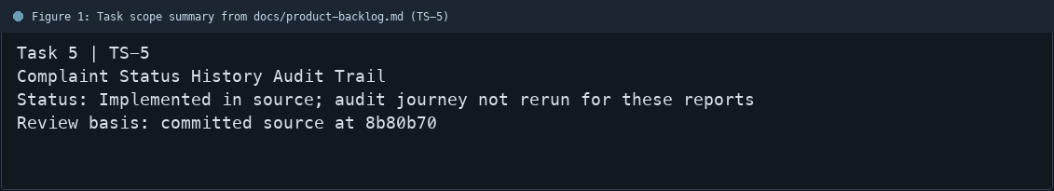
Figure 1: Task scope summary from docs/product-backlog.md (TS-5)

3. Repository Structure
Path | Task relevance
src/main/java/com/streetlight/entity/StatusHistory.java | Implementation or documentation evidence for this task
src/main/java/com/streetlight/repository/StatusHistoryRepository.java | Implementation or documentation evidence for this task
src/main/java/com/streetlight/dto/StatusHistoryEntry.java | Implementation or documentation evidence for this task
src/main/java/com/streetlight/service/ComplaintService.java | Implementation or documentation evidence for this task
Review note | StatusHistory stores a complaint association, previous status, new status, changed-by user, and
Review note | The repository returns status history ordered by changedAt.
Review note | ComplaintService records an initial REPORTED entry at complaint creation.
Review note | ComplaintService records history on valid status changes and on admin reopen.
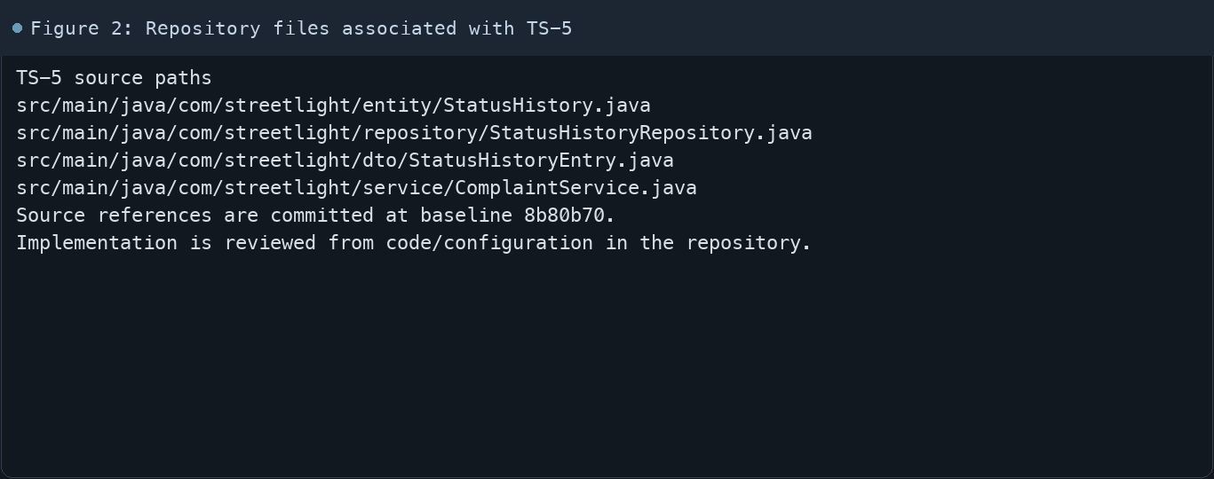
Figure 2: Repository files associated with TS-5

4. Implementation Review
Work area | Finding
Model/configuration | StatusHistory stores a complaint association, previous status, new status, changed-by user, and timestamp.
Application behavior | The repository returns status history ordered by changedAt.
Persistence/integration | ComplaintService records an initial REPORTED entry at complaint creation.
Security/validation | ComplaintService records history on valid status changes and on admin reopen.
Evidence review | The status detail DTO exposes username and timestamps to the view.
Review scope | No fresh tests were run for this report.
Evidence and status
- Committed source baseline: 8b80b70.
- Paths above identify the reviewed implementation and configuration.
- Status distinguishes source presence from a fresh run.
- No tests or deployment commands were rerun for this document.
- Next: Run a full technician transition and confirm entries render on citizen and staff detail views.

5. Acceptance Checkpoints
# | Review result | Acceptance checkpoint
1 | Source present | Status history entity is present
2 | Source present | Previous and new statuses are stored
3 | Source present | Changed-by user is recorded
4 | Source present | Change timestamp is recorded
5 | Source present | History is read in timestamp order
6 | Not rerun | Fresh status-history journey run
7 | Not rerun | Fresh targeted verification result is recorded
Review basis: committed source at 8b80b70, backlog TS-1–TS-15, and existing project documentation. No tests were rerun for this report.
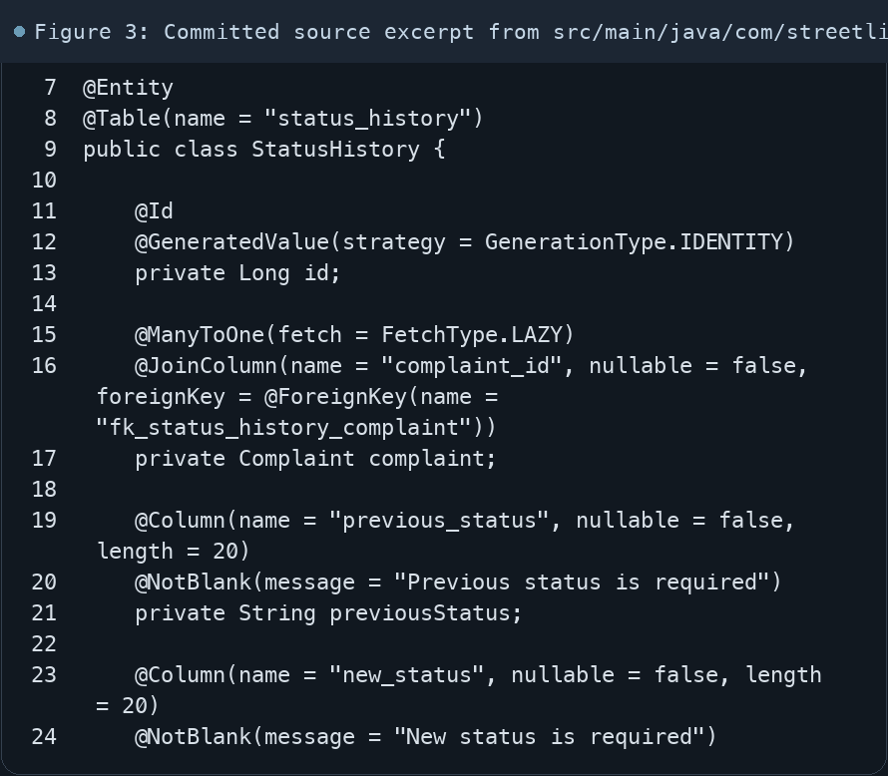
Figure 3: Committed source excerpt from src/main/java/com/streetlight/entity/StatusHistory.java
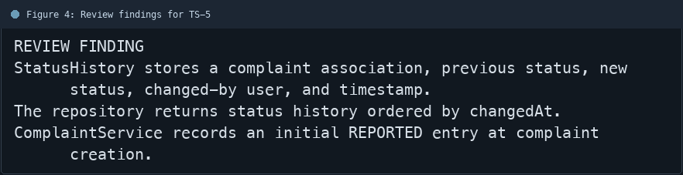
Figure 4: Review findings for TS-5
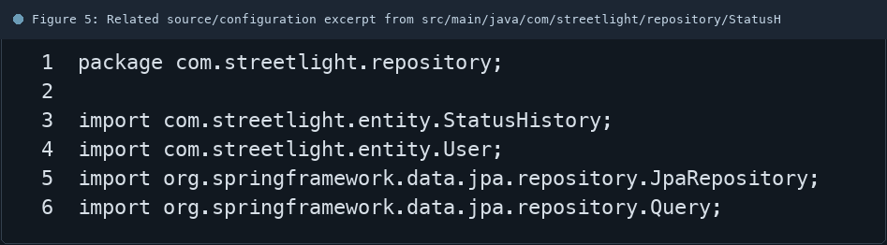
Figure 5: Related source/configuration excerpt from src/main/java/com/streetlight/repository/StatusHistoryRepository.java
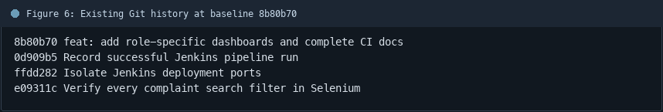
Figure 6: Existing Git history at baseline 8b80b70

6. Follow-up Items
# | Open item | Action | State
1 | Fresh automated check | Run targeted check | Pending
2 | CI evidence | Attach current report | Pending
3 | Task-specific review | Complete follow-up | Pending
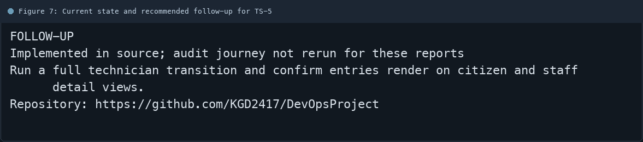
Figure 7: Current state and recommended follow-up for TS-5

