Task 4: Complaint Domain Model and Validation
Streetlight Fault Reporter
Repository | https://github.com/KGD2417/DevOpsProject
Project | Streetlight Fault Reporter
Task / status | TS-4 — Implemented in source; model validation not rerun for these reports
Branch / baseline | main / 8b80b70
Visibility | Public

1. Deliverables
Deliverable | Repository evidence
Complaint.java | src/main/java/com/streetlight/entity/Complaint.java
ComplaintController.java | src/main/java/com/streetlight/controller/ComplaintController.java
Role.java | src/main/java/com/streetlight/enums/Role.java
database-design.md | docs/database-design.md
Scope note | Implementation evidence is listed in the next section.
Verification note | Acceptance is reported as source review, not a fresh test result.

2. Task Scope and Source Evidence
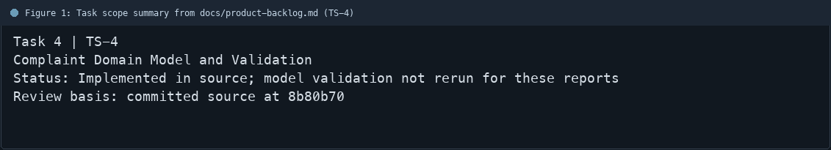
Figure 1: Task scope summary from docs/product-backlog.md (TS-4)

3. Repository Structure
Path | Task relevance
src/main/java/com/streetlight/entity/Complaint.java | Implementation or documentation evidence for this task
src/main/java/com/streetlight/controller/ComplaintController.java | Implementation or documentation evidence for this task
src/main/java/com/streetlight/enums/Role.java | Implementation or documentation evidence for this task
docs/database-design.md | Implementation or documentation evidence for this task
Review note | Complaint holds the complaint ID, reporter ID, assignee, street, ward, category, description, p
Review note | The create endpoint applies Jakarta Bean Validation with @Valid.
Review note | The entity includes created and last-updated timestamps.
Review note | Complaint status history is a separate entity and repository.
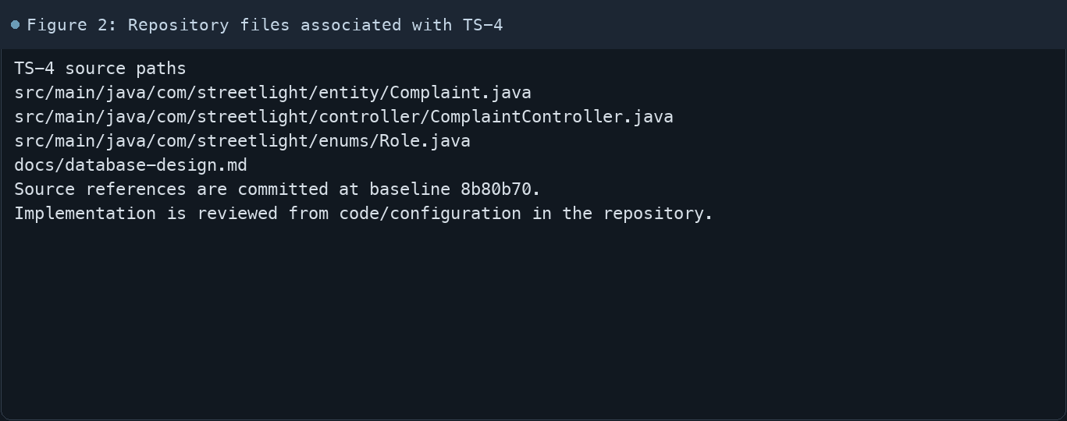
Figure 2: Repository files associated with TS-4

4. Implementation Review
Work area | Finding
Model/configuration | Complaint holds the complaint ID, reporter ID, assignee, street, ward, category, description, priority, status
Application behavior | The create endpoint applies Jakarta Bean Validation with @Valid.
Persistence/integration | The entity includes created and last-updated timestamps.
Security/validation | Complaint status history is a separate entity and repository.
Evidence review | The database design document describes intended persistence relationships.
Review scope | No fresh tests were run for this report.
Evidence and status
- Committed source baseline: 8b80b70.
- Paths above identify the reviewed implementation and configuration.
- Status distinguishes source presence from a fresh run.
- No tests or deployment commands were rerun for this document.
- Next: Review database constraints and submit invalid/valid complaints in a fresh run.

5. Acceptance Checkpoints
# | Review result | Acceptance checkpoint
1 | Source present | Complaint JPA entity is present
2 | Source present | Location and fault fields are modelled
3 | Source present | Priority and workflow status are stored
4 | Source present | Reporter and technician assignment references exist
5 | Source present | Form validation is applied at the controller boundary
6 | Not rerun | Fresh model validation run
7 | Not rerun | Fresh targeted verification result is recorded
Review basis: committed source at 8b80b70, backlog TS-1–TS-15, and existing project documentation. No tests were rerun for this report.
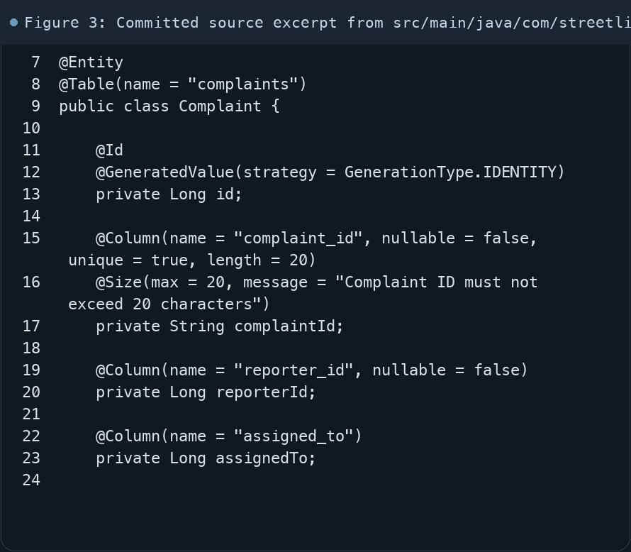
Figure 3: Committed source excerpt from src/main/java/com/streetlight/entity/Complaint.java
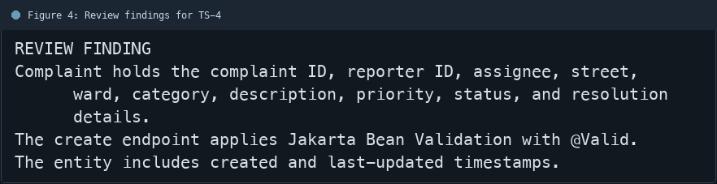
Figure 4: Review findings for TS-4
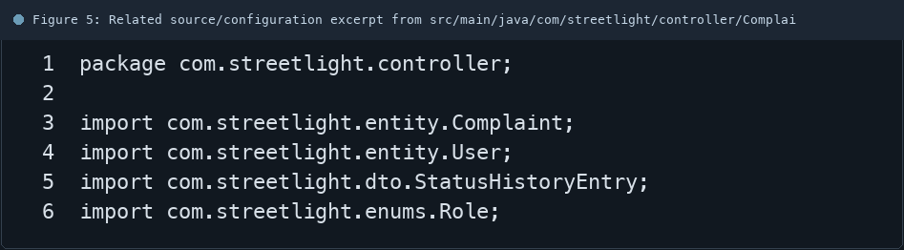
Figure 5: Related source/configuration excerpt from src/main/java/com/streetlight/controller/ComplaintController.java
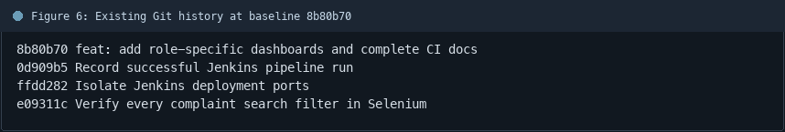
Figure 6: Existing Git history at baseline 8b80b70

6. Follow-up Items
# | Open item | Action | State
1 | Fresh automated check | Run targeted check | Pending
2 | CI evidence | Attach current report | Pending
3 | Task-specific review | Complete follow-up | Pending
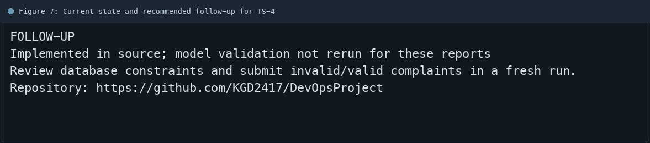
Figure 7: Current state and recommended follow-up for TS-4

