Task 10: Global Exception Handling and User-Friendly Errors
Streetlight Fault Reporter
Repository | https://github.com/KGD2417/DevOpsProject
Project | Streetlight Fault Reporter
Task / status | TS-10 — Gap: global exception handler not found in committed source
Branch / baseline | main / 8b80b70
Visibility | Public

1. Deliverables
Deliverable | Repository evidence
ComplaintController.java | src/main/java/com/streetlight/controller/ComplaintController.java
form.html | src/main/resources/templates/complaints/form.html
base.html | src/main/resources/templates/base.html
troubleshooting.md | docs/troubleshooting.md
Scope note | Implementation evidence is listed in the next section.
Verification note | Acceptance is reported as source review, not a fresh test result.

2. Task Scope and Source Evidence
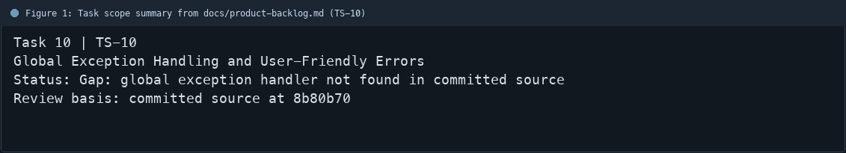
Figure 1: Task scope summary from docs/product-backlog.md (TS-10)

3. Repository Structure
Path | Task relevance
src/main/java/com/streetlight/controller/ComplaintController.java | Implementation or documentation evidence for this task
src/main/resources/templates/complaints/form.html | Implementation or documentation evidence for this task
src/main/resources/templates/base.html | Implementation or documentation evidence for this task
docs/troubleshooting.md | Implementation or documentation evidence for this task
Review note | No @ControllerAdvice or @ExceptionHandler class was found in the committed Java sources during
Review note | Complaint form validation uses BindingResult and can render field-level errors.
Review note | ComplaintService currently raises RuntimeException for not-found and workflow errors.
Review note | The global error page/handler acceptance criteria are not complete in this source revision.
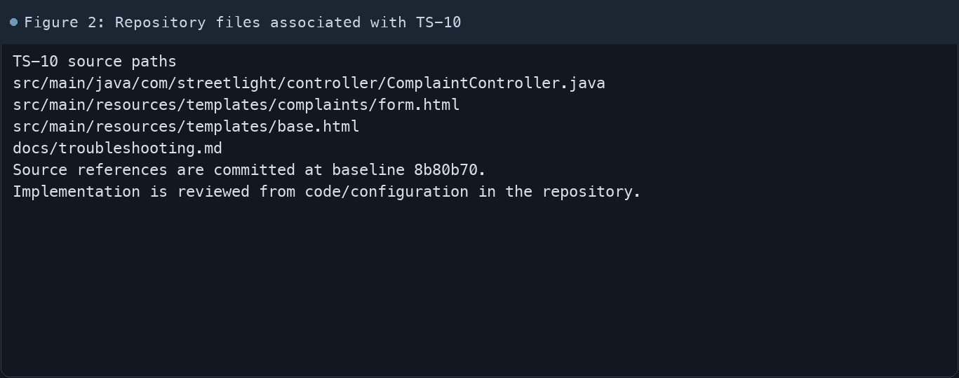
Figure 2: Repository files associated with TS-10

4. Implementation Review
Work area | Finding
Model/configuration | No @ControllerAdvice or @ExceptionHandler class was found in the committed Java sources during this review.
Application behavior | Complaint form validation uses BindingResult and can render field-level errors.
Persistence/integration | ComplaintService currently raises RuntimeException for not-found and workflow errors.
Security/validation | The global error page/handler acceptance criteria are not complete in this source revision.
Evidence review | This report records the gap; it does not claim the task is complete.
Review scope | No fresh tests were run for this report.
Evidence and status
- Committed source baseline: 8b80b70.
- Paths above identify the reviewed implementation and configuration.
- Status distinguishes source presence from a fresh run.
- No tests or deployment commands were rerun for this document.
- Next: Implement @ControllerAdvice/@ExceptionHandler, map domain errors, and add not-found/error templates.

5. Acceptance Checkpoints
# | Review result | Acceptance checkpoint
1 | Gap | A @ControllerAdvice class exists
2 | Gap | Validation failures map to useful messages
3 | Gap | Missing complaint maps to a not-found view
4 | Gap | Invalid transition maps to a safe user-facing message
5 | Gap | Error pages avoid stack-trace disclosure
6 | Not rerun | Fresh error-path tests
7 | Not rerun | Fresh targeted verification result is recorded
Review basis: committed source at 8b80b70, backlog TS-1–TS-15, and existing project documentation. No tests were rerun for this report.
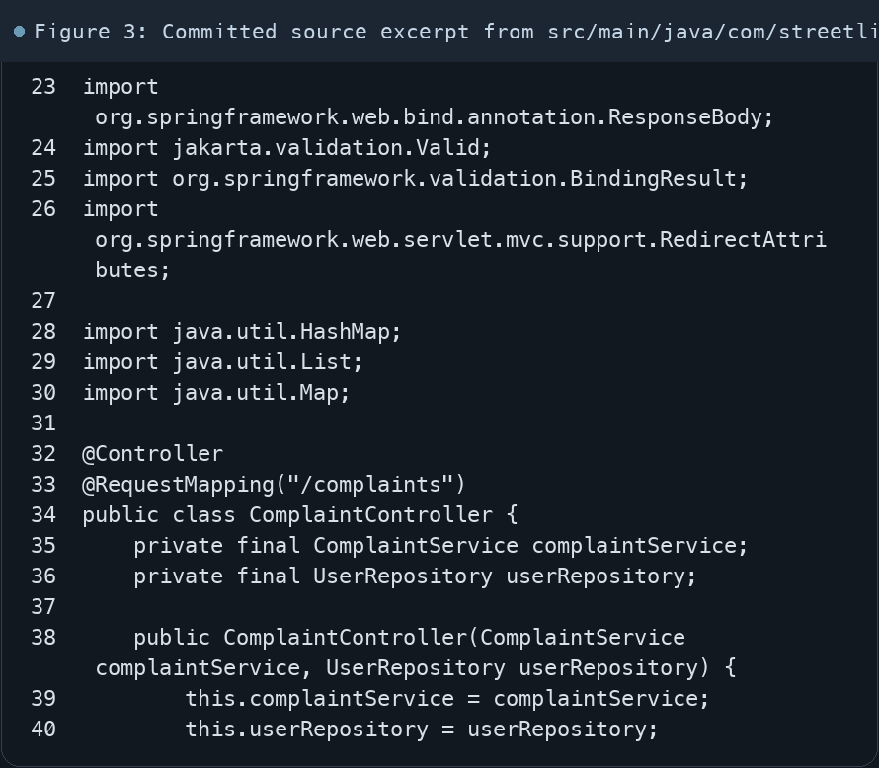
Figure 3: Committed source excerpt from src/main/java/com/streetlight/controller/ComplaintController.java
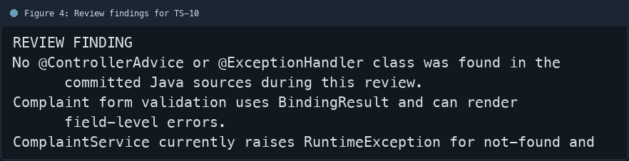
Figure 4: Review findings for TS-10
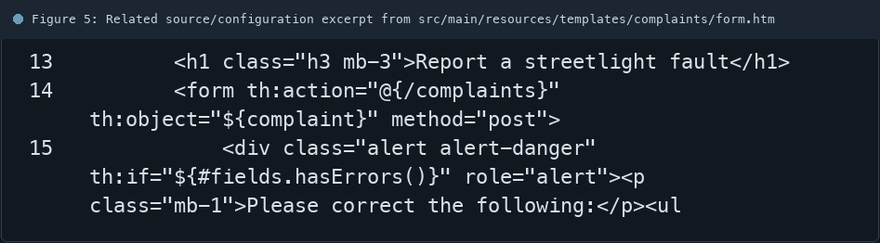
Figure 5: Related source/configuration excerpt from src/main/resources/templates/complaints/form.html
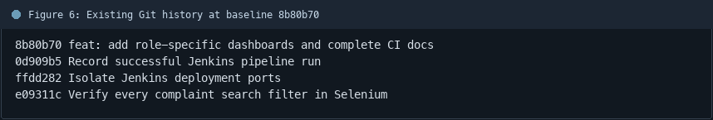
Figure 6: Existing Git history at baseline 8b80b70

6. Follow-up Items
# | Open item | Action | State
1 | Global handler missing | Add advice and error views | Open
2 | RuntimeException domain errors | Map to user-safe responses | Open
3 | Error-path coverage | Add handler tests | Open
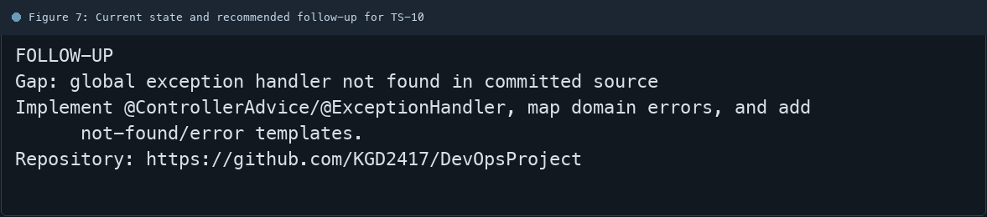
Figure 7: Current state and recommended follow-up for TS-10

