Task 2: Spring Security Role Authorization
Streetlight Fault Reporter
Repository | https://github.com/KGD2417/DevOpsProject
Project | Streetlight Fault Reporter
Task / status | TS-2 — Implemented in source; security tests not rerun for these reports
Branch / baseline | main / 8b80b70
Visibility | Public

1. Deliverables
Deliverable | Repository evidence
SecurityConfiguration.java | src/main/java/com/streetlight/config/SecurityConfiguration.java
AuthController.java | src/main/java/com/streetlight/controller/AuthController.java
Role.java | src/main/java/com/streetlight/enums/Role.java
login.html | src/main/resources/templates/auth/login.html
Scope note | Implementation evidence is listed in the next section.
Verification note | Acceptance is reported as source review, not a fresh test result.

2. Task Scope and Source Evidence
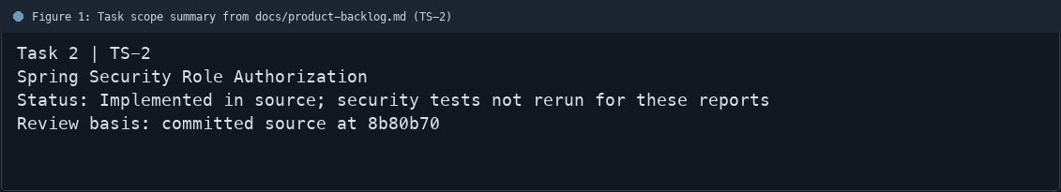
Figure 1: Task scope summary from docs/product-backlog.md (TS-2)

3. Repository Structure
Path | Task relevance
src/main/java/com/streetlight/config/SecurityConfiguration.java | Implementation or documentation evidence for this task
src/main/java/com/streetlight/controller/AuthController.java | Implementation or documentation evidence for this task
src/main/java/com/streetlight/enums/Role.java | Implementation or documentation evidence for this task
src/main/resources/templates/auth/login.html | Implementation or documentation evidence for this task
Review note | SecurityConfiguration declares a BCrypt PasswordEncoder.
Review note | Spring Security form login uses the login page and redirects to /dashboard.
Review note | Assignment and reopen POST routes require ADMIN.
Review note | Status update POST requires TECHNICIAN or ADMIN.
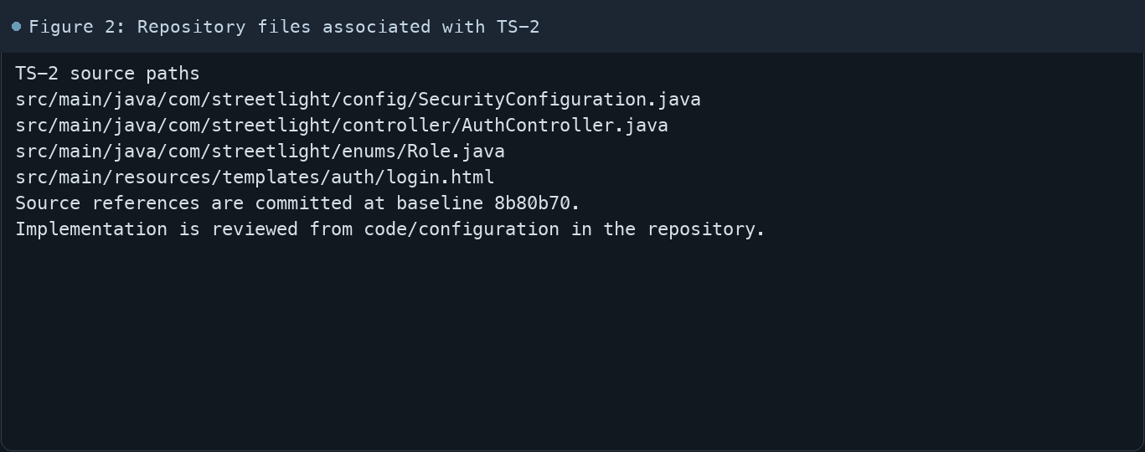
Figure 2: Repository files associated with TS-2

4. Implementation Review
Work area | Finding
Model/configuration | SecurityConfiguration declares a BCrypt PasswordEncoder.
Application behavior | Spring Security form login uses the login page and redirects to /dashboard.
Persistence/integration | Assignment and reopen POST routes require ADMIN.
Security/validation | Status update POST requires TECHNICIAN or ADMIN.
Evidence review | Other routes require authentication; finer access is also enforced by application logic.
Review scope | No fresh tests were run for this report.
Evidence and status
- Committed source baseline: 8b80b70.
- Paths above identify the reviewed implementation and configuration.
- Status distinguishes source presence from a fresh run.
- No tests or deployment commands were rerun for this document.
- Next: Run the security and Selenium role-restriction checks on the current revision.

5. Acceptance Checkpoints
# | Review result | Acceptance checkpoint
1 | Source present | Form login route and logout flow are configured
2 | Source present | BCrypt password encoder is registered
3 | Source present | ADMIN-only assignment and reopen endpoints are protected
4 | Source present | Technician/admin status endpoint is role-gated
5 | Source present | Unauthenticated requests are restricted
6 | Not rerun | Fresh security journey run
7 | Not rerun | Fresh targeted verification result is recorded
Review basis: committed source at 8b80b70, backlog TS-1–TS-15, and existing project documentation. No tests were rerun for this report.
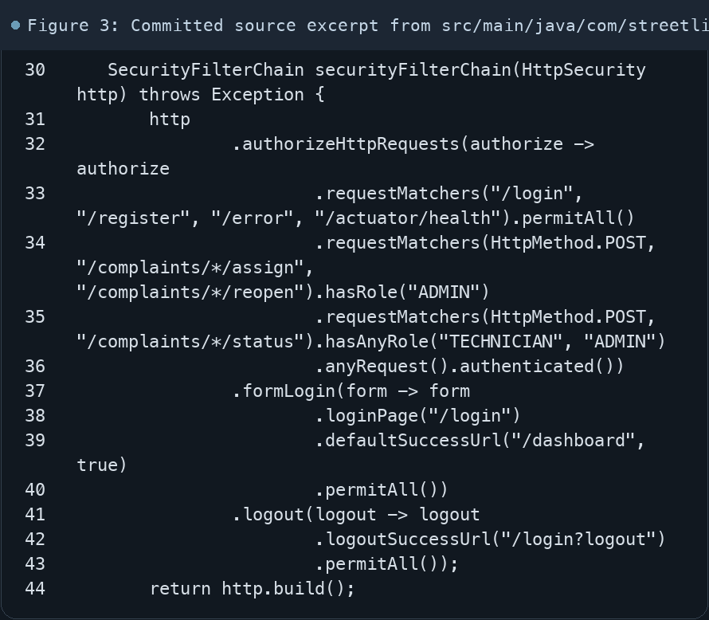
Figure 3: Committed source excerpt from src/main/java/com/streetlight/config/SecurityConfiguration.java
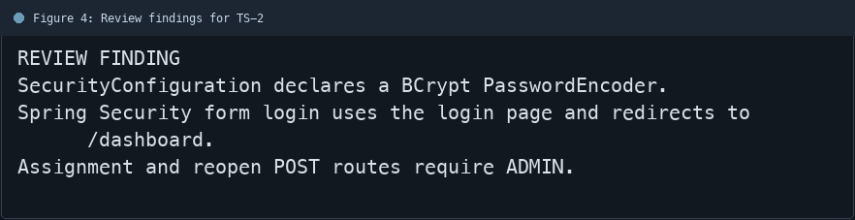
Figure 4: Review findings for TS-2
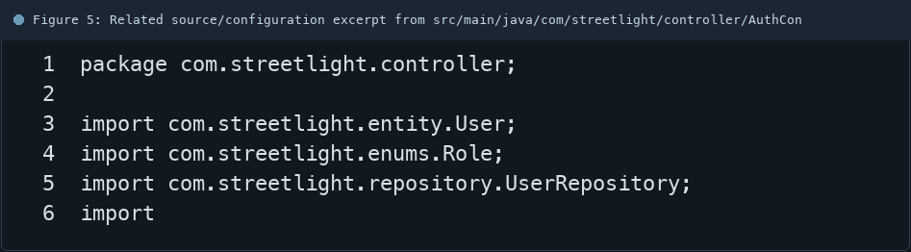
Figure 5: Related source/configuration excerpt from src/main/java/com/streetlight/controller/AuthController.java
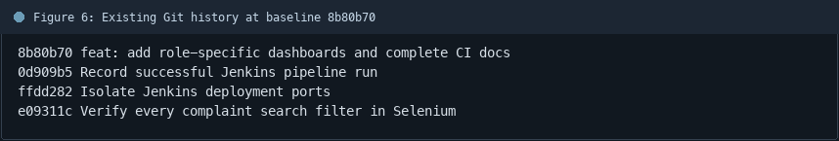
Figure 6: Existing Git history at baseline 8b80b70

6. Follow-up Items
# | Open item | Action | State
1 | Fresh automated check | Run targeted check | Pending
2 | CI evidence | Attach current report | Pending
3 | Task-specific review | Complete follow-up | Pending
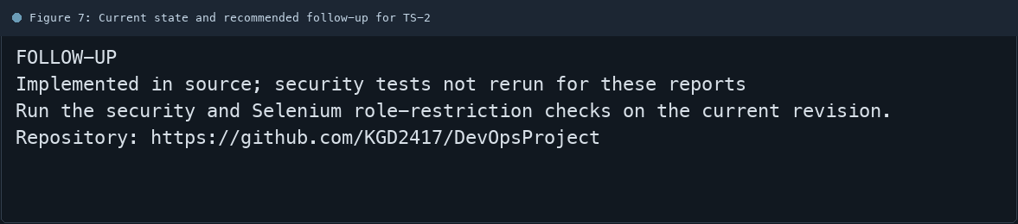
Figure 7: Current state and recommended follow-up for TS-2

