Task 15: Ansible Provisioning Playbook
Streetlight Fault Reporter
Repository | https://github.com/KGD2417/DevOpsProject
Project | Streetlight Fault Reporter
Task / status | TS-15 — Playbook and roles are present; idempotence not rerun for these reports
Branch / baseline | main / 8b80b70
Visibility | Public

1. Deliverables
Deliverable | Repository evidence
site.yml | ansible/site.yml
main.yml | ansible/roles/system/tasks/main.yml
main.yml | ansible/roles/docker/tasks/main.yml
main.yml | ansible/roles/application/tasks/main.yml
inventory.yml | ansible/inventory.yml
vars.yml | ansible/vars.yml

2. Task Scope and Source Evidence
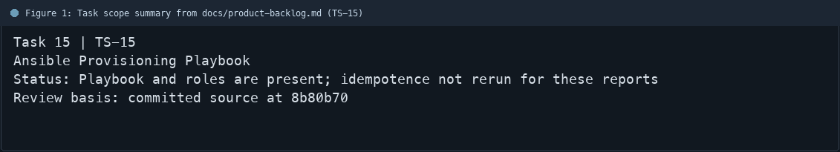
Figure 1: Task scope summary from docs/product-backlog.md (TS-15)

3. Repository Structure
Path | Task relevance
ansible/site.yml | Implementation or documentation evidence for this task
ansible/roles/system/tasks/main.yml | Implementation or documentation evidence for this task
ansible/roles/docker/tasks/main.yml | Implementation or documentation evidence for this task
ansible/roles/application/tasks/main.yml | Implementation or documentation evidence for this task
ansible/inventory.yml | Implementation or documentation evidence for this task
ansible/vars.yml | Implementation or documentation evidence for this task
docs/ansible-guide.md | Implementation or documentation evidence for this task
Review note | site.yml orchestrates system, docker, and application roles.
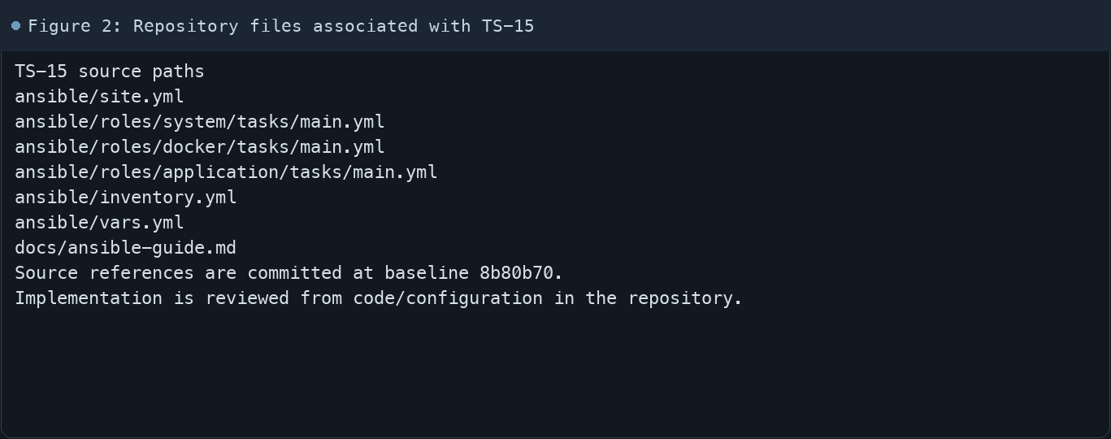
Figure 2: Repository files associated with TS-15

4. Implementation Review
Work area | Finding
Model/configuration | site.yml orchestrates system, docker, and application roles.
Application behavior | Ansible tasks check/install platform prerequisites and apply the Compose deployment.
Persistence/integration | The final play waits for actuator health and reports the result.
Security/validation | docs/ansible-guide.md documents local and remote usage.
Evidence review | The idempotence run was not repeated while preparing these reports.
Review scope | No fresh tests were run for this report.
Evidence and status
- Committed source baseline: 8b80b70.
- Paths above identify the reviewed implementation and configuration.
- Status distinguishes source presence from a fresh run.
- No tests or deployment commands were rerun for this document.
- Next: Run the playbook twice in the documented environment and capture changed=0 on the second run.

5. Acceptance Checkpoints
# | Review result | Acceptance checkpoint
1 | Source present | Inventory defines the target host
2 | Source present | Variables are separated from tasks
3 | Source present | System, Docker, and application roles are included
4 | Source present | Compose deployment is managed
5 | Source present | Health endpoint is checked
6 | Not rerun | Second run confirms idempotence
7 | Not rerun | Fresh targeted verification result is recorded
Review basis: committed source at 8b80b70, backlog TS-1–TS-15, and existing project documentation. No tests were rerun for this report.
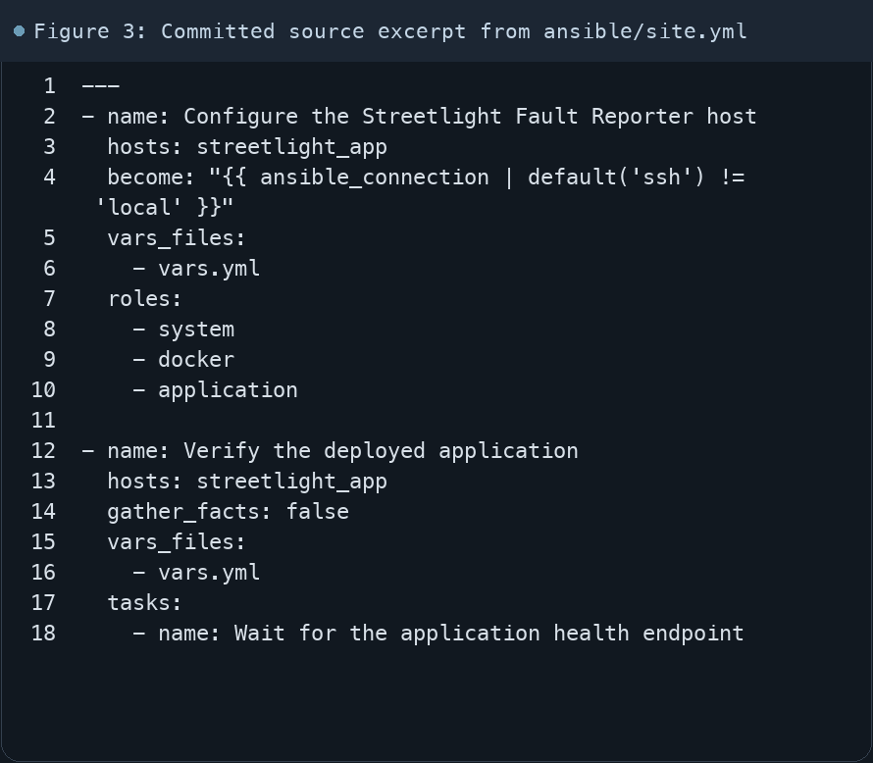
Figure 3: Committed source excerpt from ansible/site.yml
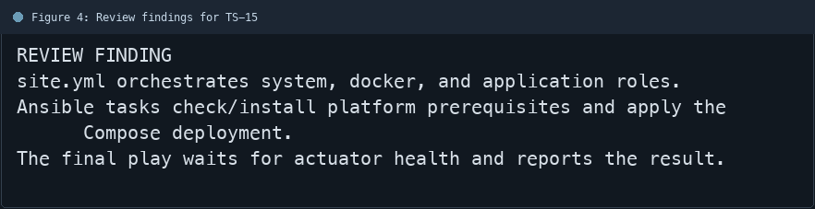
Figure 4: Review findings for TS-15
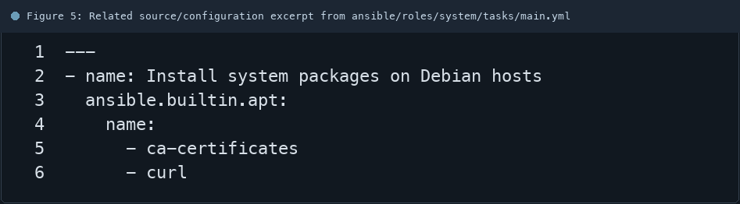
Figure 5: Related source/configuration excerpt from ansible/roles/system/tasks/main.yml
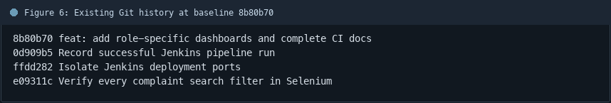
Figure 6: Existing Git history at baseline 8b80b70

6. Follow-up Items
# | Open item | Action | State
1 | Idempotence proof | Run playbook twice | Pending
2 | Target environment | Use intended inventory | Pending
3 | Health proof | Capture actuator response | Pending
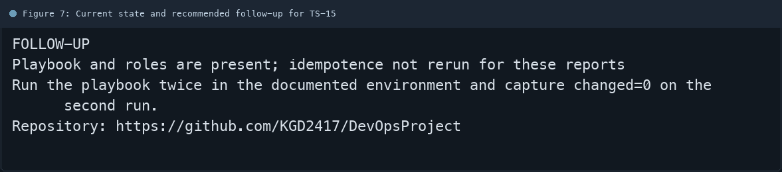
Figure 7: Current state and recommended follow-up for TS-15

