Task 6: Complaint Search, Repository Queries, and Pagination
Streetlight Fault Reporter
Repository | https://github.com/KGD2417/DevOpsProject
Project | Streetlight Fault Reporter
Task / status | TS-6 — Implemented in source; searches not rerun for these reports
Branch / baseline | main / 8b80b70
Visibility | Public

1. Deliverables
Deliverable | Repository evidence
ComplaintRepository.java | src/main/java/com/streetlight/repository/ComplaintRepository.java
ComplaintService.java | src/main/java/com/streetlight/service/ComplaintService.java
ComplaintController.java | src/main/java/com/streetlight/controller/ComplaintController.java
list.html | src/main/resources/templates/complaints/list.html
Scope note | Implementation evidence is listed in the next section.
Verification note | Acceptance is reported as source review, not a fresh test result.

2. Task Scope and Source Evidence
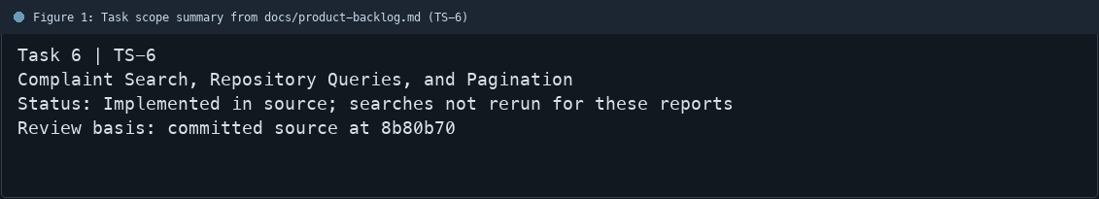
Figure 1: Task scope summary from docs/product-backlog.md (TS-6)

3. Repository Structure
Path | Task relevance
src/main/java/com/streetlight/repository/ComplaintRepository.java | Implementation or documentation evidence for this task
src/main/java/com/streetlight/service/ComplaintService.java | Implementation or documentation evidence for this task
src/main/java/com/streetlight/controller/ComplaintController.java | Implementation or documentation evidence for this task
src/main/resources/templates/complaints/list.html | Implementation or documentation evidence for this task
Review note | ComplaintRepository defines filter queries using Page results.
Review note | The service normalizes blank filters and limits page size to 100.
Review note | Reporter and technician searches scope results to the current user or assignments.
Review note | ComplaintController passes filter and page values to the service.
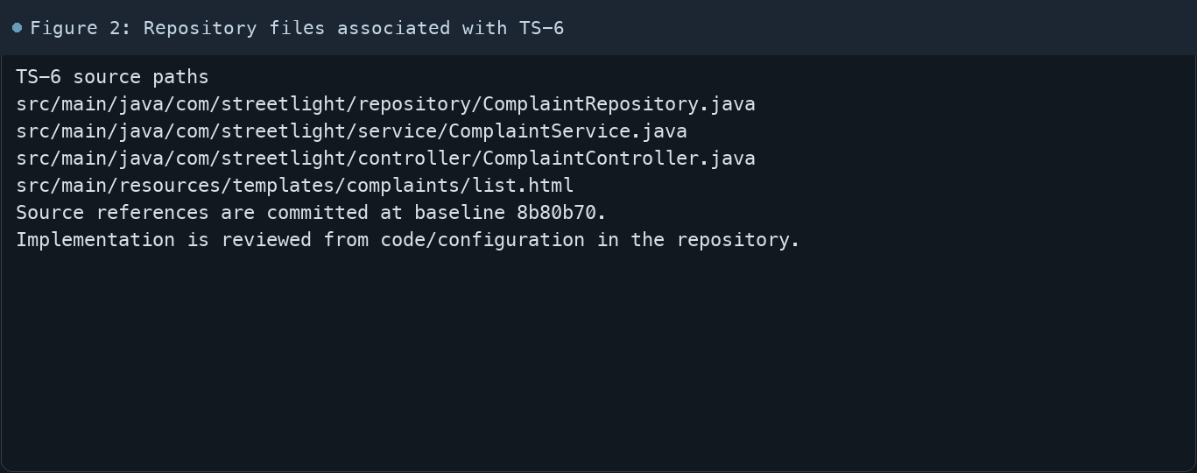
Figure 2: Repository files associated with TS-6

4. Implementation Review
Work area | Finding
Model/configuration | ComplaintRepository defines filter queries using Page results.
Application behavior | The service normalizes blank filters and limits page size to 100.
Persistence/integration | Reporter and technician searches scope results to the current user or assignments.
Security/validation | ComplaintController passes filter and page values to the service.
Evidence review | The listing template renders search controls and pagination links.
Review scope | No fresh tests were run for this report.
Evidence and status
- Committed source baseline: 8b80b70.
- Paths above identify the reviewed implementation and configuration.
- Status distinguishes source presence from a fresh run.
- No tests or deployment commands were rerun for this document.
- Next: Run the five-filter search and pagination Selenium journey against the current build.

5. Acceptance Checkpoints
# | Review result | Acceptance checkpoint
1 | Source present | Complaint ID and text search are supported
2 | Source present | Ward filter is supported
3 | Source present | Category, status, and priority filters are supported
4 | Source present | Reporter and technician results are role-scoped
5 | Source present | Page index and page size are bounded
6 | Not rerun | Fresh search/pagination journey run
7 | Not rerun | Fresh targeted verification result is recorded
Review basis: committed source at 8b80b70, backlog TS-1–TS-15, and existing project documentation. No tests were rerun for this report.
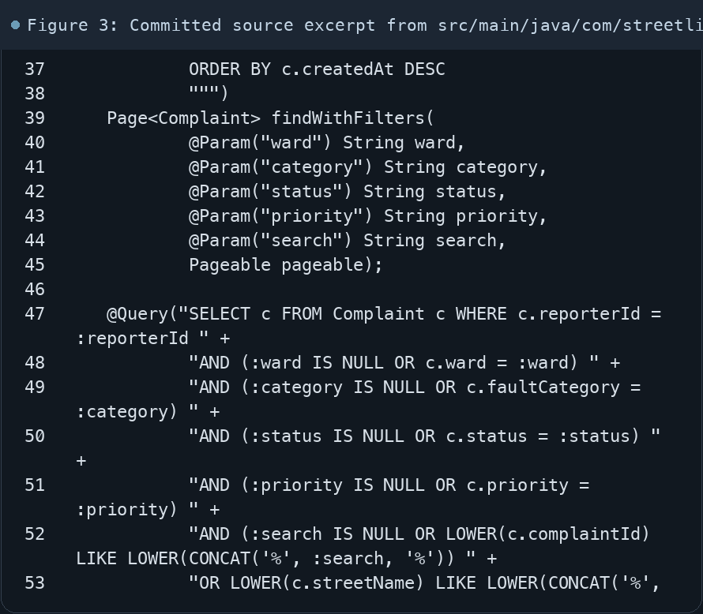
Figure 3: Committed source excerpt from src/main/java/com/streetlight/repository/ComplaintRepository.java
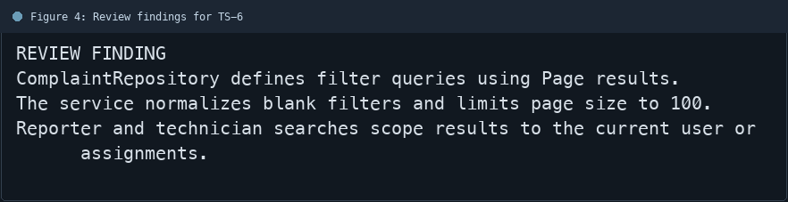
Figure 4: Review findings for TS-6
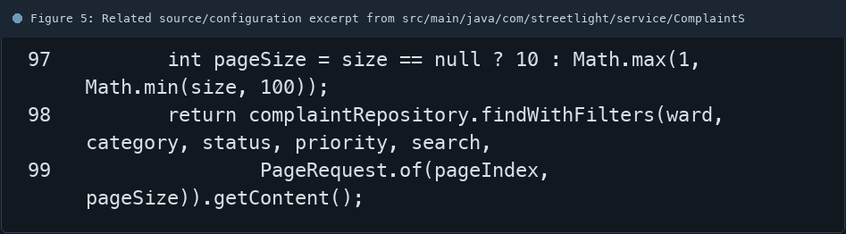
Figure 5: Related source/configuration excerpt from src/main/java/com/streetlight/service/ComplaintService.java
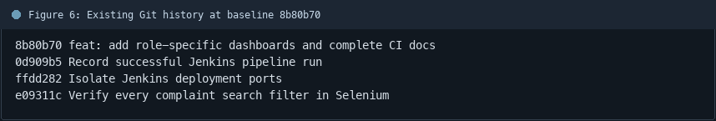
Figure 6: Existing Git history at baseline 8b80b70

6. Follow-up Items
# | Open item | Action | State
1 | Fresh automated check | Run targeted check | Pending
2 | CI evidence | Attach current report | Pending
3 | Task-specific review | Complete follow-up | Pending
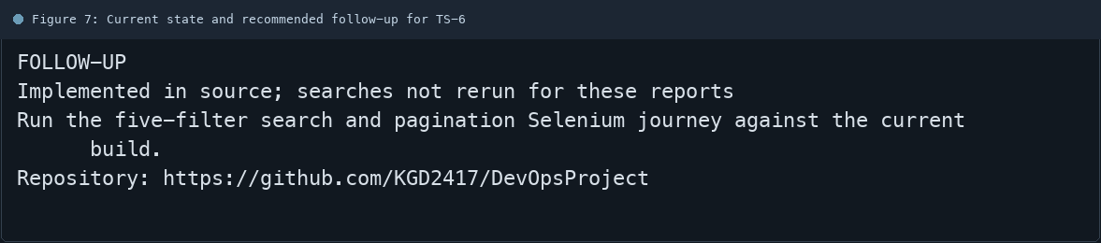
Figure 7: Current state and recommended follow-up for TS-6

