Task 3: User Entity, Roles, and Password Hashing
Streetlight Fault Reporter
Repository | https://github.com/KGD2417/DevOpsProject
Project | Streetlight Fault Reporter
Task / status | TS-3 — Implemented in source; registration flow not rerun for these reports
Branch / baseline | main / 8b80b70
Visibility | Public

1. Deliverables
Deliverable | Repository evidence
User.java | src/main/java/com/streetlight/entity/User.java
Role.java | src/main/java/com/streetlight/enums/Role.java
UserRepository.java | src/main/java/com/streetlight/repository/UserRepository.java
AuthController.java | src/main/java/com/streetlight/controller/AuthController.java
Scope note | Implementation evidence is listed in the next section.
Verification note | Acceptance is reported as source review, not a fresh test result.

2. Task Scope and Source Evidence
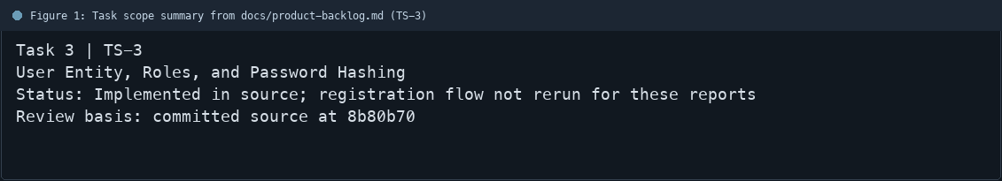
Figure 1: Task scope summary from docs/product-backlog.md (TS-3)

3. Repository Structure
Path | Task relevance
src/main/java/com/streetlight/entity/User.java | Implementation or documentation evidence for this task
src/main/java/com/streetlight/enums/Role.java | Implementation or documentation evidence for this task
src/main/java/com/streetlight/repository/UserRepository.java | Implementation or documentation evidence for this task
src/main/java/com/streetlight/controller/AuthController.java | Implementation or documentation evidence for this task
Review note | User is a JPA entity used by Spring Security.
Review note | Role enum defines CITIZEN, TECHNICIAN, and ADMIN.
Review note | UserRepository supports user lookup by username.
Review note | AuthController delegates password encoding to the configured encoder.
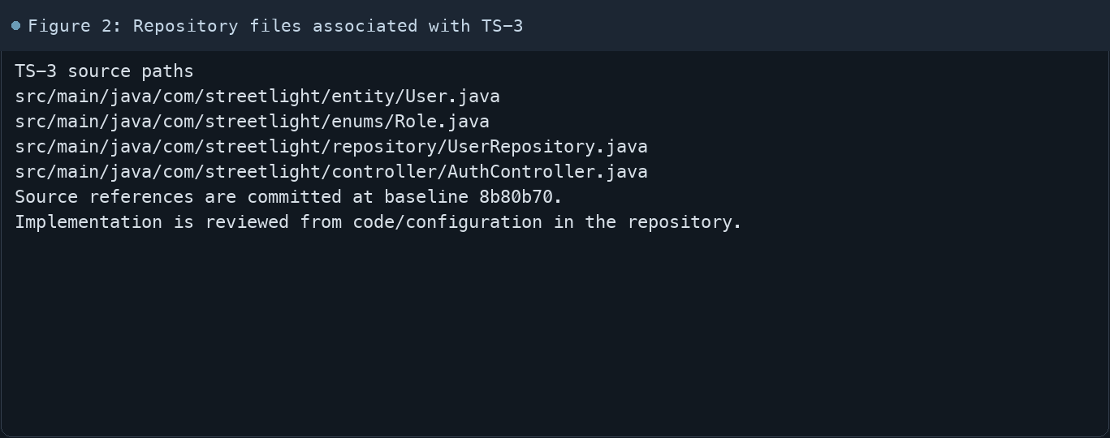
Figure 2: Repository files associated with TS-3

4. Implementation Review
Work area | Finding
Model/configuration | User is a JPA entity used by Spring Security.
Application behavior | Role enum defines CITIZEN, TECHNICIAN, and ADMIN.
Persistence/integration | UserRepository supports user lookup by username.
Security/validation | AuthController delegates password encoding to the configured encoder.
Evidence review | Demo account setup exists in Application.java; credentials are intentionally omitted from this report.
Review scope | No fresh tests were run for this report.
Evidence and status
- Committed source baseline: 8b80b70.
- Paths above identify the reviewed implementation and configuration.
- Status distinguishes source presence from a fresh run.
- No tests or deployment commands were rerun for this document.
- Next: Verify registration, duplicate usernames, and password hashing in the current environment.

5. Acceptance Checkpoints
# | Review result | Acceptance checkpoint
1 | Source present | User persistence model is present
2 | Source present | CITIZEN, TECHNICIAN, and ADMIN roles are defined
3 | Source present | User lookup by username is available
4 | Source present | Passwords are encoded before persistence
5 | Source present | Registration validates required fields
6 | Not rerun | Fresh registration journey run
7 | Not rerun | Fresh targeted verification result is recorded
Review basis: committed source at 8b80b70, backlog TS-1–TS-15, and existing project documentation. No tests were rerun for this report.
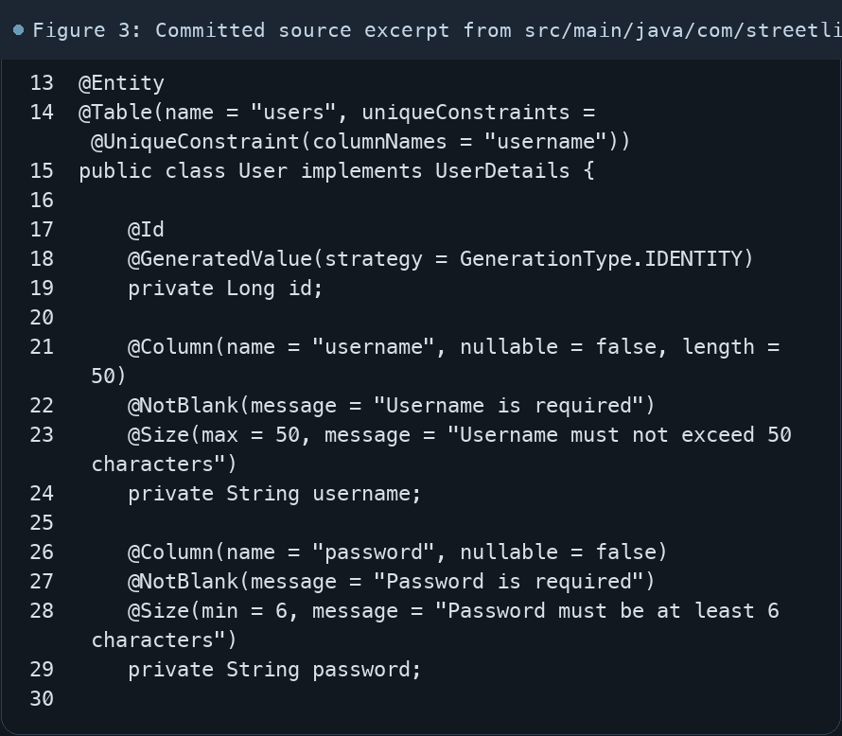
Figure 3: Committed source excerpt from src/main/java/com/streetlight/entity/User.java
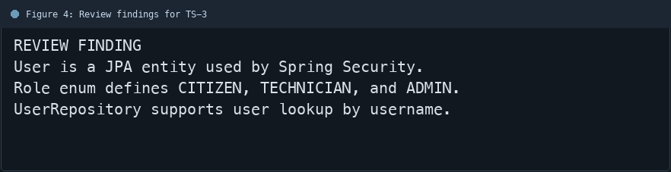
Figure 4: Review findings for TS-3
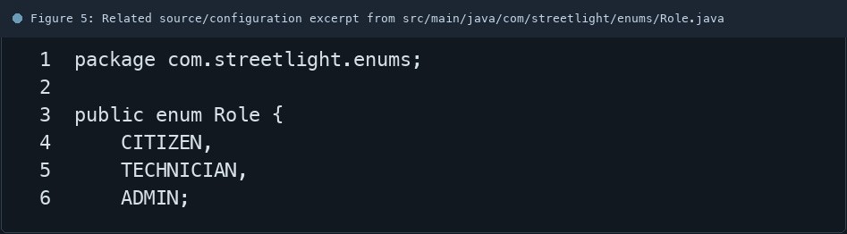
Figure 5: Related source/configuration excerpt from src/main/java/com/streetlight/enums/Role.java
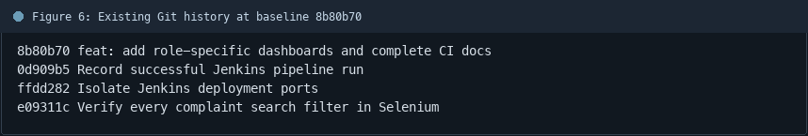
Figure 6: Existing Git history at baseline 8b80b70

6. Follow-up Items
# | Open item | Action | State
1 | Fresh automated check | Run targeted check | Pending
2 | CI evidence | Attach current report | Pending
3 | Task-specific review | Complete follow-up | Pending
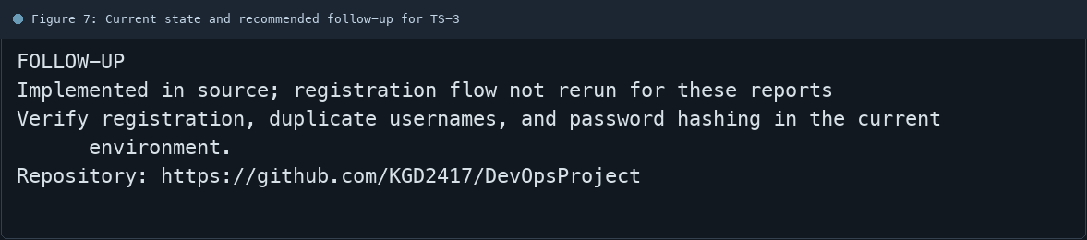
Figure 7: Current state and recommended follow-up for TS-3

