Task 11: MySQL and H2 Database Configuration
Streetlight Fault Reporter
Repository | https://github.com/KGD2417/DevOpsProject
Project | Streetlight Fault Reporter
Task / status | TS-11 — Partial: MySQL/H2 profiles exist; Flyway migration support not found
Branch / baseline | main / 8b80b70
Visibility | Public

1. Deliverables
Deliverable | Repository evidence
application.properties | src/main/resources/application.properties
application-local.properties | src/main/resources/application-local.properties
application-docker.properties | src/main/resources/application-docker.properties
pom.xml | pom.xml
database-design.md | docs/database-design.md
Verification note | Acceptance is reported as source review, not a fresh test result.

2. Task Scope and Source Evidence
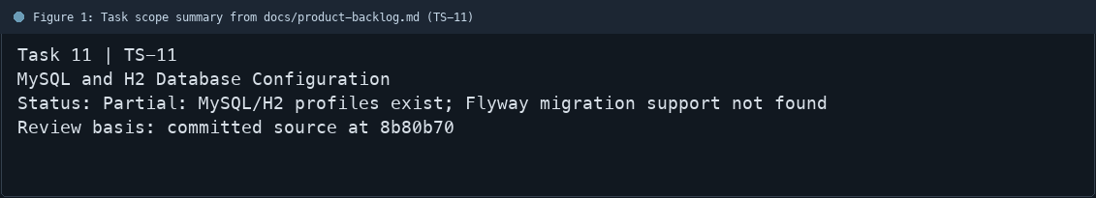
Figure 1: Task scope summary from docs/product-backlog.md (TS-11)

3. Repository Structure
Path | Task relevance
src/main/resources/application.properties | Implementation or documentation evidence for this task
src/main/resources/application-local.properties | Implementation or documentation evidence for this task
src/main/resources/application-docker.properties | Implementation or documentation evidence for this task
pom.xml | Implementation or documentation evidence for this task
docs/database-design.md | Implementation or documentation evidence for this task
Review note | The POM includes MySQL Connector/J and H2 dependencies.
Review note | application-local.properties configures in-memory H2.
Review note | application-docker.properties targets MySQL using environment variables.
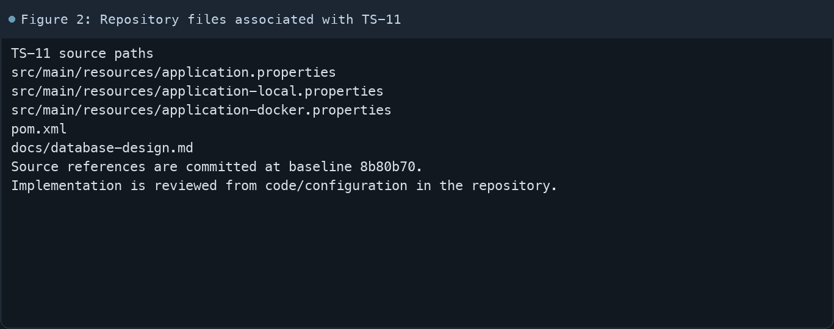
Figure 2: Repository files associated with TS-11

4. Implementation Review
Work area | Finding
Model/configuration | The POM includes MySQL Connector/J and H2 dependencies.
Application behavior | application-local.properties configures in-memory H2.
Persistence/integration | application-docker.properties targets MySQL using environment variables.
Security/validation | The committed POM and resources reviewed here do not show Flyway dependency or migration files.
Evidence review | The database design document mentions Flyway but that documentation is not evidence of an installed migration
Review scope | No fresh tests were run for this report.
Evidence and status
- Committed source baseline: 8b80b70.
- Paths above identify the reviewed implementation and configuration.
- Status distinguishes source presence from a fresh run.
- No tests or deployment commands were rerun for this document.
- Next: Add Flyway dependency and migration(s), then run local H2 and container MySQL startup checks.

5. Acceptance Checkpoints
# | Review result | Acceptance checkpoint
1 | Source present | MySQL driver dependency is present
2 | Source present | H2 driver dependency is present
3 | Source present | Local H2 profile is configured
4 | Source present | Docker MySQL profile is configured
5 | Gap | Flyway dependency and migration file exist
6 | Not rerun | Fresh database startup checks
7 | Not rerun | Fresh targeted verification result is recorded
Review basis: committed source at 8b80b70, backlog TS-1–TS-15, and existing project documentation. No tests were rerun for this report.
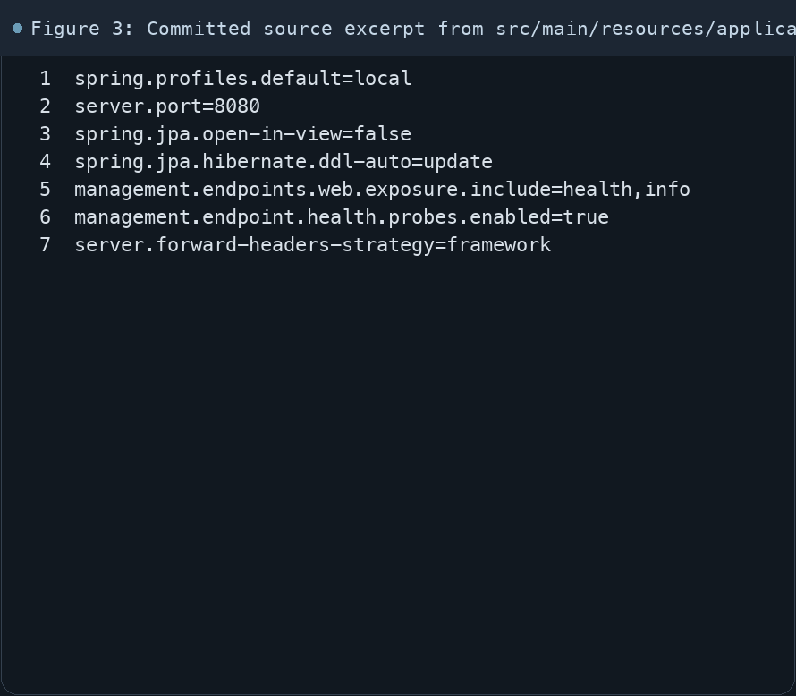
Figure 3: Committed source excerpt from src/main/resources/application.properties
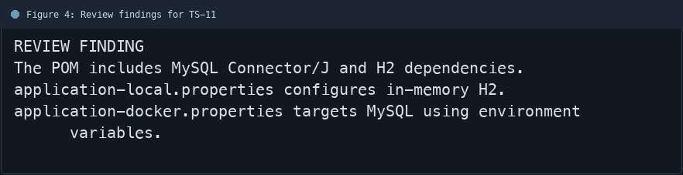
Figure 4: Review findings for TS-11
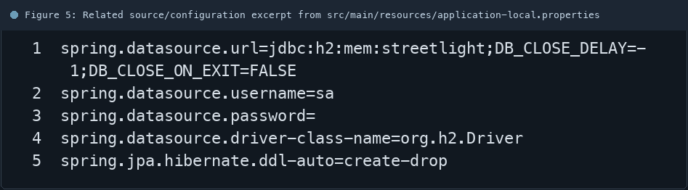
Figure 5: Related source/configuration excerpt from src/main/resources/application-local.properties
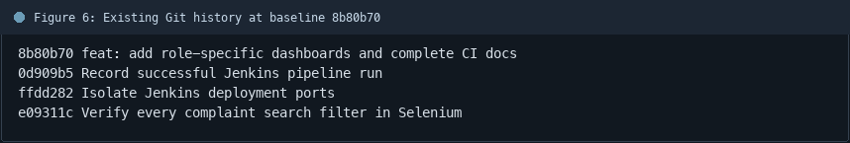
Figure 6: Existing Git history at baseline 8b80b70

6. Follow-up Items
# | Open item | Action | State
1 | Flyway dependency missing | Add dependency and migration | Open
2 | Profile compatibility | Test H2 and MySQL profiles | Open
3 | Fresh schema startup | Record both startup checks | Open
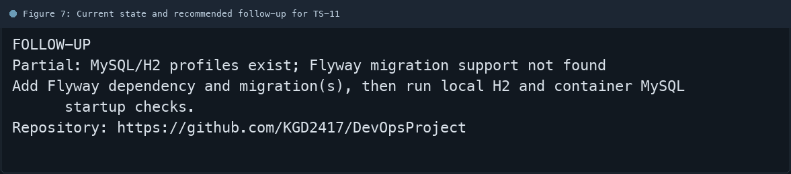
Figure 7: Current state and recommended follow-up for TS-11

