Task 14: Jenkins Continuous Integration Pipeline
Streetlight Fault Reporter
Repository | https://github.com/KGD2417/DevOpsProject
Project | Streetlight Fault Reporter
Task / status | TS-14 — Pipeline configured; latest recorded build not revalidated here
Branch / baseline | main / 8b80b70
Visibility | Public

1. Deliverables
Deliverable | Repository evidence
Jenkinsfile | Jenkinsfile
devops-workflow.md | docs/devops-workflow.md
docker-compose.test.yml | docker-compose.test.yml
Dockerfile | src/main/docker/Dockerfile
deployment-guide.md | docs/deployment-guide.md
Verification note | Acceptance is reported as source review, not a fresh test result.

2. Task Scope and Source Evidence
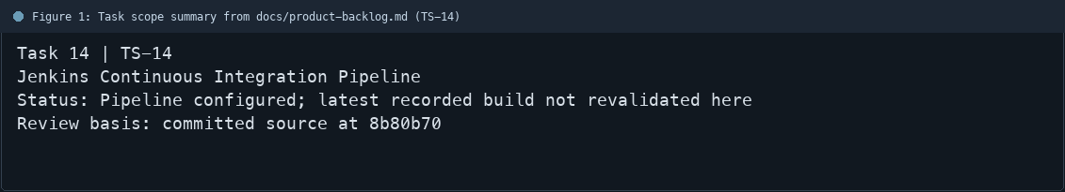
Figure 1: Task scope summary from docs/product-backlog.md (TS-14)

3. Repository Structure
Path | Task relevance
Jenkinsfile | Implementation or documentation evidence for this task
docs/devops-workflow.md | Implementation or documentation evidence for this task
docker-compose.test.yml | Implementation or documentation evidence for this task
src/main/docker/Dockerfile | Implementation or documentation evidence for this task
docs/deployment-guide.md | Implementation or documentation evidence for this task
Review note | Jenkinsfile defines checkout, toolchain, compile, unit test, package/archive, test stack, Selen
Review note | Docker Hub publication is gated by a parameter and credential ID.
Review note | docs/devops-workflow.md records a previous successful local Jenkins build #13.
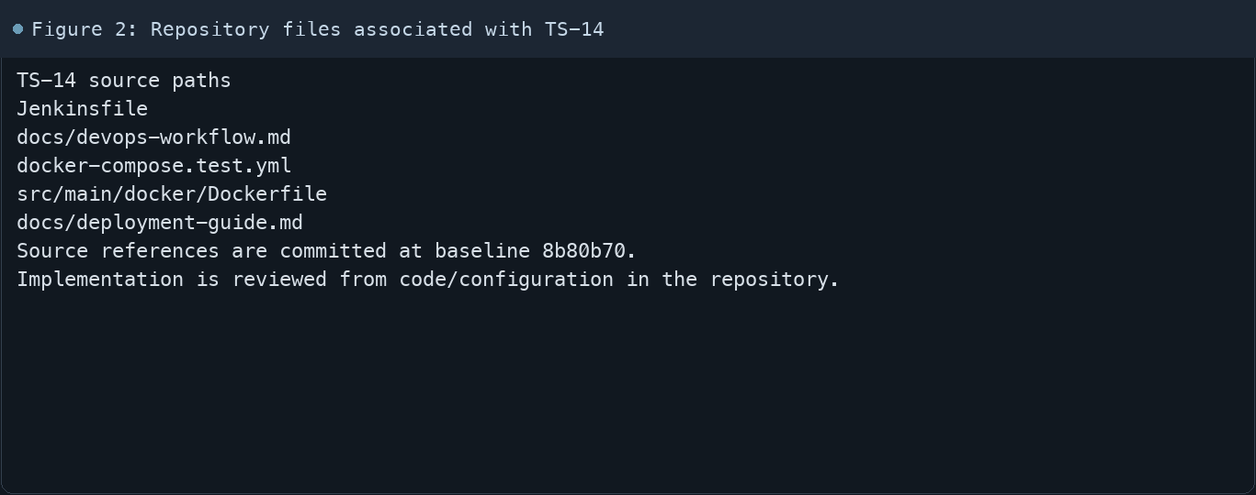
Figure 2: Repository files associated with TS-14

4. Implementation Review
Work area | Finding
Model/configuration | Jenkinsfile defines checkout, toolchain, compile, unit test, package/archive, test stack, Selenium, test repor
Application behavior | Docker Hub publication is gated by a parameter and credential ID.
Persistence/integration | docs/devops-workflow.md records a previous successful local Jenkins build #13.
Security/validation | That historical record was not revalidated during document generation.
Evidence review | Pushing task-report commits may trigger the configured SCM polling job.
Review scope | No fresh tests were run for this report.
Evidence and status
- Committed source baseline: 8b80b70.
- Paths above identify the reviewed implementation and configuration.
- Status distinguishes source presence from a fresh run.
- No tests or deployment commands were rerun for this document.
- Next: Run Streetlight-CI after the documentation pushes and confirm all stages and report artifacts.

5. Acceptance Checkpoints
# | Review result | Acceptance checkpoint
1 | Source present | Declarative pipeline is present
2 | Source present | Compile, unit test, and package stages are present
3 | Source present | Selenium stage and test report publishing are present
4 | Source present | Docker build and optional Hub publication are present
5 | Source present | Compose deployment and actuator check are present
6 | Not rerun | Fresh Jenkins run after these commits
7 | Not rerun | Fresh targeted verification result is recorded
Review basis: committed source at 8b80b70, backlog TS-1–TS-15, and existing project documentation. No tests were rerun for this report.
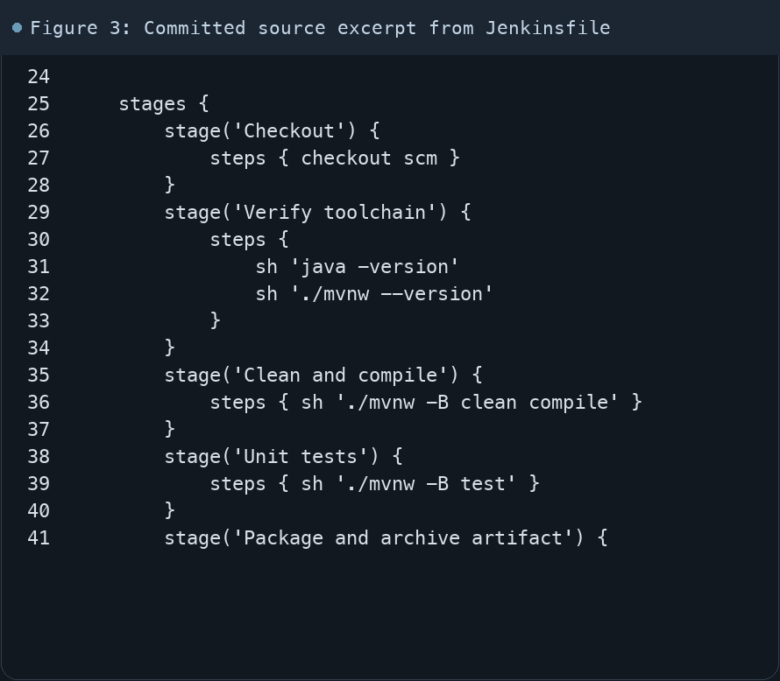
Figure 3: Committed source excerpt from Jenkinsfile
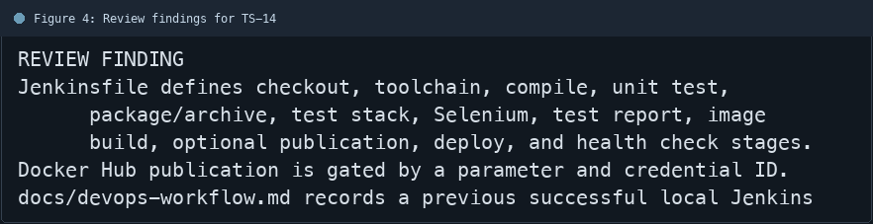
Figure 4: Review findings for TS-14
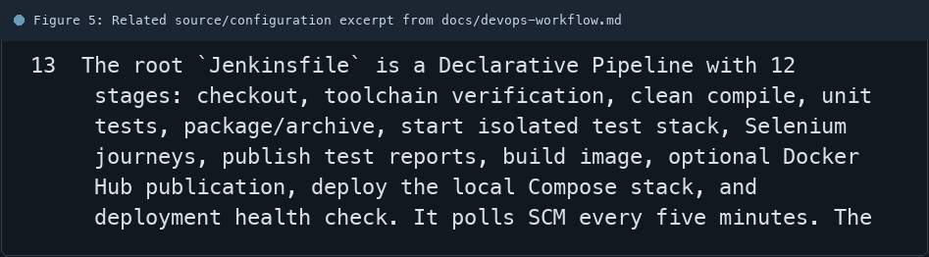
Figure 5: Related source/configuration excerpt from docs/devops-workflow.md
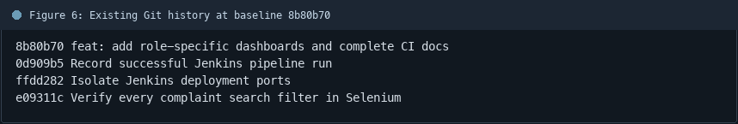
Figure 6: Existing Git history at baseline 8b80b70

6. Follow-up Items
# | Open item | Action | State
1 | Post-documentation CI | Run Streetlight-CI | Pending
2 | Image publication | Requires saved Jenkins credential | Conditional
3 | Health result | Confirm deployed URL is healthy | Pending
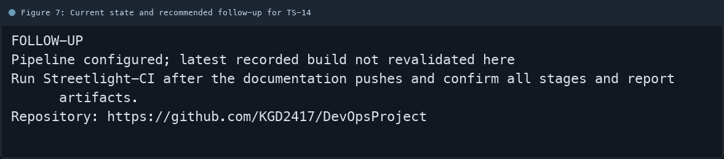
Figure 7: Current state and recommended follow-up for TS-14

