Task 1: Project Setup with Maven Wrapper
Streetlight Fault Reporter
Repository | https://github.com/KGD2417/DevOpsProject
Project | Streetlight Fault Reporter
Task / status | TS-1 — Implemented in source; build not rerun for these reports
Branch / baseline | main / 8b80b70
Visibility | Public

1. Deliverables
Deliverable | Repository evidence
pom.xml | pom.xml
mvnw | mvnw
mvnw.cmd | mvnw.cmd
Application.java | src/main/java/com/streetlight/Application.java
Scope note | Implementation evidence is listed in the next section.
Verification note | Acceptance is reported as source review, not a fresh test result.

2. Task Scope and Source Evidence
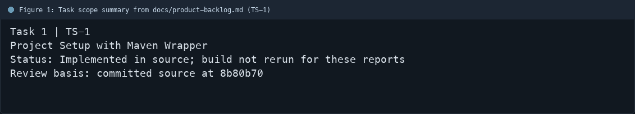
Figure 1: Task scope summary from docs/product-backlog.md (TS-1)

3. Repository Structure
Path | Task relevance
pom.xml | Implementation or documentation evidence for this task
mvnw | Implementation or documentation evidence for this task
mvnw.cmd | Implementation or documentation evidence for this task
src/main/java/com/streetlight/Application.java | Implementation or documentation evidence for this task
Review note | pom.xml sets Spring Boot 3.2.2 and Java 21.
Review note | The repository contains mvnw and mvnw.cmd.
Review note | Application.java provides the Spring Boot entry point.
Review note | Maven Wrapper lets contributors use the project Maven version.
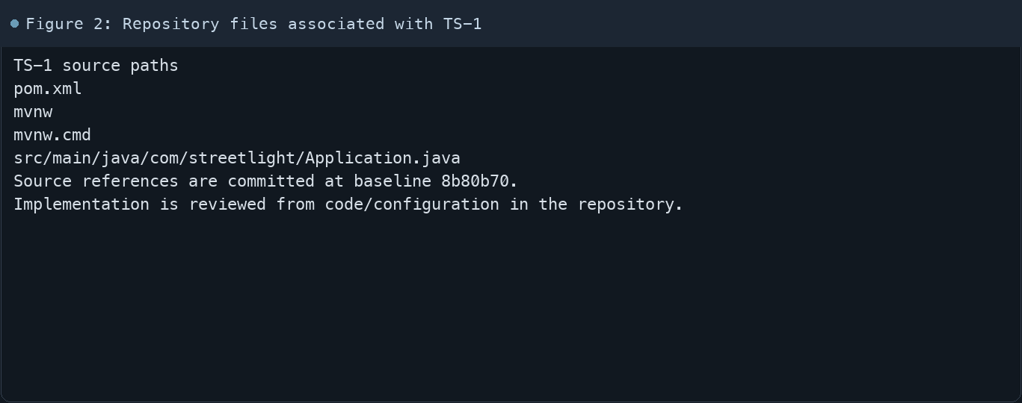
Figure 2: Repository files associated with TS-1

4. Implementation Review
Work area | Finding
Model/configuration | pom.xml sets Spring Boot 3.2.2 and Java 21.
Application behavior | The repository contains mvnw and mvnw.cmd.
Persistence/integration | Application.java provides the Spring Boot entry point.
Security/validation | Maven Wrapper lets contributors use the project Maven version.
Evidence review | The project includes web, persistence, validation, security, and actuator dependencies.
Review scope | No fresh tests were run for this report.
Evidence and status
- Committed source baseline: 8b80b70.
- Paths above identify the reviewed implementation and configuration.
- Status distinguishes source presence from a fresh run.
- No tests or deployment commands were rerun for this document.
- Next: Run ./mvnw -B clean verify and attach the fresh build result.

5. Acceptance Checkpoints
# | Review result | Acceptance checkpoint
1 | Source present | Spring Boot build definition is present
2 | Source present | Java 21 is selected in Maven configuration
3 | Source present | Unix and Windows Maven Wrapper launchers are present
4 | Source present | Application entry point is present
5 | Not rerun | Fresh Maven verification run
6 | Source present | Build result is recorded in CI
7 | Not rerun | Fresh targeted verification result is recorded
Review basis: committed source at 8b80b70, backlog TS-1–TS-15, and existing project documentation. No tests were rerun for this report.
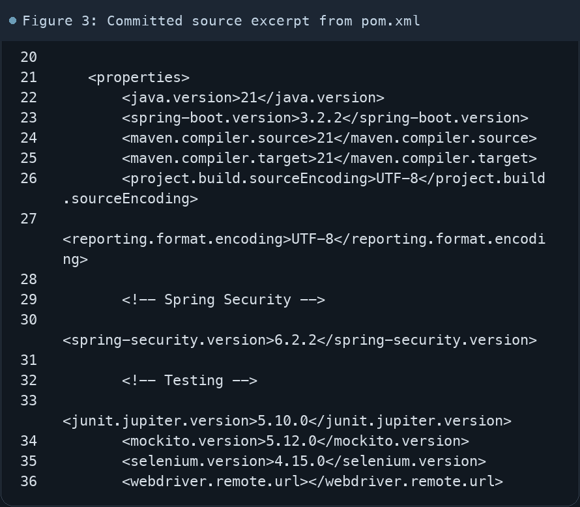
Figure 3: Committed source excerpt from pom.xml
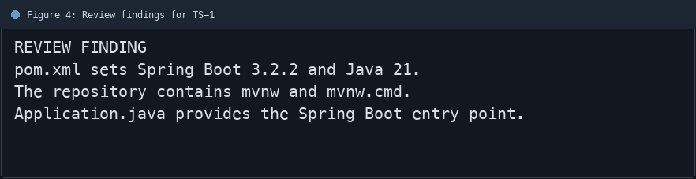
Figure 4: Review findings for TS-1
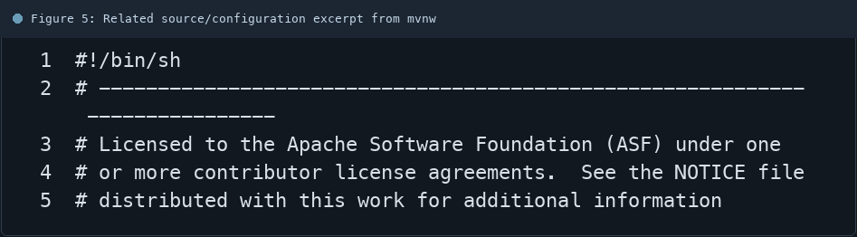
Figure 5: Related source/configuration excerpt from mvnw
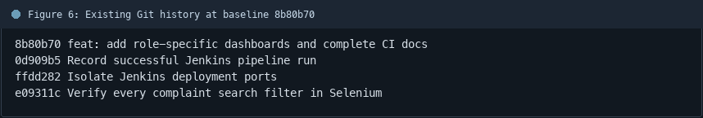
Figure 6: Existing Git history at baseline 8b80b70

6. Follow-up Items
# | Open item | Action | State
1 | Fresh automated check | Run targeted check | Pending
2 | CI evidence | Attach current report | Pending
3 | Task-specific review | Complete follow-up | Pending
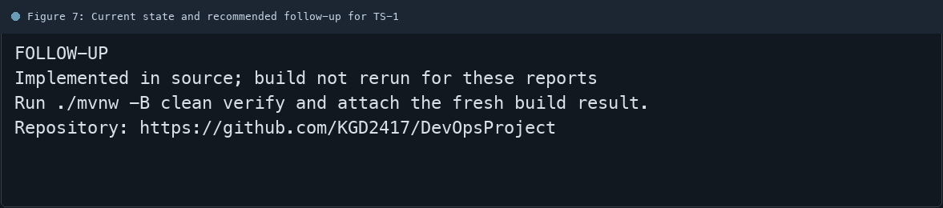
Figure 7: Current state and recommended follow-up for TS-1

