Task 7: Complaint Service and Workflow Rules
Streetlight Fault Reporter
Repository | https://github.com/KGD2417/DevOpsProject
Project | Streetlight Fault Reporter
Task / status | TS-7 — Implemented in source; workflow checks not rerun for these reports
Branch / baseline | main / 8b80b70
Visibility | Public

1. Deliverables
Deliverable | Repository evidence
ComplaintService.java | src/main/java/com/streetlight/service/ComplaintService.java
StatusHistory.java | src/main/java/com/streetlight/entity/StatusHistory.java
ComplaintRepository.java | src/main/java/com/streetlight/repository/ComplaintRepository.java
product-backlog.md | docs/product-backlog.md
Scope note | Implementation evidence is listed in the next section.
Verification note | Acceptance is reported as source review, not a fresh test result.

2. Task Scope and Source Evidence
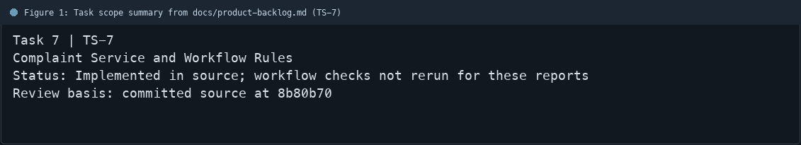
Figure 1: Task scope summary from docs/product-backlog.md (TS-7)

3. Repository Structure
Path | Task relevance
src/main/java/com/streetlight/service/ComplaintService.java | Implementation or documentation evidence for this task
src/main/java/com/streetlight/entity/StatusHistory.java | Implementation or documentation evidence for this task
src/main/java/com/streetlight/repository/ComplaintRepository.java | Implementation or documentation evidence for this task
docs/product-backlog.md | Implementation or documentation evidence for this task
Review note | ComplaintService generates IDs in the SL-year-sequence format.
Review note | Allowed transitions are checked in the service before persistence.
Review note | Resolution notes are required when moving to RESOLVED.
Review note | Technicians are limited to complaints assigned to them.
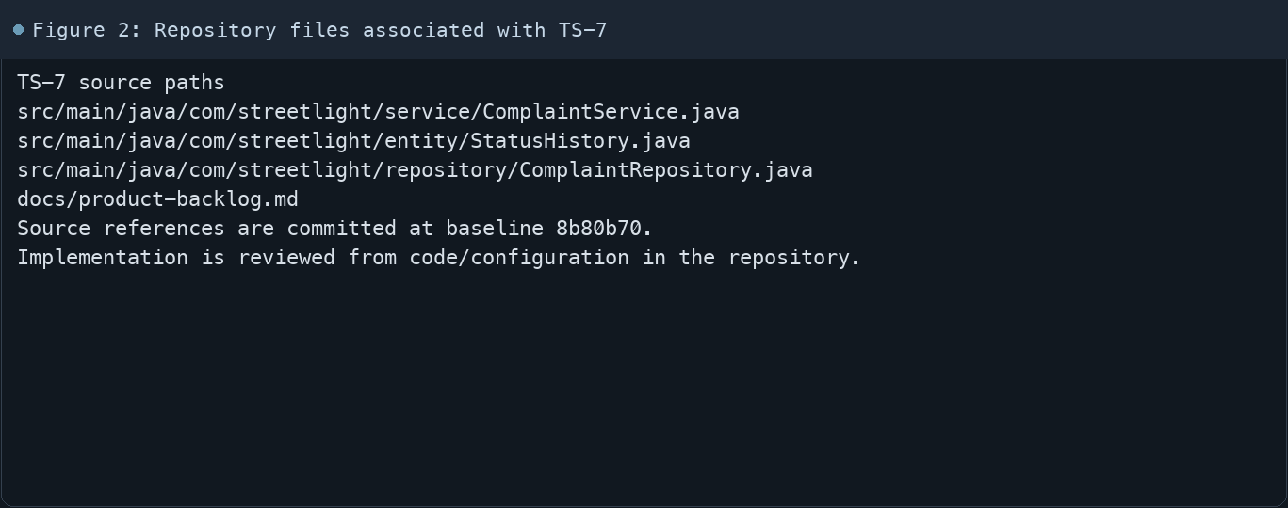
Figure 2: Repository files associated with TS-7

4. Implementation Review
Work area | Finding
Model/configuration | ComplaintService generates IDs in the SL-year-sequence format.
Application behavior | Allowed transitions are checked in the service before persistence.
Persistence/integration | Resolution notes are required when moving to RESOLVED.
Security/validation | Technicians are limited to complaints assigned to them.
Evidence review | Status changes and reopening persist history entries.
Review scope | No fresh tests were run for this report.
Evidence and status
- Committed source baseline: 8b80b70.
- Paths above identify the reviewed implementation and configuration.
- Status distinguishes source presence from a fresh run.
- No tests or deployment commands were rerun for this document.
- Next: Run accepted and rejected transitions with fresh test data and inspect history rows.

5. Acceptance Checkpoints
# | Review result | Acceptance checkpoint
1 | Source present | New complaints receive an ID and REPORTED status
2 | Source present | Allowed next-state transitions are checked
3 | Source present | Invalid status changes are rejected
4 | Source present | Resolution notes are required for RESOLVED
5 | Source present | Technicians can only update assigned complaints
6 | Source present | Admin reopen records history
7 | Not rerun | Fresh targeted verification result is recorded
Review basis: committed source at 8b80b70, backlog TS-1–TS-15, and existing project documentation. No tests were rerun for this report.
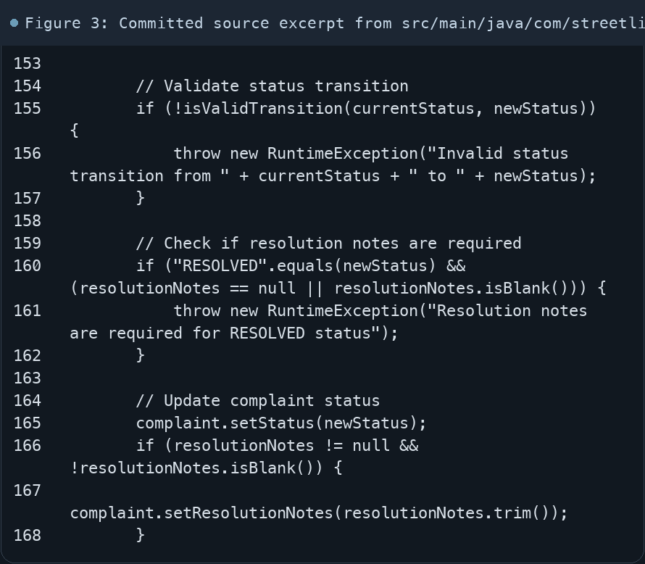
Figure 3: Committed source excerpt from src/main/java/com/streetlight/service/ComplaintService.java
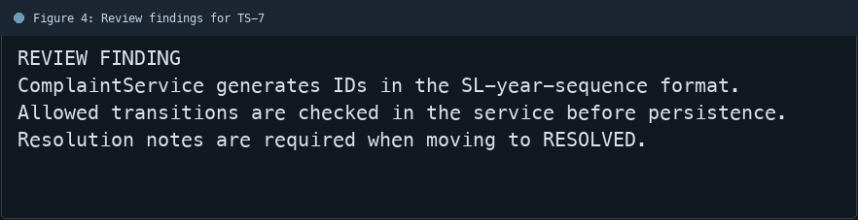
Figure 4: Review findings for TS-7
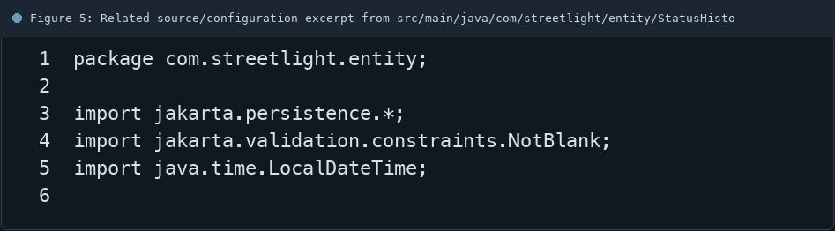
Figure 5: Related source/configuration excerpt from src/main/java/com/streetlight/entity/StatusHistory.java
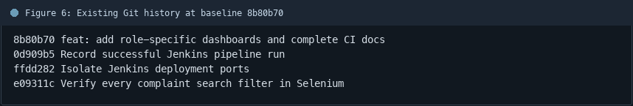
Figure 6: Existing Git history at baseline 8b80b70

6. Follow-up Items
# | Open item | Action | State
1 | Fresh automated check | Run targeted check | Pending
2 | CI evidence | Attach current report | Pending
3 | Task-specific review | Complete follow-up | Pending
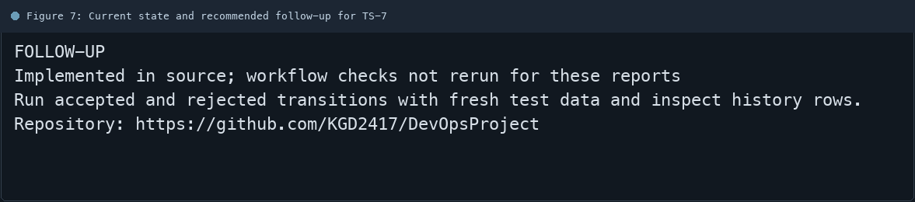
Figure 7: Current state and recommended follow-up for TS-7

