Task 12: Selenium End-to-End User Journeys
Streetlight Fault Reporter
Repository | https://github.com/KGD2417/DevOpsProject
Project | Streetlight Fault Reporter
Task / status | TS-12 — Five journeys are present in source; not rerun for these reports
Branch / baseline | main / 8b80b70
Visibility | Public

1. Deliverables
Deliverable | Repository evidence
ComplaintSeleniumIT.java | src/test/java/com/streetlight/selenium/ComplaintSeleniumIT.java
pom.xml | pom.xml
docker-compose.test.yml | docker-compose.test.yml
testing-strategy.md | docs/testing-strategy.md
Scope note | Implementation evidence is listed in the next section.
Verification note | Acceptance is reported as source review, not a fresh test result.

2. Task Scope and Source Evidence
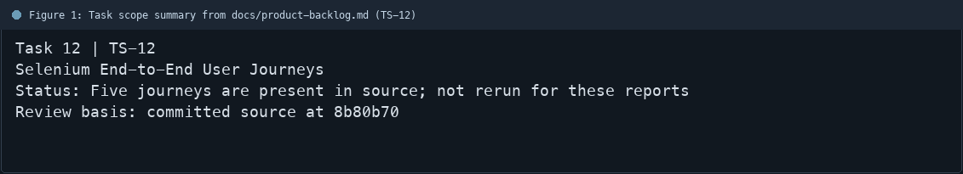
Figure 1: Task scope summary from docs/product-backlog.md (TS-12)

3. Repository Structure
Path | Task relevance
src/test/java/com/streetlight/selenium/ComplaintSeleniumIT.java | Implementation or documentation evidence for this task
pom.xml | Implementation or documentation evidence for this task
docker-compose.test.yml | Implementation or documentation evidence for this task
docs/testing-strategy.md | Implementation or documentation evidence for this task
Review note | ComplaintSeleniumIT declares five test methods that cover the listed journeys.
Review note | The test source uses Selenium WebDriver and JUnit 5.
Review note | Maven Failsafe is configured for integration-test execution.
Review note | The dedicated test compose file isolates the application and database.
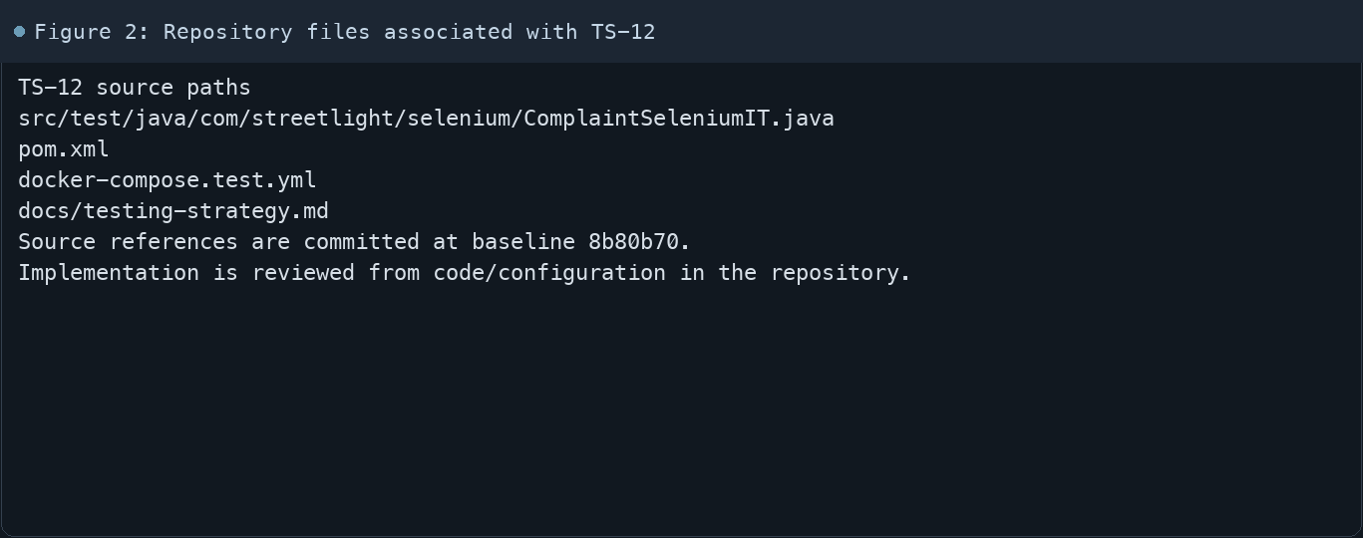
Figure 2: Repository files associated with TS-12

4. Implementation Review
Work area | Finding
Model/configuration | ComplaintSeleniumIT declares five test methods that cover the listed journeys.
Application behavior | The test source uses Selenium WebDriver and JUnit 5.
Persistence/integration | Maven Failsafe is configured for integration-test execution.
Security/validation | The dedicated test compose file isolates the application and database.
Evidence review | This documentation pass inspects the tests but does not rerun them.
Review scope | No fresh tests were run for this report.
Evidence and status
- Committed source baseline: 8b80b70.
- Paths above identify the reviewed implementation and configuration.
- Status distinguishes source presence from a fresh run.
- No tests or deployment commands were rerun for this document.
- Next: Run the isolated test stack and Failsafe suite; retain fresh XML reports and failure screenshots.

5. Acceptance Checkpoints
# | Review result | Acceptance checkpoint
1 | Not rerun | Login/logout journey exists
2 | Not rerun | Citizen complaint submit/view journey exists
3 | Not rerun | Search and pagination journey exists
4 | Not rerun | Technician assignment/status/history journey exists
5 | Not rerun | Unauthorized action restriction journey exists
6 | Not rerun | Fresh Selenium run and reports
7 | Not rerun | Fresh targeted verification result is recorded
Review basis: committed source at 8b80b70, backlog TS-1–TS-15, and existing project documentation. No tests were rerun for this report.
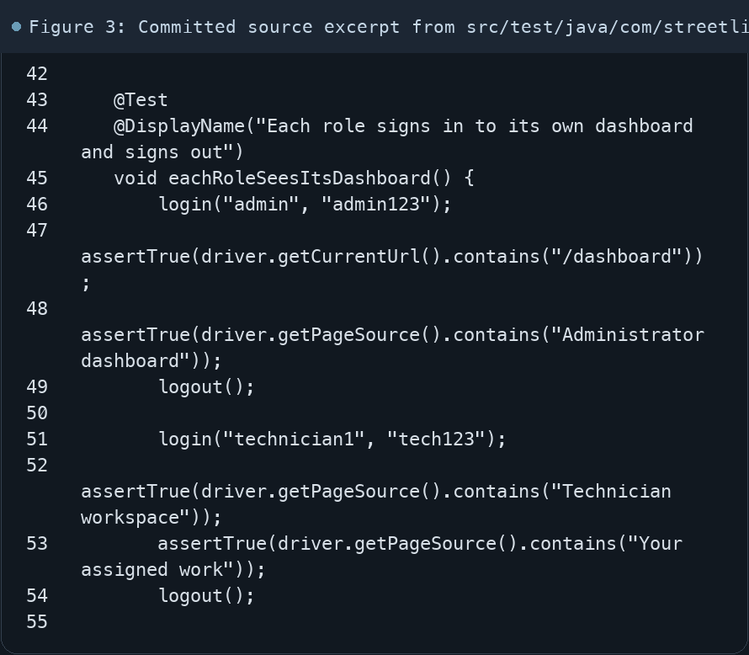
Figure 3: Committed source excerpt from src/test/java/com/streetlight/selenium/ComplaintSeleniumIT.java
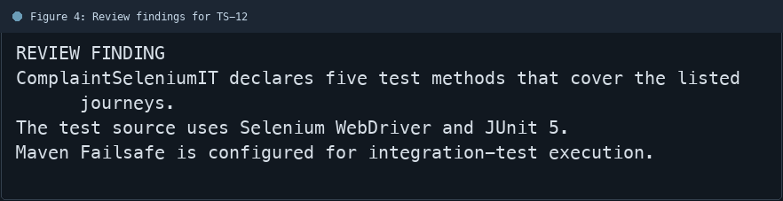
Figure 4: Review findings for TS-12
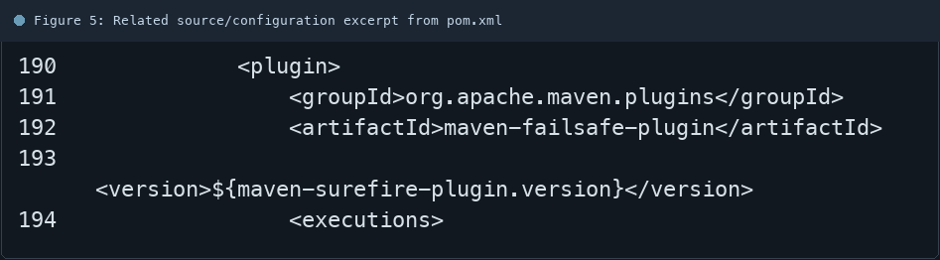
Figure 5: Related source/configuration excerpt from pom.xml
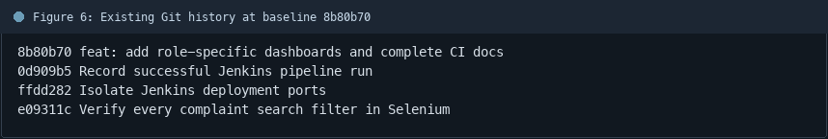
Figure 6: Existing Git history at baseline 8b80b70

6. Follow-up Items
# | Open item | Action | State
1 | Current run evidence | Run Failsafe suite | Pending
2 | Failure artifacts | Keep reports/screenshots | Pending
3 | CI quality gate | Confirm failures block deploy | Pending
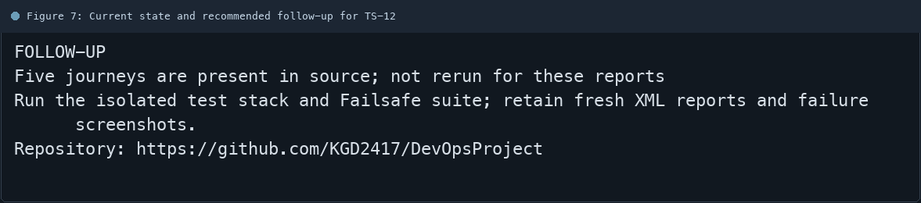
Figure 7: Current state and recommended follow-up for TS-12

