Big Data Analytics
MINI-PROJECT REPORT
ON
“GitPulse: Big Data Analytics on Open Source GitHub Activity”
BY
Ayaan Memon (A-759),
Tanmay Meshram (A-761),
Kshitij Desai (A-772)
Under the guidance of
Internal Guide
Prof. Bhavesh Panchal

Juhu-Versova Link Road, Versova, Andheri (W), Mumbai-53
Department of Computer Engineering
University of Mumbai
October 2026

Declaration
We wish to state that the work embodied in this project titled “GitPulse: Big Data Analytics on Open Source GitHub Activity” forms our own contribution to the work carried out under the guidance of “Prof. Bhavesh Panchal” at the Rajiv Gandhi Institute of Technology.
We declare that this written submission represents our ideas in our own words and where others' ideas or words have been included, we have adequately cited and referenced the original sources. We also declare that we have adhered to all principles of academic honesty and integrity and have not misrepresented or fabricated or falsified any idea, data, fact or source in our submission. We understand that any violation of the above will be cause for disciplinary action by the Institute and can also evoke penal action from the sources which have thus not been properly cited or from whom proper permission has not been taken when needed.

(Students' Signatures)
1. Ayaan Memon (A-759)
2. Tanmay Meshram (A-761)
3. Kshitij Desai (A-772)

Abstract
GitPulse is an end-to-end big data analytics platform that studies public activity on GitHub, the largest open source platform in the world. It ingests the hourly event dumps published by GH Archive, about 167,000 events per hour, together with repository metadata from the GitHub REST API, and answers ten analytical questions about trending repositories, language trends, activity patterns, bot activity, maintainer health, team structure, repository recommendations, viral-repository prediction, live spike detection and repository clustering.
The system uses twelve tools from the Hadoop ecosystem on a Dockerised multi-node cluster with two DataNodes (replication factor 2) and two YARN NodeManagers. Apache Pig with a Java UDF cleans and deduplicates the raw JSON and tags bot accounts. A custom MapReduce job ranks the top repositories per day. Apache Hive builds curated tables and enforces data-quality gates that stop the pipeline on any violation. Apache Sqoop moves data between PostgreSQL and Hadoop. Apache Spark and Apache Mahout build features, a viral-repository classifier, item-based recommendations and k-means clusters. Apache HBase serves results with salted row keys, Apache Impala answers dashboard queries in about one second, and Apache Kafka with Apache Storm processes a replayed event stream in real time. Apache Airflow orchestrates both pipelines, and memory-aware stages let the full stack run on one laptop.
On 2.4 million real events the pipeline accounted for every record, with no malformed lines and one duplicate removed. Bots produced 28% to 32% of all events and more than half of all comments. Mahout item-based collaborative filtering reached a recall at 10 of 0.251, about six times the popularity baseline, and the viral model reached an AUC-ROC of 0.73. The streaming path processed a full GitHub hour at 60 times speed with zero failed tuples. A benchmark of five engines showed Impala answering in about 1.3 seconds against 20 to 170 seconds for the YARN-based engines. An end-to-end test run on a Windows laptop passed all 25 pipeline steps and all tests.
Keywords: Big Data, Hadoop, HDFS, MapReduce, Pig, Hive, Spark, Mahout, HBase, Kafka, Storm, Impala, Airflow, GitHub, GH Archive.

Contents
Sr. No. | Contents | Pg. No.
 | Declaration | i
 | Abstract | ii
 | List of Figures | iv
 | List of Tables | v
1 | Introduction | 1
 | 1.1 Introduction Description | 1
 | 1.2 Ambiguity in Project | 1
 | 1.3 Objectives | 2
2 | Proposed System | 3
 | 2.1 Proposed Statement | 3
 | 2.2 Design Details | 3
 | 2.3 Data Pre-Processing Steps | 5
 | 2.4 Main Processing Steps | 6
 | 2.5 Tools Used | 8
 | 2.6 Software and Hardware Requirements | 9
 | 2.7 Dataset Used | 10
3 | Results | 11
 | 3.1 Results | 11
4 | Conclusion and future work | 20
 | References | 21
List of Figures
Figures | Pg. No.
Figure 2.1: Overall architecture of GitPulse | 4
Figure 2.2: HDFS and YARN cluster layout | 4
Figure 2.3: Daily batch pipeline | 5
Figure 2.4: Real-time path: Kafka to Storm to HBase | 8
Figure 2.5: The two Airflow DAGs | 8
Figure 3.1: Data-quality funnel | 11
Figure 3.2: Share of events created by bots | 12
Figure 3.3: Active repositories by team type | 13
Figure 3.4: Comparison of recommendation methods | 13
Figure 3.5: Median query time by engine, medium dataset | 15
Figure 3.6: Slowest steps of the test run | 16
Figure 3.7: HDFS NameNode: two DataNodes in service | 17
Figure 3.8: MapReduce JobHistory: completed jobs | 18
Figure 3.9: Impala daemon: completed queries | 18
Figure 3.10: HBase Master with its region server | 19
List of Tables
Tables | Pg. No.
Table 1.1: Analytical questions and the tools that answer them | 2
Table 2.1: Memory-aware stages | 5
Table 2.2: Tools used and their roles | 8
Table 2.3: Software and hardware requirements | 9
Table 2.4: Hours of GH Archive data used | 10
Table 2.5: Dataset metrics | 10
Table 3.1: Record counts through the pipeline | 11
Table 3.2: Recommendation results | 13
Table 3.3: Viral prediction results | 14
Table 3.4: Median query time in seconds by engine | 14
Table 3.5: Steps of the end-to-end test run | 15
Table 3.6: Summary of tests | 16

CHAPTER 1

Introduction

1.1 Introduction Description
GitHub is the largest home of open source software in the world. Every action a developer takes there, such as pushing code, starring a repository, opening a pull request, filing an issue or writing a comment, is recorded as a public event. The GH Archive project collects all of these events and publishes them as one compressed JSON file for every hour of every day. A single hour holds about 167,000 events and a single day holds about four million, which makes this data too large and too fast-moving to study with a spreadsheet or a single database query.
GitPulse is our end-to-end big data analytics platform for this data. It ingests the hourly GH Archive dumps together with repository details from the GitHub REST API, cleans and checks them, stores them on a Hadoop cluster and answers ten analytical questions: which repositories are trending, which languages are growing, how much of the activity comes from bots, how healthy maintainers are, which repositories a developer is likely to enjoy, whether a new repository will go viral, and what is happening right now in a live stream of events.
The main idea of the project is that every tool in the Hadoop ecosystem does the job it suits best. Pig cleans raw JSON, a hand-written MapReduce job ranks repositories, Hive and Impala answer SQL questions, Spark and Mahout build machine learning models, HBase serves millisecond lookups, Kafka and Storm handle the real-time stream, Sqoop moves data in and out of PostgreSQL, and Airflow runs everything in the right order. All twelve tools run on a multi-node cluster built with Docker Compose on a single laptop.

1.2 Ambiguity in Project
Working with real GitHub data raised several ambiguities that the design had to resolve:
- Bot or human? Close to a third of all events are created by automated accounts such as dependabot and CI tools. A repository with thousands of automated pushes is not really trending. GitPulse tags bots in three ways (a [bot] suffix, a known-bots list and a -bot name rule) and ranks repositories by distinct human users.
- What does trending mean? Raw push counts are led by automated push-spam repositories, many of which are deleted within days. Stars from humans are a much better signal of interest, so the trending tables use human stars and distinct actors.
- Deleted repositories. Some repositories that appear in the events no longer exist when the GitHub API is called. The catalogue records these with their HTTP status instead of failing.
- Late events in the stream. In a live stream, events can arrive out of order. Storm windows use the event time inside each record with a 10 second lag, so an event is counted in the minute it happened, not the minute it arrived.
- Changing data format. In October 2025 GitHub trimmed the payload of public events. GitPulse uses September 2025 data and the quality gate counts any events already in the trimmed format.
- Time zones. GH Archive uses UTC. Activity patterns are reported in both UTC and Indian Standard Time (UTC + 5:30).
- Limited hardware. A real Hadoop cluster has many machines, but this project runs on one laptop. Memory-aware stages start only the services the current step needs.

1.3 Objectives
The project answers the ten questions in Table 1.1. Each question is matched with the tools that suit it best.
Table 1.1: Analytical questions and the tools that answer them
# | Analytical question | Tools used
Q1 | Most active and fastest-rising repositories per day and week | MapReduce (top-N), Hive, Sqoop export
Q2 | Language and topic trends | Sqoop catalogue, Hive join, Impala
Q3 | Activity by hour and weekday (UTC and IST) | Hive, Impala
Q4 | Bot versus human share of activity | Pig (bot tagging), Hive
Q5 | Maintainer health: pull request merge time, issue close ratio | Hive
Q6 | Fork to star ratio, solo versus community repositories | Spark (Gini, top contributor share)
Q7 | "Starred X also starred Y" recommendations | Mahout item CF, Spark ALS, HBase
Q8 | Will a new repository go viral? | Spark MLlib (logistic regression, GBT)
Q9 | Live events per minute, top repositories, spike alerts | Kafka, Storm, HBase
Q10 | Clusters of repositories with similar activity | Mahout k-means

CHAPTER 2

Proposed System

2.1 Proposed Statement
The proposed system is a complete batch and real-time analytics pipeline for public GitHub activity that runs on commodity hardware. It follows the Lambda architecture. A batch layer on HDFS and YARN produces accurate, quality-checked tables for each day of data, and a speed layer built on Kafka and Storm produces live counters and alerts within seconds. A serving layer of Impala, HBase and PostgreSQL makes both sets of results available to a Tableau dashboard and to command-line lookups.
Every pipeline step is exposed as one command of a single entry point, bin/pulse, which runs inside an edge container that holds all the client tools. The same command is used by the Makefile, by the Airflow DAGs and during a live demonstration, so the system behaves the same way no matter how it is started. Each step overwrites only its own day or partition, so any step can be retried safely, and data-quality gates stop the pipeline as soon as the numbers do not add up.

2.2 Design Details
Architecture / Flow Diagram
Figure 2.1 shows the overall architecture. Data enters on the left from GH Archive and the GitHub REST API. Inside the HDFS and YARN cluster it moves through four zones: raw JSON, clean Parquet, curated Hive tables and the machine learning zone. Results are served by Impala, HBase and PostgreSQL, and the speed layer at the bottom carries a replayed event stream through Kafka and Storm into HBase. Apache Airflow orchestrates the batch steps.
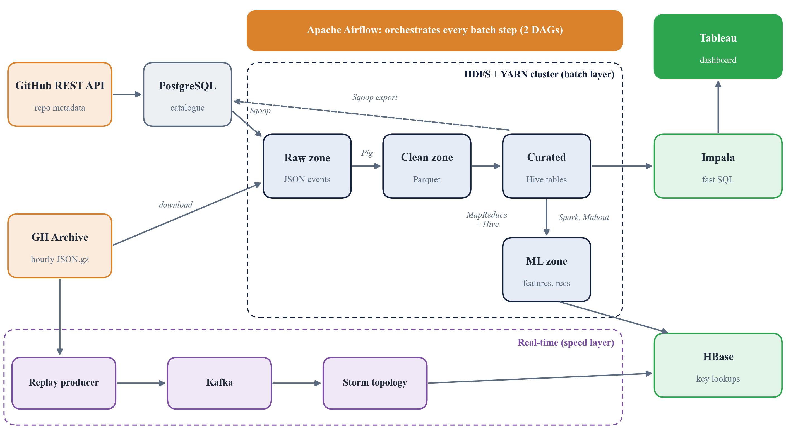
Figure 2.1: Overall architecture of GitPulse
Cluster Design
The Hadoop cluster is made of separate Docker containers that play the roles of separate machines (Figure 2.2). HDFS has one NameNode and two DataNodes with a replication factor of 2, so every block of every file is stored on both DataNodes. YARN has one ResourceManager and two NodeManagers, and a JobHistory server keeps the logs and counters of finished jobs. In total the project defines 23 services.
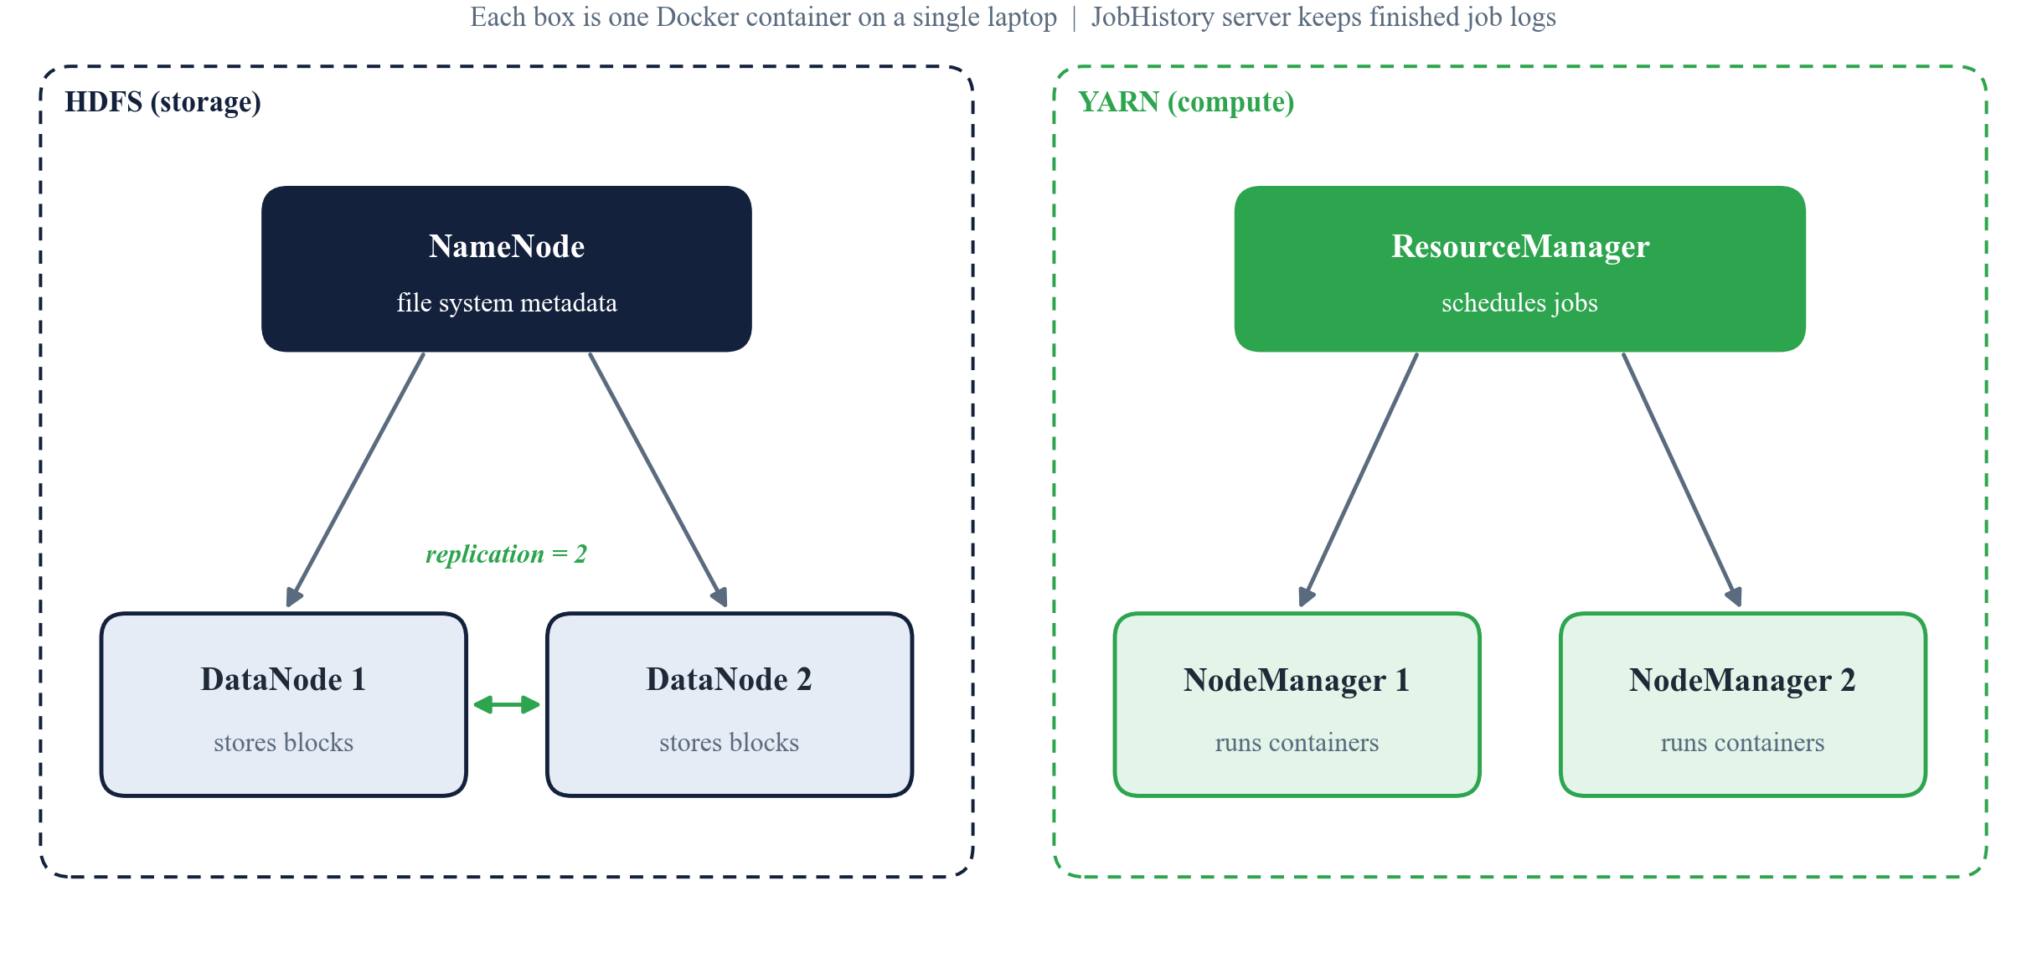
Figure 2.2: HDFS and YARN cluster layout
Memory-Aware Stages
Running all 23 services at once needs far more memory than a laptop has. The services are therefore grouped into stages (Table 2.1). The script scripts/stage.sh starts exactly the services a stage needs and stops every other running service, so the laptop never runs more than one stage at a time. The full stack works with 16 GB of RAM, and a LITE mode with one NodeManager covers 8 GB machines.
Table 2.1: Memory-aware stages
Stage | Services running | Used for
core | PostgreSQL, NameNode, 2 DataNodes, ResourceManager, 2 NodeManagers, JobHistory | HDFS and YARN demos
batch | core + edge client | Download, Pig, MapReduce, Sqoop
warehouse | core + Hive metastore + HiveServer2 + edge | Hive, Sqoop import and export
ml | core + Hive metastore + edge | Spark, Mahout
serving | core + ZooKeeper + HBase + edge | HBase loads and lookups
impala | HDFS + metastores + Impala daemons (YARN stopped) | Impala queries
streaming | HDFS + ZooKeeper + HBase + Kafka + Storm (YARN stopped) | Live topology
orchestrate | core + Airflow | DAG runs (Airflow switches stages per task)

2.3 Data Pre-Processing Steps
Figure 2.3 shows the daily batch pipeline. Its first half prepares the raw data for analysis:
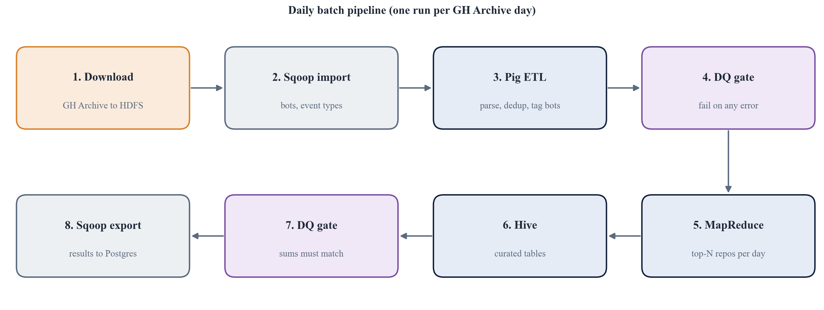
Figure 2.3: Daily batch pipeline
- Download and load: scripts/download_gharchive.sh fetches the hourly .json.gz files for the chosen dates and hours, checks them and loads them into the raw zone of HDFS under /gh/raw/events/dt=YYYY-MM-DD. The number of lines in each file is recorded for the quality gate.
- Lookup import with Sqoop: The list of known bots and the list of event types are kept in PostgreSQL and imported into Hive with Sqoop, so that Pig and Hive can join against them.
- Parsing with a Java UDF: The Pig script pig/etl_events.pig reads every line as text and parses it with ParseGhEvent, a Java user-defined function. It extracts about thirty typed fields such as event id, type, actor, repository, time, pull request number and merge status. A line that cannot be parsed becomes null and is counted as malformed.
- Deduplication: GH Archive occasionally repeats an event. Pig groups the records by event_id and keeps exactly one row for each.
- Bot tagging: Each actor is tagged as a bot if the login ends in [bot], if it appears in the known-bots list (a replicated, map-side join), or if the name ends in -bot or _bot. The reason is stored in a bot_reason column.
- Columnar storage: The clean records are written as Parquet into gh.events_clean, partitioned by date and event type, which makes later queries read only the columns and partitions they need.
- Data-quality gate: dq/check_clean.sql compares the counts at every stage. It requires the downloaded lines to equal the lines Pig read, the clean rows to equal Pig's output, no duplicate ids, no null keys, only known event types, dates that match the timestamps, and fewer than 0.1% malformed lines. Hive's assert_true() fails the query, and the Airflow task, if any rule is broken.

2.4 Main Processing Steps
Batch analytics
- MapReduce top-N: TopReposByTypeDay is a hand-written Java MapReduce job. The mapper reads the Parquet files and emits a composite key of (day, event type, repository) with a count of 1. A combiner sums counts locally, a custom partitioner sends every repository of one (day, type) group to the same reducer, and the reducer keeps a min-heap of size N to output the top N repositories.
- Hive curated tables: hive/curated/daily.sql builds daily tables for trending repositories, language trends (joined with the catalogue), the activity clock, the bot share and maintainer health. hive/curated/window.sql builds tables across the whole loaded window, such as the trending window and repository health. A second quality gate checks that every curated table adds back up to the clean count for its day.
- Sqoop export: Curated results are exported from Hive back to PostgreSQL, where the dashboard can read them directly.
- Impala: Impala shares the Hive metastore and reads the same Parquet files. Because its C++ daemons are always running, it answers dashboard queries in about one to two seconds instead of tens of seconds.
Machine learning
- Feature engineering (Spark): spark/features.py builds per-repository features (activity mix, contributor counts, Gini coefficient and top contributor share) and, for every new repository, its activity in the first F hours and the human stars in the following L hours.
- Viral prediction (Spark MLlib): A repository is labelled viral when its stars in the label window reach the 97th percentile, so roughly the top 3% of new repositories are positive. The data is split by time, and logistic regression is compared with gradient-boosted trees using AUC-ROC, AUC-PR and lift.
- Recommendations (Mahout): Each user's stars form an implicit, boolean rating. Mahout's item-based collaborative filtering with log-likelihood ratio similarity finds the 20 most similar repositories for each repository and the top 10 recommendations for each user. Spark ALS and a popularity baseline are trained on the same split for comparison, holding out each user's latest 20% of stars.
- Clustering (Mahout k-means): Repositories are clustered by their activity profile with k = 6 to find groups such as solo push projects and discussion-heavy projects.
- Serving (HBase): Results are shaped into HBase row keys with a two-character MD5 salt, for example <salt>|<repo_id>, so that new writes are spread across regions instead of all hitting the last one. They are bulk loaded with ImportTsv into the tables repo_hourly, repo_similar and user_recs.
Real-time stream
The speed layer is shown in Figure 2.4. A producer replays a real GH Archive hour into the Kafka topic gh.events at an adjustable speed (60 times faster by default). The Storm topology parses each event and sends it to three windowed bolts that use event time: TypeMinuteBolt counts events per minute by type with a bot split, RepoWindowCountBolt and a ranker keep a rolling 5-minute top 10 of repositories, and SpikeBolt keeps an exponentially weighted mean and variance per repository and raises an alert when a minute's count is at least 15 and more than 4 standard deviations above the mean. Results go to the HBase tables live_minute, live_topk and spike_alerts.
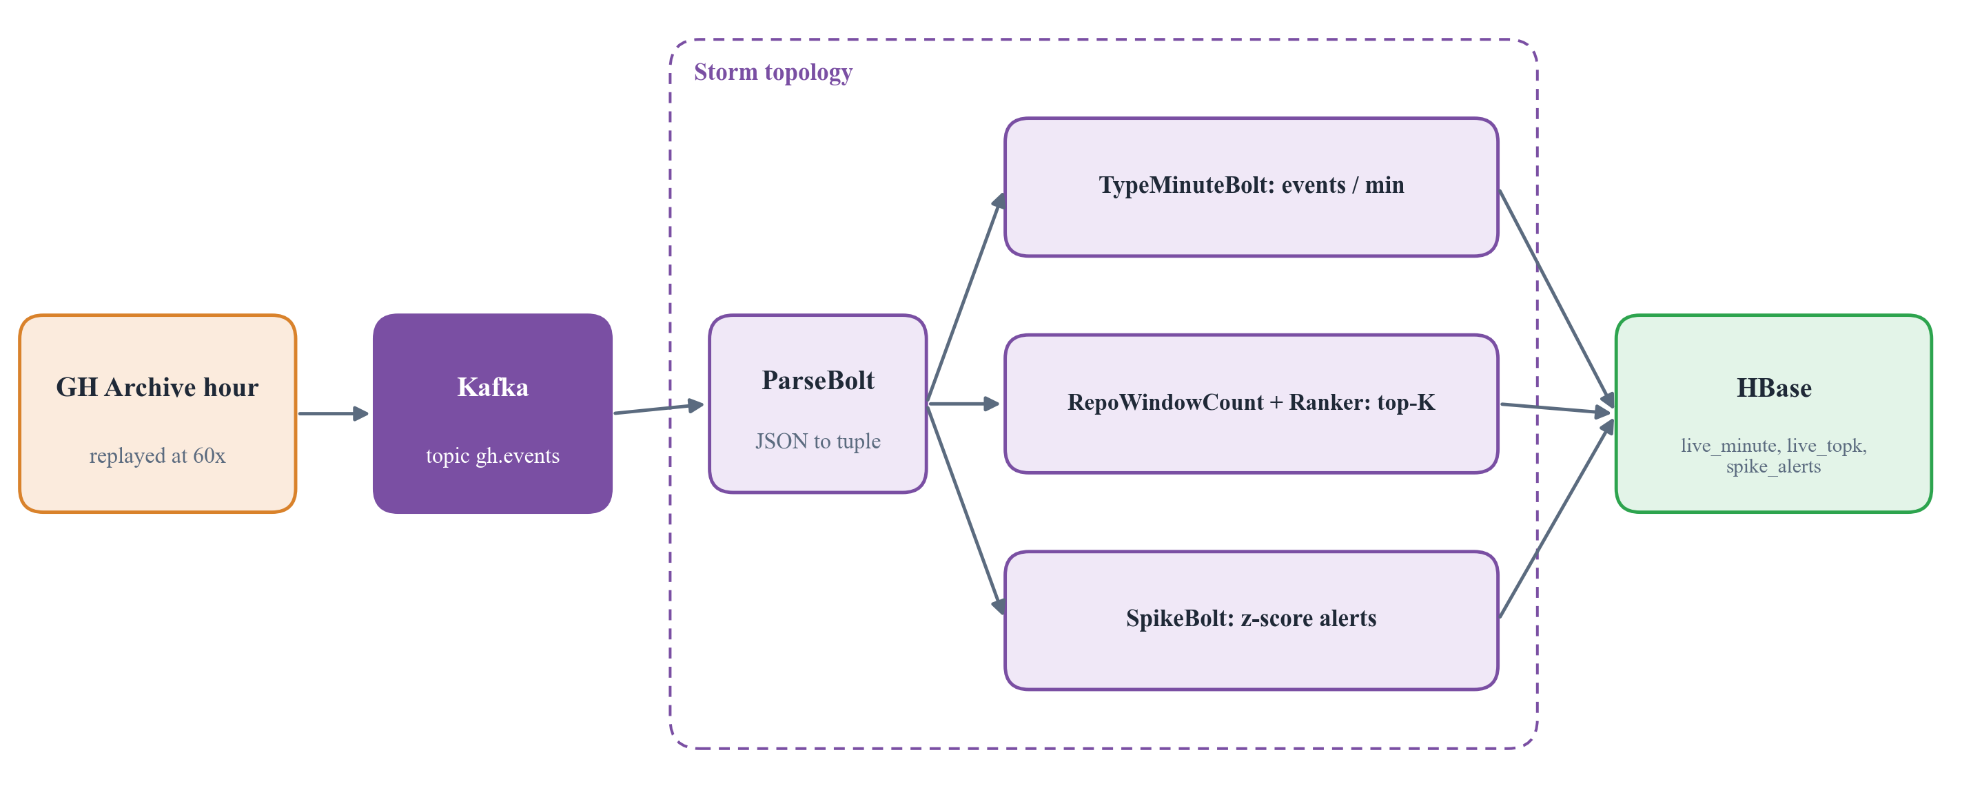
Figure 2.4: Real-time path: Kafka to Storm to HBase
Orchestration
Apache Airflow runs the batch steps as two DAGs (Figure 2.5). gh_pulse_daily runs once for each day of data, from download to the curated quality gate. gh_pulse_models runs once the window is loaded: it seeds the catalogue from the GitHub API, imports it with Sqoop, builds the window tables, runs the three machine learning branches in parallel, loads HBase and exports the results. Each task retries with exponential backoff, except the quality gates, which must stop and not retry.
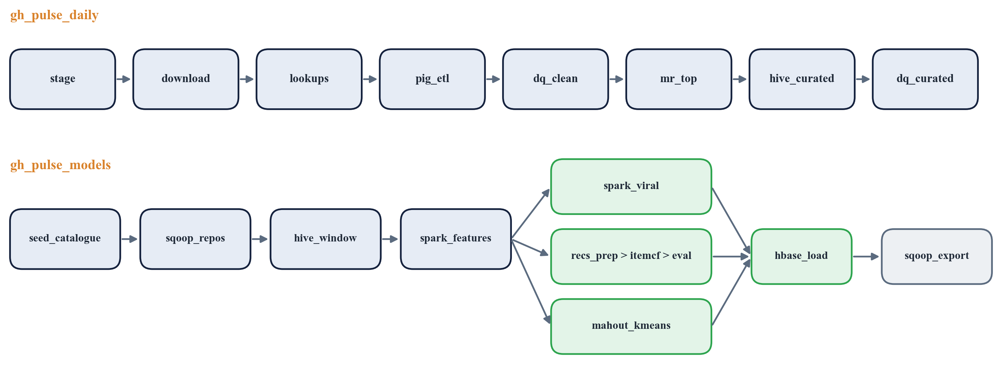
Figure 2.5: The two Airflow DAGs

2.5 Tools Used
Table 2.2 lists every tool in the stack, the version used and the single job it does in GitPulse.
Table 2.2: Tools used and their roles
Tool | Version | Role in GitPulse
HDFS | Hadoop 3.3.6 | Distributed storage for raw, clean, curated and ML zones (replication 2)
YARN | Hadoop 3.3.6 | Allocates CPU and memory to MapReduce, Pig, Hive and Spark jobs
MapReduce | Hadoop 3.3.6 | Custom Java job for the daily top-N repositories per event type
Apache Pig | 0.18.0 | ETL: parse JSON with a Java UDF, deduplicate, tag bots, write Parquet
Apache Hive | 3.1.3 | SQL data warehouse for curated tables and data-quality gates
Apache Sqoop | 1.4.7 | Import lookups and catalogue from PostgreSQL; export results back
Apache Spark | 3.5.9 | Feature engineering, viral model (MLlib), ALS recommendations
Apache Mahout | 0.13.0 | Item-based collaborative filtering and k-means clustering
Apache HBase | 2.5.16 | Low-latency serving of similar repos, recommendations and live counters
Apache Kafka | 3.9 (Confluent 7.9) | Durable message queue for the event stream
Apache Storm | 2.8.9 | Real-time topology: per-minute counts, top-K, spike alerts
Apache Impala | 4.5.3 | Interactive SQL for the dashboard on the same Parquet tables
Apache Airflow | 3.3.2 | Orchestrates both pipelines as DAGs with retries
ZooKeeper | 3.8 | Coordination for HBase and Kafka
PostgreSQL | 16 | Repository catalogue, Hive metastore and exported results
Docker Compose | Docker Desktop | Runs every node as a container on one laptop
Tableau | Desktop / Public | Dashboard over Impala and PostgreSQL extracts

2.6 Software and Hardware Requirements
Table 2.3: Software and hardware requirements
Component | Requirement
Processor | Quad-core 64-bit CPU minimum; 8 or more cores recommended (x86_64 or Apple Silicon)
RAM | 16 GB recommended for the full stages; 8 GB works with LITE=1 mode
Storage | About 30 GB free (15 GB for the sample and demo datasets, 60 GB for the large dataset)
GPU | Not required
Operating System | Windows 10/11, macOS or Linux
Container runtime | Docker Desktop with Docker Compose
Java | Java 8 inside the containers; Maven 3.9 with JDK 17 in a build container
Python | Python 3.12 (Spark jobs, catalogue seeding, Kafka producer, tests)
Shell | Bash (Git Bash on Windows)
Network | Internet access to download GH Archive files and call the GitHub API
Optional | GitHub personal access token (5,000 API requests per hour instead of 60)
Test machine used | Windows 11, 16 CPU threads, 32 GB RAM (15.5 GB given to Docker)

2.7 Dataset Used
Event data comes from GH Archive for September 2025, before GitHub trimmed public event payloads in October 2025. Repository metadata comes from the GitHub REST API and is cached on disk for seven days, with stale entries revalidated by ETag so that they do not use quota. Three dataset sizes are supported with the same commands: sample (3 hours), demo (2 days) and large (8 days). The results in this report use the 15 hours listed in Table 2.4.
Table 2.4: Hours of GH Archive data used
Dataset | Hours (UTC) | Note
sample | 2025-09-01, 12:00 to 14:00 | A Monday
medium | 2025-09-07 and 2025-09-08, 10:00 to 15:00 each | A Sunday and a Monday

Table 2.5: Dataset metrics
Metric | Value
Total events (15 hours) | 2,397,993
Events per hour | About 157,000 to 167,000
Clean, deduplicated events | 2,397,992
Human-only events | 1,685,763
Curated repository-days | 814,035
Curated human stars | 76,864
New repositories for the viral model | 67,585
Users in the recommendation evaluation | 205

CHAPTER 3

Results

3.1 Results
Data quality
Every record is accounted for at every stage (Figure 3.1 and Table 3.1). Out of 2,397,993 downloaded lines, none were malformed and exactly one duplicate event id was removed. Every curated table sums back to the clean count for its day. During development the gates also caught two real problems: an hourly file with no trailing newline, which made the line count differ from Pig's count by one, and 140 events on 2025-09-08 that were already in GitHub's newer trimmed format.
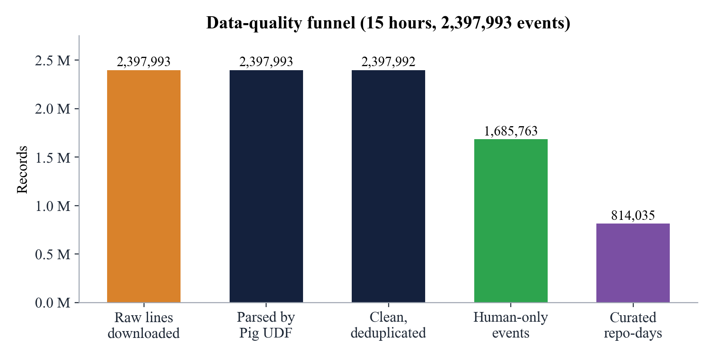
Figure 3.1: Data-quality funnel
Table 3.1: Record counts through the pipeline
Stage | Records
Raw lines downloaded | 2,397,993
Parsed by the Pig UDF | 2,397,993 (0 malformed)
Clean, deduplicated | 2,397,992 (1 duplicate removed)
Clean, human only | 1,685,763
Curated repository-days | 814,035
Curated human stars | 76,864

Answers to the analytical questions
- Q1 Trending: By human stars on 2025-09-01 between 12:00 and 15:00 UTC, the leaders were dockur/windows (168 stars), pewdiepie-archdaemon/dionysus (93) and JetBrains/koog (56). Raw push volume, in contrast, was led by an automated repository with 4,138 pushes in three hours, which is why the catalogue is ranked by distinct human actors.
- Q3 Activity clock: Sunday's 10:00 to 15:00 UTC hours carried about 157,000 events per hour against 162,000 on the weekday, only about 3% less.
- Q4 Bots: Bots produce 28% to 32% of all events. They write 60% of commit comments, 52% of issue comments and 49% of pull request events (Figure 3.2).
- Q5 Maintenance: For human-authored pull requests, NixOS/nixpkgs merges 93% of closed pull requests with a median of about 38 hours open.
- Q6 Solo versus community: Of 11,754 repositories with at least 20 events, 6,083 are solo projects, 1,877 are small teams and only 407 are community projects (top contributor below 50% and at least 10 contributors), as shown in Figure 3.3.
- Q10 Clusters: Mahout k-means with k = 6 separated push-only solo projects, bot-driven pushes, pull request and push collaboration, discussion-heavy projects, and star and issue magnets.
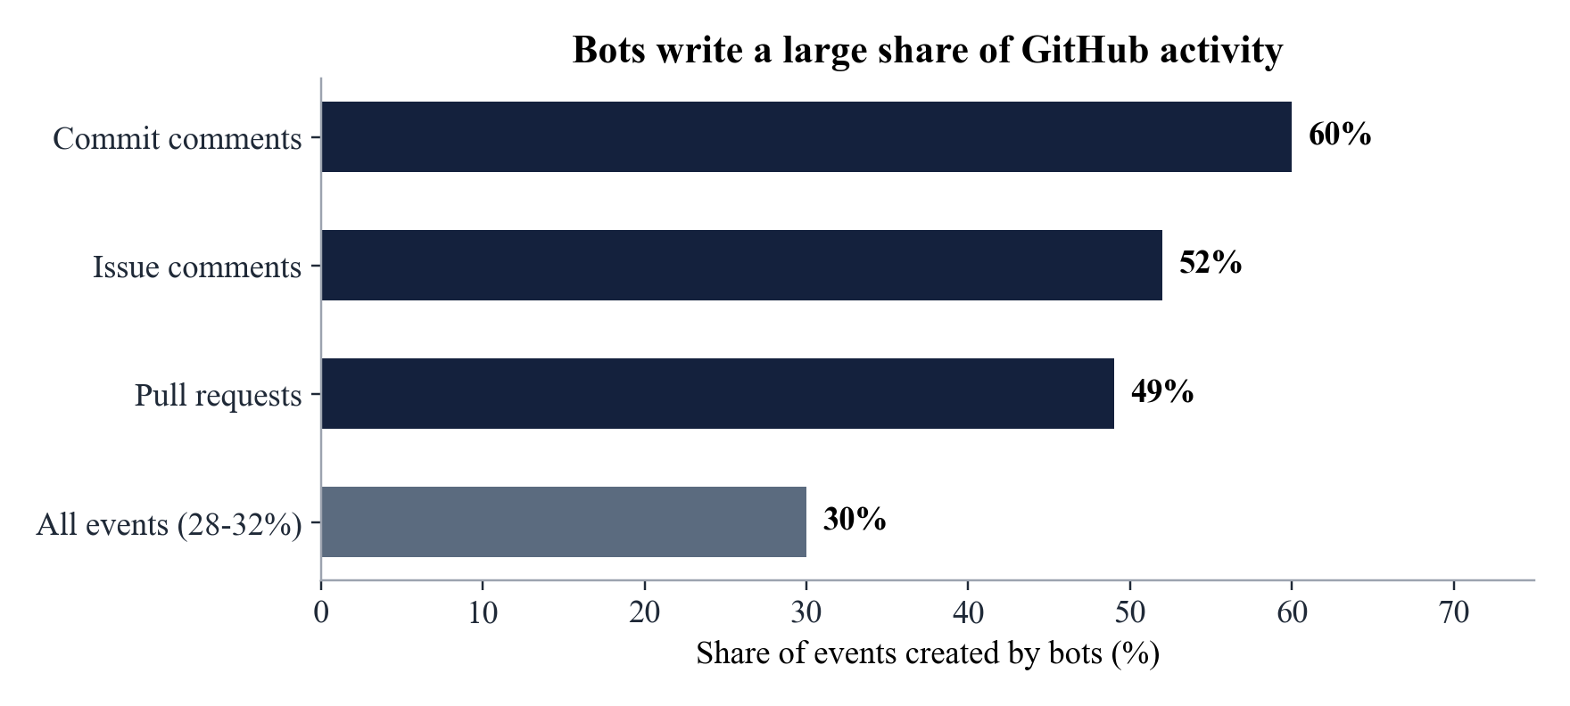
Figure 3.2: Share of events created by bots
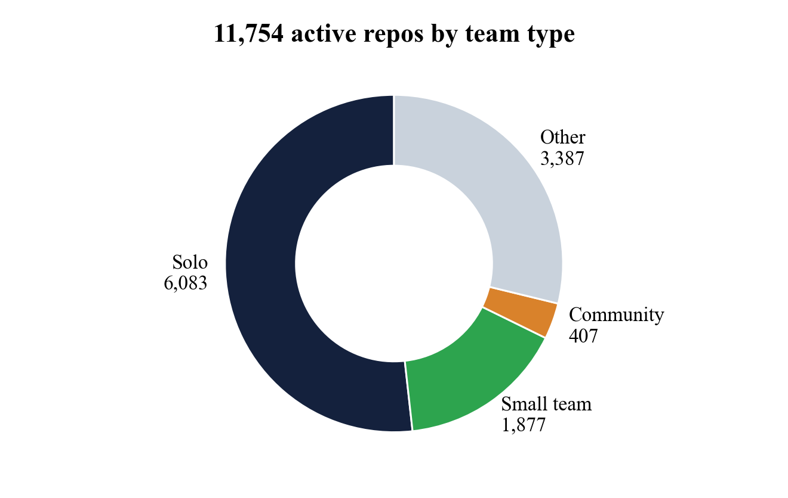
Figure 3.3: Active repositories by team type
Machine learning results
Table 3.2 and Figure 3.4 compare the recommenders on 205 users, holding out each user's latest 20% of stars. Mahout item-based filtering is best on every metric. Its recall at 10 is about six times that of the popularity baseline, and it covers 53% of the catalogue against 24% for Spark ALS.
Table 3.2: Recommendation results
Method | Hit rate | Recall@10 | Precision@10 | Coverage
Mahout item CF (LLR) | 0.263 | 0.251 | 0.028 | 0.53
Spark ALS (implicit, rank 16) | 0.259 | 0.237 | 0.026 | 0.24
Popularity baseline | 0.044 | 0.041 | 0.004 | 0.01

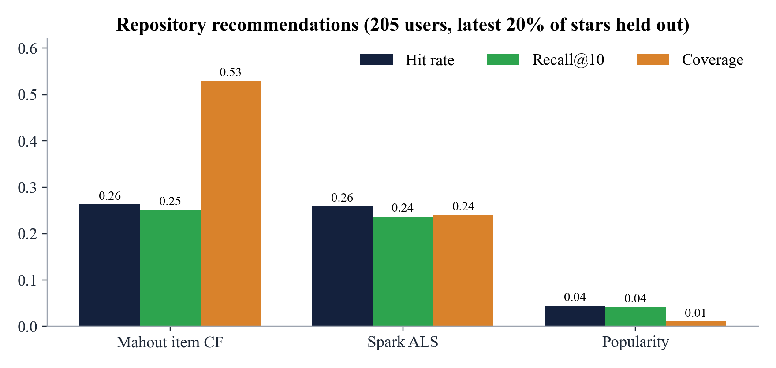
Figure 3.4: Comparison of recommendation methods
For viral prediction (1 hour of features, 3 hour label, split by time, 67,585 new repositories and 40 positives in the test set), logistic regression reached an AUC-ROC of 0.73 and an AUC-PR of 0.0033 against a base rate of 0.0012, a lift of 2.7 times. Gradient-boosted trees reached an AUC-ROC of 0.55. This is a weak but real signal, and the model is designed for the longer 24 hour and 5 day setting on the large dataset.
Table 3.3: Viral prediction results
Model | AUC-ROC | AUC-PR | Lift over base rate
Logistic regression | 0.73 | 0.0033 | 2.7x
Gradient-boosted trees | 0.55 | n/a | n/a

Real-time results
One GitHub hour of 166,000 to 167,000 events was replayed at 60 times speed in about 65 seconds through Kafka and Storm with 0 failed tuples. It produced 60 per-minute rows, 60 rolling top 10 windows and several spike alerts. For example, ursacomputing/crossbow went from no activity to 104 events in one minute, and hotspotlab/hourly reached 18 events against a mean of 0.41 (z = 12.8).
Engine benchmark
The same three queries were run on the same Parquet tables with MapReduce, Pig, Hive on MapReduce, Spark SQL and Impala (Table 3.4 and Figure 3.5). At this data size start-up time dominates: Impala's long-running daemons answer in about 1.3 seconds, while the JVM and YARN engines need 20 to 40 seconds before they read any data. MapReduce scales worst because it starts one map task for each small Parquet file created by the date and event-type partitions, while Pig combines small files into larger splits. A second worker gave a speed-up of only 1.0 to 1.9 times, because both NodeManagers share the same laptop CPU.
Table 3.4: Median query time in seconds by engine
Size (clean Parquet) | Workers | MapReduce | Pig | Hive (MR) | Spark SQL | Impala
sample (0.028 GB) | 1 | 62 to 71 | 27 to 43 | 20 to 39 | 37 to 38 | 1.2 to 1.3
sample (0.028 GB) | 2 | 53 to 59 | 27 to 38 | 15 to 28 | 20 to 37 | n/a
medium (0.130 GB) | 1 | 162 to 175 | 40 to 48 | 23 to 39 | 38 to 39 | 1.4 to 1.5

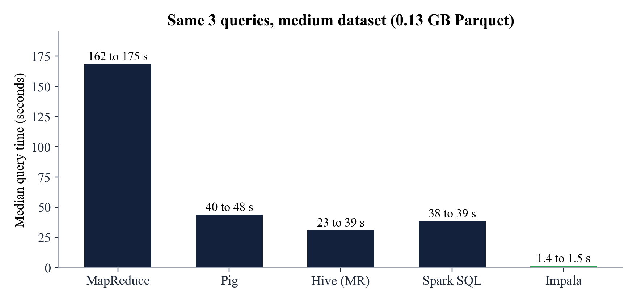
Figure 3.5: Median query time by engine, medium dataset
End-to-end test run
To test the complete system we ran it from scratch on a Windows 11 laptop with 15.5 GB of memory given to Docker, using the sample dataset (2025-09-01, 12:00 to 14:00 UTC). The cluster smoke test confirmed 2 live DataNodes, 2 NodeManagers, a completed MapReduce job and an average block replication of 2.0. All 10 JUnit tests (Pig UDF, MapReduce on LocalJobRunner and the Storm topology on LocalCluster) and the pytest suite for the Pig ETL passed. All 25 steps of both pipelines then passed, in about 58 minutes in total (Table 3.5 and Figure 3.6).
The run loaded 497,262 events with 0 malformed lines and 0 duplicates. The bot share was 31.6%, inside the 28% to 32% range seen on the larger data. The final end-to-end script found 375 trending rows exported to PostgreSQL, a working HBase similar-repositories lookup (people who starred vinta/awesome-python also starred project-based-learning, 100-Days-Of-ML-Code and sindresorhus/awesome), and 10,614 PushEvents counted by Storm in HBase from a two-minute replay.
Table 3.5: Steps of the end-to-end test run
# | Pipeline step | Time (s) | Result
1 | stage_warehouse | 47 | Passed
2 | ddl | 26 | Passed
3 | catalogue_init | 1 | Passed
4 | sqoop_import_lookups | 93 | Passed
5 | pig_etl | 178 | Passed
6 | dq_clean | 103 | Passed
7 | mr_top | 105 | Passed
8 | hive_curated | 551 | Passed
9 | dq_curated | 191 | Passed
10 | seed_catalogue | 134 | Passed
11 | sqoop_import_repos | 65 | Passed
12 | hive_window | 278 | Passed
13 | stage_ml | 13 | Passed
14 | spark_features | 68 | Passed
15 | spark_viral | 95 | Passed
16 | recs_prep | 53 | Passed
17 | mahout_itemcf | 490 | Passed
18 | recs_eval | 97 | Passed
19 | mahout_kmeans | 260 | Passed
20 | hbase_prep | 57 | Passed
21 | stage_serving | 48 | Passed
22 | hbase_init | 22 | Passed
23 | hbase_load | 352 | Passed
24 | stage_warehouse (again) | 41 | Passed
25 | sqoop_export | 114 | Passed

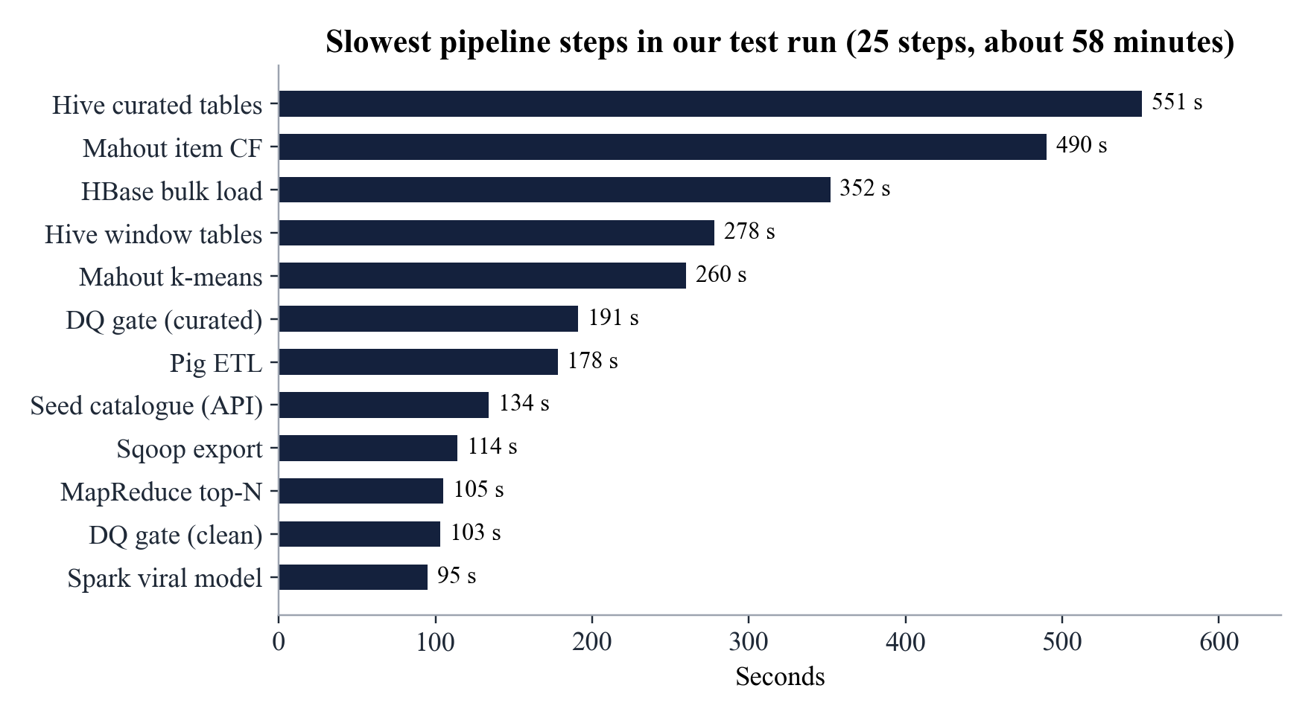
Figure 3.6: Slowest steps of the test run
Table 3.6: Summary of tests
Check | Outcome
Cluster smoke test | 2 DataNodes, 2 NodeManagers, MapReduce pi job, replication 2.0
JUnit (Pig UDF, MapReduce, Storm) | 10 of 10 passed
pytest (Pig ETL in local mode) | 1 of 1 passed
Data-quality gates (clean and curated) | All assertions passed
Batch and models pipelines | 25 of 25 steps passed
End-to-end checks (PostgreSQL, HBase, Storm) | Passed

Cluster user interfaces
Figures 3.7 to 3.10 show the web interfaces of the running cluster: the HDFS NameNode with both DataNodes in service, the MapReduce JobHistory with completed Hive jobs, Impala's completed queries and the HBase Master with its region server.
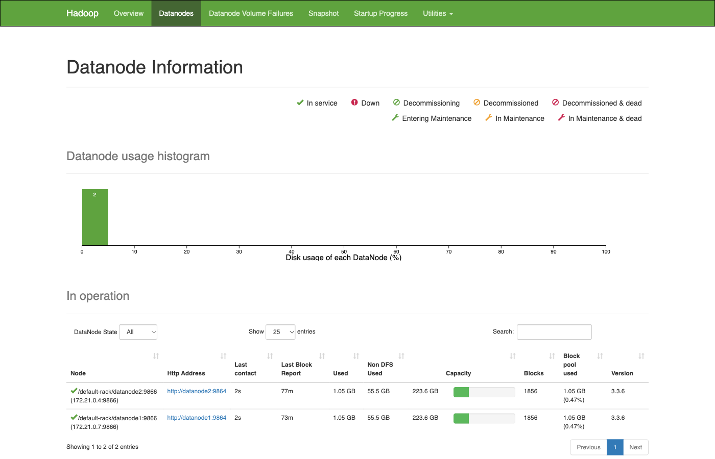
Figure 3.7: HDFS NameNode: two DataNodes in service
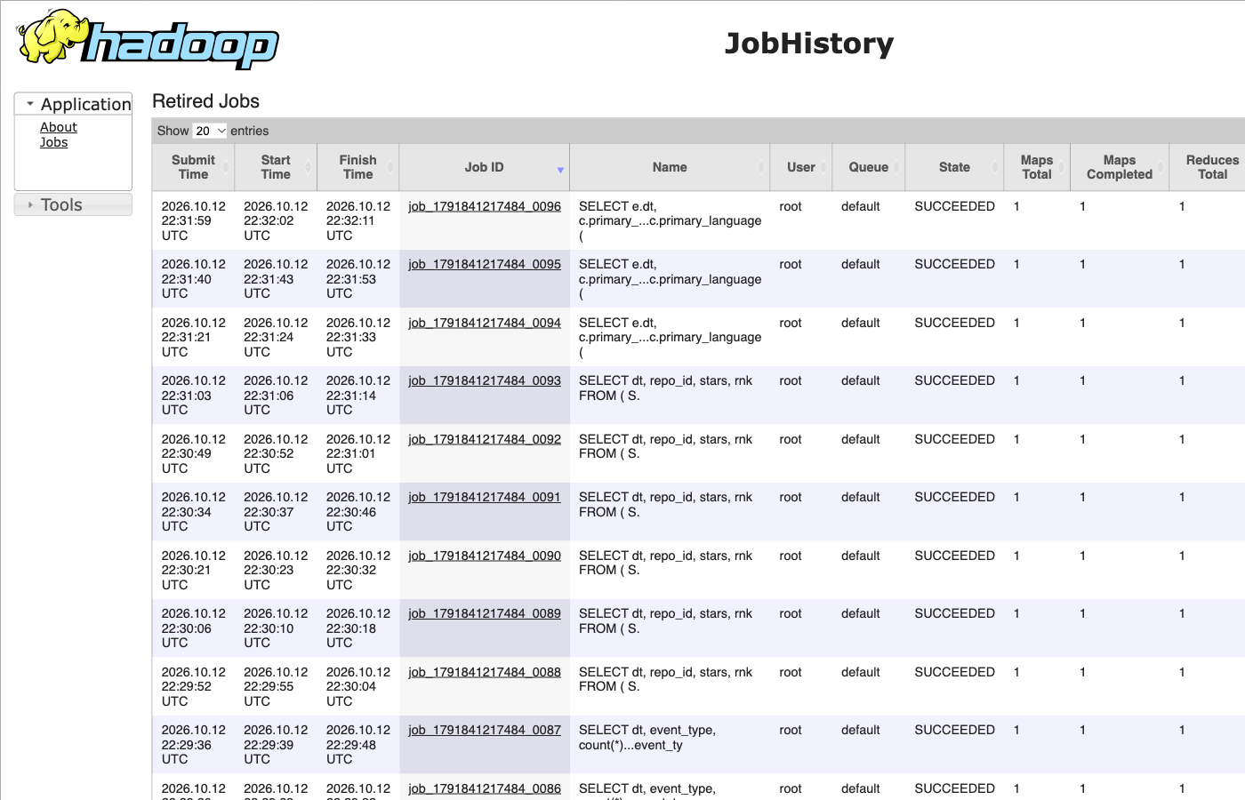
Figure 3.8: MapReduce JobHistory: completed jobs
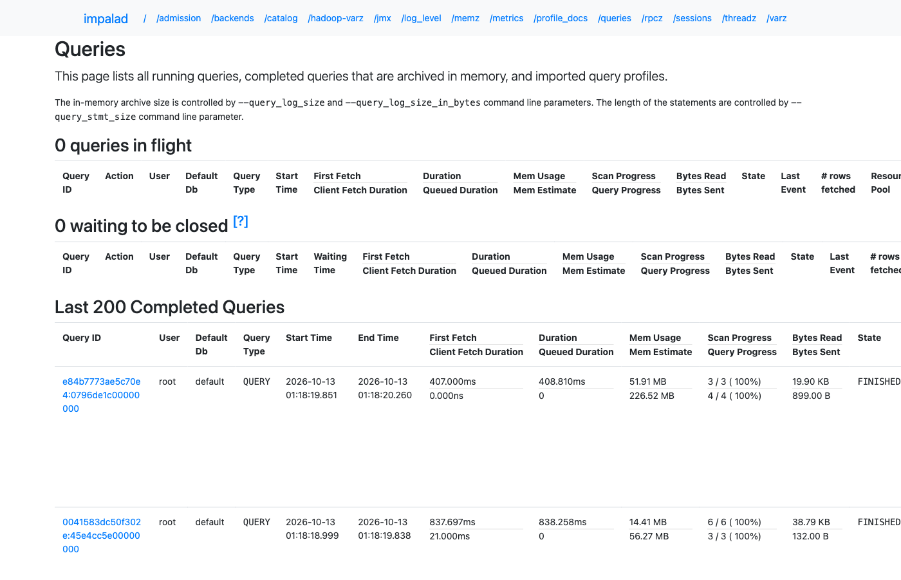
Figure 3.9: Impala daemon: completed queries
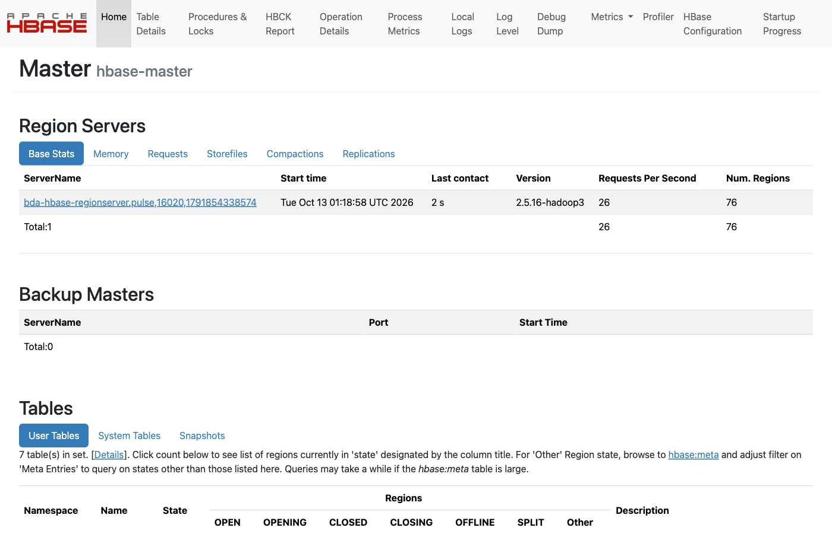
Figure 3.10: HBase Master with its region server
CHAPTER 4

Conclusion and future work
This project delivers GitPulse, a complete and tested big data analytics platform for public GitHub activity. It combines twelve tools from the Hadoop ecosystem, each used for the job it suits best: Pig for ETL, MapReduce for top-N ranking, Hive and Impala for SQL analytics, Spark and Mahout for machine learning, HBase for low-latency serving, Kafka and Storm for real-time processing, Sqoop for moving data to and from PostgreSQL, and Airflow for orchestration. Memory-aware stages make the whole multi-node cluster run on a single laptop.
The results show that the pipeline is trustworthy and that the data holds real insight. Data-quality gates account for every one of the 2.4 million events, with no malformed lines and one duplicate. Bots create close to a third of all GitHub activity and more than half of all comments. Most active repositories are solo projects. Mahout item-based filtering recommends repositories about six times better than popularity. The real-time path processes a full GitHub hour in about a minute with no failed tuples. The engine benchmark shows that for small, partitioned data, start-up cost and the small-files problem matter more than raw processing speed, which is why Impala answers in about a second while the YARN engines take 20 to 170 seconds. An end-to-end run on a Windows laptop passed all 25 pipeline steps and every test.
Future enhancements include running both pipelines on the full 8-day dataset, which the viral model is designed for, and replacing the replay with the live GitHub API feed that is already implemented. Other improvements are comparing Storm with Spark Structured Streaming, deploying the stack on a real multi-node cluster or a managed cloud service to measure true horizontal scaling, compacting small Parquet files to remove the small-files penalty, and publishing the Tableau dashboard for public use.

REFERENCES
[1] GH Archive, "GH Archive: A Project to Record the Public GitHub Timeline." Available: https://www.gharchive.org/.
[2] J. Dean and S. Ghemawat, "MapReduce: Simplified Data Processing on Large Clusters," in Proc. 6th USENIX Symposium on Operating Systems Design and Implementation (OSDI), 2004.
[3] K. Shvachko, H. Kuang, S. Radia and R. Chansler, "The Hadoop Distributed File System," in Proc. IEEE 26th Symposium on Mass Storage Systems and Technologies (MSST), 2010.
[4] V. K. Vavilapalli et al., "Apache Hadoop YARN: Yet Another Resource Negotiator," in Proc. 4th ACM Symposium on Cloud Computing (SoCC), 2013.
[5] C. Olston, B. Reed, U. Srivastava, R. Kumar and A. Tomkins, "Pig Latin: A Not-So-Foreign Language for Data Processing," in Proc. ACM SIGMOD, 2008.
[6] A. Thusoo et al., "Hive: A Warehousing Solution over a Map-Reduce Framework," Proceedings of the VLDB Endowment, vol. 2, no. 2, 2009.
[7] M. Zaharia et al., "Resilient Distributed Datasets: A Fault-Tolerant Abstraction for In-Memory Cluster Computing," in Proc. 9th USENIX NSDI, 2012.
[8] J. Kreps, N. Narkhede and J. Rao, "Kafka: A Distributed Messaging System for Log Processing," in Proc. NetDB Workshop, 2011.
[9] A. Toshniwal et al., "Storm@Twitter," in Proc. ACM SIGMOD, 2014.
[10] M. Kornacker et al., "Impala: A Modern, Open-Source SQL Engine for Hadoop," in Proc. 7th Biennial Conference on Innovative Data Systems Research (CIDR), 2015.
[11] F. Chang et al., "Bigtable: A Distributed Storage System for Structured Data," in Proc. 7th USENIX OSDI, 2006.
[12] B. Sarwar, G. Karypis, J. Konstan and J. Riedl, "Item-Based Collaborative Filtering Recommendation Algorithms," in Proc. 10th International World Wide Web Conference (WWW), 2001.
[13] Y. Hu, Y. Koren and C. Volinsky, "Collaborative Filtering for Implicit Feedback Datasets," in Proc. 8th IEEE International Conference on Data Mining (ICDM), 2008.
[14] T. Dunning, "Accurate Methods for the Statistics of Surprise and Coincidence," Computational Linguistics, vol. 19, no. 1, pp. 61-74, 1993.
[15] N. Marz and J. Warren, Big Data: Principles and Best Practices of Scalable Realtime Data Systems. Manning Publications, 2015.

