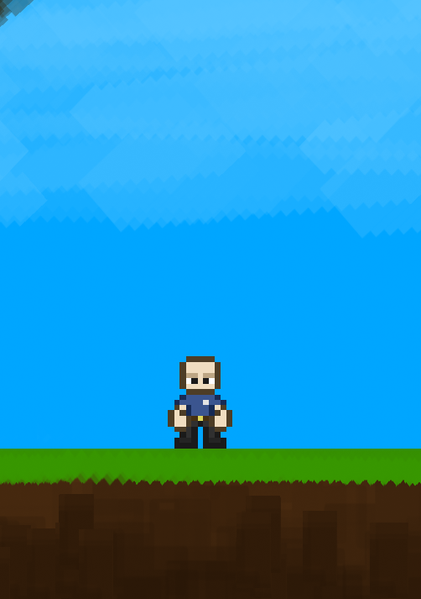

Documentation

CB Gym Rats

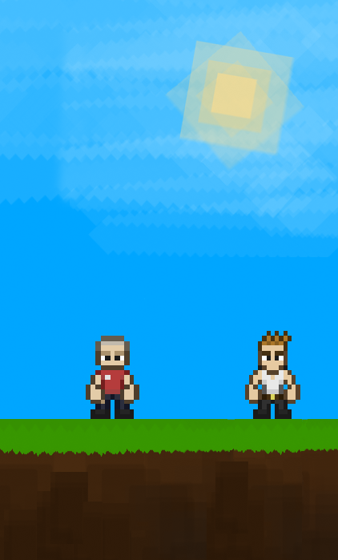

Contents

1. Team……………………………………………………………………………………. 3
2. Introduction…………………………………………………………………………. 3
3. Method and manner of implementation………………………………. 4

1. Team

|  |  |  |
| --- | --- | --- |
| **#** | **Name** | **Role** |
| 1 | Kaloyan Georgiev | Scrum Trainer |
| 2 | Ivailo Buchvarov | Back-End developer |
| 3 | Georgi Filipov | Front-End developer |
| 4 | Simeon Syarov | Quality assurance engineer |

1. Introduction

* Product

The product is a Cplusplus application about the adventure of Stanislav the book worm. The target of the game is to make people feel relaxed and play it so they can enjoy their time spent with the game. Also, it can be used at primary schools to test student’s knowledge in a different and interesting way.

* Where is it available?

You can find our collaborative work in GitHub. Files are accessible to everyone by the GitHub Repository we created about our project.

* Communication

We communicated through Microsoft Teams. This platform is the best talking to communication about working in team. Thanks to all features we easily got in touch with each other and helped ourselves.

* Used technologies

The technologies that we used are Visual Studio 2022 as an integrated development environment. Cplusplus as a programming language. Microsoft Word for the documentation, Microsoft PowerPoint for the presentation, GitHub for collaborative work.

1. **Methods and manners of implementation**

* Task alignment

Each person is assigned a task in which he does well to complete the task to the best of his ability

* Terms

Observance of dates was reminded by the Scrum Trainer. A meeting of the team is held when everyone is online to discuss the amount of time needed to complete the assigned task.

* Productive work

The tasks are defined in a way that everyone is aware of the tasks performed so far.