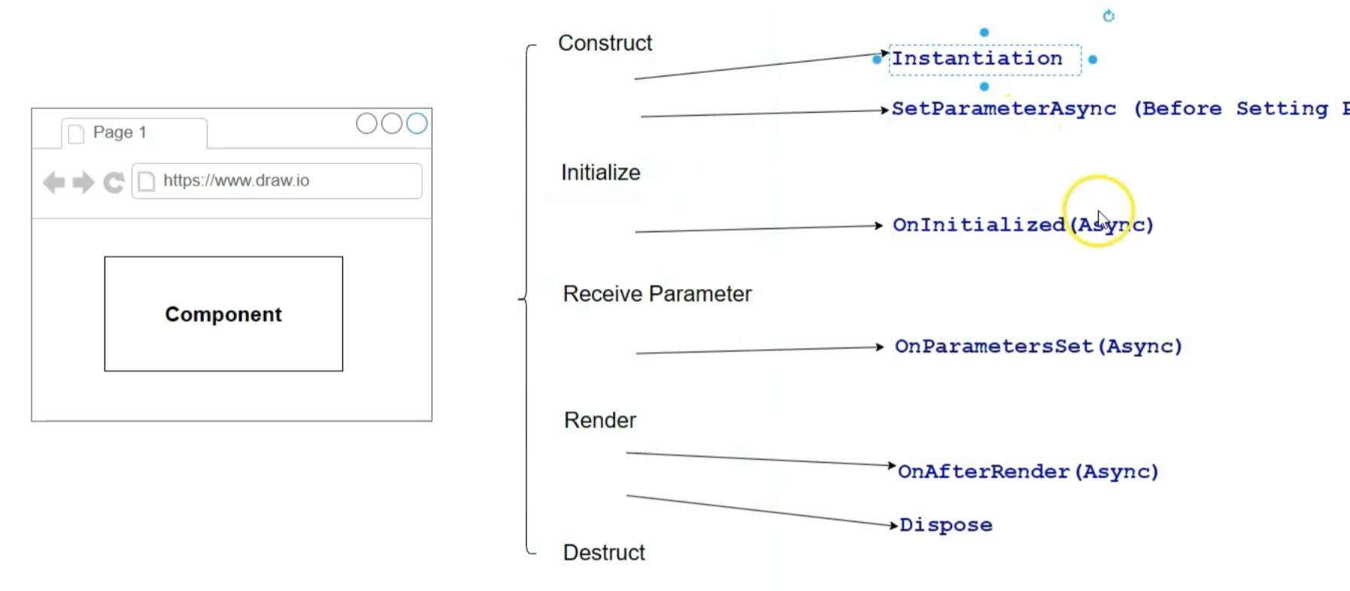
Keep in mind that in interactive mode this loop runs twice on init… because the SSR part to establish the Webhook SignalR channel needs to be established before interactivity can begin
This is a problem when doing resource intensive stuff aka DB… se solution on next page
Construct:
1. SetParameterAsync() - At this point the parameter fields still contain the old value
2. [Parameter]
public string? City { get; set; }
3. OnInitialized() - Only once
UI User loop

4. OnParametersSet() - Happens for the entire UI interaction Danger: its called for EACH
Intermission StateHasChanged - Manual re-render
5. ShouldRender() - can stop re-render But only once the interactivity is established and in a re-render, So this will not run on the first loading sequence
6. OnAfterRender() Only in interactive, because there is no component re render in SSR by principle
7. Dispose() – Requires @Disposable in the component at the top
General rules:
1. Parents render before child components..
2. After Render gets Stackt all the way in to the end yet keeping the order Parent before child
3. if the parent has no changes… ShouldRender and AfterRender is called anyways, because the rendering screen needs to be redrawn parent or not
4.Where possible Parents should hold db states
5. Never sprinkle Casscading Parameters, because it hides interfaces
Best practice until .net 9 was put it onAfterRender and fire StateHasChanged(). Feels clunky
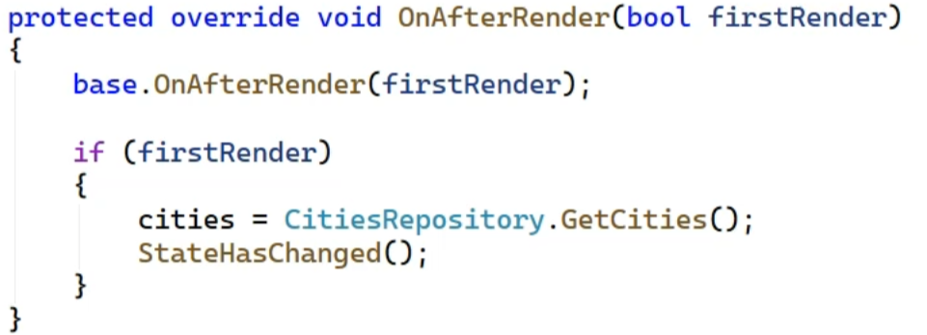

Since .Net9 you can check if the interactive channel is established This moves the init code where it belongs , which is OnInitialized()
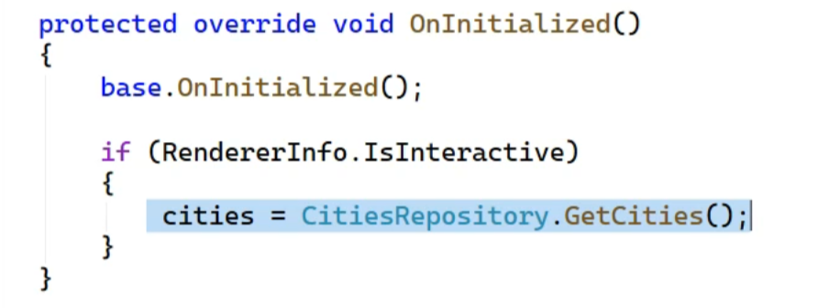

There is a problem with OnParameterSet()
It is called for EVERY parameter…. 10 Parameters will cause 10 calls of that Hook!!!
We can make use of SetParametersAsync, because we can compare incoming values with the old values that are still in the parameters.
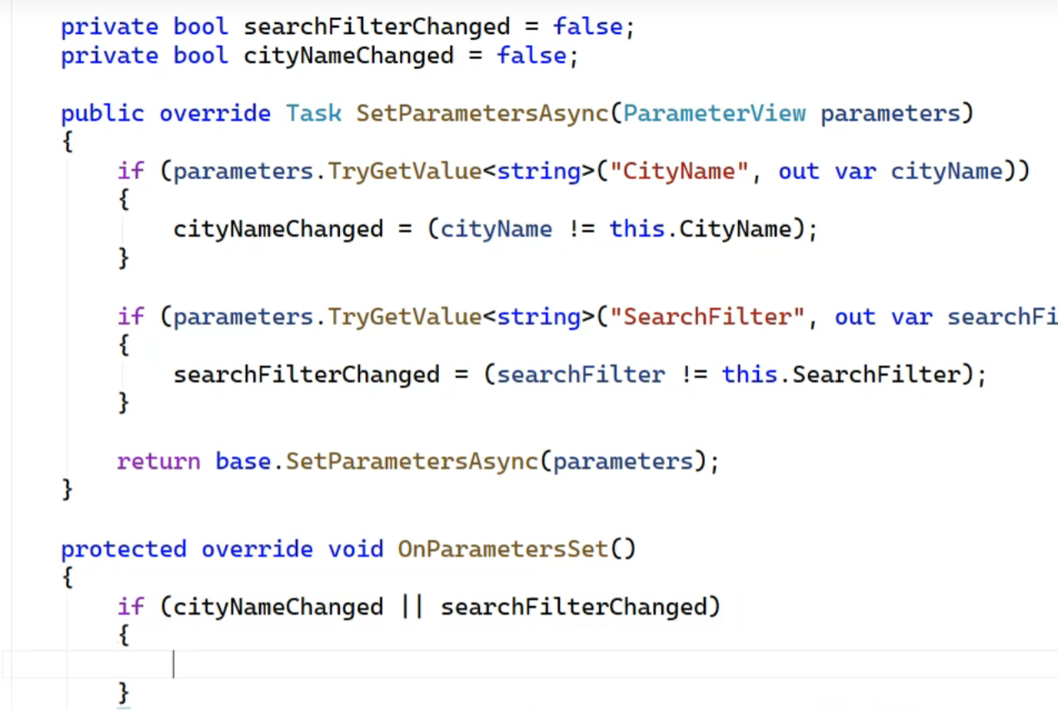

When does Re-Render happen
- First time Creation (explicit render Request)
- When events are triggered (meaning UI events, not internal delegates)
This also happens for empty events like this: @onclick=”@(()=>{}) !!!
- Changes in state variables…
  - In Parent child relationship and parent causes even child is re-rendered ifnothing changed only for complex types
  - Details matter on the datatypes
- Manual trigger with StateHasChanged() especially when the Screen is drawn but update came in late
  - Needed in Async calls…. Call might return after Screen was drawn
  - Internal non UI Delegates calls especially if that delegate “internally” changes states, Blazor will not know

Accidental Re-Rendering of large lists
If A top level component has child component… if the parameters are primitive, there will be no rerendering of children will not be a problem, Blazor can compare

But!!! If it’s a complex type Blazor wont know in detail will have changed… there for brute force renders everything again.
Use ShouldRender to improve that especially in lists.
- In the child component it becomes your duty to figure out if you should re-render that component or not by usind ShouldRender() and inspecting the parameters
- But you have to keep an “inner State” (not parameter) to compare what makes this very clumbsy

Carefull with starting Methods on other Threads, threads started outside of the server assigned Thread context can not be reverse associated with the User Thread within blazor they may have originated from.
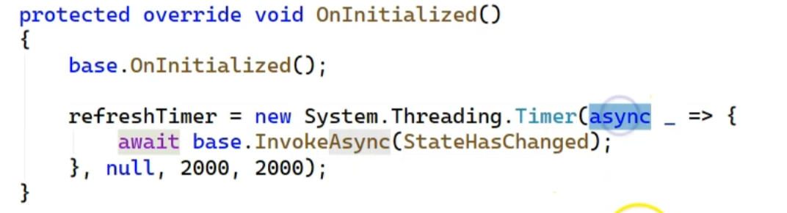

Navigation can be tampered with but beware the navigation router needs to be set to interactive for this to work
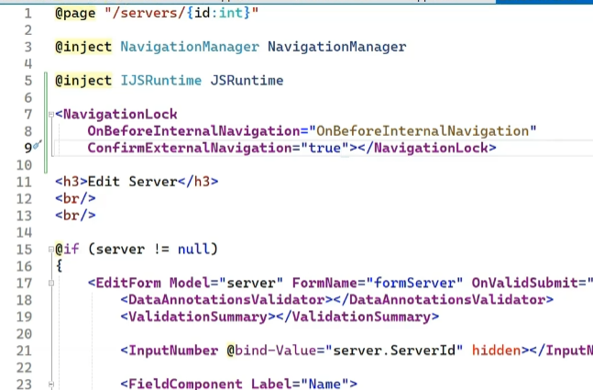

State:
- Local storage is global but per domain and it survives Browser closing
- Session storage is per domain AND each instance of that domain and does not survive Browser closing
Prefer SessionStorage over localStorage!
You can also use the dependency container with AddScope to share data across the SignalR lifetime

Dependency injection
- AddTransient: just gives you an instance, like calling new
- AddScoped: creates an instance per request
- AddSingleton: creates one instance for entire application

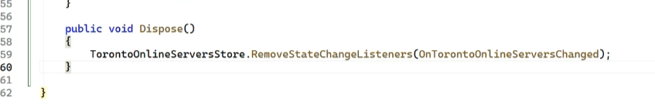

Dispose

