Quick Cart Hub – a grocery mart

INTRODUCTION

* OVERVIEW

The Grocery Mart Management System is a Python-based project aimed at streamlining the operations of a grocery store through the utilization of object-oriented programming (OOP) principles. This project serves as a virtual platform for managing billing, processing transactions, and providing an efficient shopping experience for both customers and store owners.

With the increasing demand for efficient inventory management systems in the retail sector, the Grocery Mart Management System offers a robust solution tailored to the needs of small to medium-sized grocery stores. By harnessing the power of Python's OOP paradigm, the project ensures modularity, extensibility, and maintainability, facilitating seamless scalability as the business grows.

Through this report, we delve into the intricacies of the Grocery Mart Management System, exploring its design, functionality, and implementation details. From its user-friendly interface to its sophisticated backend operations, this project represents a fusion of technology and retail management, aimed at optimizing processes and enhancing productivity.

The Grocery Mart Management System is a software application designed to facilitate the efficient management of a grocery store's operations. Built using Python and following object-oriented programming principles, the system offers a comprehensive suite of features tailored to the needs of both store owners and customers.

System Requirements and functionality

* Admin side :
  + **Hardware requirement**
    - * Computer system with normal configurations
  + **Software requirement**
    - * Python installed
      * Command prompt / terminal
      * mysql installed
      * Required libraries : prettytable, datetime
* User side :
  + **Hardware requirement**
    - * Computer system with normal configurations
  + **Software requirement**
    - * Python installed
      * Command prompt / terminal
      * mysql installed
      * Required libraries : prettytable, datetime
* Server side :

* + Local hosting for the project
  + Uses local database
* Developer side
  + **Hardware requirement**
    - * Computer system with normal configurations
  + **Software requirement**
    - * Python installed
      * Command prompt / terminal
      * mysql installed
      * Required libraries : prettytable, datetime
      * Testing Devices: Include a variety of devices for testing purposes to ensure compatibility and responsiveness
      * Development tool : text editor

BACK END OF THE SYSTEM

* DATABASE USED : MySQL
* **Data Source Selection**:
  + Begin by specifying that your application will use a **MySQL database** as its data source.
  + Mention the reasons for choosing MySQL, such as its reliability, scalability, and widespread adoption.
* **Database Schema**:
  + Outline the structure of your MySQL database.
  + Define the **tables**, **columns**, and their relationships.
  + Specify any **constraints**, such as primary keys, foreign keys, and unique indexes.
* **Table schema diagram**

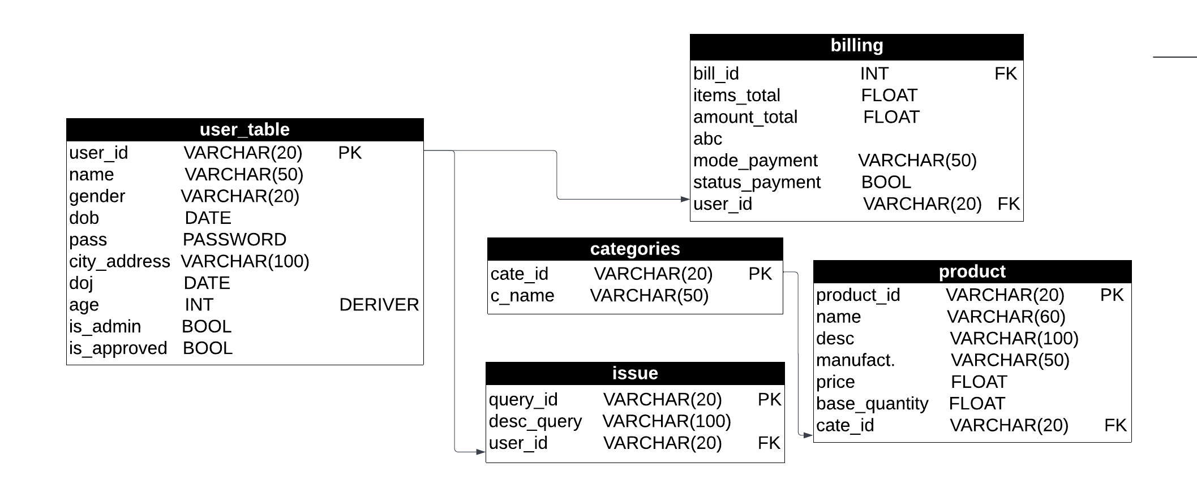

**System design**



**ACTIVITIES**

* **Admin Side Activities:**

1. MANAGE USER:

- This functionality allows the admin to manage user accounts within the system.

- It includes tasks such as creating new user accounts, updating existing user information, and deleting user accounts if necessary.

- The admin can also potentially assign roles or permissions to different users.

2. MANAGE CATEGORY:

- With this feature, the admin can oversee the categories of products available in the grocery mart inventory.

- This involves tasks like adding new categories, modifying existing ones, or removing categories that are no longer relevant.

3. MANAGE PRODUCT:

- This functionality empowers the admin to manage the products within each category.

- It includes tasks such as adding new products to the inventory, updating product information like price or quantity, and removing products that are discontinued or out of stock.

4. VIEW BILLING:

- This feature enables the admin to access and review billing information.

- It may include viewing past transactions, generating reports on sales, and monitoring overall revenue and profit margins.

5. VIEW ISSUES:

- Admins can view any issues or complaints raised by users through this functionality.

- This may involve investigating the nature of the problem, communicating with the user for clarification, and taking appropriate actions to resolve the issue.

6. LOG OUT:

- This option allows the admin to securely log out of the system, ensuring the confidentiality and security of sensitive information.

- This will redirect the user directly to the log in page

* **User Side Activities:**

1. SHOW CATEGORIES:

- Users can view the different categories of products available in the grocery mart through this feature.

- It provides an overview of the types of products offered, helping users navigate through the inventory more efficiently.

2. SHOW PRODUCTS:

- Users can explore the products available within each category using this functionality.

- It allows them to browse through the available items, view their descriptions, and potentially check their prices and availability.

3. SELECT PRODUCTS:

- With this feature, users can select the products they wish to purchase and add them to their virtual shopping cart.

- It facilitates the process of creating a list of desired items before proceeding to the checkout and payment stage.

4. BILLING:

- This functionality enables users to generate a bill for their selected items and proceed with the payment process.

- It may include calculating the total cost, applying any discounts or promotions, and generating a receipt for the transaction.

5. RAISE ISSUES:

- Users can use this feature to raise any concerns or issues they encounter during their shopping experience.

- This could include problems with products, billing discrepancies, or issues with the user interface. The system captures these issues for the admin to review and resolve.

6. LOG OUT:

- Similar to the admin side, this option allows users to securely log out of their accounts, ensuring the security of their personal information and transactions.

- This will redirect the user directly to the log in page

**DATA DICTIONARY**

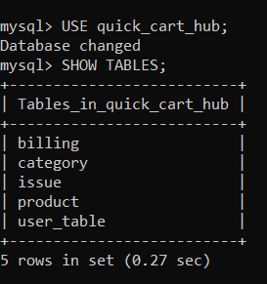

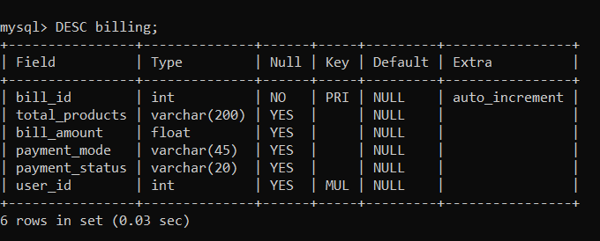

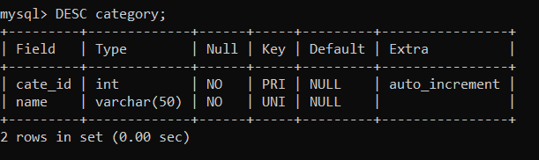

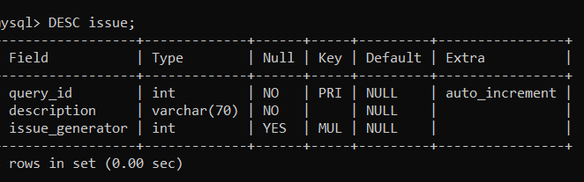

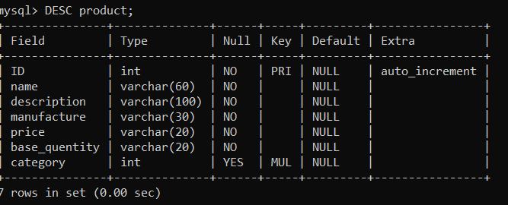

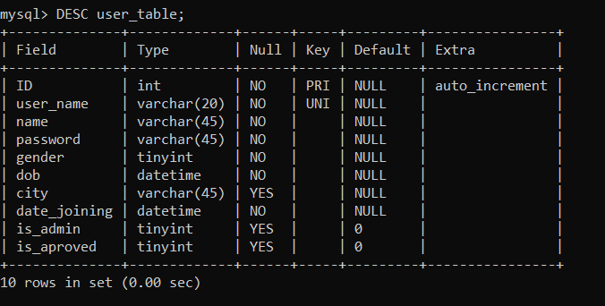

**TESTING**