## Przykład 1:

CREATE TABLE gesiak.intersects AS  
SELECT a.rast, b.municipality  
FROM rasters.dem AS a, vectors.porto_parishes AS b  
WHERE ST_Intersects(a.rast, b.geom) AND b.municipality ilike 'porto';

## Przykład 2:

CREATE TABLE gesiak.clip AS  
SELECT ST_Clip(a.rast, b.geom, true), b.municipality  
FROM rasters.dem AS a, vectors.porto_parishes AS b  
WHERE ST_Intersects(a.rast, b.geom) AND b.municipality like 'PORTO';

## Przykład 3:

CREATE TABLE gesiak.union AS  
SELECT ST_Union(ST_Clip(a.rast, b.geom, true))  
FROM rasters.dem AS a, vectors.porto_parishes AS b  
WHERE b.municipality ilike 'porto' and ST_Intersects(b.geom,a.rast);



## Przykład 4:

CREATE TABLE gesiak.porto_parishes AS  
WITH r AS (  
SELECT rast FROM rasters.dem  
LIMIT 1  
)  
SELECT ST_AsRaster(a.geom,r.rast,'8BUI',[a.id](http://a.id),-32767) AS rast  
FROM vectors.porto_parishes AS a, r  
WHERE a.municipality ilike 'porto';

## Przykład 5:

DROP TABLE gesiak.porto_parishes;  
CREATE TABLE gesiak.porto_parishes AS  
WITH r AS (  
SELECT rast FROM rasters.dem  
LIMIT 1  
)  
SELECT st_union(ST_AsRaster(a.geom,r.rast,'8BUI',[a.id](http://a.id),-32767)) AS rast  
FROM vectors.porto_parishes AS a, r  
WHERE a.municipality ilike 'porto';



## Przykład 6:

DROP TABLE gesiak.porto_parishes;  
CREATE TABLE gesiak.porto_parishes AS  
WITH r AS (  
SELECT rast FROM rasters.dem  
LIMIT 1 )  
SELECT st_tile(st_union(ST_AsRaster(a.geom,r.rast,'8BUI',[a.id](http://a.id),-  
32767)),128,128,true,-32767) AS rast  
FROM vectors.porto_parishes AS a, r  
WHERE a.municipality ilike 'porto';

## Przykład 7:

CREATE TABLE gesiak.dumppolygons AS  
SELECT  
a.rid,(ST_DumpAsPolygons(ST_Clip(a.rast,b.geom))).geom,(ST_DumpAsPolygons(ST_Clip(a.rast,b.geom))).val  
FROM rasters.landsat8 AS a, vectors.porto_parishes AS b  
WHERE b.parish ilike 'paranhos' and ST_Intersects(b.geom,a.rast);

## Przykład 8:

CREATE TABLE gesiak.landsat_nir AS  
SELECT rid, ST_Band(rast,4) AS rast  
FROM rasters.landsat8;  
select * from gesiak.landsat_nir;

## Przykład 9:

CREATE TABLE gesiak.paranhos_dem AS  
SELECT a.rid,ST_Clip(a.rast, b.geom,true) as rast  
FROM rasters.dem AS a, vectors.porto_parishes AS b  
WHERE b.parish ilike 'paranhos' and ST_Intersects(b.geom,a.rast);



## Przykład 10:

CREATE TABLE gesiak.paranhos_slope AS  
SELECT a.rid,ST_Slope(a.rast,1,'32BF','PERCENTAGE') as rast  
FROM gesiak.paranhos_dem AS a;



## Przykład 11:

CREATE TABLE gesiak.paranhos_slope_reclass AS  
SELECT a.rid,ST_Reclass(a.rast,1,']0-15]:1, (15-30]:2, (30-9999:3','32BF',0)  
FROM gesiak.paranhos_slope AS a;



## Przykład 12:

SELECT st_summarystats(a.rast) AS stats  
FROM gesiak.paranhos_dem AS a;

## Przykład 13:

SELECT st_summarystats(ST_Union(a.rast))  
FROM gesiak.paranhos_dem AS a;

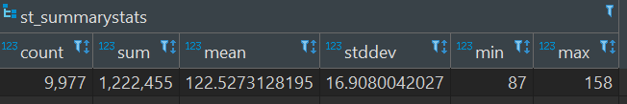

## Przykład 14:

WITH t AS (  
SELECT st_summarystats(ST_Union(a.rast)) AS stats  
FROM gesiak.paranhos_dem AS a  
)  
SELECT (stats).min,(stats).max,(stats).mean FROM t;

## Przykład 15:

WITH t AS (  
SELECT b.parish AS parish, st_summarystats(ST_Union(ST_Clip(a.rast,  
b.geom,true))) AS stats  
FROM rasters.dem AS a, vectors.porto_parishes AS b  
WHERE b.municipality ilike 'porto' and ST_Intersects(b.geom,a.rast)  
group by b.parish  
)  
SELECT parish,(stats).min,(stats).max,(stats).mean FROM t;

## Przykład 16:

SELECT [b.name](http://b.name),st_value(a.rast,(ST_Dump(b.geom)).geom)  
from rasters.dem a, vectors.places AS b  
WHERE ST_Intersects(a.rast,b.geom)  
ORDER BY [b.name](http://b.name);

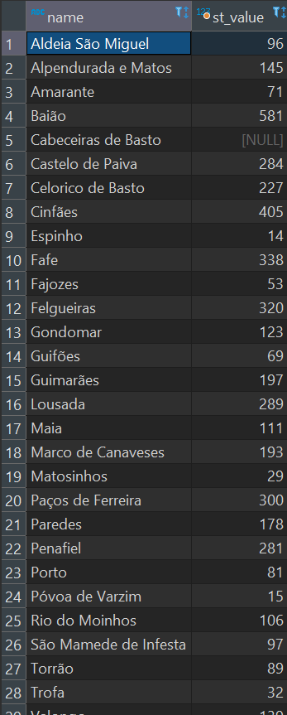

## Przykład 17:

create table gesiak.tpi30 as  
select ST_TPI(a.rast,1) as rast  
from rasters.dem a;

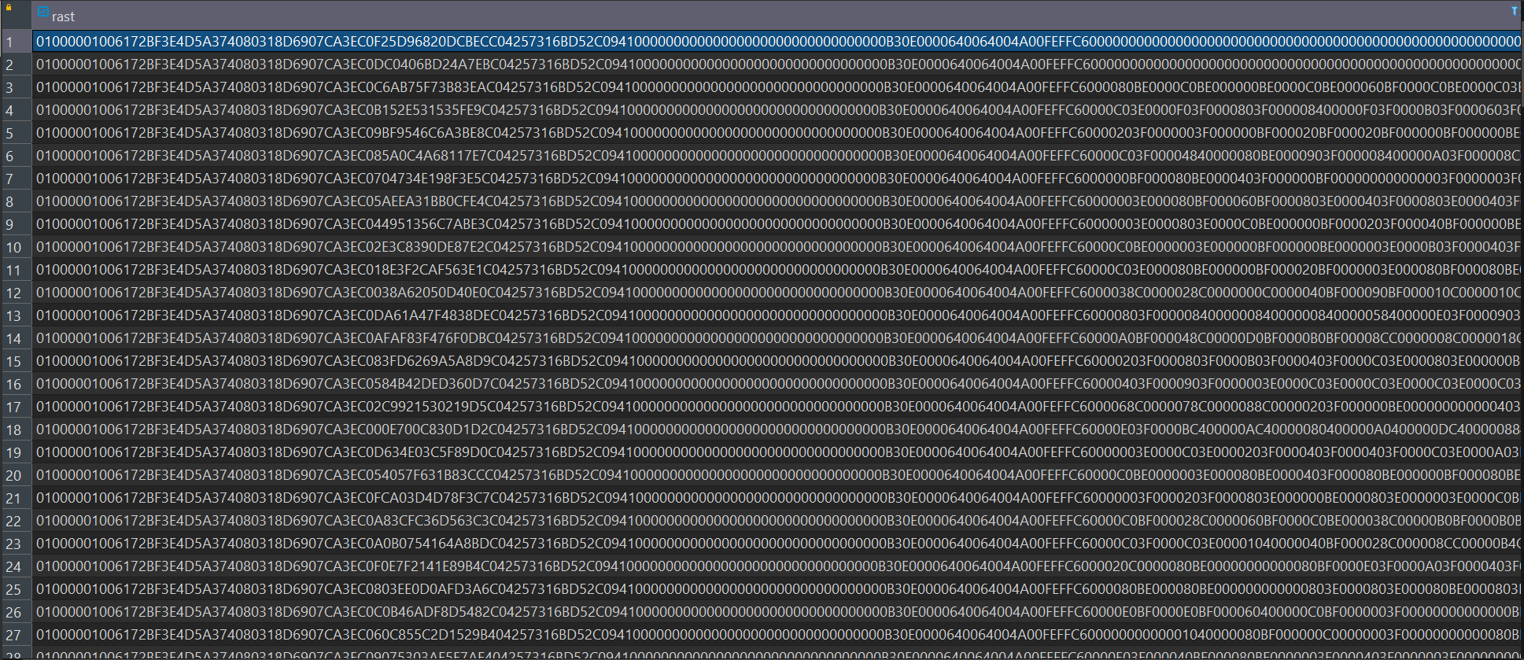

## Przykład 18:

CREATE INDEX idx_tpi30_rast_gist ON gesiak.tpi30  
USING gist (ST_ConvexHull(rast));

## Przykład 19:

SELECT AddRasterConstraints('gesiak'::name,'tpi30'::name,'rast'::name);

## Przykład 20:

CREATE TABLE gesiak.porto_ndvi AS  
WITH r AS (  
SELECT a.rid,ST_Clip(a.rast, b.geom,true) AS rast  
FROM rasters.landsat8 AS a, vectors.porto_parishes AS b  
WHERE b.municipality ilike 'porto' and ST_Intersects(b.geom,a.rast)  
)  
SELECT  
r.rid,ST_MapAlgebra(  
r.rast, 1,  
r.rast, 4,  
'([rast2.val] - [rast1.val]) / ([rast2.val] + [rast1.val])::float','32BF'  
) AS rast  
FROM r;

## Przykład 21:

CREATE INDEX idx_porto_ndvi_rast_gist ON gesiak.porto_ndvi  
USING gist (ST_ConvexHull(rast));  
  
SELECT AddRasterConstraints('gesiak'::name,  
'porto_ndvi'::name,'rast'::name);

## Przykład 22:

create or replace function gesiak.ndvi(  
value double precision [] [] [],  
pos integer [][],  
VARIADIC userargs text []  
)  
RETURNS double precision AS  
$$  
BEGIN  
RETURN (value [2][1][1] - value [1][1][1])/(value [2][1][1]+value  
[1][1][1]);  
END;  
$$  
LANGUAGE 'plpgsql' IMMUTABLE COST 1000;

CREATE TABLE gesiak.porto_ndvi2 AS  
WITH r AS (  
SELECT a.rid,ST_Clip(a.rast, b.geom,true) AS rast  
FROM rasters.landsat8 AS a, vectors.porto_parishes AS b  
WHERE b.municipality ilike 'porto' and ST_Intersects(b.geom,a.rast)  
)  
SELECT  
r.rid,ST_MapAlgebra(  
r.rast, ARRAY[1,4],  
'gesiak.ndvi(double precision[],  
integer[],text[])'::regprocedure, --> This is the function!  
'32BF'::text  
) AS rast  
FROM r;

## Przykład 23:

CREATE TABLE tmp_out AS  
SELECT lo_from_bytea(0,  
ST_AsGDALRaster(ST_Union(rast), 'GTiff', ARRAY['COMPRESS=DEFLATE',  
'PREDICTOR=2', 'PZLEVEL=9'])  
) AS loid  
FROM gesiak.porto_ndvi;  
----------------------------------------------  
SELECT lo_export(loid, '/home/admin/dev/BDP/myraster.tiff')  
FROM tmp_out;  
----------------------------------------------  
SELECT lo_unlink(loid)  
FROM tmp_out;

## Przykład 24:

MAP  
NAME 'map'  
SIZE 800 650  
STATUS ON  
EXTENT -58968 145487 30916 206234  
UNITS METERS  
WEB  
METADATA  
'wms_title' 'Terrain wms'  
'wms_srs' 'EPSG:3763 EPSG:4326 EPSG:3857'  
'wms_enable_request' '*'  
'wms_onlineresource'  
'<http://54.37.13.53/mapservices/srtm>'  
END  
END  
PROJECTION  
'init=epsg:3763'  
END  
LAYER  
NAME srtm  
TYPE raster  
STATUS OFF  
DATA "PG:host=localhost port=5432 dbname='lab6'  
user='postgres' password='admin' schema='rasters' table='dem' mode='2'"  
PROCESSING "SCALE=AUTO"  
PROCESSING "NODATA=-32767"  
OFFSITE 0 0 0  
METADATA  
'wms_title' 'srtm'  
END  
END  
END

