**DBMS LAB ASSIGNMENT – 1**

*K.Guna Sekhar*

*19BCS046*

ERD FOR TRAVEL AGENCY

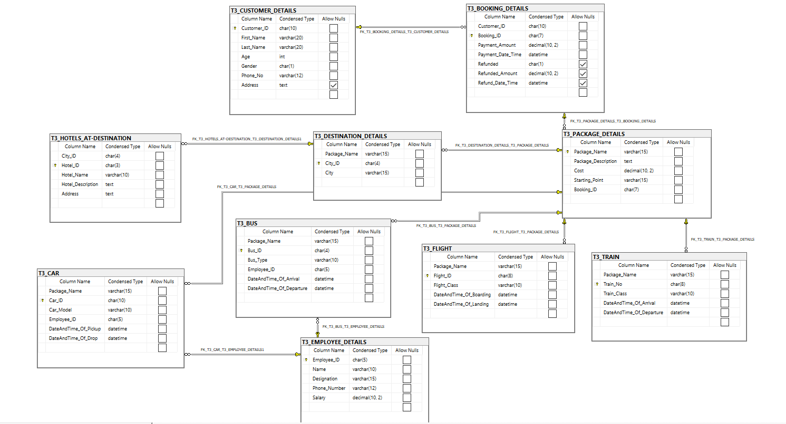

Strong Entity Interpretation

A strong entity is not dependent of any other entity in the schema. A strong entity will always have a primary key. Can be uniquely identified by its attribute alone. Strong entities are represented by a single rectangle. Strong entity may or may not have total participation.

Weak Entity Interpretation

In a relational database, a weak entity is an entity that cannot be uniquely identified by its attributes alone; therefore, it must use a foreign key in conjunction with its attributes to create a primary key. The foreign key is typically a primary key of an entity it is related to. But, as every entity here in the above Entity-Relationship diagram has its own primary key, there aren’t any weak entities here. Weak entity always has total participation.

Strong Relationship Interpretation

Dashed line in ERD diagram represents Strong relationship.

Entity is existence-dependent of other entities. Primary Key of one entity contains Primary Key component of other entity. Usually occurs utilizing a composite key for primary key, which means one of this composite key components must be the primary key of the parent entity.

Weak Relationship Interpretation

Solid line in ERD diagram represents Weak relationship. Entity is existence-independent of other entities. Primary Key of one entity doesn’t contain Primary Key component of other entity.

|  |  |  |
| --- | --- | --- |
| **TABLE NAME** | **PRIMARY KEY** | **FOREIGN KEY** |
| T3_CUSTOMER_DETAILS | Customer_ID |  |
| T3_BOOKING_DETAILS | Booking_ID | Customer_ID |
| T3_HOTELS_AT_DESTINATION | City_ID |  |
| T3_PACKAGE_DETAILS | Package_Name | Booking_ID |
| T3_DESTINATION_DETAILS | Package_Name | City_ID |
| T3_EMPLOYEE_DETAILS | Employee_ID |  |
| T3_CAR | Car_ID | Employee_ID,  Package_Name |
| T3_BUS | Bus_ID | Employee_ID, Package_Name |
| T3_TRAIN | Train_No | Package_Name |
| T3_FLIGHT | Flight_ID | Package_Name |