**DBMS Lab Assignment-4**

*K.Guna Sekhar*

*19BCS046*

**Question 1: Write 5 Nested Queries for travel database.**

# Query –

SELECT first_name, last_name, phone FROM T3_CustomerDetails WHERE customer_id IN (SELECT customer_id FROM T3_BookingDetails WHERE payment_Amount > 30000);

SELECT customer_id, first_name, last_name FROM T3_CustomerDetails WHERE customer_id NOT IN (SELECT customer_id FROM T3_BookingDetails WHERE booking_id IN (SELECT booking_id from T3_PackageDetails WHERE package_name='KULU MANALI'));

SELECT customer_id FROM T3_CustomerDetails WHERE customer_id IN (SELECT customer_id FROM T3_BookingDetails WHERE booking_id IN (SELECT booking_id FROM T3_DestinationDetails WHERE hotel_name = 'Raj Palace'));

SELECT package_name, cost FROM T3_PackageDetails WHERE booking_id IN

(SELECT booking_id FROM T3_Bus WHERE bus_type = '2 Seater');

SELECT package_name FROM T3_PackageDetails WHERE EXISTS (SELECT * FROM T3_Bus WHERE T3_PackageDetails.booking_id = T3_Bus.booking_id); **Database Output:**

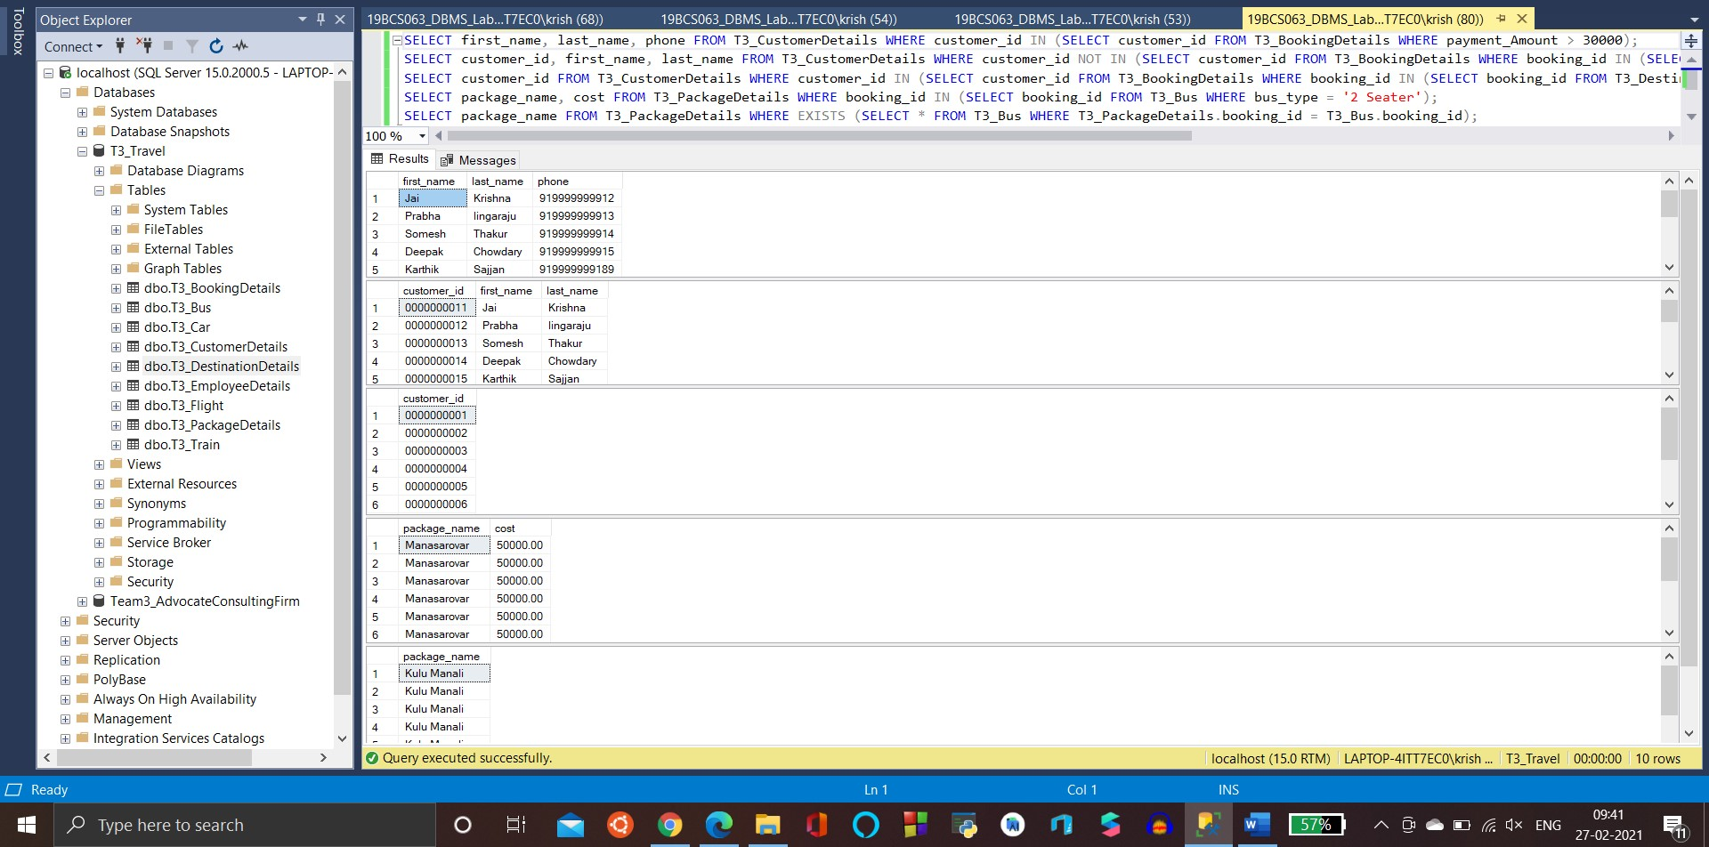

# Question 2: Illustrate how we can use CONCAT and AS operators in SQL Query –

SELECT CONCAT(first_name, ' ', last_name) AS full_name FROM T3_CustomerDetails;

SELECT customer_id, phone AS contact_details FROM T3_CustomerDetails;

SELECT TOP 1 CONCAT(package_name, ', ', package_description) AS package FROM T3_PackageDetails WHERE package_name = 'MANASAROVAR'; **Database Output:**

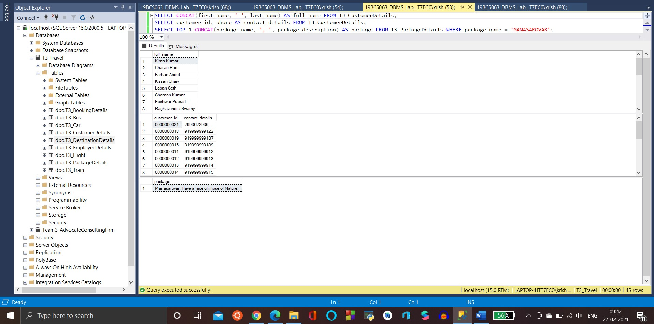

# Question 3: Illustrate all the Comparison operators Query –

SELECT customer_id, first_name, last_name FROM T3_CustomerDetails WHERE age = 21;

SELECT TOP 1 package_name FROM T3_PackageDetails WHERE cost = 25000;

SELECT customer_id FROM T3_CustomerDetails WHERE gender <> 'M';

SELECT TOP 1 bus_id, bus_type FROM T3_Bus WHERE bus_id <> 8714;

SELECT employee_id, name FROM T3_EmployeeDetails WHERE salary > 10000;

SELECT customer_id, CONCAT(first_name, last_name) AS full_name FROM T3_CustomerDetails WHERE age > 40;

SELECT employee_id, name FROM T3_EmployeeDetails WHERE salary < 8000;

SELECT customer_id, CONCAT(first_name, last_name) AS full_name FROM T3_CustomerDetails WHERE age < 30;

SELECT employee_id, name FROM T3_EmployeeDetails WHERE salary >= 10000;

SELECT customer_id, CONCAT(first_name, last_name) AS full_name FROM T3_CustomerDetails WHERE age >= 40;

SELECT employee_id, name FROM T3_EmployeeDetails WHERE salary <= 5000;

SELECT customer_id, CONCAT(first_name, last_name) AS full_name FROM T3_CustomerDetails WHERE age <= 20; **Database Output:**

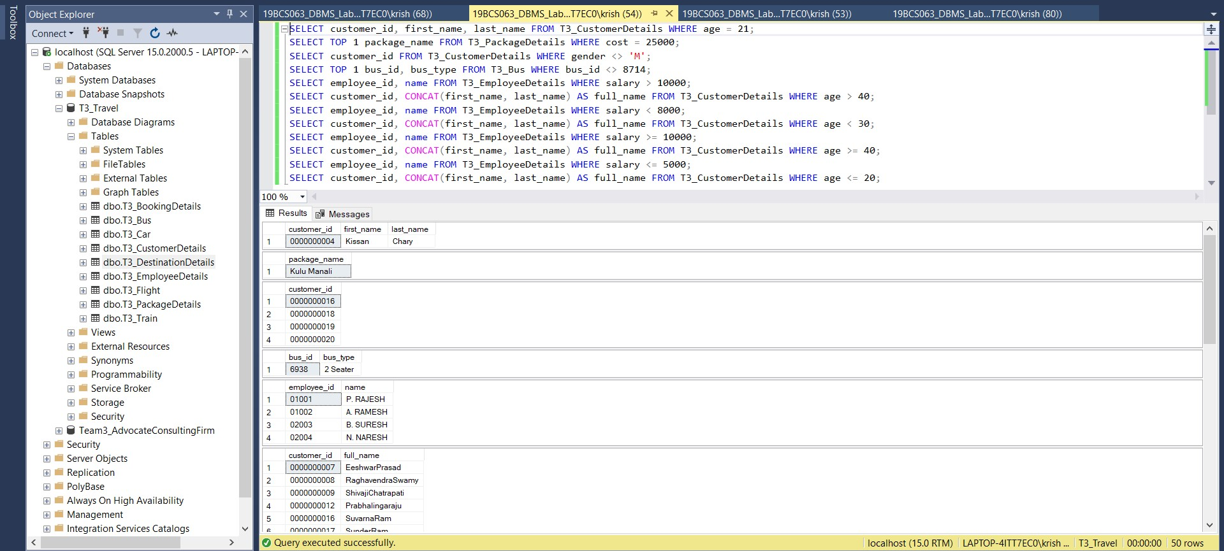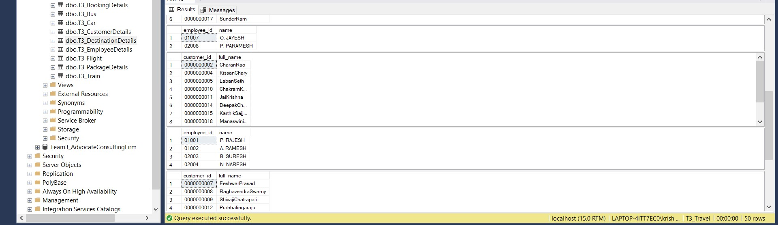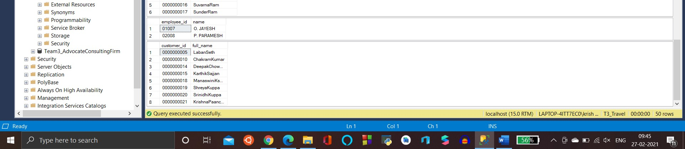

# Question 4: Illustrate Logical operators except ANY, ALL and LIKE Query –

SELECT customer_id, first_name, last_name FROM T3_CustomerDetails WHERE age >= 21 AND gender = 'M';

SELECT name FROM T3_EmployeeDetails WHERE salary>=10000 AND designation =

'Driver';

SELECT customer_id, first_name, last_name FROM T3_CustomerDetails WHERE age >= 40 OR gender = 'M'

SELECT employee_id, name FROM T3_EmployeeDetails WHERE salary>=10000 OR designation = 'Luggage Manager';

SELECT customer_id, first_name, last_name FROM T3_CustomerDetails WHERE NOT age >= 35;

SELECT bus_id FROM T3_bus WHERE NOT bus_type='Sleeper';

SELECT employee_id, name FROM T3_EmployeeDetails WHERE designation IN

('Driver', 'Cleaner');

SELECT hotel_name FROM T3_DestinationDetails WHERE city IN ('Kulu Manali', 'Burang');

SELECT employee_id, name FROM T3_EmployeeDetails WHERE salary BETWEEN 5000 AND 10000;

SELECT customer_id, CONCAT(first_name, last_name) AS full_name FROM T3_CustomerDetails WHERE age BETWEEN 21 AND 40; **Database Output:**

