Software Engineering | Sommerville 9th Ed. | Chapter 5
Assignment 2 — System Modeling
UML Sequence Diagram + State Diagram | Individual Work | Submitted via GitHub

Watch first | UML Diagrams: Sequence & State Machine in draw.io — youtube.com/watch?v=OWwm8lxT6q8 (~30 min)

Tool | draw.io — free, browser-based (go to app.diagrams.net — no account needed)

Work type | Individual submission

Reading | Sommerville Ch. 5 §5.2 (Interaction models) and §5.4 (Behavioral models) pp. 118–146

Estimated time | ~60 minutes of work after watching the tutorial

Submission | Git repository (see submission instructions at end of this document)

Learning Objectives
After completing this assignment you should be able to:

- Explain why system models are used during requirements engineering and design (Sommerville §5, p.119).
- Describe the purpose of a UML sequence diagram and identify its core components: lifelines, activations, messages, and return messages (Sommerville §5.2).
- Draw a sequence diagram that correctly represents the interactions between objects in a given scenario.
- Describe the purpose of a UML state machine diagram and identify its core components: states, transitions, events, and guards (Sommerville §5.4).
- Draw a state diagram that correctly models the lifecycle of an object in a given system.
- Use draw.io to produce clean, correctly notated UML diagrams and export them as image files.

Quick UML Reference (from Sommerville Ch. 5)

Sequence Diagram — key elements  - Lifeline: a vertical dashed line representing an object or actor over time  - Activation bar: a narrow rectangle on a lifeline showing when an object is active  - Message: a horizontal arrow from one lifeline to another (solid = call, dashed = return)  - Self-message: an arrow that loops back to the same lifeline  - Guard condition: written in [ ] brackets on a message arrow | State Machine Diagram — key elements  - State: a rounded rectangle representing a condition the object can be in  - Initial pseudo-state: a filled black circle — the starting point  - Final state: a filled circle inside a larger circle — the end point  - Transition: a directed arrow between states  - Event / Guard / Action written on a transition as: event [guard] / action  - Only one state is 'active' at any moment in time

Before you start: Watch the draw.io UML tutorial listed above. It walks through creating both a sequence diagram and a state machine diagram step-by-step in the draw.io interface. The tutorial is approximately 30 minutes. After watching, open app.diagrams.net in your browser — no account is required.

Case Study — SmartPark: A University Parking System

Background
A university wants to build a SmartPark system that allows staff and students to reserve a parking spot in advance using a web portal. The system must check availability, confirm or reject reservations, manage the physical barrier at each parking bay, and keep a record of all reservations.

You are a software engineer on this project. Your task is to produce two UML diagrams that model specific aspects of this system, as described below. Both diagrams must be drawn in draw.io and exported as PNG files.

System Description
The SmartPark system has the following components:

- Web Portal — the interface the user (staff or student) interacts with in their browser.
- Reservation System — the backend logic that handles reservation requests.
- Parking Database — stores the status of all parking bays and all reservation records.
- Barrier Controller — the physical controller attached to each parking bay barrier (arm that lifts and lowers).
- Email Service — sends confirmation and reminder emails to users.

Diagram 1
UML Sequence Diagram — 'Reserve a Parking Spot'

Scenario: Successful Reservation
Model the following interaction. A user submits a parking reservation request through the web portal. The sequence of events is:

- The User sends a reservation request to the Web Portal, specifying bay number, date, and time.
- The Web Portal forwards the request to the Reservation System.
- The Reservation System queries the Parking Database to check if the requested bay is available at that time.
- The Parking Database returns the result: bay is available.
- The Reservation System creates a reservation record in the Parking Database.
- The Reservation System sends a confirmation request to the Email Service.
- The Email Service sends a confirmation email to the User.
- The Reservation System returns a 'Reservation Confirmed' message to the Web Portal.
- The Web Portal displays a success message to the User.

What to include in your diagram:
- Five lifelines: User, Web Portal, Reservation System, Parking Database, Email Service.
- All messages described in the scenario above, in the correct order.
- At least one return message (dashed arrow) — for example, the database returning 'available'.
- Activation bars on each lifeline to show when each component is active.
- A title at the top of your diagram: 'SD: Reserve a Parking Spot'.
Solution:
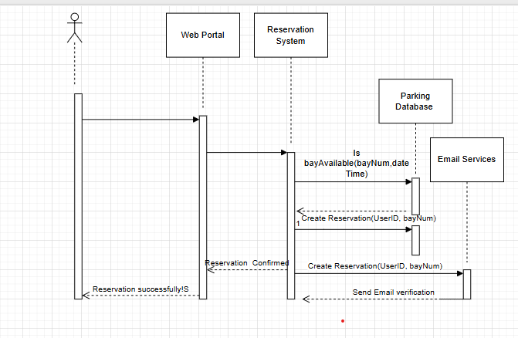

Tip: In draw.io, select Extras > Edit Diagram to see the XML, or use the UML shape panel on the left. For sequence diagrams, use 'Lifeline' shapes and 'Message' arrows. Refer to the tutorial timestamp where sequence diagrams are drawn.

Diagram 2
UML State Machine Diagram — Lifecycle of a Parking Reservation

Object: A Parking Reservation Record
A reservation in the SmartPark system can be in several different states during its lifetime. Model the complete lifecycle of a single reservation object using a state machine diagram.

States to include:
State | Description
Pending | The reservation has been submitted but not yet confirmed (e.g., awaiting database write).
Confirmed | The reservation has been successfully saved and the user has received a confirmation email.
Active | The user has arrived and the barrier has been raised — the parking bay is currently in use.
Completed | The user has left and the barrier has been lowered — the reservation period is over.
Cancelled | The user cancelled the reservation before arrival, or no-show after a timeout period.

Transitions to include:
- Initial state → Pending: triggered by 'reservationSubmitted'
- Pending → Confirmed: triggered by 'databaseWriteSuccess'
- Pending → Cancelled: triggered by 'databaseWriteFailure' (e.g., bay taken in the meantime)
- Confirmed → Cancelled: triggered by 'userCancels' [at least 1 hour before slot]
- Confirmed → Cancelled: triggered by 'noShow' [timeout after 15 minutes past slot start]
- Confirmed → Active: triggered by 'userArrives' / action: 'raiseBarrier'
- Active → Completed: triggered by 'userLeaves' / action: 'lowerBarrier'
- Completed → Final state (terminal)
- Cancelled → Final state (terminal)

What to include in your diagram:
- An initial pseudo-state (filled black circle) leading into Pending.
- All five states as rounded rectangles with the state name inside.
- All transitions listed above as directed arrows with event labels.
- At least two transitions that include a guard condition written in [ ] brackets.
- At least one transition that includes an action written after a '/' — for example: 'userArrives / raiseBarrier'.
- Two final states (filled circles inside circles) — one reached from Completed, one from Cancelled.
- A title at the top: 'SMD: Parking Reservation Lifecycle'.
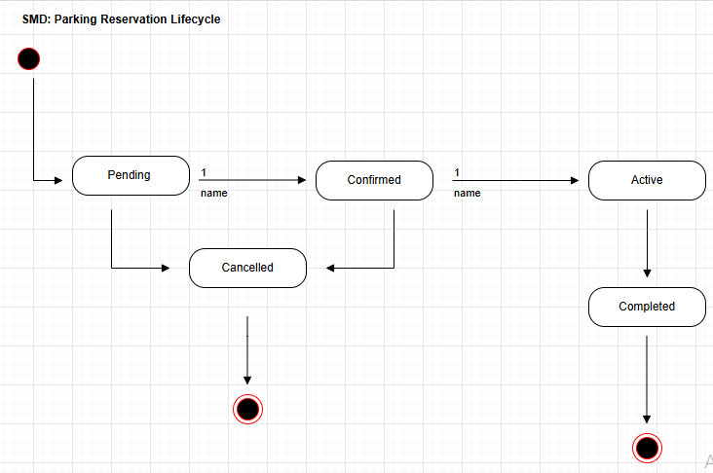

Tip: In draw.io, use 'State' shapes from the UML panel for states, and 'Start' and 'End' shapes for the initial and final pseudo-states. Double-click a transition arrow to add the event label. Refer to the timestamp in the tutorial where state diagrams are demonstrated.

Reflection Questions
Answer the following questions in a plain text file (answers.txt). Write 2–4 sentences per question.

- Q1. Purpose of modeling: Sommerville (p.119) says 'The most important aspect of a system model is that it leaves out detail.' What detail did you leave out of your sequence diagram, and why was it appropriate to do so?
Answer:
What detail was left out: The sequence diagram leaves out technical infrastructure details, such as network protocols (HTTP/HTTPS), exact database queries (SQL syntax), error handling for lost connections, user authentication tokens, and specific UI design elements.
Why it was appropriate: Leaving these out keeps the diagram readable. The goal of this model is to understand the high-level business logic and see how components interact. Adding low-level code details would clutter the diagram and distract from the overall workflow.

- Q2. Sequence diagram: What does the order of messages in your sequence diagram tell you that a simple bullet-point description of the same scenario does not?
Answer:
What the message order tells you: The vertical order of messages explicitly shows the exact timing and dependency of events. It visually proves that Component B cannot start its work until Component A sends it a message, and it maps out exactly how long an object remains active (via activation bars) waiting for a reply. A bulleted list shows a sequence, but it fails to clearly illustrate these overlapping lifelines and structural execution dependencies.

- Q3. State diagram: Identify one state transition in your diagram that has a guard condition. In plain English, explain what the guard condition means and why it is necessary.
Answer:
Identified transition: Confirmed → Cancelled triggered by userCancels [at least 1 hour before slot].
Plain English explanation: This guard condition means a user is only allowed to cancel their spot if they do it at least 60 minutes before their parking time begins.
Why it is necessary: It enforces a business rule. Without this restriction, a user could cancel at the very last second, leaving a parking bay empty and wasted when another student or staff member could have used it.

- Q4. Sequence vs State: These two diagrams model the same system from different perspectives. In one sentence, describe what each diagram emphasises that the other does not.
Answer:
The Sequence Diagram emphasizes the chronological flow of messages exchanged between multiple cooperating components over time, whereas the State Diagram emphasizes how a single object's internal condition changes across its entire lifecycle in response to events.

Deliverables Summary

# | Deliverable | Format | File name
1 | UML Sequence Diagram — Reserve a Parking Spot | PNG (exported from draw.io) | sequence_diagram.png
2 | UML State Machine Diagram — Reservation Lifecycle | PNG (exported from draw.io) | state_diagram.png
3 | Both diagrams saved together in one draw.io file | draw.io XML file (.drawio) | smartpark_diagrams.drawio
4 | Reflection answers | Plain text | answers.txt

Export tip: In draw.io, go to File > Export As > PNG to save your diagram. Make sure 'All Pages' is selected if both diagrams are on separate pages. Use File > Save As to save the .drawio source file.

Marking Criteria

Criterion | Marks | Notes
Sequence diagram: correct lifelines and message order | 4 | All 9 messages present and in sequence
Sequence diagram: correct notation (activation bars, return messages) | 3 | At least 1 return message; activation bars on active lifelines
State diagram: all 5 states present and correctly named | 3 | State names match the scenario
State diagram: all transitions with correct event/guard/action labels | 4 | At least 2 guards and 1 action label
State diagram: correct initial and final pseudo-states | 2 | Black circle start; bullseye end state(s)
Reflection answers: quality and accuracy | 4 | Demonstrates understanding of Sommerville §5.2 and §5.4
Total | 20

Submission Instructions — Git

Why Git? This assignment is submitted through GitHub. This mirrors real software engineering practice: diagrams and design artifacts are version-controlled alongside code.

Step-by-step:
- Create a new GitHub repository named smartpark-uml-[YourStudentID] (e.g., smartpark-uml-s202301). Set it to Private.
- Go to Settings → Collaborators and add your instructor's GitHub username.
- Clone the repo locally: git clone https://github.com/YOUR_USERNAME/smartpark-uml-XXXX.git
- Place your four deliverable files (sequence_diagram.png, state_diagram.png, smartpark_diagrams.drawio, answers.txt) in the repository folder.
- Stage and commit: git add . then git commit -m "Add Assignment 2 UML diagrams and reflection"
- Push to GitHub: git push
- Submit the repository URL on the course portal before the deadline.

Important: Add your instructor as a Collaborator before submitting. A private repo the instructor cannot access will receive zero marks. Verify access before the deadline.

