Jenkins CI/CD Pipeline - Ansible, Docker, Github Webhooks on AWS

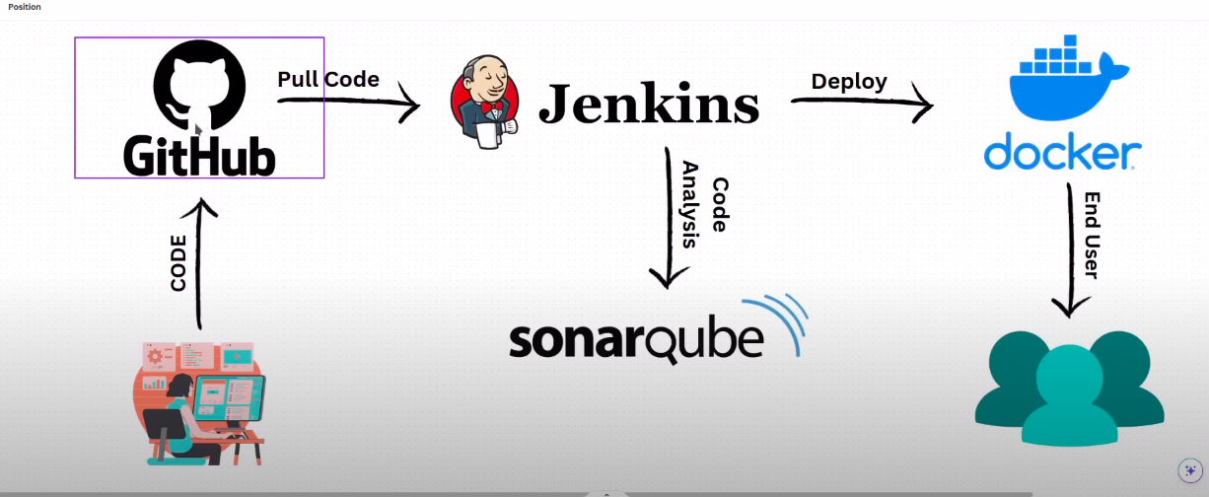

GitHub Webhooks ----- When ever an event / code change happened in GitHub, It will trigger an Event in Jenkins

Requirements
-----------------

1. Download a css Template from browser https://www.free-css.com/free-css-templates
and extract it.

2. Login to the GitHub, Create a Repositories called <Jenkins-Docker-Sonarqube>

3. Push the css template code to this Repository <Jenkins-Docker-Sonarqube>

Go to AWS Console
------------------------

- Create 3 Instances 1. Jenkins 2. Sonar-Qube (t3.small) 3. Docker

Login to Jenkins Instance ----> sudo apt update -y --> chnage the hostname <Jenkins> ---- Now install Jenkins --> go to jenkins.io website and install it ---- first install jave ---> sudo apt search openjdk ---->

- Jenkins runs on port 8080, so add rule in jenkins server security group

copy the public ip of jenkins ----> and paste it in brreowser -----> do the steps needed

Login to Jenkins Dashboard
------------------------------------

- Create a New job called <fech the code> ----- freestyle ---- click ok
- go to Source code management tab --- select git ---- and give url of the pepository
- go to build triggers ---> select github triggers for GITscm polling
- Next go to the GitHub <Jenkins-Docker-Sonarqube> Repository ----> click settings --- click on the webhooks --- add webhook – copy th jenkins url http://<ipaddress:8080> ---- and paste at payload url ------ after paste the url write “ /github-webhook/ “ http://<ipaddress:8080>/github-weebhook/ --- select let me select individual events , mark pull requests and pushes --- add webhook

Verify the webhook is working or Not
----------------------------------------------
Build the pipeline ------ it get sucess it clone data from github --- and astor it on var/lib/jenkins/workspace

- Now add a new file in github ----- and commit it

- Now you can see, the jenkins automatically fetch the changes and run the pipeline.

===================================================================

Login to Sonar-Qube
--------------------------

sudo apt update -y ----> change hostname <Sonar-Qube> ------> install sonar-qube ----

For sonarqube we need Java17 ---- install java17 first ---- sudo apt install openjdk-17-jre ----
go to browser --- sonarqube download --- https://www.sonarsource.com/products/sonarqube/downloads/

Her we download the community edition --- for that right clink on the DOWNLOAD FOR FREE and copy the link....

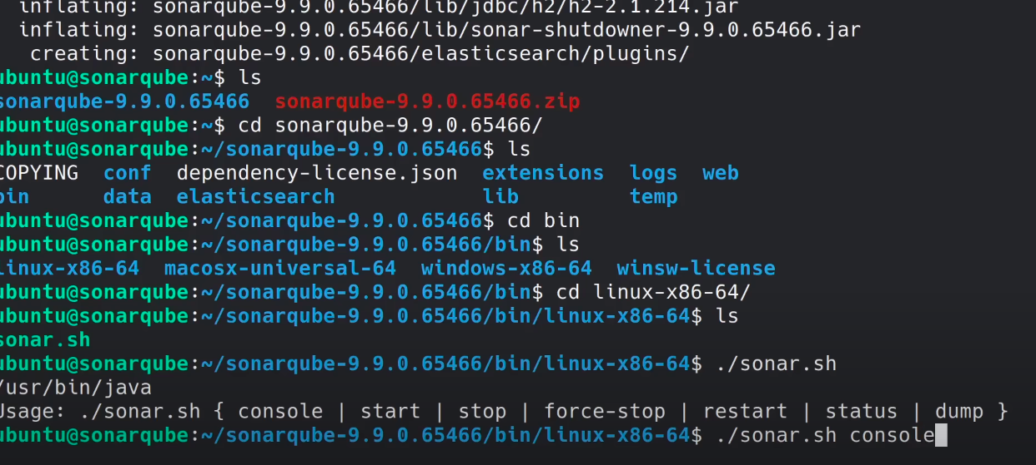
- go to terminal --- paste the linlk with wget command ------- wget paste the linlk ---- download completed ---- see here it was zip file --- to unzip ---- first we install unzip ----- sudo apt install unzip -y ------ $ unzip <filename.zip> ---- ls

- Allow port to Security group ----- sonar-qube runs on port 9000 ------

- copy the publicip of sonar-qube ----- publicip:9000 ----- default user= admin and pwd= admin of soanr-qube

- Now we are loged into the Sonar-qube ------ click on manually --- name Onix-website

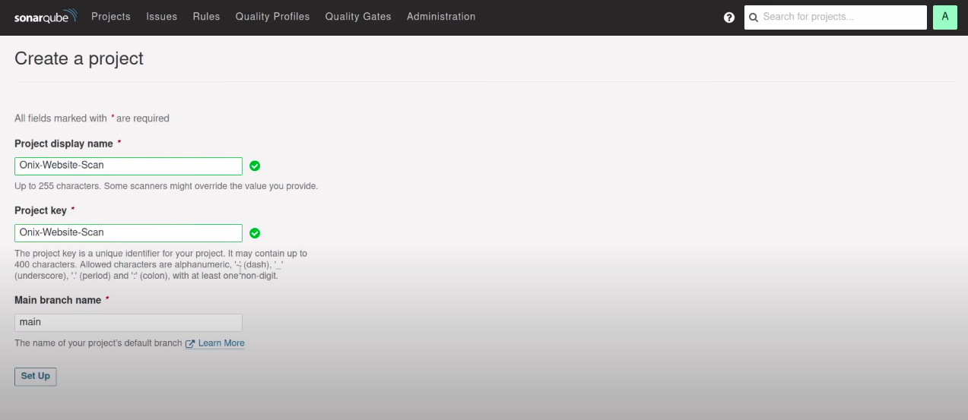

click on signup ----- after select CI --- we select jenkins ----- select github ---- click on configure analysis ---
click on continue ----- click on continue ----click on oter js,ts ----

so here we are copy the project key and paste it on any text editor -------- finish the tutorial ----- go to the admin user on the top right corner --- click go ot my accounts --- security ---- create a token --- name it Sonar-qube-token ---- select type global analysis token ---- click on generate token --- copy the token – paste it in text editor ----

