FinTech Banking Application
Full-Stack Technical Documentation
React Frontend + Spring Boot Backend · RTGS & NEFT Payments
A plain-English guide to how the whole system fits together

Contents

1. Project Overview
This project is a complete online banking system with two parts: a React frontend (the screens you click) and a Spring Boot backend (the engine that handles the money and data). The frontend talks to the backend over the internet using simple web requests.

Purpose
To let a user safely manage money online: open accounts, save people to pay, send money two different ways (RTGS and NEFT), and see a full history of every transfer — all protected by secure login.

Main banking features
- Sign up & log in — create an account and get a secure token to stay logged in.
- Accounts — open bank accounts and see their balances.
- Beneficiaries — save people you want to pay so you don't re-type their details.
- RTGS & NEFT transfers — send money instantly (RTGS) or in batches (NEFT).
- Transaction history — view every past transfer with its status.

RTGS and NEFT in simple words
- RTGS — for big amounts that must move instantly, one at a time.
- NEFT — for any amount, collected and settled together in batches at set times.

2. Full-Stack Architecture Diagram
The diagram shows the full journey of a request: from the React screen, through Axios, into the Spring Boot security gate, controllers, services, and repositories, and finally to the database. The dashed amber path is the optional Kafka notification flow.
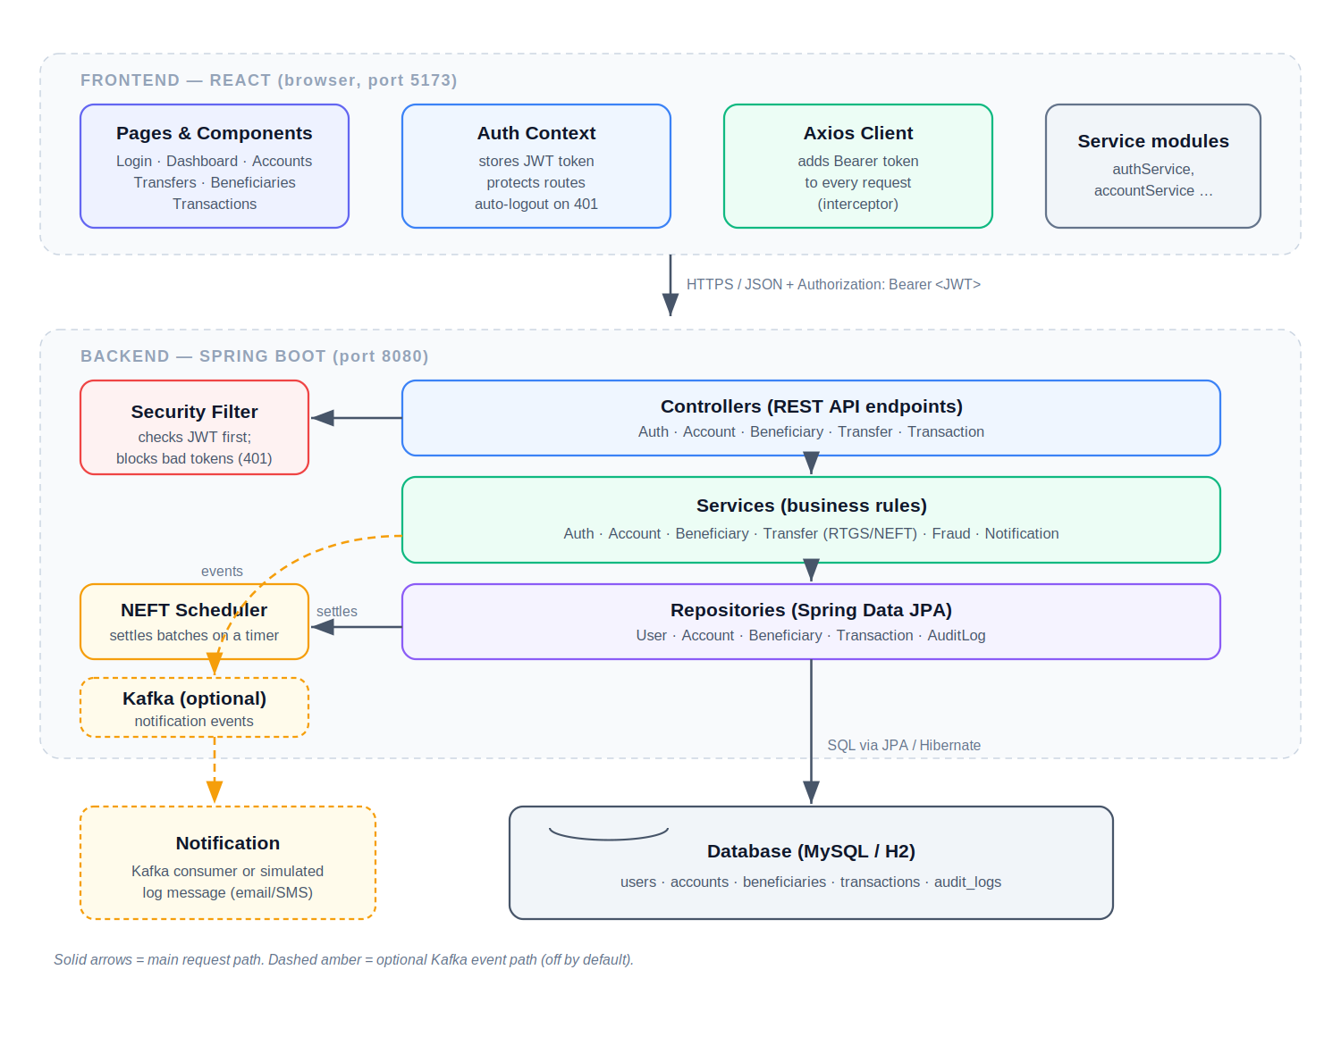
Figure 1 — Connected full-stack architecture

What each connection means
- Frontend → Axios — when you click a button, the page calls a service function which uses Axios to make the web request.
- Axios → Backend — Axios attaches your login token (JWT) and sends the request over HTTP to the backend.
- Security → Controller — the security filter checks the token first; only valid requests reach a controller.
- Controller → Service — the controller passes the work to a service that holds the actual rules.
- Service → Repository → Database — the service uses a repository to read or save data in the database.
- Service → Kafka → Notification (optional) — after a transfer, an event can be sent so a notification is delivered without slowing the transfer.

3. Frontend Structure (React)
- Pages — one screen each: Login, Signup, Dashboard, Accounts, Beneficiaries, RTGS, NEFT, Transactions.
- Components — reusable building blocks (buttons, inputs, modals, the transfer form) shared across pages.
- API services — small files (authService, accountService, etc.) that call the backend endpoints.
- State management — React Context (AuthContext) holds the logged-in user and token for the whole app.
- Protected routes — guard pages so only logged-in users can open them; others are sent to login.
- Authentication handling — login stores the token; logout clears it; an expired token logs the user out automatically.

How the frontend connects to the backend
Every API call goes through one shared Axios client. A request interceptor automatically adds the token as Authorization: Bearer <token> to every request, so you log in once and stay authenticated.

How the JWT token is stored and sent
- Stored — the token is saved in the browser's localStorage, so a page refresh keeps you logged in.
- Sent — the Axios interceptor reads it and attaches it to every outgoing request.
- Expired — if the backend replies 401 (unauthorized), the app clears the token and redirects to login.

4. Backend Structure (Spring Boot)
Each folder has one job. Data flows downward: controller receives, service decides, repository stores.
Layer | What it does (simple)
controller | Defines the API endpoints; receives requests and returns responses.
service | Holds the real rules (transfers, fraud checks, login).
repository | Reads and writes the database using Spring Data JPA.
entity | Java versions of the database tables (User, Account, etc.).
dto | Safe data shapes for requests/responses, so tables aren't exposed directly.
mapper | Converts between entities and DTOs.
security | Login: creates and checks JWT tokens; the request filter.
config | Setup: security rules, Swagger docs, audit logging, sample data, Kafka topics.
exception | Custom errors plus one handler that returns clean error responses.
kafka | Optional event sending/receiving for notifications.
scheduler | A timer that settles NEFT transfers in batches.

5. Database Design (ER Diagram)
The system has five tables. The diagram is built directly from the backend's entity classes.
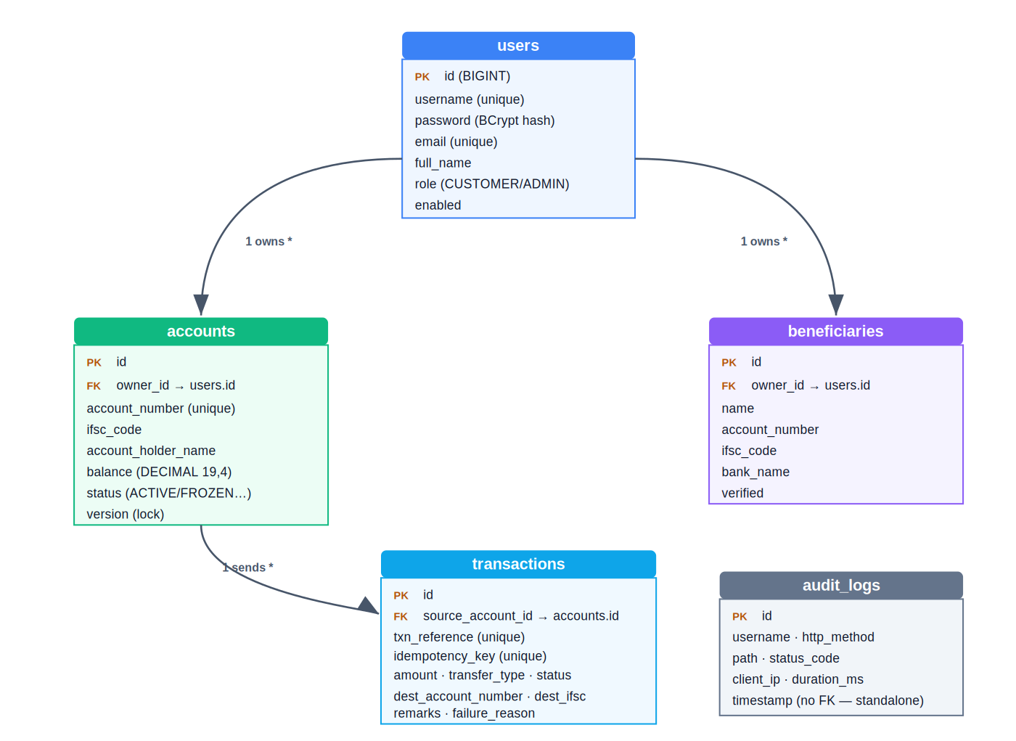
Figure 2 — Database ER diagram
- users → accounts — one user can own many accounts.
- users → beneficiaries — one user can save many payees.
- accounts → transactions — one account can send many transactions.
- audit_logs — a standalone security trail of API activity; not linked to one account.
Note on notifications: Notifications are sent as live events or log messages — they are not stored in a database table in the current code, so there is no notifications table in the diagram.

6. API Flow Diagrams
Each feature follows the same shape: Frontend → API → Service → Database → Response. Below is each one in one line.
Feature | Flow (Frontend → API → Service → DB → Response)
Login | Login page → POST /auth/login → AuthService checks password → reads users → returns JWT
Registration | Signup page → POST /auth/signup → AuthService saves user → inserts users → returns JWT
RTGS transfer | RTGS form → POST /transfers/rtgs → TransferService checks & debits → updates accounts, inserts transaction → returns SUCCESS
NEFT transfer | NEFT form → POST /transfers/neft → TransferService debits & queues → inserts transaction (PROCESSING) → returns ACCEPTED
Add beneficiary | Beneficiary form → POST /beneficiaries → BeneficiaryService validates → inserts beneficiaries → returns saved payee
Transaction history | Transactions page → GET /transactions/account/{n} → reads transactions → returns a page of results

7. JWT Authentication Flow
- What JWT is — a JWT (JSON Web Token) is a signed digital pass the server gives you after login.
- Why it is used — so the server can trust who you are on every request without storing sessions.
- How authorization works — you send the token with each request; the server checks its signature and lets you in.
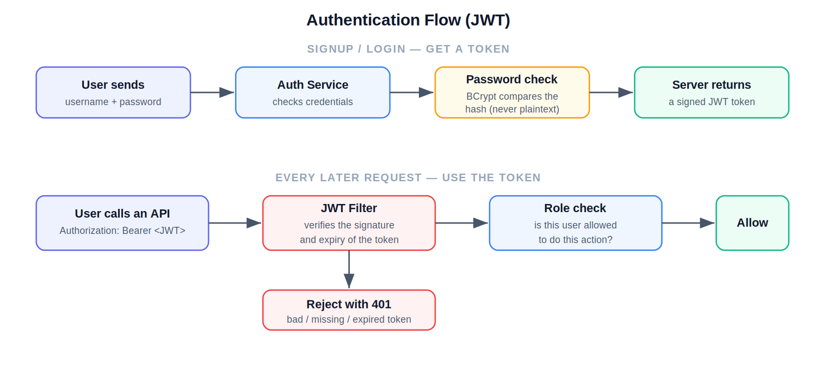
Figure 3 — Authentication flow

8. RTGS & NEFT Working Flow
Both rails run the same safety checks (login, ownership, fraud, balance). The difference is when settlement happens.

RTGS — instant
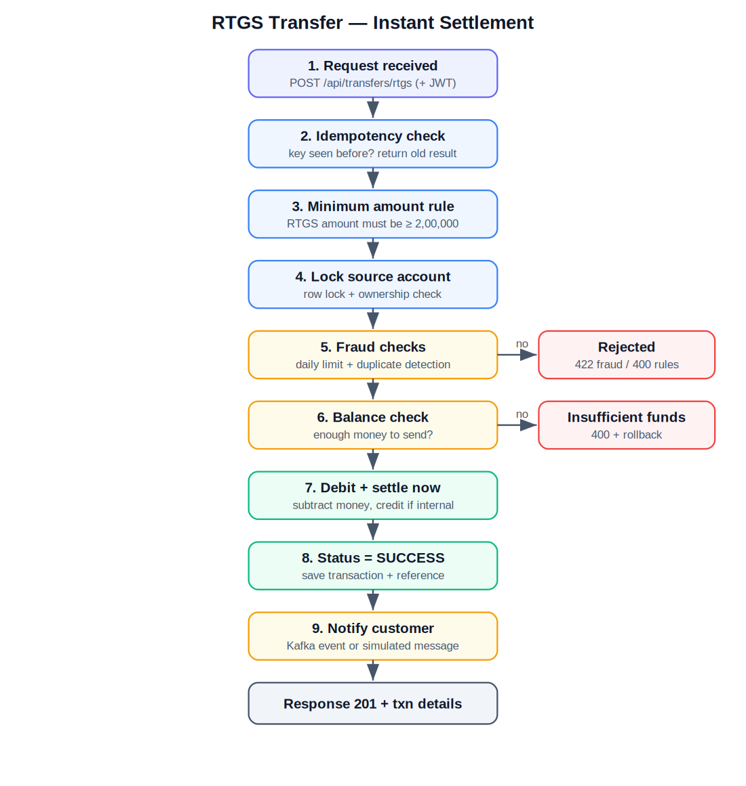
Figure 4 — RTGS instant settlement

NEFT — batch
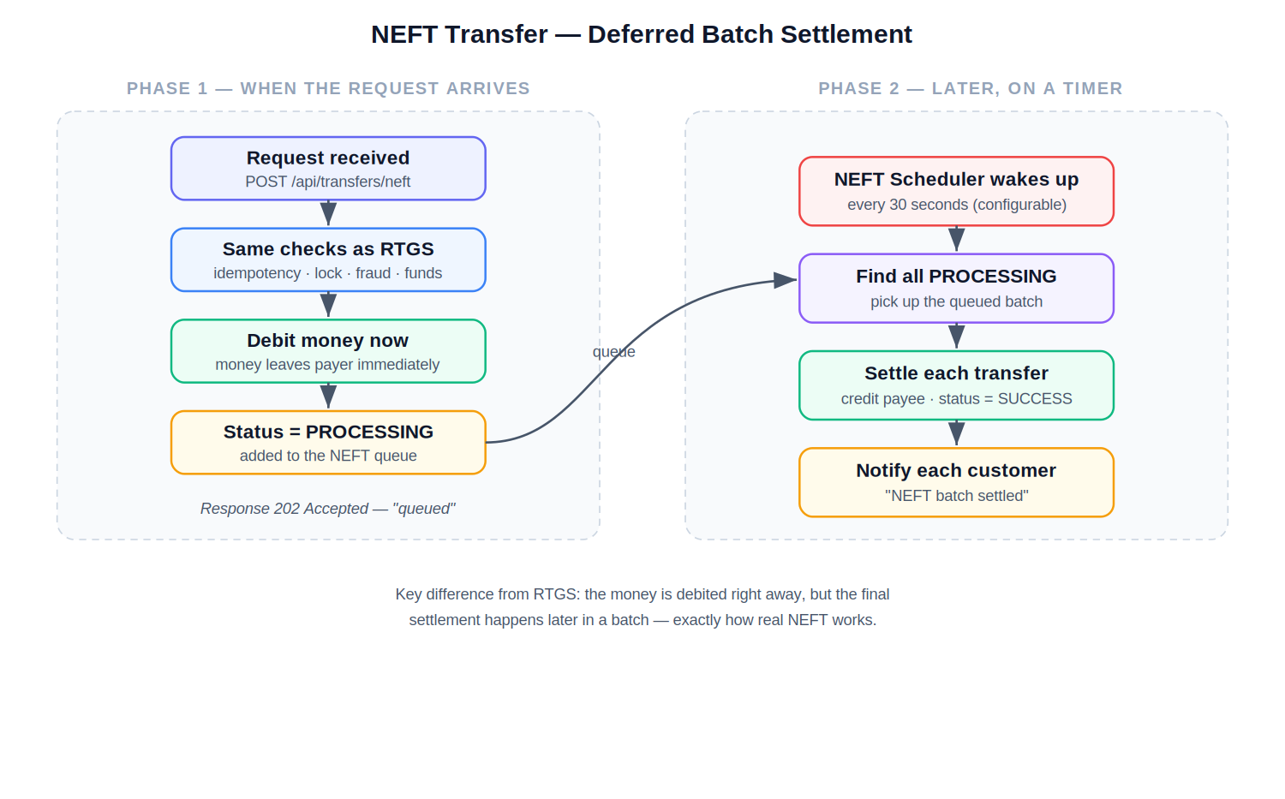
Figure 5 — NEFT batch settlement
- Validation — the request fields and amount are checked.
- Balance checking — the system confirms there is enough money.
- Transaction creation — a transaction row is created with a unique reference.
- Settlement — RTGS settles immediately; NEFT settles later in a batch.
- Notifications — a success/failure message is sent (Kafka event or log).

9. Repositories Created
- UserRepository — finds and saves users; checks if a username or email already exists.
- AccountRepository — reads/saves accounts; has a special locking query used during transfers.
- BeneficiaryRepository — reads/saves a user's saved payees and prevents duplicates.
- TransactionRepository — saves transactions and runs queries for history, daily limits, and duplicate checks.
- AuditLogRepository — saves the security activity records.

10. Tools & Technologies Used
Tool | Why it is used (simple)
Java 17 | the main programming language for the backend.
Spring Boot | the framework that makes building the backend fast and organised.
React | builds the interactive frontend screens.
JWT | the secure login token system.
Spring Security | protects the backend and handles login rules.
MySQL / H2 | the database that stores all data (H2 for quick local runs).
Kafka (optional) | sends notification events without slowing transfers.
Redis (optional) | a fast store wired in for future use (e.g. caching).
Docker (optional) | packages the app and database to run anywhere the same way.
Kubernetes (concept) | would run and scale many containers in production.
Maven | downloads libraries and builds the backend.
Axios | makes API calls from the React frontend.
Tailwind CSS | styles the frontend with a clean, responsive design.
Honest scope note: Kafka, Redis, Docker, and Kubernetes are included as optional or conceptual pieces. The app runs fully without them using H2 and simulated notifications.

11. Annotations Used

Backend (Spring / Java)
Annotation | What it does
@RestController | marks a class as an API endpoint handler.
@Service | marks a class as business logic.
@Repository | marks a class that talks to the database.
@Entity | maps a Java class to a database table.
@Autowired | lets Spring inject a needed object automatically.
@RequiredArgsConstructor | auto-creates a constructor for final fields (Lombok).
@Builder | lets you build objects field-by-field cleanly (Lombok).
@Data | auto-creates getters, setters, etc. (Lombok).
@Slf4j | adds a logger so the class can write log messages (Lombok).
@Configuration | marks a class that defines app setup beans.
@Bean | registers an object Spring should manage.
@Transactional | runs a method as one all-or-nothing database transaction.
@PreAuthorize | restricts a method to certain roles.

Frontend (React)
Feature | What it does
useState | stores changing data inside a component.
useEffect | runs code when a component loads or its data changes (e.g. fetch).
Context API | shares data (like the logged-in user) across the whole app.
React Router | switches between pages without reloading the browser.

12. Exception Handling
The backend uses one GlobalExceptionHandler that turns every error into a clean response with the right HTTP code, so the frontend always gets a predictable message.
Error | Why it happens | How it is handled
Validation error | a field is missing or badly formatted | returns 400 with the field messages
Unauthorized access | missing or invalid login token | returns 401; frontend logs the user out
Insufficient balance | not enough money to transfer | returns 400; the debit is rolled back
Duplicate transaction | same idempotency key sent twice | returns the original result; no double charge
Fraud rule hit | daily limit or duplicate detected | returns 422 and blocks the transfer
Invalid token | token is fake or expired | returns 401; user must log in again

13. Important FinTech Concepts
- RTGS — instant, one-by-one settlement for high-value transfers.
- NEFT — transfers settled together in timed batches.
- Settlement — the moment money actually moves and becomes final.
- Reconciliation — checking records match; stored transactions reproduce the balance.
- Transaction lifecycle — INITIATED → PROCESSING → SUCCESS or FAILED.
- Idempotency — a repeated request (same key) does not move money twice.
- Audit logging — a permanent record of important actions for security.

14. End-to-End Working Flow
This brings it all together — from the user clicking 'send' to the result coming back.
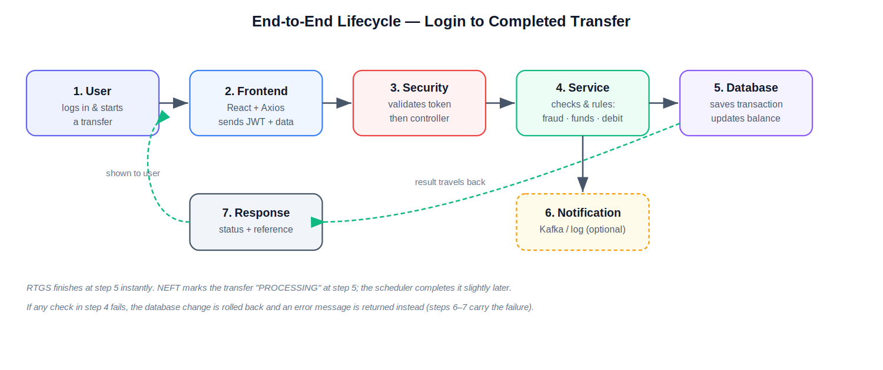
Figure 6 — End-to-end lifecycle
- 1. User — logs in and starts a transfer on a screen.
- 2. Frontend — React + Axios send the token and transfer details to the backend.
- 3. Security — the token is validated; the request reaches the controller.
- 4. Service — runs the checks (fraud, funds), then debits the money.
- 5. Database — the transaction is saved and the balance updated.
- 6. Notification — an optional event/log tells the user it succeeded.
- 7. Response — the result and transaction reference travel back to the screen.

15. Deployment Overview
- Backend — runs with mvn spring-boot:run on port 8080 (needs JDK 17 and Maven).
- Frontend — runs with npm run dev on port 5173 (needs Node.js).
- Database connection — H2 in-memory by default; switch to MySQL with the mysql profile.
- Environment variables — frontend uses VITE_API_BASE_URL; backend uses the JWT secret and business-rule limits in application.properties.
- Docker (optional) — a docker-compose file can start MySQL, Redis, and Kafka together; the app itself can also be containerised.
Local connection tip: In development the React server proxies /api to the backend on port 8080, so both must be running together. For a deployed frontend on a different address, enable CORS on the backend.
All diagrams and explanations are derived from the actual backend and frontend source code of this project.

