RayScan



## Muhammad Haris (BSE221056)

## Musharaf Ul Hassan Shah (BSE221068)

## Khayyam Shah (BSE221070)

**Supervised By** Ms.Itrat Fatima **Spring 2025 Program Name**

## BS Software Engineering

Department of Software Engineering

Contents

Chapter 1 4

1. Introduction 4

1.1. Project Introduction 4

Introduction of the Beneficiary of the Project 5

1.2. Existing Examples / Solutions 6

1. Butterfly Network 7

2. Clarius Mobile Health 7

3. GE Healthcare LOGIQ 7

2. Philips Lumify 7

Shortcomings of Existing Solutions & How Our Project Addresses Them 7

1.3. Business Scope 8

1. Business Objectives 8

2. Key Features 8

3. Target Market 9

Target Market 9

Useful Tools and Technologies 9

1. Programming Language 9

2. Database 10

3. Frontend Development 10

4. Cross-Platform Application Development 10

1.4. Project Work Break Down 10

RayScan 10

1.5. Project Time Line 11

Chapter 2 13

2. Requirement Specification and Analysis 13

s 13

2.1. Functional Requirements 13

2.2. Non-Functional Requirements 15

2.3. System Use Case Modeling 15

2.3.1. Use Case1 Title 17

2.4. System Sequence diagrams 28

2.5. Domain Model 35

2.6. Minimum Requirement 36

2.7. Limitation and Constraint 36

2.8. User Interface Design (Prototypes) 37

Link to Prototype 37

App Initial Interface: 37

Patient View: 39

Patient Portal View 40

Patient Portal: 40

Ultrasound: 41

Pharmacy: 42

Profile: 42

Doctor View: 43

Admin (Web Pannel) 44

# Chapter 1

## Introduction

In the domain of medical diagnostics, ultrasound scans are vital tools used to identify various health conditions, including kidney stones and breast cancer. Our application, RayScan, aims to redefine patient access to diagnostic tools by allowing users to upload their ultrasound images directly for analysis. By employing cutting-edge machine learning (ML) models, RayScan will provide preliminary evaluations of the uploaded scans, identifying potential signs of kidney stones or breast cancer with a focus on achieving high accuracy.   
  
The application is designed to empower users by offering insights into their health status without the immediate need for consultation with healthcare professionals. By harnessing advanced technology, we aspire to enhance the speed and effectiveness of disease detection in a user-friendly manner.

## Project Introduction

In recent years, advancements in medical technology have opened new avenues for improving diagnostic processes. This project revolves around the development of RayScan, a mobile application that empowers patients to take an active role in their health management. The app allows users to upload ultrasound scans related to kidney stones or potential breast cancer. Utilizing machine learning models in the backend, RayScan analyzes these scans and provides accurate preliminary results directly to the patients.  
  
The primary goal of RayScan is to facilitate timely access to diagnostic information, enabling users to understand their health conditions better and make informed decisions about seeking medical care. Our system is designed with user-friendliness in mind, ensuring that individuals without a medical background can easily interact with the app and receive comprehendible results.

### Introduction of the Beneficiary of the Project

The main beneficiaries of RayScan include patients who seek immediate insights into their ultrasound scans related to kidney stones or breast cancer. By providing a fast and reliable analysis, the app aims to alleviate anxiety and streamline the process of seeking further medical evaluation. While the results provided by RayScan will not undergo verification by doctors or radiologists initially, the application serves as a valuable tool for early detection awareness. This initiative seeks to promote proactive healthcare, allowing users to take charge of their health while still understanding the importance of consulting with healthcare professionals for comprehensive diagnosis and treatment.

## Existing Examples / Solutions

|  |  |  |  |  |
| --- | --- | --- | --- | --- |
| Feature | Butterfly Network | Clarius Mobile Health | GE Healthcare LOGIQ | Philips Lumify |
| Public Accessibility | Yes, through their portable ultrasound devices. | Yes, through their wireless ultrasound scanners. | Through healthcare providers. | Yes, through their portable ultrasound devices. |
| Scope of Analysis | Broad, including kidney and breast imaging. | Broad, including kidney and breast imaging. | Broad, including kidney and breast imaging. | Broad, including kidney and breast imaging. |
| User-Friendly Interface | Designed for ease of use with a portable device. | Designed for ease of use with a wireless, handheld device. | Designed for professional use in clinical settings. | Designed for ease of use with a portable device. |
| Cost` | Aims to be cost-effective compared to traditional ultrasound machines. | Aims to be cost-effective compared to traditional ultrasound machines | Varies based on the specific model and features. | Aims to be cost-effective compared to traditional ultrasound machines. |

### Butterfly Network

Butterfly Network offers portable ultrasound devices that provide broad imaging capabilities, including kidney and breast imaging. Designed for ease of use, these devices aim to be cost-effective compared to traditional ultrasound machines. However, they remain relatively expensive, limiting their accessibility.

### Clarius Mobile Health

Clarius Mobile Health provides wireless ultrasound scanners that cover a wide range of imaging needs, including kidney and breast imaging. These handheld devices are user-friendly and aim to be cost-effective. Despite their advantages, the cost still poses a barrier to widespread accessibility.

### GE Healthcare LOGIQ

GE Healthcare LOGIQ provides advanced ultrasound imaging solutions available through healthcare providers. These systems are tailored for professional use and offer a wide range of imaging capabilities. The cost varies based on the model and features, often making them expensive and less accessible.

### Philips Lumify

Philips Lumify offers portable ultrasound devices that provide broad imaging capabilities, including kidney and breast imaging. These devices are designed for ease of use and aim to be cost-effective. However, the cost remains a limiting factor for broader accessibility.

### Shortcomings of Existing Solutions & How Our Project Addresses Them

While existing solutions have made significant advancements, they have several limitations:

* 1. **Limited Accessibility:** Many of these systems are either expensive or not publicly available. There is a need for more cost-effective and easily accessible solutions.
  2. **Lack of Comprehensive Focus:** Some platforms focus on specific areas like chest or brain scans, whereas a more comprehensive solution covering a wider range of conditions, including kidney stones and breast cancer, is needed.
  3. **Cost:** Most existing systems are costly, which can limit their adoption and use. More affordable solutions are needed to ensure broader accessibility.
  4. **User-Friendly Interface:** Some solutions are complex and not user-friendly. A seamless experience where users can upload images for instant analysis is desirable.

## Business Scope

### Business Objectives

The primary objective of this system is to provide patients with a streamlined and user-friendly platform for managing their healthcare needs, including registering, uploading ultrasound scans, and consulting with doctors. It empowers doctors to efficiently handle appointments, schedule availability, and conduct consultations, both in-person and virtually. The system incorporates AI-based diagnostic capabilities to support faster and more accurate identification of conditions from ultrasound scans. Additionally, it ensures that reports are generated digitally for record-keeping and ease of access. The platform also connects patients with pharmacies for prescription management and enables secure, hassle-free payments. For administrators, it offers robust tools to manage users, monitor billing, and oversee healthcare professionals and facilities, thereby ensuring smooth and efficient operation across all user roles.

### Key Features

* **Image Analysis**

- Detects kidney stones and breast cancer in ultrasound images.

- Uses machine learning models for accurate and fast diagnoses.

* **Automated Reporting**

- Generates structured reports with key findings and recommendations.

- Provides reliable results without the need for radiologist validation.

* **Patient Healthcare Provider Collaboration**

- Enables real-time report sharing with healthcare providers.

- Supports remote consultations and expert second opinions.

* **Multi-Platform Accessibility**

- Available on mobile and web for easy access.

- User-friendly interface for smooth navigation.

- Cross-platform support for Android and web.

### Target Market

* **Hospitals & Diagnostic Centers:** Enhances efficiency in radiology departments by providing quick and accurate diagnostic tools.
* **Telemedicine Providers:** Extends diagnostic capabilities to remote areas, improving healthcare accessibility.
* **Medical Research Institutions:** Supports AI-driven advancements in ultrasound imaging for kidney stones and breast cancer detection.
* **Patients:** Empowers patients with easy-to-use tools for preliminary self-assessment and early detection.

### 

### Target Market

### Useful Tools and Technologies

In developing our application, we've carefully selected technologies that align with our project's objectives and industry best practices. Below is an overview of our chosen technologies and the rationale behind each selection:

### Programming Language

* + **Python**: Selected for its robust ML ecosystem, Python provides libraries like TensorFlow, Keras, and PyTorch, enabling deep learning model development. Its simplicity enhances collaboration and rapid prototyping.

### Database

* + **MySQL**: Chosen for structured data management, MySQL ensures efficient storage, retrieval, and integrity of patient records and imaging metadata. Its scalability and ACID compliance make it suitable for handling medical data.

### Frontend Development

* + **React.js**: Used for building the web-based user interface, React.js offers a component- based architecture, enabling responsive and dynamic UI development. Its virtual DOM improves performance, ensuring a seamless user experience.

### Cross-Platform Application Development

* + **Flutter**: Adopted for mobile and cross-platform applications, Flutter provides a single codebase for iOS and Android, ensuring a consistent UI/UX experience. Its fast rendering and native performance make it ideal for medical imaging applications.

## Project Work Break Down

### RayScan

* + Project Management – Planning, scope definition, scheduling, and risk assessment.
  + Data Collection – Gathering MRI, CT scans, and X-rays for model training.
  + Machine Learning Model – Training AI models and validating results with radiologists.
  + Application Development – Building user interface, backend processing, and report generation.
  + Testing & Validation – Internal testing and expert review for accuracy.
  + Deployment – Launching the application and monitoring performance.

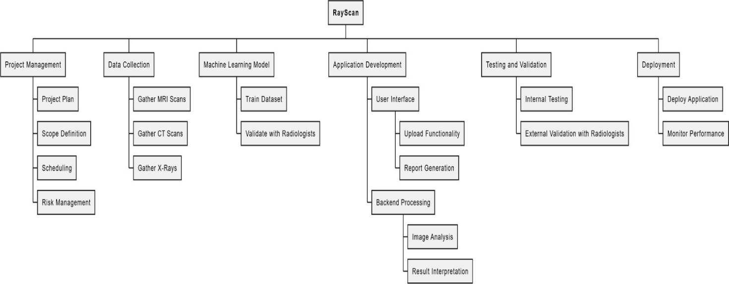

**Figure 1 Work Breakdown Structure**

## Project Time Line

This Gantt chart outlines the timeline for our project in 2025. The project follows seven key phases, from planning to final deployment:

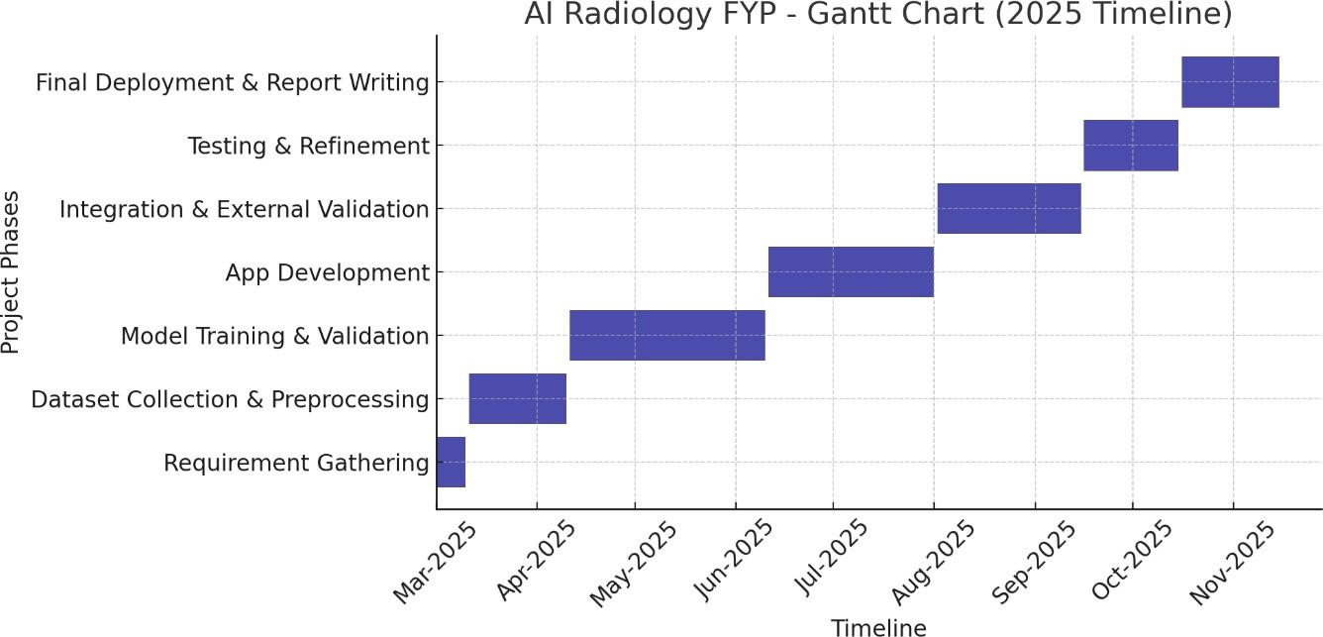

**Figure 2 Sample Gantt Chart**

# Chapter 2

# 2. Requirement Specification and Analysis

This chapter outlines the detailed requirements and analysis of our Flutter-based final year project (FYP) application focused on assisting patients with early detection and medical consultation regarding breast cancer and kidney stones based on uploaded ultrasound scans.  
  
The application will allow patients to register and log in to their accounts securely. After logging in, users can choose between two options to upload ultrasound scans—either for kidney stone detection or breast cancer analysis. Once a scan is uploaded, it is processed by an integrated AI/ML model, which detects any signs of disease. The generated results are then reviewed and verified by a qualified radiologist or doctor.

Following verification, the app generates a detailed medical report, which is presented to the patient. Based on this report, patients are given the option to consult a doctor directly through video conferencing within the app. Additionally, the application allows users to upload valid prescriptions and order medicines through the platform.

The system is designed to be secure, responsive, and user-friendly, ensuring a smooth experience while maintaining the confidentiality and integrity of all medical data. It is built to support real-time interactions, accurate diagnoses, and seamless communication between patients and healthcare professionals.

## Functional Requirements

The Functional Requirements Specification documents the operations and activities that the system must be able to perform. The descriptions are made in simple language to ensure they can be understood by a non-technical audience.

Table 2-1: Functional Requirements

|  |  |  |  |
| --- | --- | --- | --- |
| S. No. | Functional Requirement | Type | Status |
|  | Patient can register an account | Functional | Pending |
|  | Patient can log in to the system. | Functional | Pending |
|  | Patient can upload ultrasound scans for breast cancer or kidney stone detection. | Functional | Pending |
|  | Patient can download Result | Core | Pending |
|  | Patient receives notification about verified report and next steps. | Functional | Pending |
|  | Patient can book an appointment with a doctor for consultation. | Core | Pending |
|  | Patient can directly consult with a doctor or radiologist via video call or chat. | Functional | Pending |
|  | Patient can search Pharmacies | Functional | Pending |
|  | Patients can contact pharmacy via chat or WhatsApp | Functional | Pending |
|  | Doctors can login through given credentials. | Functional | Pending |
|  | Doctors can add time slots | Functional | Pending |
|  | Doctors can view appointments | Functional | Pending |
|  | Doctors can join consultation virtually | Functional | Pending |
|  | Doctors can cancel appointment | Functional | Pending |
|  | Doctors can view their patients list | Functional | Pending |
|  | Admin can add nearby pharmacies to system | Functional | Pending |
|  | Admin can add Doctors/Radiologists to the system | Functional | Pending |
|  | Admin can manage doctor/radiologist profiles. | Functional | Pending |
|  | Admin can refund patients in case of unattended sessions | Functional | Pending |
|  | Admin can approve patient registration | Functional | Pending |
|  | System detects breast cancer or kidney stones | Functional | Pending |
|  | System generates a preliminary report based on provided data | Functional | Pending |
|  | Verified diagnostic results are displayed to the patient. | Functional | Pending |

## Non-Functional Requirements

These specify the criteria that judge the operation of a system rather than specific behaviors.

Table 2-2: Non-Functional Requirements

|  |  |  |
| --- | --- | --- |
| S. No. | Non-Functional Requirement | Category |
| 1 | The system shall update diagnosis status for all users in real-time. | Performance |
| 2 | The system shall be accessible 99.9% of the time. | Availability |
| 3 | All patient data must be encrypted and stored securely. | Security |
| 4 | App should work smoothly on devices with Android 8.0 and IOS or above. | Compatibility |
| 5 | The app interface shall be user-friendly and intuitive. | Usability |
| 6 | Payment methods should be secure | Security |
| 7 | Video, voice and chat consultations must maintain end-to-end encryption. | Security |
| 8 | The system should support concurrent users without degradation in experience. | Scalability |

## System Use Case Modeling

A use case defines the expected behavior of a software system as it interacts with users (actors). It is essential for defining the functional behavior of the system in real-world scenarios. The use cases in this system include scan upload, ML-based detection, radiologist review, report generation, and video consultation. These use cases represent real goals and interactions between patients and the healthcare system via the mobile app.

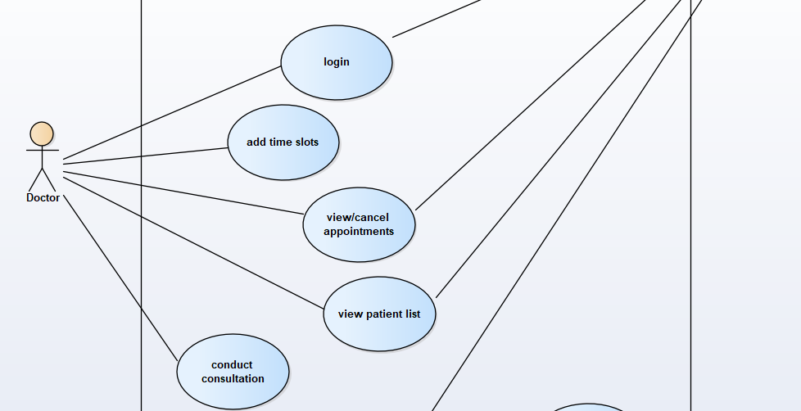

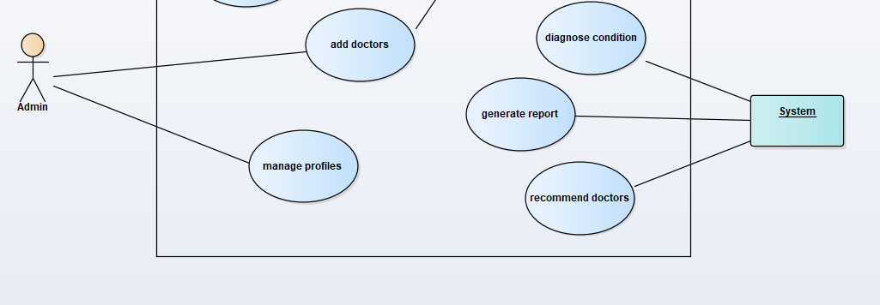

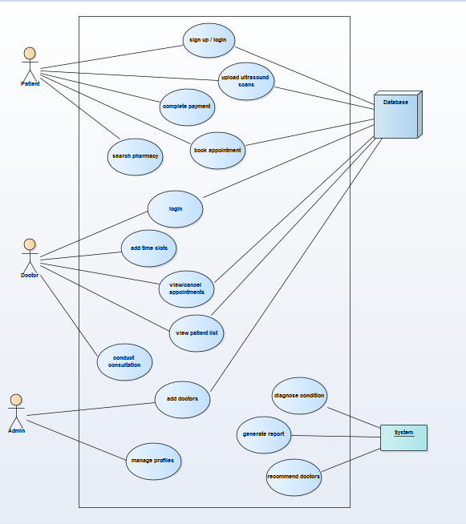

Figure 2‑1 Sample Use-case Diagram

### Use Case1 Title

Describe the use case (expected behavior of the software) in the form of steps and sub steps in the format given below. You should also proved a brief description of user interface that will satisfy the requirement of each use case.

Table 2‑3 Use-case Title

**Use case 1:**

|  |  |  |  |  |  |
| --- | --- | --- | --- | --- | --- |
| **Use Case ID:** | UC01 | | | | |
| **Use Case Name:** | Register and Log In | | | | |
| **Created By:** | Musharaf Shah | | **Last Updated By:** | | Khayyam Shah |
| **Date Created:** | April 20, 2025 | | **Last Revision Date:** | | April 20, 2025 |
| **Actors:** | | Patient, System | | | |
| **Description:** | | A patient creates an account and logs into the system securely | | | |
| **Trigger:** | | New patient opens app or an existing patient logs in | | | |
| **Preconditions:** | | App installed | | | |
| **Post conditions:** | | User is authenticated and redirected to dashboard | | | |
| **Normal Flow:** | | Actor | | System | |
| * Patient selects register/login * Enters required credentials | | * System authenticates and opens dashboard | |
| **Alternative Flows:** | | Incorrect login credentials → Show error message | | | |
| **Exceptions:** | | Server offline → Show retry message | | | |

**Use case 2:**

|  |  |  |  |  |  |
| --- | --- | --- | --- | --- | --- |
| **Use Case ID:** | UC02 | | | | |
| **Use Case Name:** | Book Appointment | | | | |
| **Created By:** | Khayyam Shah | | **Last Updated By:** | | Muhammad Haris |
| **Date Created:** | April 20, 2025 | | **Last Revision Date:** | | April 20, 2025 |
| **Actors:** | | Patient,Doctor | | | |
| **Description:** | | Patient books an appointment with a doctor for further consultation | | | |
| **Trigger:** | | Patient selects "Book Appointment" option after viewing report or diagnosis. | | | |
| **Preconditions:** | | Patient is logged in. | | | |
| **Post conditions:** | | Appointment is scheduled and notification is sent to doctor. | | | |
| **Normal Flow:** | | Actor | | System | |
| * Patient selects available doctor * Chooses date and time slot | | System confirms and books the appointment | |
| **Alternative Flows:** | | Module loading delay Show progress spinner | | | |
| **Exceptions:** | | Backend API unresponsive   * Display retry option | | | |

**Use case 3:**

|  |  |  |  |  |  |
| --- | --- | --- | --- | --- | --- |
| **Use Case ID:** | UC03 | | | | |
| **Use Case Name:** | Upload Ultrasound Scans | | | | |
| **Created By:** | Musharaf Shah | | **Last Updated By:** | | Muhammad Haris |
| **Date Created:** | April 20, 2025 | | **Last Revision Date:** | | April 20, 2025 |
| **Actors:** | | Patient, System | | | |
| **Description:** | | The patient uploads a breast or kidney ultrasound scan. The system performs analysis using trained ML models. | | | |
| **Trigger:** | | User selects a scan and uploads it | | | |
| **Preconditions:** | | User is logged in and has a scan ready for upload. | | | |
| **Post conditions:** | | System displays initial results and forwards to radiologist for review. | | | |
| **Normal Flow:** | | Actor | | System | |
| Actor uploads scan | | * System processes scan * Runs ML model and Prepares result | |
| **Alternative Flows:** | | ML model confidence is low → Request re-scan or alternate review path | | | |
| **Exceptions:** | | Scan file corrupt or unsupported format → Display error | | | |

.

**Use case 4:**

|  |  |  |  |  |  |
| --- | --- | --- | --- | --- | --- |
| **Use Case ID:** | UC04 | | | | |
| **Use Case Name:** | SearchPharmacy | | | | |
| **Created By:** | Muhammad Haris | | **Last Updated By:** | | Khayyam Shah |
| **Date Created:** | April 20, 2025 | | **Last Revision Date:** | | April 20, 2025 |
| **Actors:** | | Patient,System | | | |
| **Description:** | | Patient browses medicines and places an order using a valid prescription. | | | |
| **Trigger:** | | Patient selects the Pharmacy module | | | |
| **Preconditions:** | | Logged-in user with valid prescription | | | |
| **Post conditions:** | | Order is confirmed, and pharmacy receives prescription | | | |
| **Normal Flow:** | | Actor | | System | |
| * Patient browses Pharmacies * Contacts Pharmacy via whatsapp | | System redirects patient to whatsapp number | |
| **Alternative Flows:** | | Pharmacies not found   * Prompt to click again | | | |
| **Exceptions:** | | Pharmacy not available   * Notify user | | | |

**Use case 5:**

|  |  |  |  |  |  |
| --- | --- | --- | --- | --- | --- |
| **Use Case ID:** | UC05 | | | | |
| **Use Case Name:** | CompletePayment | | | | |
| **Created By:** | Musharaf Shah | | **Last Updated By:** | | Khayyam Shah |
| **Date Created:** | April 20, 2025 | | **Last Revision Date:** | | April 20, 2025 |
| **Actors:** | | Patient | | | |
| **Description:** | | Patient pays for consultation, or appointment. | | | |
| **Trigger:** | | A service requiring payment is initiated. | | | |
| **Preconditions:** | | Service and billing amount is generated. | | | |
| **Post conditions:** | | Payment is processed and receipt issued. | | | |
| **Normal Flow:** | | Actor | | System | |
| * Patient chooses payment method * Enters required details | | System processes payment | |
| **Alternative Flows:** | | Payment failed   * Retry or choose another method | | | |
| **Exceptions:** | | Payment gateway timeout | | | |

**Use case 6:**

|  |  |  |  |  |
| --- | --- | --- | --- | --- |
| **Use Case ID:** | UC06 | | | |
| **Use Case Name:** | Add Doctor | | | |
| **Created By:** | Musharaf Shah | | **Last Updated By:** | Khayyam Shah |
| **Date Created:** | April 20, 2025 | | **Last Revision Date:** | April 20, 2025 |
| **Actors:** | | Admin | | |
| **Description:** | | Admin adds new doctor profiles into the system for patient access and consultation linkage. | | |
| **Trigger:** | | Admin accesses the dashboard and selects “Add Doctor” | | |
| **Preconditions:** | | Admin must be logged in with proper privileges. | | |
| **Post conditions:** | | Doctor is successfully added to the system and is available for selection by patients. | | |
| **Normal Flow:** | | Admin | | |
| * Admin navigates to the manage section * Selects “Add Doctor” * Enters required details and submits * System stores and confirms addition | | |
| **Alternative Flows:** | | Missing required fields   * Prompt user to fill mandatory details | | |
| **Exceptions:** | | Database insertion error → Show error message and log issue | | |

**Use case 7:**

|  |  |  |  |  |
| --- | --- | --- | --- | --- |
| **Use Case ID:** | UC07 | | | |
| **Use Case Name:** | Manage Profile and Billings | | | |
| **Created By:** | Musharaf Shah | | **Last Updated By:** | Khayyam Shah |
| **Date Created:** | April 20, 2025 | | **Last Revision Date:** | April 20, 2025 |
| **Actors:** | | Admin | | |
| **Description:** | | Admin manages user profiles (doctors, patients) and handles billing details for services like appointments, consultations, and pharmacy orders. | | |
| **Trigger:** | | Admin navigates to profile or billing section from dashboard. | | |
| **Preconditions:** | | Admin must be logged in with required privileges. | | |
| **Post conditions:** | | Profiles are updated and billing records are modified or confirmed. | | |
| **Normal Flow:** | | Admin | | |
| * Admin selects “Manage Profiles” or “Manage Billing” * Searches for target user or record * Updates or corrects details * Refunds patient with cancelled apointments * System saves changes and confirms update | | |
| **Alternative Flows:** | | Invalid data format   * Show validation error message | | |
| **Exceptions:** | | Database update fails   * Log error and show retry option | | |

**Use case 8:**

|  |  |  |  |  |
| --- | --- | --- | --- | --- |
| **Use Case ID:** | UC08 | | | |
| **Use Case Name:** | Diagnose Condition | | | |
| **Created By:** | Musharaf Shah | | **Last Updated By:** | Khayyam Shah |
| **Date Created:** | April 20, 2025 | | **Last Revision Date:** | April 20, 2025 |
| **Actors:** | | System | | |
| **Description:** | | System uses ML models to detect disease from ultrasound scans. | | |
| **Trigger:** | | Scan is Analyzed | | |
| **Preconditions:** | | Valid ultrasound scan uploaded. | | |
| **Post conditions:** | | Disease if any is detected | | |
| **Normal Flow:** | | System | | |
| * System applies ML model * Identifies disease or confirms absence | | |
| **Alternative Flows:** | | Model confidence low   * Request manual review | | |
| **Exceptions:** | | ML module fails to load | | |

**Use case 9:**

|  |  |  |  |  |
| --- | --- | --- | --- | --- |
| **Use Case ID:** | UC09 | | | |
| **Use Case Name:** | Recommend Doctors | | | |
| **Created By:** | Musharaf Shah | | **Last Updated By:** | Khayyam Shah |
| **Date Created:** | April 20, 2025 | | **Last Revision Date:** | April 20, 2025 |
| **Actors:** | | System | | |
| **Description:** | | System recommends suitable doctors based on diagnosis and patient location. | | |
| **Trigger:** | | Diagnoses is completed. | | |
| **Preconditions:** | | System has access to available doctors. | | |
| **Post conditions:** | | Pateint recieves recommendation list | | |
| **Normal Flow:** | | System | | |
| * System fetches doctors by specialty * Filters based on proximity and availability | | |
| **Alternative Flows:** | | No matching doctor   * Suggest alternative specialties | | |
| **Exceptions:** | | Doctor Databse unavailable | | |

**Use case 10:**

|  |  |  |  |  |
| --- | --- | --- | --- | --- |
| **Use Case ID:** | UC010 | | | |
| **Use Case Name:** | Generate Report | | | |
| **Created By:** | Musharaf Shah | | **Last Updated By:** | Khayyam Shah |
| **Date Created:** | April 20, 2025 | | **Last Revision Date:** | April 20, 2025 |
| **Actors:** | | System | | |
| **Description:** | | Final report is generated based on scan | | |
| **Trigger:** | | ML model completes scan analysis | | |
| **Preconditions:** | | Scan has been successfully processed | | |
| **Post conditions:** | | PDF report is generated and stored. | | |
| **Normal Flow:** | | System | | |
| * System compiles results * Generates PDF report | | |
| **Alternative Flows:** | |  | | |
| **Exceptions:** | | Report generation failure | | |

**Use case 11:**

|  |  |  |  |  |  |
| --- | --- | --- | --- | --- | --- |
| **Use Case ID:** | UC011 | | | | |
| **Use Case Name:** | Doctor Log In | | | | |
| **Created By:** | Musharaf Shah | | **Last Updated By:** | | Khayyam Shah |
| **Date Created:** | April 20, 2025 | | **Last Revision Date:** | | April 20, 2025 |
| **Actors:** | | Doctor,System | | | |
| **Description:** | | Doctor logs into the application securely to access their dashboard, appointments, and availability schedule. | | | |
| **Trigger:** | | Doctor opens the app and selects “Login”. | | | |
| **Preconditions:** | | Doctor must be registered and approved by admin. | | | |
| **Post conditions:** | | Doctor is redirected to the dashboard with access to their profile. | | | |
| **Normal Flow:** | | Doctor | | System | |
| * Doctor enters email and password | | · System authenticates credentials  · Doctor is redirected to dashboard | |
| **Alternative Flows:** | | Incorrect credentials   * Show error message | | | |
| **Exceptions:** | | Authentication service unavailable   * Show retry option | | | |

**Use case 12:**

|  |  |  |  |  |  |
| --- | --- | --- | --- | --- | --- |
| **Use Case ID:** | UC12 | | | | |
| **Use Case Name:** | Schedule Availability | | | | |
| **Created By:** | Musharaf Shah | | **Last Updated By:** | | Khayyam Shah |
| **Date Created:** | April 20, 2025 | | **Last Revision Date:** | | April 20, 2025 |
| **Actors:** | | Doctor,System | | | |
| **Description:** | | Doctor checks a list of upcoming appointments for the selected day/week. | | | |
| **Trigger:** | | Doctor clicks “View Appointments” from dashboard. | | | |
| **Preconditions:** | | Doctor is logged in and appointments are scheduled. | | | |
| **Post conditions:** | | Appointments are listed with details. | | | |
| **Normal Flow:** | | Doctor | | System | |
| * Doctor selects the Profile tab * Doctor sets available time slots | | * System saves time slots for specific timeslots | |
| **Alternative Flows:** | | * No Free time slots * “All slots are filled” | | | |
| **Exceptions:** | | Time Slot data fetch fails   * Show system error | | | |

**Use case 13:**

|  |  |  |  |  |  |
| --- | --- | --- | --- | --- | --- |
| **Use Case ID:** | UC13 | | | | |
| **Use Case Name:** | Conduct Consultation | | | | |
| **Created By:** | Musharaf Shah | | **Last Updated By:** | | Khayyam Shah |
| **Date Created:** | April 20, 2025 | | **Last Revision Date:** | | April 20, 2025 |
| **Actors:** | | Doctor, System | | | |
| **Description:** | | Doctor conducts a consultation (video or in-person) with a patient and adds clinical notes. | | | |
| **Trigger:** | | Scheduled appointment time is reached. | | | |
| **Preconditions:** | | Valid appointment exists; patient is available. | | | |
| **Post conditions:** | | Consultation summary or notes are recorded. | | | |
| **Normal Flow:** | | Doctor | | System | |
| * Doctor opens consultation session * Interacts with patient (video or in-person) * Enters notes/prescription | | * System saves the record | |
| **Alternative Flows:** | | Patient no-show   * Mark as no-showShow | | | |
| **Exceptions:** | | Connectivity issue   * Attempt reconnection | | | |

**Use case 14:**

|  |  |  |  |  |  |
| --- | --- | --- | --- | --- | --- |
| **Use Case ID:** | UC14 | | | | |
| **Use Case Name:** | View and Cancel Appointments | | | | |
| **Created By:** | Musharaf Shah | | **Last Updated By:** | | Khayyam Shah |
| **Date Created:** | April 20, 2025 | | **Last Revision Date:** | | April 20, 2025 |
| **Actors:** | | Doctor, System | | | |
| **Description:** | | Doctor views upcoming appointments and may cancel any if necessary. The system updates the schedule and notifies affected patients. | | | |
| **Trigger:** | | Doctor selects the “Appointments” section from the dashboard. | | | |
| **Preconditions:** | | Doctor is logged in and appointments are scheduled. | | | |
| **Post conditions:** | | Appointments are listed; any cancellations are processed and patients notified. | | | |
| **Normal Flow:** | | Doctor | | System | |
| * Doctor navigates to the appointments section * Doctor selects an appointment to cancel * Confirms cancellation | | * System displays all upcoming appointments * System removes appointment and notifies patient | |
| **Alternative Flows:** | | No appointments available   * Show “No upcoming appointments”   Doctor changes mind after selecting cancel   * Cancel process aborted | | | |
| **Exceptions:** | | Appointment deletion fails   * Show error message   Patient notification fails   * Log issue and alert admin | | | |

**Use case 15:**

|  |  |  |  |  |  |
| --- | --- | --- | --- | --- | --- |
| **Use Case ID:** | UC15 | | | | |
| **Use Case Name:** | View Patient List | | | | |
| **Created By:** | Musharaf Shah | | **Last Updated By:** | | Khayyam Shah |
| **Date Created:** | April 20, 2025 | | **Last Revision Date:** | | April 20, 2025 |
| **Actors:** | | Doctor, System | | | |
| **Description:** | | Doctor views a list of patients who have appointments or past consultations with them. | | | |
| **Trigger:** | | Doctor clicks on “Patient List” section from their dashboard. | | | |
| **Preconditions:** | | Doctor is logged in and has patients linked to past or scheduled appointments. | | | |
| **Post conditions:** | | Patient list is displayed with names, reports, and history access. | | | |
| **Normal Flow:** | | Doctor | | System | |
| * Doctor accesses the patient list section * Doctor selects a patient to view details | | * System fetches and displays linked patients * System displays Patient Details | |
| **Alternative Flows:** | | No patients found   * Show “No patients available” | | | |
| **Exceptions:** | | Patient data fetch fails   * Display system error | | | |

## System Sequence diagrams

Sequence diagrams are created to show the sequence of events among user and the system to complete an action / use case. A sample is presented in Fig 2.2.

You are required to provide SSD of all the uses cases that you have provided above.

**1.**

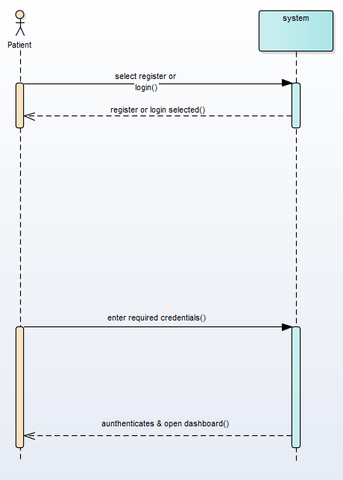

**2.**

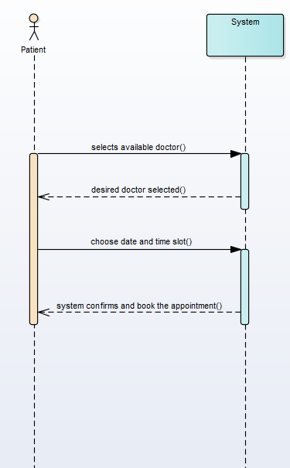

**3.**

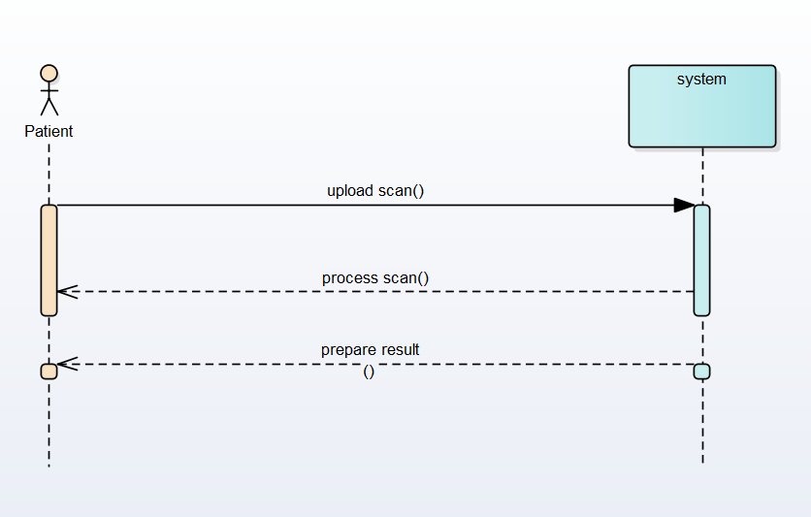

**4.**

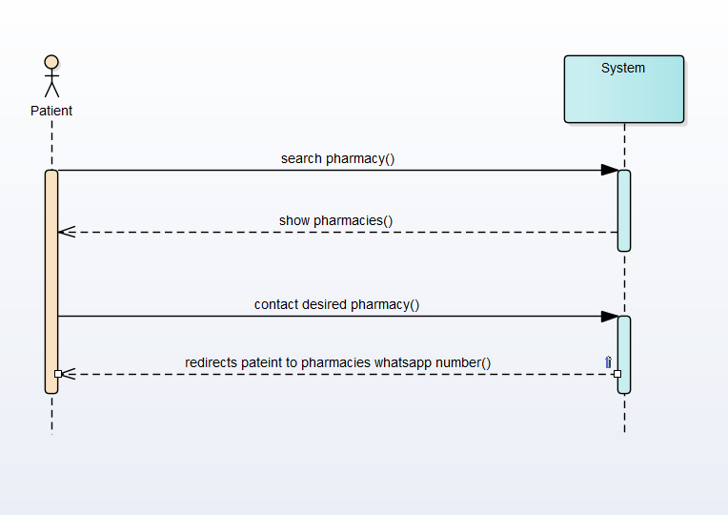

**5.**

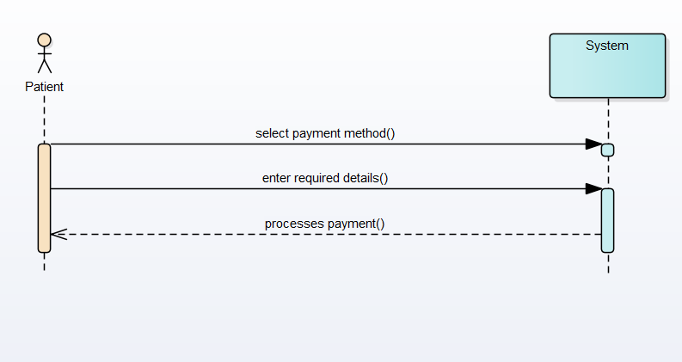

**6.**

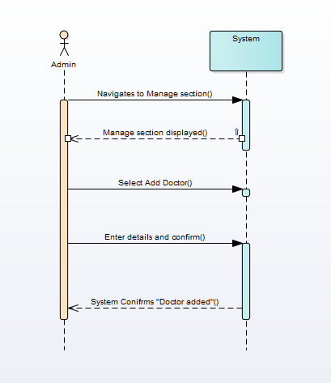

**7.**

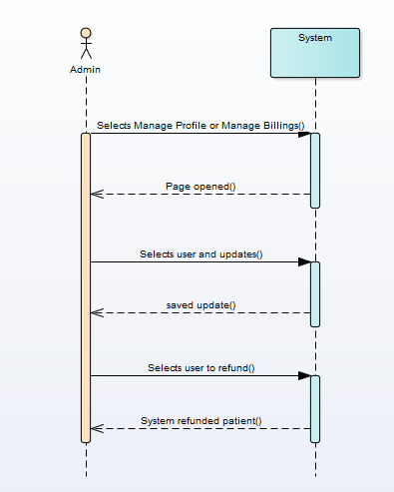

**8.**

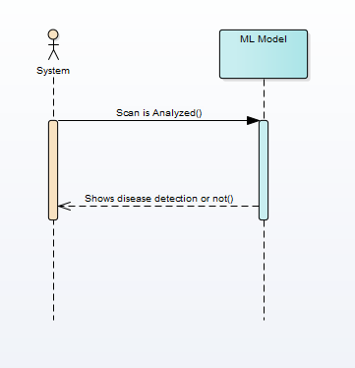

**9.**

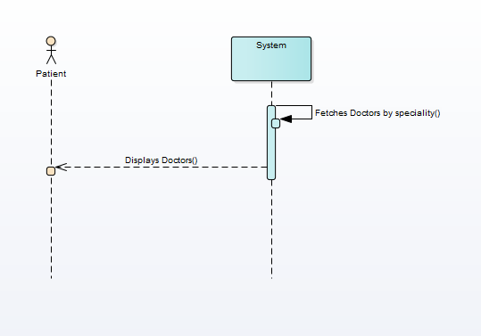

**10.**

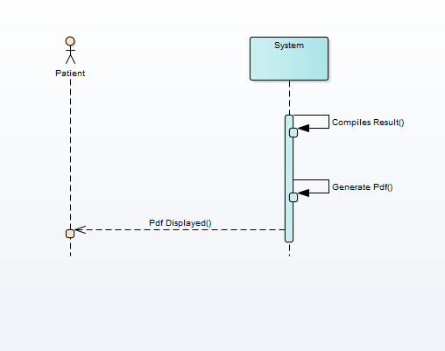

**11.**

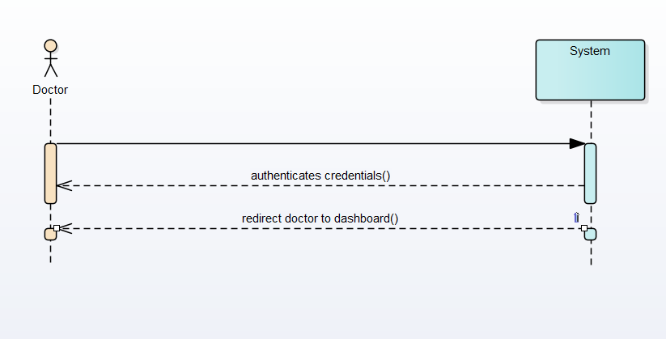

**12.**

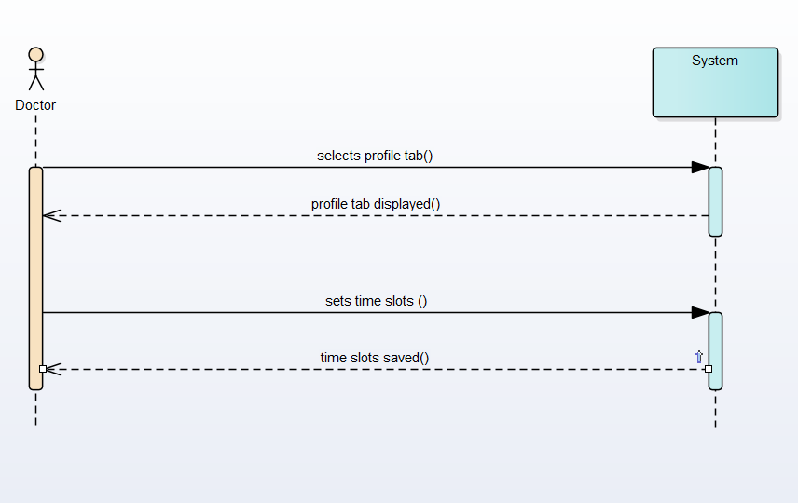

**13.**

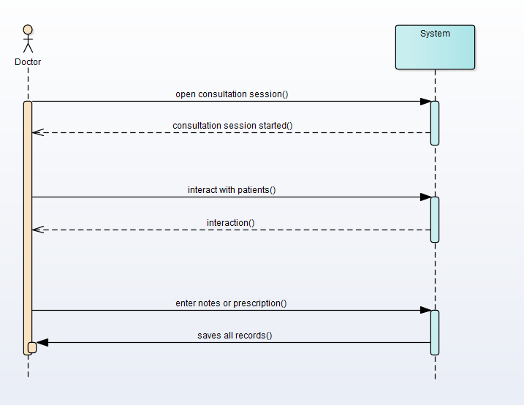

**14.**

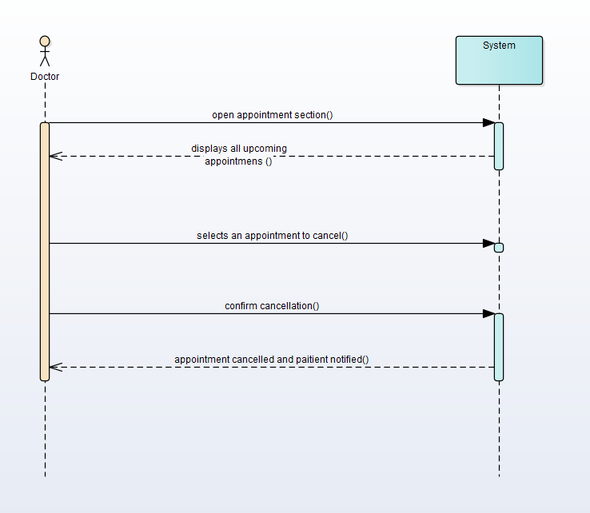

**15.**

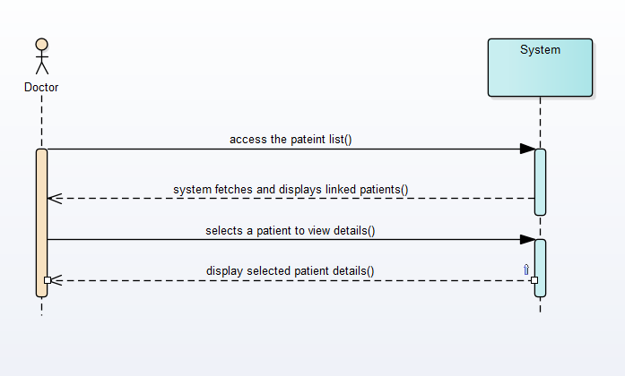

Figure 2‑2 Sample SDD

## Domain Model

Figure 2‑3 sample Domain Model

## Minimum Requirement

This section outlines the minimum hardware and software requirements needed to run the application efficiently on supported platforms.

* OS: Android 8.0 (Oreo) or above / Windows 10+ for Web version
* Processor: 1.8 GHz quad-core processor or higher
* RAM: Minimum 3 GB
* Storage: Minimum 500 MB free space
* Camera: For video consultation (front-facing camera)
* Internet: Required for ML API calls and video consultation
* Mobile App Dependency: Camera, File Access, Microphone Permissions

## Limitation and Constraint

* The app requires an active internet connection for uploading scans and consultations.
* Image quality can impact detection accuracy.
* Diagnosis may not be 100% accurate; always validated by professionals.
* App usage restricted to approved regions for telemedicine consultations.
* Limited support for older Android versions (below 8.0).

## User Interface Design (Prototypes)

The application's UI is designed with simplicity and usability in mind. It is intuitive for patients with minimal digital literacy. Each screen serves a unique function, from scan upload to video consultations.

### Link to Prototype

https://www.figma.com/design/3ytLeIYriQgPG4ffKGjle0/Radiology-kit?node-id=0-1&t=7SQX7oTBJ1nP7gwH-1

### App Initial Interface:

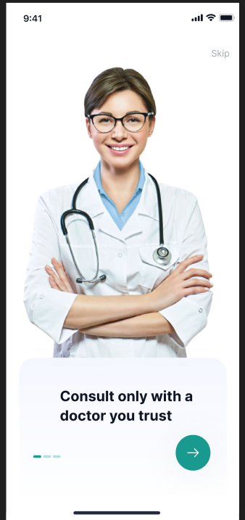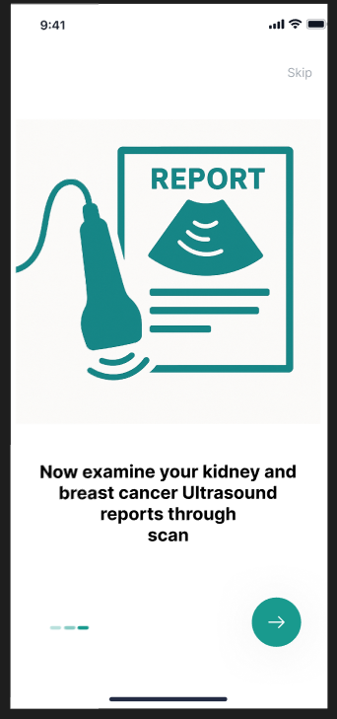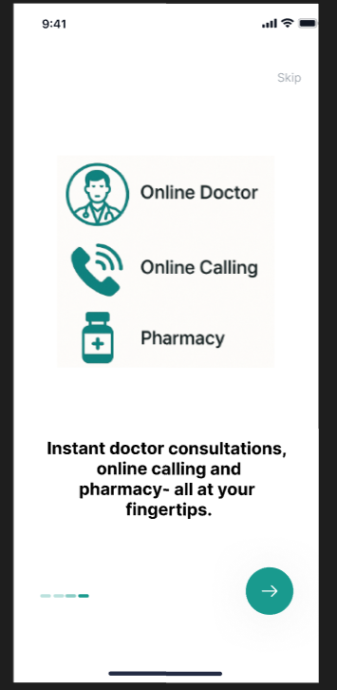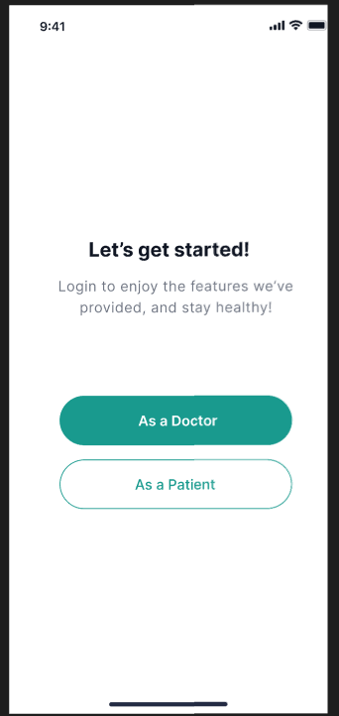

### Patient View:

* **Registration and Log In**

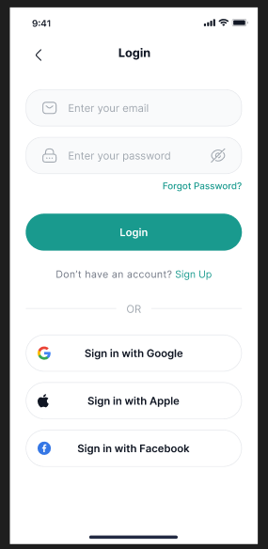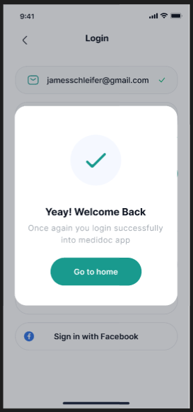

### Patient Portal View

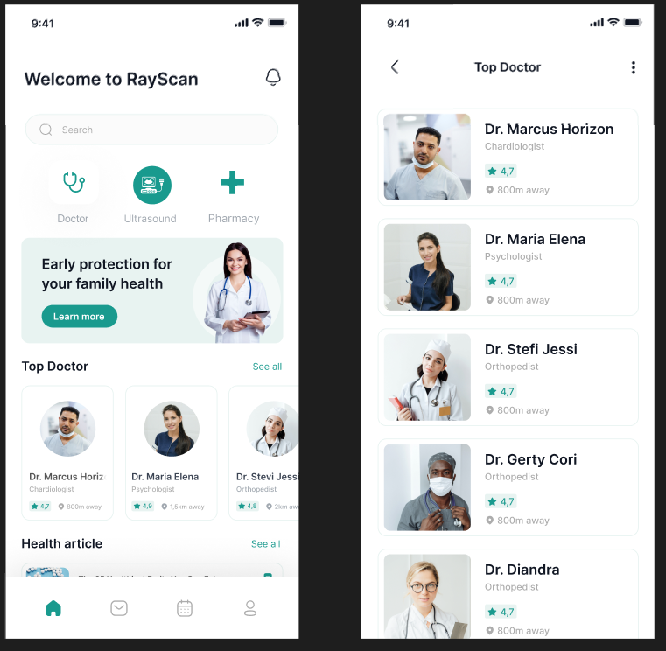

### Patient Portal:

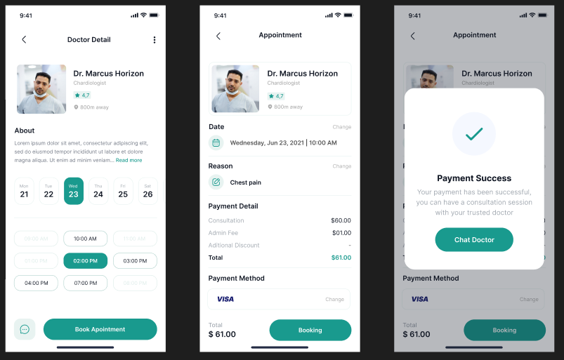

 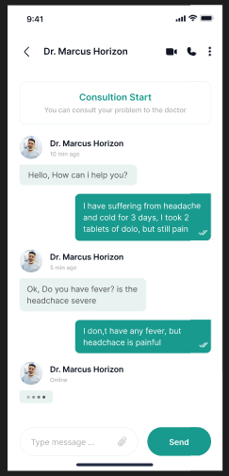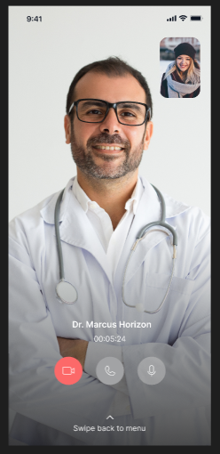

### Ultrasound:

### Pharmacy:

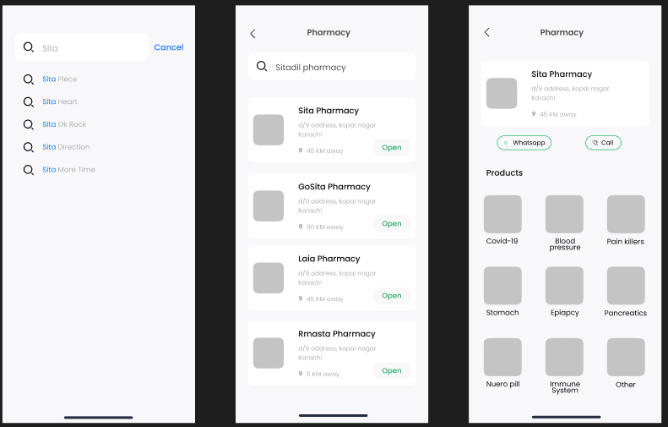

Profile:

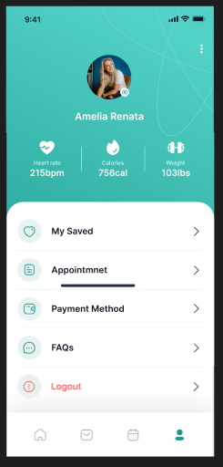

### Doctor View:

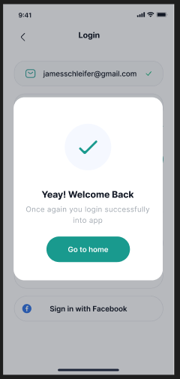 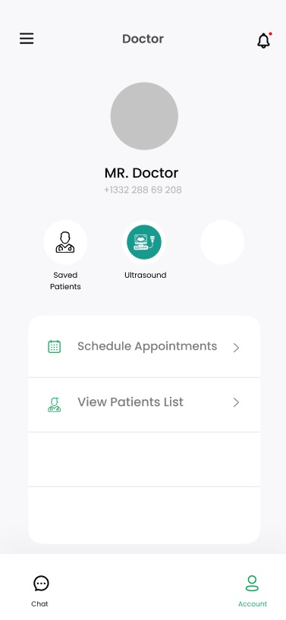

### Admin (Web Pannel)

