Compiler Construction
CISB220 #3

DB22868
Yu Lingxiao

PREFACE

· Main code and Elaboration

· Test report

· Conclusion

· Appendix : String

The project is aiming at crafting an enhanced Triangle language processor that supports case-command. And the case-command is in form of

case E of
lL₁: C₁;
lL₂: C₂;
…;
lL_{n}: C_{n};
else: C₀

- where the integer literals followed by commands. And if no case matches, it will execute the command labeled by zero (the last line of command). The Triangle language processor will perform run-time and compile-time index checks with error report including line number of the error in the source program.

Main code and Elaboration

The command was first accepted by parser.java(syntactic analyzer). The process starts at detecting token case, where we use a hash map to accept the following command body.
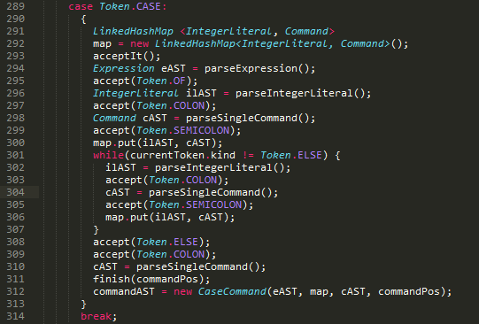
map.put() command puts the ASTs into the hash table by order.
and while we haven’t see token else, which means that we are not at the last line of case-command. then we continue putting integer literals and commands into table.
commandAST is returned as a new object CaseCommand() with parameters of AST , hash map, and its position.

In checker.java(contextual analyzer) we accept the AST of case-command and visit it. The purpose is to do type checking (and others) following the generated AST by syntactic parsing.
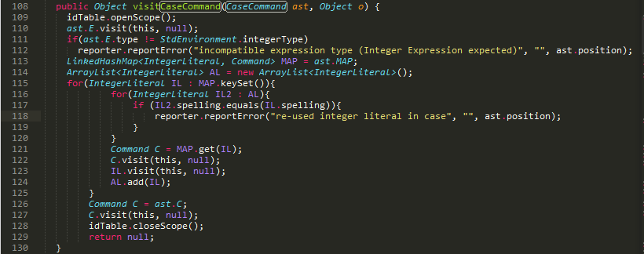
first we check redundance of case-command, where constructs an array-list of the integer literals (same as in the hash map). for each key in the map, if it’s re-used the report an error (compare the spelling by IL2.spelling.equals() ).
and separate commands by Command C = MAP.get(IL), because IL is the key for each command in a hash table (such as a “name”).
add IL into array-list if check has been done.
during the process, visit each command.

In encoder.java we visit the command again to generate machine code.
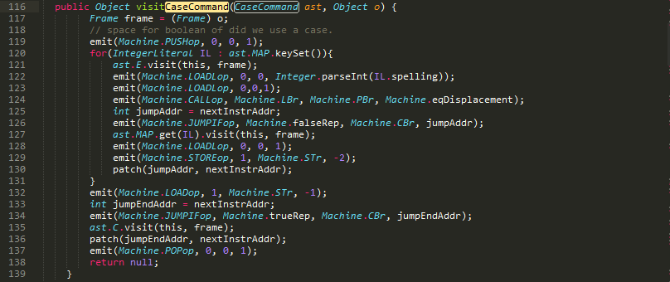
ast.E.visit() visits the expression and later loaded by emit(Machine.LOADop, 0,0,1) onto the stack. with loading IL onto the stack first (and then the expression), and call equal operation, push that result onto stack.
int jumpAddr = nextInstruAddr defines the next machine instruction’s address. if the previous equal operation results false, then jump out of this case integer literal/command, to the address of patch(jumpAddr, nextInstrAddr), where is the next case-literal. if true, then execute the command “named” by IL.
the visitor will traverse all the case-literals (and terminates the for-loop).
if all not matched (not executed), then visit ast.C, or, jump to end.

The AST of CaseCommand.java used above is shown.
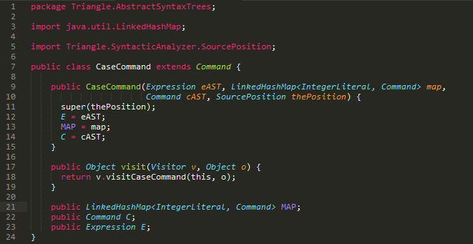
which has a special data structure that uses hash table to store undetermined size of commands. and the hash table has IntegerLiteral as keys for Command.

Test report

The test under windows 8.1, NetBeans 7.4 runs well.

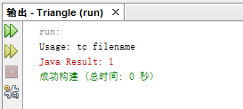

Conclusion

The language processor implements case-command successfully. It is similar with C language’s switch statement, which also traverse all case statements in the scope.

Appendix : String

The string type is implemented as follow:

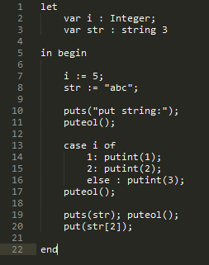
string is a keyword for type string, and the number follows it is the length of string (implemented as array). And string can be operated in array’s way such as string[index]. Function puts() prints a string.

In contextual analysis, the visitors are aimed to check string length and detect duplicated identifiers.
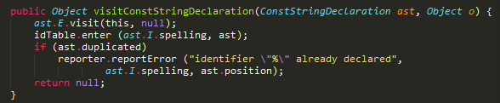
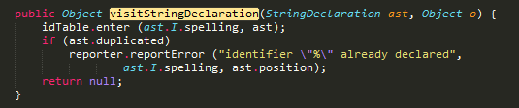
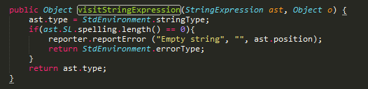

In AST we have the denoters and types.
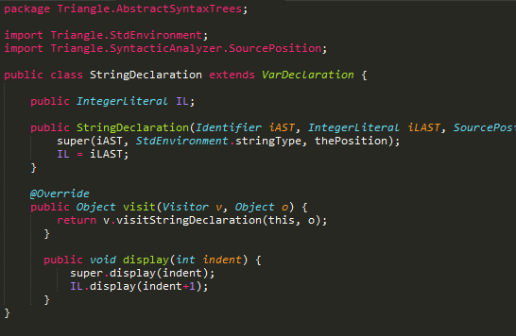
(defines the declaration format.)

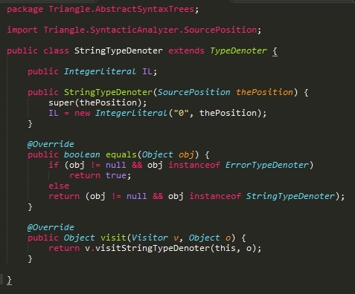
(defines the string type, which is similar to other TypeDenotor.)

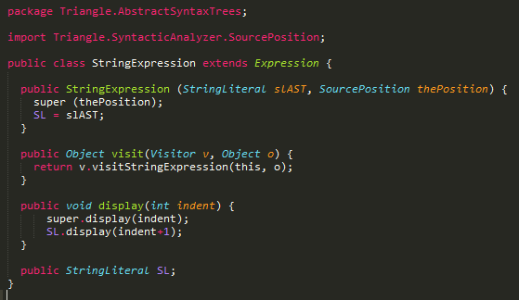
(defines the display method that string can be represented as an array.)

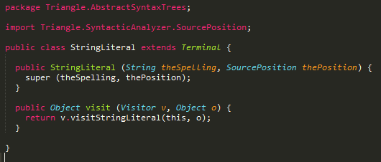
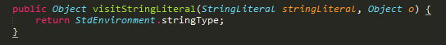
(defines the literal that can be visited as standard string type in TAM.)
(the second picture defines the string literal visitor in contextual analysis, i.e. checker.java)
The other also follows Integer type. See more in source code.

