RAG Evaluation Project
Evaluating RAG Systems with RAGAS Concepts — Week 8 Day 1 Report
Applied RAG Engineering Course · EnlivenAI Solutions · September 2026
Scope: manual evaluation framework for faithfulness and context precision, with improvement strategies and a path to RAGAS automation

1. Executive Summary
This project provides a hands-on evaluation framework for Retrieval-Augmented Generation (RAG) systems. It implements manual evaluation of faithfulness and context precision metrics as described in the RAGAS framework. The framework treats a RAG system as a pipeline — user question → retriever → retrieved context → language model → final answer — and asks one key evaluation question: Did the system retrieve the right information, and did the answer use that information correctly?
The project ships with an orchestration script (main.py) that walks an evaluator through six test examples drawn from an HR-policy domain, a scoring module (manual_evaluation.py) implementing both metrics, a six-example dataset (evaluation_data.json), and two generated outputs: a per-example score breakdown (results/evaluation_report.csv) and a summary with an improvement recommendation (results/improvement_report.json). The report that follows documents the metrics, the dataset, the workflow, score interpretation, and concrete improvement strategies for each failure mode.

2. Introduction and Objectives

2.1 Why RAG evaluation matters
1. Runs ≠ Reliable. A RAG app can execute without errors and still return weak, incomplete, or unsupported answers. A clean run is not evidence of a good answer.
2. Finds Root Cause. Evaluation separates retrieval problems from answer-generation problems, so effort is spent on the component that actually needs fixing.
3. Controls Experiments. Changing one setting (chunk size, top-k, prompt) may improve one score while weakening another. Scores make those trade-offs visible.

2.2 Learning objectives
- Create a small evaluation dataset
- Run manual quality checks on RAG outputs
- Read and interpret evaluation scores
- Identify which component (retriever vs LLM) needs improvement
- Write an improvement report with actionable recommendations

3. Background: The RAG Workflow
A RAG system follows this workflow:
User Question → Retriever → Retrieved Context → Language Model → Final Answer
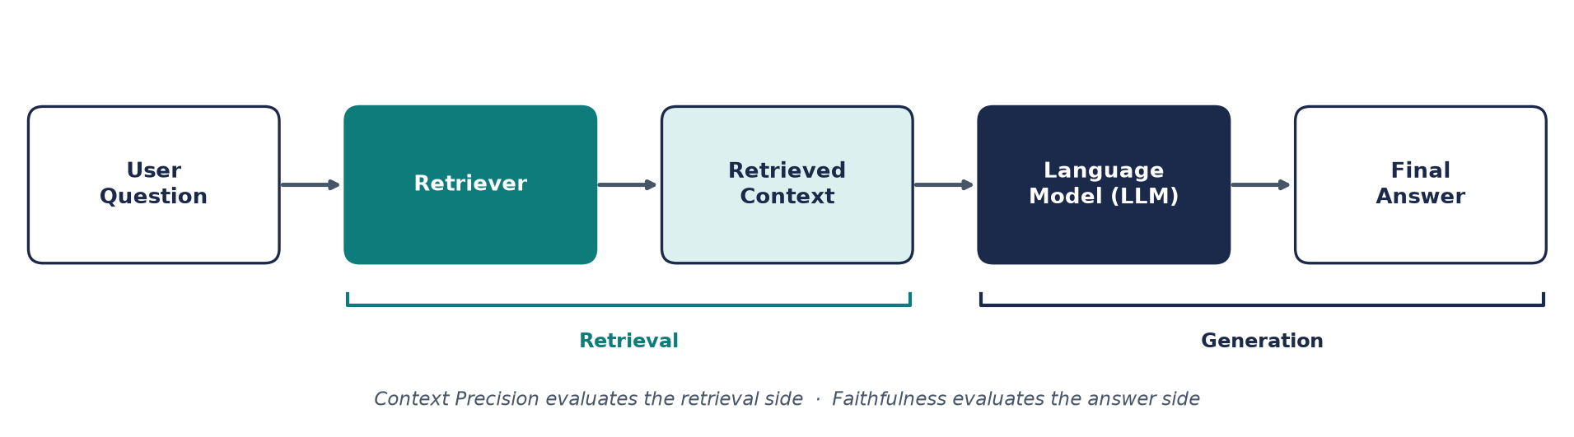
Figure 1. The RAG pipeline. Context Precision evaluates the retrieval side; Faithfulness evaluates the answer side.
Evaluation attaches to both halves of this pipeline: the retrieval half is judged by how much of the retrieved context is actually useful, and the generation half is judged by whether the final answer stays within the evidence it was given.

4. Evaluation Metrics

4.1 Faithfulness
Question: Is every important claim supported by the retrieved context?
Definition: measures whether the answer stays within the evidence.
Formula: score = (supported claims) / (total claims)
Good for detecting: LLM hallucinations, unsupported claims, information drift.
Worked example:
Context: "Employees receive 20 annual leave days."
Answer: "Employees receive 20 days and a travel allowance."
Result: "travel allowance" is unsupported → lower faithfulness

4.2 Context Precision
Question: How much of the retrieved context is actually useful?
Definition: measures the quality and relevance of retrieval.
Formula: score = (useful chunks) / (total chunks)
Good for detecting: retriever noise, irrelevant results, over-fetching.
Worked example:
Question: "What is the remote work policy?"
Retrieved 5 chunks, but only 3 are relevant → precision = 0.60

4.3 Context Precision + Recall Matrix
 | High Precision | Low Precision
High Recall | ✓ Best state | Important evidence present, but too much noise
Low Recall | Useful chunks, but key evidence missing | Needs major improvement

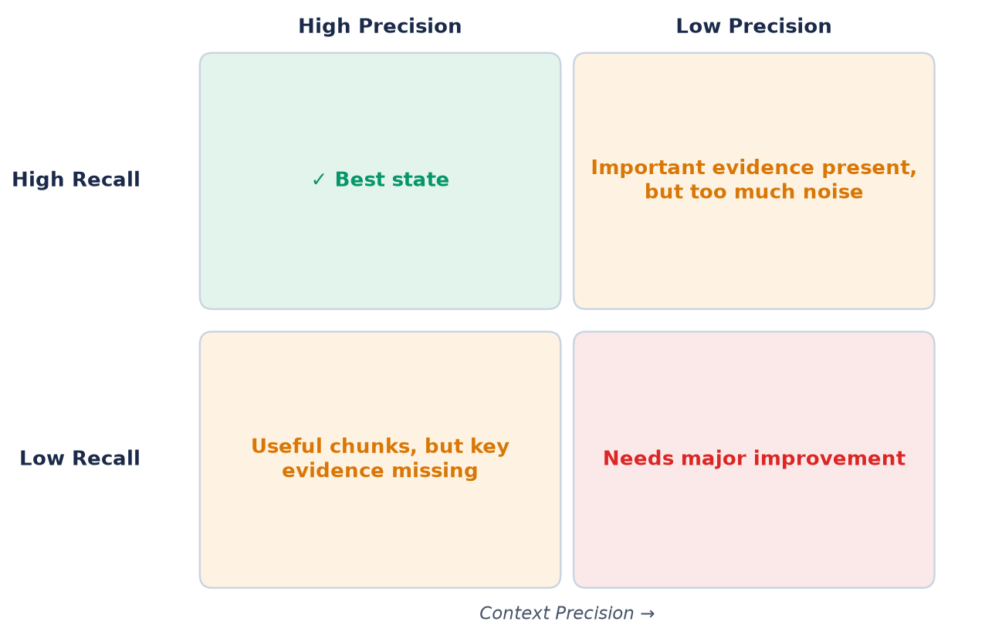
Figure 2. The precision × recall quadrants. Precision is measured directly by this project; recall gaps are diagnosed from missing evidence.

5. Project Architecture and Components
Component | Role
main.py | Main orchestration script: prints welcome and instructions, loads evaluation_data.json, iterates over the six examples calling ManualEvaluator.evaluate_example, prints the summary, asks for one improvement recommendation, and saves both output files.
manual_evaluation.py | ManualEvaluator class: calculate_faithfulness (prompts the evaluator to count total claims and supported claims, computes supported/total), calculate_context_precision (prompts for the useful-chunk count out of total chunks), evaluate_example, print_summary (averages + weakest metric), save_results_to_csv.
evaluation_data.json | Test dataset — 6 examples, each with four fields: question, answer, contexts (list of retrieved chunks), ground_truth.
results/evaluation_report.csv | Generated output: detailed per-example scores (11 columns, see Section 7).
results/improvement_report.json | Generated output: summary and recommendation (schema below).
requirements.txt | Core dependency: python-dotenv==1.0.0. Optional: ragas==0.1.12, langchain==0.1.0, anthropic==0.7.0.
.env.example | Environment template: ANTHROPIC_API_KEY, OPENAI_API_KEY, EVALUATION_MODEL (claude-3-sonnet-20240229), EMBEDDING_MODEL (text-embedding-3-small), plus project settings and DEBUG flag.

5.1 improvement_report.json schema
{
"total_examples_evaluated": 6,
"average_faithfulness_score": <avg of per-example scores>,
"average_context_precision_score": <avg of per-example scores>,
"weakest_metric": "Faithfulness" | "Context Precision",
"weakest_metric_score": <score>,
"improvement_recommendation": "<your one recommendation>"
}
The weakest metric is whichever average is lower; the recommendation is supplied by the evaluator at the end of the run.

6. The Evaluation Dataset
The dataset contains six HR-policy examples. Each example carries question, answer, contexts (retrieved chunks), and ground_truth.
# | Topic | Question | Key facts in the answer | Ground truth | Chunks
1 | Annual leave | How many annual leave days are allowed? | 20 annual leave days per year | 20 paid annual leave days per year | 1
2 | Remote work | What is the remote work policy? | Remote 3 days per week; 2 days required in office for collaboration and meetings | 3 days remote, 2 days office required per week | 2
3 | Health insurance | What is the health insurance coverage? | Medical, dental, vision, and mental health services; 80% employee / 50% dependent coverage | 80% employee, 50% dependent; includes medical, dental, vision, mental health | 2
4 | Performance reviews | When is the performance review scheduled? | Twice a year — June and December; possibility of additional reviews during onboarding | Mid-year in June and year-end in December | 3
5 | Parental leave | What is the parental leave policy? | 12 weeks paid for both mothers and fathers; extendable with unpaid leave up to 6 months total | 12 weeks paid parental leave for both parents | 1
6 | Professional development | What professional development budget is available? | $2,500 annual budget for courses, conferences, certifications, or training programs | $2,500 annual professional development budget per employee | 3

Evaluator’s note — a claim-support nuance: example 3’s answer mentions mental health coverage while its two contexts list only medical, dental, and vision plans (plus the 80%/50% premium split). When counting supported claims, that mental-health claim has no supporting chunk — exactly the kind of unsupported detail the faithfulness metric is designed to catch. Similarly, example 4’s answer adds an onboarding nuance beyond the June/December ground truth, and example 5’s answer mentions an unpaid extension (up to 6 months total) not present in its single context.

7. Evaluation Workflow
The evaluation runs as a guided, interactive session:
- Step 1 — Install dependencies. pip install -r requirements.txt
- Step 2 — Launch. python main.py — the script prints the welcome banner and loads the 6 examples from evaluation_data.json.
- Step 3 — Score faithfulness per example. Read the answer and the retrieved contexts; count the total claims in the answer; count how many claims are supported by the contexts; the score is supported ÷ total (e.g., 2/2 = 1.0 — faithful).
- Step 4 — Score context precision per example. Read the question and all retrieved chunks; count the total chunks; count how many are genuinely useful for answering the question (not just topically related); the score is useful ÷ total (e.g., 2 useful out of 4 → 0.50).
- Step 5 — Summary. After the examples, the script prints averages, a per-example breakdown table, and identifies the weakest metric.
- Step 6 — Recommendation and outputs. The evaluator enters ONE improvement recommendation; results are saved to results/evaluation_report.csv and results/improvement_report.json.

7.1 Output: evaluation_report.csv columns
Example · Question · Ground Truth · Faithfulness Score · Total Claims · Supported Claims · Unsupported Claims · Context Precision Score · Total Chunks · Useful Chunks · Irrelevant Chunks — with a SUMMARY block at the bottom (average faithfulness, average context precision).

7.2 Output: improvement_report.json
Fields: total_examples_evaluated, average_faithfulness_score, average_context_precision_score, weakest_metric, weakest_metric_score, improvement_recommendation (see Section 5.1).

8. Score Interpretation Framework
Both metrics produce a score between 0.0 and 1.0. The interpretation rubric:
Band | Faithfulness — what it means | Context Precision — what it means
0.0–0.3 Poor | Answer frequently makes unsupported claims; LLM is hallucinating or confabulating; likely needs prompt adjustment | Retriever is returning mostly irrelevant chunks; search is not working well; major tuning needed
0.4–0.6 Fair | Mix of supported and unsupported claims; occasional hallucinations; prompt review needed | Mixed results — some useful chunks, significant noise; retriever needs adjustment
0.7–0.85 Good | Most claims are supported; occasional minor unsupported details; room for improvement in prompt specificity | Most retrieved chunks are relevant; minor irrelevant results; good foundation, can optimize further
0.9–1.0 Excellent | All claims stay within evidence; LLM is faithful to context | Retriever is highly accurate; minimal noise in results

8.1 Score patterns and the first thing to inspect
Score Pattern | Possible Meaning | First Thing to Inspect
Low Faithfulness | Answer adds unsupported claims | Prompt + generated answer
Low Precision | Too many irrelevant chunks | Retriever, top-k, filters
Low Recall | Important evidence missing | Chunking, query expansion, coverage

Experiment best practice: change only ONE setting at a time and keep questions + documents the same. This helps you understand what actually caused the score change.

9. Improvement Strategies

9.1 If faithfulness is low (< 0.7) — the LLM is making unsupported claims
Step 1: Check the prompt. A vague prompt leaves room for interpretation:
# ✖ Bad prompt
prompt = "Based on the context, answer the user's question."
# ✓ Good prompt — explicitly constrains the answer
prompt = """Answer the user's question ONLY using the provided context.
If the context doesn't contain the answer, say 'The provided context
does not contain this information.'
Do not use any external knowledge or make assumptions."""
Step 2: Add context-grounding instructions.
prompt = """You are a helpful assistant. Answer STRICTLY based on the provided context.
Context:
{context}
User Question: {question}
Rules:
1. Only use information from the provided context
2. Do not add your own knowledge
3. If information is missing, clearly state it
4. Cite which part of the context supports your answer"""
Step 3: Use temperature = 0 for consistency. Temperature controls randomness: 0 = deterministic (best for factual answers); 1.0 = more creative, which is not good for RAG.
response = client.messages.create(
model="claude-3-sonnet",
temperature=0, # Deterministic output
messages=[...]
)
Step 4: Chain-of-thought reasoning.
prompt = """Answer the user's question step by step.
Step 1: Search the context for relevant information
Step 2: Extract only the facts that directly answer the question
Step 3: Provide your answer with citations
Context: {context}
Question: {question}"""

9.2 If context precision is low (< 0.7) — the retriever is returning irrelevant chunks
Step 1: Lower the top-k value. Retrieve fewer, better results:
results = retriever.search(query, top_k=20) # Too many irrelevant results
results = retriever.search(query, top_k=5) # Tighter results
Step 2: Add filtering to the retriever. Filter by metadata (date, category, section):
results = retriever.search(
query=question,
top_k=5,
filter={
"source": "employee_handbook",
"category": "benefits"
}
)
Step 3: Improve query preprocessing.
# ✖ Raw query — might include noise
query = "tell me about leave days and also can you explain vacation policies"
# ✓ Cleaned query — focused on core concept
query = "annual leave days policy"
Step 4: Adjust the similarity threshold. Add a minimum similarity score and filter weak matches:
results = retriever.search(query, top_k=10)
relevant_results = [r for r in results if r.score > 0.5]
Step 5: Use hybrid search (vector + keyword). Vector search alone can miss exact matches; keyword search alone can be too broad:
vector_results = vector_index.search(query, top_k=5)
keyword_results = keyword_index.search(query, top_k=5)
combined = deduplicate_and_rank(vector_results + keyword_results)

9.3 If context recall is low (< 0.7) — relevant chunks are missing from retrieval results
Step 1: Increase the top-k value. Widen the net, then check precision doesn’t drop too much:
results = retriever.search(query, top_k=3) # Current: missing important chunks
results = retriever.search(query, top_k=20) # Solution: more results to increase chances
Step 2: Improve the chunking strategy. Chunks that are too large or misaligned lose information at boundaries. Smaller, overlapping chunks help capture information that spans chunks:
# ✖ Current: chunk size 2000 tokens, overlap 0
# ✓ Better: smaller, overlapping chunks
chunk_size = 400
chunk_overlap = 50
Step 3: Add query expansion. The original query “leave policy” can miss results about “vacation days”, “time off”, or “PTO” — expand with synonyms:
expanded_queries = [
"leave policy", "vacation days", "time off",
"paid time off", "annual leave"
]
all_results = []
for q in expanded_queries:
all_results.extend(retriever.search(q, top_k=3))
unique_results = deduplicate(all_results)
Step 4: Add multi-hop retrieval. For complex questions, retrieve in steps and merge with ranking:
step1_results = retriever.search("company benefits", top_k=10)
step2_results = retriever.search("health insurance", top_k=5)
step3_results = retriever.search("mental health coverage", top_k=5)
combined = merge_with_ranking(step1_results, step2_results, step3_results)
Step 5: Index more content. Recall is limited by what you have — add more documents/sections; more comprehensive coverage means better recall.

10. Systematic Improvement Workflow
Phase | What happens
Phase 1 — Diagnosis | Complete the manual evaluation; identify the weakest metric; run the improvement report.
Phase 2 — Targeted Fix | Pick ONE metric to improve first; implement ONE change (from Section 9); re-evaluate with the same dataset; measure the change.
Phase 3 — Measure & Iterate | Compare scores before and after the change; keep what worked; move to the next metric.
Phase 4 — Balance & Optimize | Don’t over-optimize one metric at the expense of others; aim for balanced improvement; sometimes trade-offs are necessary.

Worked micro-example of Phase 3:
Current Scores:
Faithfulness: 0.65
Precision: 0.72
Change: Add temperature=0 to prompt
New Scores:
Faithfulness: 0.78 ✓ Improved
Precision: 0.72 (unchanged)
Next: Apply precision improvement

11. Example Improvement Journey
A complete worked example of the one-change-at-a-time method, from the project’s improvement guide:
Step | Change made | Measured result
Initial evaluation | — | Faithfulness 0.60 ✖ (too many unsupported claims) · Precision 0.75 ✓ (retriever working okay)
Change 1 | Added constraint to prompt: “Do not add information not in the context” | Faithfulness → 0.72 ✓
Change 2 | Lowered top-k from 10 to 5 to reduce noise | Precision → 0.85 ✓
Change 3 | Improved chunking: chunk size from 1000 to 500 tokens | Precision → 0.88 ✓✓ · Faithfulness → 0.75 ✓
Final score | — | Faithfulness 0.75 · Precision 0.88

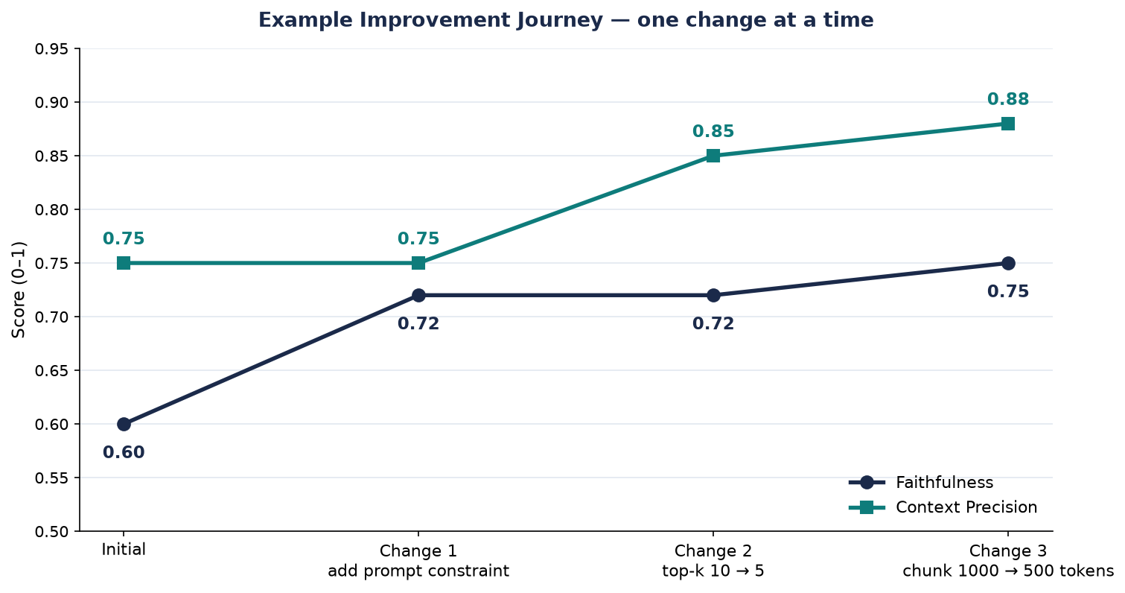
Figure 3. The improvement journey: each change moves one metric while the other is watched for regressions.

12. When to Escalate
If scores don’t improve after 2–3 changes:
- Data quality issue: check if your documents are accurate.
- Dataset too small: maybe your 6 examples aren’t representative.
- Wrong model: consider a more capable LLM.
- Architecture problem: your RAG approach might need rethinking.

13. Manual vs Automated Evaluation
Approach | Strengths | Limitation
Manual evaluation (this project) | ✓ Easy to understand for beginners · ✓ Best for small classroom tests | ⚠ Human judgment can vary
RAGAS automated evaluation (optional) | ✓ Faster for many examples · ✓ Useful for repeated experiments | ⚠ Scores still need human review

Recommended workflow: start with manual evaluation to understand the concepts, then use RAGAS for repeated experiments.

13.1 Enabling RAGAS automation
pip install ragas
from ragas import evaluate
from ragas.metrics import faithfulness, answer_relevancy, context_precision, context_recall
result = evaluate(
dataset=dataset,
metrics=[faithfulness, answer_relevancy, context_precision, context_recall]
)

14. Common Failure Patterns and Debugging

14.1 Failure patterns
- Retriever returns the wrong chunk
- Correct chunk is missing from results
- Answer adds unsupported information (hallucination)
- Answer is correct but not relevant to the question
- Too many settings changed at once (confounds results)

14.2 Debugging tips
- Use the same question set for all experiments
- Inspect retrieved chunks, not only the final answer
- Compare one controlled change at a time
- Combine automatic scores with human review

14.3 Common mistakes to avoid
- Changing multiple things at once — you won’t know what helped
- Using different datasets for re-evaluation — results aren’t comparable
- Ignoring trade-offs — improving one metric might hurt another
- Premature automation — manual evaluation first, then RAGAS
- Setting unrealistic targets — 0.95+ scores are rare in production

15. Security Considerations
- Never commit real API keys to git.
- Use .env.example as a template (ANTHROPIC_API_KEY, OPENAI_API_KEY, EVALUATION_MODEL, EMBEDDING_MODEL, project settings).
- Add .env to .gitignore.
- Load secrets from environment variables (python-dotenv==1.0.0 is the core dependency).

16. Next Steps
- Try different retriever settings (top-k, filters) and re-evaluate.
- Modify the LLM prompt and compare faithfulness scores.
- Build a RAGAS-based evaluation pipeline for automation.
- Create a more complex dataset from your own domain.
Troubleshooting quick reference:
“FileNotFoundError: evaluation_data.json” — make sure you’re running from the project directory. CSV file is empty — check that you completed all evaluations and they were saved properly. Scores seem wrong — double-check that you’re counting claims accurately, considering all claims (including implicit ones), and that chunks are truly useful, not just topically related.

17. References
- RAGAS Paper — https://arxiv.org/abs/2309.15217
- RAGAS GitHub — https://github.com/explodinggradients/ragas
- LLM Evaluation Guide — https://docs.anthropic.com/Claude3/reference/evaluating-claude-models

— End of report · RAG Evaluation Project, Week 8 Day 1 · EnlivenAI Solutions, September 2026 —

