1. Identify input, storage, retrieval and manipulation of data at Onslow
2. Explain the file management considerations related to shared information
3. Describe legal/ethical issues related to shared information at Onslow and the related procedures and conventions for privacy and permission.
   1. Also: Discuss these issues and their implications for procedures at Onslow
   2. Also: Evaluate the procedures and conventions at Onslow
4. Describe backup procedures for the Onslow information system
   1. Also: Explain the implications of these backup procedures at Onslow
   2. Also: Evaluate the backup procedures and conventions at Onslow
5. Explain the role of Onslow's information system for managing shared information
   1. Also: Discuss the dis/advantages of an information system form managing shared information at Onslow
   2. Also: Evaluate the effectiveness of the information system at Onslow

Library

Arial 11pts

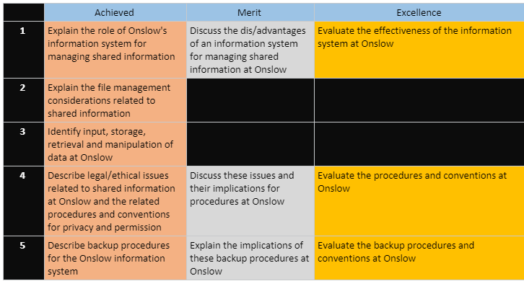

## Role of information systems

Information important – birthdays grades allergies – END – students – standards – grades – END - Information – help inform decisions – END – Ex medical – explain options – better decision – END – organization – more info – better decisions – 4 students – END – Students – low attendance – special education – END – teachers – resources – more budget? Less budget? – adjust spending – END – better decisions – better organization – END – Ex. Database assessment – example USE – END – talk about data use – PERSONAL ANECDOTE – END – information systems – EXPENSIVE – END – school – data to Microsoft – cloud – more reliance on third party – third party with more resources – reliance on third party – access data everywhere -

[Link lol](https://onslowcollege-my.sharepoint.com/personal/shane_fairhall_onslow_school_nz/_layouts/15/WopiFrame.aspx?sourcedoc=%7b7f8d1a3a-86ad-4a95-8d27-ebb614419591%7d&action=view&wd=target%28_Content%20Library%2FInformation%20Systems.one%7Cff9b70a0-44b9-4c1e-8105-9587427e989b%2F1.%20The%20role%20of%20an%20information%20system%20for%20managing%20%7Cc22185f8-91e5-4f45-a746-240bf839e586%2F%29)

1. What does an IS do generally?

* Monitor employees
* Keep managers and employees informed
* Coordinate activities among divisions
* Sell their products to customers via the internet.
* Knowledge sharing across the organisation is increasingly used as a strategic tool, to:
* Boost customer service,
* Reduce product development times
* Share best practice

1. Specifically what Onslow’s IS allow us to do

Easier assignment hand in – END – Check grades – END

* Keep track of student grades/ monitor progress
* Keep track of student attendance
* Create and store files (notes, assessments, exercises, classwork etc)
* Allow teachers and students to share class notes and student work/assessments
* Book parent/teacher interviews
* Send reports to parents
* Keep track of payroll data
* Book equipment like the COWs, school vans, rooms
* Communicate between teachers/students/parents/school suppliers/coaches etc.

1. Why good?

## File management considerations

## Input, Storage, Manipulation and Retrieval of Data

## Legal and Ethical Issues related to shared information

<https://www.onslow.school.nz/application/files/2714/9626/9924/Onslow_College_Cybersafety_Use_Agreement_fromatted_June_2017.pdf>

There are laws and regulations regarding information stored on students by schools in order to ensure that -----. For example, what information are parents allowed to retrieve about their children if they call the school? What information can they retrieve on other students for that matter? Can anyone get information? What about students? Should they be able to retrieve all information on themselves? These are just some of the things that need to be considered by a school regarding their information.

### Privacy/access to information

Schools must act in loco parentis, and so they must store information about their students. This information is potentially sensitive however, so schools have guidelines and have systems in place to ensure that information is properly secured. Before we discuss how schools can safeguard their information, however, let’s first consider what information needs to be safeguarded.

Onslow College holds a whole bunch of information about the students and staff at the school which they most likely do not wish to be in the public domain. For students and staff, these include things such as family information, medical record, contact details etc. For students specifically, grades and assessments are things that they don’t want to be leaked, and for staff information such as pay rates, disputes and complaints would need to be hidden

Why would these need to be hidden? If students could freely look at other students work and grades, it could create an unhealthy environment of competition, as well as potentially raise up issues with plagiarism. If students a could view other student b’s past assessments, what’s to stop them from plagiarising their work? There’s no proof that the student b willingly helped student a with cheating, which also means that there’s no way to tell if student b did help student a.

For Teachers, looking at other’s pays could result in feelings of jealousy and inequality among other teachers, especially if only the number was able to be accessed. Even if special conditions such as training, education and experience was up in the public domain, there’s still a reasonable chance that these would be glossed over, resulting in feelings of jealousy (Papandrea, n.d.) which would then produce an unhealthy work environment.

Luckily, at Onslow College this information isn’t in the public domain. In fact, theres a whole system of permissions which dicate which pieces of information is available for teachers and students to see. At Onslow College, information is stored on PC Schools. All teachers are able to access all student’s surface information, such as their grades and/or specific pieces of medical information such as allergies. Students on the other hand, are only able to access their own grades and absences on the PC Schools web portal, and not anyone else’s. Some special individuals however, such as senior management, whanau leaders, student services and the school nurse have greater access to information about students than teachers on PC School. Generally, information is on a need to know basis. A teacher has no need to view a student’s vaccination history so they do not have access, but this information may be useful to a school nurse, so they are able to view it.

### Drives

Onslow College also has numerous shared drives, that each serve different purposes. There are 6 drives in total. The (S)tudent drive, the (H)ome drive, the Q Scanning drive, the X drive, and the N and U drives. Students are not able to see the last 2 drives as they relate to teaching materials.

The student drive is a drive that is used by all students. This drive typically contains resources relating to students, such as learning resources and/or assessment submissions. Students as a rule, except in some specific folders, can read and copy files, but are not able to write. In folders used for assessment submissions however, the opposite is true. Students are able to write files but are not able to read or even view. This is done to ensure that assessments students hand in are not seen by other students.

The home drive is a drive that is exclusive and unique to each individual student. On this drive, a student has most, if not all, of file system permissions. They can read, write, copy, view, and delete as they wish in this drive. This is because the home drive is meant for a student’s personal usage and as such they should be able to perform the operations they require in there. Students should be aware however, that other students are not access other home drives (to prevent copying) and that network managers and teachers are able to view the contents of all student home drives. Network managers, as the name implies, can check to make sure that no inappropriate content (including, but not limited to; illegal content, plagiarised material, adult content and copyrighted content). Possession of material of this nature on a school drive is a violation of the Onslow ICT Agreement and may result in the termination of their account. Teachers can also check for inappropriate content, but they can also use their view permissions to check the work of students.

The scanning drive is the drive where scanned images and files are stored. There are numerous scanners around the school that a student can use to save their physical work digitally. Everyone can view and copy, but as far as I’m aware only the scanners can write files.

The Install drive, q, is the drive that contains the software files to be installed by ‘Zenworks’ on boot up. This file is, again, read and copy only. IT management are able to modify the files here, but otherwise there is no reason for students to use this drive.

The last 2 drives are exclusive to teachers, and students have no rights to these drives at all. This includes the ‘read’ right, which is important because these drives contain information that is in the N drive sensitive to teachers, and the U drive sensitive to all students.

N drive is the teachers common drive, similar to the students common drive. This drive contains lesson plans, faculty meeting presentations etc etc. Students are not able to access this drive, as they have no need to. Why should a student be able to view budget cuts for the language department?

The U drive is a collection of all the h drives of students. In this drive, teachers only have read access and they are unable to modify the contents of any of the student’s drives. This drive serves as a hub for teachers to navigate to a specific students drive.

### Passwords

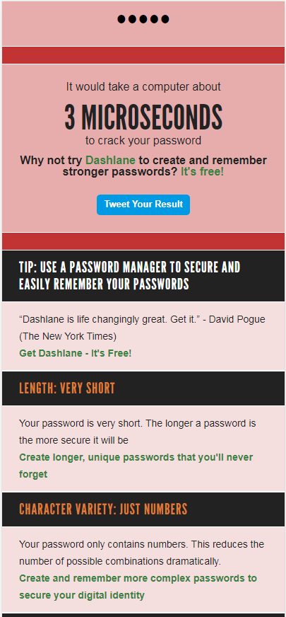Passwords are a method used to safeguard data to ensure that others do not get a hold of personal data. A good password is effective because it can take a long time to brute force, but when it’s weak then it becomes a vulnerability. Onslow College’s password requirements is that the chosen password has more characters than 4, with 5 being the minimum. Apart from this, there is no other special requirement such as special characters, or a variety of upper case and lower, or even numbers.

This is my current password at the time of writing this. It consists of 5 characters, all of them numbers. The password in question here is “23366”, which is an extremely insecure password. Some of the flaws, as can be seen in the attached photo, is that it contains no special characters or letters and consists of only numbers. In addition, it’s extremely short just barely making the 5 character minimum. According to How secure is my password? my current password would take 3 microseconds to brute force.

According to the cyber agreement, students are not allowed to share passwords with other students. This is done to make sure that students do not freely give each other access to their fellow peer’s drives which prevents cases of plagiarism and griefing of their materials. Teachers can change the passwords of any student, which is helpful for when a student inadvertently forgets their password and is then locked out of accessing their accounts. At Onslow College, for maximum security, students are required to log in multiple times to access different services. For example, if a student has logged into a school machine with their credentials, they are required to log in again if they wish to access PC Schools on the same machine. Even though the credentials to log into both are the same, the need to input the credentials a second time is a method of verifying that the student is the one that wishes to view their credentials, and that it’s not a random person that happened to stumble onto a student’s unlocked computer.

There are some weak points with Onslow College’s current password system however. One important security concern is that passwords at Onslow College tend to not be changed by the average student. An informal questionnaire of a 12DTM class, a class where usage of computers is heavy and they would have need to keep files on the student drive, showed that no users change their password on a regular basis. Online research shows that having periodic password resets that are mandatory in a short period of time has a detrimental effect on password security, but encouraging users to reset their password at least once in their time at Onslow College wouldn’t be a bad thing.

In addition, increasing the length of school passwords wouldn’t go amiss either. Microsoft recommends that a minimum of 8 characters for a password is a good starting point, which is already more secure than the current 5 character minimum. A extra 3 characters may not sound like much, but the increase of another character exponentially increases the amount of attempts needed to brute force a password open. Even though passwords at Onslow College aren’t stored in plaintext, these extra security measures would add another boost to Onslow College’s security.

<https://howsecureismypassword.net/>

<https://docs.microsoft.com/en-us/office365/admin/misc/password-policy-recommendations?view=o365-worldwide>

## Backup Procedures

Protect Hack – hardware failure – software failure – natural disasters – accidental deletion

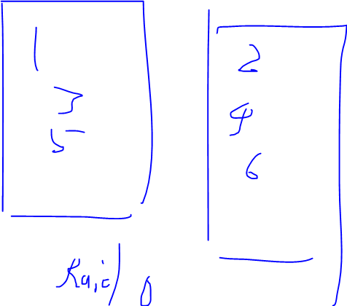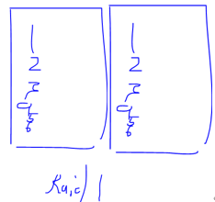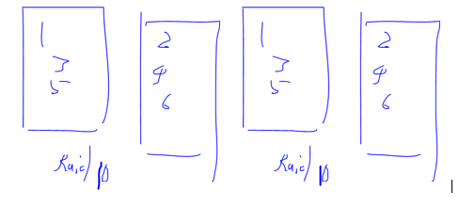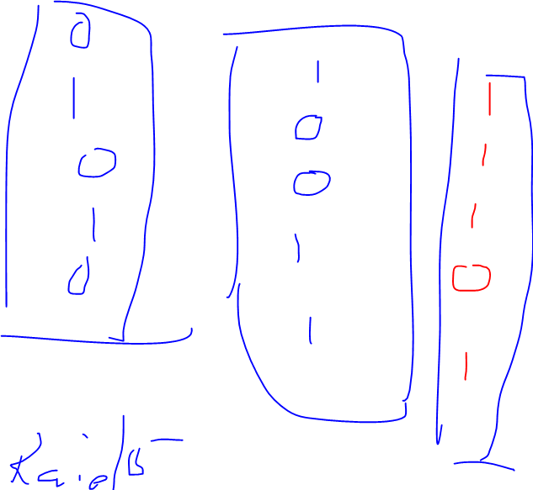School backups – cloud + hardware – main backup is on tapes (cassette) - 1.5 gb – backup per day, but not everything – student work backup every day as it changes daily – less important like videos on media server or staff drive backups less frequently. More than 1 tape to backup. Backup is done in rotation – oldest tape is used , vice versa – done if virus can use older version – might have realised you deleted 2-3 weeks later – onedrive backup – done by Microsoft – RESEARCH – clouidbackup is done but not much – pc schools for student information – backups physically should be away from the server room – if not everything goes boom together – table mountain so computer block burns, it technicians and server rooms boom but table mountain not – off site is good too- some data at end of year stored at home yearly – Christchurch earthquake example – red zone data school – cant reenter – but some data stored at houses outside redzone – data can be reenetered into different system – one disk for pcschools one for server

RAID – Storing data on numerous disks – server room has a lot of hard drives in server racks – striping data – striping means to alternate data storage on different disks, which allows faster access of data RAID 0 – RAID 1 dosent focus on speed but security – Raid 10 – Raid 5 uses parity bits in the last drive – Speed of raid 10 but only 3 disks instead of 4 which is cheaper and gives the user more space to play around with.

## QIANG

S tudent

H ome

Q Scanning

X Install -

N Staff Common – Students no permissions at all -

U All the students drives. – Teachers can see home drives here directory – Only read

