Database Test: Visual

No answer key exists yet for this test! If you understand Database Design, please e-mail your answers to fblatests@brinkster.net, I stick to Economics myself :P

Question 1

You open an Access 95 database and select the menu option shown below.
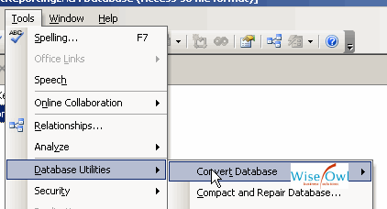
What are the different file formats to which you can convert?

Choose an answer
Answer A | Access 97, 2000, 2002 and 2003
Answer B | Access 97 and 2003
Answer C | Access 2000, 2002 and 2003
Answer D | Access 97, 2000 and 2002/03

Question 2

In the form below, you can use the big buttons with the arrows to move between records, but you can also use the much smaller buttons at the bottom left.
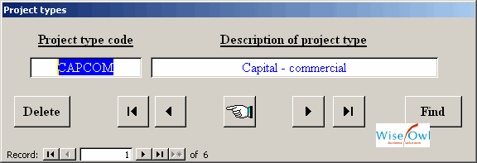
What property would you change to remove the smaller buttons?

Choose an answer
Answer A | RecordBar
Answer B | RecordCursors
Answer C | NavigationButtons
Answer D | RecordSelectors

Question 3

In the report below, the subtotals appear with lines above and below them.
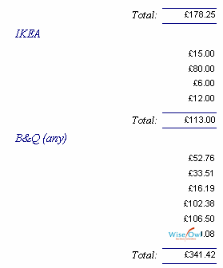
How can you most easily achieve this?

Choose an answer
Answer A | Use the borders tool to apply a top and bottom border
Answer B | Draw a horizontal line with the SHIFT key held down, copy and paste it and align the two lines by their left edge
Answer C | It happens automatically when you choose a currency format for any expression in a group footer
Answer D | Set the LineFormat property of the summation text box to AccountingStyle

Question 4

Suppose that you start to type in the box as shown (to enter another skin type record).
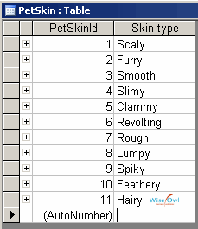
What number will appear in the box to the left of it?

Choose an answer
Answer A | Nothing - it will be blank
Answer B | It depends on the autonumbering options chosen in Tools / Options
Answer C | At least 12, but it could be higher
Answer D | 12

Question 5

Part of a report is shown below.
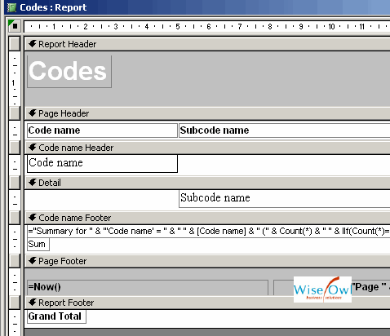
How many sections are visible?

Choose an answer
Answer A | 7
Answer B | 3
Answer C | It is not possible to say without scrolling to the right
Answer D | 13

Question 6

In the query below, the Question field is effectively included twice.
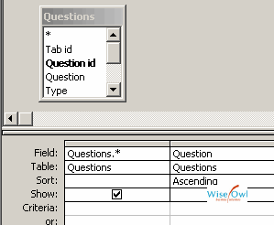
How will these fields be displayed?

Choose an answer
Answer A | The field will appear once only, and be called Question
Answer B | They will both be called Question
Answer C | You won't be able to run the query - Access will force you to correct the error before you can view the query in datasheet mode
Answer D | As Questions.Question and Field0

Question 7

You create a form as shown below.
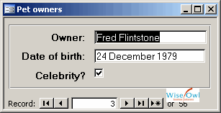
Which control is used to show whether this person is a celebrity or not?

Choose an answer
Answer A | YesNoBox
Answer B | Checkbox
Answer C | Tickbox
Answer D | ToggleButton

Question 8

ou create a query on a table, and see this by default when you add in the fields from the table:
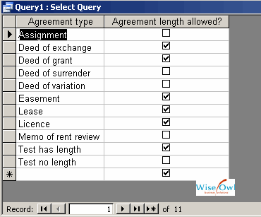
What type of field is the Agreement length allowed? field?

Choose an answer
Answer A | True/False
Answer B | Logical
Answer C | Yes/No
Answer D | Boolean

Question 9

You have 10 records in the Questions table.
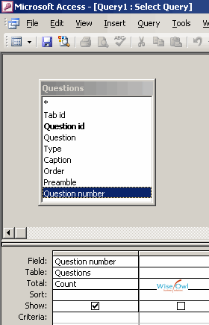
If you run the query below, how many rows will there be in the answer?

Choose an answer
Answer A | 10
Answer B | More than 1 but less than 10
Answer C | 0
Answer D | 1

Question 10

Suppose that you create a macro as shown below.
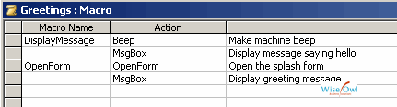
If you double-clicked on the Greetings macro in the database window, what would happen?

Choose an answer
Answer A | Nothing - you can not run macros like this when there is more than one macro in the macro sheet
Answer B | The DisplayMessage macro only would run
Answer C | Access would ask you which macro in the macro sheet you wanted to run
Answer D | All of the macros in the macro sheet would run, in order

Question 11

The table new object short-cuts in the database window are shown below
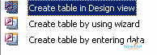
How can you stop these appearing?

Choose an answer
Answer A | You can't
Answer B | By choosing Tools / Options, and deselecting the option on the View tab
Answer C | By right-clicking and toggling New Object Shortcuts from the menu which appears
Answer D | By toggling View / New Object Shortcuts from the main menu

Question 12

You have created a form for viewing projects, with a subform for viewing benefits for each project as shown below.
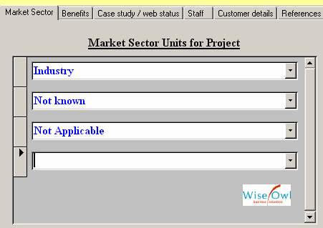
A user complains that it looks messy having a blank line at the bottom of the subform. What is your reaction?

Choose an answer
Answer A | To set the DataEntryAllowed property of the subform to False
Answer B | to change the subform control's InsertionPossible property to False
Answer C | To set the AllowAdditions property of the subform to False
Answer D | Nothing - this is a feature of Access subforms which can't be changed

Question 13

You have built a system containing a menu bar like this.
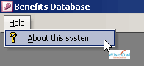
How would you get this to appear when you load the database?

Choose an answer
Answer A | You would have to do it in code, by manipulating the CommandBars collection
Answer B | By creating a macro called Menu containing the options shown
Answer C | Using the Tools / Startup menu
Answer D | By setting the DefaultMenu property of the database

Question 14

You are viewing a report in print preview, and choose the option shown.
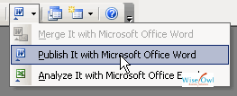
What format file does Access create in Word?

Choose an answer
Answer A | HTML
Answer B | RTF (rich text format)
Answer C | TXT (text format)
Answer D | Native Word format

Question 15

ou are creating a new query as shown below.
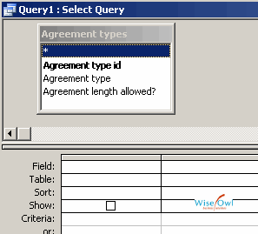
What does the * field shown selected do?

Choose an answer
Answer A | Adds all of the fields listed into the query - any new fields added subsequently will not be shown
Answer B | Displays all of the records, ignoring any criteria set
Answer C | Displays all of the unique visible records given the fields chosen
Answer D | Shows all of the fields at the time the query is run - new fields added will be included

