Description of the data

Development of an Integrated Forecasting System for Inventory Management in Oil Depots.
Loading Steps for a Dispatcher
1. Edit and save a new order
2. Enter Quantities to Ship by Compartment
3. Dispatcher the command
4. Print FAN
5. Validate the order at the Accuload
6. If the upload is complete, print the BOL

BULK MOVEMENT:
Bulk movement types:
- 1: Bulk Receipt
- 2: Bulk Disposal
- 3: Bulk Transfer
- 4: Bulk external transfer
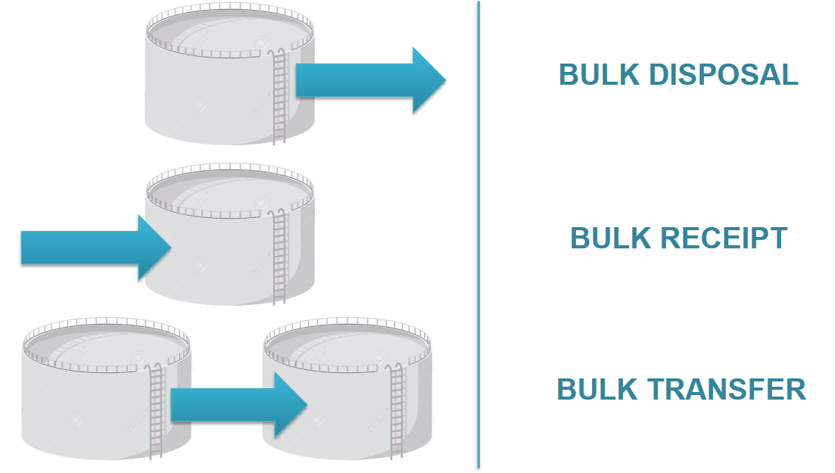

The following table describes, for each type of bulk movement, whether the from supplier, to supplier, and to destination are present in the transaction:
Bulk movement type | From Supplier | To Supplier | To Destination
Bulk Receipt | No | Yes | No
Bulk Disposal | Yes | no | Optional
Bulk transfer | Yes | Yes | No
Bulk external transfer | Optional | Optional | No

- Folio Number: Number identifying which folio the order was loaded in
- Revision Number: Number of times the order has been revised
- Type: order type

- 1: ENTERING

- 2: DISPATCHED: Order shipped and ready for loading
- 3: LOADING: When the order is validated and FAN LOADING

- 4: LOADING AT BAY: Compartments are loading

- 5: VALIDATING
- 6: LOADED: The quantity shipped is fully loaded, the BOL is ready for printing

- 7: CANCELE: Only loaded orders can be canceled
- Purchase Order Number: Purchase order number entered for the order
Carriers
- Trailers
- Tractors
- Drivers
- Vehicle (tractor+ trailer)
- Barge
- Railcar
Container Types
Types | Owner Type
Tank | Terminal owner
Trailer | Carrier
Vapor | Terminal owner
ship | Carrier
Railcar | Carrier
Barge | Carrier

The default container type is trailer and thus when the container type is not specified, the container code is the trailer code

Presets/Meters and Injectors:
Field name | Description | Domain
Preset Code | The Preset at which the product was loaded/unloaded | HARDWARE TYPE
Meter Code | the meter at which the product  was metered | HARDWARE TYPE
Injector Code | the injector at which the additive was injected | HARDWARE TYPE

Order Recipe:
Field Name | Description | Domain
Tank code | Tank code of the tank the terminal  product was delivered from/to | Container type
Preset Code | Preset at which the product was loaded/unloaded | HARDWARE TYPE
Meter Code | The meter at which the product  was metered | HARDWARE TYPE
Injector Code | The injector at which the additive was injected | HARDWARE TYPE
Terminal Product Number | Terminal product number for the product in the tank | SQL LONG
Terminal Product Type | Whether the terminal product was metered, injected, or weighed | TERMINAL PRODUCT TYPE
Ordered Quantity | Quantity of the terminal product ordered | SQL LONG
Gross Quantity | Gross quantity of the terminal product delivered | SQL LONG
Blend Percent | If metered, the percentage of the total blend this terminal product makes up | SQL FLOAT
Rate | If injected, the rate in PPM at which injection was done | SQL LONG
Weight | Weight in air of the terminal product delivered | SQL LONG
Density | Density of the terminal product delivered | SQL LONG
Start Gross Totalizer | the start gross totalizer of the meter | SQL LONG
End Gross Totalizer | the end gross totalizer of the meter | SQL LONG
Start Net Totalizer | the start net totalizer of the meter | SQL LONG
End Net Totalizer | the end net totalizer of the meter | SQL LONG
RVP | Reid vapor pressure of the terminal product delivered | SQL FLOAT
Weight in Vacuum | Weight in vacuum of the terminal product delivered | SQL LONG

Injector Record
- Preset Code: Preset code that the injector is attached to
- Injector Code: injector code that the totalize Information is for
- Terminal Product Number: Terminal product number for the product being injected
- Totalizer: Totalizer quantity value for the injector at the end of the day
- Throughput: Quantity of product moved through the injector for the day
- Unaccounted: Quantity of unaccounted product for the injector for the day
- Certification Rate: Minimum injection rate for the terminal product being injected

Meter Record
- Preset Code: Preset code that the meter is attached to
- Injector Code: injector code that the totalize Information is for
- Terminal Product Number: Terminal product number for the product being metered
- Gross Totalizer: Gross Totalizer quantity value for the meter at the end of the day
- Gross Throughput: Gross Quantity of product moved through the meter for the day
- Gross Unaccounted: Gross Quantity of unaccounted product for the meter for the day
- Net Totalizer: Net totalizer quantity value for the meter at the end of the day
- Net Throughput: Net Quantity of product moved through the meter for the day
- Net Unaccounted: Net Quantity of unaccounted product for the meter for the day

Host Type:
HOSTS
Terminal Owner
Supplier
Customer

PRODUCT
Product group
Product Group Code | Name
ADD | ADDITIVE
DSL | DIESEL
GAS | GASOLINE
HFO | HEAVY FUEL

Tank Inventory:
Field Name | Description | Domain
Gross Fractional Quantity | Fractional portion of the declared gross quantity | SQL LONG
Net Fractional Quantity | Fractional portion of the declared net quantity | SQL LONG
Fractional Weight | Fractional portion of the declared weight in air | SQL LONG
Weight in Vacuum | Whole portion of the declared weight in vacuum | SQL LONG
Fractional Weight in  Vacuum | Fractional portion of the declared weight  in vacuum | SQL LONG

