

VITYARTHI PROJECT
(FUNDAMENTALS OF AI AND ML)

TOPIC: AI-Driven Expert Medical Diagnostic System

Submitted By: Khush M Lohar

Registration Number: 25BAI11336

University Mail Id: khush.25BAI11336@vitbhopal.ac.in

Submitted on: 24 March 2026
- Introduction

The AI-Driven Expert Medical Diagnostic System is a hybrid intelligent application designed to evaluate an individual's health condition based on two key inputs: body temperature and symptom duration. The system integrates two distinct AI paradigms — a supervised Machine Learning model for probabilistic risk assessment, and a Prolog-based symbolic expert system for deterministic rule-driven diagnosis and treatment recommendation.
The system has been significantly enhanced to handle a wider clinical range including hypothermia detection (body temperature below 35°C), healthy status classification, and a live real-time
temperature gauge powered by matplotlib embedded directly in the GUI.

2. Problem Statement

Modern diagnostics frequently require both probabilistic risk assessment and precise, rule-based clinical guidance. The challenge is to build a unified system that can:
• Accept simple numerical patient inputs — body temperature (°C) and symptom duration (days).
• Deliver a fast, data-driven Risk Category evaluation: Low, Medium, or High.
• Apply expert rules to infer a conclusive diagnosis and an appropriate treatment plan.
• Present findings via an intuitive, modern graphical user interface.
- Handle edge cases: dangerously low temperatures (hypothermia) and healthy/normal conditions.

3. Functional Requirements (FR)

ID | Requirement Description | Component
FR1 | Accept Body Temperature (°C) and Symptom Duration (Days) as input. | app.py(GUI)
FR2 | Validate inputs: temperature > 0 and duration > 0. | app.py
FR3 | Train Decision Tree from symptoms_data.csv if model file is missing. | classifier_model.py
FR4 | Predict Risk Category (Low, Medium, High) using the trained ML model. | classifier_model.py
FR5 | Translate inputs into Prolog facts based on defined thresholds. | app.py
FR6 | Prolog engine derives diagnosis from asserted facts. | rules.pl
FR7 | Prolog engine retrieves treatment plan for the diagnosed condition. | rules.pl
FR8 | GUI displays ML Risk, Prolog Diagnosis, Treatment, and Temperature Gauge. main.py (GUI) | app.py
FR9 | Detect hypothermia: temperature below 35°C → assert temp_very_low. | app.py + rules.pl
FR10 | Detect healthy/normal temperature (35–37.5°C) → assert normal_temp. | app.py + rules.pl
FR 11 | Render live matplotlib temperature gauge inside the Tkinter window. | app.py

4. Non-Functional Requirements (NFR)

ID | Requirement | Category
NFR1 | Diagnosis and risk assessment complete within 3 seconds of button press. | Performance
NFR2 | GUI is simple and intuitive for non-technical users. | Usability
NFR3 | Input errors handled gracefully with messagebox alerts. | Reliability
NFR4 | Diagnostic rules editable in rules.pl without changing Python code. | Maintainability
NFR5 | Requires SWI-Prolog installation for pyswip to function. | Portability

5. System Architecture

Layer / Component | File | Responsibility
Presentation Layer | app.py | Dark-themed Tkinter GUI — accepts inputs, trigger analysis, shows output
ML Service | classifier_model.py | Loads CSV data, trains a Decision Tree Classifier, persists the model via jolib
Expert System Engine | rules.pl | Prolog knowledge base. Defines diagnosis/1 and treatment/2 rules.
Training Data | symptoms_data.csv | 190-row labelled dataset with Temperature_C, Symptom_Duration_Days,Risk_Category
Persisted Model | risk_classifier.pkl | Serialised trained Decision Tree(Joblib).Auto generated on first run if absent model trains automatically

6. Prolog Rule Base (rules.pl)

Condition | Trigger Facts | Status
severe_infection | fever_high + duration_long | Original
acute_infection | fever_high + duration_short | Original
mild_viral_fever | fever_low + duration_short | Original
prolonged_fever | fever_low + duration_long | Original

hypothermia | temp_very_low (temp < 35°C) | Original
healthy | normal_temp (35–37.5°C) | Original
no_clear_diagnosis | no matching symptom facts | Updated

7. Design Decisions & Rationale

Decision | Rationale
Hybrid AI (ML + Prolog) | Machine Learning handles probabilistic pattern recognition on numerical data, while Prolog provides transparent and auditable logical reasoning
Decision Tree Classifier | It is an interpretable model aligned with the rule-based theme, fast to train on small datasets, and provides decision boundaries that are easy to understand.
Hardcoded High Risk for temp < 32°C | Extreme hypothermia falls outside the training distribution. A deterministic override ensures patient safety.
Prolog fact retractall per query | Prevents stale facts from prior queries contaminating new diagnoses. Ensures each analysis is fully independent
matplotlib embedded in Tkinter | Provides real-time visual feedback via a colour-coded temperature gauge. Enhances usability for users.
Dark modern UI theme | Improves readability in varied lighting conditions. Colour-coded risk labels (red/yellow/green) provide quick visual cues for risk levels.

8. Implementation Details
Language & Libraries

Component | Technology | Purpose
Application & GUI | Python 3.13, Tkinter | Main logic and dark-themed GUI
ML Model | scikit-learn, numpy, joblib | Decision Tree training, prediction, persistence
Expert System | SWI-Prolog, pyswip | Rule-based diagnosis and treatment lookup
Visualisation | matplotlib | Embedded live temperature gauge widget

Temperature Classification Thresholds

Condition | Temperature Range | Prolog Fact | ML Used
Severe Hypothermia | < 32°C | temp_very_low | No (hardcoded High)
Hypothermia | 32°C – 34.9°C | temp_very_low | No (hardcoded High)
Normal | 35.0°C – 37.4°C | normal_temp | Yes
Low-grade Fever | 37.5°C – 38.9°C | fever_low | Yes
High Fever | ≥ 39°C | fever_high | Yes

Duration Thresholds
• Short duration: fewer than 5 days → asserts duration_short
- Long duration: 5 days or more → asserts duration_long

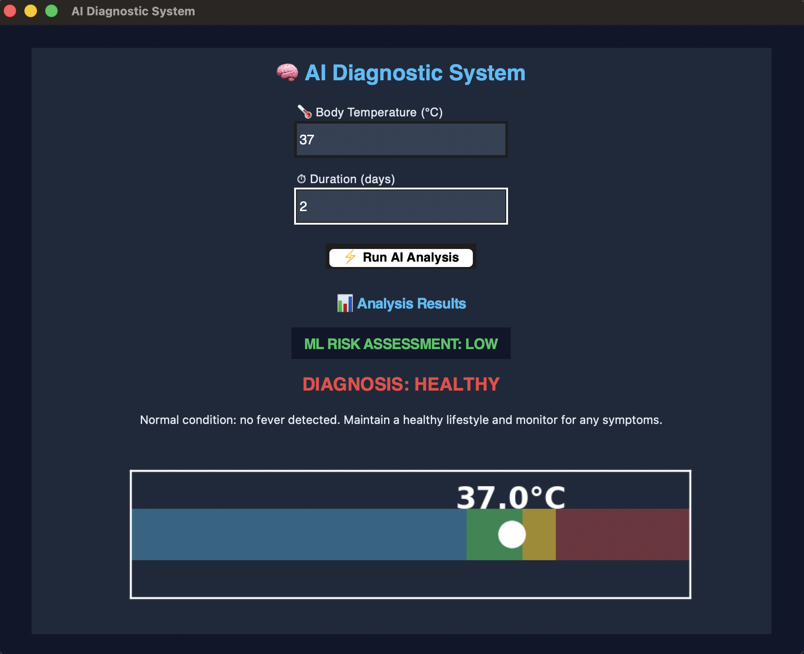
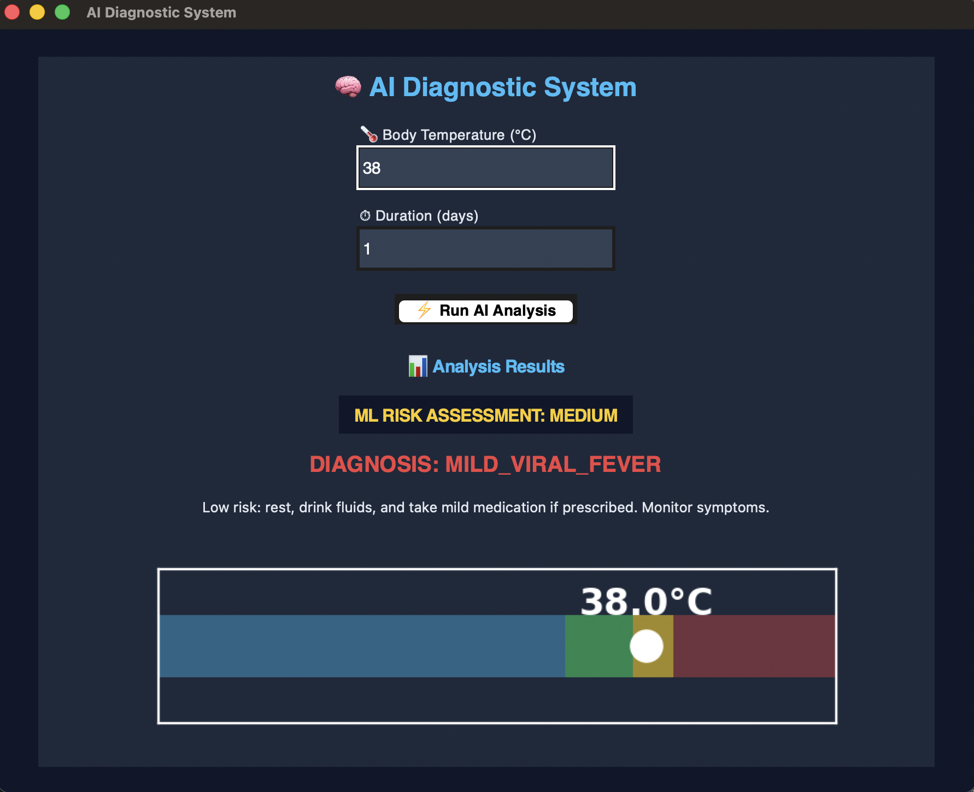
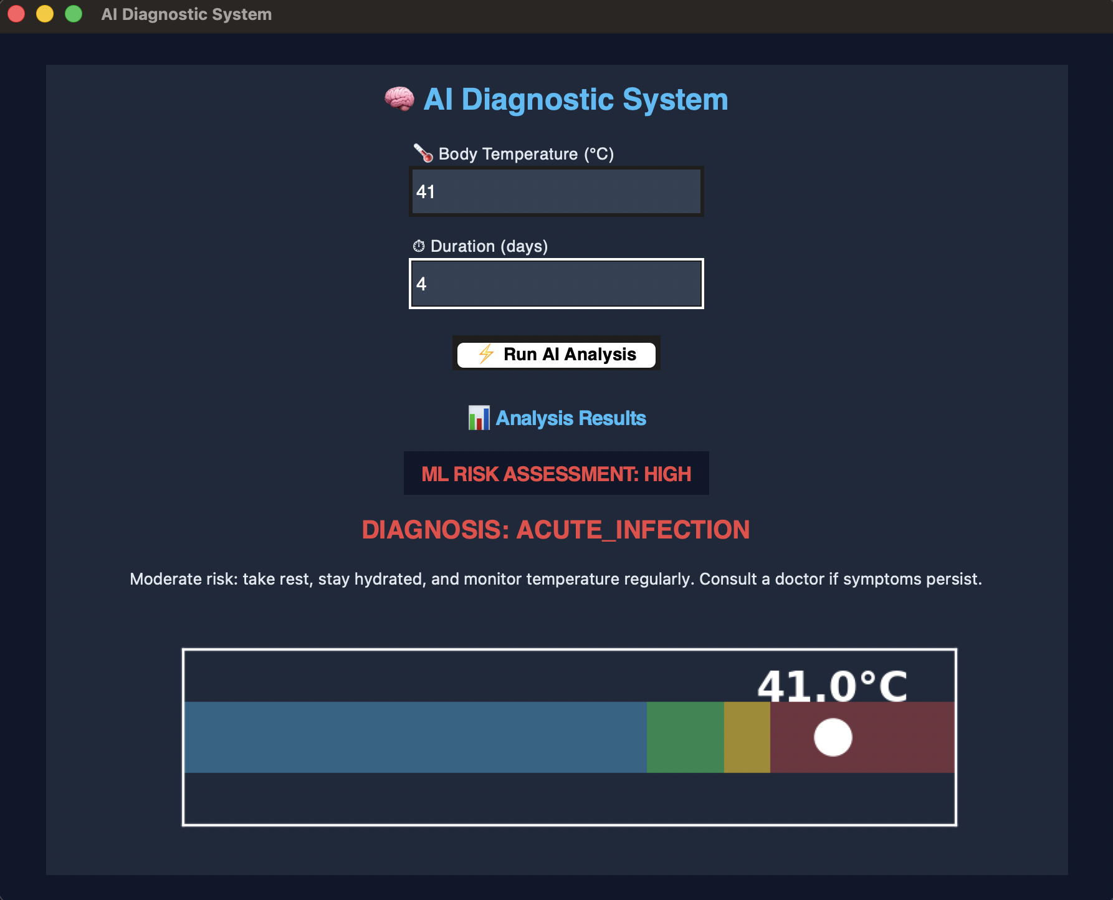
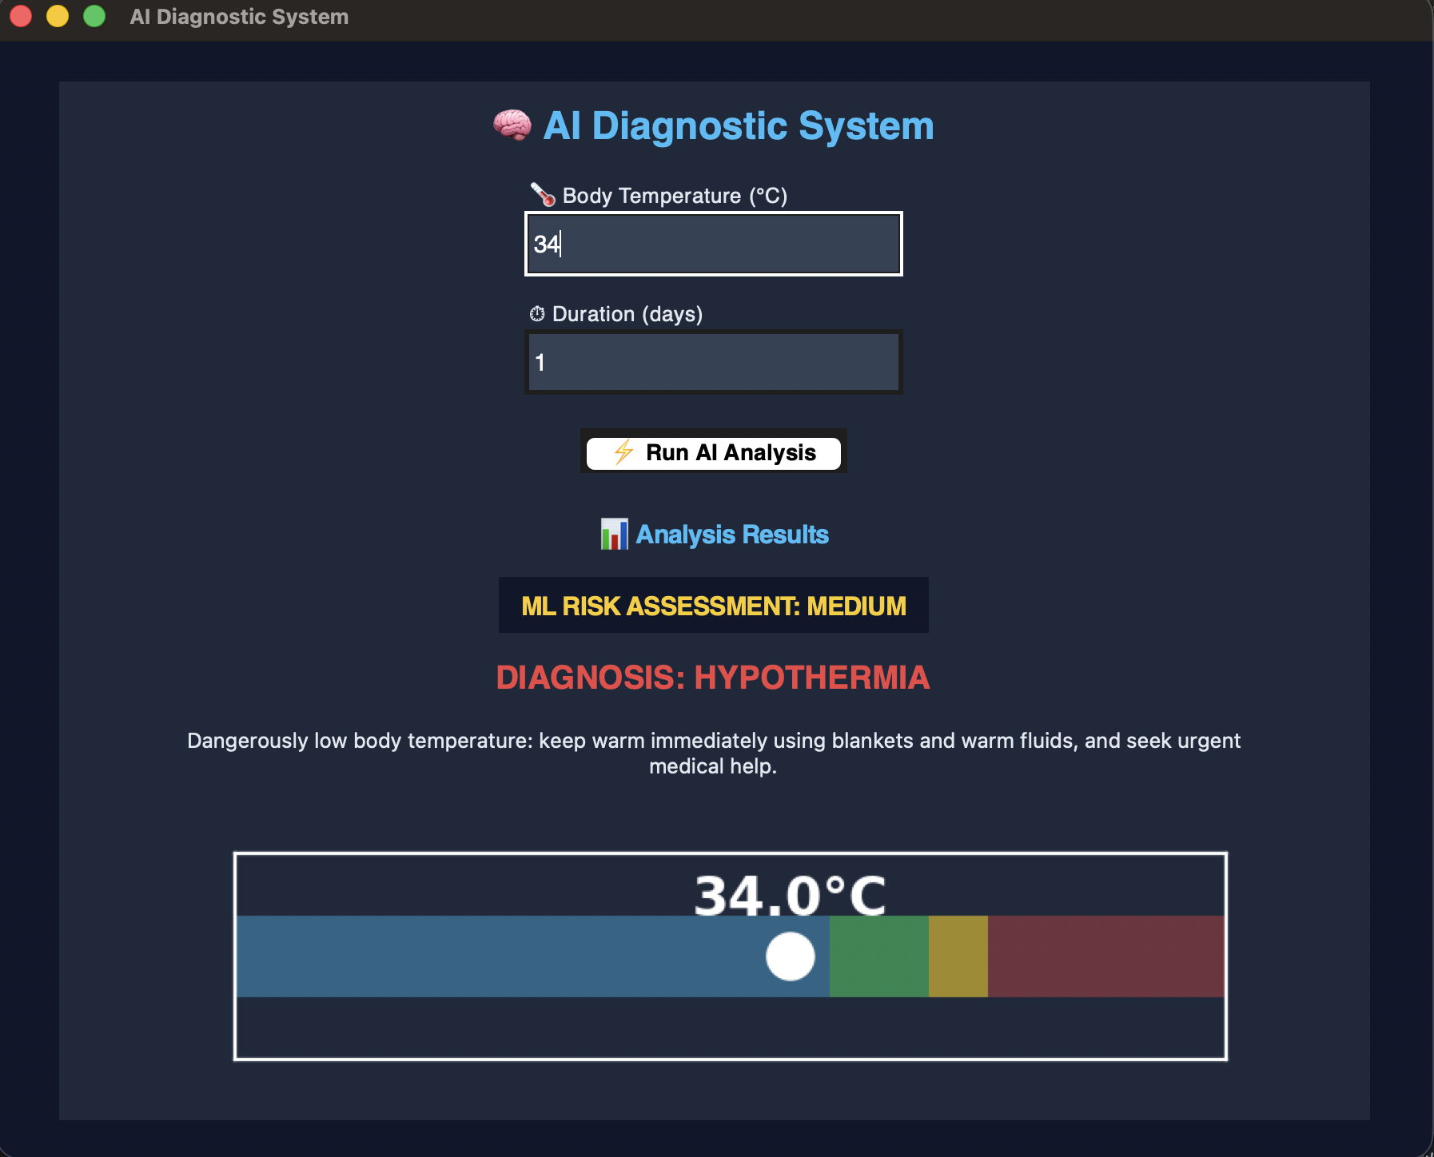
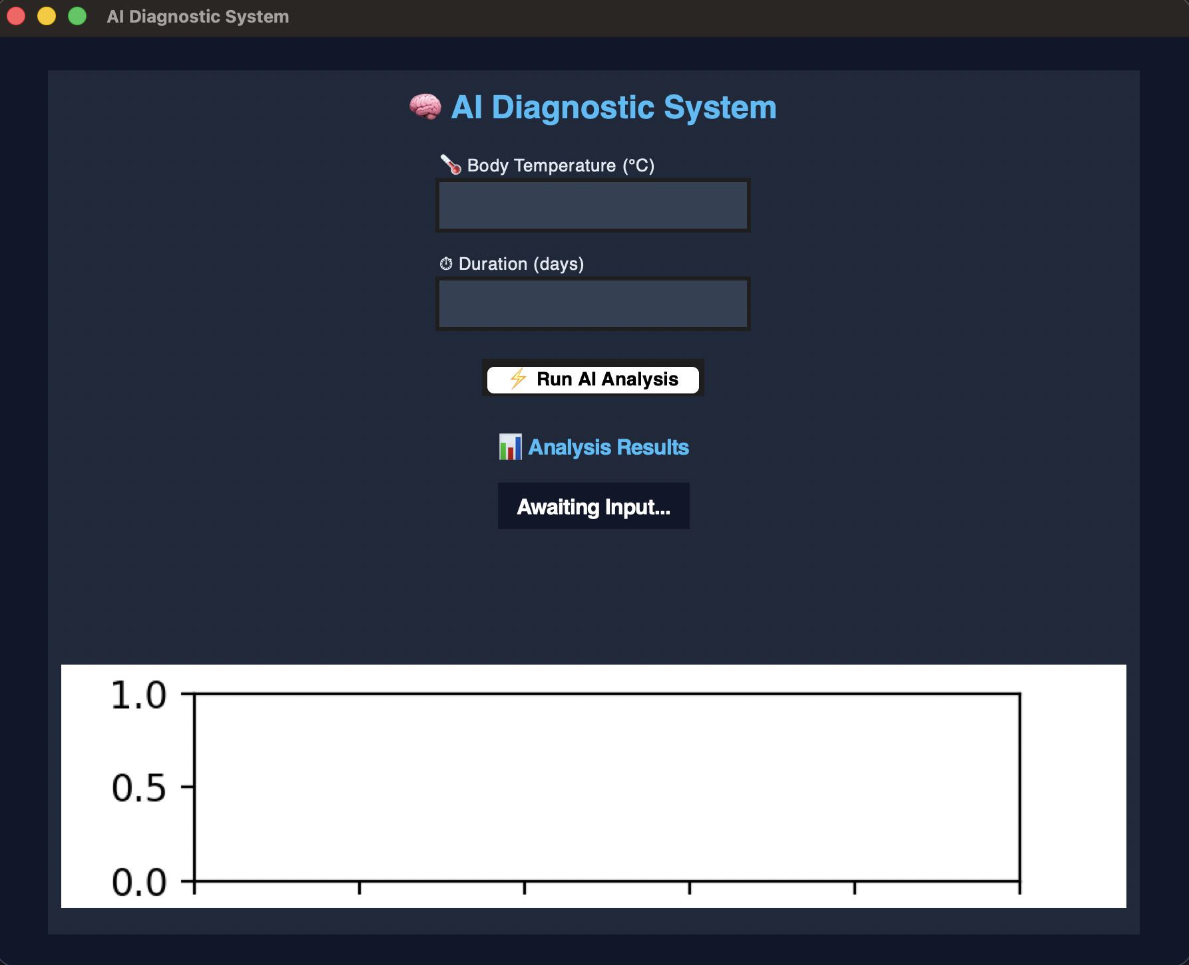
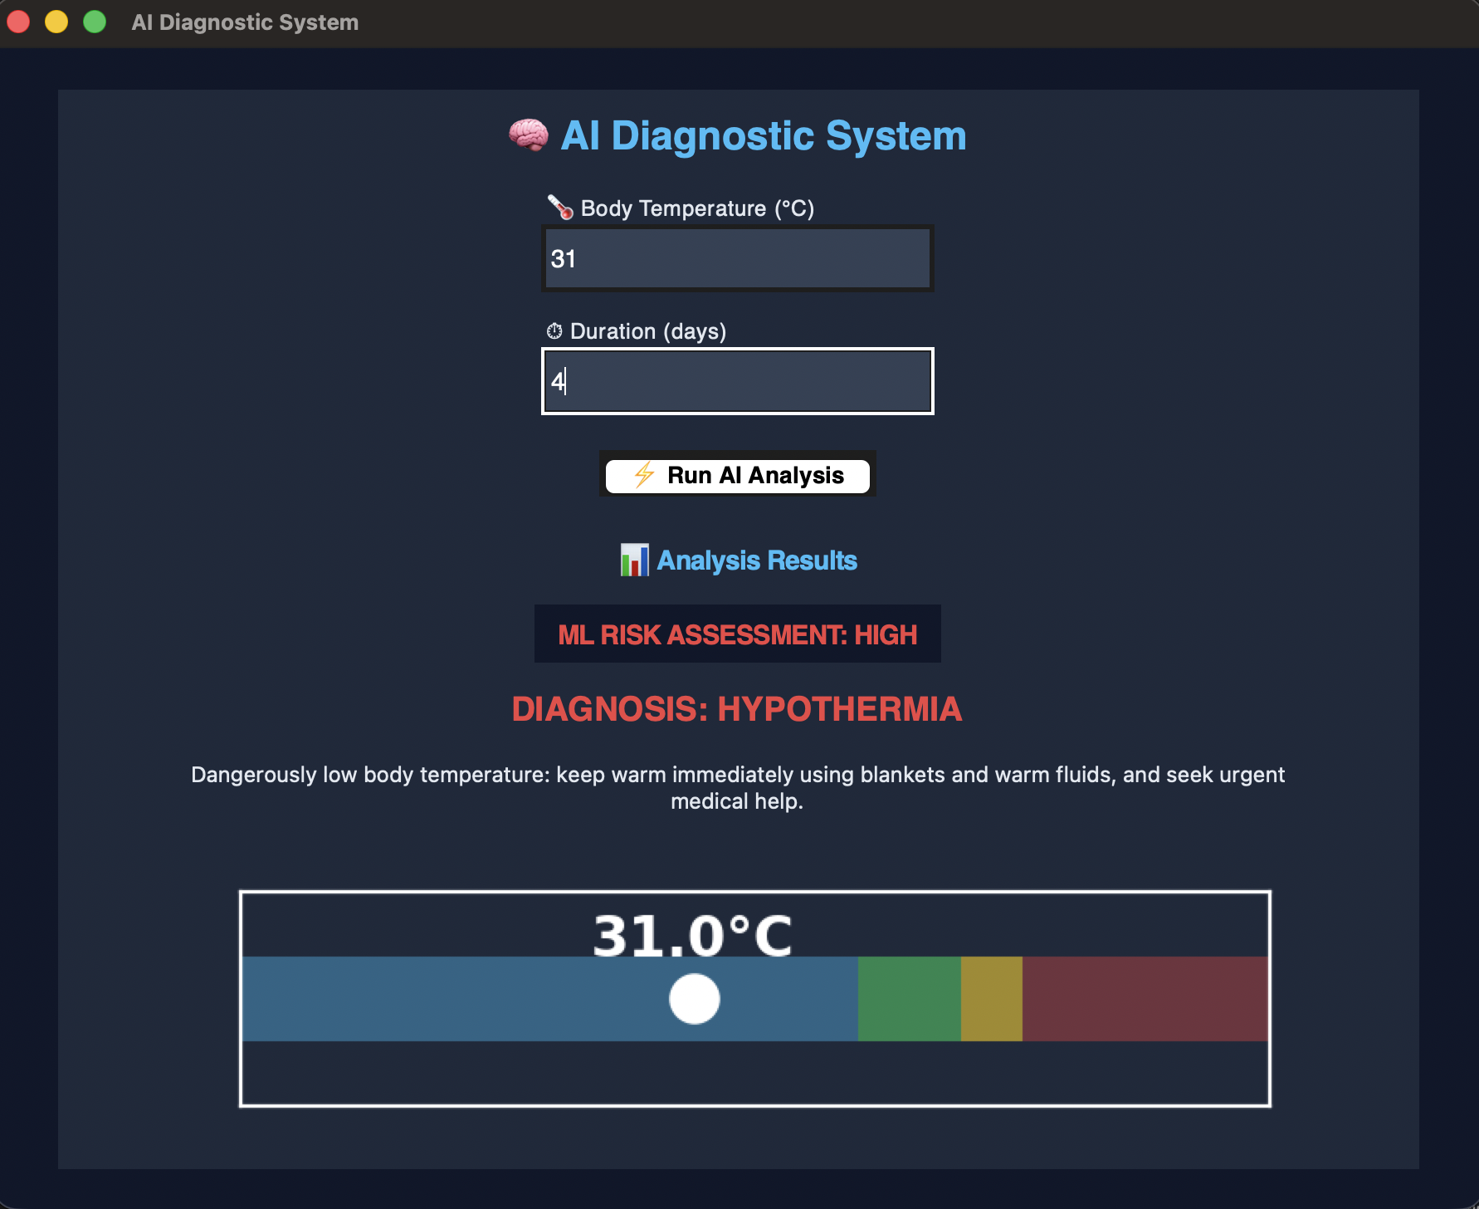
9. Screenshots/Results

10. Workflow Diagram

Step | Component | Description
1. Input | app.py (GUI) | User enters Body Temperature (°C) and Symptom Duration (days).
2. Validation | app.py | Checks inputs are valid numbers and > 0.
3. ML Risk | classifier_model.py | Decision Tree predicts Low / Medium / High risk. Hardcoded High for temp < 32°C.
4. Display Risk | app.py | Risk label updates with colour coding (green/yellow/red).
5. Prolog Facts main.py | app.py | Retracts old facts; asserts new symptom/2 facts for temperature and duration.
6. Prolog Query main.py | app.py | Executes prolog.query('get_diagnosis(X, T)').
7. Rule Inference rules.pl | app.py | Prolog matches facts to diagnosis rules and retrieves treatment text.
8. Display Results main.py | app.py | GUI updates diagnosis label and treatment recommendation text.
9. Gauge Update | app.py (matplotlib) | Live temperature bar chart re-renders with colour zones and marker.

11. Testing Approach
ML Model Testing

Boundary conditions validated on symptoms_data.csv:
Temperature (°C) | Duration (days) | Expected Risk | Result
37.0 | 1 | Low | ✓ Pass
37.5 | 3 | Medium | ✓ Pass
39.5 | 6 | High | ✓ Pass
34.0 | 2 | High | ✓ Pass
36.5 | 1 | Low | ✓ Pass

Prolog Rule Testing — All 6 Scenarios
Facts Asserted | Expected Diagnosis | Result
fever_high + duration_long | severe_infection | ✓ Pass
fever_high + duration_short | acute_infection | ✓ Pass
fever_low + duration_short | mild_viral_fever | ✓ Pass
fever_low + duration_long | prolonged_fever | ✓ Pass
temp_very_low | hypothermia | ✓ Pass
normal_temp | healthy | ✓ Pass

12. Challenges Faced

• Prolog Initialization: Configuring pyswip with the correct SWI-Prolog path required careful
environment setup, especially on macOS where the GMP library dependency needed manual installation.
• State Management in Prolog: Using retractall before each query was essential to prevent stale
symptom facts from prior analyses from corrupting new results.
• Hypothermia Edge Case: The ML model, trained primarily on fever data, could not reliably predict risk
for very low temperatures. A hardcoded override was implemented for temperatures below 32°C.
• Matplotlib in Tkinter: Embedding a live matplotlib figure inside a Tkinter window required
FigureCanvasTkAgg and careful dynamic axis rescaling to handle the full temperature range.
• Data Translation Thresholds: Defining clinically meaningful thresholds to map continuous
temperature values to discrete Prolog facts required domain research to avoid misclassification.

13. Learnings & Key Takeaways

• AI Hybridisation: ML excels at pattern recognition in data while symbolic AI provides transparent,auditable reasoning. Combining both paradigms produces a more robust and trustworthy system than either alone.
• Prolog Integration: Dynamically asserting and retracting facts from Python into a live Prolog engine is a powerful pattern for building stateful expert systems with a modern programming language frontend.
• Model Deployment: The full lifecycle — training, serialising with joblib, and loading for inference —mirrors real-world ML deployment practices even at a prototype scale.
- Interpretability in Medical AI: A Decision Tree's explainable boundaries are more appropriate in a health context than a black-box model, even if accuracy is marginally lower.
- Edge Case Engineering: Hardcoded overrides for extreme clinical values (severe hypothermia) are a legitimate and necessary engineering pattern when training data coverage is limited.

14. Future Enhancements

• Richer Inputs: Add discrete symptoms (cough, headache, fatigue, SpO2) as additional Prolog facts for more comprehensive diagnosis.
• Larger Dataset: Train on a real-world clinical dataset (500+ samples) and evaluate ensemble models(Random Forest, SVM) for improved accuracy.
• Uncertainty Handling: Introduce fuzzy logic or certainty factors in Prolog to handle borderline
temperature readings more gracefully.
• Web Deployment: Port the Tkinter GUI to a Flask/FastAPI + React web application for broader
accessibility without local installation.
• Multilingual Support: Add localisation for Hindi and other regional languages to serve rural Indian communities.

15. References

• Vityarthi Course Modules — Fundamentals of AI and ML
• Python Language Reference: https://docs.python.org/3/
• SWI-Prolog Official Documentation: https://www.swi-prolog.org
• pyswip Python-Prolog Interface: https://github.com/yuce/pyswip
• scikit-learn Documentation: https://scikit-learn.org
• Tkinter Official Documentation — Widget parameters and methods
• matplotlib Documentation: https://matplotlib.org
• World Health Organization — Clinical Guidelines on Fever and Hypothermia

