TUXEDO – FINAL MASTER FRD (All 4 Apps with Images)

Passenger Mobile App

Step 1
Details: Step as per flow.
Business Rules: Refer FRD.
Flow: Sequential progression.


Step 2
Details: Step as per flow.
Business Rules: Refer FRD.
Flow: Sequential progression.
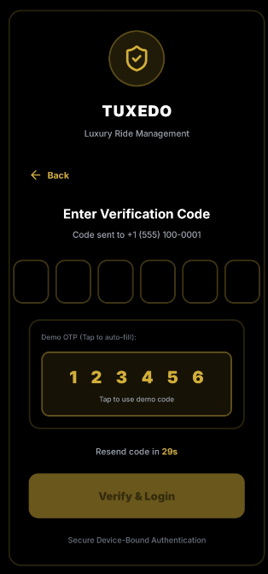

Step 3
Details: Step as per flow.
Business Rules: Refer FRD.
Flow: Sequential progression.
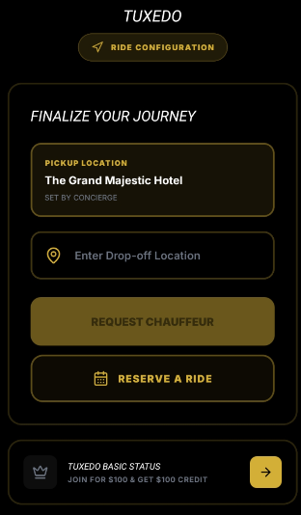

Step 4
Details: Step as per flow.
Business Rules: Refer FRD.
Flow: Sequential progression.
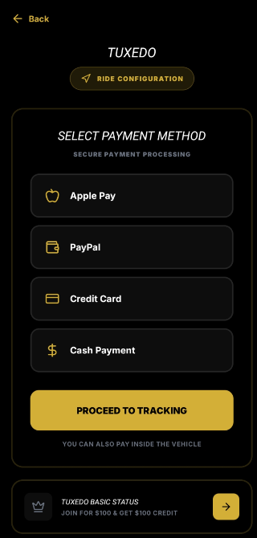

Step 5
Details: Step as per flow.
Business Rules: Refer FRD.
Flow: Sequential progression.


Step 6
Details: Step as per flow.
Business Rules: Refer FRD.
Flow: Sequential progression.


Step 7
Details: Step as per flow.
Business Rules: Refer FRD.
Flow: Sequential progression.
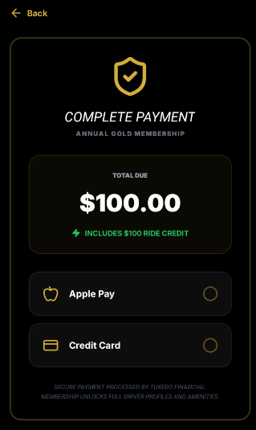

Step 8
Details: Step as per flow.
Business Rules: Refer FRD.
Flow: Sequential progression.
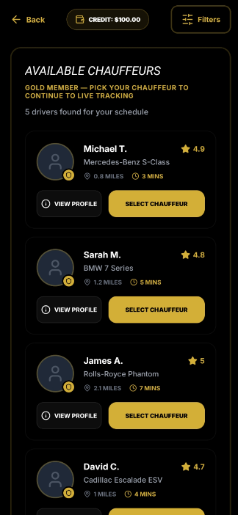

Step 9
Details: Step as per flow.
Business Rules: Refer FRD.
Flow: Sequential progression.
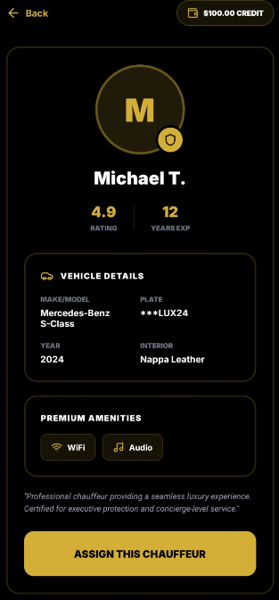

Step 10
Details: Step as per flow.
Business Rules: Refer FRD.
Flow: Sequential progression.
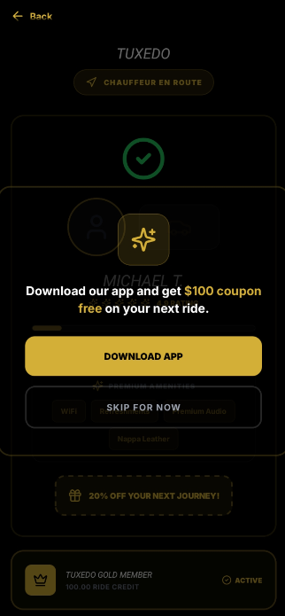

Step 11
Details: Step as per flow.
Business Rules: Refer FRD.
Flow: Sequential progression.
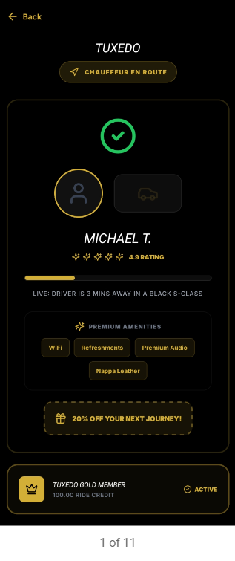

Step 12
Details: Step as per flow.
Business Rules: Refer FRD.
Flow: Sequential progression.
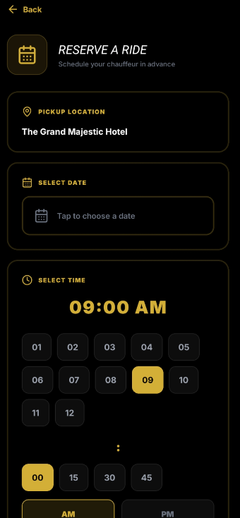

Step 13
Details: Step as per flow.
Business Rules: Refer FRD.
Flow: Sequential progression.
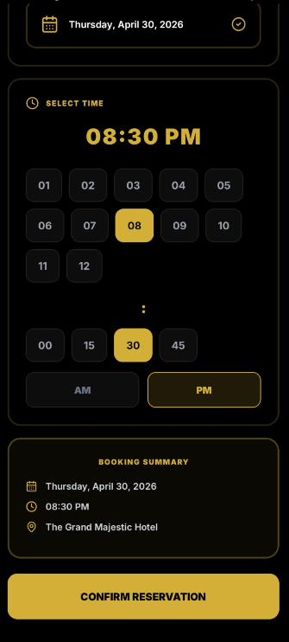

Concierge Mobile App

Step 1
Details: Step as per flow.
Business Rules: Refer FRD.
Flow: Sequential progression.
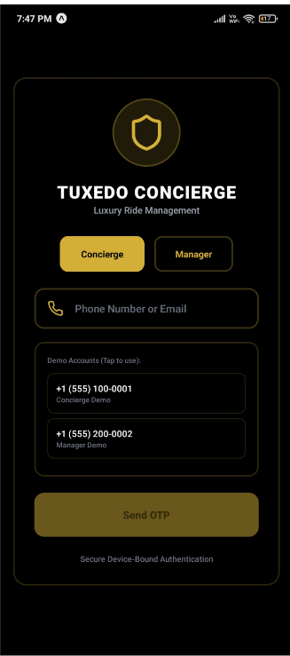

Step 2
Details: Step as per flow.
Business Rules: Refer FRD.
Flow: Sequential progression.
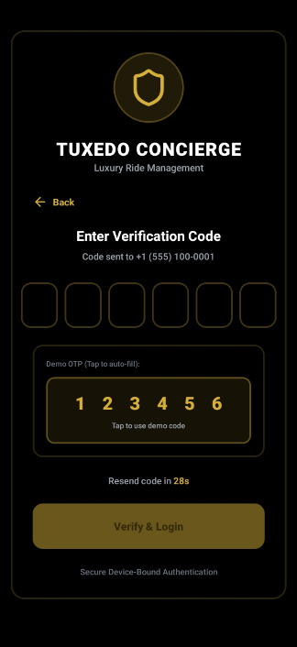

Step 3
Details: Step as per flow.
Business Rules: Refer FRD.
Flow: Sequential progression.
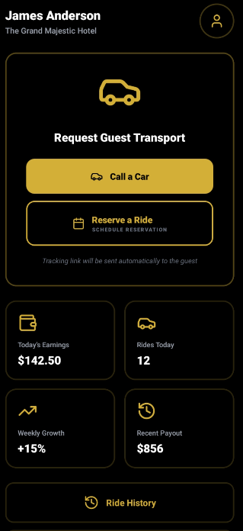

Step 4
Details: Step as per flow.
Business Rules: Refer FRD.
Flow: Sequential progression.


Step 5
Details: Step as per flow.
Business Rules: Refer FRD.
Flow: Sequential progression.


Step 6
Details: Step as per flow.
Business Rules: Refer FRD.
Flow: Sequential progression.
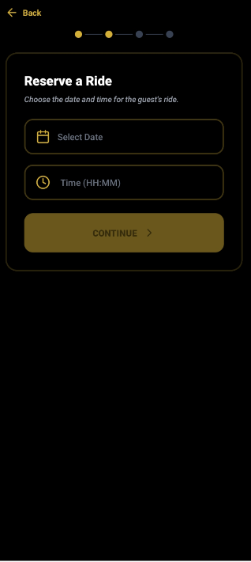

Step 7
Details: Step as per flow.
Business Rules: Refer FRD.
Flow: Sequential progression.
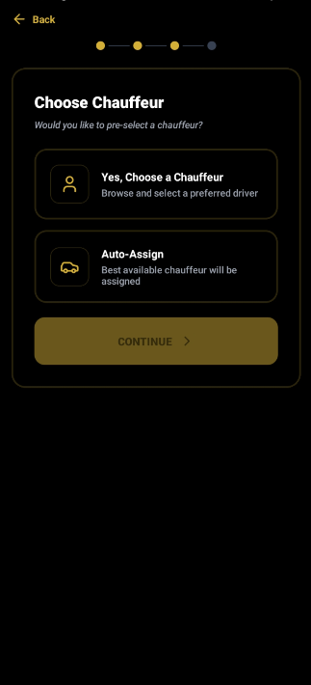

Step 8
Details: Step as per flow.
Business Rules: Refer FRD.
Flow: Sequential progression.
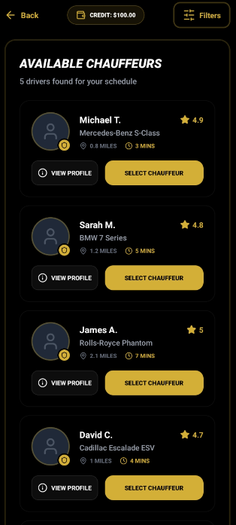

Step 9
Details: Step as per flow.
Business Rules: Refer FRD.
Flow: Sequential progression.


Step 10
Details: Step as per flow.
Business Rules: Refer FRD.
Flow: Sequential progression.
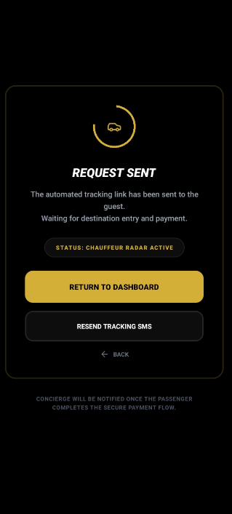

Driver Mobile App

Step 1
Details: Step as per flow.
Business Rules: Refer FRD.
Flow: Sequential progression.


Step 2
Details: Step as per flow.
Business Rules: Refer FRD.
Flow: Sequential progression.
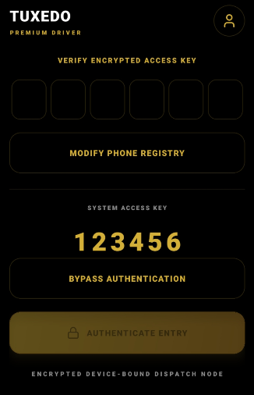

Step 3
Details: Step as per flow.
Business Rules: Refer FRD.
Flow: Sequential progression.
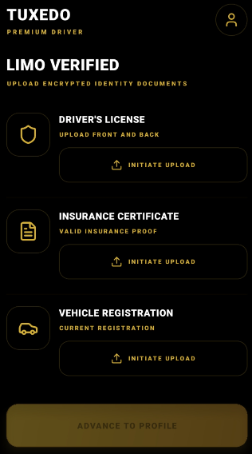

Step 4
Details: Step as per flow.
Business Rules: Refer FRD.
Flow: Sequential progression.
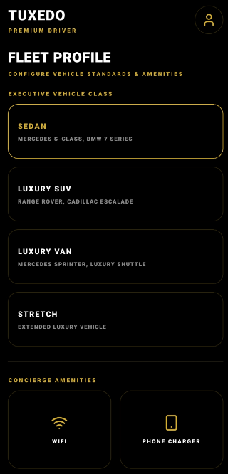

Step 5
Details: Step as per flow.
Business Rules: Refer FRD.
Flow: Sequential progression.
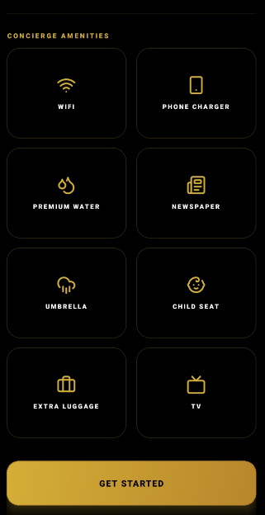

Step 6
Details: Step as per flow.
Business Rules: Refer FRD.
Flow: Sequential progression.
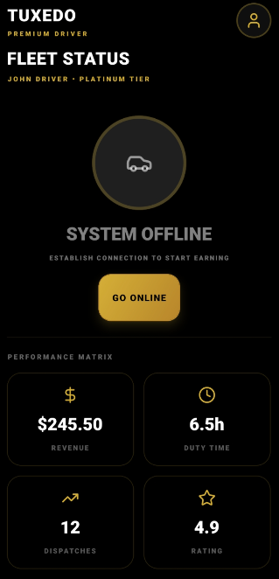

Step 7
Details: Step as per flow.
Business Rules: Refer FRD.
Flow: Sequential progression.
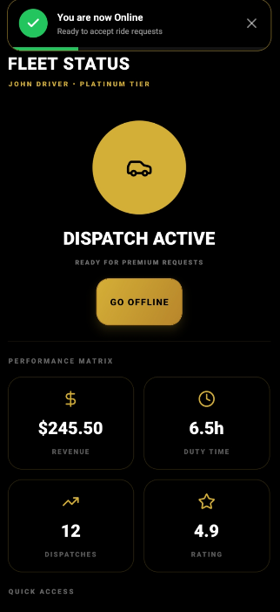

Step 8
Details: Step as per flow.
Business Rules: Refer FRD.
Flow: Sequential progression.
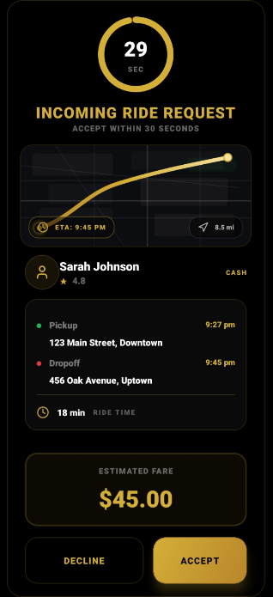

Step 9
Details: Step as per flow.
Business Rules: Refer FRD.
Flow: Sequential progression.
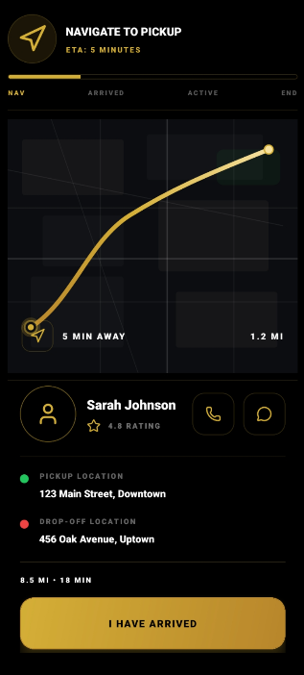

Step 10
Details: Step as per flow.
Business Rules: Refer FRD.
Flow: Sequential progression.
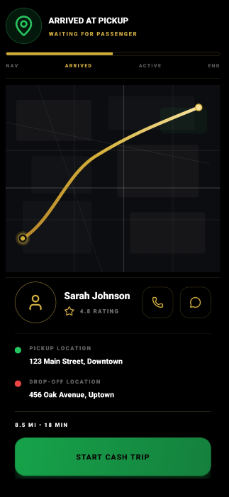

Step 11
Details: Step as per flow.
Business Rules: Refer FRD.
Flow: Sequential progression.
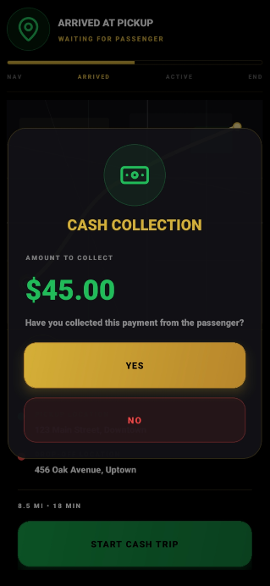

Step 12
Details: Step as per flow.
Business Rules: Refer FRD.
Flow: Sequential progression.
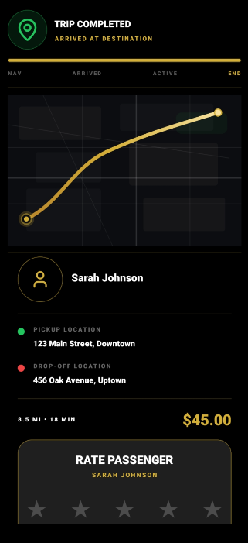

Step 13
Details: Step as per flow.
Business Rules: Refer FRD.
Flow: Sequential progression.
