## horizontal line

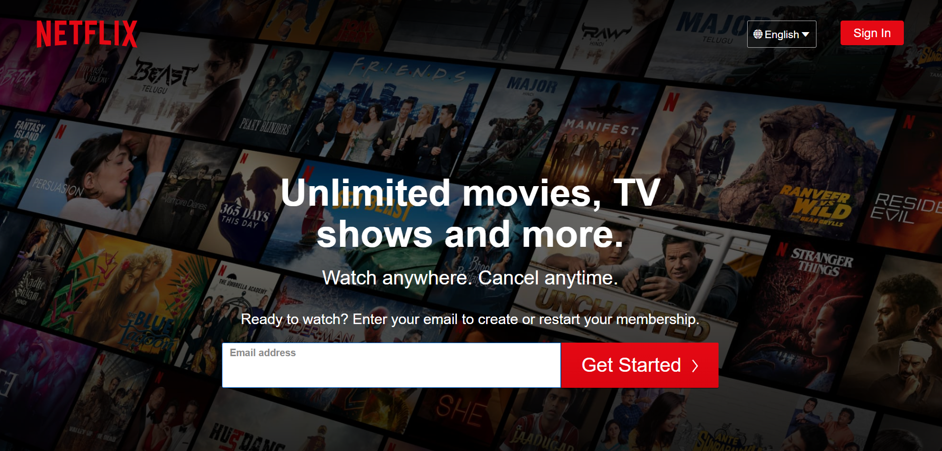

NETFLIX

25.07.2022

# Overview

Netflix is a streaming service that offers a wide variety of award-winning TV shows, movies, anime, documentaries, and more – on thousands of internet-connected devices. You can watch as much as you want, whenever you want, without a single ad – all for one low monthly price. There's always something new to discover, and new TV shows and movies are added every week!

# 

# Goals

1. Login Page
2. Subscription Page
3. Payment Page
4. Streaming Page
5. Login and Logout Page

# Specifications

1. Login Page

The login page is for logging into the platform

1. Subscription Page

The subscription page is for viewing and selecting a plan as per the needs of the customers

1. Payment Page

The payment page displays and uses several options available for making payments for a particular subscription plan.

1. Streaming Page

The streaming page is for displaying new releases and recommended shows and movies and many such options.

1. Login and Logout Page

By simply logging out of the platform

# Technologies used in Netflix

## Front-End

1. HTML

2. CSS

3. Bootstrap

4. React

## Backend

1. NodeJS

## Database

1. MongoDB

## Code Compilers

1. Visual Studio Code

2. Git bash

3. GitHub