MYConnect Telecom Analytics Platform
Looker + LookML Implementation Guide
Enterprise BI Semantic Layer Implementation

This is a guide to Google Looker (LookML) — not Looker Studio.

MYConnect | Looker | LookML | BigQuery | Dataform | Implementation Guide

Architecture: Simulated Telecom Sources → GCS → BigQuery Bronze → Dataform Silver →
Dataform Gold/Mart → Looker (LookML) → Business Dashboards
BigQuery project: myconnect-analytics · Region: asia-southeast1

Table of Contents
1. Executive Summary 3
2. Looker vs. Looker Studio 3
3. MYConnect BI Architecture 4
4. What Actually Happens Inside Looker 6
5. Build MYConnect LookML From Scratch 9
6. LookML Views — Real MYConnect Examples 11
7. Dimensions vs. Measures 17
8. Explores and Joins 18
9. The Model File 22
10. Full LookML Project Walkthrough 23
11. Revenue Assurance Example 23
12. Derived Metrics 25
13. Generated SQL 26
14. Dashboard Construction 27
15. Filters 28
16. Development Workflow 30
17. LookML Validation / Testing 31
18. Common LookML Mistakes 32
19. Where Dataform Ends and LookML Begins 33
20. End-to-End Implementation Checklist 34
21. Interview Cheat Sheet 35
22. References 37
23. MYConnect Looker Implementation — Mental Model 38

1. Executive Summary
Looker is Google Cloud's enterprise BI platform. Unlike report-level BI tools, Looker separates *how data is modeled* from *how it is visualized*: every metric, join, and dimension is defined once, centrally, in code — and every dashboard built on top of it inherits that definition. That modeling layer is written in LookML (Looker Modeling Language), a YAML-like, Git-versionable DSL that compiles down to SQL at query time.
LookML exists to solve a specific problem: in tools where every report writes its own SQL (or its own calculated fields), two dashboards can quietly disagree — one computes "revenue" as SUM(total_amount), another as SUM(total_amount) - SUM(discount_amount), and nobody notices until finance does. LookML forces every metric to be declared once, in one file, reviewed like code, and reused everywhere.
In the MYConnect architecture, Looker sits after the warehouse and before the business user. Dataform builds and curates myconnect_gold (atomic facts and dimensions) and myconnect_mart (pre-aggregated monthly marts) in BigQuery. LookML then wraps those physical tables in a semantic layer — Views, Explores, governed measures — and Looker generates SQL against BigQuery on demand, on behalf of whatever a business user asks for on a dashboard.
This is not Looker Studio. Looker Studio is a free, report-first tool that queries BigQuery directly with no semantic layer — every calculated field lives inside a single report and can silently diverge from the same field in another report. Looker is the opposite: the modeling layer is the product, dashboards are a thin consumption layer on top of it. Section 2 makes this comparison explicit.
What the semantic layer accomplishes for MYConnect specifically: it turns eleven-plus raw Gold/Mart tables into a small number of governed, business-friendly Explores — billing, customers, subscriptions, churn_events, and others — each with joins that are pre-validated not to fan out, and measures (total_revenue, collection_rate, leakage_pct, dso) that are defined exactly once and cannot be recomputed differently by two different analysts.
HOW TO READ THIS DOCUMENT — This guide is written as an implementation runbook: what you would actually do, in order, to stand up Looker + LookML for MYConnect. It assumes you already know SQL, BigQuery, dimensional modeling, and Dataform — it does not re-explain those.

2. Looker vs. Looker Studio
These are two different Google products that solve different problems. Confusing them is the single most common mistake in a portfolio or an interview — be precise about which one you mean.
Area | Looker | Looker Studio
Semantic modeling | LookML (code) | Report-level configuration
Version control | Git-backed LookML project | Limited (report revision history only)
Explores | Yes — governed, joined query surfaces | No such concept
Views | Yes — one per physical table | "Data sources," 1:1 per table, no shared logic
Metric governance | Strong — one measure: definition, reused everywhere | Weak — calculated fields live per-report
Joins | Declared once in an Explore (join: + relationship:) | "Blending," configured per-chart, easy to get wrong
Nested/repeated BQ fields (ARRAY<STRUCT<>>) | Supported via UNNEST in a derived table | Not supported — hidden or errors
Cost | Licensed, enterprise | Free
Typical use | Enterprise BI platform, governed self-service analytics | Lightweight reporting / dashboards
Development workflow | Looker IDE + Git branches + PR review | Browser-based report editing

Why MYConnect would use Looker + LookML if building an enterprise semantic layer: the Gold/Mart layer already encodes non-trivial business rules — point-in-time MRR reconstruction, orphan-payment-excluded collection rate, invoice-level reconciliation. Those rules deserve a semantic layer with the same rigor as the warehouse: reviewed, version-controlled, and impossible to quietly re-derive incorrectly inside a single report. Looker Studio has no mechanism to guarantee that; LookML does.

3. MYConnect BI Architecture
Looker is added as the last two hops of the existing pipeline — it does not introduce a new transformation layer, and it does not replace Dataform. It reads the tables Dataform already produces.
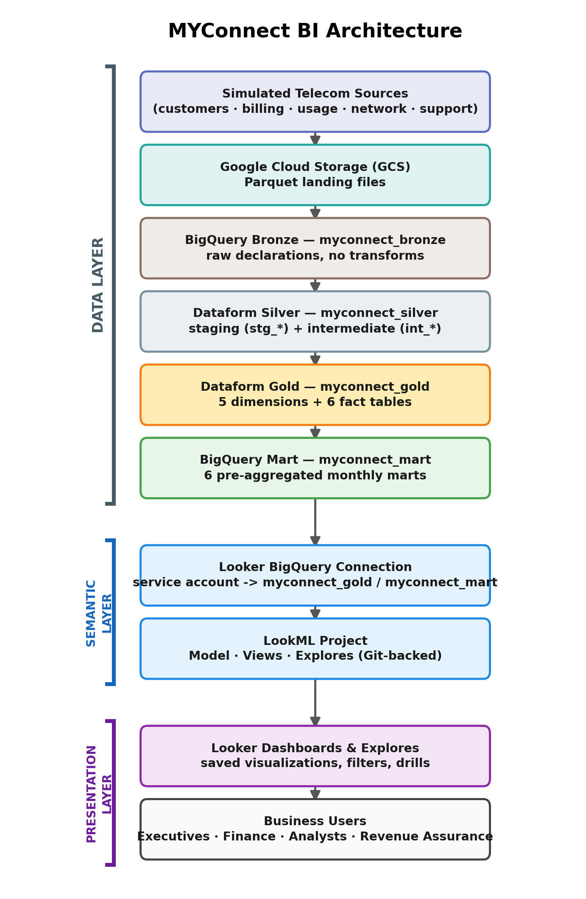
Figure 1. MYConnect BI architecture. Looker connects directly to BigQuery Gold and Mart — Silver is never exposed to the BI layer. (Schematic diagram, not a product screenshot.)

Three layers, three jobs

Data layer — Dataform + BigQuery
Everything up through myconnect_gold and myconnect_mart. This layer's job is correctness and grain: clean, deduplicated, well-typed, reconciled tables with clear primary keys. It knows nothing about how a business user will slice the data.

Semantic layer — LookML
The BigQuery connection, the LookML project (Views, Explores, Model), all living in Git. This layer's job is to give physical tables business meaning: human-readable labels, governed metric formulas, and pre-validated join paths. It knows about BigQuery table names, but a business user never sees them directly.

Presentation layer — Looker dashboards
Saved Explores, tiles, filters, and dashboards. This layer's job is consumption: a business user picks dimensions and measures, applies filters, and never writes SQL. It knows nothing about BigQuery at all — only about Explores and fields.
ARCHITECTURAL RULE — myconnect_silver (staging + intermediate models) is never exposed to Looker. The BigQuery service account backing the Looker connection should be scoped with roles/bigquery.dataViewer on myconnect_gold and myconnect_mart only — enforcing the boundary at the IAM layer, not just by convention.

4. What Actually Happens Inside Looker
Six concepts make up the whole platform. Everything else in Looker is built from these.
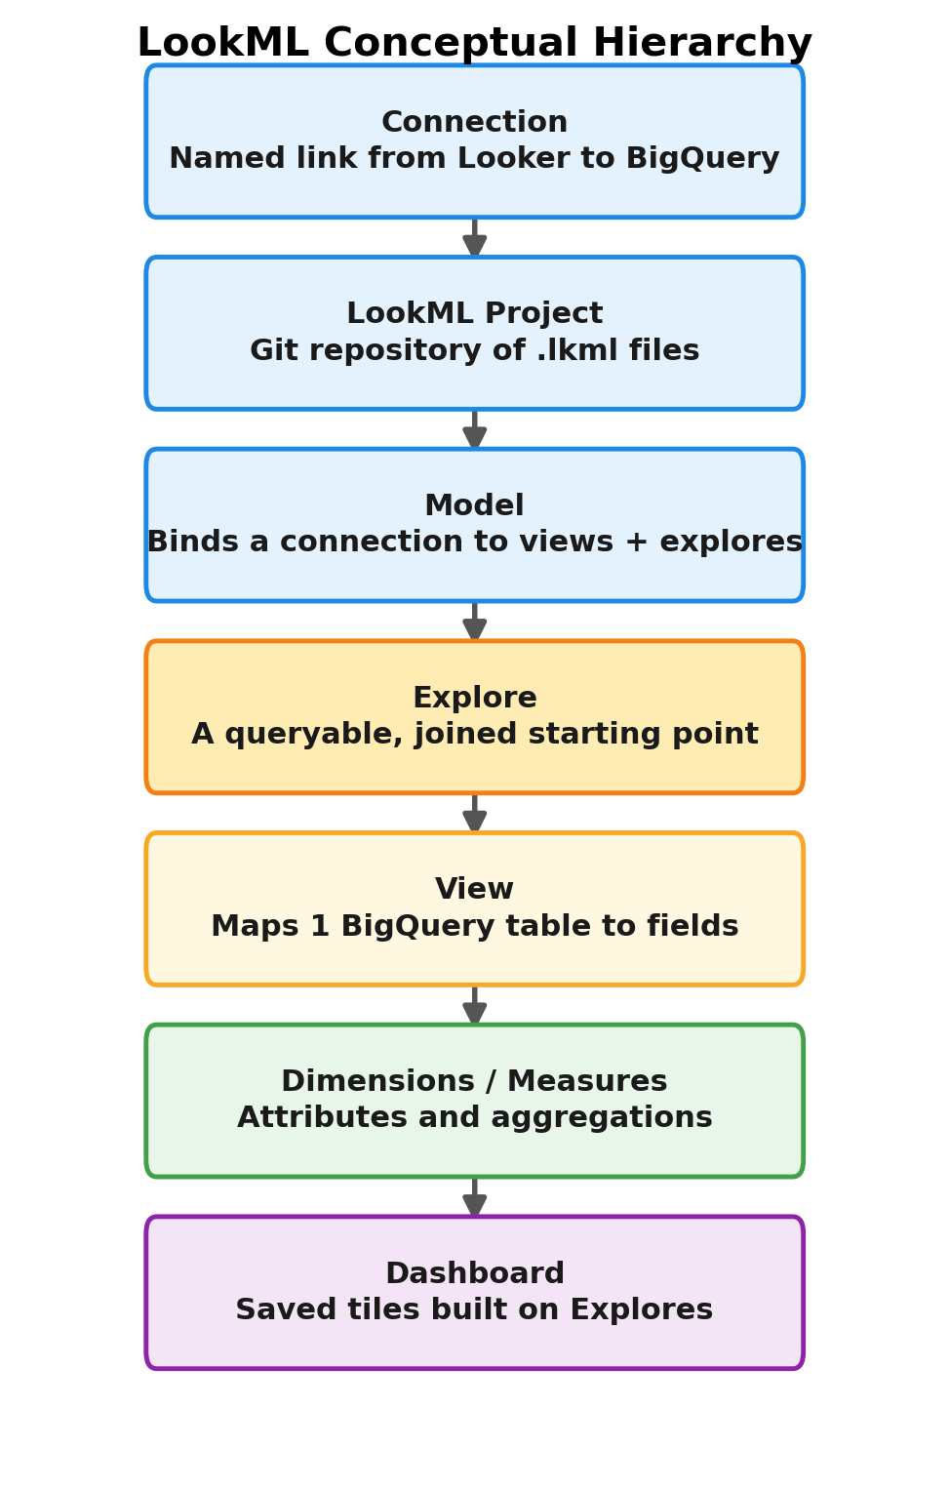
Figure 2. The LookML conceptual hierarchy — each layer is built from the one above it.

Connection
A named link from Looker to a database, configured once in the Looker Admin UI (not in Git — see the callout below). For MYConnect this is a single BigQuery connection, e.g. myconnect_bigquery, pointing at project myconnect-analytics, region asia-southeast1. It carries:
- Credentials — a service-account JSON key with roles/bigquery.dataViewer and roles/bigquery.jobUser, scoped to myconnect_gold and myconnect_mart only.
- Database/dataset access — which BigQuery datasets the connection can query. This is where the Silver boundary is enforced, not in LookML.
- Dev vs. production — Looker can point a developer's personal Git branch at a separate dev connection (e.g. a smaller dataset) so exploratory queries during modeling don't run against full production volume. For a project this size, one connection for both is a reasonable simplification.
NOT IN GIT — The connection is the one piece of a Looker project that is not a .lkml file and not in Git. LookML only ever references it by name (connection: "myconnect_bigquery"). Credentials never enter version control.

LookML Project
A Git repository of .lkml files — this is genuinely just a repo, cloned, branched, and reviewed the same way myconnect-analytics (the Dataform repo) already is. It is a separate repository from the Dataform project; the two communicate only through a contract at the table boundary (a Gold column rename is a breaking change for both). Development Mode is a per-developer session where LookML edits are visible only to that developer until merged and deployed — nothing you change breaks a live dashboard until you deploy.

Model
The file that binds a connection to a set of Views and Explores. Without a model, Views are inert — they describe a table's fields but expose nothing queryable. A model is what turns myconnect.model.lkml into a URL business users can query against (.../explore/myconnect/billing).
📄 myconnect.model.lkml
connection: "myconnect_bigquery"
include: "/views/**/*.view.lkml"
include: "/explores/*.explore.lkml"
datagroup: myconnect_default {
sql_trigger: SELECT MAX(created_at) FROM `myconnect-analytics.myconnect_gold.fct_billing` ;;
max_cache_age: "12 hours"
}
persist_with: myconnect_default
Minimal but real model file for MYConnect (fully covered in Section 9).

View
The LookML representation of one physical table. A View declares sql_table_name, then a set of dimension: and measure: fields mapped to columns (or expressions) on that table. A View is a noun — it describes what a table is, not how it relates to other tables.

Explore
A queryable, joined starting point — the unit a dashboard tile actually runs against. An Explore names one base View and zero or more join: blocks to other Views, each with sql_on: (the join condition) and relationship: (the cardinality). Only fields reachable from an Explore's base View + its joins are exposed to a business user querying that Explore. A Model is a sentence — it says how Views relate and where the data lives.

Dashboard
The end-user consumption surface: a saved query against an Explore ( a "Look"), or a grid of such tiles with shared filters (a dashboard). Business users interact only with Explores and dashboards — they never see LookML, sql_table_name, or BigQuery directly.

5. Build MYConnect LookML From Scratch
This is the actual sequence — starting from nothing — to stand up the Looker layer for MYConnect. Each step is what you would click, write, or run.

Step 1 — Create the BigQuery connection
In the Looker Admin panel (Admin → Connections → New Connection), configure:
Field | Value for MYConnect
Name | myconnect_bigquery
Dialect | Google BigQuery Standard SQL
Project | myconnect-analytics
Dataset access | myconnect_gold, myconnect_mart (never myconnect_silver)
Service account key | JSON key with roles/bigquery.dataViewer + roles/bigquery.jobUser, uploaded once, never in Git
Location | asia-southeast1 (must match the BigQuery dataset region)

This is a one-time, click-through setup. It produces nothing to commit — only a connection *name* that the model file will reference.

Step 2 — Create the LookML project
In Looker: Admin → Projects → New LookML Project, name it looker-myconnect, and connect it to a new Git repository (GitHub/GitLab/Bitbucket, via deploy key). This becomes a second, independent repository alongside myconnect-analytics. Expected structure once views, explores, and dashboards exist:
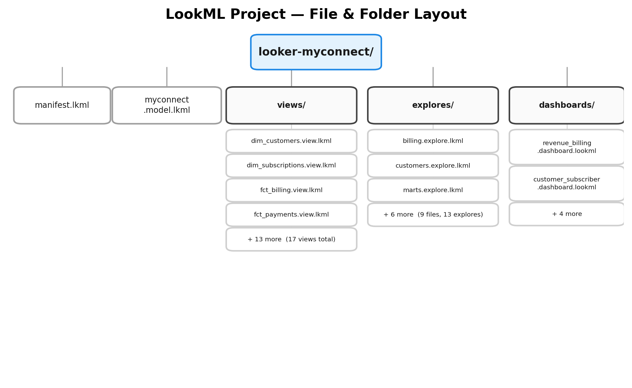
Figure 3. LookML project layout for MYConnect — 17 views (5 dims + 6 facts + 6 marts), 9 explore files (13 Explores total, five of them sharing one file), and one file per LookML dashboard.
File / folder | Purpose
manifest.lkml | Project identity (project_name) and shared constant: values, e.g. the GCP project id, so it isn't repeated in 17 view files.
myconnect.model.lkml | Binds connection: "myconnect_bigquery" to the views and explores via include: statements. Exactly one per project.
views/gold/*.view.lkml | One file per myconnect_gold dimension/fact table — 5 dims + 6 facts = 11 files.
views/mart/*.view.lkml | One file per myconnect_mart table — 6 files. Nested ARRAY<STRUCT<>> columns are deliberately excluded (Section 11).
explores/*.explore.lkml | One file per subject area, each holding one or more explore: blocks with their joins.
dashboards/*.dashboard.lookml | Optional — version-controlled dashboards. Note the extension is .dashboard.lookml, not .lkml.
tests/data_tests.lkml | Optional LookML data tests — the semantic-layer equivalent of Dataform assertions (Section 18).

WHY THIS SPLIT — A view is reused across many Explores with different joins each time — dim_customers is the base View for the customers Explore but a *joined* View in billing, churn_events, and support_tickets. This is exactly why joins live in Explores and never inside a View file.

6. LookML Views — Real MYConnect Examples
Every example below maps to a Gold table that already exists in this project (definitions/gold/**). Field names are the actual output columns of those Dataform models, not invented placeholders.

dim_customers — a dimension view
📄 views/gold/dim_customers.view.lkml
view: dim_customers {
sql_table_name: `@{GCP_PROJECT}.myconnect_gold.dim_customers` ;;
dimension: customer_id {
primary_key: yes
type: string
sql: ${TABLE}.customer_id ;;
}
dimension: name { type: string sql: ${TABLE}.name ;; }
dimension: type { type: string sql: ${TABLE}.type ;; label: "Customer Type" }
dimension: state { type: string sql: ${TABLE}.state ;; }
dimension: city { type: string sql: ${TABLE}.city ;; }
dimension: dwelling_type { type: string sql: ${TABLE}.dwelling_type ;; }
dimension: lifecycle_stage { type: string sql: ${TABLE}.lifecycle_stage ;; }
dimension: current_plan_name { type: string sql: ${TABLE}.current_plan_name ;; }
dimension: has_active_subscription {
type: yesno
sql: ${TABLE}.has_active_subscription ;;
}
dimension: tenure_months {
type: number
sql: ${TABLE}.tenure_months ;;
value_format_name: decimal_0
}
dimension_group: registration {
type: time
timeframes: [raw, date, week, month, quarter, year]
sql: ${TABLE}.registration_date ;;
}
measure: count {
type: count
drill_fields: [customer_id, name, state, city, current_plan_name]
}
measure: average_tenure_months {
type: average
sql: ${tenure_months} ;;
value_format_name: decimal_1
}
}
Line-by-line, the parts that matter:
- sql_table_name: @{GCP_PROJECT}.myconnect_gold.dim_customers — the fully qualified BigQuery table. @{GCP_PROJECT} is a constant: declared once in manifest.lkml (Section 9), not a hardcoded literal repeated in 17 files.
- primary_key: yes on customer_id — not decorative. This is what lets Looker's symmetric-aggregate SQL correctly dedupe rows when this View is joined into an Explore as a one-to-many parent (Section 8 explains why this matters).
- ${TABLE}.customer_id — ${TABLE} is a LookML macro that always resolves to *this view's own* table alias in the generated SQL, so the same dimension definition still works no matter what alias Looker assigns the table when it appears as a join.
- type: yesno on has_active_subscription — the column is already a BigQuery BOOL; yesno is the correct LookML type and renders as a Yes/No filter control.
- dimension_group: registration with type: time — one declaration produces registration_date, registration_week, registration_month, registration_quarter, and registration_year dimensions for free, instead of six separate hand-written dimensions.
- measure: count — every View should declare a base count measure (type: count, no sql: needed — it counts the primary key). drill_fields: names what a user sees when they click through a value in this measure.
DO NOT MODEL — speed_tier on dim_subscriptions/dim_plans and is_holiday_my / fiscal_quarter on dim_date are NULL in every row — the Dataform models leave them unimputed because no bucket boundary or holiday calendar is defined anywhere in the spec. Do not model these as LookML dimensions. Shipping a field that is always NULL is worse than omitting it — it looks queryable and silently returns nothing.

dim_date — a conformed date dimension
📄 views/gold/dim_date.view.lkml
view: dim_date {
sql_table_name: `@{GCP_PROJECT}.myconnect_gold.dim_date` ;;
dimension: date_key {
primary_key: yes
type: date
datatype: date
sql: ${TABLE}.date_key ;;
}
dimension: day { type: number sql: ${TABLE}.day ;; }
dimension: month { type: number sql: ${TABLE}.month ;; }
dimension: month_name { type: string sql: ${TABLE}.month_name ;; }
dimension: quarter { type: number sql: ${TABLE}.quarter ;; }
dimension: year { type: number sql: ${TABLE}.year ;; }
dimension: day_of_week { type: string sql: ${TABLE}.day_of_week ;; }
dimension: is_weekend { type: yesno sql: ${TABLE}.is_weekend ;; }
measure: count { type: count }
}
dim_date is joined into more Explores than any other View (every fact table has at least one date-grained join to it) but is never a base View on its own dashboard page — it exists purely to be joined, which is a normal and correct role for a conformed date dimension.

dim_subscriptions and dim_plans — a dimension hierarchy
📄 views/gold/dim_subscriptions.view.lkml + dim_plans.view.lkml
view: dim_subscriptions {
sql_table_name: `@{GCP_PROJECT}.myconnect_gold.dim_subscriptions` ;;
dimension: subscription_id { primary_key: yes type: string sql: ${TABLE}.subscription_id ;; }
dimension: customer_id { type: string hidden: yes sql: ${TABLE}.customer_id ;; }
dimension: plan_id { type: string hidden: yes sql: ${TABLE}.plan_id ;; }
dimension: plan_name { type: string sql: ${TABLE}.plan_name ;; }
dimension: contract_months { type: number sql: ${TABLE}.contract_months ;; }
dimension: is_active { type: yesno sql: ${TABLE}.is_active ;; }
dimension: monthly_charge {
type: number
sql: ${TABLE}.monthly_charge ;;
value_format: "\"RM\"#,##0.00"
}
dimension_group: subscription {
type: time
timeframes: [raw, date, week, month, year]
sql: ${TABLE}.start_date ;;
}
measure: count { type: count }
measure: active_count { type: count filters: [is_active: "yes"] }
measure: total_monthly_charge {
type: sum
sql: ${monthly_charge} ;;
value_format: "\"RM\"#,##0"
}
}
view: dim_plans {
sql_table_name: `@{GCP_PROJECT}.myconnect_gold.dim_plans` ;;
dimension: plan_id { primary_key: yes type: string sql: ${TABLE}.plan_id ;; }
dimension: plan_name { type: string sql: ${TABLE}.plan_name ;; }
dimension: category { type: string sql: ${TABLE}.category ;; label: "Plan Category" }
dimension: speed_mbps { type: number sql: ${TABLE}.speed_mbps ;; }
dimension: is_current { type: yesno sql: ${TABLE}.is_current ;; }
dimension: monthly_price {
type: number
sql: ${TABLE}.monthly_price ;;
value_format: "\"RM\"#,##0.00"
}
measure: count { type: count }
}
Two things worth noting here. First, customer_id and plan_id on dim_subscriptions are marked hidden: yes — they are join keys, not fields a business user should pick from a field picker; they still work perfectly inside sql_on: expressions in an Explore. Second, value_format: (not value_format_name:) is used for the Ringgit amounts — explained in the callout below.
CURRENCY FORMATTING — value_format_name: only accepts Looker's built-in named presets (usd, gbp, eur, percent_1, decimal_2, and a short fixed list of others) — Malaysian Ringgit is not one of them. For MYConnect's MYR amounts, use the custom value_format: parameter with a literal format string, e.g. value_format: "\"RM\"#,##0.00". Always check the current list of built-in presets against the Looker reference docs before assuming a currency is included (Section 22 — References).

fct_billing — a fact view with filtered measures
📄 views/gold/fct_billing.view.lkml
view: fct_billing {
sql_table_name: `@{GCP_PROJECT}.myconnect_gold.fct_billing` ;;
dimension: invoice_id { primary_key: yes type: string sql: ${TABLE}.invoice_id ;; }
dimension: customer_id { type: string hidden: yes sql: ${TABLE}.customer_id ;; }
dimension: subscription_id { type: string hidden: yes sql: ${TABLE}.subscription_id ;; }
dimension: is_overdue { type: yesno sql: ${TABLE}.is_overdue ;; }
dimension: reconciliation_flag { type: yesno sql: ${TABLE}.reconciliation_flag ;; }
dimension: payment_reconciliation_status {
label: "Payment Status"
type: string
sql: ${TABLE}.payment_reconciliation_status ;;
description: "unpaid / full_payment / underpayment / overpayment — NOT the raw 4-value invoice status."
}
dimension: total_amount {
type: number
sql: ${TABLE}.total_amount ;;
value_format: "\"RM\"#,##0.00"
}
dimension_group: invoice {
type: time
timeframes: [raw, date, week, month, quarter, year]
sql: ${TABLE}.invoice_date ;;
}
dimension: invoice_age_days {
type: number
hidden: yes
sql: DATE_DIFF(CURRENT_DATE(), ${TABLE}.due_date, DAY) ;;
}
dimension: invoice_aging_band {
label: "Invoice Aging"
type: tier
tiers: [0, 31, 61, 91]
style: integer
sql: ${invoice_age_days} ;;
}
measure: invoice_count { type: count }
measure: total_revenue {
type: sum
sql: ${total_amount} ;;
value_format: "\"RM\"#,##0"
}
measure: overdue_amount {
type: sum
sql: ${total_amount} ;;
filters: [is_overdue: "yes"]
value_format: "\"RM\"#,##0"
}
measure: dso {
label: "DSO (days to payment)"
type: average
sql: ${TABLE}.days_to_payment ;;
value_format_name: decimal_1
}
measure: mismatch_count {
type: count
filters: [reconciliation_flag: "yes"]
}
}
- type: tier on invoice_aging_band buckets a numeric field into fixed ranges (0–30, 31–60, 61–90, 91+ days) without a CASE WHEN written by hand in every query that needs it — this is the LookML-native way to express the aging-bucket business rule once.
- measure: overdue_amount uses filters: to pre-filter the aggregation to is_overdue: "yes" rows only — a filtered measure, distinct from a dashboard filter a user applies later. This guarantees "Overdue Amount" always means the same thing everywhere it's used.
- total_paid and the invoice-level payment reconciliation columns are deliberately *not* joined in from fct_payments — fct_billing already carries total_paid at invoice grain precisely so this View never needs that join (Section 8 explains why).

fct_payments and fct_usage_daily
📄 views/gold/fct_payments.view.lkml + fct_usage_daily.view.lkml
view: fct_payments {
sql_table_name: `@{GCP_PROJECT}.myconnect_gold.fct_payments` ;;
dimension: payment_id { primary_key: yes type: string sql: ${TABLE}.payment_id ;; }
dimension: invoice_id { type: string hidden: yes sql: ${TABLE}.invoice_id ;; }
dimension: customer_id { type: string hidden: yes sql: ${TABLE}.customer_id ;; }
dimension: payment_method { type: string sql: ${TABLE}.payment_method ;; }
dimension: is_successful { type: yesno sql: ${TABLE}.is_successful ;; }
dimension: is_orphan_payment { type: yesno sql: ${TABLE}.is_orphan_payment ;; }
dimension: payment_amount {
type: number
sql: ${TABLE}.payment_amount ;;
value_format: "\"RM\"#,##0.00"
}
dimension_group: payment {
type: time
timeframes: [raw, date, week, month, quarter, year]
sql: ${TABLE}.payment_date ;;
}
measure: payment_count { type: count }
measure: successful_payment_amount {
type: sum
sql: ${payment_amount} ;;
filters: [is_successful: "yes", is_orphan_payment: "no"]
value_format: "\"RM\"#,##0"
}
measure: orphan_payment_count {
type: count
filters: [is_orphan_payment: "yes"]
}
}
view: fct_usage_daily {
sql_table_name: `@{GCP_PROJECT}.myconnect_gold.fct_usage_daily` ;;
dimension: usage_pk {
primary_key: yes
hidden: yes
type: string
sql: CONCAT(${TABLE}.subscription_id, '-', CAST(${TABLE}.usage_date AS STRING)) ;;
}
dimension: subscription_id { type: string sql: ${TABLE}.subscription_id ;; }
dimension: total_gb { type: number sql: ${TABLE}.total_gb ;; value_format_name: decimal_1 }
dimension: avg_speed { type: number sql: ${TABLE}.avg_speed ;; }
dimension: speed_achievement_pct { type: number sql: ${TABLE}.speed_achievement_pct ;; }
dimension_group: usage {
type: time
timeframes: [raw, date, week, month]
sql: ${TABLE}.usage_date ;;
}
measure: total_usage_gb { type: sum sql: ${total_gb} ;; value_format_name: decimal_1 }
measure: avg_speed_achievement_pct { type: average sql: ${speed_achievement_pct} ;; value_format_name: percent_1 }
}
COMPOSITE PRIMARY KEYS — fct_usage_daily's natural key is the composite (subscription_id, usage_date) — there is no single physical id column. primary_key: yes still must go on *some* dimension, so a synthetic string key is built with CONCAT() and marked hidden: yes. Skipping this — or worse, marking subscription_id alone as the primary key on a 1-row-per-subscription-per-day table — silently breaks symmetric aggregates the first time this View is joined into anything.

7. Dimensions vs. Measures
Every LookML field is one or the other. Getting this distinction automatic is the first real fluency checkpoint in LookML — Looker Studio blurs it (any numeric field can be dropped into a chart and auto-aggregated); LookML forces you to declare intent.
 | Dimension | Measure
Used for | Grouping, filtering, slicing | Aggregation, KPIs, metrics
Grain | One value per row | One value per group of rows
LookML keyword | dimension: / dimension_group: | measure:
MYConnect examples | current_plan_name, region, payment_reconciliation_status, invoice_month | total_revenue, invoice_count, payment_amount (summed), active_count, total_usage_gb
Can reference another field? | Yes, via sql: (e.g. a CASE WHEN) | Yes, via sql: referencing dimensions or other measures (e.g. ${a}/${b})

A field can only be queried the way it is declared: total_amount as a dimension: returns one row per invoice; the same column exposed as measure: total_revenue { type: sum } returns one aggregated number per group. Declaring both is normal and common — dim_subscriptions.monthly_charge (Section 6) is a dimension for row-level display, and total_monthly_charge sums it as a measure.

Measure types used across MYConnect's views
`type:` | What it computes | Example
count | Row count (of the primary key) | dim_customers.count
sum | SUM() of a numeric field | fct_billing.total_revenue
average | AVG() of a numeric field | fct_billing.dso
count_distinct | COUNT(DISTINCT …) | distinct customers touched by a ticket
number | A formula over other measures — not a direct aggregate | collection_rate (Section 13)
max / min | MAX()/MIN() of a field | latest churn_date in a cohort

8. Explores and Joins
This is where most real LookML mistakes happen, and where MYConnect's Gold/Mart design already did the hard thinking (in looker_studio_to_looker_plan.md) that this section reuses.
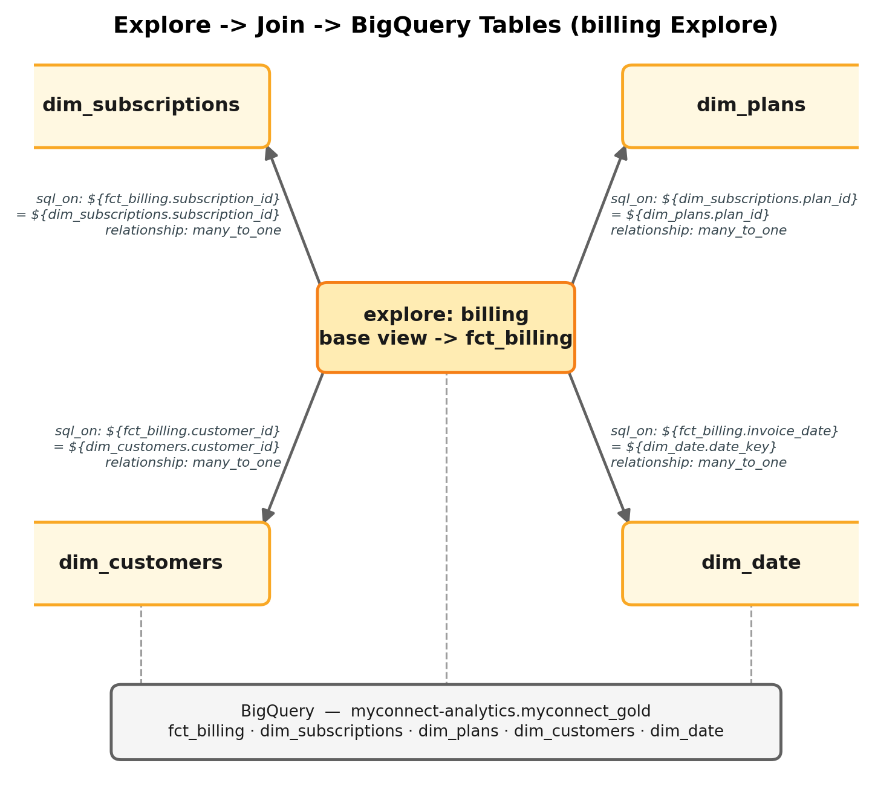
Figure 4. The `billing` Explore: one base view, three joined dimension views, all `many_to_one`, all resolving back to physical tables in `myconnect_gold`.
📄 explores/billing.explore.lkml
explore: billing {
view_name: fct_billing
label: "Billing"
description: "Invoice-grain billing facts. 1 row per invoice. Do NOT join fct_payments here."
join: dim_subscriptions {
type: left_outer
relationship: many_to_one
sql_on: ${fct_billing.subscription_id} = ${dim_subscriptions.subscription_id} ;;
}
join: dim_plans {
type: left_outer
relationship: many_to_one
sql_on: ${dim_subscriptions.plan_id} = ${dim_plans.plan_id} ;;
}
join: dim_customers {
type: left_outer
relationship: many_to_one
sql_on: ${fct_billing.customer_id} = ${dim_customers.customer_id} ;;
}
join: dim_date {
type: left_outer
relationship: many_to_one
sql_on: ${fct_billing.invoice_date} = ${dim_date.date_key} ;;
}
}

The four things that matter in a join block
- `explore:` — names the Explore and its base view (view_name:). This is the table every join in this block is ultimately anchored to.
- `join:` — names another View to bring into this Explore. A View can be joined into many different Explores, each time with different sql_on: — the join lives on the Explore, never on the View.
- `sql_on:` — the literal join condition, written as real SQL referencing ${view.field} on both sides. Looker substitutes each ${...} with the actual column expression and table alias at query time.
- `relationship:` — declares the cardinality from the joined view back to the Explore's row stream: many_to_one (many invoices, one customer — the overwhelmingly common case for a fact joined to a dimension), one_to_one, or one_to_many. This is not documentation — Looker uses it to decide how to deduplicate aggregates.

Why the relationship declaration is not optional
Looker's SQL generator uses symmetric aggregates — a windowed, primary-key-based deduplication technique — so that a measure like fct_billing.total_revenue still sums correctly even after a many_to_one join fans a row out. This is genuinely clever and usually works. It depends entirely on two things being correct: the joined view's primary_key: yes (Section 6), and the declared relationship: matching the real cardinality. Get either wrong and Looker still runs the query and still returns a number — it just silently inflates it. There is no error.

Fan-out, concretely
If dim_customers were joined to dim_subscriptions and then a dashboard asked for COUNT(dim_customers.customer_id), a customer with three subscriptions is counted three times unless the measure uses ${dim_customers.count} (which *is* fan-out-safe via symmetric aggregates) rather than a naive COUNT(*) over the joined result. This is the textbook fan-out scenario, and it's why MYConnect's plan explicitly lists forbidden joins rather than trusting every developer to reason about cardinality correctly under time pressure.

MYConnect's forbidden joins — and what to use instead
Forbidden join | Why | Use instead
fct_billing ⋈ fct_payments | One invoice can have several payments (partial payments, retries) — a one-to-many fact-to-fact join. Correct with symmetric aggregates *and* the right relationship direction, but two SUMs from either side in the same query still fan out one of them. | fct_billing.total_paid — already computed at invoice grain in Gold.
fct_billing ⋈ fct_support_tickets ⋈ fct_churn_events on customer_id | Three facts sharing a dimension key, chained together — a many × many × many explosion, not a simple fan-out. | mart_customer_360 — pre-aggregated to one row per customer for exactly this cross-domain view.
dim_customers ⋈ dim_subscriptions, then COUNT on the customer side | One-to-many from customer to subscription; naive counts inflate. | dim_customers.count, or COUNT(DISTINCT customer_id) explicitly.
fct_network_events ⋈ anything customer/subscription | No foreign key exists — network telemetry is infrastructure-grain by design, not customer-grain. | Keep network_events a permanently separate, isolated Explore (only joined to dim_date).

The 13 MYConnect Explores
One Explore per fact or subject area — never one giant Explore joining everything. 8 Gold-based Explores + 5 single-table Mart Explores (no joins — Mart rows are already monthly aggregates).
Explore | Base view | Joins
billing | fct_billing | dim_subscriptions, dim_plans, dim_customers, dim_date
payments | fct_payments | dim_customers, dim_date
customers | dim_customers | dim_geography (on state+city)
subscriptions | dim_subscriptions | dim_plans, dim_customers
churn_events | fct_churn_events | dim_customers, dim_subscriptions, dim_date
support_tickets | fct_support_tickets | dim_customers, dim_date
network_events | fct_network_events | dim_date only — isolated by design
usage_daily | fct_usage_daily | dim_subscriptions, dim_date
mart_revenue, mart_churn, mart_service_quality,  mart_customer_support, mart_revenue_assurance | each respective mart table | none — single-table Explores

9. The Model File
myconnect.model.lkml is the only file that knows about the connection and about every view and explore — it is the binding layer. Paired with manifest.lkml for shared constants:
📄 manifest.lkml
project_name: "looker-myconnect"
constant: GCP_PROJECT {
value: "myconnect-analytics"
export: override_optional
}
📄 myconnect.model.lkml
connection: "myconnect_bigquery"
include: "/views/gold/*.view.lkml"
include: "/views/mart/*.view.lkml"
include: "/explores/*.explore.lkml"
datagroup: myconnect_default {
sql_trigger: SELECT MAX(created_at) FROM `myconnect-analytics.myconnect_gold.fct_billing` ;;
max_cache_age: "12 hours"
}
persist_with: myconnect_default
- `connection:` — a string name only, resolved against the connection configured in Step 1. No credentials appear here.
- `include:` — pulls Views and Explores into this model's scope. Order doesn't matter; Looker resolves the dependency graph. Glob patterns (*.view.lkml) avoid a growing hand-maintained list as new tables are added.
- `datagroup:` + `persist_with:` — a caching policy. sql_trigger re-checks a cheap query on a schedule; when its result changes (here, a new max created_at on fct_billing), Looker invalidates the cache. Reasonable for MYConnect since Gold/Mart refresh on a Dataform schedule, not in real time.

View vs. Model — the distinction that matters
 | View file | Model file
Describes | One table's fields | A queryable universe — connection + joins
Knows the DB connection? | No | Yes — owns connection:
Knows about other tables? | No — joins never appear here | Yes — every join: lives here (via included Explores)
Count in MYConnect | 17 | 1

10. Full LookML Project Walkthrough
The pieces built in Sections 6–9 are internally consistent — the same field names carry through every layer, end to end:
📄 Dependency trace — billing subject area
manifest.lkml
-> declares constant GCP_PROJECT = "myconnect-analytics"
myconnect.model.lkml
-> connection: "myconnect_bigquery"
-> include: views/gold/*.view.lkml, views/mart/*.view.lkml, explores/*.explore.lkml
views/gold/fct_billing.view.lkml
-> sql_table_name: `@{GCP_PROJECT}.myconnect_gold.fct_billing`
-> dimension: invoice_id, customer_id, subscription_id, total_amount, is_overdue ...
-> measure: total_revenue, overdue_amount, dso, mismatch_count
explores/billing.explore.lkml
-> explore: billing { view_name: fct_billing }
-> join: dim_subscriptions, dim_plans, dim_customers, dim_date
dashboards/revenue_billing.dashboard.lookml
-> explore: billing
-> measures: [fct_billing.total_revenue, fct_billing.overdue_amount]
-> dimensions: [dim_plans.plan_name, dim_customers.state]
Nothing here is a disconnected snippet: total_amount is the same column name in the Gold table, the View's dimension, and (summed) the Explore's measure; plan_name is reachable from the billing Explore only because the join to dim_plans (via dim_subscriptions) actually exists. This is the concrete meaning of "the model is a sentence" from Section 4 — every field a dashboard can use is fully determined by which Explore it queries and which joins that Explore declares.
CROSS-REPO CONTRACT — Two-repo relationship. myconnect-analytics (Dataform — builds the tables) and looker-myconnect (LookML — exposes them) are independent Git repositories with a contract at the table boundary. Renaming fct_billing.total_amount in Dataform silently breaks views/gold/fct_billing.view.lkml — there is no compiler across repos that catches this. Treat a Gold/Mart column rename as a breaking change requiring a matching LookML pull request.

11. Revenue Assurance Example
Revenue assurance is MYConnect's sharpest use case for a governed semantic layer: every metric below already embeds a business rule that would be easy to get subtly wrong if re-derived per-report (Looker Studio's failure mode). LookML defines each one exactly once.
Metric | Source view | LookML measure
Billed revenue | fct_billing | total_revenue — sum(total_amount)
Collected (successful) revenue | fct_payments | successful_payment_amount — filtered sum, excludes orphans
Outstanding balance | fct_billing | total_revenue - total_paid, a number measure (Section 12)
Payment collection rate | mart_revenue | collection_rate — pre-computed in Mart (excludes orphan payments correctly)
Overdue invoice count | fct_billing | invoice_count filtered on is_overdue: "yes"
Overdue amount | fct_billing | overdue_amount (Section 6)
Active subscription count | dim_subscriptions | active_count(Section 6)
ARPU | mart_revenue | arpu — pre-computed point-in-time in Mart (Section 12 explains why)
Revenue by plan | fct_billing ⋈ dim_plans | total_revenue grouped by dim_plans.plan_name
Revenue by region | fct_billing ⋈ dim_geography | total_revenue grouped by dim_geography.region

mart_revenue_assurance — a Mart view
📄 views/mart/mart_revenue_assurance.view.lkml
view: mart_revenue_assurance {
sql_table_name: `@{GCP_PROJECT}.myconnect_mart.mart_revenue_assurance` ;;
dimension: assurance_month {
primary_key: yes
type: date_month
datatype: date
sql: ${TABLE}.assurance_month ;;
}
dimension: billing_mismatch_count { type: number sql: ${TABLE}.billing_mismatch_count ;; }
dimension: orphan_payments { type: number sql: ${TABLE}.orphan_payments ;; }
dimension: overpayments { type: number sql: ${TABLE}.overpayments ;;
description: "A COUNT, not an amount." }
dimension: underpayments { type: number sql: ${TABLE}.underpayments ;;
description: "A COUNT, not an amount." }
dimension: billing_mismatch_amount {
type: number
sql: ${TABLE}.billing_mismatch_amount ;;
value_format: "\"RM\"#,##0.00"
}
dimension: leakage_pct {
type: number
sql: ${TABLE}.leakage_pct ;;
value_format_name: percent_2
}
# This view's rows are already one-per-month aggregates — see Section 12 for why
# every measure below uses `average`, never `sum`, across a multi-month range.
measure: avg_billing_mismatch_count { type: average sql: ${billing_mismatch_count} ;; }
measure: avg_leakage_pct { type: average sql: ${leakage_pct} ;; value_format_name: percent_2 }
measure: avg_orphan_payments { type: average sql: ${orphan_payments} ;; }
}
This View exposes these fields to the mart_revenue_assurance Explore (Section 8), which has no joins — Mart rows carry no slicing dimensions (no plan, no region, no state), only a month grain. When a dashboard needs revenue leakage broken down *by plan*, that tile queries the billing Explore instead (Gold, sliceable) — not this one. Section 19 makes this Gold-vs-Mart choice explicit.

12. Derived Metrics
A derived metric is a formula over other measures, expressed with measure: { type: number sql: ... } — it does not aggregate a raw column itself, it combines already-aggregated measures.
📄 Derived measure examples
# Inside the mart_revenue view (myconnect_mart.mart_revenue)
measure: collection_rate {
type: average # Mart rows are already monthly aggregates — average, not sum
sql: ${TABLE}.collection_rate ;;
value_format_name: percent_1
}
# Inside the fct_billing view — outstanding balance computed from two Gold columns
measure: outstanding_balance {
type: number
sql: ${total_revenue} - ${total_paid_sum} ;;
value_format: "\"RM\"#,##0"
}
# Inside the dim_subscriptions / mart_revenue relationship — ARPU
measure: arpu {
type: average
sql: ${TABLE}.arpu ;; # already point-in-time reconstructed in Mart — do not recompute in LookML
value_format: "\"RM\"#,##0.00"
}

Three places the same formula could live — and why it matters which one you pick
Where the formula lives | What happens
In SQL (Dataform/Mart) | Computed once, at the grain the table is built at (monthly, for mart_revenue). Correct and fast, but inflexible — it can't be recomputed at a different grain without a new model.
As a LookML measure | Computed on demand, at whatever grain the Explore is queried — but defined once, in Git, reviewed like code. Every dashboard that uses this measure gets an identical formula, forever.
In a dashboard/report (Looker Studio's model) | Computed per-report, by whoever built that report. Two reports can define "collection rate" differently and nobody is notified. This is the exact failure mode LookML exists to prevent (Section 1).

COMMON MISTAKE — Mart rows are already monthly aggregates. Declaring measure: mrr { type: sum } on mart_revenue.mrr and then viewing an 18-month range sums 18 already-aggregated monthly MRR figures into a meaningless number. Every measure defined on a Mart view in this guide uses type: average (or forces a single-month filter) instead of type: sum — this trap does not exist on Gold views, where measures aggregate real per-row facts.
Governed metric definitions are valuable for exactly one reason: they make "collection rate went from 94% to 91%" a fact everyone in the business agrees on, instead of the start of a meeting spent reconciling two spreadsheets. The cost is real too — every new metric now requires a Git branch, a review, and a deploy, not a five-minute edit inside a report. That trade-off is the entire point of choosing Looker over Looker Studio for a metric layer this load-bearing.

13. Generated SQL
LookML never runs against the warehouse directly — it compiles to SQL, and Looker sends that SQL to BigQuery. Understanding roughly what gets generated is what makes LookML debuggable.
Suppose the billing Explore (Section 8) is extended with one more many_to_one join, dim_geography (via dim_customers.state/city → dim_geography.state/city), so region becomes queryable alongside billing measures. A user then picks: Region (`dim_geography.region`), Invoice Month (`fct_billing.invoice_month`), Total Revenue, and Overdue Amount — both measures already defined on fct_billing (Section 6), so no fact-to-fact join is involved.
📄 Approximate SQL generated by Looker
-- Illustrative only — Looker's actual output includes header comments, full
-- backtick-quoted table paths, and may differ in aliasing conventions.
SELECT
dim_geography.region AS dim_geography_region,
DATE_TRUNC(fct_billing.invoice_date, MONTH) AS fct_billing_invoice_month,
SUM(fct_billing.total_amount) AS fct_billing_total_revenue,
SUM(CASE WHEN fct_billing.is_overdue THEN fct_billing.total_amount ELSE 0 END)
AS fct_billing_overdue_amount
FROM `myconnect-analytics.myconnect_gold.fct_billing` AS fct_billing
LEFT JOIN `myconnect-analytics.myconnect_gold.dim_subscriptions` AS dim_subscriptions
ON fct_billing.subscription_id = dim_subscriptions.subscription_id
LEFT JOIN `myconnect-analytics.myconnect_gold.dim_customers` AS dim_customers
ON fct_billing.customer_id = dim_customers.customer_id
LEFT JOIN `myconnect-analytics.myconnect_gold.dim_geography` AS dim_geography
ON dim_customers.state = dim_geography.state AND dim_customers.city = dim_geography.city
GROUP BY 1, 2
ORDER BY 2 ASC
LIMIT 500
VERSION / ACCURACY NOTE — LookML defines the semantic model; Looker generates the SQL. The example above is illustrative, not a literal capture. Once a query would fan out (e.g. two measures from different one-to-many-joined tables), Looker's real output wraps each side in its own deduplicated subquery (symmetric aggregates) — noticeably more complex than a flat GROUP BY. Always read the SQL tab in the Explore for the real, current query before trusting a number.

14. Dashboard Construction
The practical path from a question to a tile on a dashboard:
📄 Explore -> Dashboard workflow
Explore (pick dimensions + measures, apply ad-hoc filters)
-> Run (inspect the result table + the generated SQL)
-> Save as a Look, or "Add to dashboard"
-> Position the tile on the dashboard grid
-> Configure dashboard-level filters + wire tiles to listen to them
-> Test (does every tile respond to every filter it should?)
-> Deploy (if built as a LookML dashboard — commit, PR, merge, deploy)
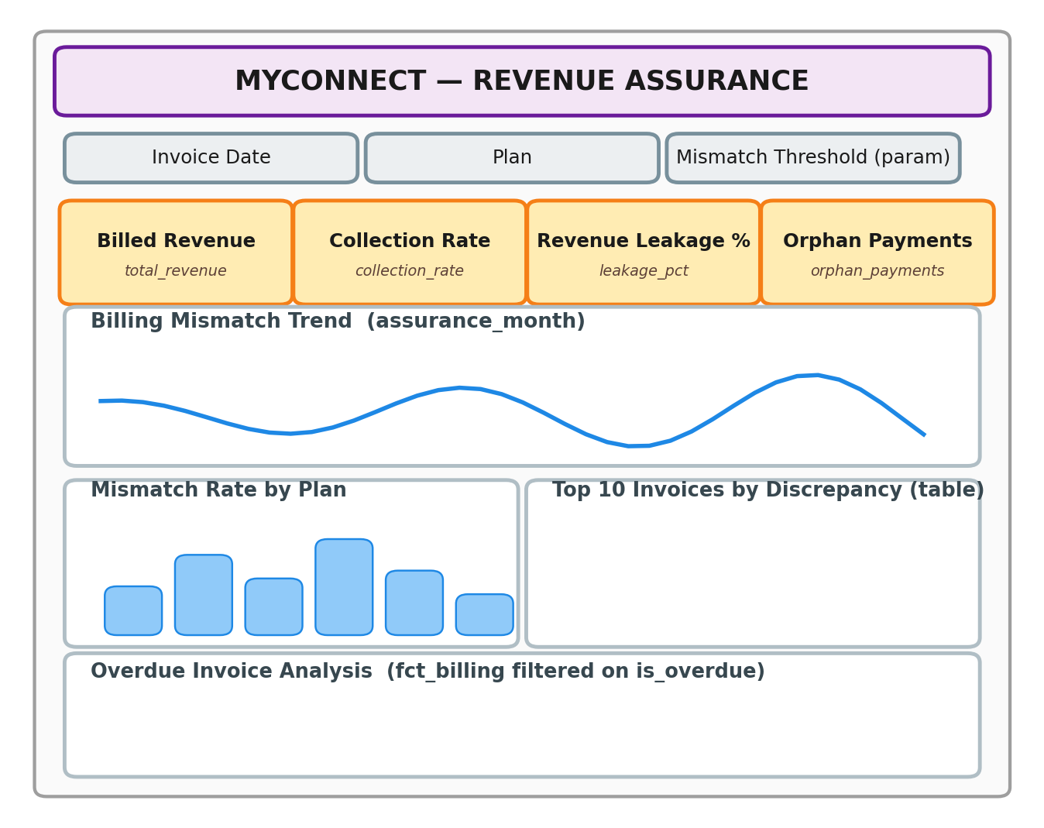
Figure 5. Schematic wireframe — MYConnect's Revenue Assurance dashboard (not a Looker screenshot).
Dashboard element | Powered by
KPI tiles (Billed Revenue, Collection Rate, Leakage %, Orphan Payments) | billing.total_revenue; mart_revenue.collection_rate; mart_revenue_assurance.avg_leakage_pct; mart_revenue_assurance.avg_orphan_payments
Billing Mismatch Trend (line) | mart_revenue_assurance Explore, assurance_month × avg_billing_mismatch_count
Mismatch Rate by Plan (bar) | billing Explore, dim_plans.plan_name × fct_billing.mismatch_count
Top 10 Invoices by Discrepancy (table) | billing Explore, sorted by a derived ABS(total_amount - line_item_total) dimension, limit: 10
Overdue Invoice Analysis | billing Explore filtered to is_overdue: "yes"

15. Filters
Filter type | Scope | MYConnect example
Explore (ad-hoc) filter | One query, applied while exploring | Analyst filters payment_reconciliation_status = "overpayment" while investigating a spike
Dashboard filter | Every tile that listens to it | "Invoice Date" filter on the Revenue & Billing dashboard, default "last 18 months"
Tile-scoped filter | One tile only, ignores dashboard filters it doesn't listen to | "Plan" filter wired only to the New-vs-Churned comparison tile
Field filter (dashboard-level, on a specific field) | Any tile using that field | type: field_filter bound to dim_plans.plan_name
Date filter (via dimension_group) | Any timeframe of that group | invoice_date, payment_date, churn_date — each already exposes date/week/month/quarter for free
Parameter | A user-supplied value plugged into sql: at query time, not a row filter | Page 6's numeric "Mismatch Threshold" control

📄 dashboards/revenue_billing.dashboard.lookml (filters excerpt)
filters:
- name: invoice_date
title: Invoice Date
type: field_filter
default_value: 18 months
model: myconnect
explore: billing
field: fct_billing.invoice_date
- name: plan
title: Plan
type: field_filter
model: myconnect
explore: billing
field: dim_plans.plan_name
A tile opts into a dashboard filter with a listen: block mapping the filter name to a field on that tile's own Explore — a tile that omits a filter from its listen: block simply never responds to it. This is the exact mechanism behind Section 14's tile-scoped filters.

16. Development Workflow
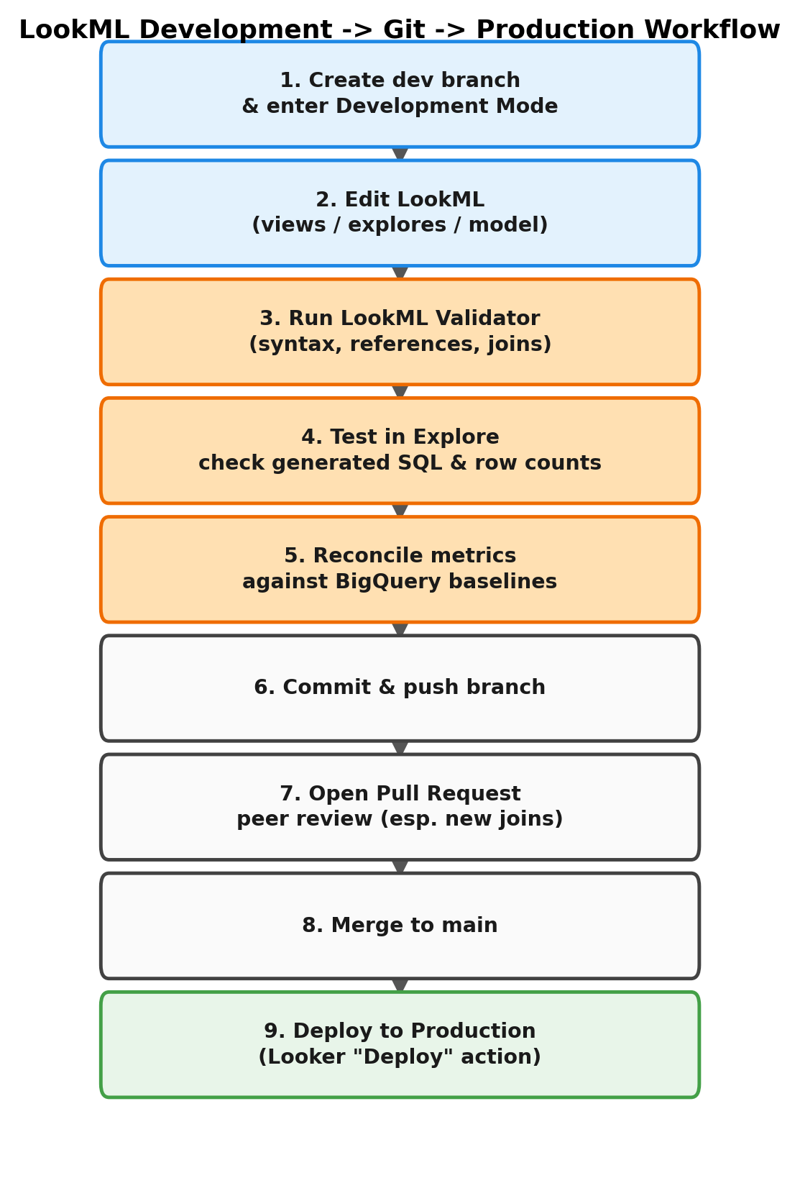
Figure 6. LookML development, Git, and production deployment — the same shape as any reviewed code change, applied to a semantic layer.
Git integration in Looker is not optional tooling bolted on afterward — every LookML project *is* a Git repository from creation. Development Mode is what makes this safe: each developer works on a personal branch, and Looker compiles and serves *that developer's* branch only to them. Every other user keeps querying the last deployed production commit. This means a developer can restructure all 13 Explores in a branch without a single live dashboard changing behavior — until that branch is merged and explicitly deployed.
Step | What actually happens
1–2. Branch & edit | A developer creates a branch, enters Development Mode, edits .lkml files in the Looker IDE (or a local clone + the Looker VS Code extension).
3. LookML Validator | Looker statically checks the branch for syntax errors, broken ${...} references, and undeclared joins — before any query runs (Section 17).
4–5. Test & reconcile | The developer runs real queries against the new/changed Explore, reads the SQL tab, and reconciles the resulting numbers against a known BigQuery baseline (e.g. SELECT COUNT(*) FROM fct_billing should equal the Explore's row count for invoice_count).
6–8. Commit, PR, merge | Standard code review — for LookML, the reviewer's first question on any diff touching a join: block should be "what's the relationship:, and is that actually true of this data?"
9. Deploy to Production | An explicit "Deploy to Production" action in Looker promotes the merged commit — dashboards only pick up new logic at this point, never before.

17. LookML Validation / Testing
What to check before a branch is deployed, roughly in the order it becomes checkable:
☐ LookML syntax — the Validator catches malformed blocks, missing ;; terminators, unbalanced braces.
☐ Broken references — a ${field_name} pointing at a dimension that was renamed or deleted. The Validator flags this at compile time, before any query runs.
☐ Joins — every join: has a sql_on: that actually references fields that exist on both sides.
☐ Field definitions — every dimension:/measure: has a valid type: and, where required, a sql:.
☐ Primary keys — every View that will ever be joined has exactly one primary_key: yes (composite keys built via CONCAT() where the physical table has no single-column key, e.g. fct_usage_daily, Section 6).
☐ Relationship correctness — relationship: matches the true cardinality, verified by row-count reconciliation, not assumption.
☐ Metric correctness — a changed or new measure reconciles against an independent BigQuery query on the same table.
☐ Generated SQL — read the SQL tab for anything non-trivial (new join, new derived measure) before trusting the result.
☐ Dashboard behavior — every tile responds to the filters it should, and *only* those it should (tile-scoped filters, Section 15).
☐ Performance — a new Explore against fct_usage_daily (millions of rows) should be tested at a realistic date range before it ships on a dashboard that defaults to "all time."

Common Validator errors
📄 Representative LookML Validator output
Error: Could not find a field named 'dim_plans.speed_tier'
-> a dimension referenced in drill_fields/sql that doesn't exist on that view
(speed_tier is NULL by design and was never modeled — Section 6)
Error: Join 'dim_geography' has invalid property 'realtionship'
-> typo'd LookML key; the Validator does not silently ignore unknown keys
Error: Circular reference detected: total_revenue -> outstanding_balance -> total_revenue
-> a derived (type: number) measure referencing a measure that references it back

18. Common LookML Mistakes

1. Wrong join relationship
Declaring many_to_one when the real cardinality is one_to_many (or vice versa). The query still runs and still returns a number — just silently the wrong one. Avoid it: reconcile every new Explore's row count against BigQuery directly (Section 17) before it reaches a dashboard.

2. Missing primary key
A View with no primary_key: yes can still be queried standalone, but the moment it's joined as the "one" side of a many_to_one relationship, Looker has no key to deduplicate against — symmetric aggregates silently stop protecting the query. Avoid it: every View gets a primary_key: yes, composite keys included (fct_usage_daily, Section 6).

3. Fanout inflating measures
Joining two fact tables (or a dimension into a one-to-many position) and summing a measure from the "one" side — it gets multiplied by the row count on the "many" side. Avoid it: never join fct_billing to fct_payments directly (Section 8); use the invoice-level total_paid column Gold already provides.

4. Incorrect SQL reference
Writing sql: total_amount ;; instead of sql: ${TABLE}.total_amount ;; — the first is ambiguous once this View is joined and multiple tables in the query have a column with that name. Avoid it: always qualify with ${TABLE}. (own column) or ${other_view.field} (referencing another view's LookML field, not its raw column).

5. Duplicated metric logic
Redefining "collection rate" as a second measure with slightly different filters instead of reusing mart_revenue.collection_rate. Avoid it: before adding a measure, grep the project for an existing one that already does this — LookML has the same duplication risk as any codebase.

6. Putting transformation logic in LookML that belongs in Dataform
Writing a multi-join derived table in LookML to reconcile payments against invoices — logic that already exists, tested, in int_billing_reconciliation. Avoid it: if the logic touches more than one raw table and produces a reusable business entity, it belongs in Dataform's Silver/Gold layer, not in a LookML derived_table: (Section 19 draws this line precisely).

7. Building everything inside dashboards instead of reusable semantic definitions
Defining "Overdue Amount" as a one-off dashboard calculation on a single tile instead of as fct_billing.overdue_amount (Section 6). The moment a second dashboard needs the same number, it either duplicates the logic or drifts from it. Avoid it: a formula used on more than one tile is a LookML measure, not a tile-level calculation, by definition.

19. Where Dataform Ends and LookML Begins
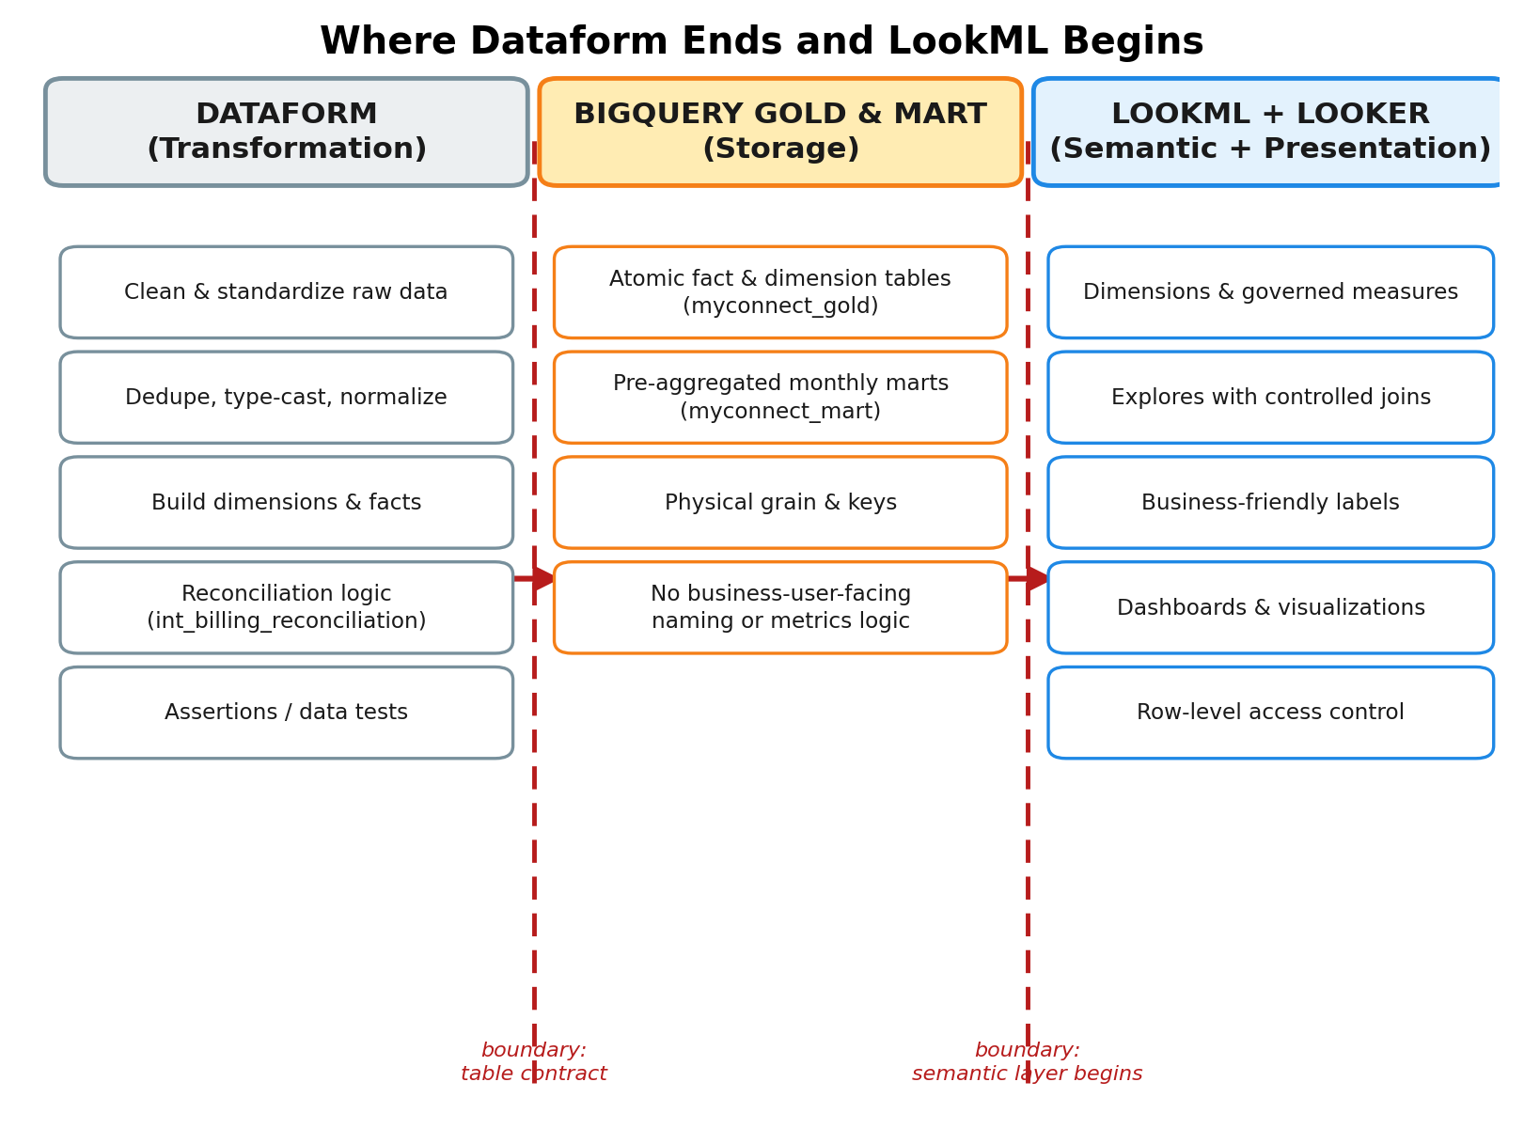
Figure 7. The responsibility boundary — a Gold/Mart column rename is a breaking change on both sides of the left boundary; a relabeled dimension only touches the right.
Responsibility | Dataform | LookML
Data cleaning | Yes | No
Data transformation | Yes | Limited (row-level sql: dimensions only)
Fact/dimension creation | Yes | No
Business semantic definitions | Limited (Mart pre-aggregates a few) | Yes
Dimensions exposed to BI | No | Yes
Measures / KPIs | Sometimes (Mart) | Yes
Joins for exploration | No | Yes
Dashboard visualizations | No | Yes

THE PRINCIPLE — Dataform prepares trusted analytical data. LookML defines how business users understand and analyze that data. Looker dashboards present the analysis. Each layer does exactly one job; a change that crosses this boundary in either direction — reconciliation logic written in a LookML derived table, or a business label decision made in a Dataform config { description } — is the seed of a future "why do these two numbers disagree" incident.
A concrete test for "which layer does this belong in": if the logic joins more than one raw table and produces a reusable business entity (a customer, an invoice, a churn event), it's Dataform. If it takes an already-clean Gold/Mart column and gives it a label, a format, a governed aggregation, or a join for exploration, it's LookML.

20. End-to-End Implementation Checklist

BigQuery
☐ Gold marts exist (myconnect_gold: 5 dimensions, 6 facts) and Mart aggregates exist (myconnect_mart: 6 tables)
☐ Required fields exist on each table — cross-checked against the Dataform .sqlx definitions, not assumed
☐ Primary keys understood for every table, including the two composite ones (fct_usage_daily, dim_geography)
☐ Foreign-key relationships between Gold tables documented (Section 8's Explore table)

Looker
☐ BigQuery connection created, scoped to myconnect_gold + myconnect_mart only
☐ LookML project created, Git-backed, deploy key configured
☐ manifest.lkml + myconnect.model.lkml created
☐ 17 Views created (5 dims + 6 facts + 6 marts), each with primary_key: yes
☐ Dimensions created, NULL-by-design fields (speed_tier, is_holiday_my, fiscal_quarter) deliberately omitted
☐ Measures created for every governed KPI in Sections 6 and 11
☐ 13 Explores created (8 Gold + 5 Mart), none of them the four forbidden joins (Section 8)
☐ Every Explore's row count validated against a direct BigQuery query
☐ Model configured with include: covering all Views and Explores
☐ Dashboards created for each subject area
☐ Dashboard and tile-scoped filters tested against every tile that should respond
☐ LookML Validator passes with zero errors
☐ Generated SQL checked (SQL tab) for every new or changed Explore
☐ Metrics reconciled against BigQuery baselines (MRR ≈ RM32.0M, leakage ≈ 0.079%, mismatch amount ≈ RM427,280, orphan payments = 6,859)
☐ Production deployment completed

21. Interview Cheat Sheet

How I Would Explain Looker + LookML in an Interview
TALKING POINT — “Looker provides the BI platform, while LookML defines the semantic model. For MYConnect, I'd connect Looker to the BigQuery Gold and Mart layers, create one reusable View per physical table, define governed measures for the KPIs finance actually cares about — collection rate, DSO, revenue leakage — expose them through a small number of scoped Explores with carefully declared join relationships, and only then build dashboards on top. The join design is the part that takes real judgment: I'd never join fct_billing to fct_payments directly, because that's a one-to-many fact-to-fact join that risks fanning out revenue — Gold already gives me an invoice-level total_paid column instead.”

What is LookML?
A YAML-like, Git-versioned modeling language that defines Looker's semantic layer — Views, Explores, dimensions, and measures — and compiles to SQL at query time.

What is a View?
The LookML representation of one physical table: sql_table_name plus a set of dimension:/measure: field definitions mapped to its columns.

What is an Explore?
A named, queryable starting point — one base View plus its join: blocks. It's the unit a dashboard tile actually queries against, and it determines exactly which fields are reachable.

What is a Model?
The file that binds a connection: to a set of included Views and Explores — without it, Views exist but nothing is queryable.

Difference between Dimension and Measure?
A dimension returns one value per row (for grouping/filtering); a measure returns one aggregated value per group (sum, count, average, or a number formula over other measures).

How does Looker generate SQL?
It compiles the requested fields' LookML sql: expressions plus the Explore's declared joins into a single SQL statement, substituting ${...} references with real table aliases and columns — visible any time in the Explore's SQL tab.

How do joins work?
Declared on the Explore (never the View) with join:, sql_on: (the literal condition), and relationship: (the cardinality) — a View can be joined differently in different Explores.

What is fanout?
When a join multiplies rows on one side of a relationship and a naive aggregate (SUM/COUNT) on the un-multiplied side inflates as a result — e.g. summing an invoice-level amount after joining in a one-to-many payments table.

Why define relationships?
relationship: tells Looker's symmetric-aggregate SQL generator how to deduplicate before aggregating. Get it wrong and the query still runs and still returns a number — just silently the wrong one, with no error.

How does Git work with LookML?
Every LookML project is a Git repository from creation. Developers work in personal branches under Development Mode — changes are invisible to end users until merged and explicitly deployed to production.

Looker vs. Looker Studio?
Looker Studio queries BigQuery directly with no semantic layer — every report's calculated fields can drift from every other report's. Looker centralizes metric and join logic once, in version-controlled LookML, that every dashboard inherits.

Dataform vs. LookML?
Dataform builds and cleans the warehouse tables (Bronze → Silver → Gold/Mart) — it owns grain, keys, and reconciliation. LookML wraps those already-correct tables in a business-facing semantic layer — labels, governed metrics, controlled joins. Neither should do the other's job (Section 19).

Where should business logic live?
Multi-table transformation logic that produces a reusable entity → Dataform. Single-table labeling, formatting, or governed aggregation for BI consumption → LookML. Logic used on more than one dashboard tile is a LookML measure, never a copy-pasted tile calculation.

How would you optimize Looker performance?
Push heavy transformation to already-materialized Gold/Mart tables rather than LookML derived tables; set sensible datagroup caching; avoid unnecessary joins/fanout-prone Explores; default wide-range dashboards (e.g. against fct_usage_daily) to a bounded date filter; and check the System Activity Explores for slow queries in production.

How would you validate a Looker dashboard?
Reconcile every KPI tile against an independent BigQuery query and known baselines, confirm each filter (dashboard-level and tile-scoped) actually reaches the tiles it should and only those, read the SQL tab on anything non-trivial, and re-check after any upstream Gold/Mart schema change.

22. References
Official Google Cloud / Looker documentation used to verify the LookML behavior described in this guide. Google periodically reorganizes the Looker docs site — if a link below has moved, search cloud.google.com/looker/docs for the page title.
Topic | Reference
Looker documentation home | cloud.google.com/looker/docs
What is Looker | cloud.google.com/looker/docs/what-is-looker
LookML terms and concepts | cloud.google.com/looker/docs/lookml-terms-and-concepts
LookML parameter reference | cloud.google.com/looker/docs/reference/lookml-reference
Connecting Looker to BigQuery | cloud.google.com/looker/docs/db-config-google-bigquery
Explore and join parameters | cloud.google.com/looker/docs/reference/param-explore-join
Version control / Git in Looker | cloud.google.com/looker/docs/setting-up-version-control
Building LookML dashboards | cloud.google.com/looker/docs/building-lookml-dashboards
Value format strings | cloud.google.com/looker/docs/reference/param-field-value-format

VERSION / ACCURACY NOTE — Symmetric aggregates, fan-out, and the exact set of value_format_name: presets are version- and edition-sensitive areas of Looker. This guide describes them at the level of durable, documented behavior — verify exact syntax and current presets against the live reference pages above before shipping.

23. MYConnect Looker Implementation — Mental Model
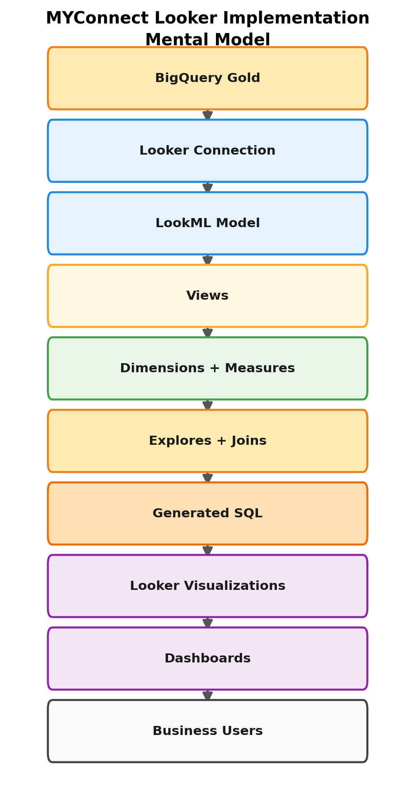
Figure 8. The end-to-end chain, BigQuery Gold to business user.

Ten things to remember
- Looker is not Looker Studio — LookML is a version-controlled semantic layer, not report-level configuration.
- Looker connects to Gold and Mart only — myconnect_silver is never exposed to the BI layer, enforced at the connection's IAM scope.
- A View = one physical table. Joins never live inside a View — they live on the Explore, because the same View joins differently in different Explores.
- `primary_key: yes` on every View is not decorative — it is what makes symmetric aggregates (and therefore safe joins) work at all.
- `relationship:` must match true cardinality. Wrong direction = silently wrong numbers, not an error.
- Never join two fact tables directly if it can be avoided — MYConnect's Gold layer already denormalizes the one number (total_paid) that would have required it.
- Measures are governed metrics — defined once, reused everywhere. A formula used on more than one dashboard tile belongs in LookML, not copy-pasted into each tile.
- Mart tables are pre-aggregated — average or single-month-filter their measures, never sum across a multi-month range.
- Development Mode + Git mean nothing you write breaks a live dashboard until it's merged and explicitly deployed to production.
- Dataform prepares trusted data. LookML defines how business users understand it. Looker dashboards present the analysis. Keep each layer doing exactly one job.

