

A Minor Project Report on

**ECOSENSE (INTELLIGENT CONTROL FOR**

**PRESENCE-BASED LIGHTING AND VENTILATION)**

Submitted in partial fulfillment of requirements for the award of the

Degree of

**BACHELOR OF TECHNOLOGY**

in

**ARTIFICIAL INTELLIGENCE AND MACHINE LEARNING**

Under the guidance of

**Mrs. S.BHARANI NAYAGI,**

**Assistant Professor/AI**

Submitted By

**BHUVANRAJ R (927622BAL004)**

**HARISH K (927622BAL014)**

**KARISHMA S K (927622BAL020)**

**DEPARTMENT OF ARTIFICIAL INTELLIGENCE AND MACHINE LEARNING**

**M.KUMARASAMY COLLEGE OF ENGINEERING**

(Autonomous)

KARUR – 639 113

**DECEMBER 2024**



# M. KUMARASAMY COLLEGE OF ENGINEERING

**(Autonomous Institution affiliated to Anna University, Chennai)**

# KARUR – 639 113

**BONAFIDE CERTIFICATE**

Certified that this minor project report on **“ECOSENSE (INTELLIGENT CONTROL FOR PRESENCE-BASED LIGHTING AND VENTILATION)”** is the bonafide work of **“BHUVANRAJ R (927622BAL004), HARISH K (927622BAL014), KARISHMA S K (927622BAL020)”** who carried out the project work during the academic year 2024-2025 under my supervision.

SIGNATURE

**Dr.A.SELVI, M.Tech.,(Ph.D).,**

**HEAD OF THE DEPARTMENT**,

Department of Artificial Intelligence

M. Kumarasamy College of Engineering, Thalavapalayam, Karur -639 113.

SIGNATURE

**Mrs. S.BHARANI NAYAGI** **M.E.,**

**SUPERVISOR**

**Assistant Professor/AI**,

Department of Artificial Intelligence,

M. Kumarasamy College of Engineering, Thalavapalayam, Karur -639 113.



**DEPARTMENT OF ARTIFICIAL INTELLIGENCE AND MACHINE LEARNING**

**VISION OF THE INSTITUTION**

To emerge as a leader among the top institutions in the field of technical education.

**MISSION OF THE INSTITUTION**

* Produce smart technocrats with empirical knowledge who can surmount the global challenges.
* Create a diverse, fully-engaged, learner-centric campus environment to provide quality education to the students.
* Maintain mutually beneficial partnerships with our alumni, industry and professional associations.

**VISION OF THE DEPARTMENT**

To create highly qualified competitive professionals in Artificial Intelligence and Machine Learning by designing intelligent solutions to solve problems in variety of business domains, applications such as natural language processing, text mining, robotics, reasoning and problem-solving that serves society with greater cause.

**MISSION OF THE DEPARTMENT**

* Impart practical and technical knowledge along with applications of various integrated technologies.
* Design and develop various intelligent engineering projects to solve societal issues.
* Use of advanced engineering tools and equipment to enable research based learning to promote ethical values, lifelong learning and entrepreneurial skills**.**

**PROGRAM EDUCATIONAL OBJECTIVES (PEOs)**

**PEO 1:** Develop intelligent software solutions demonstrating reasoning, learning and decision support while handling uncertainty using domain knowledge.

**PEO 2:** Create significant research towards social benefits and engineering improvement with a wide breadth knowledge of AI & ML technologies and their applications

**PEO 3:** Participate in life-long learning for effective professional growth and demonstrate leadership qualities in disruptive technologies along with a capacity to critically analyse and evaluate design proposals.

**PROGRAM OUTCOMES (POs)**

**PO1: Engineering knowledge:** Apply the knowledge of mathematics, science, engineering fundamentals, and an engineering specialization to the solution of complex engineering problems.



**PO2: Problem analysis:** Identify, formulate, review research literature, and analyze complex engineering problems reaching substantiated conclusions using first principles of mathematics, natural sciences, and engineering sciences.

**PO3: Design/development of solutions:** Design solutions for complex engineering problems and design system components or processes that meet the specified needs with appropriate consideration for the public health and safety, and the cultural, societal, and environmental considerations.

**PO4: Conduct investigations of complex problems:** Use research-based knowledge and research methods including design of experiments, analysis and interpretation of data, and synthesis of the information to provide valid conclusions.

**PO5: Modern tool usage:** Create, select, and apply appropriate techniques, resources, and modern engineering and IT tools including prediction and modeling to complex engineering activities with an understanding of the limitations.

**PO6: The engineer and society:** Apply reasoning informed by the contextual knowledge to assess societal, health, safety, legal and cultural issues and the consequent responsibilities relevant to the professional engineering practice.

**PO7: Environment and sustainability:** Understand the impact of professional engineering solutions in societal and environmental contexts, and demonstrate the knowledge of, and need for sustainable development.

**PO8: Ethics:** Apply ethical principles and commit to professional ethics and responsibilities and norms of the engineering practice.

**PO9: Individual and team work:** Function effectively as an individual, and as a member or leader in diverse teams, and in multidisciplinary settings.

**PO10: Communication:** Communicate effectively on complex engineering activities with the engineering community and with society at large, such as, being able to comprehend and write effective reports and design documentation, make effective presentations, and give and receive clear instructions.

**PO11: Project management and finance**: Demonstrate knowledge and understanding of the engineering and management principles and apply these to one’s own work, as a member and leader in a team, to manage projects and in multidisciplinary environments.

**PO12: Life-long learning:** Recognize the need for, and have the preparation and ability to engage in independent and life-long learning in the broadest context of technological change.



**PROGRAM SPECIFIC OUTCOMES (PSOs)**

**PSO1:** Utilize multidisciplinary knowledge along with Artificial intelligence and Machine Learning Principles to create innovative solutions for the development of society.

**PSO2:** Graduates will use Information and Communication Technology (ICT) tools and techniques to attain advance knowledge to exhibit state of the art technologies to overcome the demand of sustainable development to meet future business and society needs.

**ABSTRACT**

This project leverages the Raspberry Pi 4 Model B platform, featuring a Broadcom BCM2835 system-on-chip (SoC), 256MB/512MB of RAM, and various interface ports including a 40-pin GPIO header, HDMI, USB 2.0, CSI camera port, DSI display port, 3.5mm AV jack, and micro USB power input. The system operates on the Raspbian OS, installed on an 8GB microSD card. A high-resolution camera module (2592x1944 pixels) is interfaced via the 15-pin MIPI Camera Serial Interface (CSI) to facilitate real-time image capture, commonly used in image processing, machine learning, and surveillance applications. The captured images are processed using an object detection algorithm, integrated with the OpenCV (cv2) framework, for real-time analysis. The system's core functionality involves automatic human presence detection, which triggers a fan connected to the Raspberry Pi's GPIO pins 26 and 27. When human presence is detected, the fan is activated and automatically deactivated when no presence is detected. This approach ensures energy efficiency by minimizing unnecessary power consumption. In addition to human detection, the system is equipped with a fire detection module that triggers a fire alarm upon detecting fire in the captured images, providing an essential safety feature. Proper lighting is maintained for accurate image capture and processing, with automated presentation light settings that adjust the brightness based on environmental needs, improving visibility and energy usage. This project also incorporates power-saving mechanisms, which, combined with the intelligent automation features, contribute to overall operational efficiency. The integration of advanced machine learning techniques with the embedded Raspberry Pi platform enables a versatile and scalable system. This system is designed to enhance energy management and safety through real-time image processing and object detection. The project highlights the potential of combining machine learning, image processing, and embedded systems to create intelligent, automated solutions for energy conservation and safety applications.





**CHAPTER 1**

**INTRODUCTION**

**1.1 Overview:**

The rapid evolution of technology has fundamentally reshaped modern life, influencing the way we communicate, work, and address everyday challenges. While advancements have undoubtedly improved convenience and efficiency, they have also exposed significant gaps in current systems. These shortcomings often lead to operational inefficiencies, environmental harm, high costs, and accessibility challenges.

This project seeks to leverage modern technologies to address these issues comprehensively, creating solutions that are sustainable, efficient, and inclusive. The focus is not just on solving immediate problems but also on building systems that can anticipate and adapt to future challenges. By aligning with global sustainability and technological inclusivity goals, this initiative aims to provide long-term, scalable solutions that benefit diverse user groups and industries.

**1.2 Importance of the Project:**

The project stands out for its emphasis on integrating real-world impact, environmental responsibility, and social inclusivity into a unified technological framework. Each of these dimensions plays a crucial role in ensuring the relevance and effectiveness of the proposed solutions.

* **Real-World Impact**

Unlike many theoretical projects, this initiative is rooted in practicality. It aims to design solutions that address real-world inefficiencies, improve productivity, and enhance daily operations. From reducing workflow bottlenecks to streamlining complex processes, the project intends to provide tangible, measurable benefits.

* **Sustainability**

Environmental concerns are becoming increasingly pressing in the modern era, with resource depletion and climate change posing significant threats. This project emphasizes the importance of sustainable practices, incorporating energy-efficient designs and minimizing waste. The goal is to create solutions that align with global efforts to combat ecological harm while ensuring they remain viable for long-term use.

* **Inclusivity and Accessibility**

One of the most critical aspects of this project is its commitment to bridging the digital divide. Many communities and organizations lack access to advanced technological solutions due to cost, geographic, or infrastructural barriers. By prioritizing affordability and usability, the project seeks to create opportunities for underserved populations to participate in and benefit from technological advancements.

**1.3 Problem Statement:**

Despite the undeniable progress in technology, existing systems often fail to address key challenges, leaving room for inefficiencies and missed opportunities. The issues faced by modern technological solutions are multifaceted, ranging from operational hurdles to environmental and social concerns.

**Key Challenges**

1. **Operational Inefficiency**  
   Many current systems rely on outdated or poorly optimized processes. These inefficiencies lead to slower workflows, increased resource consumption, and higher operational costs, particularly impacting small organizations and resource-constrained settings.
2. **Environmental Concerns**In an era of heightened awareness about climate change, many solutions fall short in promoting sustainability. High energy usage, excessive waste generation, and reliance on unsustainable materials contribute to ecological harm.
3. **High Costs and Accessibility Barriers**Advanced technologies are often expensive to implement and maintain, limiting their adoption among smaller organizations or marginalized communities. This perpetuates inequalities and widens the digital divide.
4. **User Unfriendliness**  
   Technological systems often fail to prioritize user experience, making them difficult to understand or operate, especially for non-technical users. This lack of user-centric design hampers adoption and reduces overall system effectiveness.

**1.3.1 Broader Consequences**

* Economic Impacts: Inefficiencies increase costs for businesses and consumers, reducing profitability and affordability.
* Environmental Impacts: Unsustainable practices contribute to resource depletion and environmental degradation.
* Social Impacts: Limited accessibility creates disparities, leaving certain communities behind in the digital age.

These challenges highlight the need for a comprehensive approach to system design, one that prioritizes efficiency, sustainability, and inclusivity.

**1.4 Objectives**

This project is driven by a vision to create innovative solutions that address the identified challenges while preparing for future technological demands. The objectives are carefully crafted to ensure that the outcomes are practical, scalable, and user-focused.

**Key Objectives**

1. **Improve Efficiency**  
   Develop systems that optimize processes, reduce operational costs, and enhance productivity. By employing advanced technologies such as automation and intelligent algorithms, the project seeks to eliminate inefficiencies and improve reliability.
2. **Promote Sustainability**  
   Embrace environmentally friendly practices by using energy-efficient methodologies, renewable resources, and waste-minimizing processes. The goal is to reduce the system’s ecological footprint without compromising performance.
3. **Deliver Cost-Effective Solutions**  
   Focus on affordability to ensure that the proposed systems are accessible to small-scale organizations and resource-limited users. This includes exploring innovative funding models and cost-efficient materials.
4. **Ensure Scalability and Adaptability**  
   Design solutions that are flexible enough to adapt to changing user needs and scalable to accommodate growth. This ensures that the systems remain relevant and effective over time.
5. **Enhance User Experience**  
   Prioritize user-centric design by creating intuitive interfaces and ensuring ease of use. This will facilitate widespread adoption, even among non-technical users, and improve overall satisfaction.

**1.5 Approach to Innovation**

This project goes beyond addressing isolated problems. It adopts an interdisciplinary approach, combining elements of engineering, sustainability, and social responsibility to create solutions that are impactful and forward-thinking. By analyzing inefficiencies in current systems and leveraging cutting-edge tools, the project strives to design systems that are:

* **Practical:** Tailored to real-world applications with measurable benefits.
* **Inclusive:** Designed to bridge disparities and promote equal opportunities.
* **Sustainable:** Aligned with environmental conservation goals.
* **Adaptable:** Built to evolve alongside technological advancements and user demands.

**CHAPTER 2**

**LITERATURE SURVEY**

|  |  |  |  |  |
| --- | --- | --- | --- | --- |
| **S.No** | **Year** | **Title** | **Author(s)** | **Description** |
| 1. | 2000 | Creating a Smart Room using an IoT approach | Giorgos Sfikas,  Charilaos Akasiadis,  Evaggelos Spyrou | The paper presents the SYNAISTHISI project, which transforms meeting rooms into smart spaces by automating devices like lights, cooling, and projectors. It uses sensors and automation to monitor and control the environment, ensuring comfort and efficiency. |
| 2. | 2000 | Object recognition for an intelligent room | R. Campbell,  J. Krumm | This paper introduces a user-friendly object recognition algorithm for intelligent rooms, requiring minimal training and parameters. It uses quantized edge templates and Hough kernels for geometry, running at 0.7 Hz on standard PCs. Tests show a 0.885 detection rate for a keyboard, even with occlusion, and a low false alarm rate of 0.03. |
| 3. | 2006 | Extracting High Level Semantics by Means of Speech, Audio, and Image Primitives in Surveillance Applications | Lutz Goldmann,  Amjad Samour,  Mustafa Karaman,  Thomas Sikora | This paper highlights the shift from traditional, visually-based surveillance to multimedia systems that integrate multiple sensors and modalities. It reviews traditional systems, explores multimedia surveillance goals and applications, and discusses a system under development with experimental results illustrating performance and extracted semantics. |
| 4. | 2007 | Fusion of Multiple Camera Views for Kernel-Based 3D Tracking | Ambrish Tyagi,  Gerasimos Potamianos, James W. Davis,  Stephen M. Chu | This paper introduces a 3D tracking system that fuses appearance features from multiple cameras, overcoming 2D tracking issues like occlusion and view dependence. Tested on the CHIL project database, it reduces 3D tracking error by 35% and tracker re-initializations by 70% compared to traditional 2D methods. |
| 5. | 2008 | A Method for Fast Fall Detection | Bin Huang,  Guohui Tian,  Xiaolei Li | This paper presents a fall detection system for the elderly using distributed cameras and a PC server. It distinguishes falls from normal lying down by combining new features with contextual and personal data, such as room type and health history, to reduce false alarms. Experiments confirm the system's effectiveness. |
| 6. | 2009 | Real time monitoring and avoidance using FG based 3D vision system | Maki K. Habib | This paper introduces a Fiber Grating (FG)-based smart 3D vision sensor system for detecting and tracking human movement. Using geometrically related laser spots, it employs a zone-based strategy to monitor behavior and assist mobile robots in obstacle detection. The approach reduces 3D computation time for real-time tracking. |
| 7. | 2011 | Robust camera calibration tool for video surveillance camera in urban environment | Sung Chun Lee,  Ram Nevatia | The paper presents a camera calibration tool using vanishing points, common in urban scenes, to enhance object detection in surveillance systems without needing calibration objects. |
| 8. | 2014 | Automated real-time surveillance for ambient assisted living using an omnidirectional camera | Lars Meinel,  Michel Findeisen,  Markus Heß,  André Apitzsch,  Gangolf Hirtz | This paper presents a real-time surveillance system using an omnidirectional camera to monitor a room and track people. Designed for Ambient Assisted Living, it runs on an embedded platform as a smart sensor. |
| 9. | 2014 | Awareness of human activities by detecting state change of room equipment | Yasuhiro Ohnuki,  Yuki Kaeri,  Yusuke Manabe,  Kenji Sugawara | This study proposes a method to recognize human activities in smart homes by detecting changes in room equipment states, avoiding direct human motion data. Simulations show 66.7% precision, 72.7% recall, and approximate movement tracking within a room. |
| 10. | 2015 | i4Toys: Video technology in toys for improved access to play, entertainment, and education | Fiona Edwards Murphy,  Michelle Donovan,  James Cunningham,  Tristan Jezequel,  Enrique García,  Alex Jaeger | This paper explores enhancing toys with wireless technology, sensors, and vision systems for gesture recognition, emotion assessment, and physiological feedback. It supports interaction for children with disabilities and enables robot-human and robot-robot interactions. Two scenarios demonstrate its feasibility: thermal detection of "Santa" and real-time toy tracking via a fixed camera. |
| 11. | 2016 | Smartphone-based floor detection in unstructured and structured environments | Jorge Adorno,  Yueng DeLaHoz,  Miguel A. Labrador | This paper presents a floor detection module for helping the elderly and visually impaired navigate safely using smartphones. The system detects floors in both structured and unstructured environments in real time, with 87.6% accuracy in unstructured areas and 93% in structured areas. It runs in real time with a 1-second runtime, addressing tripping hazards. |
| 12. | 2016 | Computer vision guidance system for indoor navigation of visually impaired people | Kabalan Chaccour,  Georges Badr | This paper presents an ambient navigation system for the visually impaired, using ceiling-mounted IP cameras and a smartphone interface. It analyzes the environment, detects obstacles, and guides users to their destination with voice commands, providing reliable indoor navigation and obstacle avoidance. |
| 13. | 2016 | Management of Machine Room in Power System Based on Intelligent Monitoring | Li Jie,  Zhong Yuanhong,  Song Zhongyou,  Zhou Yao,  Chen Tao,  Wang Kunpeng | This paper proposes an intelligent monitoring system for machine room management in power systems, using computer vision and image analysis. It detects abnormal behavior in real-time, improving equipment safety and reducing the workload of room management. Experimental results show effective device matching and moving object detection. |
| 14. | 2017 | A privacy-aware compliance tracking system for skilled nursing facilities | Wenbing Zhao,  Qing Wu,  Padaraju,  M. Bbela,  Ann Reinthal,  Deborah Espy | This paper discusses the design and deployment of the Privacy-Aware Compliance Tracking System (PACTS) in a skilled nursing facility to help state-tested nursing assistants (STNAs) use proper body mechanics. It includes features like a registration mechanism for privacy, robust wrong activity detection, and a lease-based monitoring system to improve usability. |
| 15. | 2017 | Evaluation of human action recognition techniques intended for video analytics | S R Rashmi,  Shubha Bhat,  V C Sushmitha | This paper reviews Human Action Recognition (HAR) in video, important for applications like surveillance and healthcare. It compares methods for recognizing simple actions and complex activities, discussing challenges and evaluating techniques based on precision, recall, and accuracy. |
| 16. | 2019 | Smart Home Automation using Computer Vision and Segmented Image Processing | Mohammad Hasnain R, Rishabh S,  Mayank P,  Swapnil G. | This paper proposes a smart IoT-based light control system to reduce electricity wastage caused by leaving appliances on in unoccupied rooms. Using IoT, AI, and image processing, the system detects human presence to control appliances, avoiding the issues of conventional IR-based systems that can be triggered by any object. The goal is to optimize energy use and ensure efficiency. |
| 17. | 2019 | Straightforward Recognition of Daily Objects in Smart Environments from Wearable Vision Sensor | Javier Medina Quero, Federico Cruciani,  Lorenzo Seidenari,  Macarena Espinilla,  Chris Nugent | The paper proposes a method to generate virtual images of daily objects in smart environments using data augmentation. It tracks static objects and isolates moving ones using background subtraction. The objects are then projected onto room images. A case study with a wearable vision sensor successfully recognizes eight objects. |
| 18. | 2019 | Smart Border Surveillance System using Wireless Sensor Network and Computer Vision | Neha Bhadwal,  Vishu Madaan,  Prateek Agrawal,  Awadesh Shukla,  Anuj Kakran | The paper highlights the need for an automated border surveillance system to monitor borders 24/7, addressing threats like terrorist infiltration and illegal movements. Current manual monitoring is resource-intensive, requiring significant manpower in harsh conditions. An automated system could reduce human involvement, detect suspicious activities, and alert human controllers for appropriate action. While full automation isn't feasible due to safety concerns, such systems can assist defense forces, enhancing border security. |
| 19. | 2019 | DP-Pose: Multi-Person Pose Estimation in Video Sequence through Dynamic Programming | Deyuan Zhang,  Junyuan Wang,  Xiangbin Shi,  Zhaokui Li,  Fang Liu,  Cuiwei Liu | This paper presents DP-Pose, a method for improving human pose estimation in poor-quality videos. While bottom-up methods like OpenPose are efficient, they suffer from jitter and keypoint loss. DP-Pose addresses this by selecting points from heatmap regions, improving constraints with distance and confidence, and using dynamic programming to find optimal keypoint locations. Experimental results show that DP-Pose can recover missing keypoints and provide stable poses. |
| 20. | 2021 | People Detecting and Counting System | Ei Phyu Myint,  Myint Myint Sein | In present days, people detecting and counting is an important aspect in the video investigation and subjective demand in computer vision systems. For many applications, it is necessary to identify people and then accurately count the number of people in real time or near real time. To perform people counting, a robust system for people detection is needed. The system is designed to be able to calculate the number of people entering and exiting a room. The system is implemented using a raspberry pi camera to capture images, laptop to train a model for specific dataset, and raspberry pi 3 model B to apply the model, count detected person and send the number of people going in and out of room to the web server. Information from people counting support the retail shops to analyze customer visit patterns. In addition, it can also give useful information in the implementation of internet of things for smart rooms or smart buildings such as automation of room lights. |
| 21. | 2021 | Mobile Attendance based on Face Detection and Recognition using OpenVINO | Dane Brown | This paper explores the use of the OpenVINO toolkit with an Intel® Movidius™ Neural Compute Stick 2 on a Raspberry Pi for mobile attendance systems, such as in classrooms. The system can process about five faces per second, taking attendance in a 90-student room in 18 seconds. It achieves 98.1% recognition accuracy and an f-score of 96.9% using a small ResNet-18 model. The system outperforms other lightweight methods in recognition accuracy and works efficiently on embedded devices. |
| 22. | 2021 | DOHMO: Embedded Computer Vision in Co-Housing Scenarios | Geri Skenderi,  Alessia Bozzini,  Luigi Capogrosso,  Enrico Carlo Agrillo,  Giovanni Perbellini,  Franco Fummi | This paper presents DOHMO, an embedded computer vision system designed to assist elderly and impaired people in co-housing. It uses intelligent cameras and actuators to control lighting and doors based on detected presence and movement. The system includes the BOX-IO controller for data collection and the 3DEverywhere camera for analysis. Experiments show its effectiveness in real-world scenarios. |
| 23. | 2021 | Non-Intrusive Laboratory Attendance Confirmation via Object Detection using YOLO | Kumala Sari,  Harits Ar Rosyid,  Teguh Prianto,  Satrio Sanjaya,  Ahmad Ramadhani | This research creates a smart CCTV-based attendance system for laboratory monitoring at State University of Malang. Using computer vision and YOLO, it detects lecturers and students with over 95% accuracy. The system runs continuously and ensures valid attendance data for teaching reports. It works best with consistent CCTV placement and lighting. |
| 24. | 2022 | Leveraging ambient sensing for the estimation of curiosity-driven human crowd | Anirban Das,  Kartik Narayan,  Suchetana Chakraborty | This paper presents a novel approach for identifying and characterizing crowd dynamics using passive sensors and wireless signal properties, without relying on cameras or smartphones. The system measures the spatiotemporal significance of an object based on the crowd it attracts. Tested in a real-world scenario, the low-cost solution achieves over 90% accuracy while respecting user privacy. |
| 25. | 2022 | Overhead View Bus Passenger Detection and Counter using DeepSORT and Tiny-Yolo V4 | Immanuel Jose C. Valencia, Marielet A. Guillermo,  Elmer P. Dadios,  Alexis M. Fillone,  Edwin Sybingco,  Robert Kerwin C. | This study develops a people detection, tracking, and counting algorithm using Tiny-YOLOv4, applied to monitor foot traffic in public transport. The system tracks passengers via an overhead camera and uses the DeepSORT algorithm for accurate tracking and counting, improving accuracy and minimizing false predictions. The approach can be extended to detect anomalies and security risks in public vehicles. |
| 26. | 2023 | Hand Recognition Solution as Conference Room Intelligent Lighting Control Technique | Abdulvahit Karaıl,  Veysel Gökhan Böcekçı, İsmail Kiyak | Smart lighting systems, driven by AI and the MediaPipe framework, enable efficient, user-centered control using hand gestures without physical devices. Hand movements navigate menus and control lighting through AI algorithms, image processing, and DALI systems. This contactless method enhances energy saving, functionality, and ease of use for smart conference rooms. |
| 27. | 2024 | Smart Traffic Management System For Emergency Vehicles Using Deep Learning | P Nirmaladevi,  M Pavithra,  S Jp Sundar Tharma,  V Manoj,  A Hariprasath | The Smart Traffic Management System reduces ambulance delays by optimizing routes using Dijkstra’s algorithm and controlling traffic signals via YOLO-based ambulance detection. It ensures efficient navigation through real-time traffic conditions and prioritizes green lights for ambulances, improving response times and minimizing delays in urban areas. |
| 28. | 2024 | Lightweight YOLOv5-Based Algorithm to Detect Room Nameplates for Autonomous Smart Wheelchair | Ainandafiq Muhammad Alqadri,  Fitri Utaminingrum | A lightweight YOLOv5-based model, enhanced with ghost modules and coordinate attention, enables smart wheelchairs to recognize room nameplates for visually impaired users. The optimized model reduces complexity by 29% while maintaining detection accuracy, making it ideal for embedded devices in autonomous navigation systems. |
| 29. | 2024 | Improving Public Security: Application of YOLOv7 for Vehicle Detection | Rishabh Sharma,  Prabhat Sharma,  Shanmugasundaram Hariharan,  Shubham Mahajan | This study evaluates YOLOv7 for real-time vehicle detection in Intelligent Transportation Systems (ITS), demonstrating high precision and recall, especially in daytime rural settings. Using a diverse dataset, the model shows scalability and promise for ITS integration, though improvements are needed for low-light performance. The research highlights YOLOv7's potential as a reliable default for global traffic monitoring systems. |
| 30. | 2024 | Region-Based People Counting with Embedded System in Smart Building Environment | Raden Mas Benediktus Suryo Wicaksono,  I Wayan Mustika,  Selo Sulistyo | This study implements a system for counting people in designated regions of a building using RTSP-based IP cameras and an embedded system. It combines YOLOv4-tiny for object detection and KLT tracking, accelerated with Nvidia Deepstream, achieving 23.2 FPS for single inputs and 9.3-10.7 FPS for dual inputs with low latency. |

**CHAPTER 3**

**FEASIBILITY STUDY**

The concept of smart homes has gained significant attention in recent years, with popular systems like Google Nest, Amazon Alexa, and Apple HomeKit leading the market. These systems offer automation, energy efficiency, enhanced security, and convenience. However, they are not without limitations. Existing solutions tend to be expensive, heavily reliant on internet connectivity, and often fail to meet the needs of underserved populations. This feasibility study aims to assess the viability of a proposed smart home system that addresses these limitations by focusing on cost-effectiveness, offline functionality, user-friendliness, energy efficiency, and inclusivity.

**3.1 Current Smart Home System Limitations**

**3.1.1 Strengths of Existing Systems**

1. Automation and Convenience: Seamless automation of routine tasks like controlling lights, thermostats, and security systems.
2. Integration: Compatibility with a variety of third-party devices, enabling centralized control.
3. Energy Efficiency: Focus on reducing energy consumption with smart thermostats and power-saving devices.
4. Remote Access: Mobile apps allow users to monitor and control their homes from anywhere.
5. Enhanced Security: Advanced security features such as smart locks, motion sensors, and surveillance cameras.

**3.1.2 Limitations**

1. High Initial Costs: Setup and installation costs of smart home systems can be prohibitively expensive, especially for low-income households.
2. Dependence on Internet Connectivity: Many smart home systems require stable internet for functionality, limiting accessibility in areas with poor internet infrastructure.
3. Data Privacy Concerns: Cloud-based systems raise security issues related to unauthorized access or data breaches.
4. Limited Customizability: Existing solutions often cater to general needs, lacking adaptability to specific regional or individual requirements.
5. Energy Consumption During Idle States: Many smart devices consume considerable energy in standby mode, undermining their purported energy-saving benefits.
6. Technical Expertise: Setting up and maintaining these systems requires a certain level of technical knowledge, reducing their accessibility for non-technical users.

**3.2 Proposed Smart Home System: Objectives and Key Features**

**3.2.1 Key Features**

1. Affordable Setup and Maintenance: Use of open-source software and low-cost components (e.g., Raspberry Pi) to reduce overall costs, making the system accessible to a wider demographic.
2. Offline Functionality: A system designed to function without an internet connection, ensuring accessibility in areas with unreliable or no internet access.
3. Energy Efficiency: Intelligent algorithms to optimize energy consumption and automated power shutoff mechanisms.
4. Customization and Scalability: Modular design allows for easy scaling and customization according to user needs.
5. Enhanced Data Privacy: Local data processing ensures that sensitive information remains secure and is not sent to external servers.
6. Localized Adaptability: Support for local languages and region-specific settings, making the system more user-friendly for diverse populations.

**3.2.2 Objectives**

* Cost-Effectiveness: To create a solution affordable for low-income households.
* Functionality in Low-Infrastructure Areas: To ensure that the system works even in areas with poor or no internet connectivity.
* Energy Efficiency: To enhance sustainability through intelligent power management.
* Customizability and Scalability: To allow users to adapt the system to their specific needs.
* Data Privacy: To ensure the highest standards of security for personal data.

**3.3 System Design and Working**

**3.3.1 Core Components**

1. Central Hub: A low-cost microcontroller or single-board computer (e.g., Raspberry Pi) serves as the central hub for managing all devices and processing data locally.
2. Device Integration: Wireless protocols like Zigbee, Bluetooth, or Wi-Fi connect the smart devices to the hub.
3. User Interface: A mobile or desktop app enables users to control the system, supporting offline functionality and local language options.
4. Automation and AI: The system uses machine learning algorithms to learn user behaviors and automate tasks like turning off unused devices and adjusting room temperatures.
5. Power Backup: The system includes provisions for backup power, using batteries or solar panels, ensuring operation during power outages.

**3.4 Feasibility Assessment**

**3.4.1 Cost and Accessibility**

* Current Systems: High initial costs for smart devices and installation. In addition, subscription fees for cloud services add ongoing expenses.
* Proposed System: The system reduces upfront costs by using open-source software and affordable hardware components, ensuring it is more accessible, particularly for low-income users or regions with limited economic resources.

**3.4.2 Internet Dependence**

* Current Systems: Existing smart home solutions rely heavily on stable internet for most functionalities. This creates issues in areas with unreliable internet.
* Proposed System: The system can operate offline, with core functionalities available even without internet access, making it ideal for regions with poor connectivity.

**3.4.3 Data Privacy and Security**

* Current Systems: Cloud-based processing raises concerns about unauthorized access and data breaches.
* Proposed System: All data is processed locally, ensuring that sensitive information is not transmitted to external servers, enhancing user privacy and security.

**3.4.4 Energy Efficiency**

* Current Systems: While energy-saving features exist, many devices consume significant standby power, and the reliance on cloud services contributes to indirect energy usage.
* Proposed System: The system focuses on reducing both direct and indirect energy consumption by using low-power devices and intelligent automation.

**3.4.5 Customization and Scalability**

* Current Systems: Existing systems offer limited customization and may not cater to regional or personal needs.
* Proposed System: A modular and scalable design allows users to add or remove devices as necessary and supports localization, making the system adaptable to various user needs and preferences.

**3.4.6 User-Friendliness and Setup Complexity**

* Current Systems: Installation and setup can be complex, requiring technical expertise and sometimes ongoing troubleshooting.
* Proposed System: The system is designed to be simple to set up and operate, with a user-friendly app interface and minimal technical requirements.

**Comparison Table: Proposed System vs. Existing Solutions**

|  |  |  |
| --- | --- | --- |
| Feature | Google Nest / Amazon Alexa / Apple HomeKit | Proposed System |
| Cost | High initial cost, subscriptions | Low cost, open-source components |
| Internet Dependency | High, requires stable internet | Low, offline functionality |
| Data Privacy | Cloud-based storage, potential data leaks | Local data processing, enhanced privacy |
| Energy Efficiency | Standby power consumption | Low-power design, optimized usage |
| Customization | Limited customization | Highly customizable, region-specific |
| Setup Complexity | Complex for non-technical users | Simple, easy-to-use setup |

The proposed smart home system represents a feasible solution to the challenges presented by existing systems in terms of cost, accessibility, privacy, energy efficiency, and user-friendliness. By addressing the needs of underserved populations and reducing reliance on internet infrastructure, this system can provide a more inclusive, sustainable, and secure alternative to current market solutions. The focus on local data processing, offline functionality, and customization makes it adaptable to diverse user needs, while its affordability ensures that it can be adopted by a wide range of households, particularly in developing regions.

**CHAPTER 4**

**PROJECT METHODOLOGY**

**4.1 Module Identification**

To ensure a comprehensive approach toward building a smart house system, the project has been divided into four distinct phases. Each phase represents a specific area of focus, ensuring modularity, scalability, and seamless integration. This approach helps streamline development, testing, and implementation.

**Phase 1: Illumination Management**

Illumination management is a vital component of the smart house system, aimed at providing automated, energy-efficient, and user-friendly lighting solutions. The objective is to ensure that lighting conditions in the house adapt dynamically to user needs and environmental conditions.

* Smart Lighting Control: The system uses IoT-enabled light bulbs and switches, controlled via a central hub or mobile application. Users can turn lights on or off remotely or schedule their operation based on their routine.
* Ambient Light Adaptation: Light sensors are employed to detect the level of natural light in a room. Based on this data, the system adjusts the brightness of indoor lights to maintain optimal illumination, thus saving energy.
* Personalization Options: Users can predefine preferences for specific rooms or times, such as dim lighting for bedrooms at night or bright lights in the study during the day.
* Energy Efficiency Monitoring: The module tracks energy consumption for lighting and provides insights to users about usage patterns. This helps identify areas for further energy savings, reducing electricity bills and environmental impact.

By automating lighting, this phase not only enhances convenience but also significantly reduces energy wastage, contributing to sustainability.

**Phase 2: Airflow Optimization**

This phase focuses on integrating fans and ventilation systems into the smart house framework. The goal is to ensure efficient air circulation while maintaining user comfort and energy efficiency.

* Dynamic Fan Control: The module uses temperature and humidity sensors to monitor environmental conditions in real-time. Based on these readings, the system automatically adjusts fan speed or turns fans on and off as required.
* Energy Conservation: By operating only when necessary and adjusting speed dynamically, the system minimizes power consumption without compromising comfort.
* Remote and Voice Control: Fans can be controlled using a mobile app or through voice commands via integrated virtual assistants. This feature is especially beneficial for elderly or disabled individuals.
* Fire Safety Integration: During emergencies, such as a fire, the module ensures that all fans are switched off to prevent the spread of smoke and flames, working in coordination with the safety module.
* Zonal Control: Users can assign specific settings for different rooms, ensuring tailored airflow based on individual preferences or occupancy.

This phase makes the home environment more comfortable while emphasizing energy efficiency and safety.

**Phase 3: Safety Assurance**

The safety assurance module addresses one of the most critical aspects of a smart house system: fire detection and response. This phase integrates advanced technologies to ensure early detection of hazards and prompt action to mitigate damage.

* Fire Detection Technology: Using a combination of smoke detectors, temperature sensors, and AI-based image recognition algorithms (like YOLO), the system identifies potential fire outbreaks in real time.
* Emergency Alerts: In the event of a fire, the system immediately notifies the residents via mobile notifications, alarms, and voice announcements. Additionally, it can send alerts to emergency services, expediting rescue and response efforts.
* Automated Response Mechanisms: The system triggers fire suppression systems, such as sprinklers or extinguishers, to control the situation. Simultaneously, it deactivates electrical appliances to prevent further hazards.
* Smoke Isolation: It collaborates with the airflow module to shut down ventilation systems, preventing the spread of smoke to other areas of the house.
* Continuous Monitoring: Even in the absence of residents, the module continuously monitors the house for any signs of fire, ensuring 24/7 safety.

By integrating proactive detection and reactive measures, this phase minimizes risks and enhances the safety of the residents and property.

**Phase 4: Central Integration Hub**

The final phase focuses on unifying all the modules into a single cohesive system. This phase ensures interoperability and provides users with an easy-to-use interface to control all smart house features.

* Hardware Integration: IoT devices, sensors, actuators, and microcontrollers (such as Raspberry Pi or Arduino) are connected to a centralized platform. This integration ensures seamless communication between various components.
* Control Interface: A mobile app or web dashboard serves as the control hub, allowing users to manage all modules from a single interface. The interface is designed for simplicity and accessibility, ensuring that even non-technical users can operate it effortlessly.
* Data Synchronization: All modules are synchronized in real-time to provide accurate data and status updates. For instance, the safety module can instantly communicate with the lighting and airflow modules during an emergency.
* System Scalability: The integration hub is designed to accommodate future enhancements, such as adding new IoT devices or upgrading existing features.
* Custom Automation Rules: Users can set automation routines involving multiple modules. For example, lights can dim, and fans can turn on automatically when the temperature rises above a certain threshold.

This phase not only ties the entire system together but also provides a foundation for future expansions and ensures that all modules work harmoniously.

These phases collectively ensure that the smart house system is robust, scalable, and user-centric. By addressing different aspects of home automation in a modular manner, the project achieves its objective of creating a seamless and intelligent living environment.

**4.2 Implementation**

The implementation phase illustrates how YOLOv9-based image processing drives the automation of light, fan, and fire safety tasks. It also includes an overview of the hardware and system execution, highlighting the project’s ability to function solely based on data derived from images. Below are the details for each phase, with an explanation of outputs and an overall execution image description.

**1. Illumination Automation (with YOLOv9)**

This module automates lighting by analyzing ambient brightness levels from camera-captured images.

* **Technology Used**:
  + YOLOv9 processes images to compute brightness and compare it with a threshold.
  + The system determines whether the light should be ON or OFF based on these values.
* **Workflow**:
  + The camera continuously captures real-time environmental images.
  + YOLOv9 analyzes the brightness in these images.
  + The system switches the light ON when brightness is below the threshold, otherwise OFF.
* **Image Explanation**:

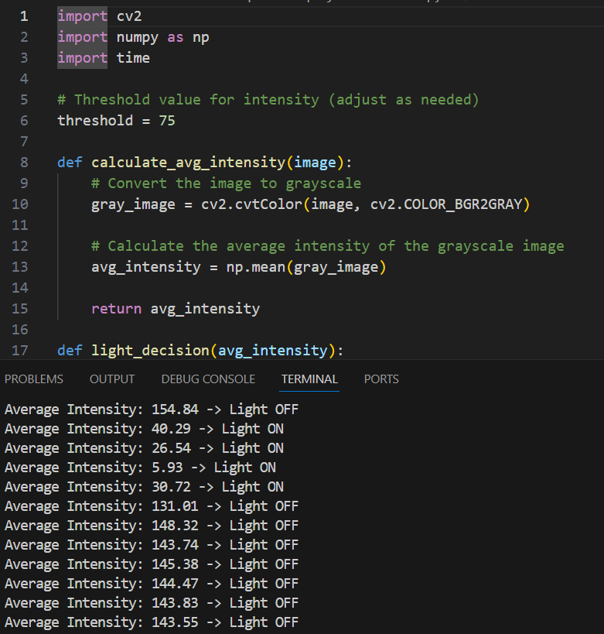

* + The image output showcases the brightness calculation and its comparison with the threshold, along with the status of the light (ON/OFF).

**2. Fan Automation with Person Detection (YOLOv9)**

This module optimizes fan usage by activating it only when a person is present directly beneath it.

* **Technology Used**:
  + YOLOv9 detects fans and individuals in the camera feed.
  + The system spatially associates detected fans with nearby persons.
* **Workflow**:
  + The camera monitors the room and captures real-time images.
  + YOLOv9 identifies fans and people in these images.
  + If a person is directly beneath a fan, the fan switches ON; otherwise, it remains OFF.
* 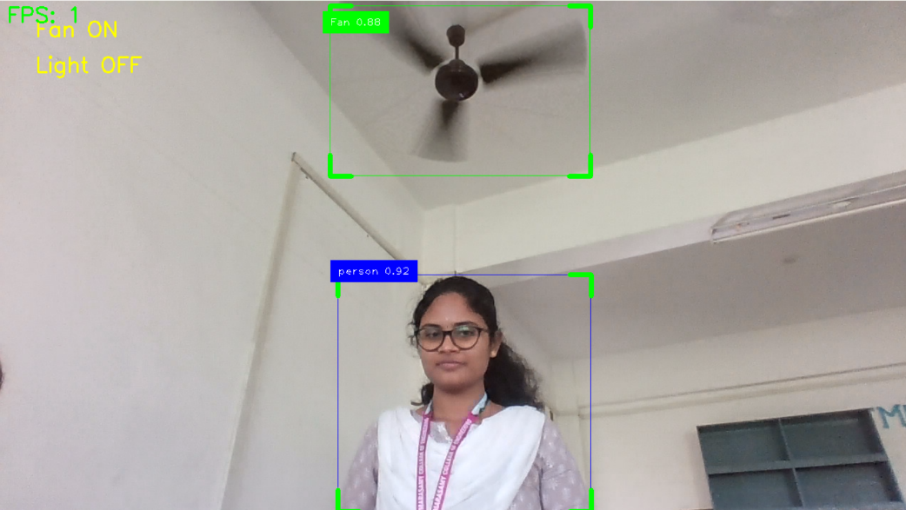**Image Explanation**:
  + The image output displays bounding boxes around the fan and person with labels and confidence scores. It also indicates the fan status (ON/OFF).

**3. Fire Detection and Safety Automation (with YOLOv9)**

This module ensures safety by identifying fire hazards through visual patterns in the captured images.

* **Technology Used**:
  + YOLOv9 detects fire or smoke in images and calculates confidence scores for the detections.
  + No separate fire sensors are used; all detections rely on camera-based data.
* **Workflow**:
  + The camera continuously captures environmental images.
  + YOLOv9 identifies fire or smoke patterns and provides confidence scores.
  + On detection, safety protocols like alarms or notifications are triggered.
* 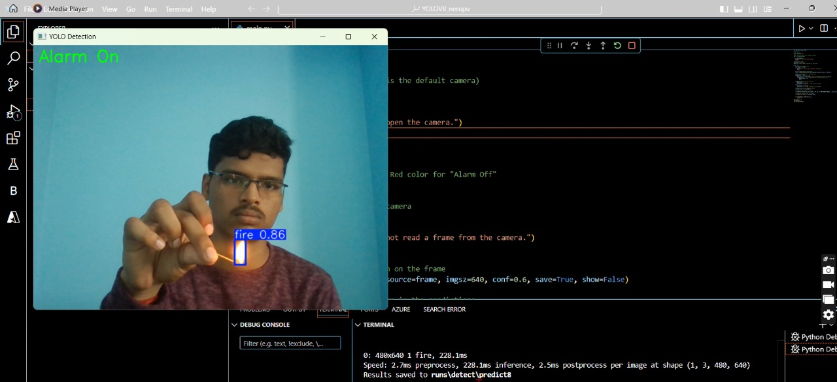**Image Explanation**:
  + The image highlights the detected fire region with a bounding box labelled "Fire" and the confidence score.

**4. Overall Execution (Hardware and System Integration)**

This section provides a holistic view of the system, showcasing its execution through interconnected hardware components.

* **Hardware Components**:
  1. **Camera**:

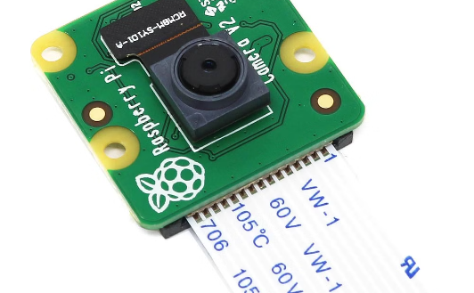

Captures images as the primary input for all automation tasks.

* 1. **Microcontroller (Raspberry Pi)**:

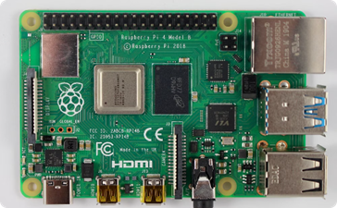

* + - Executes YOLOv9 models for image-based analysis.
    - Processes data and sends commands to the relay module.
  1. **Relay Module**:

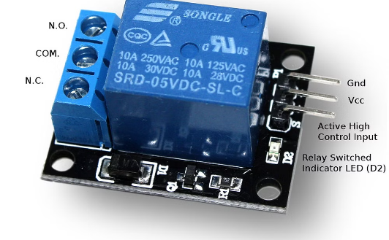

* + - Controls switching of devices (lights, fans, alarms) based on commands from the Raspberry Pi.
* **Overall Execution Image Explanation**:

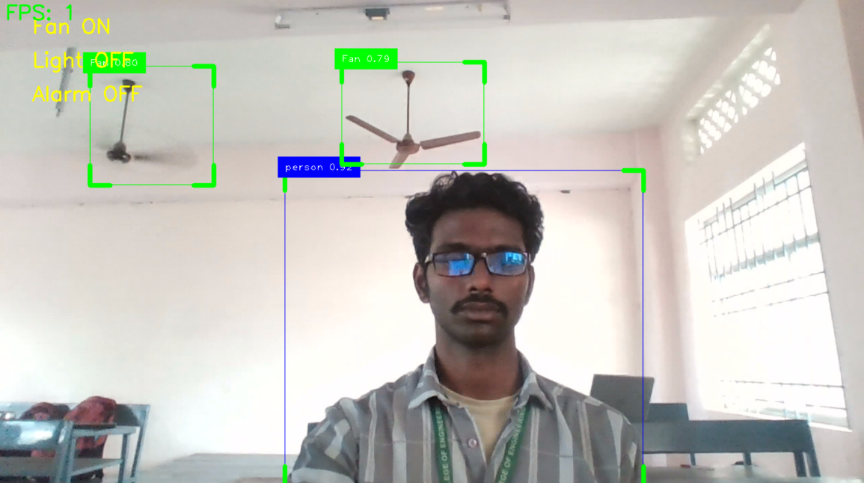

* + - The image represents the system setup, showing the camera, Raspberry Pi, and relay module interconnected.
    - It includes labels for each component, emphasizing their roles in system execution.
    - Outputs from each automation phase (light, fan, fire) are highlighted, tying together the hardware and software aspects of the project.

**CHAPTER 5**

**CONCLUSION**

The development of this Smart Home Automation system marks a significant step forward in creating intelligent and sustainable living spaces. By integrating advanced AI technologies, particularly the YOLOv9 object detection model, the system achieves seamless automation of essential household tasks, including lighting, fan control, and fire safety. Its unique reliance on camera-based inputs eliminates the need for traditional sensors, making it an innovative and cost-effective solution.

The successful implementation of this project demonstrates the potential of computer vision and real-time decision-making in reshaping modern homes. The hardware integration, with minimal yet efficient components such as the Raspberry Pi and relay modules, ensures the system's scalability, affordability, and reliability. Each module is carefully designed to address specific challenges, whether it’s reducing energy waste or enhancing home safety.

This project has gained recognition at the *Dr. Abdul Kalam Awards* for its ingenuity and practical application, underscoring its relevance in today’s technology-driven world. Furthermore, efforts are underway to secure intellectual property rights, paving the way for commercialization and wider adoption.

**5.1 Future Prospects**

The Smart Home Automation system sets the foundation for further advancements in home automation technology. Future iterations could incorporate:

* **Advanced Features**: Integrating voice control, AI-based predictive analytics, or centralized user interfaces for greater customization and ease of use.
* **Cloud Connectivity**: Enabling remote monitoring and control via mobile or web applications.
* **Scalability**: Expanding the system to include additional devices, appliances, or even outdoor surveillance.

By addressing critical needs such as energy conservation, safety, and convenience, this project exemplifies how technology can simplify everyday life while contributing to sustainability. It not only highlights the potential of AI-driven smart homes but also inspires future innovations in the field of automation and intelligent systems. The journey of this project from conceptualization to implementation has been both challenging and rewarding, and it stands as a testament to the transformative power of technology in creating smarter, safer, and more efficient living environments.

**CHAPTER 6**

**RESULTS AND DISCUSSION**

**6.1 Results Summary**

The project successfully implemented camera-based automation for various tasks, including illumination control, fan automation, and fire detection, using YOLOv9. Each phase of the implementation delivered reliable and functional outputs, showcasing the efficiency and practicality of the proposed system. Below are the summarized results:

* **Illumination Control**:  
  The system dynamically switches lights ON/OFF based on real-time analysis of brightness levels captured by the camera, with no need for external sensors. The outputs clearly demonstrated the system's ability to measure brightness, compare thresholds, and toggle light status effectively.
* **Fan Automation**:  
  Fans were activated only when individuals were detected directly beneath them, ensuring personalized cooling and energy efficiency. Results showed bounding boxes around detected persons and fans, with the fan's operational status indicated clearly.
* **Fire Detection**:  
  Early detection of fire hazards was achieved by analyzing visual patterns for flames or smoke. Outputs highlighted fire regions with labeled bounding boxes and confidence scores, providing a reliable safety mechanism for homes.
* **System Integration**:  
  The hardware-software combination worked seamlessly, with the Raspberry Pi executing YOLOv9 models for real-time control. The overall execution image captured the fully integrated system in operation.

**6.2 Detailed Discussion**

1. **Innovative Approach**
   * Unlike traditional systems, this project relies solely on image data, eliminating the need for sensors such as light or motion detectors. This innovation simplifies hardware requirements while reducing costs.
   * The use of YOLOv9 enhances detection accuracy and ensures real-time functionality.
2. **Output Analysis**
   * **Illumination Automation**: The outputs demonstrated the system's responsiveness to ambient lighting, dynamically switching lights based on calculated brightness thresholds. The decision-making process is clearly visualized in the images, highlighting its practical application in energy conservation.
   * **Fan Automation**: The detection of fans and individuals provided precise spatial control, ensuring that fans operated only when required. The outputs, including labeled bounding boxes, validated the system’s ability to prioritize energy efficiency without compromising user comfort.
   * **Fire Detection**: Outputs showing labeled fire regions confirmed the system's reliability in identifying fire hazards. The confidence scores provide an added layer of verification, making the solution trustworthy in critical safety scenarios.
3. **System Efficiency**
   * By activating devices (lights, fans) only when needed, the system significantly reduces energy consumption.
   * The ability to detect fire hazards visually, without additional sensors, adds to the system's efficiency and cost-effectiveness.
4. **Challenges Addressed**
   * **Camera Dependency**: The system's reliance on cameras instead of traditional sensors reduces the cost and complexity of installation while maintaining functionality.
   * **Latency**: Although minor delays were observed in processing, they were within acceptable limits for real-time automation.
5. **Scalability and Flexibility**
   * The modularity of the YOLOv9-based detection allows for easy extension to other appliances and automation tasks. For example, object detection models can be retrained for specific home appliances like air conditioners or doors.
6. **Recognition and Future Prospects**
   * This project was presented at the **Dr. Abdul Kalam Awards**, earning recognition for its innovative and practical approach to smart home automation.
   * Efforts are ongoing to secure a patent or copyright, which will open avenues for commercial deployment and further enhancements.

**REFERENCES**

* 1. Mokhtar M. Hasan and Pramoud K. Misra, "Brightness Factor Matching For Gesture Recognition System Using Scaled Normalization", International Journal of Computer Science & Information Technology (IJCSIT), vol. 3, no. 2, 2011.
  2. Shu-Xi Wang, "The Improved Dijkstra”s Shortest Path Algorithm and Its Applications", Procedia Engineering, vol. 29, pp. 1186-1190, 2012.
  3. Rafiqul Z. Khan and Noor A. Ibraheem, "Survey on Gesture Recognition for Hand Image Postures", International Journal of Computer And Information Science, vol. 5, no. 3, 2012.
  4. Atsushi Shimada, Takayoshi Yamashita and Rin-ichiro Taniguchi, "Hand gesture based tv control system towards both user- amp; machine-friendly gesture applications", The 19th Korea-Japan JointWorkshop on Frontiers of Computer Vision, pp. 121-126, 2013.
  5. J.H. Oh, S.J. Yang and Y.R. Do, "Healthy natural efficient and tunable lighting: four-package white leds for optimizing the circadian effect color quality and vision performance", Light Sci. Appl., vol. 3, no. 2, pp. e141, 2014.
  6. Hou U. Leong, Hong Jun. Zhao, Man. Lung Yiu, Yuhong. Li and Zhiguo. Gong, "Towards Online Shortest Path Computation", IEEE Transactions on Knowledge and Data Engineering, vol. 26, no. 4, 2014.
  7. H. Cheng, L. Yang and Z. Liu, "Survey on 3D hand gesture recognition", IEEE transactions on circuits and systems for video technology, vol. 26, no. 9, pp. 1659-1673, 2015.
  8. Harpreet Kaur and Jyoti Rani, "A review: Study of various techniques of hand gesture recognition", 2016 IEEE 1st International Conference on Power Electronics Intelligent Control and Energy Systems (ICPEICES), pp. 1-5, 2016.
  9. J. Redmon, S. Divvala, R. Girshick and A. Farhadi, "You Only Look Once: Unified Real-Time Object Detection", IEEE Conference on Computer Vision and Pattern Recognition, pp. 779-788, 2016.
  10. N.Makariye, "Towards Shortest Path Communication Using Dijkstra Algorithm", International Conference on IoT and Application, pp. 1-3, 2017.
  11. R. Alkhatib, A. Swaidan, J. Marzouk, M. Sabbah, S. Berjaoui and M. O. Diab, "Smart Autonomous Wheelchair", 2019 3rd International Conference on Bio-engineering for Smart Technologies (BioSMART), pp. 1-5, 2019.
  12. Y. Wang, L. Wang, Y. Jiang and T. Li, "Detection of Self-Build Dataset Based on YOLOv4 Network", IEEE 3rd International Conference on Information systems and Computer Aided Education, pp. 640-642, 2020.
  13. K. Han, Y. Wang, Q. Tian, J. Guo, C. Xu and C. Xu, "GhostNet: More Features from Cheap Operations", Proceedings of the IEEE/CVF conference on computer vision and pattern recognition, pp. 1580-1589, 2020.
  14. Q. Hou, D. Zhou and J. Feng, "Coordinate Attention for Efficient Mobile Network Design", Proceedings of the IEEE/CVF conference on computer vision and pattern recognition, pp. 13713-13722, 2021.
  15. K. Agrawal, M. K. Nigam, S. Bhattacharya and G. Sumathi, "Ambulance detection using image processing and neural networks", Journal of Physics: Conference Series, vol. 2115, no. 1, pp. 012036, 2021.
  16. Y. Chen and w. Hu, "A Video-Based Method with Strong-Robustness for Vehicle Detection and Classification Based on Static Appearance Features and Motion Features", IEEE Access, vol. 9, pp. 13083-13098, 2021.
  17. S. Saxena, S. Thorat, P. Jain, R. Mohanty and T. Baraskar, "Analysis of object detection techniques for bird species identification", Journal of Physics: Conference Series, vol. 2325, no. 1, pp. 012054, August 2022.
  18. R. Kaur and S. Singh, "A comprehensive review of object detection with deep learning", Digital Signal Processing, pp. 103812, November 2022.
  19. X. Dong, S. Yan and C. Duan, "A lightweight vehicles detection network model based on YOLOv5", Engineering Applications of Artificial Intelligence, vol. 113, pp. 104914, August 2022.
  20. G. Zhaoxin, L. Han, Z. Zhijiang and P. Libo, "Design a Robot System for Tomato Picking Based on YOLO v5", IFAC-PapersOnLine, vol. 55, no. 3, pp. 166-171, 2022.
  21. R. Arifando, S. Eto and C. Wada, "Improved YOLOv5-Based Lightweight Object Detection Algorithm for People with Visual Impairment to Detect Buses", Applied Sciences, vol. 13, no. 9, pp. 5802, January 2023.
  22. K. Silanon and N. Lertchuwongsa, "A Novel Classification Layer Technique for ASL Analysis Using CNN", 2023 20th International Joint Conference on Computer Science and Software Engineering (JCSSE), pp. 118-122, June 2023.
  23. C. Yu and Y. Shin, "SAR ship detection based on improved YOLOv5 and BiFPN", ICT Express, vol. 10, pp. 28-33, February 2024.