Block diagrams of map reduce

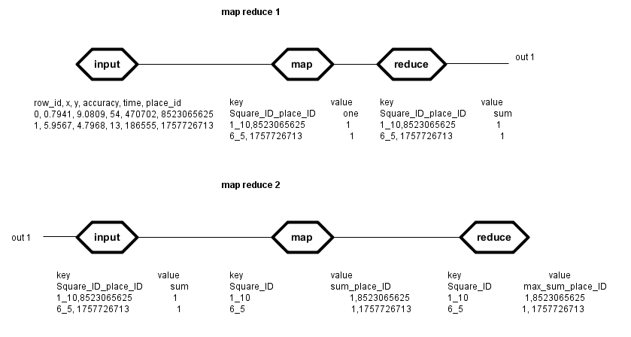

Pseudo code for map 1

1) take the input line by line

2) split the line into tokens by delimiter “,”

3) iterate over the tokens and increment a counter by 1 every time

4) if counter == 1 store value of x

X = ciel (x)

if counter == 2 store value of y

y = ciel (y)

if counter == 5 store value of the place_ID

write to the output of the map (x+”_” + y+”,”place_ID, 1);

Pseudo code for reduce 1

1) For the same square_ID and place_ID

Sum their values

Pseudo code for map 1

1) take the output of the first map reduce line by line

2) split the line into tokens by delimiter “/t”

3) write to the output of the map (square_ID, place_ID,Sum)

Pseudo code for reduce 1

1) For the same square_ID

2) split the value to sum and place_ID

3) find the max Sum

4) update bestPlace = place_ID