@startuml
title **Sequence Diagram knowledge base creation**

activate RuleTree
autonumber
RuleTree -> RuleTree : creat RuleTree

actor Client
activate Rule
Client -> Rule : logg to creat Rule

activate Actions
Client -> Actions : logg to creat Actions
Actions -> Actions : creat Actions
Rule <- Actions : affect Actions to Rule
deactivate Actions

activate Condtion
Client -> Condtion : logg to creat Condtion
Condtion -> Condtion : creat Condtion
Rule <- Condtion : affect Condtion to Rule
deactivate Condtion

Rule -> Rule : creat Rule

Rule -> RuleTree : registre Rule into RuleTree
deactivate Rule
deactivate RuleTree
@enduml
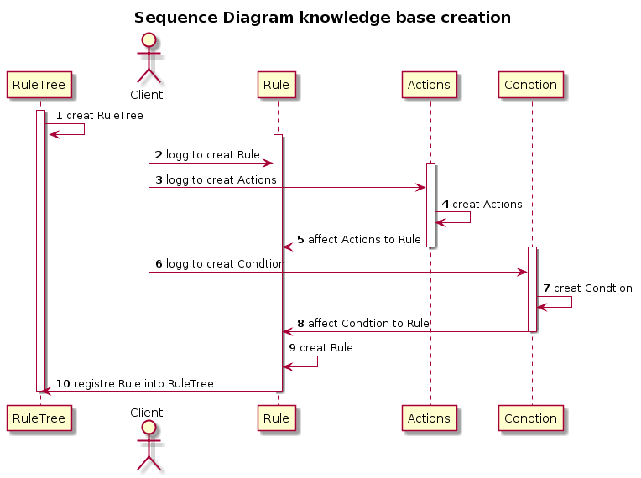

@startuml
title **Sequence Diagram Inference Rule Engine creation**

database Queue
activate Facts
Queue -> Facts : take Facts
Facts -> Facts : creat Facts
deactivate Facts

activate RulesEngine
RulesEngine -> RulesEngine : creat RulesEngine
RulesEngine <- Facts : affect Facts to fire
activate RulesTree
RulesEngine <- RulesTree : get Rule to fire
deactivate RulesTree

activate RulesListener
RulesListener <- RulesListener :creat RulesListener
RulesListener -> RulesEngine : beforeExecute Rule
activate InferenceRulesEngine
InferenceRulesEngine <- InferenceRulesEngine : creat InferenceRulesEngine
InferenceRulesEngine <- RulesEngine : fire InferenceEngine

deactivate InferenceRulesEngine
deactivate RulesListener
deactivate RulesEngine
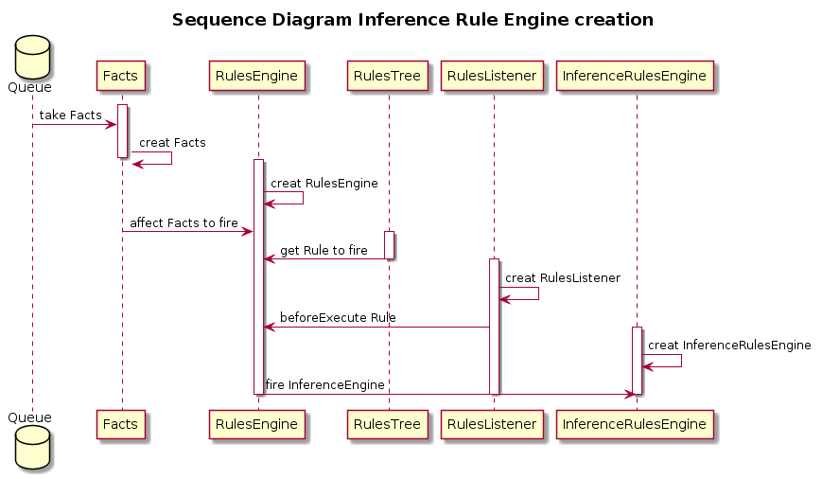
@enduml

