Ex1:

Ex2:

Ex 4:

Ex 5:

Ex 6:

Ex 7:

Ex 8:

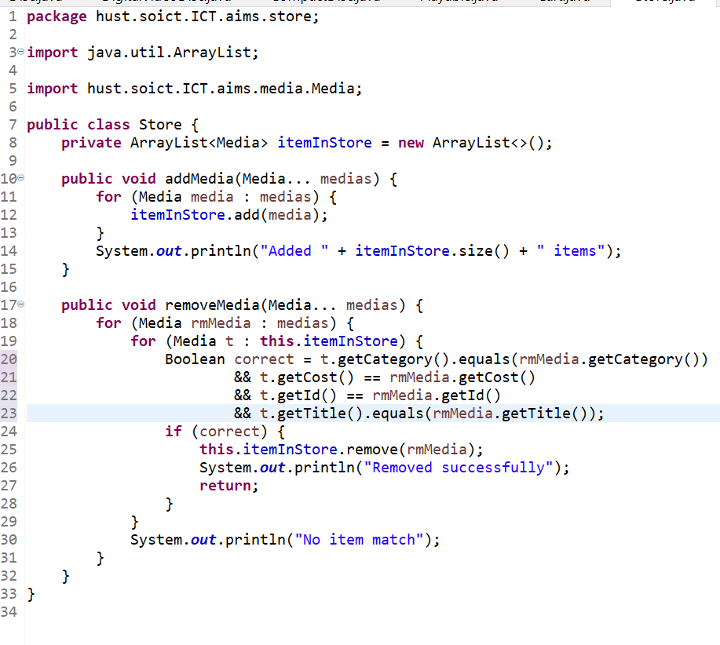

Ex 9:

Ex 10:

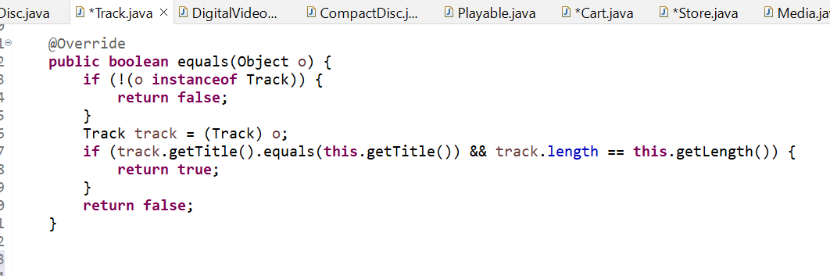

Ex 11:

Ex 12:

Ex 13:

