VWS SDR Test Guide
V2, 5 April 2025
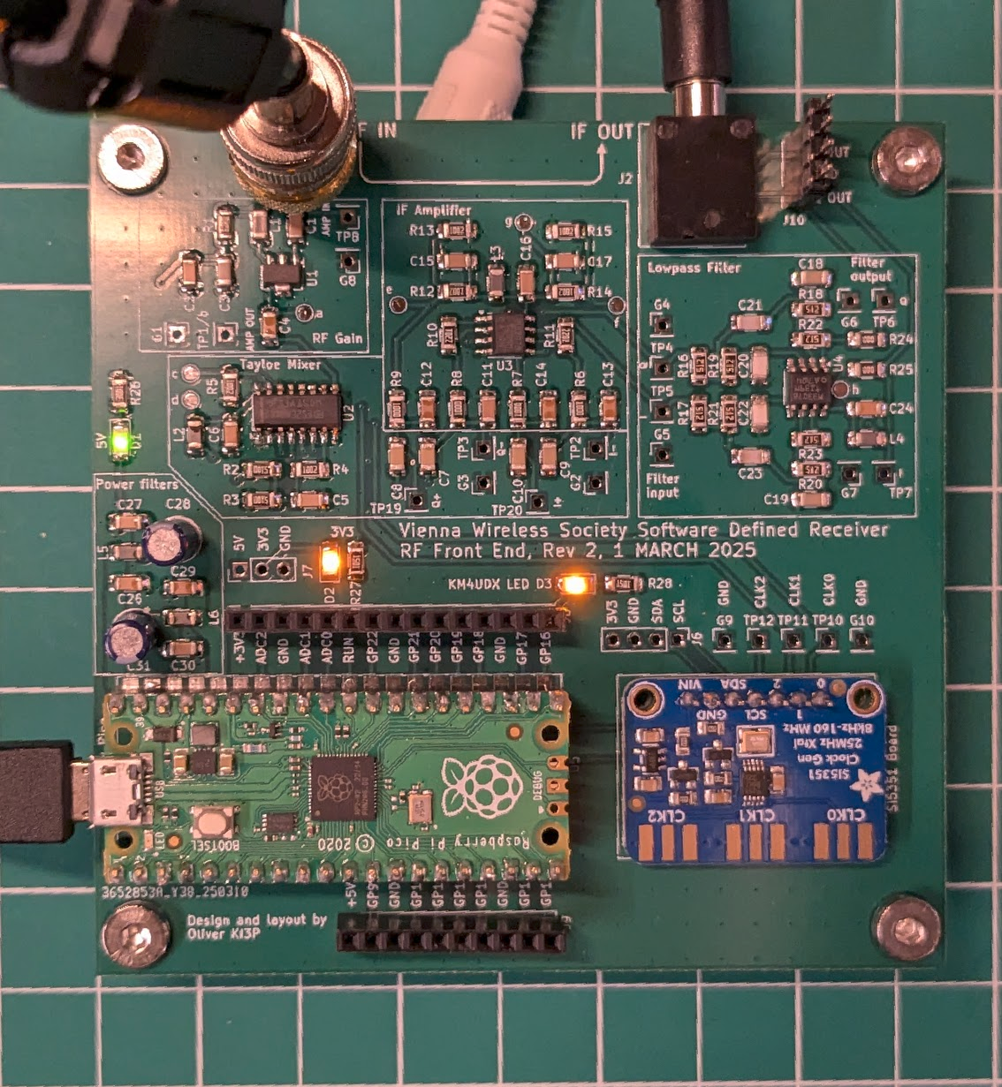

Current consumption

Upon being plugged in, the board should draw roughly 80 mA of current from the USB cable.

DC levels
Measure the DC voltage levels at the points indicated below and confirm that they are close to the values in the table.

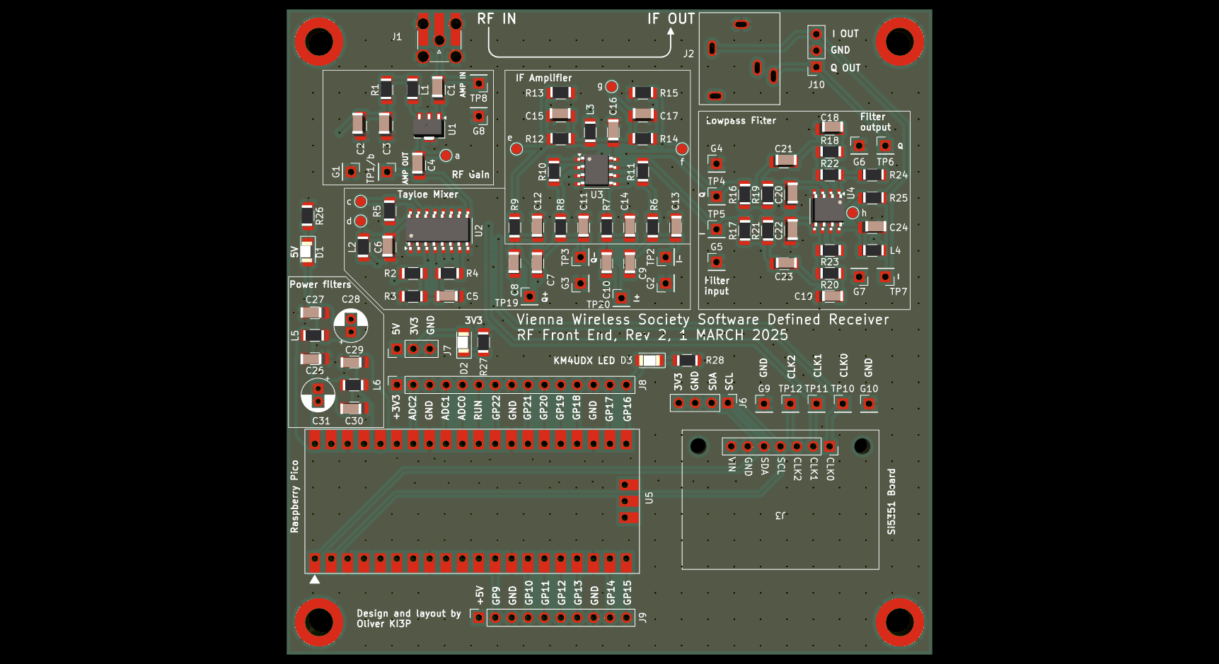
Test point | Description | Expected | Measured
5V | 5V rail | 5V
3.3V | 3.3V rail | 3.3V
a | LNA bias | 3.5 - 4V
b | Mixer bias | 1.65V
c | Mixer enable | 0V
d | Mixer DC | 3.3V
e | Q offset | 2.5V
f | I offset | 2.5V
g | Amplifier DC | 5V
h | Filter DC | 5V

RF levels
Test the RF performance by putting a known RF signal in and measuring it at various points through the circuit.
By default, the VWS SDR will tune to a frequency of 10,000 kHz.
Inject a signal at 10,005 kHz with an amplitude of -53 dBm.
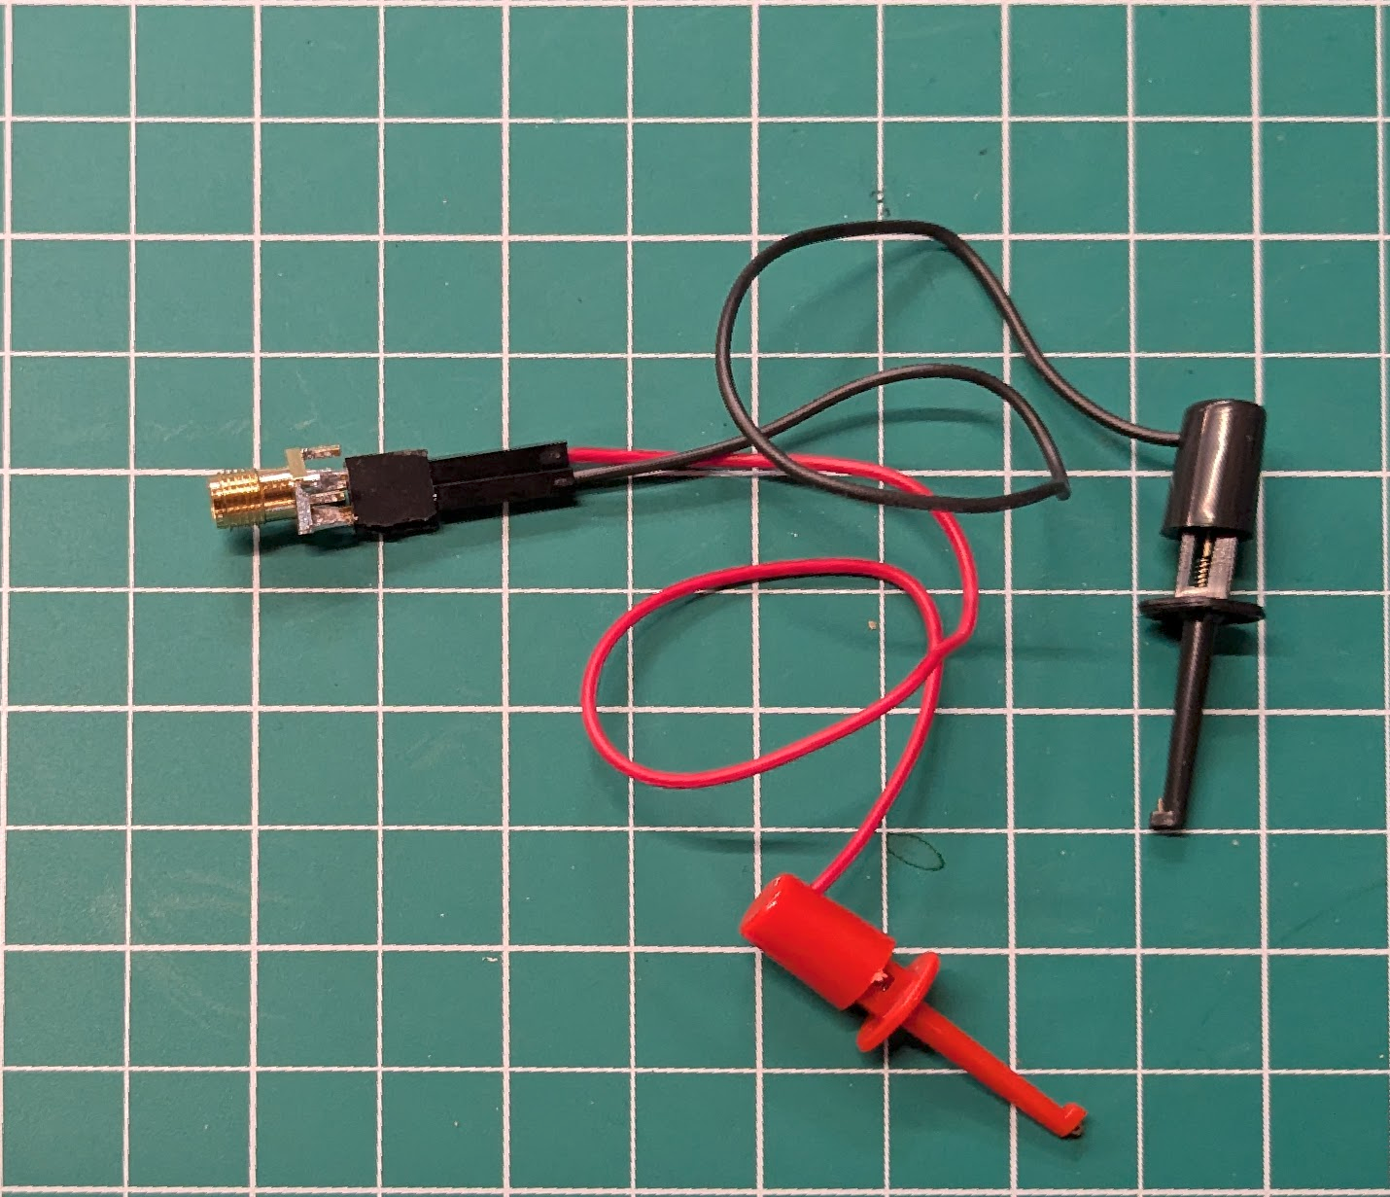
You can measure the RF power at TP8 and TP1 using some clips connected to an SMA connector as shown above.
On the prototype board I found the following signal levels. You should expect to see similar (but not identical) values on your board.

Test point | Vpp [mV] | Vrms [mV] | P [dBm] | Measured
TP8 (RF in) |  |  | -54.7
TP1 (after LNA) |  |  | -37.5
TP2/TP3 (I-,Q-) | 73 | 26.5
TP4/TP5 (after tayloe) | 566 | 200
TP6/TP7 (after LPF) | 1130 | 400

