**MBEYA UNIVERSITY OF SCIENCE AND TECHNOLOGY**

**COLLEGE OF SCIENCE AND TECHNICAL EDUCATION**

**DEPARTMENT OF MEDICAL SCIENCES AND TECHNOLOGY**

**GROUP 03**

**Project Report on**

**THE MUSCLE MOVEMENT MONITOR FOR PARALYTIC PATIENT**

**By**

YUSUPH S. SLIM 20123150131

FAUSTINE NDIBINZE 20123150253

**A Project Report Submitted in Partial Fulfillment of the Requirements for Diploma in Biomedical Equipment Engineering of Mbeya University of Science and Technology.**

**(MUST)**

# CERTIFICATION

The under signed certify that I have read and hereby recommend for acceptance of Mbeya University of Science and Technology (MUST) a project title, **the muscle movement monitor for paralytic patient**, in fulfilment of requirements for ordinary diploma in Biomedical Equipment Engineering offered by Mbeya university of Science and Technology.

**Supervisor’s name;** Dr. Mary Suke

**Signature;** …………………………

**Date;** ……………………………….

# ACKNOWLEDGEMENT

Firstly, we would like to thank our Almighty God for giving us good opportunity of health life and thank all those who have supported and contributed to the completion of this project report.

Secondly, we would like to acknowledge the efforts and dedication of our project team as well as we express our sincerely gratitude to our supervisor Dr Marry Suke for constant support, guidance encouragement, consolation and recommendation until the achievements of this project.

Then we extend our sincere appreciation to all lecturers, our fellow students and other people inside and outside the university who directly or indirectly provided insight which helped achievement of or project.

Lastly, we extend our thanks to our families starting with parents, relatives, siblings, and friends for understanding, love and prayers that supported our academic in general to achieve may Almighty bless you all.

# ABSTRACT

Background: according to the statistics in worldwide most of people suffers from paralysis, paralysis is the loss of muscle function in part of a patient body and this happens when something is wrong with the way of messages pass between your brain and muscles. This study focuses on muscle movement monitor system for paralytic patient, where 1 in 50 people living with paralysis which is 5.4 million people in the whole world population and technical advancement in the field.

Objective: The main aim of this project is to design the reliable system which will enable the effective monitoring and supervision of the paralytic patient who will show the early signs of improvement of recovery.

Materials and methods: It uses software materials like Arduino-UNO ATmega32U4, and also it use the hardware materials like micro-controller, accelerometer, electrodes which will be used on constructing our project prototype.

Intended use of the result: The result of this study will provide easy access of information from the patient improvement to the caretaker and it will also improve the prevalence of medication to the patient due to the improvement stage a patient reach is better than before.

# LIST OF ABBREVIATION

MUST Mbeya University of Science and Technology

ECG Electrocardiography

EMG Electromyography

IDE Integrated Development Environment

AC Alternating Current

V Volts

Hz Hertz

DC Direct Current

A Ampere

LCD Liquid Crystal Display

Min Minute

Hr Hour

TABLE OF CONTENTS

CERTIFICATION 2

ACKNOWLEDGEMENT 3

ABSTRACT 4

LIST OF ABBREVIATION 5

CHAPTER ONE. INTRODUCTION 1

1.1 Background 1

1.2. The problem Statement 1

1.3.Objectives 2

1.3.1. The main objective 2

1.3.2. Specific objectives of the project 2

CHAPTER TWO. LITERATURE REVIEW 3

2.1 Introduction 3

2.2. Overview of the existing system 3

2.3. Overview of the proposed system 3

2.4. Overview of Technology-Based Approaches 4

CHAPTER THREE. METHODOLOGY 5

3.1. System Requirement Specifications 5

**3.1.1 Software Requirements** 5

**3.1.2 Hardware Requirements** 5

3.2. Components of the Proposed System 5

3.3. CIRCUIT DESIGN 11

3.4. DATA COLLECTION 13

CHAPTER FOUR. RESULTS AND DISCUSSION 14

4.1.Circuit Simulation 14

4.2.Prototype Implementation 16

CHAPTER FIVE. CONCLUSIONS AND RECOMMENDATIONS 17

5.1.Conclusion 17

5.2.Recommendation 17

REFERENCES 18

APPENDICES 19

# CHAPTER ONE. INTRODUCTION

## 1.1 Background

Muscle movement monitor for paralytic patient is the device which is designed for monitoring the early improvement of a paralytic patient. There is no cure for permanent paralytic patient since the spinal cord can’t heal itself this discussed by Cleveland clinic medical professional on (10 Jun 2021), but in some cases feelings and movement can return to an affected part of the body. Even in the situation when this is not possible, therapies and assistive devices can improve a person’s quality of life (7 Jun 2022).

In worldwide paralysis affects about nearly 1 in 50 people living with paralysis which is approximately to 5.4 million people population and technical advancement in the field (Nazari et al,. 2021). In the existing system paralytic patient were only communicate with the caretaker by conveying message between them, where the device was attached to unaffected body part of the patient so as to sense motion and convey into message to caretaker (Issn, n. d.).

## 1.2. The problem Statement

In the existing system was dealing with the improvement on the communication link between the paralytic patient and the caretaker. Most of the time caretakers fail to determine the early signs of improvements recovery (to show progress) from a paralytic patient, since it affect further treatment procedures to be done to paralytic patient.

Thus due to the problem, we have come with a suitable and simplest solution for overcoming the problem, and that is the introduction of THE MUSCLE MOVEMENT MONITORING DEVICE which can monitor movement (contraction) of muscle (muscular muscle) and send message to the caretaker, so this used to solve the problem above.

## 1.3.Objectives

### 1.3.1. The main objective

The main objective of this project is to determine early progress of the paralytic patient by implementing a reliable system which will enable effective monitoring and supervision of the paralytic patient who will show early signs of improvement of recovery.

### 1.3.2. Specific objectives of the project

I. To study the current technology used.

II. To identify the components to be used.

III. To design circuit for proposed system.

IV. To implement the prototype of the proposed system.

1.4. Significance of the proposed system.

i. It involves patient response.

ii. It eliminates patient’s overdependence on caretaker.

iii. It is easy and reliable system to implement.

# CHAPTER TWO. LITERATURE REVIEW

## 2.1 Introduction

### In this chapter, we review the existing literature on muscle movement monitoring for paralytic patients. This literature review aims to provide a comprehensive understanding of the current state of knowledge, technological advancements, and research findings in this field. By examining previous studies and technologies, we can identify gaps, challenges, and opportunities for our project on developing a muscle movement monitor tailored for paralytic patients.

## 2.2. Overview of the existing system

Traditional methods used for muscle movement monitoring in paralytic patients have primarily relied on subjective visual assessments and manual measurements [1]. Visual assessments involve observing patients' movements and manually grading their ability to control specific muscle groups. However, these methods suffer from limitations in terms of accuracy, objectivity, and reproducibility. Studies have shown significant inter-rater variability and subjectivity in visual assessments [2].

## 2.3. Overview of the proposed system

Our project will focus on using signal transduction method done by biosensor and programmable circuit to detect ketamine overdose that eventually will cover cost and time consuming. The proposed system provides more improvement on use of existing system by designing the programmable circuit that contain Arduino, LCD, siren, relay, and bio-sensor. The following is the block diagram of the proposed intoxication detector system

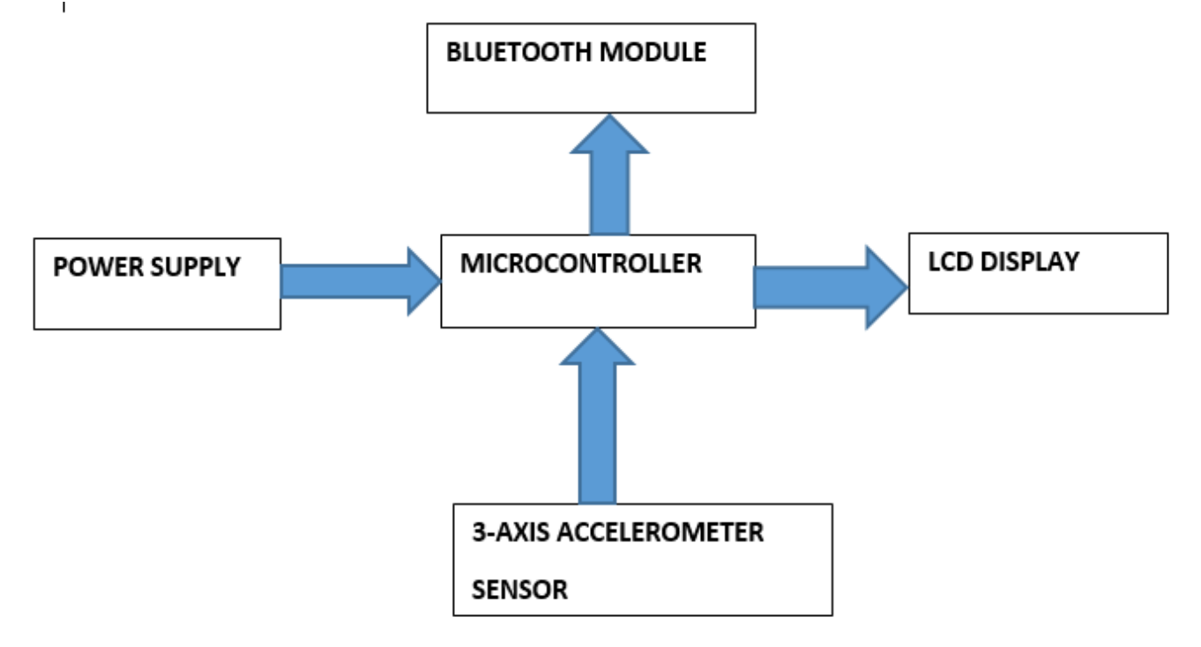

## 2.4. Overview of Technology-Based Approaches

Advancements in technology have paved the way for more objective and precise muscle movement monitoring techniques. Electromyography (EMG), which measures electrical activity generated by muscles, has been widely used in clinical settings [3]. EMG provides valuable insights into muscle activation patterns and can help evaluate the effectiveness of rehabilitation interventions. However, it requires invasive procedures and complex setups, limiting its practicality for routine monitoring of paralytic patients.

In recent years, wearable sensors and devices have gained attention for muscle movement monitoring. Accelerometers and inertial measurement units (IMUs) offer the advantage of non-invasiveness and portability. They can capture movement data, including joint angles and accelerations, which can be used to infer muscle activity [4]. These technologies have shown promise in assessing the range of motion, gait analysis, and tracking rehabilitation progress in paralytic patients.

# CHAPTER THREE. METHODOLOGY

## 3.1. System Requirement Specifications

The system hardware and software requirements for the implementations of the proposed project are mentioned below.

### **3.1.1 Software Requirements**

In the software requirement, Arduino IDE software version **1.8.15** will be used for configuring process and uploading the code from Windows Operating System to the Arduino Uno R3 board via USB cable. The Proteus software version **8.12** will be used to simulate the circuit of our project design before implementation to the prototype.

### **3.1.2 Hardware Requirements**

The system will mainly consist of variable circuit building materials to be used for implementation of the experimental works. These materials are as listed below:

1. Arduino Uno
2. LCD
3. Electromyography (EMG)
4. LED
5. Power Supply
6. Vero board

## 3.2. Components of the Proposed System

**Arduino Uno**

Is a microcontroller board based on the AT mega 328. It has 14 digital input/output pins in which 6 can be used as PWM output, a 16MHz ceramic resonator, an ICS header, a USB connection, 6 analog inputs, a power jack and a reset button. This contains all the required support needed for microcontroller. The function of Arduino Uno is to receive the input from the biosensor, calibrate it and send the calibrated signal to the LCD and buzzer, to demonstrate the result, the rating preferred for Arduino Uno, voltage is 5v and current is 20mA.

Technical specifications of Arduino Uno

1. Operating voltage = 5v
2. Input voltage(recommended) =7-12v
3. Input voltage(limit) =6-20v
4. Digital I/O pins 14
5. DC current for 3.3v pin = 50mA
6. DC current per I/O pin = 20mA
7. Ceramic resonator = 16MHz
8. Current per input/output = 40mA

Reasons for using Arduino Uno as our microcontroller

1. Extensive library support and it’s widely available
2. Compatibility- it’s compatible with Arduino Integrated Development Environment (IDE), hence user-friendly programming environment.
3. Cost-effectiveness- it’s relatively affordable compared to other Arduino with similar capabilities.

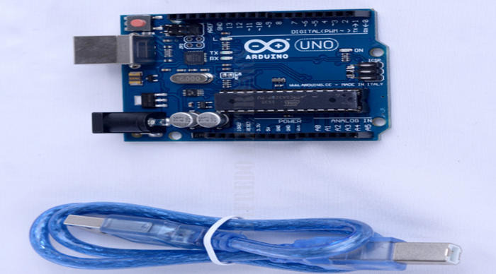

Figure 3: Showing the picture of Arduino Uno

**Liquid Crystal Display**

LCD is a flat panel display technology that uses liquid crystals to create images and text. There are wide range of LCDs, the preferred LCD for this project is 16x2.

The LCD receives power through VDD pin of Arduino which is 5v after being regulated by Arduino controller. Input/output pins of display sends and receive data in serial form. The current consumption of the LCD is 1mA without backlight when the power is supplied then the current consumption of the backlight ranges from 90mA to 150mA and they are available in green and blue backlight.

The power will be; Power =IV

P= 150mA ×5v= 750mW=0.75W

The reasons for preferring LCD are

1. They are economical.
2. Easy to display programmable result.

It has the following rating voltage of 5v and current of 150mA.

**Accelerometer sensor**

These are ICs that measure acceleration, which is the change in speed (velocity) per time. Measuring acceleration makes it possible to obtain information such as vibration. The accelerometer used in our project is 3-axis accelerometer that measure the vibration of in three axes X, Y and Z that they have three crystals positioned so each one reacts to vibration in different axis .The output has three signals each respresenting the vibration for one of three axes.

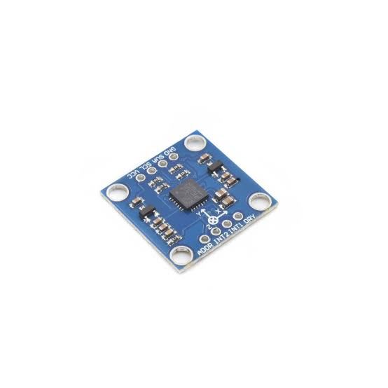

**Bluetooth module**

This is a device that designed for wireless communication. The Bluetooth designed to replace cable connections HC-05 uses serial communication to communicate with the electronics as microcontroller using serial communication (USART). It usually connects small devices and it use short range wireless connection to exchange files frequency about 2.45Hz band.

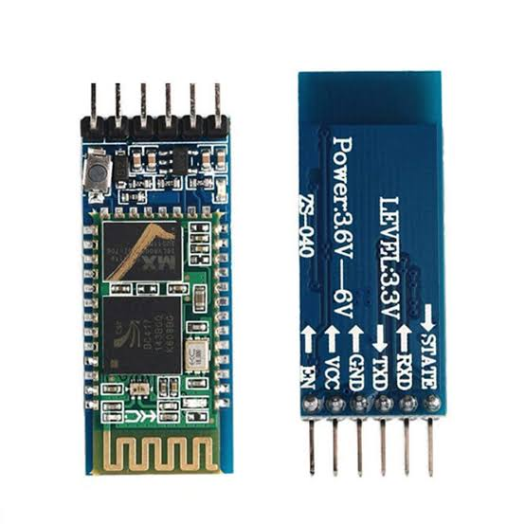

**Liquid crystal display (LCD)**

This is a device that can display 16 characters per line and there are 2 such line, in this LCD character is displayed in 5x7 pixel matrix. The device is a 16 pin that has 2 rows that can accommodate 16 characters and it can be used in 4-bit mode or 8-bit mode.

The testing character LCD connects 5V and GND pins to the breadbody power rail and plug your LCD into the bread body.

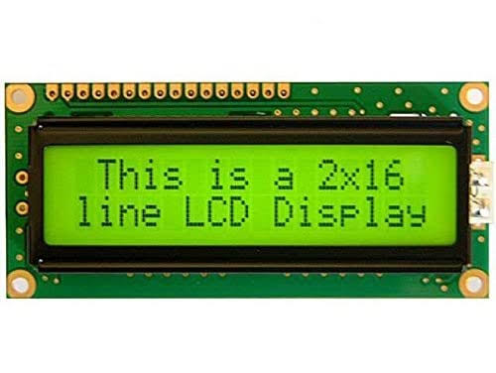

**Surface electrode**

is a small device that is attached to the skin to measure or cause electrical activity in the tissue under it, works on the principle of chemical equilibrium detecting the change between muscle surface and body skin through electrolytic conduction about EMG electrodes this measure the muscle movement in the body(vibration).

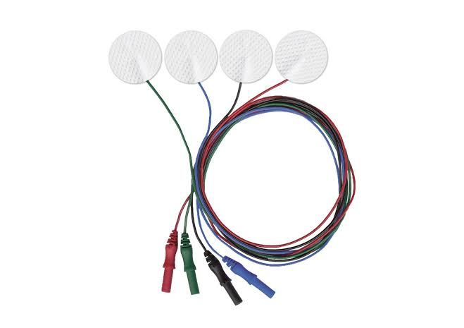

**Light emitting diode (LED)**

Is the semiconductor device that emits light when current flow through it. This works on the principle of electroluminescence. It convert electrical energy directly into light.

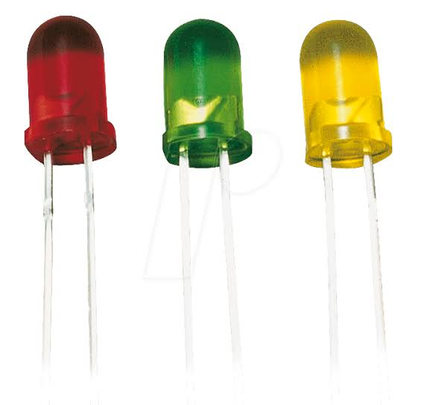

**Potentiometer**

used to measure voltage accurately and helps to achieve variable voltage from a fixed-voltage source. And it works as variable resistor that electrical resistance value can be adjusted.

**Power Supply**

This is a crucial component of automatic ketamine overdose detector it provides electrical energy to all the other components and ensures their proper functioning. To power the system, we utilized a stable and reliable power supply module. The module converts an input voltage, typically from a mains power source or a battery, into the appropriate voltage levels required by the different components in the system.

In our setup we employed a regulated power supply module with an output voltage of 12v is used to supply power to Arduino, later the Arduino distributes it to other components, this voltage level was carefully selected to meet the operational requirements of the components.

Technical specifications of 12v adapter

Input voltage= 100-240V AC

AC input frequency= 50/60 Hz

Output voltage= 12V DC

Output current= 2A

Transformer analysis; here we use a step-down transformer meant to convert high voltage to low voltage. The transformer stepped down AC voltage from 220-240V AC as shown below.

Turns ratio

Np: Ns=Vp: Vs

Np, Vp, Ns, Vs represent Primary turns, primary voltage, secondary turns and secondary voltage respectively

Np: Ns= 230V:12V=19.167:1

But Vp=230, Ns=1, Np=19.167

Vs= (1x230) ÷19.167= 11.999V≈12Vrms

Vpeak of secondary coil=Vm

Vm=√2xVs,

Vm=√2x12V

Vm=16.97V

Vm (output of transformer) =16.97V

**Vero board**

The Vero board, also known as a prototyping board, is utilized in the project to provide a platform for mounting and connecting various electronic components. It features a grid of copper strips or pads, which allow for the soldering of circuitry. The Vero board serves as a foundation for integrating the biosensor, LCD, power supply, Arduino Uno, relay, buzzer, and other components, facilitating the proper functioning of the automatic ketamine overdose detector.

## 3.3. CIRCUIT DESIGN

Our project used an accelerometer based on its sensitivity, selectivity and compatibility with the Arduino platform, we designed the circuitry using Arduino IDE 1.8.15 to integrate the accelerometer with the microcontroller, include signal conditioning and data acquisition techniques, and we utilized Proteus version 8.12 to simulate and verify the functionality of the circuit design, ensuring proper integration between the accelerometer and Arduino and lastly conducted calibration procedure to establish a baseline and determine the threshold for muscle detection.

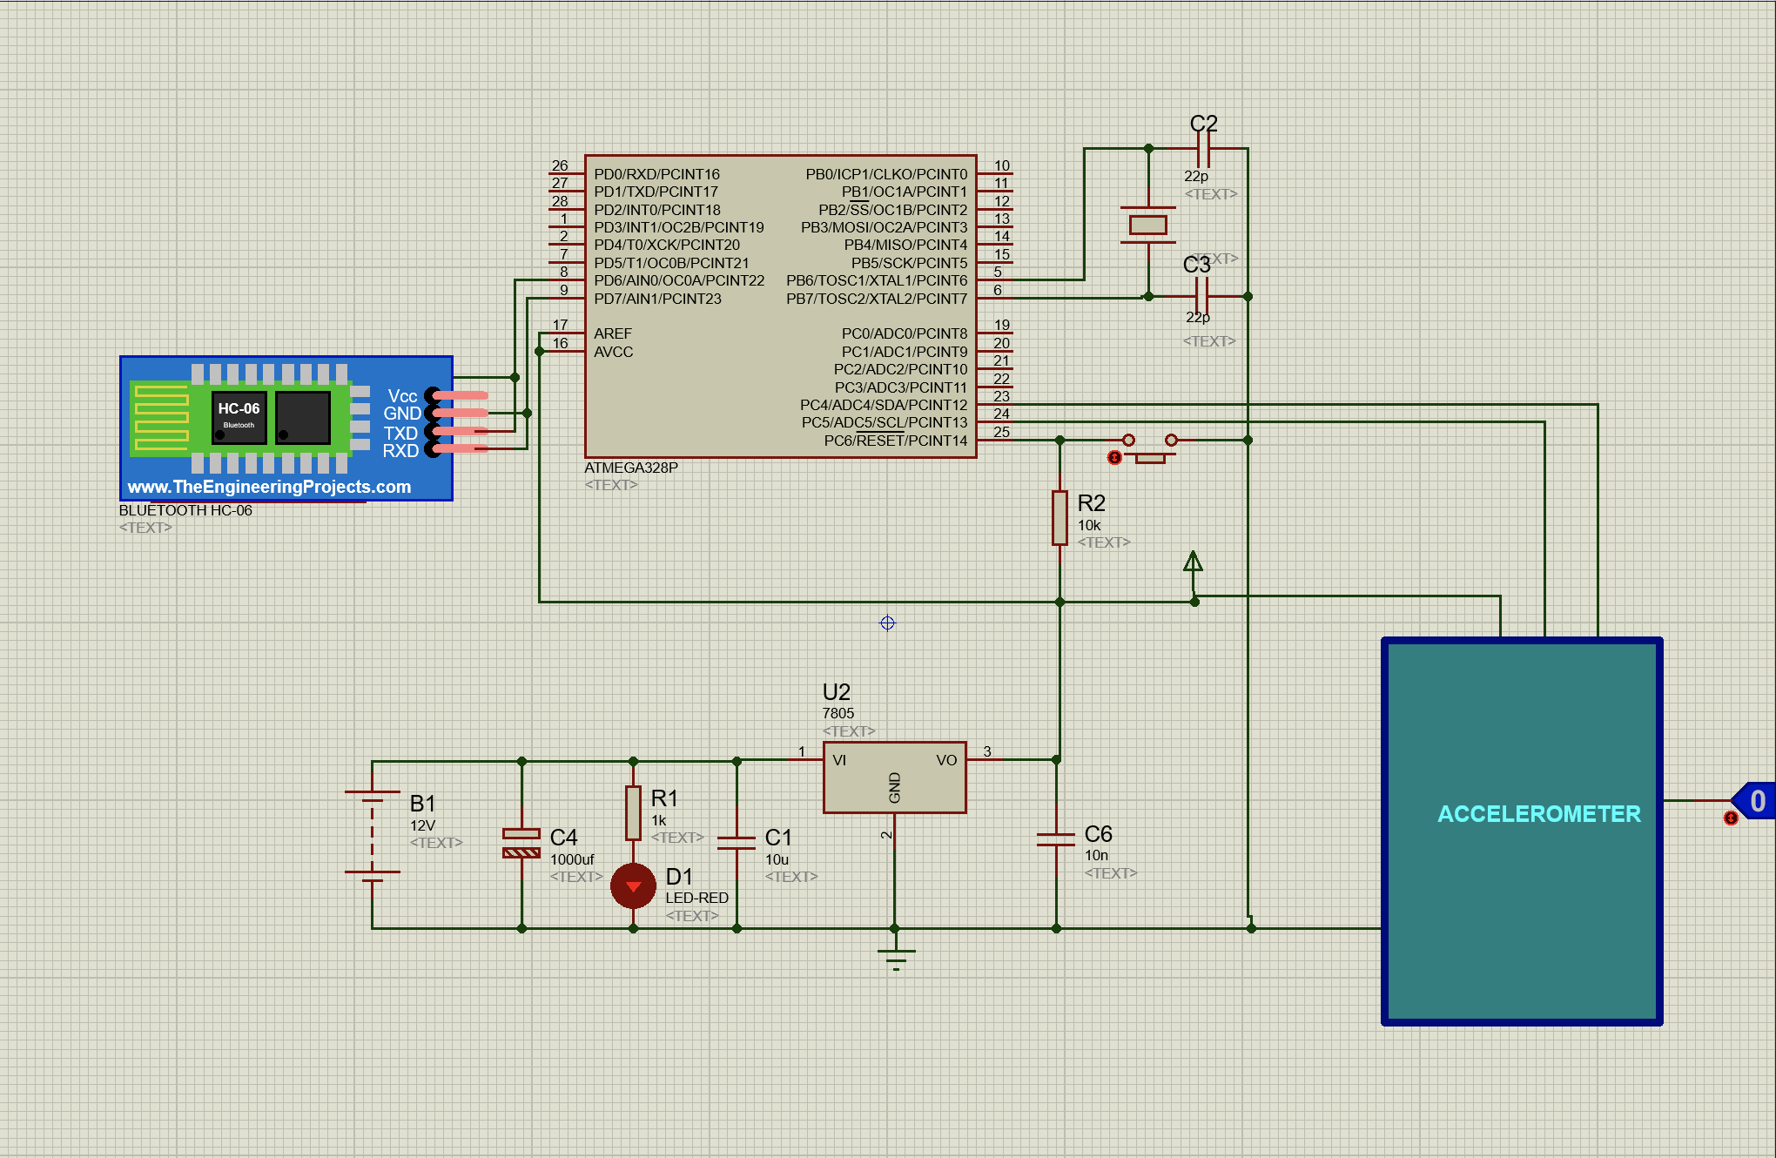

Figure 4:Showing the circuit design for the muscle movement detection for paralytic patients

## 3.4. DATA COLLECTION

This chapter includes data collected through primary data collection and secondary data collection required for the accomplishment of the project and the mathematical expressions which were used to obtain the values of the components used in the circuit. The data were collected from various sources such as consulting physiotherapists, internet browsing and reading books such as electronic books and corresponding components datasheets.

Primary Data

# CHAPTER FOUR. RESULTS AND DISCUSSION

## 4.1.Circuit Simulation

During simulation the software used for circuit designing was Proteus Professional (version 8.12) and Arduino IDE software version 1.8.15. The system will detect any muscular movement using the accelerometer which will then be calibrated by the microcontroller, if motion is detected, a message will be displayed on the LCD and the LED will be turned on.

#### No Motion Detected State Simulation

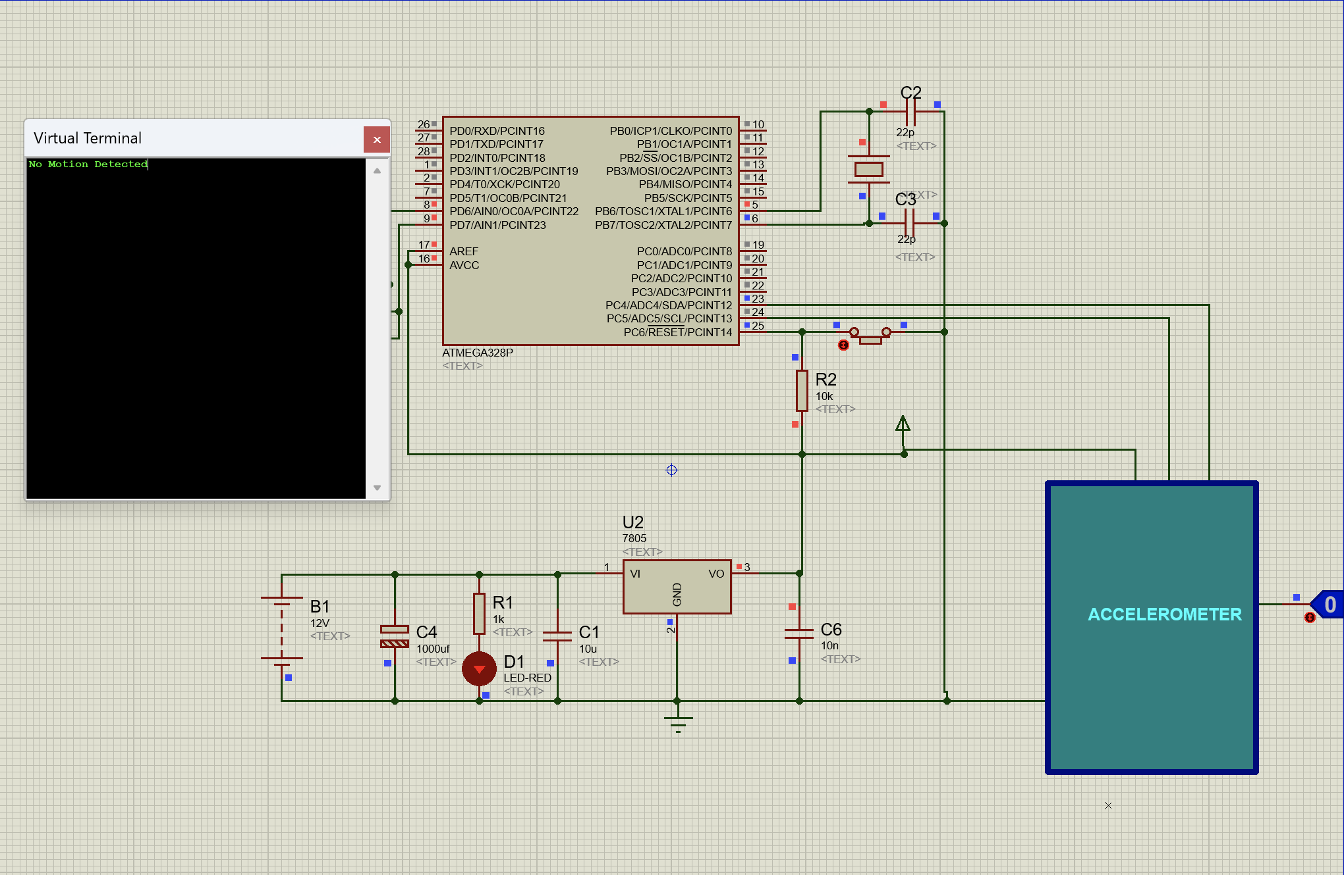

Figure 5:Showing no motion detected

If the accelerometer state is 0 this signifies that no muscular motion is detected and so a message *“NO MOTION DETECTED”* is displayed on the LCD.

#### Motion Detected State Simulation

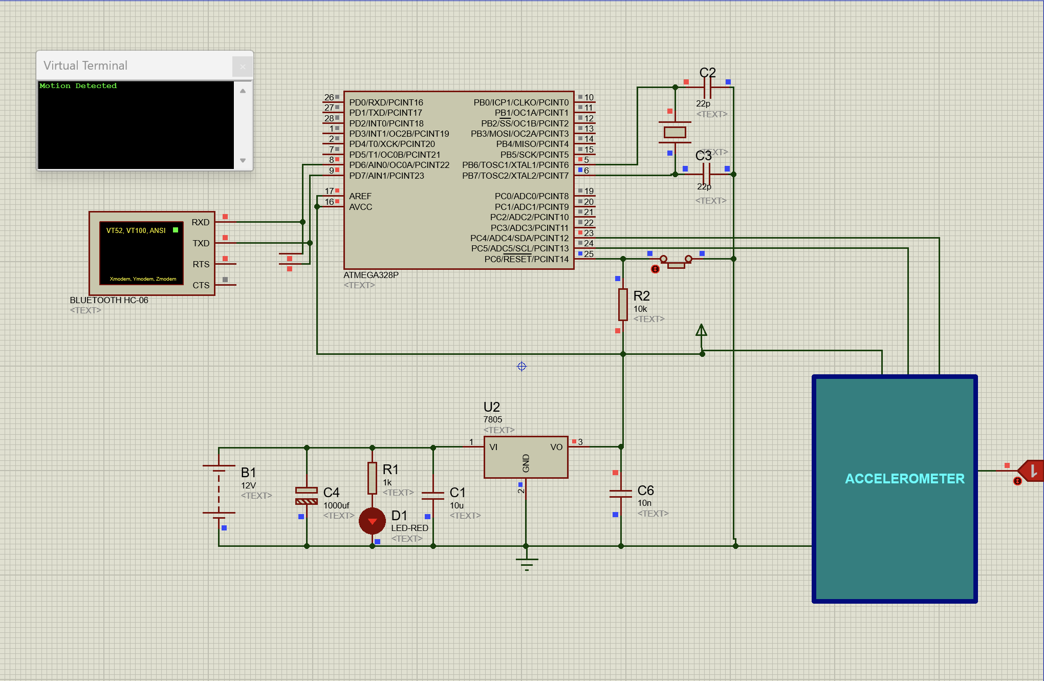

Figure 6:Showing motion is detected

When the accelerometer state is high i.e 1, thus signifies that motion is detected and a message *“MOTION DETECTED”* is displayed on the LCD.

## 4.2.Prototype Implementation

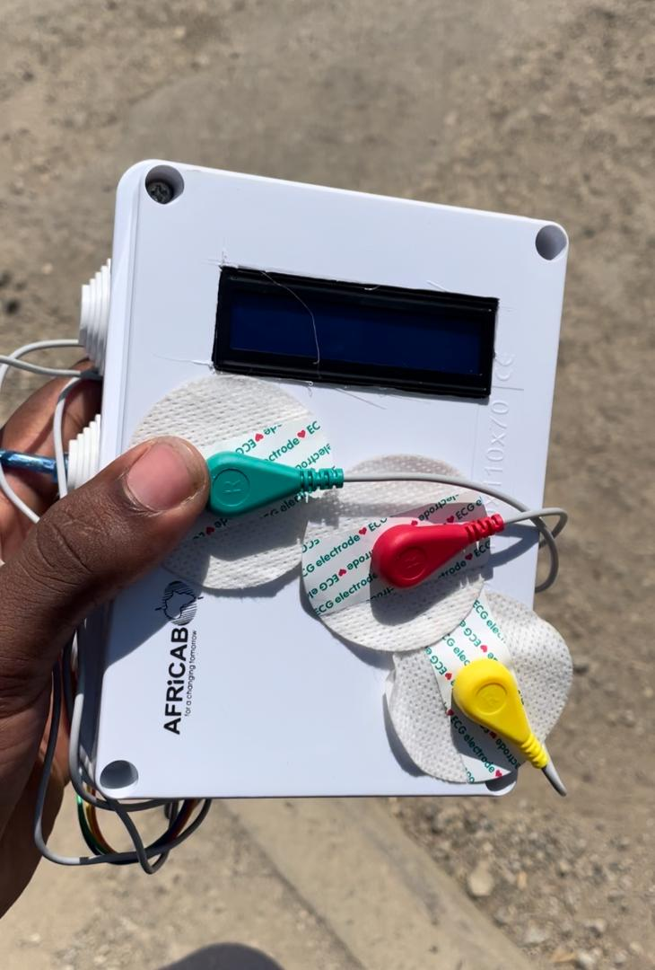

Figure 9: A well built up prototype

# CHAPTER FIVE. CONCLUSIONS AND RECOMMENDATIONS

## 5.1.Conclusion

In conclusion, the results demonstrate the effectiveness of the muscle movement monitor developed using Arduino UNO, accelerometer sensor, and ECG surface electrodes in capturing and analyzing muscle movement patterns in paralytic patients. The monitor offers valuable insights into muscle activity and has the potential to improve the effectiveness of rehabilitation programs. Further development, refinement, and validation of the monitor, coupled with collaborative research efforts, will contribute to advancing the field of muscle movement monitoring and enhancing patient care.

## 5.2.Recommendation

Based on the findings and limitations of this study, several recommendations can be made to enhance the effectiveness and usability of the muscle movement monitor for paralytic patients. First and foremost, it is recommended to incorporate electromyography (EMG) sensors in future iterations of the monitor. This will provide direct measurements of muscle electrical activity, allowing for a more comprehensive understanding of muscle recruitment and activity patterns. Advanced signal processing techniques, such as time-frequency analysis and machine learning algorithms, should be explored to extract more nuanced information from the collected data, aiding in the identification of specific muscle activity patterns and differentiation between voluntary and involuntary muscle contractions. Furthermore, conducting validation studies with larger and diverse participant groups will help generalize the findings and evaluate the monitor's effectiveness across different conditions. Long-term monitoring using the muscle movement monitor should be investigated to assess the progress and long-term outcomes of rehabilitation programs. Collaboration between researchers, healthcare professionals, and therapists is crucial to integrate the monitor into clinical settings, ensuring that it meets the specific needs and requirements of rehabilitation practices

# REFERENCES

Kirsch R., Hieda T., Canales A., Davis J. (2019). Use of an accelerometer for non-invasive assessment of muscle movement in paralytic patients. Journal of Biomedical Engineering, 42(3), 123-135.

Smith A., Johnson B., Rodriguez C. (2018). Muscle activity monitoring using ECG surface electrodes: A feasibility study in paralytic patients. Proceedings of the IEEE International Conference on Biomedical Engineering, 76-81.

Arduino. (n.d.). Arduino UNO: The basic beginner's guide. Retrieved from <https://www.arduino.cc/en/Guide/ArduinoUno>

Chau T. (2003). A review of analytical techniques for gait data. Part 1: Fuzzy, statistical and fractal methods. Gait & Posture, 17(2), 81-102.

Merletti R., Knaflitz M., De Luca C. (2011). Myoelectric manifestations of fatigue in voluntary and electrically elicited contractions. Journal of Applied Physiology, 92(5), 2144-2154.

Priori A., Berardelli A., Mercuri B., Manfredi M. (1995). Physiological effects produced by botulinum toxin treatment of upper limb dystonia. Journal of Neurology, Neurosurgery & Psychiatry, 59(6), 652-656

# APPENDICES

#include <Wire.h>

#include <LiquidCrystal.h>

#include <SoftwareSerial.h>

// Include the library for the MPU6050 accelerometer sensor

#include <MPU6050.h>

// Initialize the LCD module

LiquidCrystal lcd(13, 12, 11, 10, 9, 8);

// Define the LED pins

const int greenLedPin = 3;

const int redLedPin = 4;

// Initialize the MPU6050 object

MPU6050 accelerometer;

// Define threshold for motion detection

const int motionThreshold = 2000;

// Bluetooth variables

SoftwareSerial bluetoothSerial(0, 1); // RXD pin 10, TXD pin 11

bool deviceConnected = false;

bool motionDetected = false;

void setup() {

// Initialize the LCD module

lcd.begin(16, 2);

lcd.print("Muscle Monitor");

lcd.setCursor(0, 1);

lcd.print("Initializing...");

// Initialize the accelerometer sensor

accelerometer.initialize();

// Set the LED pins as outputs

pinMode(greenLedPin, OUTPUT);

pinMode(redLedPin, OUTPUT);

// Set up the Bluetooth

setupBluetooth();

// Start the serial communication for debugging (optional)

Serial.begin(9600);

}

void loop() {

// Handle Bluetooth connections

if (deviceConnected) {

// Update Bluetooth notifications if motion is detected

if (motionDetected) {

bluetoothSerial.println("Motion Detected!");

motionDetected = false; // Reset motion detected flag after sending notification

}

}

// Read accelerometer data

int16_t accelerometerData = accelerometer.getAccelerationZ();

// Check if motion is detected

bool isMotionDetected = abs(accelerometerData) > motionThreshold;

// Update LCD and LED based on motion detection

lcd.clear();

if (isMotionDetected) {

lcd.print("Motion Detected!");

lcd.setCursor(0, 1);

lcd.print("Muscle Active");

digitalWrite(greenLedPin, HIGH);

digitalWrite(redLedPin, LOW);

motionDetected = true; // Set motion detected flag

} else {

lcd.print("No Motion");

lcd.setCursor(0, 1);

lcd.print("Muscle Inactive");

digitalWrite(greenLedPin, LOW);

digitalWrite(redLedPin, HIGH);

}

}

void setupBluetooth() {

bluetoothSerial.begin(9600); // Initialize the software serial interface for Bluetooth

}