A complement solution for retail shops

Arti Sharma
Computer Science
KIET Group of Institutions
Ghaziabad, India
0000-0001-6540-1639
Priyambda Pandey
Computer Science
KIET Group of Institutions
Ghaziabad, India
priyambda.***@kiet.edu

Aman Malik
Computer Science
KIET Group of Institutions
Ghaziabad, India
aman.1923co1031@kiet.edu

Gauri Dargar
Computer Science
Kiet Group of Institutions
Ghaziabad, India
gauri.1923co1064@kiet.edu

Abstract—The continuous increase in the variety of products has led to an issue of difficulty in maintaining the inventory of small retail shops with limited space available and limited capital to buy only a few products. This paper aims to explore different machine learning algorithms to forecast the future demand for products to efficiently maintain the inventory of small shops. [1]Demand forecasting plays an important role in managing retail logistics processes. The quality of the resulting forecasts has a direct impact on the efficiency of processes not only in retail stores but also throughout the supply chain they are a part of. Nowadays data is generated in abundance which can be cleaned and then after applying appropriate machine learning algorithms can be used for forecasting the future demands for products.
This prediction system will help small retail shop owners in maximizing their profit margins. Along with forecasting sales, we aim for customer segmentation to take effective decisions to generate a good amount of revenue.

Keywords—Machine Learning; Data Cleaning Prediction System; Demand Forecasting, customer segmentation, KNN algorithm.

Introduction
Machine learning is an artificial intelligence (AI) based technique that has the power to develop a model [2] which can learn automatically and improve itself from its own experiences. No explicit programming is required for this. The main idea behind machine learning is pattern recognition and computational learning [6].
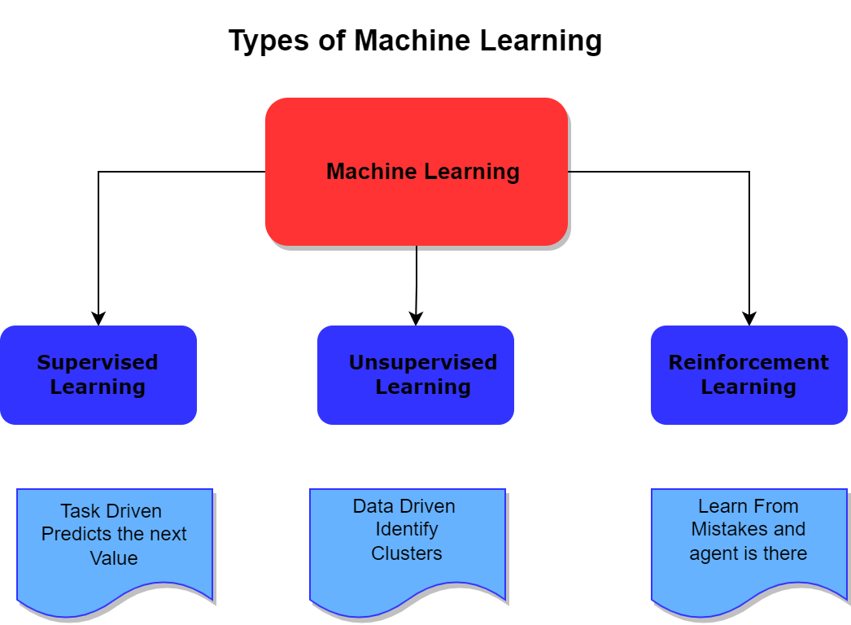
- Types of Machine Learning Techniques
Supervised Learning performs the training of the proposed model with some suitable datasets and on basis of that, the proposed algorithms respond accurately to all realistic inputs. Regression and classification are two types of supervised learning [5]. Unsupervised Learning finds out the resemblance between input data [7]. After that, it classifies the data. Clustering is an example of unsupervised learning. Semi-Supervised Learning uses data that is unlabeled [6] and is used for training the model. It lies in between unsupervised and supervised learning. Reinforcement Learning is also termed as learning with a critic. Behaviorist psychology [3] is the main source of inspiration behind it. If the answer is wrong then the algorithm is informed. This algorithm doesn't inform how to correct it. It uses the idea of fitness to check the accuracy of the solution [4]. Deep Learning is mainly based on high-level abstraction algorithms. A deep graph with various processing layers is used in it. It is made up of linear and nonlinear transformation layers [8].
Retail is one of the most important business domains for data science and data mining applications because of its prolific data and numerous optimization problems such as optimal prices, discounts, recommendations, and stock levels that can be solved using data analysis methods. Sales forecasting is known as the process of making future estimations concerning product sales over a specific period. Generally, sales forecasting will consider historical data and other analytical information to produce the most accurate predictions. More specifically, the methods of sales forecasting entail using predictive analytics of historical data to understand and predict customer demand to understand key economic conditions and assist in making crucial supply decisions to optimize business profitability. Many machine-learning techniques hence have been discovered for this purpose. In this paper, we are trying to predict the sales of a retail store using different machine-learning techniques and trying to determine the best algorithm suited to our particular problem statement. We have implemented normal regression techniques as well as boosting techniques in our approach and have found that the boosting algorithms have better results than the regular regression algorithms.
Predicting the right demand at each retail outlet is crucial for the success of every retailing company because it helps with inventory management, results in better distribution of products across stores minimize over and under-stocking at each store thereby minimizing losses, and most importantly maximizes sales and customer satisfaction. Nowadays the growing competition in the retailers market needs to be operated effectively so along with sales forecasting we need to focus on different customer’s interests Customer Segmentation is useful to divide the large data from the dataset into several groups based on their age, demographics, spent, income, gender, etc. These groups are also known as clusters. By this, we can get to know, which product got a huge number of sales and which age groups are purchasing, etc. And, we can supply that product much for better revenue generation.
Small retail shops can benefit from forecasting and customer analysis to efficiently manage their inventory the demand for the products will be predicted based on historical data.

RELATED WORKS
Over the years, the commercial world has become more competitive, as retail markets must meet the needs and desires of their customers, to retain, and attract customers thus improving their businesses [9]. The methods to attract retain and maintain customer involves customer segmentation and sales forecasting. The findings of the research paper [10] indicate that Machine Learning approaches, as well as a mixture of different techniques used in market forecasting models, will help fast-moving consumer goods, producers, and retailers. The two methods used by us that are segmentation and predictions say that-
Sales prediction is a vital piece of present business intelligence. It is often an opulent issue, particularly in the case of absence of information, or missing information. Segmentation on the other hand is a form of clustering the entities. Clustering is the process of grouping information into a dataset based on some commonalities. There are several algorithms, which can be applied to datasets based on the provided condition.[11] Having rigorous demand forecasting and stocktaking management systems for vulnerable operational management is essential because of rivalry and financial constraints in the retail industry, as well as cost-oriented supply chain operations, and retailers
entail optimizing their provision to degrade the financial risk [12]

Going through a few pieces of research on sales forecasting and customer segmentation. K-means algorithm is implemented which is present in the python scalar library but no universal clustering algorithm exists. During the sales forecasting models exploration, we come across various models that include Linear regression, XGBoost, random forest, and LSTM, the predictions using all the models are done and showcased in the paper.

The research paper [13] explored a stacking method for creating a regression ensemble of single models. The findings suggest that predictive model efficiency for sales time series forecasting can be enhanced by using stacking techniques. We used a relative mean absolute error (MAE), Root means squared error (RMSE), and R2 score for error estimation.

PROPOSED METHODOLOGY
We have proposed a way for retail shop owners to generate more profit which has a combined approach of forecasting sales along with customer segmentation.
We have performed our analysis on the dataset provided by the Kaggle website. For our problem statement, we will use K-Means Clustering which groups the data into different clusters based on their similar characteristics. And then we will visualize the data. Along with the forecasting of sales where we have used regression models LSTM networks and we have also taken care of the time series data using the ARIMA model.

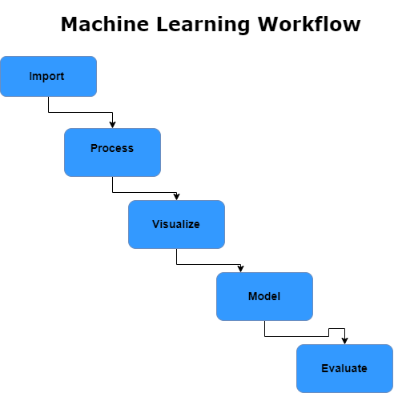

Fig 2. A basic machine learning workflow
Step 1: Data Collection
The very first step is data accumulation, for our work, we have selected predefined data from Kaggle which contains loads of information the data is segregated into two parts. One part goes for customer segmentation which contains the customer demo graphs along with the product details. The other part goes for forecasting purposes which contains information about the types of products the stores and their particular sales. The customer data consists of approx. 25000 unique customers combined with their orders.

Step 2: Data Cleaning, Preprocessing, and EDA

After the data collection, we have to pre-process the data values and extract their useful attributes, the main processing is done in the form of aggregating the data month wise which will be used in the time series forecasting. For the Customer segmentation part, we have to prepare some attributes which rightfully define customer behavior they include the number of products ordered, Average return rate, and Total spending.

Step 3: Statistics, Machine Learning

The predictive analytics process employs many statistical and machine learning techniques. Probability theory and regression analysis are the most important techniques which are popularly used in analytics. Similarly, artificial neural networks, and decision trees, are the tools of machine learning which are widely used in many predictive analytics tasks. All the predictive analytics models are based on statistical and/or machine learning techniques. Hence the analysts apply the concepts of statistics and machine learning to develop predictive models. Machine learning techniques have an advantage over conventional statistical techniques, but techniques of statistics must be involved in developing any predictive model. Since we are working with time series data the predictions in our case are technically termed forecasting.

Step 4: Models for forecasting sales.

In this phase, the data is trained on different regression models based on statistical and machine learning techniques and the example dataset. After the development, it is tested on the test dataset which is a part of the main collected dataset to check the validity of the model and if successful, the model is said to be fit. Once fitted, the model can make accurate predictions on the new data input to the system. In many applications, the multi-model solution has opted for a problem and that is the case with our problem-
- The best results were obtained from the XGBoost and LSTM models
- All models predicted within 2% of monthly mean sales for 12-month prediction.

Step 5: Segmenting the customers

Customer segmentation will be applied to the customer info using the K-means Clustering algorithm from python’s Scikit-learn.

5.1
K-Means Clustering

- K Means algorithm is an iterative algorithm that tries to partition the dataset into K predefined distinct non-overlapping subgroups which are called clusters.
- Here K is the total no of clusters.
- Every point belongs to one cluster.
- Clusters cannot overlap each other.
Steps of Algorithm
- Arbitrarily choose k objects from D as the initial cluster centers.
- Repeat.
- Assign each object to the cluster to which the object is the most similar, based on the mean value of the objects in the cluster.
- Update the cluster means, i.e. calculate the mean value of the objects for each cluster.
- Until no change.

As mentioned above the features created that will be used for the segmentation are:
- Products ordered or items purchased
It is the count of the products ordered in the product_type column by a customer.
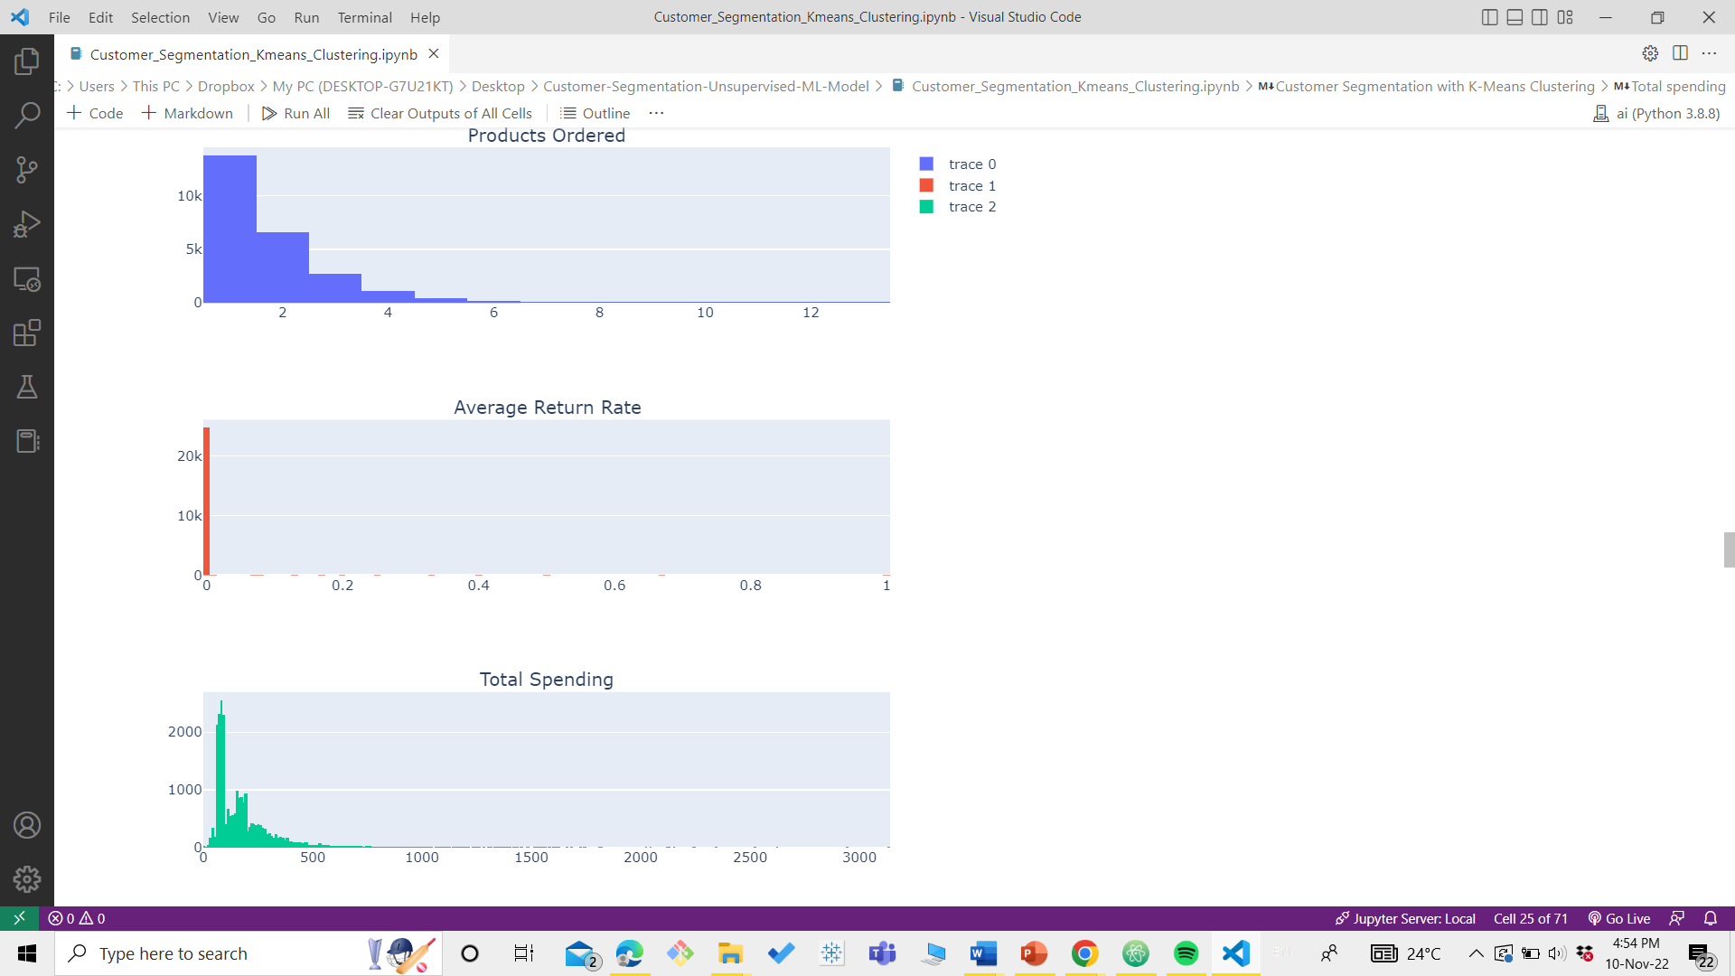
- Average Return Rate:
It is the ratio of returned item quantity and ordered item quantity. This ratio is first calculated per order and then averaged for all orders of a customer.

- Total Spending

Total spending is the aggregated sum of total sales value which is the amount after taxes and returns.

5.2 Models for forecasting

- Linear Regression
Regression analysis is a statistical technique for estimating the relationship among variables that have reason and result relation. The main focus of univariate regression is to analyze the relationship between a dependent variable and one independent variable and formulates the linear relation equation between the dependent and independent variable. Regression models with one dependent variable and more than one independent variable are called multi-linear regressions.[14]
RMSE: 16221.040790693221
MAE: 12433.0
R2 Score: 0.9907155879704752

Comparison between actual and predicted values are shown below in fig 5.
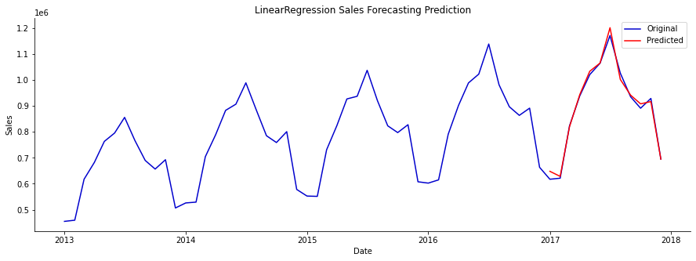
Fig 5. Comparison between actual and predicted values using a linear regression model.

2. Random Forest Regression:
Random Forest developed by Leo Breiman. Random features are selected in the induction process. Prediction is made by aggregating (majority vote for classification or averaging for regression) the predictions of the ensemble.[15]
Random Forest can also be used for time series forecasting, although it requires that the time series dataset be transformed into a supervised learning problem first. It also requires the use of a specialized technique for evaluating the model called walk-forward validation, as evaluating the model using k-fold cross-validation would result in optimistically biased results.
RMSE: 18035.41487139493
MAE: 15064.916666666666
R2 Score: 0.9885224485928914
Comparison between actual and predicted values are shown below in fig 6.
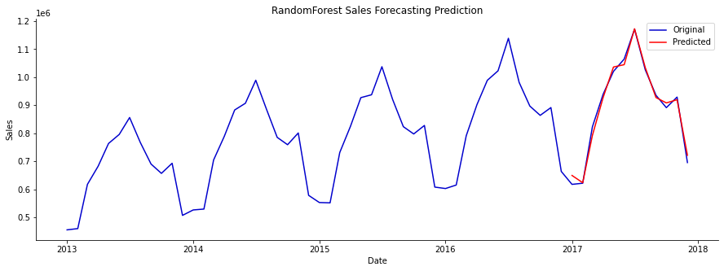
Fig 6. Comparison between actual and predicted values using a random forest regression model
3.XGBoost for Regression
The XGBoost algorithm is a gradient-boosting framework created by Chen et al.[2ii] in 2016. It is widely used in various data mining scenarios and algorithm competitions. The algorithm takes its main advantages in precision, flexibility, and automatic processing of missing values.
XGBoost is an implementation of Gradient Boosting, which combines multiple weak classifiers into a strong classifier in a linear way. XGBoost supports both CART and linear classifiers as base classifiers, and performs second-order Taylor expansion on the cost function, expressing more plentiful information. In terms of operating speed, XGBoost supports the parallel selection of split points, and the model training cost much less time.[16]
RMSE: 15701.003359658262
MAE: 13342.666666666666
R2 Score: 0.9913013514225064
Comparison between actual and predicted values are shown below in fig 7.
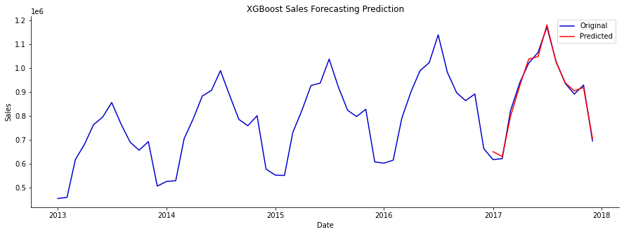
Fig 7. Comparison between actual and predicted values using decision xgboost regression model
4. LSTM Network
The Long Short-Term Memory Network (LSTM)is a specific form of RNN, suitable for processing time series and relatively long delay important events, but it is easy to fall into the local optimum. [17]
The main idea behind LSTM cells is to learn the important parts of the sequence seen so far and forget the less important ones. This is achieved by the so-called gates, i.e., functions that have different learning objectives such as:
- a compact representation of the time series seen so far
- how to combine new input with the past representation of the series
- what to forget about the series
- what to output as a prediction for the next step.
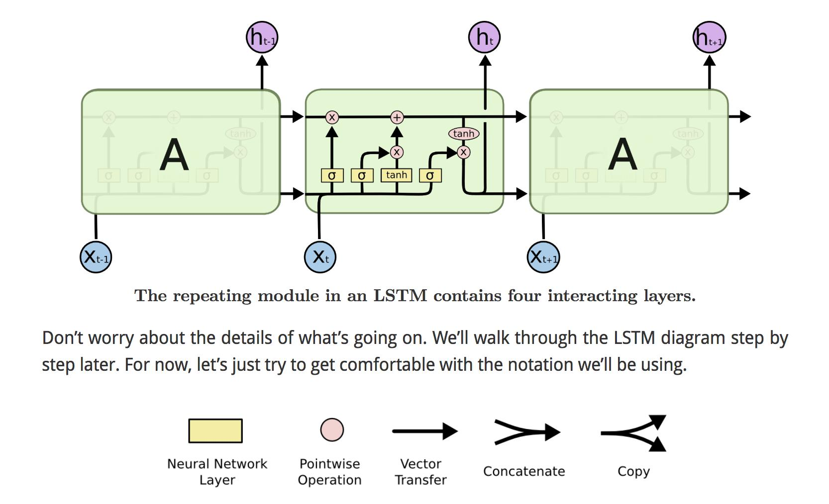
Fig 8. Basic Architecture f LSTM network [19]
RMSE: 16483.005609313692
MAE: 12860.083333333334
R2 Score: 0.9904132856830274

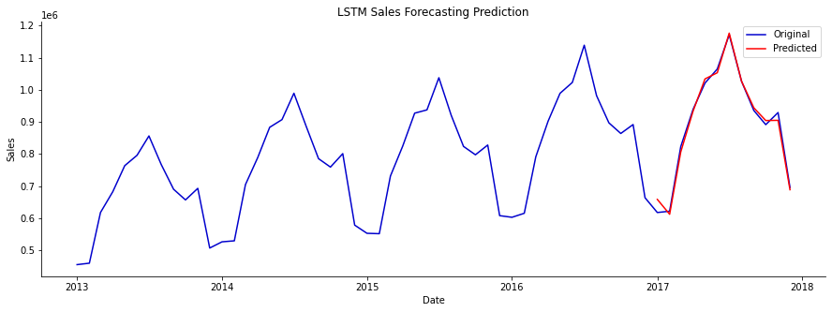
Fig 9. Comparison between actual and predicted values using decision LSTM model
IV Time Series Forecasting
ARIMA
Various models of demand forecast include Autoregressive (AR), Moving Average (MA), and Autoregressive Moving Average (ARIMA). Autoregressive Integrated Moving Average (ARIMA). Compared with the early AR, MA, and ARMA models, the ARIMA model is more flexible in application and more accurate in the quality of the simulative or predictive results.[18]
In the ARIMA analysis, an identified underlying process is generated based on observations to a time series for generating a good model which shows the process-generating mechanism precisely.
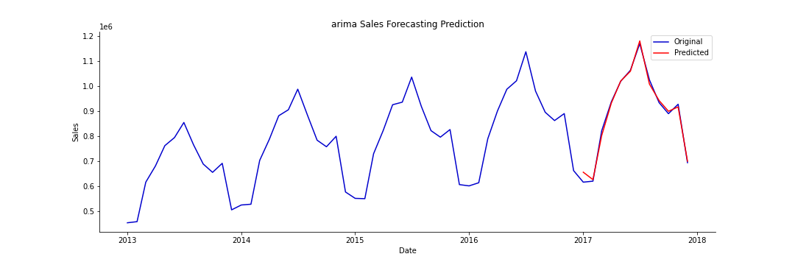
Fig 9. ARIMA model predictions
We can also get dynamic predictions. The one-step-ahead prediction uses the true values of the endogenous values at each step to predict the next in-sample value. Dynamic predictions use one-step-ahead prediction up to some point in the dataset (specified by the dynamic argument); after that, the previous predicted endogenous values are used in place of the true endogenous values for each new predicted element.
V RESULTS
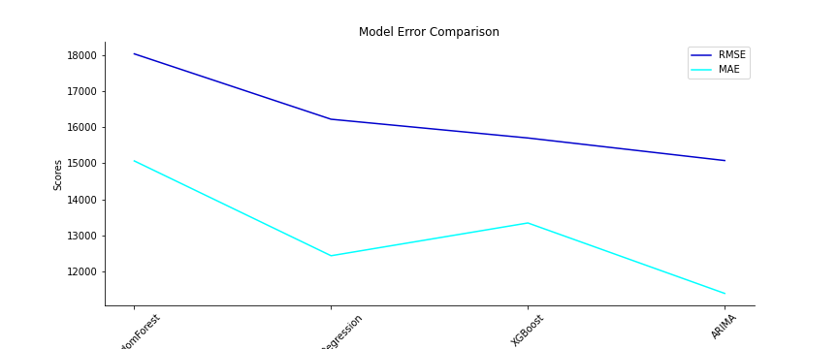
No algorithm works best for all the datasets. So depending on the data you can try various algorithms and choose the best for your data. I have tried ARIMA, SARIMA, etc, lstm, Random forest, XGBoost, and time series forecasting and each of these algorithms worked best for one category or the other. Random forest, XGBoost outperformed for multivariate and intermittent data.

Conclusion
A concise literature review based on various machine learning techniques used in the predictive analysis is provided in this paper. It also provides a unique approach to designing an artificial intelligence-based prediction system. The designed system will mainly work as a recommendation system. It will use the concepts of machine learning and data mining technologies. Various machine learning models for predictive analysis have been tested and analyzed.XGBoost regression model gave the best performance in predicting future sales. we can predict future demand for products. This prediction system will be used to recommend products to small retail shops to keep in their inventory to help them maximize their profit.

References
[1]. N.p., Web. 28 Nov. 2022.
https://kkhsou.ac.in/eslm/E-SLM_Main/1st Sem/Bachelor Degree/BBA/GBA S1 02 (Block 1).
[2] Dalal Bardou, Kun Zhang, and Sayed Mohammad Ahmad, “Classification of Breast Cancer Based on Histology Images Using Convolutional Neural Networks” IEEE Access, 01-May-2018, pp. 24680-24693.
[3] Gillian Pearce, Julian Wong, “Artificial Neural Network and Mobile Applications in Medical Diagnosis” International Conference on Modelling and Simulation, IEEE Computer Society, March - 2015, pp. 61-64.
[4] Alex Shenfield, Shahin Rostami, “Multi-objective evolution of artificial neural networks in multi-class medical diagnosis problems with class imbalance” IEEE Xplore, October-2017, pp. 01-08
[5] Gunawardena, Rajapakse, Kodikara, “Applying Convolutional Neural Networks for Pre-detection of Alzheimer’s Disease from Structural MRI data” IEEE Xplore, December-2017, pp. 01-07.
[6] Vijay Huddar, Vaibhav Rajan, “Predicting Complications in Critical Care using Heterogeneous Clinical Data” IEEE Access - 2016, pp. 01-13.
[7] Valkonen, Kartasalo “Dual structured convolutional neural network with feature augmentation for quantitative characterization of tissue histology” IEEE Computer Society, October-2017, pp. 27-35.
[8] Shurouq Hijazi and Alex Page, “Machine Learning in Cardiac Health Monitoring and Decision Support” IEEE Computer Society, November - 2016, pp. 38-48
[9] Puwanenthiren Premkanth, - Market
Classification and Its Impact on Customer
Satisfaction and Special Reference to the
Commercial Bank of Ceylon PLC.‖ Global
Journal of Management and Business Publisher
Research: Global Magazenals Inc. (USA). 2012.
Print ISSN: 0975-5853. Volume 12 Issue 1

[10] Blanchard, Tommy. Bhatnagar, Pranshu. Behera,
Trash. (2019). Marketing Analytics Scientific
Data: Achieve your marketing objectives with
Python's data analytics capabilities. S.l: Packt
printing is limited

[11] Sulekha Goyat. "The basis of market
segmentation: a critical review of the literature.
European Journal of Business and Management
www.iiste.org. 2011. ISSN 2222-1905 (Paper)
ISSN 2222-2839 (Online). Vol 3, No.9, 2011

[12] [2] Kilimci ZH 2019 Hindawi 2019 1

[13] vlyshenko, B. M. (2019). Machinelearning models for sales time series
forecasting. Data, 4(1), 15.
[14] Kaya Uyanık, Gülden & Güler, Neşe. (2013). A Study on Multiple Linear Regression Analysis. Procedia - Social and Behavioral Sciences. 106. 234–240. 10.1016/j.sbspro.2013.12.027.
[15] Ali, Jehad & Khan, Rehanullah & Ahmad, Nasir & Maqsood, Imran. (2012). Random Forests and Decision Trees. International Journal of Computer Science Issues(IJCSI). 9.
[16] Zhang, Lingyu & Bian, Wenjie & Qu, Wenyi & Tuo, Liheng & Wang, Yunhai. (2021). Time series forecast of sales volume based on XGBoost. Journal of Physics: Conference Series. 1873. 012067. 10.1088/1742-6596/1873/1/012067.
[17] Yuzhen Wang et al 2019 J. Phys.: Conf. Ser. 1314 012215
DOI 10.1088/1742-6596/1314/1/012215
[18] AIP Conference Proceedings 1931, 030017 (2018); https://doi.org/10.1063/1.5024076
[19] http://colah.github.io/posts/2015-08-Understanding-LSTMs/

